Contents
DFD – Dataflow Diagram 2
Policies 3
User Policies 3
Device Management Policies 3
Security Policies 3
Configuration of Hyper-fort 4
Mobile Device Management Software 5
Intune 5
BYOT 6
Advantages 6
Disadvantages 7
Data retained by mobile devices 7
Potential data leaks 7
Blending of personal and business usage 8
Different brand of devices 8
Different Operating System 8
Different Application on user devices 8
Employee leaves or device is lost, stolen or fails 9
Appendix 9

DFD – Dataflow Diagram
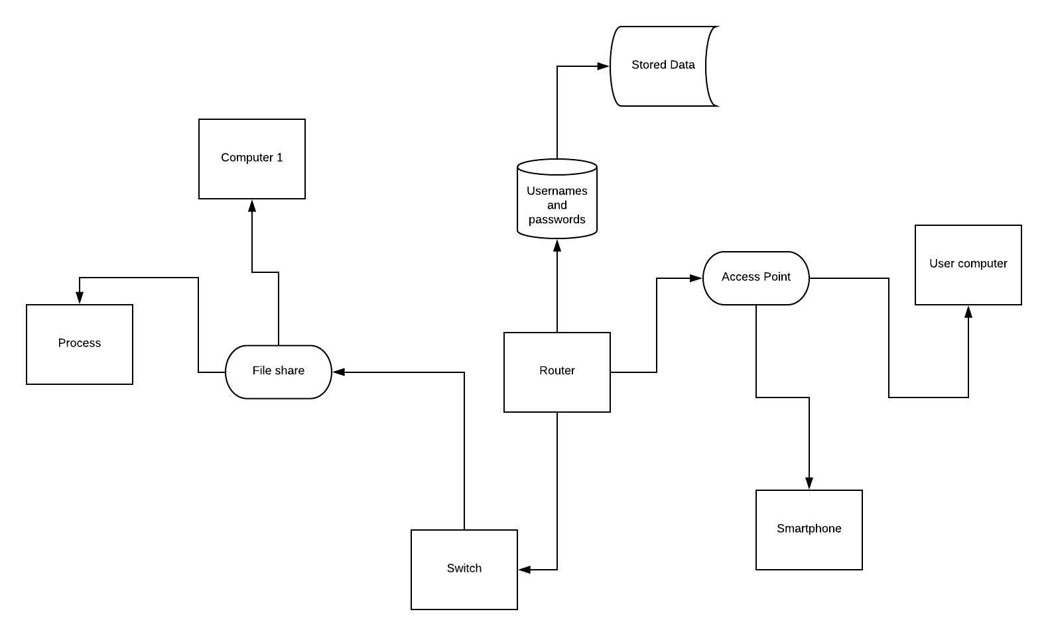

Policies

User Policies
- User must have a username, username must not contain any hints to the password in order to keep the network secure as if they did then it will be easier for their accounts to be hacked by someone on the outside
- User must have a password
- Password must have more than 8 characters and have 1 special letter, this making it more secure and also their password must not contain their personal name.
- Not allowed to go use social media on the network unless told so by a supervisor, so not allowed on Facebook, Twitter or any social media unless for example it’s the only way to communicate to a client and you are authorized and even then, need to be monitored
- No downloading any files off any website without permission, if an employee wants to download a cracked version of a software then they aren’t allowed to do it as it can come with virus or ransomware and will be very bad for the network and company.
- No playing games in the network, this is a very strict rule and it will be distracting to work if you are playing games and shows that the work place isn’t very professional

Device Management Policies
- Every router and switch have to be appropriately configured to the company’s security requirements, if they aren’t securely configured then it will be easy to hack the network. So, they have to be properly configured
- All default passwords must be changed
- Formal testing for the routers and switches needs to be taken place
- Evidence that there is a regular critical patching to the network, if it isn’t being critically patched then it can be hacked really easily and data can be loss/leaked if there is a virus.
- Routers and switches are patched and updated on a documented, regular, and timely schedule

Security Policies
- Staff members found in policy violation may be subject to disciplinary action, up to and including termination
- The creation and management of all accounts, including system and user accounts, must be authorized in advance in writing by the Systems Manager.
- Privileged accounts such as admins must be logged and reviewed consistently.
- Network manager needs to approve any creation of any user.
- Can’t use the computer for personal usage
- Computer must have anti-software, normally all laptop comes with windows anti-virus but it is also helpful to have your own one to be extra sure.
- Must be checked constantly for virus, the employee device must be weekly checked, and this can be done by doing a full computer scan with an anti-virus.

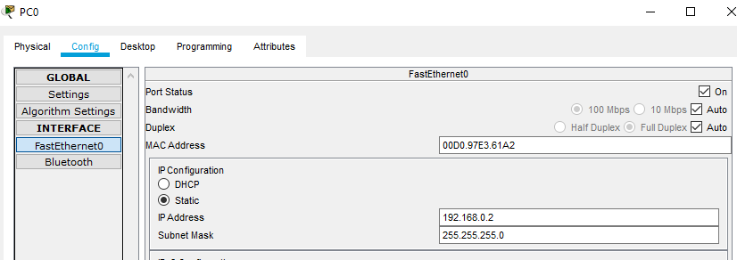
Configuration of Hyper-fort
Go to a PC config and then I had to configure the ip addresses to match with the routers ip in order for the PC to have internet connection.

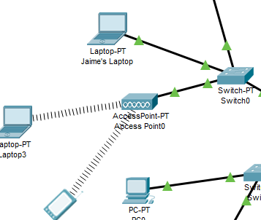

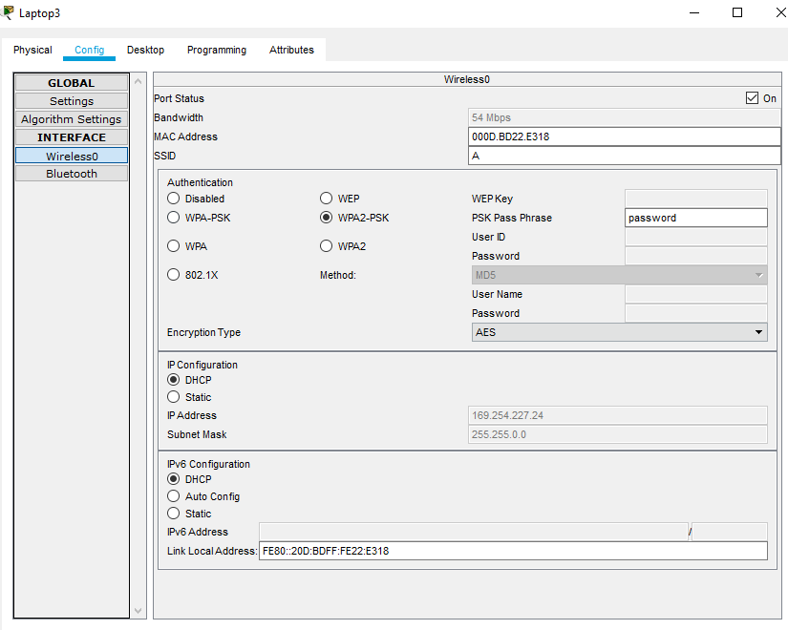
After I set up the router with the PC’s I created a Access Point for smart phones and for other laptops. As you can see from the screenshot bellow, the access point requires you to type the SSID and password before you can join it; for this case I put the password as password to just show and see if it works.

Mobile Device Management Software

Intune
Intune is designed to support your diverse mobile ecosystem, enabling you to securely manage iOS, Android, Windows, and macOS devices from a single, unified mobile solution. It also helps you safeguard company data with or without device enrolment by creating app protection policies, as well as achieve IT efficiencies in the cloud so you don’t have to maintain on-premise servers. This software starting plans cost £4.50/use per month.
Intune features are such as:
- Mobile device & app management
- Advanced Microsoft Office 365 data protection
- Integrated PC management
- Integrated on-premises management
- Identity & access management
- Information protection
- Identity-driven security

I chose this mobile device management software because it was rated no. 1 for device management on various websites. Also, the features it offers it really good and mobile device and app management is really good for BYOD as they can see how much network usage is being used where and when.

Intune provides information protection and identity-driven security, so the data is always safe and not anyone can just gain access and manage it, you have to have a certain method of entry such as username and password or any form of identity-driven security.

There are a lot more benefits of having this mobile device management software such as:
- Central management of devices
- Manual app and configuration
- Security improvements and AI to identify and improve productivity
- Easier to manage all mobiles
- Keeps data and applications secure

BYOT

Advantages
- Feel more comfortable working on their own device, by bringing their own device the employee will be more comfortable as they are used to do work on their device at home. This will improve work productivity as they will have their own tricks on their devices to make work be more accessible and doable.
- May have their own software to make work easier, they might buy software on their own time to help with work and increase their productivity and reduce time spent on the work.
- Make them feel more like at home, they will still have a desk and a place to work obviously so by them being able to have their own computer makes it that more home welcoming as the only setting different is your work table, but the main aspect is your computer and you will have that.
- Cheaper for the company, this will be a lot cheaper for the company as they won’t have to invest as much money on PC’s for the work place or have to provide laptops for the employees so they can take it home and work there.
- Workers can pick their own device that they will actually like, the employee can now choose and buy a device that they like, and will enjoy work, increasing happiness and satisfaction of the employee in the work place
- Most likely be a laptop, more mobile to carry and making it easy to carry the laptop with them all around. They can do work anywhere and anytime, on the way to work and on the way home from work, either if they get the bus or train.

Disadvantages
- They can have incriminating things on their device on the company’s network and it might back lash on them, so if the employee has something illegal on their computer like “Childporn” then it can back lash on the company and give them a bad name, so with that being said they will have to monitor the internet usage of the employees.
- Might be a security risk, as they won’t be able to monitor the computers all twenty-four/7. Because this is BYOD then the company can’t know what information and data their employee take home with them, so if an employee takes data from the work place home that they shouldn’t be then it can damage the company because that means data isn’t being secure and means future data leaks can happen with ease.
- If the employee has to pay with their own money then it is a bad thing for them, as they might not have enough money to buy the minimum requirements, some employees won’t be as money stable as the others so they might not be able to get a decent enough device or any device for that matter, they might be relying on the job to pay rent meaning for the start of new employees they will have to struggle.
- Scalability, the network could maybe not take too many devices, because some employees will have multiple devices with them, if the company has many employees then it can be a problem as most of them will most likely have multiple devices and if the network infrastructure can’t take it then it will be a problem and no one will be able to do their work properly.

Data retained by mobile devices

Word documents and other type of data such as:
- PowerPoint
- Video files
- Audio files
This will stay on their own files if they give assistant through videos and etc. Also, the internet password and other stuff will stay so when they come back to the workplace they will connect to the network automatically.

Potential data leaks

The potential data leakage the company may suffer from employees leaving the office environment is too high, as you have so many employees and they all bring their own device then all of them can be a potential leak.
The employees depending on what access level they have on the network they can leak fellow colleges personal information or work data; this can then affect the company on a bad level as their competitors can take advantage of this data if leaked to them. If conferences are recorded, then some employees can gain access to the recording and leak it.

Blending of personal and business usage

There are many different ways to address and stop the blending of personal usage of the network in the work place, the network manager will have block website URL’s such as: “Facebook, Instagram, Twitter, Tumbler, Pornhub”.
For mobile phones you will be required to block certain apps, so they don’t use their phones to play game and get distracted from the work they are supposed to be doing.
Entertainment websites in general, if they have long hours of work and they feel like they have a lot of spare time then they might go on Netflix, Amazon Video Prime, or any other website and this will take a lot of the network usage and will waste a lot of the employees time, so by blocking any social media or streaming platform will be the best way to address this problem.

Different brand of devices

Different brand of devices can be a problem for example a Mac will have certain features that an Acer, ASUS or HP laptop won’t have, like Photoshop, iMovie and other apps which can be used in the workplace and useful.
But then again, the other brands of laptop will have certain apps and software that a Mac can’t handle well; the company will have to check the mandatory software’s that the employees will need and then tell them to make sure their brand of device is compatible with the software.

Different Operating System

With this will be a problem because different Operating System (OS), handle different software differently, some may not work at all or some may only work if its an older version and it matches with the version of the OS.
In order to avoid this the best strategy to deploy and not to have this problem would be to say to the employees that their device for the work place will have to be a certain OS, this will eliminate this problem and it won’t restrict them a lot because even if they can’t pick the OS they can still pick the device and the brand of it allowing it to still be a more friendly environment and give them the satisfaction to bring their own device.

Different Application on user devices

To avoid different application used for work then the company got to have a standard on their policy on what application they to use in the work place, for example the employees have to use Word document or Google docs only, they cant be using libre office as it will impact the work efficiency as when they share their work with colleges then there will be a problem in terms of opening work between colleges.
If they have to edit videos, for example a conference and they have to all use the same application that can read that video file format.

Employee leaves or device is lost, stolen or fails

In the scenario an employee leave, then the company got to have a strategy to avoid the fact of when they leave, they leave with sensitive data of the company. The best way to deal with this is to write on the contract of employment saying that in the instance of the employee leaving they are required give all the files they have to the company to and after factory reset their device so the device is brand new and ensure they have zero files that can impact the company.
Now in the scenario of losing/stolen device the employee will have to make sure that the laptop’s hard drive is encrypted so who ever finds/steals the device can’t gain access to their work and company files, by encrypting means that the data is secure as it can be, but the employee must also make sure he doesn’t look the key/password to unencrypt; and for the recovery/backup they will need a method to use, and the best way is the 3-2-1 backup, because you will always have a spare drive safe inside a safe, to you won’t need to waste as much time on recovery.
In terms of the device failing or being corrupt then you just need to have a backup and recovery mode, but if the computer fails because of file corruption then you need to make sure your backup isn’t corrupt either and if it then you can use the windows settings to back track the computer to a certain day and recover your device to that day and keep doing it until you find the backup that has a uncorrupted file.

Appendix

https://www.1rti.com/the-advantages-disadvantages-of-byod/
https://financesonline.com/mobile-device-management/

