

Developing Relationships and Workplace Achievement
BMSW5102-A1
Student Name : Andrada Balaban
Student Id : 1920286
Lecturer Name : Nishi M Ramsurrun

Table of Contents
Introduction 3
Knowledge Required by HR Professionals 4
Skills Required by HR Professionals 5
Behaviours Required by HR Professionals 6
Importance of Human Resource Officer (HRO) in an Organisation 7
SWOT Analysis 8
Personal Skills Audit 11
Identification of Training and Development Needs 12
Benefits of Mine as HRO 13
Conclusion 14
Reference List 15

Introduction
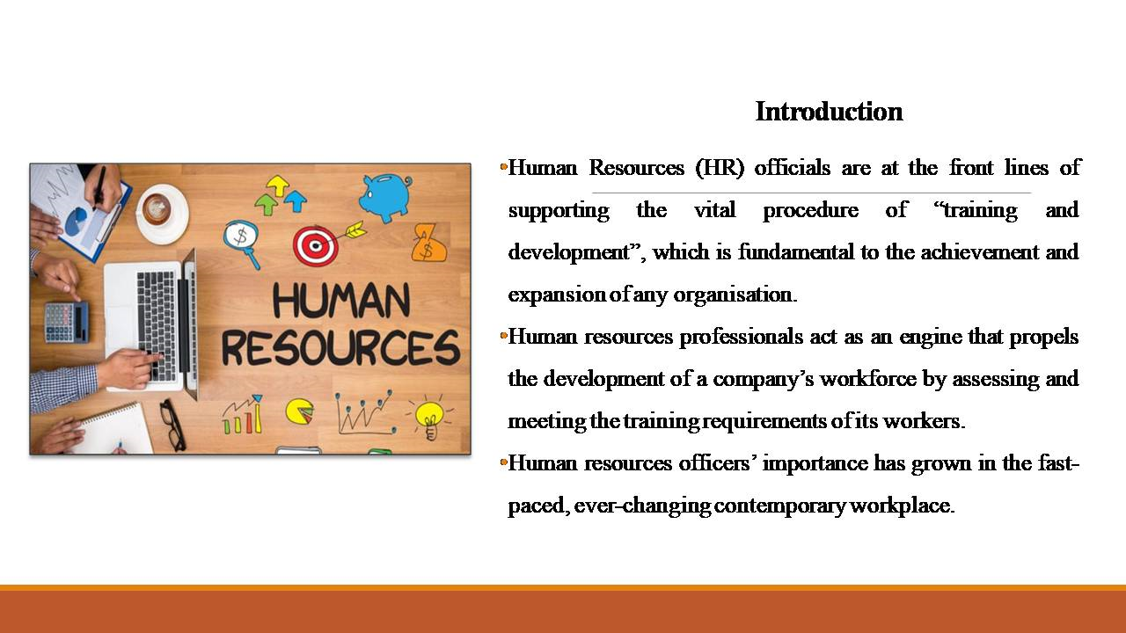
- Human Resources (HR) officials are at the front lines of supporting the vital procedure of “training and development”, which is fundamental to the achievement and expansion of any organisation.
- Human resources professionals act as an engine that propels the development of a company’s workforce by assessing and meeting the training requirements of its workers.
- Human resources officers’ importance has grown in the fast-paced, ever-changing contemporary workplace.
Human resources professionals need to be able to analyse their employees’ and organisations’ training needs, recognise skill shortages, and design robust training programmes. This presentation aims to assess the current skills, knowledge and behaviours of an HRO (human resource officer) for giving the best performance in the appointed role in the organisation Unilever.

Knowledge Required by HR Professionals
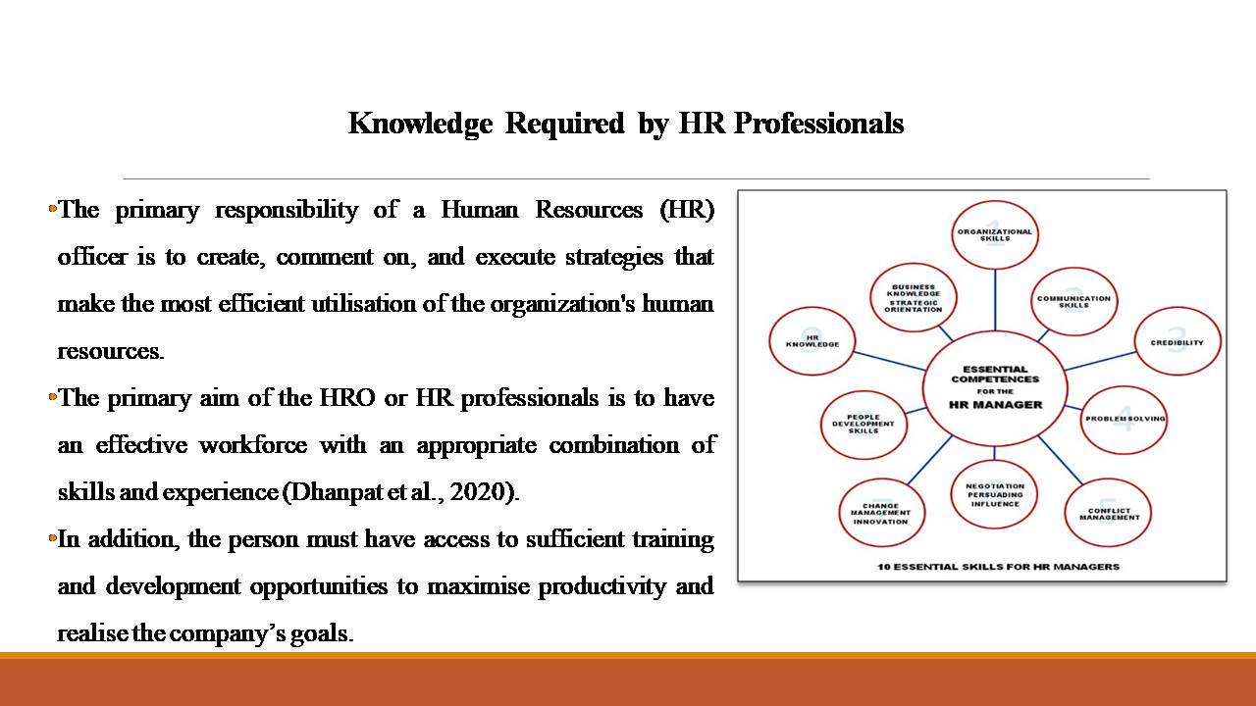
- The primary responsibility of a Human Resources (HR) officer is to create, comment on, and execute strategies that make the most efficient utilisation of the organization's human resources.
- The primary aim of the HRO or HR professionals is to have an effective workforce with an appropriate combination of skills and experience (Dhanpat et al., 2020).
- In addition, the person must have access to sufficient training and development opportunities to maximise productivity and realise the company’s goals.
The HR professionals need a deep knowledge of current principles and procedures for recruitment, selection, training, etc for the personnel of Unilever (Mymajors, 2023). The development of strategies, allocating resources, modelling human resources, successful administration, efficient production processes, and coordinating personnel and assets all need an understanding of the fundamentals of business and management by HR professionals. Human resources professionals are essential in every organisation because of the crucial roles they play in organising the workforce, analysing training requirements in conjunction with department supervisors, and conducting training programmes (such as worker inductions). They have a diverse set of talents and information that they can utilise for the benefit of the company they represent.

Skills Required by HR Professionals
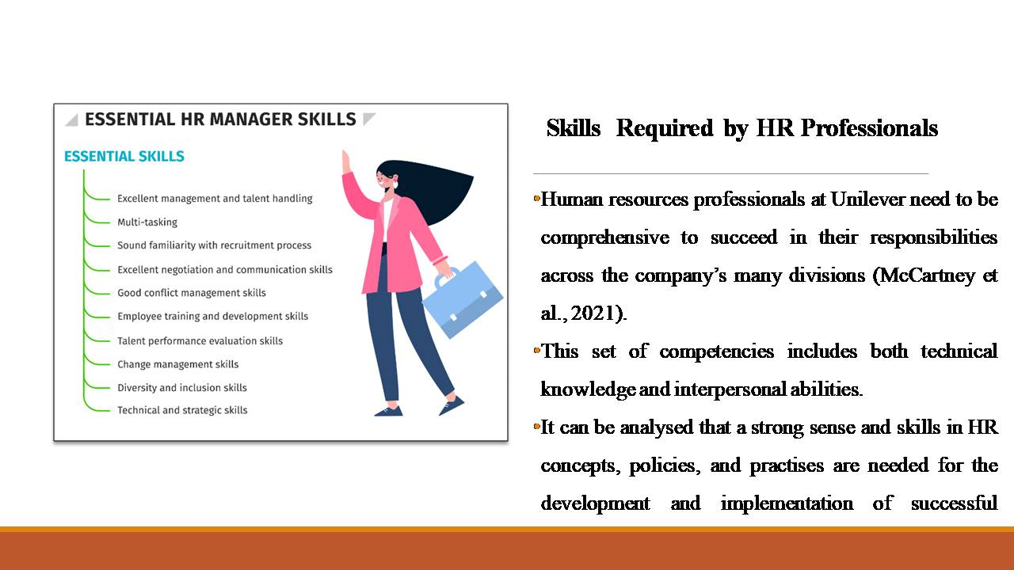
- Human resources professionals at Unilever need to be comprehensive to succeed in their responsibilities across the company’s many divisions (McCartney et al., 2021).
- This set of competencies includes both technical knowledge and interpersonal abilities.
- It can be analysed that a strong sense and skills in HR concepts, policies, and practises are needed for the development and implementation of successful initiatives.
The skill of selecting and recruiting employees is another significant one and it needs the ability to effectively find, evaluate, and hire excellent candidates to fill open positions. Another crucial talent for an HR professional at Unilever is the ability to develop beneficial connections between employees and supervisors, address complaints, and enforce disciplinary processes when necessary. The HR professionals at the concerned organisation need to have strong communication skills along with effective written and verbal skills for easily conversate with employees, upper hierarchy and outside shareholders. A deep understanding of Unilever’s business acumen is another effective skill that should be possessed by the concerned professionals (Varshney, 2020). It will be helping them to gain a deep understanding of the company’s business goals and the ever-shifting business climate in which it operates.

Behaviours Required by HR Professionals
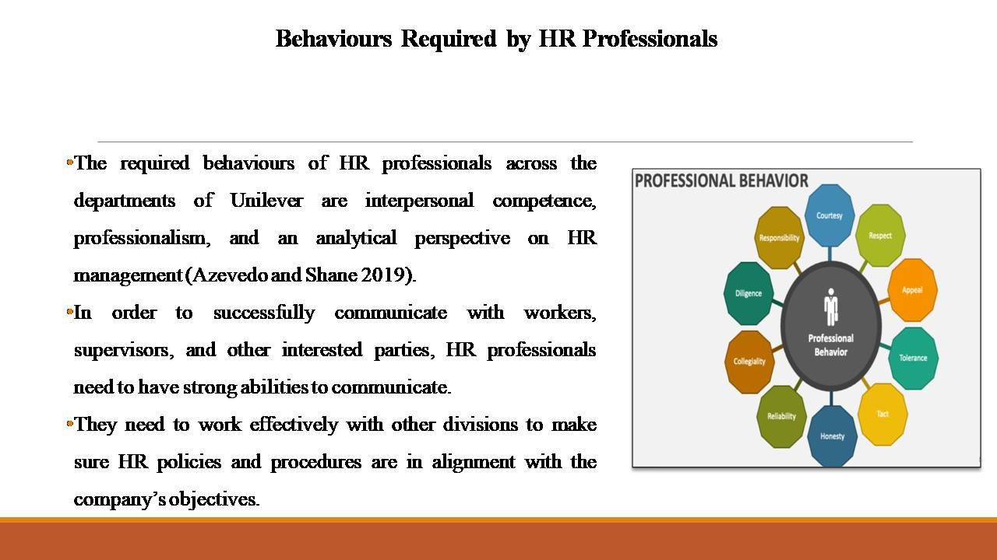
- The required behaviours of HR professionals across the departments of Unilever are interpersonal competence, professionalism, and an analytical perspective on HR management (Azevedo and Shane 2019).
- In order to successfully communicate with workers, supervisors, and other interested parties, HR professionals need to have strong abilities to communicate.
- They need to work effectively with other divisions to make sure HR policies and procedures are in alignment with the company’s objectives.
By taking on a more consultative approach, human resources professionals can more effectively assess the requirements of various groups and provide individualised responses to organisational issues. The HR professionals at Unilever need to act as strong leaders of the organisation and they must make sure that proper ethical conduct is maintained by the company (Tien 2020). Since the team of Unilever and its workforce are diversified, conflicts will arise and it is the duty of the HR professionals to check fully handle this situation. The HR professionals’ capability to swiftly and flexibly adapt in shifting circumstances along with responding easily to current HR requirements and organisational dynamics of Unilever is another beneficial behaviour.

Importance of Human Resource Officer (HRO) in an Organisation
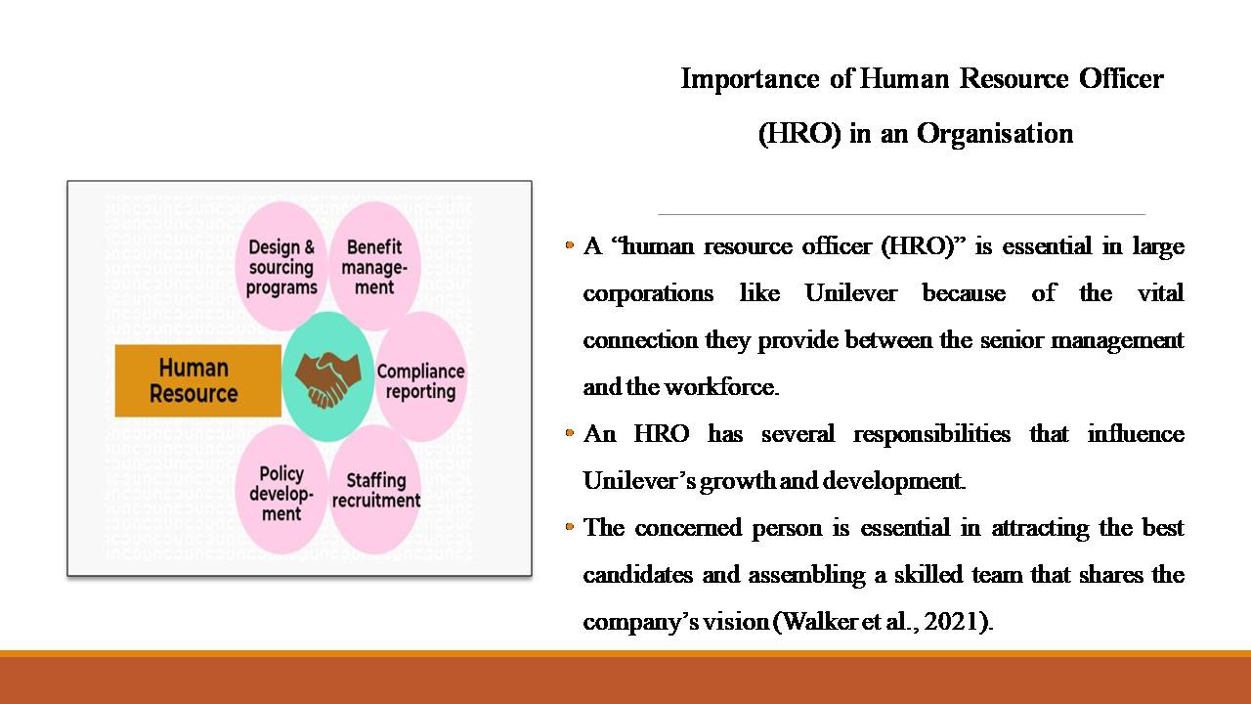
- A “human resource officer (HRO)” is essential in large corporations like Unilever because of the vital connection they provide between the senior management and the workforce.
- An HRO has several responsibilities that influence Unilever’s growth and development.
- The concerned person is essential in attracting the best candidates and assembling a skilled team that shares the company’s vision (Walker et al., 2021).
The HRO is accountable for formulating, enforcing, and consulting on human resources rules and regulations to maintain a competent and diverse workforce (Mosha et al., 2022). In order to ensure a driven and involved workforce, an HRO is crucial in encouraging inclusiveness, diversity, and equality in the workplace. They deal with relations with staff members, such as handling complaints and enforcing disciplinary measures, which helps keep the work environment peaceful. The concerned person helps workers improve in their careers, which in turn raises productivity and helps the company reach its goals. The person is also responsible for overseeing compensation, including salary evaluations and the implementation of fair pay policies. Every firm needs to engage in HRM procedures and recruit a skilled HRO for being effective and growing in the strong business climate.

SWOT Analysis
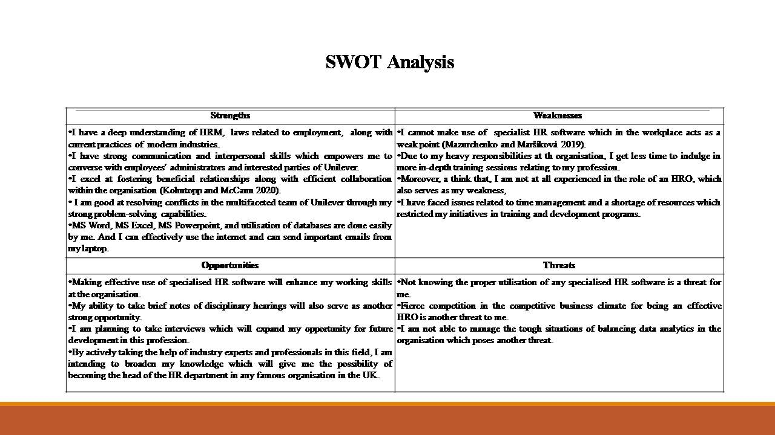

Strengths | Weaknesses
- I have a deep understanding of HRM, laws related to employment, along with current practices of modern industries.  - I have strong communication and interpersonal skills which empowers me to converse with employees administrators and interested parties of Unilever.  - I excel at fostering beneficial relationships along with efficient collaboration within the organisation (Kohntopp and McCann 2020).  - I am good at resolving conflicts in the multifaceted team of Unilever through my strong problem-solving capabilities.  - MS Word, MS Excel, MS Powerpoint, and utilisation of databases are done easily by me. And I can effectively use the internet and can send important emails from my laptop. | - I cannot make use of specialist HR software which in the workplace acts as a weak point (Mazurchenko and Maršíková 2019).  - Due to my heavy responsibilities at th organisation, I get less time to indulge in more in-depth training sessions relating to my profession.  - Moreover, a think that, I am not at all experienced in the role of an HRO, which also serves as my weakness,  - I have faced issues related to time management and a shortage of resources which restricted my initiatives in training and development programs.
Opportunities | Threats
- Making effective use of specialised HR software will enhance my working skills at the organisation.  - My ability to take brief notes of disciplinary hearings will also serve as another strong opportunity.  - I am planning to take interviews which will expand my opportunity for future development in this profession.  - By actively taking the help of industry experts and professionals in this field, I am intending to broaden my knowledge which will give me the possibility of becoming the head of the HR department in any famous organisation in the UK. | - Not knowing the proper utilisation of any specialised HR software is a threat for me.  - Fierce competition in the competitive business climate for being an effective HRO is another threat to me.  - I am not able to manage the tough situations of balancing data analytics in the organisation which poses another threat.

The SWOT analysis of mine as an HRO in Unilever has been demonstrated in this slide.

Personal Skills Audit
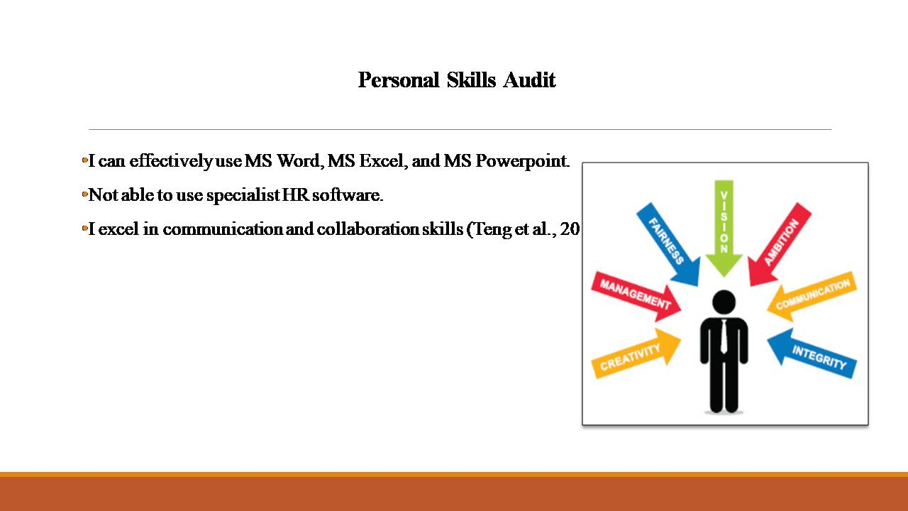
- I can effectively use MS Word, MS Excel, and MS PowerPoint.
- Not able to use specialist HR software.
- I excel in communication and collaboration skills (Teng et al., 2019).
Under the broad spectrum of communication skills, I am finding an opportunity to build various contracts of employment, make materials for demonstrating a robust presentation etc (Teng et al., 2019). I am efficient in my problem-solving capabilities and can handle conflicts in the organisation. However, I find that I am not experienced enough to fit in this role and not many people can be handled by me at the organisation.

Identification of Training and Development Needs
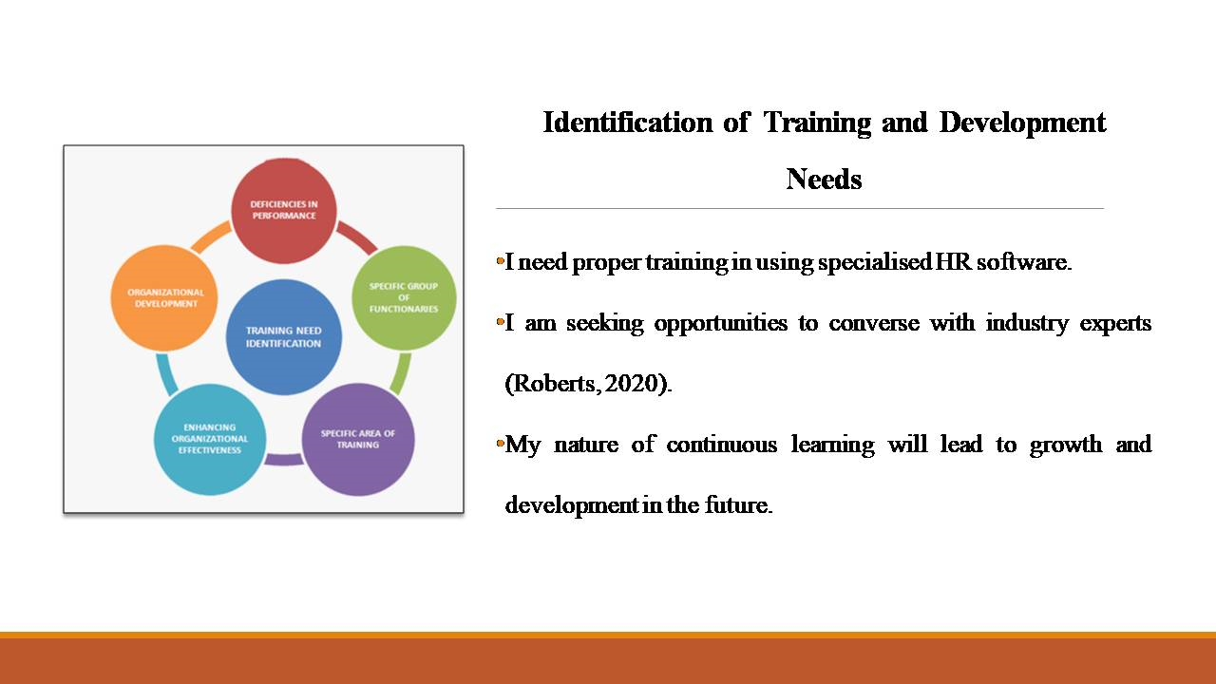
- I need proper training in using specialised HR software.
- I am seeking opportunities to converse with industry experts (Roberts, 2020).
- My nature of continuous learning will lead to growth and development in the future.
For conducting any interview, I will be seeking help from upper management. I will be getting more training in problem-solving for understanding the cruciality of every possible problem at Unilever (Roberts, 2020).

Benefits of Mine as HRO
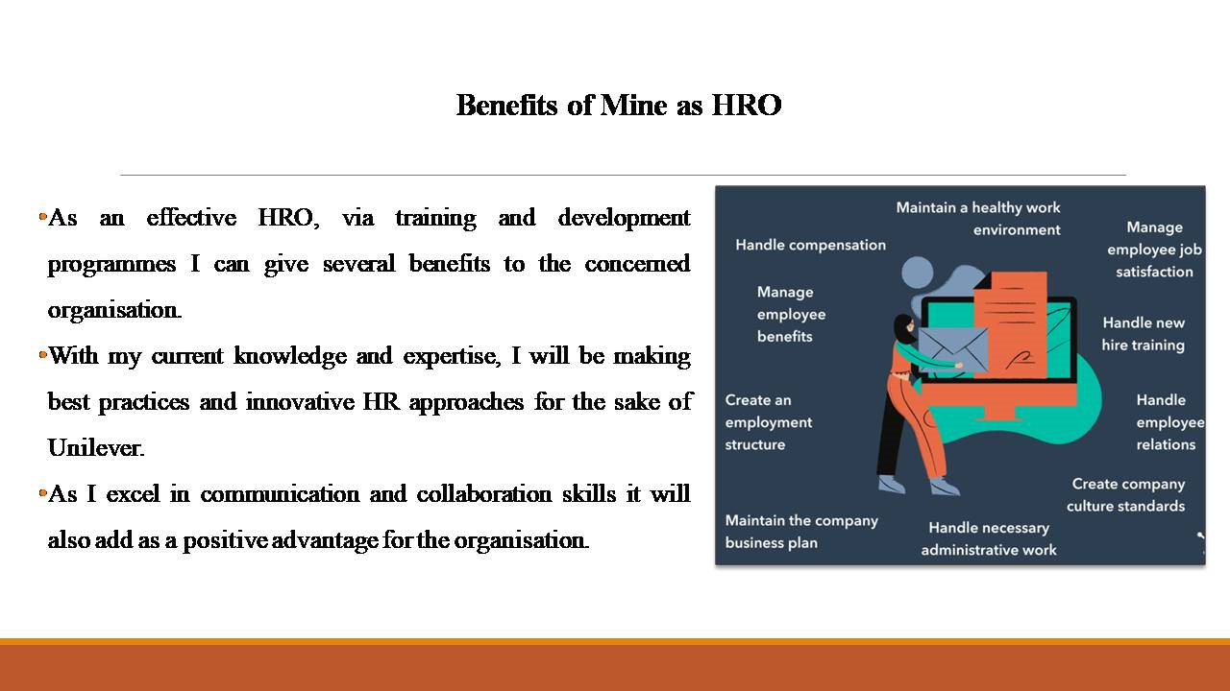
- As an effective HRO, via training and development programmes I can give several benefits to the concerned organisation.
- With my current knowledge and expertise, I will be making best practices and innovative HR approaches for the sake of Unilever.
- As I excel in communication and collaboration skills it will also add as a positive advantage for the organisation.
As an HRO, I will be facilitating positive work culture and beneficial relationships with all the concert parties in the organisation (Nazir et al., 2019). The procedures of recruiting selecting and hiring talented candidates will be done by me and it also serves as an added benefit. Any organisation’s overall success and development can be partially attributed to an effective HRO.

Conclusion
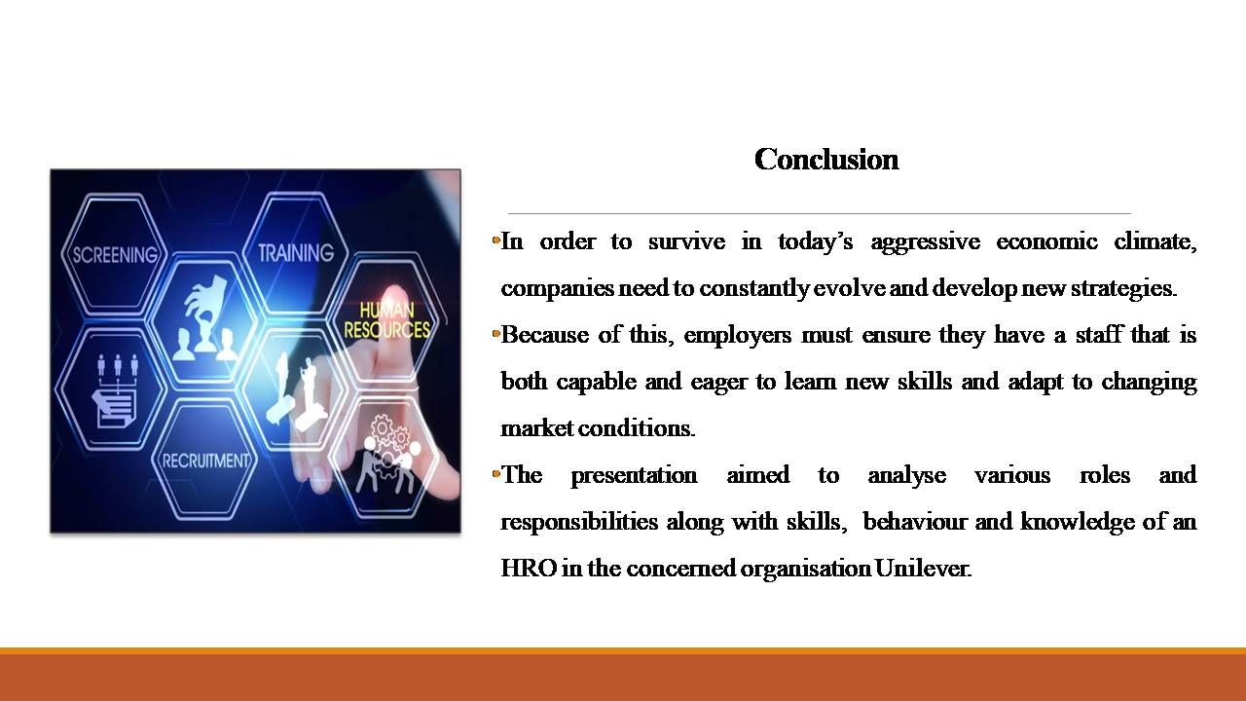
- In order to survive in today’s aggressive economic climate, companies need to constantly evolve and develop new strategies.
- Because of this, employers must ensure they have staffs that are both capable and eager to learn new skills and adapt to changing market conditions.
- The presentation aimed to analyse various roles and responsibilities along with skills, behaviour and knowledge of an HRO in the concerned organisation Unilever.
A SWOT analysis of the concerned person along with a personal audit analysis has also been done in this presentation.

Reference List
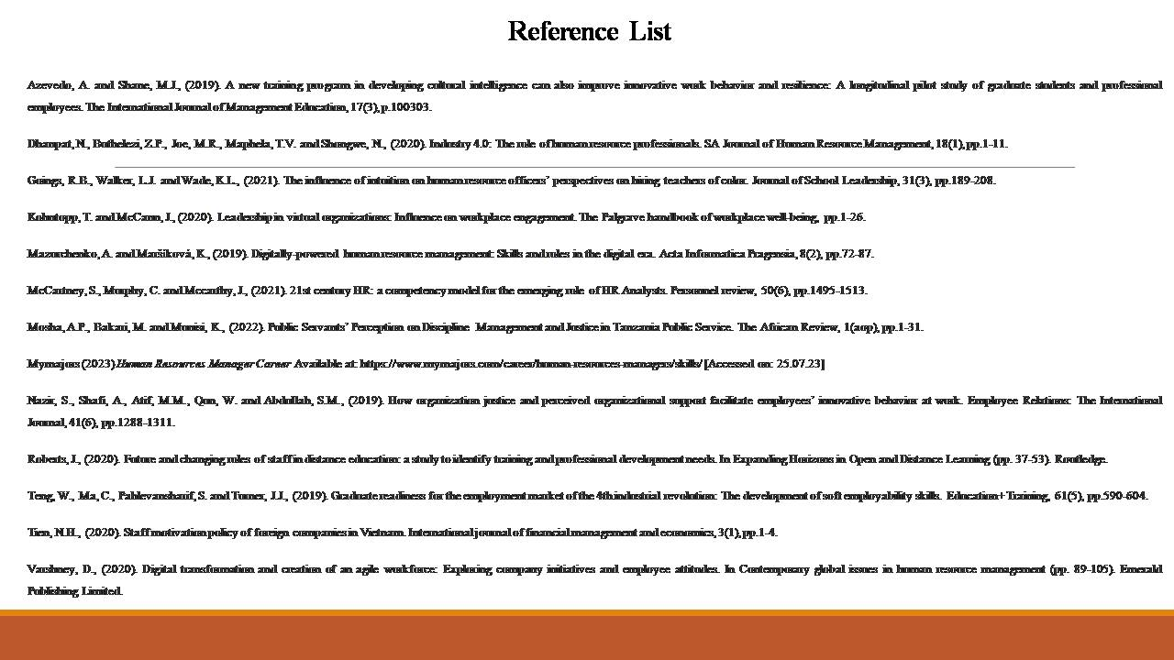
Azevedo, A. and Shane, M.J., (2019). A new training program in developing cultural intelligence can also improve innovative work behavior and resilience: A longitudinal pilot study of graduate students and professional employees. The International Journal of Management Education, 17(3), p.100303.
Dhanpat, N., Buthelezi, Z.P., Joe, M.R., Maphela, T.V. and Shongwe, N., (2020). Industry 4.0: The role of human resource professionals. SA Journal of Human Resource Management, 18(1), pp.1-11.
Goings, R.B., Walker, L.J. and Wade, K.L., (2021). The influence of intuition on human resource officers’ perspectives on hiring teachers of color. Journal of School Leadership, 31(3), pp.189-208.
Kohntopp, T. and McCann, J., (2020). Leadership in virtual organizations: Influence on workplace engagement. The Palgrave handbook of workplace well-being, pp.1-26.
Mazurchenko, A. and Maršíková, K., (2019). Digitally-powered human resource management: Skills and roles in the digital era. Acta Informatica Pragensia, 8(2), pp.72-87.
McCartney, S., Murphy, C. and Mccarthy, J., (2021). 21st century HR: a competency model for the emerging role of HR Analysts. Personnel review, 50(6), pp.1495-1513.
Mosha, A.P., Bakari, M. and Munisi, K., (2022). Public Servants’ Perception on Discipline Management and Justice in Tanzania Public Service. The African Review, 1(aop), pp.1-31.
Mymajors (2023) Human Resources Manager Career Available at: https://www.mymajors.com/career/human-resources-managers/skills/ [Accessed on: 25.07.23]
Nazir, S., Shafi, A., Atif, M.M., Qun, W. and Abdullah, S.M., (2019). How organization justice and perceived organizational support facilitate employees’ innovative behavior at work. Employee Relations: The International Journal, 41(6), pp.1288-1311.
Roberts, J., (2020). Future and changing roles of staff in distance education: a study to identify training and professional development needs. In Expanding Horizons in Open and Distance Learning (pp. 37-53). Routledge.
Teng, W., Ma, C., Pahlevansharif, S. and Turner, J.J., (2019). Graduate readiness for the employment market of the 4th industrial revolution: The development of soft employability skills. Education+ Training, 61(5), pp.590-604.
Tien, N.H., (2020). Staff motivation policy of foreign companies in Vietnam. International journal of financial management and economics, 3(1), pp.1-4.
Varshney, D., (2020). Digital transformation and creation of an agile workforce: Exploring company initiatives and employee attitudes. In Contemporary global issues in human resource management (pp. 89-105). Emerald Publishing Limited.

