LCBB4003
Introducing the Modern Workplace
Assessment 1

Name: Mihaela Madalina Calugaru
Student ID: 2013036
Module Title: LCBB4003 Introducing the Morden Workplace
Module Lecturer’s Name: Dr. Gregory Cowan

Table of Contents
1. Introduction 3
2. Organisational structure 4
3. Organisational Culture 5
4. Organisational structure on organisational performances 7
5. Organisational culture on organisational performances 7
6. Different factors that influence individual behavior 8
7. Recommendation 9
8. Conclusion 10
References 11

1. Introduction
Organizational structures and cultures are very important for the purpose of managing the organizational activities. There are different issues associated with the functional structures in creative ways. By comparing the skills of the employees, they build a specific hierarchy to pass the responsibilities on different phases. When this structure is being used, an organization can be able to make decisions in effective manner. In some of the cases, there are different difficult communication roles. Apple Inc is being able to make better decisions when they are using the flat structure.

2. Organisational structure
Organizational structure means the ways in which the functions of an organization are widely managed and controlled. In most of the cases, organizational structures are very important for the purpose of managing the organizational activities. In any organization, there are different structures and each of these structures are very important to be managed and controlled. These structures are given on the following:
Functional structure: In an organization, there are different functions based on the departmental activities. Considering these departmental activities, the functional structures are being arranged on effective manner. There are different issues associated with the functional structures in creative ways. The functional structural issues are helping to create differences on the function related issues (Janićijević, 2013). It helps organization to get the highly skilled employees on significant manner. In the same way, it helps the organization to work on the growth on proper roles. Compared to that, there are also different disadvantages on the products’ variety on different cases.
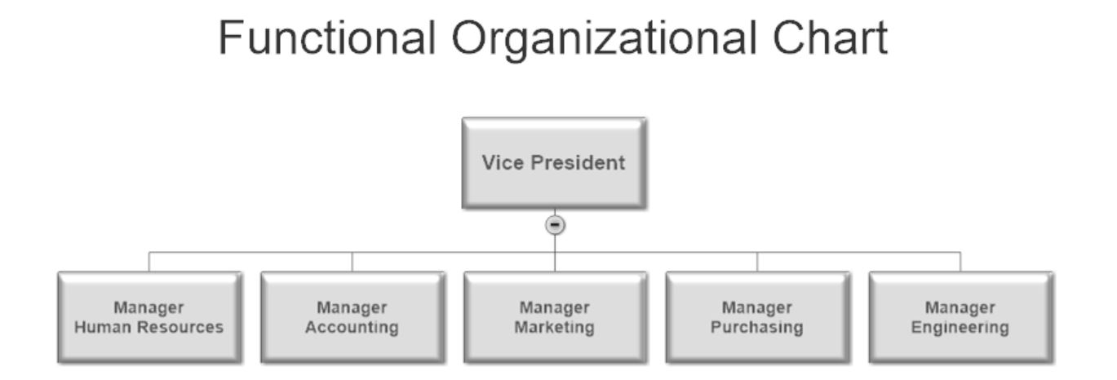
Figure: Functional chart (Alvesson, 2012)
Hierarchical structure: Hierarchical structure is also very important for classifying the employees based on the skills of them. By comparing the skills of the employees, they build a specific hierarchy to pass the responsibilities on different phases. In this place, hierarchical structure can be very much important for authority and responsibilities. On the other side, in some of the cases, it also fails to meet the demands of the customers. Compared to that, it can not be used to collaborate outside of the firm (O'Neill et al., 2016). These hierarchical structures can be very important for understanding the path of promotion clearly.
Flat structure: In a flat structure organization, a degree of leadership is used to ensure proper participation from the employees. It helps to train the creative and skilled employees on different manners. When this structure is being used, an organization can be able to make decisions in effective manner. On the other side, this structure can also help to work on the coordination, and communication (Watkins, 2013). All of these are being the advantages of this flat structure procedure. In most of the cases, it usually makes the duties very much unclear. However, it may also fail to lose focus on the project related conditions.
Divisional structure: Divisional structure is very important where different geographic areas and small organizations are consisting within an organization. All of these divisional structures are useful for controlling the resources in effective manner. It helps to bring greater flexibility within operational procedures. On the other side, it is also important for meeting the organizational demands rapidly (Alvesson, 2012). In some of the cases, there are different difficult communication roles. In most of the cases, the processes are relatively costly in nature.
In most of the cases, small and medium organizations can actually focus on functional structure. Compared to that, hierarchical structure is fit for the organizations where multiple management levels are available. Flat and divisional structures are relatively higher in large organizations. As example, Google had been using divisional structure where Apple had been using the flat organizational structures. If any organization has wider product range, they might need to focus on divisional aspects.

3. Organisational Culture
Organizational culture is connected with the expectations, values, and thoughts that are possessed by the team members. There are different types of organizational culture and all of these cultures are connected with the operational concepts in different aspects. These organizational cultures are given on the following:
Clan culture: In the clan culture, the main focus of the organization is depending on the mentorship and teamwork. It helps to mentor the employees of the organization so that they can easily be successful at working within a team. On the other side, it also helps to bring the utmost quality in terms of effectiveness and flexibility (Domínguez Gonzalez et al., 2014). This process is very much focused on the integration and internal focus processes.
Adhocracy culture: Adhocracy culture supports to take risks on creative manner. There are different risks that an organization is required to take. All of these risks are also connected with the development of innovation. Thus, by the support of adhocracy culture, an organization can solve the problems with effective innovation (Wei et al., 2011). On the contrary, it is used to bring the flexibility with the effective discretion. In most of the cases, it helps to focus on the external operations.
Market culture: In the market culture, organizations mostly focus on the growth and expansion. Market culture focuses on the market operations which is completely depending on the growth related prospects. Based on the growth, expansion will also be managed because it will help to expand the areas of operations in the market (Ostroff et al., 2012). Compared to that, it helps to bring the stability and control within the organization. In some of the cases, it also helps to work on differentiation techniques.
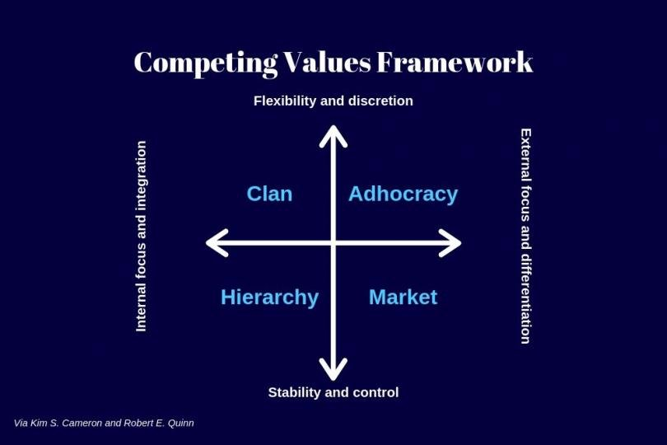
Figure: Types of organizational culture (Wei et al., 2011)
Hierarchy culture: In the hierarchy culture, the organizational focus is completely bestowed on the organizational structure and stability. It focuses on the organizational structures. Based on these structures, the organizational safety can also be successfully assured. It brings the stability depending on the internal focus and effective integration (Dauber et al., 2012). In the long run, this culture helps to accomplish the organizational activities in right process.
Here, the culture of these types can be connected with the activities that are perceived by the organization. As example, if the organization is totally objective based, it will need to work on the market structure and clan culture. However, if the organization is focused on their employee’s performance and internal operations, they can use the hierarchy, and adhocracy culture.

4. Organisational structure on organisational performances
Organizational structure is always very important for the performance of the organization. In the same way, organizational structure is connected with the wider operations of Apple Inc. They have been using the flat organizational structure, and it enables them to perform in different manner. As example, Apple Inc is being able to make better decisions when they are using the flat culture. It enables them to understand the better ideas about the market. On the other side, it has reduced the rep tape culture in the organization (Zheng et al., 2010). Compared to that, it has ignited and supported the organization to achieve the progression and innovation.
Apple Inc has been able to treat the employees and managers equally by using this specific flat culture. As example, when the flat culture is being used in Apple Inc, it effectively reduces the power gap. In this way, the equal opportunities can be given to the employees of Apple Inc. When they are using this structure, they are being able to ensure proper speed on the communication. In the same way, Apple Inc has also been successful at ensuring effective coordination because of applying flat culture (Islam et al., 2015). Apple Inc has reduced their cost by this tool as the organizational overheads have been managed widely.
All the other organizational structures are also capable of making impact on the operations of Apple Inc. Based on the structure, the workforce management of Apple Inc can be controlled. It can help to mark the working area of the organization too. On the other side, it enables to focus on proper resource allocation and management. In this way, organizational structure is being able to shape the operations of Apple Inc in effective manner.

5. Organisational culture on organisational performances
Organizational culture is used to forecast and formulate the belief and processes within organization. So, the culture of Apple Inc can easily shape the way in which the organization performs. Apple Inc has been using the market culture significantly. In the market culture, organizations mostly focus on the growth and expansion. So, it enables Apple Inc to be very much detail oriented. On the other side, it is also being able to shape the core operations of Apple Inc. In this way, stability can be assured on the operations of Apple Inc (Janićijević, 2013). Market culture focuses on the market operations which is completely depending on the growth related prospects.
So, it helps the organization to be very much innovative and stable. With the innovativeness and stability, operations of Apple Inc usually take effective momentum. It inspires the organization to act on a team oriented manner. Based on the growth, expansion will also be managed because it will help to expand the areas of operations in the market. Thus, they use the team so that they can assure proper expansion on market. This is how, the organizational performances can be shaped and changed in Apple Inc (Alvesson, 2012). Compared to that, it helps to bring the stability and control within the organization. In some of the cases, it also helps to work on differentiation techniques.
This culture helps the organization to take a detail oriented and aggressive turn toward the market. It is enabling Apple Inc to mobilize their teams with the detail oriented goals, and objectives. This is how, the organizational performances are being facilitated and influenced. It can also support the organization to perform better in the long run.

6. Different factors that influence individual behavior
In any organizational context, there are a handful of factors which can make impact on the behavior of the individuals. Skills and abilities of the employees are the first factor which will have to be managed. When the skills and abilities are well controlled, it helps the organization to perform better. In this way, the behavior of the individuals can be influenced significantly. Personal factors are also important for the individual behaviors because peoples might act differently based on different age, gender, and other groups (Watkins, 2013). All of these personal factors can shape the ways in which the behavior of individuals can be shaped.
Organizational factors might include the leadership, management, teamwork, working environment and so on. These factors shape the procedure of the individual behavior. Based on the leadership tools, organizational control can be influenced. On the other side, working environment helps the employees to perform in creative manner. Compared to that, the demographic factors are also very important for performing in individual performance. Motivational factors are also playing important role on making impact on individual behavior (O'Neill et al., 2016). In John Lewis Partnership, they have special abilities of the employees based on skill set. At the end, the completer finisher will be responsible for completing any task with the total details.

7. Recommendation
Organizations will need to make several changes and it will start with presenting the operations in different manners. It is very much important for changing the present operations in different ways. Organizations can establish these by using various theories such as classical management theory, contingency theory, and management by objectives and so on. Goals and teams will have to be controlled in the changing condition (O'Neill et al., 2016). Apart from that, group and team behaviour will have to be crafted through a specific process of the team roles and team forming process. All of these team roles are used to accomplish specific kind of goals and objectives. In this way, better performance can be seen from cultural and structural issues.

8. Conclusion
In any organization, there are different structures and each of these structures are very important to be managed and controlled. Organizational culture is connected with the expectations, values, and thoughts that are possessed by the team members. This process is very much focused on the integration and internal focus processes. Based on the growth, expansion will also be managed because it will help to expand the areas of operations in the market. It brings the stability depending on the internal focus and effective integration. When they are using this structure, they are being able to ensure proper speed on the communication.

References
Alvesson, M. (2012). Understanding organizational culture. Sage.
Dauber, D., Fink, G., and Yolles, M. (2012). A configuration model of organizational culture. Sage Open, 2(1), 2158244012441482.
Domínguez Gonzalez, R. V., and Martins, M. F. (2014). Knowledge management: an analysis from the organizational development. Journal of technology management and innovation, 9(1), 131-147.
Islam, M. Z., Jasimuddin, S. M., and Hasan, I. (2015). Organizational culture, structure, technology infrastructure and knowledge sharing. Vine.
Janićijević, N. (2013). The mutual impact of organizational culture and structure. Economic annals, 58(198), 35-60.
O'Neill, J. W., Beauvais, L. L., and Scholl, R. W. (2016). The use of organizational culture and structure to guide strategic behavior: An information processing perspective. Journal of Behavioral and Applied Management, 2(2), 816.
Ostroff, C., Kinicki, A. J., and Muhammad, R. S. (2012). Organizational culture and climate. Handbook of Psychology, Second Edition, 12.
Watkins, M. (2013). What is organizational culture? And why should we care. Harvard Business Review, 15.
Wei, L. Q., Liu, J., and Herndon, N. C. (2011). SHRM and product innovation: Testing the moderating effects of organizational culture and structure in Chinese firms. The International Journal of Human Resource Management, 22(01), 19-33.
Zheng, W., Yang, B., and McLean, G. N. (2010). Linking organizational culture, structure, strategy, and organizational effectiveness: Mediating role of knowledge management. Journal of Business research, 63(7), 763-771.

