

University of Wales Trinity Saint David (London)
Module: Introducing the Modern Workplace
Module code: LCBB4003
Lecturer: Aparna Venkatesan
Assignment Title: Assessment 2 Individual reflective report
By: Kristina D. Ralcheva
Date: November 2022

Contents
1. Introduction
2. Main Body
2.1 Gibb's Reflective Cycle
- Description
- Feelings
- Evaluation
- Analysis (SWOT Analysis in addition)
- Conclusion
- Action Plan
3. Conclusion
4. References

Introduction.
The purpose of this essay is to reflect on how the author and their team performed and collaborated to complete their group presentation.
This essay will discuss the whole process of work from the beginning and how one situation can change into another when the team realises how important it is to work together.
The essay will also discuss Gibb's reflective model, which applies directly to this situation. Additionally, a SWOT analysis will be provided to help the audience understand the author's better reflection.

Gibb’s Reflective Model
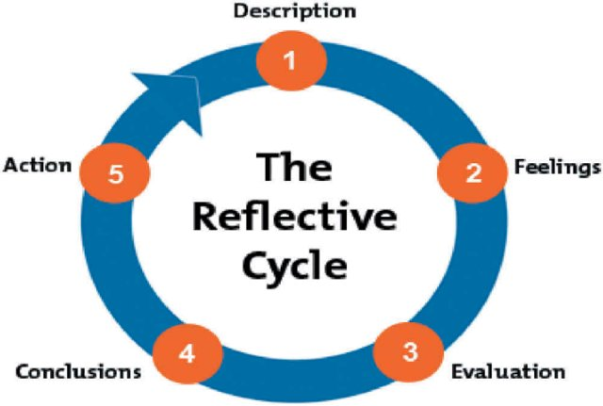
Figure 1. Gibb’s Reflective Cycle (Ahmed, 2019)

According to Wain (2017) Gibbs devised the reflective cycle to encourage students to think systematically about the various stages of an activity or experience. The process of reflection was viewed as a cyclical pattern of behaviour in which previous reflections inform future actions. This process is common in higher education programmes and allows students to build on prior knowledge and understanding while developing clinical skills.

Description.
In Week 7, the author and her group had to conduct and present a group presentation regarding the organisation in the UK and evaluate it critically. As a group leader, the author decided to give her team freedom and ensure that each member could choose a topic and describe it himself. There were 5 topics in the task description, and each member was quite happy to deliver his part to the team. According to Buchanan (2015, p.323) once formed, all groups, whether government ministers agreeing on a policy or university students completing a group project, face several challenges.
Feelings.
Because each team member has a strong personality, it is difficult to communicate, and the team has struggled to pick a point of view. This obviously had an impact on the presentation and its performance, and the team received negative feedback.
The team managed in the end to work together coherently, but each team member felt a bit dissatisfied with their performance, and now they are motivated to show their potential and knowledge on the next assignment.
Evaluation.
At the end of the day, it only matters that the project is realised through collaboration. Stated by Mullins (2010, p.300) certain tasks can only be completed with the combined efforts of several people working together. The members' diverse experience, knowledge, and expertise creates a synergistic effect that can be applied to the increasingly complex problems of modern groups.

Analysis.
According to the author, this presentation was a good lesson on how she should act in the future as a team leader and if there are any miscommunications, misunderstandings, or just people of different opinions, to find a solution and progress further.
The author was motivated and act in each situation with a positive attitude, however, she was generous in almost any issue in the team and didn’t manage to motivate the team enough on time.
On the one hand, the leader has the support of the lecturers in the module to receive any feedback or recommendations. Moreover, the university that the group leader studies have an online library, which saves time and requires less travel.
On the other hand, the first threat came when the team didn’t manage to accept its leader, and this challenged the situation a lot.
However, when the team finally made the decision to work together, the deadline of the teamwork came across, and the preparation was even harder than before because of the pressure.
Lack of time and enthusiasm worked in the end. The team saw that each of them put in a lot of effort, and they wanted to be evaluated by the lecturers and show a good quality of work.

SWOT Analysis.
The following SWOT analysis will examine the strengths, weaknesses, opportunities, and the threat that the author had as a part of the Gibb’s Reflective Model above.
Strengths  - Familiar with the process  - Positive attitude  - Driven | Weaknesses  - Failing to set clear expectations  - Generous to any issue  - Lack of knowledge in module’s materials
Opportunities  - Supportive Lecturers  - Online Library to use  - Available materials on Moodle | Threats  - Deadline  - Lack of time  - Lack of support in the team
Table of SWOT Analysis of the leader in the group presentation

Conclusion in Gibb’s Reflective Cycle.
As a result, the author learned that she had to find a more convincing way of approaching the members for the task and be able to convince her team to work together and harder on time. She could also spend extra time reviewing each member's material more thoroughly and motivating them to prepare for the class material. The author became competent using the sources at his university and the opportunity to ask his teacher for feedback before presenting any work.

Action plan.
The author will make sure in the next group activity that all the ideas are supported by academic evidence and lecturer recommendations. If any of the group members stay silent and just agree, the leader will make sure that they understand the task properly and have prepared themselves with knowledge from the module. This is valid for the leader as well, as on this presentation, he wasn't as prepared as he should have been.
Conclusion.
In other words, it is vital to reflect on what you learn in class. Furthermore, it is crucial to reflect on each experience, so she can learn from his mistakes and continue to develop herself.
In the group presentation, the author understood how to express her ideas clearly and to be even more prepared with the class material than her team.
The author uses Gibb’s Reflective Cycle in her report to show the audience the process and reflection of the group presentation preparation and conduct itself.

References.
Ahmed, A.M. (2019) Gibb’s reflective cycle [Figure 1]. Available at: https://www.researchgate.net/publication/341090108_Students%27_reflective_journaling_an_impactful_strategy_that_informs_instructional_practices_in_an_EFL_writing_university_context_in_Qatar (Assessed: 5 December 2022)
Cole, G. A. and Kelly, P. (2020) Management theory and practice, 9th Ed, Hampshire: Cengage Learning EMEA.
Huczynski, A. and Buchanan, D.A. (2019) Organizational behaviour. 10th Ed. Harlow: Pearson
Mullins, L. J. (2019) Organisational behaviour in the workplace. 12th Ed. Harlow: Pearson Education Limited.
Robbins, S., and Coulter, M. (2020) Management, Global Edition. 15th Ed. Pearson.
Wain, A. (2017) ‘Learning through reflection’, ResearchGate, October. Available at: https://www.researchgate.net/publication/320342913_Learning_through_reflection (Accessed: 5 December 2022)

