Business Plan – Vegan food truck
Module name: Managing enterprise in 21st century
Elena Stanca 1918159

Introduction
Throughout this assignment my business plan will be outlined.
A business plan is the key document an entrepreneur should present their business idea within order for it to be considered (Abrams and Kleiner, 2003).
The following content will detail the business plan that I have found to be fair, realistic, and based on the marketing research I have done to make my business a success.

Business description

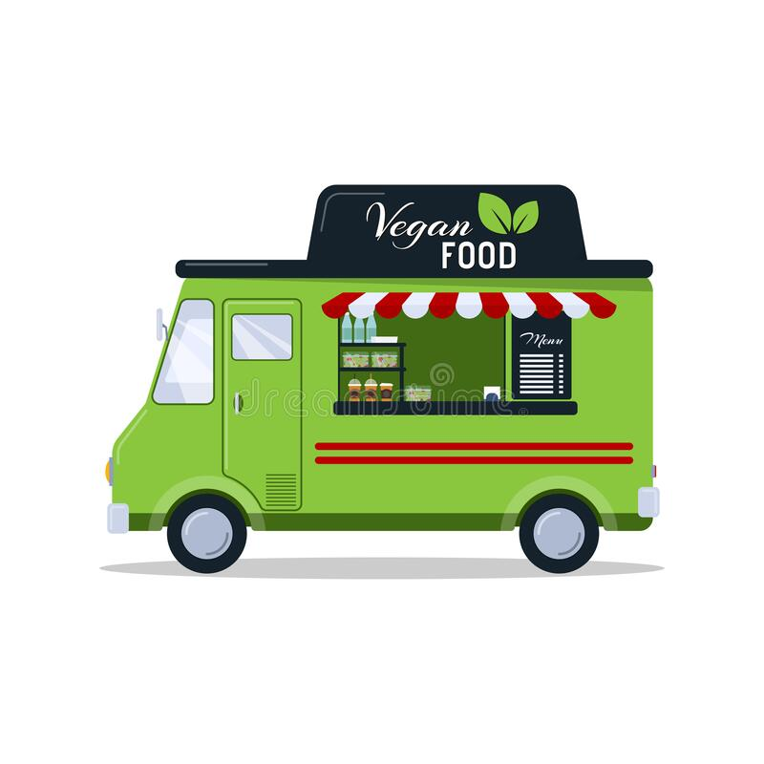

The business idea that I decide to start is a vegan food truck that will use different locations to sell and promote my products. Therefore, my food truck will offer a variety of vegan product such us:
Breakfast:
    - Whole oats porridge bowl
    - Vegan bagels
    - Vegan French toast
    - Banana pancakes
    - Scrambled tofu

Lunch:
        - Vegan soup (mushroom cream soup, broccoli soup, lentil soup)
        - Sandwiches
        - Veggie wraps.
        - Salads
        - Veggie pastry

Drinks:
    - Coffee
    - Tea
    - Milkshakes
    - Fresh orange juice
    - Water

My business will prime quality instead of quantity.
The ingredient will be fresh and hight quality.

My business name will be Vegan on Wheels.
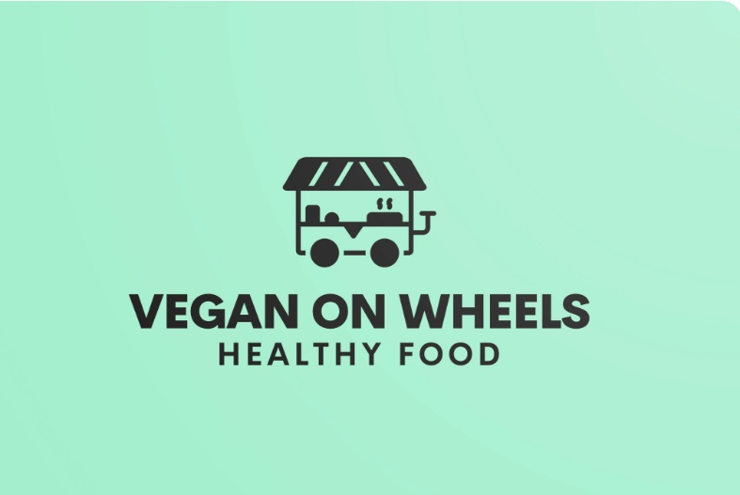

My business legal status will be Sole trader.
Sole trader ownership is the most common form of business ownership found in the UK, especially among young people (Wallace, 2001).
I will start my business as a sole trader because that is the easiest way to start as I will work on my own.
Sole trader ownership has the simplest operational business structure form.
Sole trader owner has many advantages such us:
- Ease of founding.
- Lowest cost.
- Straightforward operating.
- Sole owner decision making.
- Profits belong to sole owner.
- Flexibility in decisions.
- Business closure control.
The most important advantage for me as a new trader on market I consider to be the flexibility in decisions, because this will allow me to bring my own vision in my business structure. Moreover, the advantages of sole trader ownership are encouraging to my business plan success.
As a sole trader there are also several disadvantages:
- Unlimited liability.
- Less financial capacity.
- Unstable duration of business.
- Sole decision-making.
- Profit taxes disadvantages.

Disadvantages as a sole trader can be seen as a challenge to succeed as a trader in the chosen field.
The challenging disadvantage that I will take inconsideration for my business is the less financial capacity because of the inflation and rise of prices.

Mission statement
The mission statement is the guide that will keep a business owner focused on his business priorities (Fiore, 2005).
My business mission statements are:
- Healthy food.
- Alternative meat variants.
- Quality.
- Fresh homemade food.

The mission of the Vegan on wheels is to provide our customers with high-quality, meat-free meals that are full of nutrients and taste. Moreover, our ingredients will be carefully selected and cooked in a healthy way to encourage a healthy and tasty lifestyle.

Aims

The goal of every business should be to understand the needs and wants of customers (Madeswaran, 2019).
Vegan on wheels' main aim is to attract customers from Cardiff and open them up to the concept of vegan food.
Vegan on wheels aim is to delight customers with fast and fresh dishes prepared in a clean and sparkling environment.
Also, our food will offer a customer full variety of tastes from vegan cuisine.
The goals of my business will be the benchmarks that will direct it to a successful place in the market.

Objectives
Vegan on wheels has several objectives such us:
- To hire a sale assistant in month 2.
- To change the menu every two weeks.
- To build a social media account and post everyday menu.
- To make 10% profit in 2nd month.
- To conduct market research.
- To promote the business in new locations from 3rd month.
- To collaborate with local farmers from 4th month.
- To open for home delivery from 1st month.
- To gain new customers.

My business objectives are real, and my future customers will be my priority. Moreover, objectives will step by step help my business to become popular in Cardiff area and gain loyal customers.

Vegan on wheels location
My business location will mainly be in Cardiff of around. The location will vary between popular areas of the city.
The first location that I choose to spread the joy of my freshly made product is the industrial area by the DPD depot as there are several depots around with no accessibility of corners shops, bakery or other kind of food shops.
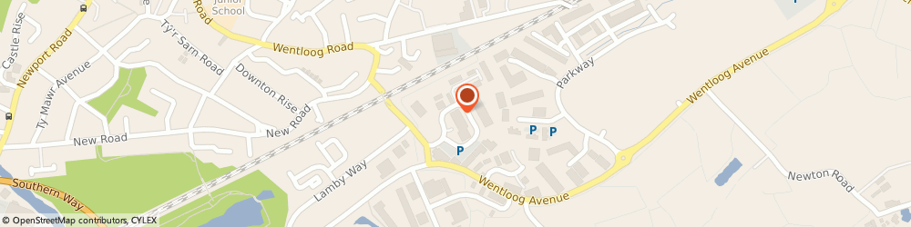

The second location that I decided to explore is Riverside, Cardiff. This location is close to some important points of the city such as Sunday Market, Wales Rugby Stadium, The Bakery student accommodation, Cardiff University and few others.
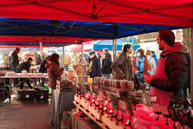

The third location that I choose will be Sully Car Boot sale because that is a busy location on weekend with potential customers or partnership connections.
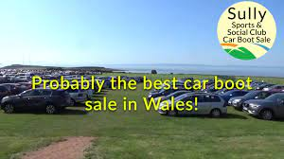

The necessary equipment for my business idea is the food van equipped with stove, oven, fridge-freezer, coffee machine, blender.

Human resources
In a food truck industry employ can face multi jobs tasks because of the limited space available but the multiple tasks that need to be achieved. Therefore, is very important to find the right employ for a business in this field.
Human resources are the business partners in the way to success (Miller, 2017).
Vegan on wheels will be owned be myself. There will be one more employee, my sister-in-low.
I choose my sister-in-low as an employ because she has experience in food industry, as a cashier. Moreover, she will be able to work as a team and put customers need on the top of my priorities. She knows how to deal under pressure work or multi tasks. Her role will be as a cashier.
My business will also need an accountant to keep the financial evidence.
The cleaning services will also be my responsibility.
Hierarchy scheme Vegan on wheels

Manager
Accountant
Digital creator
Elena
Elena - Chef
Cristina - Cashier

Cleaner
Elena

Marketing activities
Marketing research
Marketing research is a combination of factors essential to gather information regarding market and society (Bravo and Sanz, 2021).
Marketing research is influenced by the environment of the company and can be divided in macro - environment and micro - environment.
Macro – environment is represented by external factors such as demographics, economics, legal and technological.
On the other side micro – environment involve internal factors such as competitors, suppliers, and customers.
As a new business owner marketing research is key component part of my business plan.
My marketing research started with macro – environment.
I did research on how widespread the concept of vegan food is nationally, and locally.
According to World Population Review (2023) vegan food in UK has become more and more popular among citizens placing the country on the first place in the world.
From popular fast-food chains such as McDonalds, KFC, Burger King of Greggs to hight street restaurants has introduced vegan food part of their menu (Plant Based News, 2022).
Based on my local research result was Cardiff in on top 10 vegan friendly cities in the UK (Vegan, 2020).
An important aspect of my research proved the vegan food is more attractive for young and mid-aged citizens (Statista, 2023).
Therefore, a considerable number of students, 33K, enrolled to Cardiff Universities (HESA, 2023).
Based on my marketing research, a vegan grocery business has the right factors to thrive, such as potential plant-based products customers.
In conclusion, my marketing research are proving my business idea has a numerous positively factors to be a success in the area chosen.

Marketing Strategy
The purpose of marketing promotion is to use different ways to capture the attention of target customers and sell the products (Kaya and Ayman, 2020).
Vegan on wheels marketing promotion will be using different marketing channels:
- Web page.
- Social media (Instagram).
- Loyalty points/cards.
- Student discounts.
- Too good to go discount package.
- Questionnaires.
- Free samples events.
- Leaflet.
- Local newspaper.
- Local weekly market.
- Radio advert.

Those tools have an aim to promote my business to the future customers.
Marketing promotion is a key factor in food industry field.
Marketing promotion will help me to promote and share information about my products, services, and brand recognition.
My PR strategy is to promote my business to the target audience, student accommodation, industrial areas, and open public. Therefore, I will hand out leaflets near student accommodations and business areas of the town. Also, another strategy to promote my business is to organize a meeting in industrial areas and offer me product samples for the purpose of future collaboration.
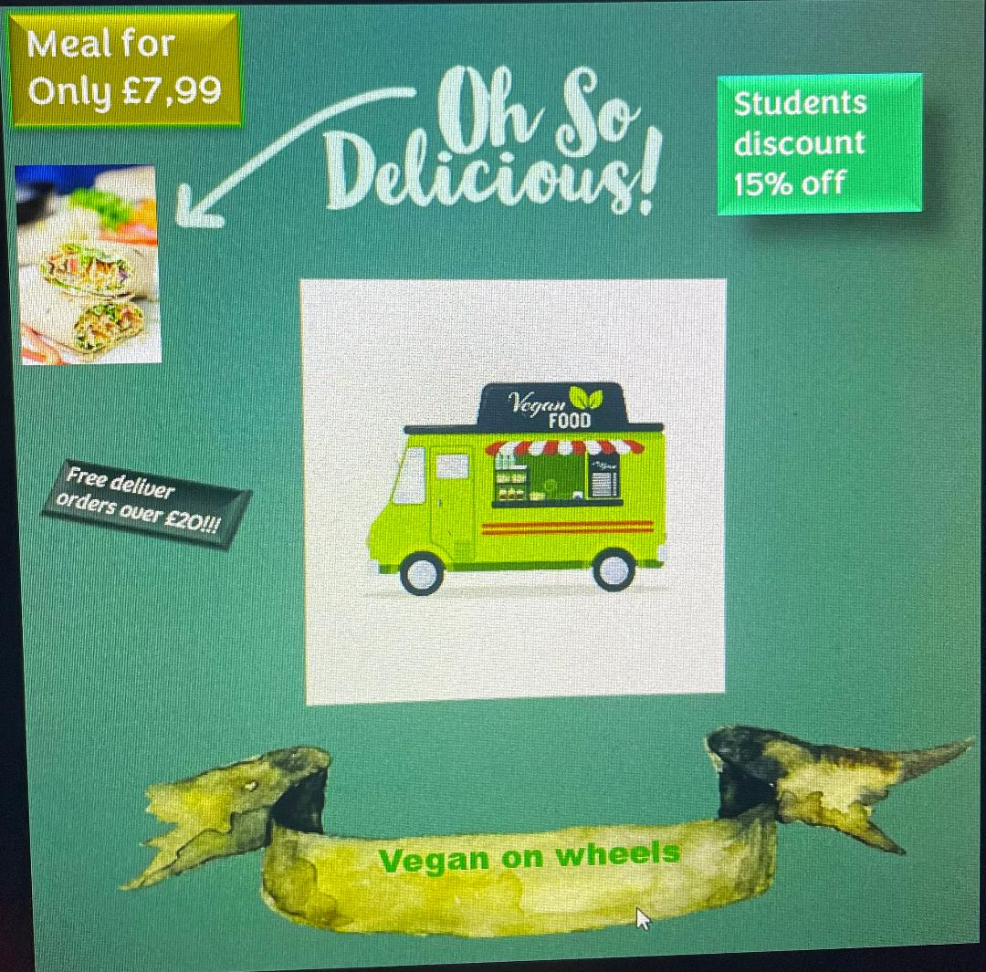

One more important information that I found during my marketing research is in Cardiff vegan food truck are not often seen as there are only a few. So this will be an advantage for my business because I will bring the newest food to the market.

Financial resources
Business source of finance are the financial resources who cover the costs of activities and investments in an organisation (Triantis, 2019).
Business source of finance can be from different sources as: family or friends, savings, bank loan, government grant, crowd founding, subsidies, business angels.

My business financial resources will be:
- Government grant
- Saving
- Bank loan

Vegan on wheels source of finance will be a government grant completed by my savings.
I choose as a source of finance the government grant because is a non-repayable source who could lend me up to 12k to set up my business (Business News Wales, 2023). The source of finance will be completed with my own savings who are up to 10k and are without obligation or pressure to be returned. The last source of finance will be a bank loan who will be accessed just in case of emergency situations or unforeseen events.



Vegan on Wheels SWOT Analysis

A SWOT analysis will help a business assess its strengths, weaknesses, opportunities, threats and gain insight into its real situation (RMA – USDA, 2008).
The SWOT Analysis of my business highlight important points of it such as:

SWOT Analysis is a framework who use internal and external factors to evaluate a business potential, competition, risks, and performance (Investopedia, 2022).
Strengths are represented by internal factors who can be controlled by a business owner. Moreover, those are helpful for a business growth and success.
My business has several strengths.
One of the most important strengths is the flexibility of the location. This will be an advantage as my location can be changed based on customer demand, number of customers, revenue generated, strategic areas formed based on marketing research.
Another strength of my business is the savings on rent because I don't have to pay rent and the money saved can be invested in technology or other customer service that will increase my business growth in the market such as promoting.
Our food will be fresh, and the ingredients quality will be prime, that will also be a strength.

Weaknesses are also an internal factor that will need periodic attention because I will have total control over them to be turned into strengths.
The weak points of my business are aspects that cannot be offered as a sit-down dinner, competitors, trends, and the lack of a varied menu.
The most important weakness that must always be at the top of the list are the competitors because I will always have to bring something new, the quality of the products and their taste to be at a high level, the services offered to put the customer first.
Opportunities are external factors that cannot be controlled but can be helpful in helping the business succeed.
Two of the most important opportunities who will bring success to my business are mobility and partnership opportunities.
Mobility will help my business to explore several areas such as organised events, beaches, and busy places as cities centres.
The partnership will help my business to work as a team, to integrate my kitchen side by of others.
Threats are external and harmful factors that delay or prevent normal organizational activity (Sarsby, 2016).
The threats that my business may confront are related to the economical situation of the country, inflation, who face rise of ingredients prices. The consequences of this threat will force my business to compromise, to make change in pricing area.
Another threats to look after for my business is customer service. As for a business customers are “the boss” those need should always be the business priority. Therefore, improving the way customers are served will be a top priority for my organization.

Cashflow forecast.
A business running is about money running (Jury, 2012).

 | M 1 | M 2 | M 3 | M 4 | M 5 | M 6 | M 7 | M 8 | M 9 | M 10 | M 11 | M 12 | TOTALS
INCOME
SALES | 4000 | 5000 | 5500 | 4500 | 5500 | 6500 | 6500 | 6500 | 6000 | 5500 | 4000 | 6000 | 65500
LOANS
GRANTS
INVESTMENT | 8000 |  |  |  |  | 4000 |  |  |  |  |  |  | 12000
TOTAL IN | 12000 | 5000 | 5500 | 4500 | 5500 | 10500 | 6500 | 6500 | 6000 | 5500 | 4000 | 6000 | 77500
MONEY OUT
WEGES |  | 1600 | 1600 | 1600 | 1600 | 1650 | 1650 | 1650 | 1650 | 1650 | 1650 | 1650
DRAWINGS | 2000 | 2000 | 2000 | 2000 | 2000 | 2000 | 2500 | 2500 | 2500 | 2500 | 2500 | 2500 | 25000
ELEC/GAS | 300 | 400 | 400 | 400 | 500 | 500 | 500 | 500 | 500 | 400 | 500 | 600 | 5200
TEL | 25 | 25 | 25 | 25 | 25 | 25 | 25 | 25 | 25 | 25 | 25 | 25 | 300
INGREDIENTS | 400 | 400 | 400 | 450 | 450 | 450 | 500 | 500 | 400 | 450 | 400 | 500 | 5300
NINO | 25 | 25 | 25 | 25 | 25 | 25 | 25 | 25 | 25 | 25 | 25 | 25 | 300
ADVERTS | 120 |  |  |  | 100 |  |  |  |  | 50 |  |  | 270
PETROL | 200 | 200 | 200 | 200 | 200 | 200 | 200 | 200 | 200 | 200 | 200 | 200 | 2400
STATIONARY | 150 |  |  |  |  |  |  |  |  |  |  |  | 150
INSURANCE | 100 | 100 | 100 | 100 | 100 | 100 | 100 | 100 | 100 | 100 | 100 | 100 | 1200
TOTAL EXPEDITURE | 3070 | 4750 | 4750 | 4800 | 4900 | 4950 | 5500 | 5500 | 5400 | 5400 | 5400 | 5600 | 54520
NET CASH FLOW | 8930 | 250 | 750 | -300 | 600 | 5500 | 1000 | 1000 | 600 | 100 | -1400 | 400
OPENING BALANCE | 0 | 8930 | 9180 | 9930 | 9630 | 10230 | 15780 | 16780 | 17780 | 18380 | 18480 | 17080 | 17480
CLOSING BALANCE | 8930 | 9180 | 9930 | 9630 | 10230 | 15780 | 16780 | 17780 | 18380 | 18480 | 17080 | 17480

References list

- Alan Sarsby. (2016). SWOT Analysis. [Online]. Spectaris Limited. Available at: https://www.google.co.uk/books/edition/SWOT_Analysis/Yrp3DQAAQBAJ?hl=en&gbpv=1 [Accessed 13 March 2023].

- Anıl Kemal Kaya, Umut Ayman. (2020). Promotion and Marketing Communications. [Online]. IntechOpen. Available at: https://www.google.co.uk/books/edition/Promotion_and_Marketing_Communications/Z0v9DwAAQBAJ?hl=en&gbpv=1 [Accessed 12 March 2023].

- Business News Wales. (2023). Welsh Government Business Grants. [Online]. https://businessnewswales.com. Available at: https://businessnewswales.com/welsh-government-business-grants/ [Accessed 13 March 2023].

- Diane Wallace. (2001). GCSE Business Studies. [Online]. Pearson Education. Available at: https://www.google.co.uk/books/edition/GCSE_Business_Studies/mzSEawYibycC?hl=en&gbpv=1 [Accessed 12 March 2023].

- Dr A Madeswaran. (2019). Consumer - The Boss (Essentials on Consumer Behaviour and marketing Strategies). [Online]. Archers & Elevators Publishing House. Available at: https://www.google.co.uk/books/edition/Consumer_The_Boss_Essentials_on_Consumer/qXltEAAAQBAJ?hl=en&gbpv=1 [Accessed 12 March 2023].

- Frank Fiore. (2005). Write a Business Plan in No Time. [Online]. Que. Available at: https://www.google.co.uk/books/edition/Write_a_Business_Plan_in_No_Time/DZfFCVXd7xIC?hl=en&gbpv=1 [Accessed 12 March 2023].

- HESA. (2023). Higher Education Student Statistics: UK, 2021/22 - Where students come from and go to study Statistical Bulletin SB265 1. [Online]. www.hesa.ac.uk. Available at: https://www.hesa.ac.uk/news/19-01-2023/sb265-higher-education-student-statistics/location [Accessed 8 March 2023].

- Investopedia. (2022). SWOT Analysis: How To With Table and Example. [Online]. https://www.investopedia.com/. Available at: https://www.investopedia.com/terms/s/swot.asp [Accessed 13 March 2023].

- John E. Triantis. (2018). Project Finance for Business Development. [Online]. Wiley. Available at: https://www.google.co.uk/books/edition/Project_Finance_for_Business_Development/HVpQDwAAQBAJ?hl=en&gbpv=1 [Accessed 13 March 2023].

- Mercedes Esteban-Bravo, Jose M. Vidal-Sanz. (2021). Marketing Research Methods. [Online]. Cambridge University Press. Available at: https://www.google.co.uk/books/edition/Marketing_Research_Methods/sSoNEAAAQBAJ?hl=en&gbpv=1 [Accessed 12 March 2023].

- Nils-Gerrit Wunsch. (2023). Veganism and vegetarianism in the United Kingdom - statistics & facts. [Online]. www.statista.com. Available at: https://www.statista.com/topics/7297/veganism-in-the-united-kingdom/ [Accessed 6 March 2023].

- Plant Based News. (2022). Leading Restaurateur Says Fast Food’s Future Is Vegan. [Online]. www.plantbasednews.org. Available at: https://plantbasednews.org/news/economics/leading-restaurateur-fast-foods-future-vegan/ [Accessed 12 March 2023].

- Rhonda M. Abrams, Eugene Kleiner. (2003). The Successful Business Plan. [Online]. Planning Shop. Available at: https://www.google.co.uk/books/edition/The_Successful_Business_Plan/hpFxjEsZLUwC?hl=en&gbpv=1 [Accessed 11 March 2023].

- Timothy Jury. (2012). Cash Flow Data. [Online]. Wiley. Available at: https://www.google.co.uk/books/edition/Cash_Flow_Analysis_and_Forecasting/OHC2l4BQLhYC?hl=en&gbpv=1 [Accessed 13 March 2023].

- Tony Miller. (2017). his practical book sets out how HR can become a true business partner. It will r. [Online]. Business Expert Press. Available at: https://www.google.co.uk/books/edition/Human_Resources_As_Business_Partner/8y4xDwAAQBAJ?hl=en&gbpv=1 [Accessed 12 March 2023].

- United States. Department of Agriculture. Risk Management Agency. (2009). SWOT analysis. [Online]. U.S. Department of Agriculture, Risk Management Agency. Available at: https://www.google.co.uk/books/edition/SWOT_analysis/NkYLbgFrPZYC?hl=en&gbpv=1 [Accessed 13 March 2023].

- Vegan Food and Living. (2020). The UK’s most vegan-friendly cities have been revealed. [Online]. www.veganfoodandliving.com. Available at: https://www.veganfoodandliving.com/news/the-uks-most-vegan-friendly-cities-have-been-revealed/ [Accessed 7 March 2023].

- World Population Review. (2023). Veganism by Country 2023. [Online]. www.worldpopulationreview.com. Available at: https://worldpopulationreview.com/country-rankings/veganism-by-country [Accessed 12 March 2023].

