MSc Digital Transformation
for the Health and Care Professions
BMDS7005

Maternity Staff Readiness for the Introduction of a Digital Maternity Record in Cwm Taf Morgannwg University Health Board: A Mixed-Methods Study of Implementation Factors

Dissertation submitted in partial fulfilment of the award of
Master of Science in Digital Transformation for the Health and Care Professions

Stella Seppings
2318794
02/05/2026

Acknowledgements

I would like to thank Dr Edward Conley for his cheerful and patient supervision of this project despite many challenges. He went beyond the call of duty to help me optimise my work and I truly appreciate it.

I would also like to thank Professor Philip Scott for stepping in to help in an hour of need.

Declaration

This work has not previously been accepted in substance for any degree and is not being concurrently submitted in candidature for any degree.

Signed…………………………

Date………01/05/2026………

Use of Generative AI
RESEARCH | For this assessment, you can use Generative AI to support you in research, including searching for bibliography, using tools to summarise, compare and interrogate materials. | Yes ☒  No ☐
STRUCTURE | For this assessment, you can use Generative AI to support you in structuring your submission, including creating a draft argument structure, identifying parts and headings, etc. | Yes ☐  No ☒
PROOFREADING | For this assessment, you can use Generative AI to check your own text/creation for grammatical and syntactical mistakes, including rephrasing of your own work within specific standards. | Yes ☐  No ☒
WRITING | For this assessment, you can use Generative AI to create text for submission. | Yes ☐  No ☒
CREATIVE | For this assessment, you can use Generative AI to create creative materials, such as images. | Yes ☒  No ☐
PROGRAMMING | For this assessment, you can use Generative AI to create and check code. | Yes ☐  No ☒

Table of Contents
Chapter 1 Introduction 6
1.1 Background and Context 6
1.2 Rationale and motivation for the study 8
1.3 Project Aim 9
1.4 Research Questions 9
Research Question 1: 9
Research Question 2: 10
Research Question 3: 10
1.5 Anticipated Value 10
1.6 Expected risks and challenges 11
1.7 Chapter Summary 12
Chapter 2 Methodology 13
2.1 Introduction 13
2.2 Research Question 1 13
2.3 Research Question 2 14
2.4 Research Question 3 14
2.5 Justification for Methodological Approach 15
2.6 Data Analysis 16
2.7 Interpretation of Findings 17
2.8 Legal and Information Governance Considerations 17
2.9 Ethical Considerations 18
2.9 Mixed Methods Design and Integration 19
Chapter 3 Literature Review 20
3.1 Research Question 1 20
3.2 Search Methodology 20
3.3 Thematic Review of the Literature 24
3.4 Summary of Literature Review 29
Chapter 4 Survey Results 30
4.1 Introduction 30
4.2 Participant characteristics 30
4.3 Coherence: understanding the digital maternity record 30
Awareness of change 30
Previous experience of digital maternity records 30
Preferences for record format 31
Perceived benefits of digital maternity records 32
4.4 Cognitive Participation: engagement and readiness 32
Confidence in using digital records 32
Training preferences 34
4.5 Collective Action: operationalising the system 35
Access to devices 35
Location of record access 35
Frequency of record use 35
Perceived disadvantages 35
4.6 Reflexive Monitoring: evaluating the system 36
Free-text comments 36
4.7 Conclusion 36
Chapter 5 Interview Findings 37
5.1 Introduction 37
5.2 Coherence: understanding the purpose and value of the system 37
5.3 Cognitive Participation: engagement and commitment to the system 37
5.4 Collective Action: operationalising the system in practice 38
Technical factors 38
Workflow integration 39
Organisational factors 39
5.5 Reflexive Monitoring: evaluating the system 40
5.6 Summary 40
Chapter 6 Conclusion 42
6.1 Introduction 42
6.2 Summary of Findings by Research Question 42
Research Question 1: Literature review 42
Research Question 2: Survey findings 42
Research Question 3: Interview findings 43
6.3 Discussion: Integrating Survey, Interview and Literature Findings 43
6.4 Synthesis Using NPT 45
6.5 Key Factors for Successful Implementation 47
6.6 Gaps and Areas for Further Research 49
6.7 Limitations 49
6.8 Final Conclusion 50
Chapter 7 References 52
Chapter 8 Appendices 57
8.1 Project Brief 57
8.2 Ethical Review Application Form 66
8.3 Staff Survey Questions 77
8.4 Semi-structured Interview Questions 83

Word count excluding tables, appendices and references= 13,854

Introduction

Background and Context
Digital maternity records are being introduced across Wales to improve access to information, continuity of care, patient safety and service efficiency. However, the success of this change depends not only on the technical system selected, but also on whether staff are prepared, supported and able to integrate the record into everyday maternity work. This study therefore examines maternity staff readiness for the introduction of BadgerNet within Cwm Taf Morgannwg University Health Board.
Digital transformation has become a major strategic priority across UK health services, including maternity services, where the limitations of paper-based records and fragmented information flows are being increasingly recognised. In maternity care, patients interact with multiple professionals across community, outpatient, emergency and inpatient settings. Care is delivered over the relatively compressed timescale of a pregnancy, during which clinical circumstances may change rapidly, and urgent admission may be required. This creates a strong need for records that are accessible, legible, contemporaneous and able to support safe, coordinated care (NHS England, 2016; Welsh Government, 2024).
Maternity care in Wales has historically relied on patient-held paper records, including the All Wales Maternity Notes. These records have supported continuity by allowing women to carry their maternity information between care settings. However, paper records are also vulnerable to loss, damage, illegibility and incomplete availability in urgent situations. The current move towards digital maternity records should therefore be understood as part of a wider attempt to improve information access, safety and continuity of care. The All Wales paper maternity notes have now started to be replaced by digital systems, with Aneurin Bevan University Health Board implementing the first Welsh digital maternity record in 2024, followed by Cardiff and Vale in 2025 (ABUHB, 2024; CAVUHB, 2025).
Welsh Government policy supports this transition and has mandated that all health boards in Wales switch to a digital maternity record (Welsh Government, 2019). Maternity care in Wales is intended to deliver safe, high-quality, person-centred care that improves the health and wellbeing of mothers and babies and gives children the best start in life (Welsh Government, 2019). A maternity record supports this by creating a single account of pregnancy, risk factors, clinical decisions and care plans, which can aid continuity of care, improve communication between professionals, and support timely escalation. Welsh Government has linked the move to digital maternity records with improvements in the quality and safety of care, stating that digital access should enable women to receive ‘the right care, at the right time’ while making it easier for professionals to share important information and make informed decisions (Welsh Government, 2024).This is particularly important in Wales, where a recent report has highlighted that fragmented and non-interoperable records create risks for continuity of care, especially when women move across Health Board boundaries or require cross-border services. The same report also suggested that improved digital systems could strengthen the routine capture and use of data, including data relevant to inequalities and outcomes, thereby supporting earlier identification of concerning patterns in care and service provision (Holland, 2026). Wales has made progress in digital health infrastructure in recent years but remains less advanced than some other UK nations in achieving a fully integrated, interoperable electronic patient record across care settings, with variation between health boards persisting (DHCW, 2023a; Welsh Government, 2023).
The initial hope was for a bespoke “All Wales” solution in the form of “Digital Maternity Cymru”, to be led by Digital Health and Care Wales (DHCW) (Morgan, 2022). The intention was for this system to form part of a standardised clinical framework integrated with wider NHS Wales digital infrastructure, and £7m of funding was released for the programme (DHCW, 2023b). However, any aspirations of an All Wales solution were dashed in 2025 when Welsh government made the decision that it was not achievable, and instead issued a requirement that individual health boards invite commercial providers of digital maternity records to tender, with instructions for health boards to present business cases to their executives by February 2025 with a view to roll out the chosen systems by April 2026.
In CTMUHB, BadgerNet was selected within a wider Welsh context in which several other health boards had also moved towards the same system. This offered a pragmatic route towards maintaining interoperability and continuity of care across organisational boundaries, particularly where women require care outside their local health board area.
The final users of the digital record will include patients, midwives, obstetricians, anaesthetists, neonatologists, pharmacists, administrators, ward clerks, receptionists, managers and research teams (amongst others). Unfortunately, paramedics will not have access to the record despite their involvement in maternity emergency care. Physician’s Associates do not currently work in maternity care in CTMUHB so they would not be included.
CTMUHB provides maternity care for women across Bridgend, Rhondda Cynon Taf and Merthyr Tydfil. Patient records are currently held in a paper format, which are created at the 8-week booking appointment and given to the patient to hold for the duration of her pregnancy (“handheld notes”). Postnatally, the patients’ notes are collated into her main CTMUHB paper medical record and archived. Patients are expected to bring their handheld notes to all appointments, and in fact to carry them at all times, including when travelling outside of the health board. This ensures safe care and transfer of information when patients seek care whilst out of area (for example when on holiday)(NHS Wales, 2024).
Although this model supports continuity across settings, it also creates practical and safety-related challenges. Paper records may be unavailable when urgently needed, are vulnerable to loss or damage, and vary in legibility and completeness. In a specialty where clinical circumstances can change rapidly, delays in accessing accurate information may have significant consequences for both mother and baby. Maternity related clinical negligence claims are consistently among the highest cost areas for the NHS, with a small number of severe cases driving very high lifetime costs. This adds urgency to record quality, accessibility and defensibility during digital transition. The mandate to store maternity and neonatal records for 25 years presents logistical and financial challenges which are greater with paper-based records (NICE, 2022a). Digitising maternity records also facilitates audit and research by providing standardised datasets which can be more easily interrogated than paper-based records.
However, optimising these benefits will require staff to perceive the system positively as useful, usable and sufficiently supported within their local clinical environment. Implementation of a digital maternity record is an organisational, professional and cultural change. It affects how staff document patient care, how they retrieve information, how they communicate with one another, and how they interact with women and families during clinical encounters. For this reason, the introduction of a digital record may generate both enthusiasm and concern among staff.

Rationale and motivation for the study
Phase 1 of implementation is March 17th 2026, at which point all new pregnancies will be booked by community midwives via the BadgerNet system. Phase 2 will start on 9th June 2026, at which point the hope is that the system will be used by all maternity patients in all hospital areas. This project is therefore timely as it will explore the readiness of staff in CTMUHB for the digital transformation of maternity records and assess their perceptions of the change during its introduction into routine service delivery. The study is also justified by the need for user-centred implementation. Digital transformation within healthcare is most likely to succeed when it takes account of the people expected to use the system in routine care. Evidence from maternity settings indicates that staff attitudes, confidence, preparedness and perceived organisational support are important determinants of whether new electronic systems become normalised in everyday clinical work (McCrorie et al., 2019; Scantlebury et al., 2017). More broadly, recent evidence suggests that digital readiness among healthcare professionals is shaped by training, organisational culture, infrastructure, leadership and opportunities for capability development (Alotaibi et al., 2025).
This report will give the opportunity to understand staff views while implementation is active rather than retrospectively. At the policy level, the project aligns with a wider Welsh commitment to improving outcomes by digitising maternity care and improving the availability, consistency and portability of maternity information (DHCW, 2023a; Welsh Government, 2024).
A structured evaluation of staff perceptions and readiness will provide actionable findings that can inform implementation support, training priorities and future optimisation of the digital maternity record. It also offers an opportunity to contribute local evidence to the growing literature on digital transformation in maternity services.

Project Aim
The aim of this dissertation is to evaluate maternity staff readiness for the introduction of BadgerNet within CTMUHB and to identify the organisational, technical and workflow-related factors that staff perceive as important for successful implementation.
The central dissertation question is:
“To what extent are maternity staff within Cwm Taf Morgannwg University Health Board prepared for the introduction of a digital maternity record, and what factors do they identify as important to successful implementation?”
As well as assessing the digital readiness of CTMUHB staff for the digital record, the project will explore how staff will access and utilise the application, and which features users feel are needed. Potential areas of weakness will be identified, along with solutions for making the digital record useful and usable by end users. Accessibility by staff to the necessary infrastructure will be evaluated, as will the accessibility of the application itself.
Although the digital maternity record will affect a wide range of users, this study focuses on maternity staff groups within CTMUHB, including midwives, doctors, healthcare support workers and administrative staff. The study does not evaluate patient experience directly, although patient-facing implications are acknowledged in the discussion and limitations.
To optimise the success and efficiency of digital systems, their design needs to be user-centred (NHS England, 2024), and therefore informed by user research (NHS Digital, 2020). It is therefore important to conduct research into what the end users need in Cwm Taf Morgannwg, in order to optimise design, function, and usability of the digital record. The aim is to identify needs, risks and opportunities regarding the content, configuration and rollout of the digital record, and how it is accessed by the different end users.

Research Questions
To address this aim, the dissertation will answer three specific research questions:

Research Question 1:
What does the published literature identify as the key factors influencing staff readiness for, and implementation of, digital maternity records or comparable electronic health records in clinical settings?
This question will be addressed through the literature review, which will establish the wider evidence base relating to digital record implementation.

Research Question 2:
What are the levels of confidence, preparedness, perceived benefits, perceived barriers, and support needs among CTMUHB maternity staff regarding the introduction of a digital maternity record?
This question will be addressed through staff surveys.

Research Question 3:
How do CTMUHB maternity staff describe the organisational, technical, and workflow-related factors that they believe will influence the successful adoption of a digital maternity record in routine practice?
This question will be addressed through semi-structured interviews. It will explore how staff understand the transition to a digital maternity record, how they believe it may affect their everyday work, and what they perceive as the main facilitators and barriers to its integration into routine maternity care.
More detailed aspects of these questions include:
- What are staff preferences regarding digital records versus paper-based ones?
- Do staff have previous experience of BadgerNet or other digital maternity records that can be used to facilitate implementation?
- Are there any staff groups or demographics who will be disadvantaged by the move to digital records?
- What is the digital readiness of users, and their perceptions around the change?
- Which aspects of the record will be most utilised, how they will be accessed, and where?
- Where are potential areas of non-engagement with the change?
- What are the barriers to successful implementation?
- What are facilitatory factors in implementation?

Anticipated Value
At an organisational level, the study may identify barriers to implementation such as uneven digital confidence, limited access to devices, concerns about workflow disruption, or uncertainty regarding training and support. These findings could be used to guide targeted interventions such as focused training, digital champions, clearer communication, or adaptations to local implementation processes.
At the clinical level, the project may help clarify how staff expect the digital record to affect safety, continuity, efficiency and patient interaction. Such findings are valuable because they identify not only the expected benefits of digital transformation but also the conditions required for those benefits to be realised in practice.
At a strategic level, the study may generate learning that is relevant beyond CTMUHB, particularly as other Welsh maternity services continue to embed digital records within their own local contexts.
The project will utilise a mixed-methods examination of a live digital transformation initiative in a Welsh maternity setting. By combining literature review, survey data and semi-structured interviews, the study will generate both breadth and depth of understanding regarding readiness, perception and implementation.
Answering the research questions will facilitate the minimisation of identified risks and the strengthening of weaknesses. For example, if a particular staff group is found to have low confidence in navigating a digital record, that group can be provided with focussed IT support, tutorials, or digital champions.
If one demographic or staff group is found to be particularly resistant to the change, work can then be done to improve engagement and attitudes to this government mandated change.
The value of this study lies in generating local evidence about staff readiness during a live implementation process. The findings can help identify where staff confidence, training, device access, workflow fit or communication may need strengthening. They may also provide useful learning for other Welsh maternity services implementing digital records in similar organisational contexts.

Expected risks and challenges
Risks and challenges associated with the introduction of digital maternity records include temporary reductions in efficiency during the transition period (“the productivity paradox of information technology”), concerns about increased documentation burden, inconsistent access to appropriate hardware or connectivity, disruption to established workflows, variable digital confidence between staff groups, and the risk that technology use could be perceived as detracting from interpersonal care (Brynjolfsson, 1993; Clarke et al., 2016; Craswell et al., 2021).
There are also wider equity and governance considerations. Digital transformation can inadvertently disadvantage individuals or groups who have lower confidence, poorer access to infrastructure or greater vulnerability to digital exclusion. In addition, digital maternity systems require robust attention to data security, confidentiality and information governance. These issues are especially important in maternity care, where records contain highly sensitive personal and clinical information.
From a research perspective, limitations such as variable survey response rates, uneven representation of staff groups and selective participation in interviews may affect the generalisability of findings.

Chapter Summary
This chapter has introduced the context for the study, outlined the local relevance of digital maternity record implementation within CTMUHB, and established the rationale for investigating staff readiness. It has defined the project aim and specific research questions, and delineated how these relate to the literature review, staff survey and semi-structured interviews. The chapter has also considered the anticipated value of the project, together with the expected benefits, risks and challenges associated with introducing a digital maternity record in maternity services.
The next chapter explains the methodological approach used to address these questions. Chapter 3 reviews the relevant literature on digital maternity record and EHR implementation. Chapter 4 presents the survey findings, and Chapter 5 the interview findings. Chapter 6 concludes the dissertation by discussing these findings using Normalization Process Theory, integrating them with the literature review findings and summarising the implications for practice and future work.

Methodology

Introduction
This chapter outlines and justifies the methods used to answer the three specific research questions identified in Chapter 1.
This dissertation used a mixed-methods approach comprising a structured literature review, a staff survey and semi-structured staff interviews or qualitative free-text analysis. This approach was chosen because the study sought both breadth and depth of understanding: breadth through survey responses across staff groups, and depth through qualitative comments and interpretation using Normalization Process Theory.
The three research questions and the methods used to address them are outlined below.

Research Question 1
“What does the published literature identify as the key factors influencing staff readiness for, and implementation of, digital maternity records or comparable electronic health records in clinical settings?”
Research Question 1 was addressed through a structured review of the published evidence relating to digital record implementation, with a particular focus on staff readiness and implementation barriers and facilitators. Relevant databases such as Embase and Medline was searched using keywords and Medical Subject Headings (MeSH terms). A PRISMA flow diagram documents the study selection process, including identification of papers, removal of duplicates, title and abstract screening, full-text assessment and final inclusion. Attention was paid to staff readiness, implementation barriers and facilitators, organisational support, training, workflow integration, and infrastructure requirements. The review focussed primarily on maternity-specific literature; however, because specialty-specific evidence was limited in some areas, it also draws upon wider electronic health record literature from comparable clinical settings where appropriate.
A literature review is appropriate for this question to establish the wider evidence base within which the CTMUHB study is situated. Before examining local staff readiness, it is necessary to identify what is already known about the implementation of digital maternity records and similar systems, including the factors that support or hinder successful adoption in practice. This places the local findings within the broader literature, and identifies relevant implementation themes. The literature review therefore helps provide the background and theoretical basis for interpreting the survey and interview findings.

Research Question 2
“What are the levels of confidence, preparedness, perceived benefits, perceived barriers, and support needs among CTMUHB maternity staff regarding the introduction of a digital maternity record?”
This question was addressed through staff surveys created in Microsoft Forms, as this is a format supported within NHS Wales. The survey was distributed to maternity staff through NHS Wales email cascades via service managers. QR codes linking to the survey were also displayed in staff areas across maternity departments at Princess of Wales Hospital, Prince Charles Hospital and Royal Glamorgan Hospital. This approach was intended to maximise accessibility for staff working across different sites and roles. Surveys assessed awareness of the move to digital records, previous experience of digital maternity records, self-rated confidence, access to digital devices, anticipated advantages and disadvantages, and preferred methods of training and implementation support.
Survey responses were collected from January to April 2026. Question types included ranking questions, Likert scales, yes/no items, and multiple-response questions. Although ranking and Likert-scale questions provide more detailed quantitative data than yes/no or multiple-response items, they are also more time-consuming for respondents and therefore cannot be used for all questions. Some free-text responses were available where participants select “Other” and at the end of the survey, where they were asked whether there was anything else they would like to comment on. Some questions were optional in order to improve completion rates, as requiring a response to every item may have deterred participants from finishing the survey.
A survey is appropriate for this question because it allows data to be gathered from a broad range of staff groups across different professional roles and care settings. This is particularly important in a study of implementation readiness, where confidence, previous experience, perceived barriers, and support needs may vary substantially between staff groups. The survey method therefore provided a practical way to capture breadth across the workforce and to generate mainly quantitative data that could be used to describe overall patterns and explore differences between staff groups or demographic categories. At the same time, the inclusion of limited free-text responses allowed some qualitative insight into issues not fully captured by the structured response options.

Research Question 3
“How do CTMUHB maternity staff describe the organisational, technical, and workflow-related factors that they believe will influence the successful adoption of a digital maternity record in routine practice?”
Research Question 3 was addressed through semi-structured interviews with CTMUHB maternity staff. Interviews were conducted via Microsoft Teams, audio recorded with consent, transcribed, and analysed thematically using a Normalization Process Theory coding frame. Interview questions were be grouped broadly around the four constructs of Normalization Process Theory: coherence, cognitive participation, collective action, and reflexive monitoring, in order to support both focused data collection and theoretically informed thematic analysis.
Staff were recruited for interview by including an invitation in the surveys. Those who consented and provided contact details were be approached to arrange online interviews.
The interviews explored how staff understand the transition to a digital maternity record, how they believe it may affect their everyday work, and what they perceive as the main facilitators and barriers to its integration into routine maternity care. Semi-structured interviews allowed for deeper exploration of staff experiences, concerns, expectations, and interpretations of change. Interviews examined how staff make sense of the change and what they believe will be required for successful implementation. The responses aid a deeper understanding of experiences, concerns, expectations and implementation factors than could be captured by quantitative survey items alone.

Justification for Methodological Approach
These three methods form a mixed-methods approach that is well suited to the aims of this dissertation. The literature review identifies what is already known about staff readiness and implementation in maternity and wider clinical digital record settings. The staff survey quantifies levels of confidence, preparedness, perceived barriers, and support needs within the local workforce. The semi-structured interviews then explore in greater depth how staff understand the proposed change and what they believe will influence its successful integration into routine practice.
This approach is appropriate because the dissertation seeks to evaluate maternity staff preparedness for implementation, the practical conditions they believe are necessary for successful use, and the support required to embed the digital maternity record safely and effectively within routine maternity care.
By combining quantitative and qualitative methods, the study aims to produce a fuller and more meaningful understanding of the barriers, opportunities, and support needs associated with the introduction of a digital maternity record in CTMUHB (P. Scott, 2016).
This was an explanatory sequential mixed methods study. The survey provided a broad descriptive profile of readiness, and the interviews explored and explained the survey patterns in greater depth. Integration occurred during interpretation, where survey and interview findings were brought together within Normalization Process Theory to generate a single set of implementation implications.

Data Analysis
As discussed above, this project utilised mixed methods of data collection to provide a rich understanding of factors impacting the implementation of a digital maternity record in CTMHB.
To determine the statistical significance of the quantitative data, the study needs to be adequately powered. This requires adequate sample size, which was estimated using the guidance by Bartlett, Kotrlik and Higgins (Bartlett et al., 2001). The eligible staff population was approximately 300, comprising 225 midwives, healthcare assistants, ward clerks and receptionists, together with 75 obstetricians. Their sample size table indicates that, at an alpha level of .05, a population of 300 requires a minimum returned sample of 85 for continuous data and 169 for categorical data. As staff survey responses are commonly analysed using grouped or categorical response options, the categorical estimate was considered the more appropriate guide for this study. On this basis, a target of approximately 169 completed questionnaires would be required. These figures refer to the minimum number of returned questionnaires, the number of staff approached will be higher (all 300 eligible staff) to account for non-response (Bartlett et al., 2001).
The achieved sample of 76 respondents was below the estimated sample size required for adequately powered inferential statistical analysis. For this reason, the survey findings are treated as descriptive and exploratory. Percentages and group patterns are reported to identify possible areas of concern or variation, but no claims of statistical significance or generalisability are made.
Quantitative survey data were analysed using descriptive statistics, including frequencies, percentages, means and medians. Where appropriate, responses were compared descriptively across staff groups and demographic categories. Free-text responses were reviewed thematically and used to support interpretation of the quantitative findings. The overall findings were then mapped against the four constructs of Normalization Process Theory: coherence, cognitive participation, collective action and reflexive monitoring.
As digital maternity records have been mandated for all health boards across Wales at the same time, it would be useful if this project could be transferable for maternity colleagues in other Welsh health boards. In qualitative research, transferability is not automatically determined by the chosen design, but depends on how much contextual detail is provided to allow readers to judge the relevance of the findings to other settings (Stalmeijer et al., 2024). Mixed methods approaches are particularly valuable in health informatics because they support a more holistic understanding of complex interventions while remaining attentive to context and setting(P. Scott, 2016). In this study, transferability is enhanced by describing the demographic and professional characteristics of the Cwm Taf Morgannwg University Health Board maternity workforce, identifying how the respondent sample compares with that wider staff population, and presenting selected interview extracts to illustrate key themes. This enables readers, including maternity staff in other Welsh health boards undergoing implementation of digital maternity records, to assess the extent to which the findings may be applicable within their own contexts.
Attention has also been paid to achieving sufficient depth in the qualitative data. In the context of this project, this meant collecting and analysing data until the principal themes relating to staff perceptions and readiness for implementation were fully identified and explored. Mixed methods research can provide holistic understanding by integrating qualitative insight with quantitative findings, allowing different forms of data to complement one another in the evaluation of complex health informatics interventions(Scott, 2016). All survey respondents who indicated a willingness to participate in a follow-up interview were invited to do so, although a large number of interview requests was not anticipated due to the business of maternity staff and the practical difficulties of synchronising staff rota commitments to achieve interviews. Interview questions developed themes discovered by the surveys, organised into an NPT framework. Interview data was analysed alongside the free-text survey responses, thereby supporting a richer exploration of the topic and improving the likelihood that the main themes were captured comprehensively.

Interpretation of Findings
Normalization Process Theory (NPT) was used as the principal interpretive framework for the discussion. It was not used to test implementation success directly, because implementation was still in progress. Instead, it provided a structured way to interpret staff readiness by considering sense-making, engagement, practical enactment and early appraisal of the digital maternity record.
NPT is concerned with understanding why new technologies and working practices are implemented successfully in some settings but not in others, and whether they become embedded within routine organisational practice over time (Bracher & May, 2019). It conceptualises implementation as a set of social processes and focuses on what individuals and groups do to operationalise a new intervention. The theory is organised around four constructs: coherence (sense-making work), cognitive participation (relational work to build and sustain engagement), collective action (the operational work of enacting the practice), and reflexive monitoring (the appraisal work through which participants assess its effects). This framework is well suited to the present study because the introduction of a digital maternity record represents a complex organisational change. Applying NPT supported a structured analysis of how staff understand the proposed system, how they anticipate engaging with it, how they believe it may affect day-to-day work, and how its value and impact may be judged in practice.
Analysis used a hybrid approach, with initial inductive coding of survey free text and interview transcripts, followed by mapping of themes to the four NPT constructs to support structured interpretation of readiness and implementation risk.

Legal and Information Governance Considerations
According to the Data Protection Act 2018:
“…the purpose for which personal data is collected on any occasion must be specified, explicit and legitimate…and must be adequate, relevant and not excessive in relation to the purpose for which it is processed.(Data Protection Act, 2018)”
At the start of the surveys and interviews, a statement will therefore be provided outlining the purpose for which the data is being collected, and how it will be stored (including for how long) and used.
Ethnicity data will be collected according to the principles set out by the Office for National Statistics, using a Welsh-focussed modification of their national census ethnicity questions. These include “mixed/multiple ethnic groups,” “Gypsy” and “Arab” as options, and specify “Welsh” first in the list of British ethnicities instead of the usual Anglo-centric tradition of stating “English” first (ONS, 2021a).
The Data Protection Act describes data pertaining to racial or ethnic origin as “sensitive”, requiring “sensitive processing” (Data Protection Act, 2018). Demographic data will be collected pertaining to age and ethnicity to help identify whether there are differences in accessibility, usage patterns or digital readiness/poverty between different groups. According to the Data Protection Act, it is especially important that this data is optional, non-identifying, and stored and used with due care, with a clear explanation given to users regarding the nature of its use.
Data pertaining to gender, sexuality and disability will not be collected by survey, although they may be raised by participants during individual interviews.
Identifiable data will not be stored, with the exception of those staff members who provide their email address or phone number voluntarily to be contacted to participate in further interviews.

Ethical Considerations
According to the University of Wales Trinity St David’s (UWTSD) guidance on research integrity and ethics, ethical approval should be sought in research which involves NHS patients, and NHS staff where the research is not limited to non-sensitive questions about their personal role (UWTSD, 2022).
According to the Health Research Authority (HRA) Student Research Kit, this project does qualify as research because the findings are hoped to be generalisable, but as patients are not involved, it does not require NHS ethics approval (NHS HRA, 2022).
Participants were given information about the purpose of the study before completing the survey. Participation was voluntary, and survey responses were anonymous unless participants chose to provide contact details for follow-up. Demographic questions were optional. Any contact details were stored separately from survey responses. Data were held securely on password-protected NHS systems, accessible only to the researcher, and no identifiable data were included in the dissertation.
This project was conducted as a staff facing evaluation of readiness for a mandated digital change, using voluntary and anonymous survey responses and consented interviews; local organisational permission was obtained through the relevant CTMUHB governance route, and no patient data were collected or accessed.

Mixed Methods Design and Integration
This study adopted a sequential explanatory mixed methods design, in which quantitative survey data were collected and analysed first, followed by qualitative semi-structured interviews to explore and explain emerging patterns in greater depth. This design was selected to enable both breadth and depth of understanding, allowing initial identification of trends in staff readiness and perceptions, and subsequent exploration of how and why these patterns arose within the organisational context of CTMUHB maternity services.
Integration occurred at multiple stages. The survey informed the sampling and focus of the interview phase. Patterns identified in the survey—particularly variation in confidence, mixed preferences for record format, and concerns relating to infrastructure and workflow—were used to shape interview questions and ensure that the qualitative component directly addressed areas of uncertainty and tension. So one method informed the development of the next.
Integration was also achieved during analysis through the use of Normalization Process Theory (NPT). Both quantitative findings and qualitative data were interpreted through the constructs of coherence, cognitive participation, collective action, and reflexive monitoring. This enabled direct comparison between what the survey suggested and how interview participants explained those patterns in practice.
Finally, findings were merged during interpretation, particularly within the discussion chapter, where survey trends and interview insights were synthesised and considered alongside existing literature. This approach ensured that the study produced a coherent, theoretically informed account of implementation processes.

Literature Review
This chapter discusses findings in relation to the literature to answer Research Question 1.

Research Question 1
“What does the published literature identify as the key factors influencing staff readiness for, and implementation of, digital maternity records or comparable electronic health records in clinical settings?”
This question was addressed through a structured review of the published evidence relating to digital record implementation, with a particular focus on staff readiness and implementation barriers and facilitators. Relevant databases such as Medline and CINAHL were searched using keywords and Medical Subject Headings (MeSH terms). Particular attention were paid to staff readiness, implementation barriers and facilitators, organisational support, training, workflow integration, and infrastructure requirements. The review focuses primarily on maternity-specific literature; however, because specialty-specific evidence is limited in some areas, it also draws upon wider electronic health record literature from comparable clinical settings where appropriate.
A literature review is appropriate for this question to establish the wider evidence base within which the CTMUHB study is situated. Before examining local staff readiness, it was necessary to identify what is already known about the implementation of digital maternity records and similar systems, including the factors that support or hinder successful adoption in practice. This places the local findings within the broader literature and identifies relevant implementation themes. The literature review thereby provides the background and theoretical basis for interpreting the survey and interview findings.

Search Methodology
Medline and CINAHL databases were searched for papers.
The following search was conducted in Medline (hosted by Ovid) for dates 1996 to 2026. English language papers only. Capitalised phrases are Medline Controlled Vocabulary.

Table 3.1: Medline Search Terms
# | Query | Results
1 | exp Electronic Health Records/ | 34,985
2 | digital record*.tw,kf. | 714
3 | electronic record*.tw,kf. | 3,524
4 | e-record*.tw,kf. | 64
5 | erecord*.tw,kf. | 7
6 | 1 or 2 or 3 or 4 or 5 | 38,716
7 | exp "Attitude of Health Personnel"/ | 156,511
8 | attitude*.tw,kf. | 157,962
9 | *Attitude to Computers/ | 2,073
10 | 7 or 8 or 9 | 287,080
11 | 6 and 10 | 1,826
12 | exp Maternal Health Services/ | 50,011
13 | exp Midwifery/ | 16,579
14 | midwi*.tw,kf. | 22,769
15 | 12 or 13 or 14 | 71,493
16 | 11 and 15 | 25
17 | 6 and 15 | 203
18 | nhs.tw,kf. | 33,733
19 | (england or wales or scotland or UK or (United adj kingdom)).mp. or (Great adj Britain).tw,kf. | 386,445
20 | 18 or 19 | 398,545
21 | 6 and 15 and 20 | 27
22 | 11 and 20 | 87

Medline Field Codes
.tw = title/abstract
.ti = title only
.kf = author supplied keywords
.mp = all fields (default)

The following search was conducted in the “Cumulative Index to Nursing and Allied Health Literature” (CINAHL) with Full Text via EBSCOhost Advanced Search for dates 1996 to 2026. English language papers only. Truncation symbol (*) was used where appropriate to capture word variants. CINAHL subject headings are represented by MH (searches both major and minor headings) and MM (Searches just for major headings).
Table 3.2: CINAHL Search Terms
Search ID# | Search terms | Search options | Results
S1 | electronic health record | Expanders - Apply equivalent subjects; Search modes - Proximity | 46,115
S2 | (MH "Electronic Health Records+") | Expanders - Apply equivalent subjects; Search modes - Proximity | 36,477
S3 | computerized health record | Expanders - Apply equivalent subjects; Search modes - Proximity | 12
S4 | "computerized patient record" | Expanders - Apply equivalent subjects; Search modes - Proximity | 16,156
S5 | electronic patient record* | Expanders - Apply equivalent subjects; Search modes - Proximity | 17,070
S6 | e-record* | Expanders - Apply equivalent subjects; Search modes - Proximity | 81
S7 | erecord* | Expanders - Apply equivalent subjects; Search modes - Proximity | 10
S8 | S1 OR S2 OR S3 OR S4 OR S5 OR S6 OR S7 | Expanders - Apply equivalent subjects; Search modes - Proximity | 47,335
S9 | (MH "Maternal Health Services+") OR (MH "Midwifery Service+") OR (MM "Obstetric Service") | Expanders - Apply equivalent subjects; Search modes - Proximity | 44,669
S10 | nurse-midwifery service | Expanders - Apply equivalent subjects; Search modes - Proximity | 264
S11 | (MM "Nurse-Midwifery Service+") OR (MH "Midwifery Service+") | Expanders - Apply equivalent subjects; Search modes - Proximity | 2,279
S12 | midwi* | Expanders - Apply equivalent subjects; Search modes - Proximity | 65,899
S13 | (matern* service*) | Expanders - Apply equivalent subjects; Search modes - Proximity | 2,514
S14 | S9 OR S10 OR S11 OR S12 OR S13 | Expanders - Apply equivalent subjects; Search modes - Proximity | 101,615
S15 | implementation | Expanders - Apply equivalent subjects; Search modes - Proximity | 187,781
S16 | (MM "Systems Implementation") OR (MM "Program Implementation") | Expanders - Apply equivalent subjects; Search modes - Proximity | 23,397
S17 | acceptance | Expanders - Apply equivalent subjects; Search modes - Proximity | 35,483
S18 | (MM "Attitude to Change") OR (MM "Attitude to Computers") OR (MH "Attitude+") | Expanders - Apply equivalent subjects; Search modes - Proximity | 629,027
S19 | reluctance | Expanders - Apply equivalent subjects; Search modes - Proximity | 3,902
S20 | barrier* | Expanders - Apply equivalent subjects; Search modes - Proximity | 146,319
S21 | S15 OR S16 OR S17 OR S18 OR S19 OR S20 | Expanders - Apply equivalent subjects; Search modes - Proximity | 895,566
S22 | S8 AND S14 AND S21 | Expanders - Apply equivalent subjects; Search modes - Proximity | 154

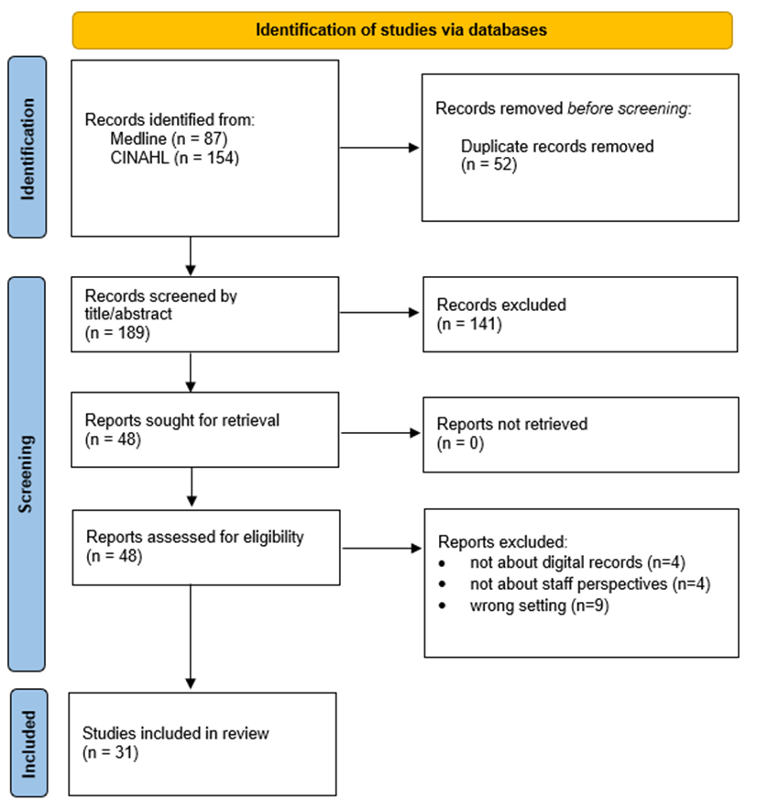
Figure 3.1: PRISMA flow diagram for study identification, screening, eligibility assessment and final inclusion in the literature review

This was a structured literature review with transparent search and selection reporting using a PRISMA style flow diagram; it did not include a formal risk of bias appraisal, so findings are presented as thematic implementation lessons rather than pooled effect estimates.

Thematic Review of the Literature
The published literature indicates that staff readiness for, and successful implementation of, digital maternity records or comparable electronic health records (EHRs), depends on the interaction of technical, organisational, professional and relational factors. The literature shows that implementation is most successful where staff understand the purpose of the system, perceive benefits to patient care, receive sufficient training and support, and are able to incorporate the technology into existing clinical workflows without too much disruption. By contrast, implementation is hindered where systems are poorly aligned with established practice, increase documentation burden, lack interoperability, or are introduced in ways that do not facilitate staff engagement and ownership(Mair et al., 2012a; McCrorie et al., 2019; Scantlebury et al., 2017).
A core theme in the literature is that staff readiness depends on whether clinicians can make sense of the rationale for digital change. McCrorie et al. (2019), drawing on Normalisation Process Theory, found that staff were more willing to engage with EHR implementation when they understood why the system was being introduced and could identify likely benefits for safety, efficiency and communication. However, they also found marked variation between staff groups in how the purpose of the system was interpreted, with some viewing it largely as a data-entry tool rather than a clinically useful resource. This suggests that readiness is secured through construction of a shared rationale for use. Mair et al. (2012)make a similar point, arguing that the implementation literature has too often neglected the “sense-making” work required to establish the value and purpose of e-health systems for users (Mair et al., 2012a; McCrorie et al., 2019).
The literature also identifies training, preparation and support as major determinants of readiness. McCrorie et al. found that willingness to participate in implementation depended heavily on the adequacy of staff preparation, including demonstrations, tailored training opportunities and access to “super-users” during rollout. There was variation in preparedness across staff groups, suggesting that generic approaches to training may be insufficient in complex clinical environments (McCrorie et al., 2019). Jankowitz et al in their account of implementing an accessible electronic maternity record system in Bradford, similarly emphasise that involving, training and supporting staff was crucial, particularly for community midwives who were required to adapt to mobile technology and remote access (Jankowitz, 2017). Edwards et al. likewise found that nurses raised concerns about insufficient training and the practical difficulties of using electronic care plans with patient (Edwards, 2011). Kinnunen et al. showed that nurses’ informatics competence was strongly associated with perceived adequacy of training, system usability and prior experience of EHR use (Kinnunen et al., 2019).
Educational preparation for digital practice also appears to influence later readiness for implementation. Mollart et al. argue that undergraduate nursing and midwifery curricula have not kept pace with the rapid expansion of electronic medical records in practice settings, with the result that some students enter placement insufficiently prepared to use digital systems safely and confidently. They suggest that exposure to electronic records during pre-registration education can improve work-readiness and support patient safety by allowing students to rehearse documentation, decision-making and information retrieval before entering clinical environments (Mollart et al., 2023). However, Ng et al. found that nursing students viewed a simulated electronic medical record as acceptable, easy to use and useful for learning, with perceived usefulness being a significant influence on intention to use the system (Ng et al., 2024). Overall, these studies suggest that readiness for implementation can begin before employment, and that staff confidence with digital records is likely to be strengthened when familiarity is developed during professional education rather than left to ad hoc learning in practice.
This emphasis on early exposure is also consistent with wider concerns in the literature that digital competence should not be treated as an optional skill. Mollart et al. note that although contemporary students are often assumed to be comfortable with technology, this does not necessarily translate into the ability to use electronic records appropriately for patient care (Mollart et al., 2023). Ng et al. show that students were more likely to accept and intend to use electronic systems when they regarded them as relevant to future practice (Ng et al., 2024). This suggests that staff readiness may be strengthened when digital training is explicitly linked to the students’ future clinical role instead of being presented as a purely technical exercise.
Another theme concerned the fit between digital systems and the realities of clinical workflow. The literature shows that implementation becomes problematic when electronic systems fail to reflect how care is delivered in real life. In one maternity unit, Scantlebury et al. found that the coexistence of paper and electronic systems, alongside poor integration with other systems, hindered the normalisation of the electronic record and contributed to perceived negative effects on time, patient safety and the patient-clinician relationship (Scantlebury et al., 2017). McCrorie et al. similarly report concerns that standardised templates and structured fields do not allow for the complexity of clinical reasoning and local practice (McCrorie et al., 2019). This is developed further by Eason and Waterson, who argue that many electronic patient record systems are more effectively designed for managerial and strategic purposes than for frontline clinical use, with the consequence that staff resort to workarounds to complete care tasks (Eason & Waterson, 2014). Ali et al. likewise describe health information systems as exerting control over clinical work, sometimes obstructing, delaying or reshaping everyday practice in unintended ways (Ali et al., 2010). This has been seen in CTMUHB, where the configuration of the BadgerNet system has forced changes in local guidelines, as it is configured based on national guidance.
In respect to maternity specific literature, there is concern that electronic records will negatively impact the relational nature of the midwife-patient dynamic, which is necessarily more intimate than nurse-patient interactions in other specialties. Hawley et al. note that the paper hand-held record has historically functioned not only as a documentation tool but also as a mechanism for communication, continuity and integration within maternity shared care. Although electronic records were recognised as having potential to improve communication and referrals, the review found continuing fragmentation and persistent use of paper (Hawley et al., 2014). Fawdry et al. extend this by questioning the assumption that electronic maternity records will inevitably replace paper, arguing that the flexibility of paper has been insufficiently acknowledged and that rigid electronic structures impose significant burdens of re-entry and standardisation (Fawdry et al., 2011). Craswell et al. further illuminate this issue by showing that midwives perceived computerised perinatal data entry as shifting focus away from the woman and baby towards the machine, with some participants characterising technology as “invading birth”(Craswell et al., 2015). It should be noticed that these two papers are now quite dated, and one would expect perceptions to have changed since their publication. However, this concern is echoed in more recent work by Kearney et al, who found that midwives spent a substantial proportion of care episodes engaged with integrated electronic medical records, raising concern that time-intensive documentation may hinder woman-centred care (Kearney et al., 2023).
Some literature also points to the potential safety and quality gains that underpin the case for digital records in maternity care. George and Bernstein argue that prenatal care is particularly well suited to electronic records because women are seen repeatedly, often by multiple professionals and across inpatient and outpatient settings, making accessible and complete documentation especially important. They highlight the potential for electronic prenatal records to improve communication, reduce missing information and support more comprehensive documentation, thereby reducing errors and risk (George & Bernstein, 2009). However, the maternity literature also makes clear that such benefits cannot be assumed if digitalisation compromises the relational aspects of care. In a preliminary ethnographic study, Craswell et al. found that although midwives and women recognised advantages in having one accessible digital record, midwives remained concerned that the volume and frequency of electronic documentation interrupted care and affected confidence in their ability to provide woman-centred support. The authors therefore conclude that the potential benefits of maternity EMRs depend not simply on digitisation itself, but on whether implementation preserves the established strengths of maternity documentation while improving safety, access and integration (Craswell et al., 2021).
Usability is repeatedly identified as important for staff attitudes and implementation success. Baillie et al. found that nursing and midwifery students valued improved legibility, accessibility and information sharing associated with EHRs, but also encountered concerns about poor usability, insufficient computers, duplication of written and electronic information, and the stress of adapting to digital systems (Baillie et al., 2012). Similar tensions are evident in practice-based studies of qualified staff. Smyth et al. found that both nurses and midwives identified negative effects of EMR documentation on productivity, patient relationships and wellbeing, with midwives particularly likely to report that the system had not improved quality of care or women’s safety (Smyth et al., 2024). Wynter et al. likewise describe mixed responses in the first phase of EMR implementation, with improved access to data and some perceived safety benefits offset by slow navigation, system outages, hybrid documentation and increased cognitive workload (Wynter et al., 2022). Collectively, these studies suggest that staff readiness is undermined when systems are experienced as time-consuming, frustrating or poorly matched to the cognitive and relational demands of care.
Interoperability and infrastructure are also consistent themes. Jankowicz et al. identify connectivity as the major challenge in community maternity care, despite the advantages of mobile access to electronic notes (Jankowitz, 2017). Hawley et al. similarly note that electronic systems in maternity shared care are often constrained by fragmentation and continued paper use (Hawley et al., 2014). At the wider system level, King et al. argue that structural and professional boundaries, incompatible IT systems and poor inter-organisational cooperation have slowed progress in effective electronic data sharing (King et al., 2012). More recently, Li et al. report that physicians in the English NHS perceived interoperability to be rudimentary, with limited data sharing contributing to inefficiency, repeated investigations and possible threats to patient safety (Li et al., 2025). These findings are highly relevant to maternity services, where care pathways frequently cross organisational and geographical boundaries and rely on timely access to accurate shared information. This is the situation in CTMUHB, as the Welsh Ambulance Service Trust (WAST) will not have access to BadgerNet maternity records, which has the potential for delays in communication during emergencies.
The importance of stakeholder engagement and local ownership is also well established. Cresswell et al.(Cresswell et al., 2011) found that meaningful user engagement was not achieved in the context of the English national EHR programme, partly because staff were not consulted in system choice and often perceived local engagement efforts as superficial. Sheikh et al. also found that implementation in early adopter hospitals was slowed by unrealistic expectations, the complexity of building and configuring the software, evolving national policy priorities and insufficient support for end users (Sheikh et al., 2011). Fragidis and Chatzoglou, drawing on international evidence from 13 countries, similarly identify stakeholder commitment and involvement as the single most important success factor in national EHR implementation, while lack of support and negative reactions to change among staff were identified as the most critical failure factors (Fragidis & Chatzoglou, 2018). These papers suggest that implementation is more likely to succeed when staff experience digital change as something shaped with them, rather than imposed upon them. As discussed earlier, the Welsh context is that this change has been mandated by Welsh government, so it is particularly relevant to this project that we anticipate the possibility of a lack of staff ownership of the project and try to ameliorate this.
Closely linked to engagement is the issue of leadership, particularly leadership that is clinically credible. Jankowicz et al. describe the value of a dedicated clinical EMR team in Bradford, whose clinical credibility reassured staff that implementation was not merely an IT project but a change grounded in service delivery (Jankowitz, 2017). This is especially salient in the maternity literature, where the role of the digital midwife has emerged as an important, though still under-researched, implementation mechanism. Eyers argues that digital midwives are leaders who combine clinical and informatics expertise in order to support implementation, adoption and change management in maternity services. However, Eyers also notes that the evidence base for this role remains poor (Jane Eyers, 2021). Smith et al. offer a more recent and practice-based example of such leadership, describing a Digital Nurse, Midwife and Allied Health Professional team that acted as a bridge between clinical and technical teams during readiness, go-live and stabilisation of a major EPR implementation (Smith et al., 2024). In CTM a Senior Midwifery Information Officer and a Digital Midwife have been employed as part of the BadgerNet Implementation project.
Finally, the literature suggests that staff readiness must be viewed within the wider context. Greenhalgh et al. argue that shared electronic records are complex systems shaped by organisational readiness, inter-organisational linkages and the broader socio-political setting (Greenhalgh, 2008). Mair et al. likewise conclude that published implementation literature has often focused too narrowly on organisational issues without sufficient attention to the wider social framework. In this respect, staff readiness is best understood as something produced through the interaction of system design, infrastructure, leadership, culture, workload and implementation strategy (Mair et al., 2012a).

Summary of Literature Review
Overall, the literature suggests that staff readiness for, and implementation of, digital maternity records or comparable EHRs is facilitated by a clear rationale for change, perceived clinical value, adequate training, high usability, strong workflow fit, good interoperability, meaningful stakeholder involvement and clinically credible leadership. In maternity settings, these factors are further shaped by the distinctive importance of continuity, shared care and woman-centred practice. Where digital systems are experienced as increasing documentation burden, duplicating paper processes, disrupting relationships or failing to reflect the realities of maternity care, staff readiness is likely to be weakened. By contrast, where implementation is clinically led, and well supported, digital records are more likely to become embedded as effective tools.

Survey Results

Introduction
This chapter presents the survey findings addressing Research Question 2: what are the levels of confidence, preparedness, perceived benefits, perceived barriers and support needs among CTMUHB maternity staff regarding the introduction of a digital maternity record? Findings are interpreted using Normalization Process Theory (NPT), which provides a framework for understanding how new interventions are implemented and embedded into routine practice. Results are presented according to the four key NPT constructs: coherence, cognitive participation, collective action, and reflexive monitoring.
A total of 78 staff members responded. As this was below the target sample size identified in the methodology chapter, the results are presented descriptively. The findings should be interpreted as indicating patterns within the respondent group, not statistically generalisable findings across the whole CTMUHB maternity workforce.

Participant characteristics
The sample included a broad range of staff groups, with obstetricians (37.2%) and hospital midwives (25.6%) comprising the largest proportions. Additional participants included anaesthetists, specialist midwives, community midwives, and healthcare support staff.
The age distribution was relatively balanced, with the largest group aged 35–44 years (34.6%). The sample was predominantly White British (71.8%), with smaller representation from Indian (9.0%), Black African (6.4%), Arab (5.1%), and other ethnic groups.
The diversity of roles represented captures perspectives across multiple areas of maternity care. However, smaller subgroup sizes—particularly in relation to ethnicity—limit the ability to draw robust comparative conclusions. They should therefore be treated as possible indicators of variation in readiness more than firm evidence of demographic differences.

Coherence: understanding the digital maternity record
Coherence refers to how staff understand and make sense of the purpose and value of the digital maternity record.

Awareness of change
Of the 76 respondents, four reported that they were not aware of the planned change to a digital maternity record. All four were doctors: two obstetricians and two anaesthetists. This finding indicates that awareness was high overall, but not universal.

Previous experience of digital maternity records
Overall, prior experience of digital maternity records was limited. Only 12 of 76 respondents reported previous exposure to such systems, and this experience was concentrated mainly among obstetricians. Most staff groups, including anaesthetists, healthcare support workers, labour ward coordinators, receptionists and ward clerks, reported no prior experience. This suggests that many staff will be approaching BadgerNet without direct experience of a comparable digital maternity platform.
From an NPT perspective, limited prior exposure may constrain staff’s ability to fully understand how the system will function in practice. This may affect coherence by reducing familiarity and increasing uncertainty about how digital records will differ from existing systems.

Preferences for record format
Preferences for record format were mixed:
- Digital: 43.6%
- Mixed: 23.1%
- Paper: 20.5%
- Not sure: 12.8%

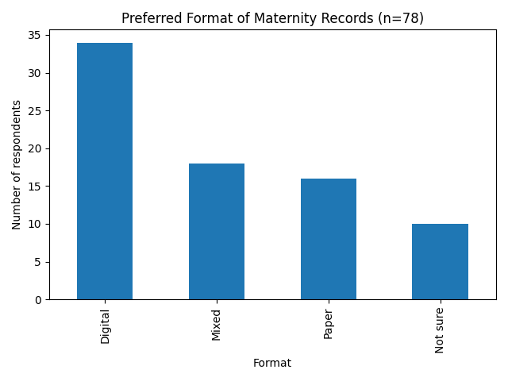Figure 4.1: Preferred format of maternity records
These findings indicate partial coherence. While digital systems were the most preferred option, a substantial proportion of respondents preferred mixed or paper systems. This suggests that although staff recognise the benefits of digital records, there still isn’t a consensus on the best record format.

Perceived benefits of digital maternity records
Respondents identified multiple anticipated benefits, including:
- Improved information sharing across borders (n = 53)
- Reduced risk of records being lost or damaged (n = 52)
- Easier readability (n = 39)
- Improved legal compliance (n = 39)
- Audit and research benefits (n = 39)
- Improved patient safety (n = 36)
These findings demonstrate strong coherence. Staff recognise the value of digital records, particularly in relation to accessibility, safety, and record quality.

Cognitive Participation: engagement and readiness
Cognitive participation refers to how staff engage with and commit to the implementation of the digital maternity record.

Confidence in using digital records
The mean confidence score was 4.46/10, indicating moderate confidence overall.
Confidence varied by staff group, with higher scores among obstetricians and specialist midwives, and lower scores among community midwives, coordinators, and support staff.
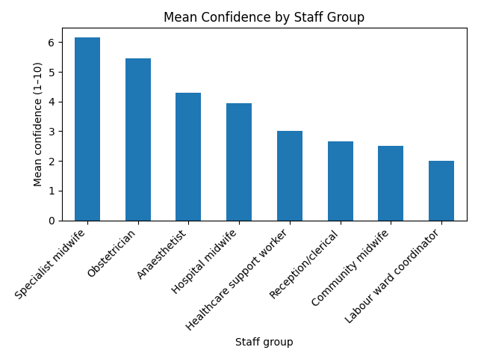
Figure 3: Mean confidence in digital maternity records by staff group
These findings suggest uneven readiness across the workforce. The staff groups that are the most involved in direct patient care were the ones who reported lower confidence, which may impact successful implementation of the system.

Confidence by age group
Mean confidence varied by age group, although interpretation is limited by the small numbers in some categories. The highest mean confidence score was reported by the single respondent aged 18–24 years (10.0, n=1), followed by respondents aged 35–44 years (4.81, n=27), 25–34 years (4.44, n=16), 55–64 years (4.14, n=14), and 45–54 years (4.12, n=17). The lowest mean score was among respondents aged over 64 years (1.50, n=2). One respondent selected “prefer not to say” and reported a confidence score of 6.0.
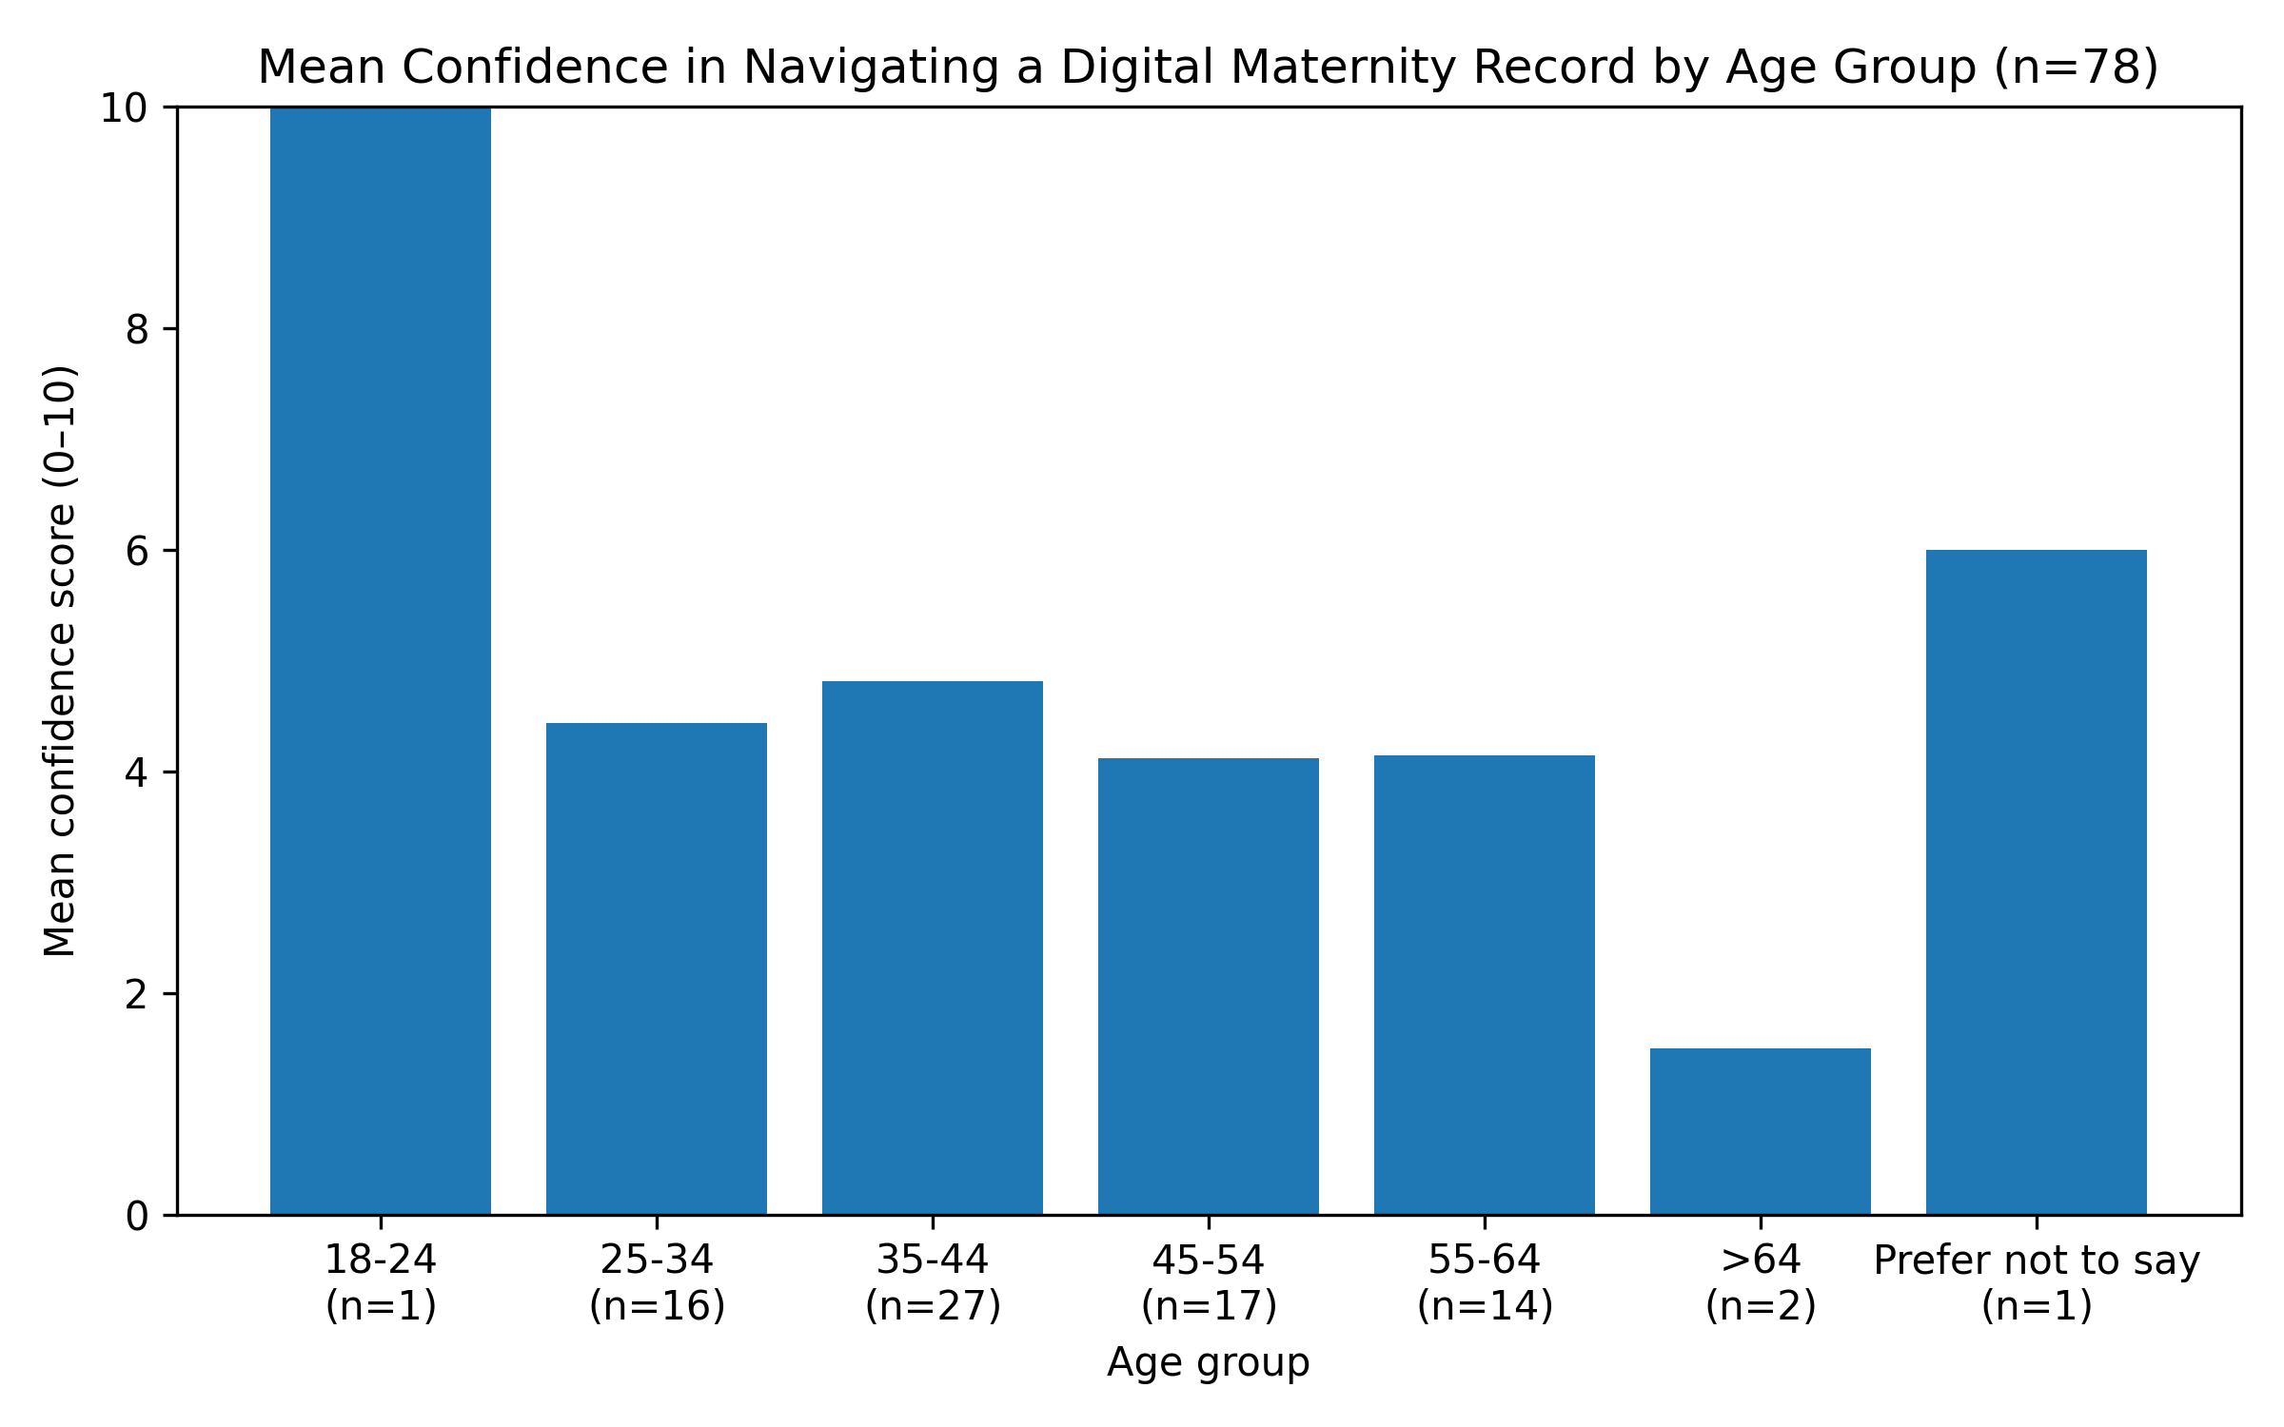Figure 4: Mean confidence by age group

The data do not show a simple linear relationship between age and confidence. The 45–54 and 55–64 groups reported similar mean scores, while the 35–44 group reported slightly higher confidence than the 25–34 group. The very high and very low scores in the youngest and oldest categories should be interpreted cautiously because these groups contained very small numbers. Overall, the findings suggest that digital readiness is not determined by age alone, and that role, prior exposure, training, and access to support are likely to be more important influences on engagement.

Confidence by ethnicity
Analysis by ethnicity is limited by small subgroup sizes. Respondents from minority ethnic backgrounds appeared more likely than White British respondents to report prior experience of digital maternity systems and to express a preference for fully digital or mixed record formats. They also tended to report slightly higher confidence scores in navigating a digital maternity record and were more likely to indicate accessing work applications on personal devices.
In this sample, ethnicity and role were closely linked, with doctors both more ethnically diverse and more likely to report prior exposure to digital systems. For that reason, any apparent differences by ethnicity should be interpreted cautiously as likely reflecting role and exposure rather than ethnicity itself.

Training preferences
Respondents expressed clear preferences for:
- Group training (n = 50)
- Floorwalkers or superusers (n = 47)
- Video tutorials (n = 42)
- One-to-one training (n = 40)
Training is viewed as essential to engagement. The preference for interactive and practical support suggests that staff anticipate needing ongoing assistance to use the system effectively.

Collective Action: operationalising the system
Collective action refers to how the digital maternity record will be used in practice.

Access to devices
Device access emerged as an important operational issue. Forty-one respondents reported having no permanent access to a work device. This indicates that implementation will occur in a context where many staff may
depend on shared hardware, which could affect workflow, confidence and the practical usability of the digital maternity record

Location of record access
Most respondents anticipated accessing the system within hospital settings, although some expected to use it across community clinics, patients’ homes, and remote environments.
The system must function across multiple clinical settings, requiring flexibility and reliable connectivity.

Frequency of record use
Respondents reported frequent use of clinical data, including:
- clinical encounters
- laboratory results
- management plans
The digital maternity record will need to support high-frequency clinical tasks, making system speed and usability critical.

Perceived disadvantages
Key concerns included:
- Learning a new system (n = 53)
- Hybrid working (n = 49)
- System outages (n = 47)
- Lack of devices (n = 44)
These findings highlight that staff concerns are primarily operational. Challenges relate to workflow integration more than resistance to digital systems.
When considered together, these responses suggest that CTM maternity staff recognised the potential value of digital maternity records, particularly for information sharing, governance and record quality. However, their concerns focused on whether the system would be usable, reliable and properly supported in everyday clinical practice.

Reflexive Monitoring: evaluating the system
Reflexive monitoring refers to how individuals and groups evaluate the effectiveness and impact of a new system once it is in use. As this survey was conducted prior to full implementation of the digital maternity record, so direct evaluation of system performance was not possible. However, responses provide insight into how staff anticipate assessing the system in practice.
The prominence of concerns relating to device access and system reliability suggests that these factors will be central to how the system is judged following implementation. If the system is perceived to increase workload, delay access to information, or disrupt clinical processes, it is likely to be evaluated negatively. Conversely, if it improves accessibility and reduces duplication, it is more likely to be seen as beneficial.
Overall, the survey data indicate that reflexive monitoring within CTMUHB is likely to be pragmatic and experience-based in the early stages of implementation. Staff appear likely to assess the system based on its immediate impact on efficiency and patient care, rather than through formal evaluation mechanisms. This suggests that early user experience will play a critical role in shaping perceptions of the system and its longer-term integration into routine practice.

Free-text comments
The free-text comments should be interpreted as illustrative only They do not represent a complete qualitative dataset. They nevertheless provide useful insight into why some staff felt anxious or cautious about the transition to digital records.
Respondents expressed mixed views. Some highlighted concerns about training, workflow disruption, and reduced patient interaction. Others acknowledged potential benefits if the system was well implemented.
Staff anticipate both benefits and challenges. Their evaluation of the system is likely to depend on its impact on daily practice.

Conclusion
Survey findings demonstrate that staff are broadly supportive of digital maternity records but identify significant challenges related to implementation.
Summarising the results from an NPT perspective:
- Coherence: Moderate — benefits understood but not universally accepted
- Cognitive participation: Variable — engagement depends on confidence and support
- Collective action: Challenging — infrastructure and workflow issues dominate
- Reflexive monitoring: Pragmatic — success judged by impact on practice
Overall, the survey suggests that staff awareness of BadgerNet was high, but readiness was uneven. Respondents recognised important potential benefits, especially improved information sharing and reduced risk of lost or illegible records. However, they also identified significant implementation risks, particularly training needs, device access, system reliability, hybrid working and the impact of digital documentation on clinical workflow.

Interview Findings

Introduction
This chapter presents findings from six semi-structured interviews conducted with maternity staff within Cwm Taf Morgannwg University Health Board (CTMUHB). The interviews explored staff perceptions of the organisational, technical, and workflow-related factors that may influence the successful implementation of a digital maternity record (BadgerNet).
Data were analysed using Normalization Process Theory (NPT), which provides a framework for understanding how new practices are implemented and embedded into routine work. Findings are presented according to the four NPT constructs: coherence, cognitive participation, collective action, and reflexive monitoring.

Coherence: understanding the purpose and value of the system
Participants generally demonstrated a clear understanding of the practical benefits of a digital maternity record. These benefits were typically framed in terms of improved access to information, increased efficiency, and enhanced communication across teams.
One participant described how digital records would allow staff to:
“Not have to hunt for the notes… we can just see everything on screen”
This reflects a strong operational understanding of the system’s value. Participants frequently compared digital records with existing paper systems, highlighting inefficiencies associated with locating, transporting, and maintaining physical notes.
However, while participants understood the practical advantages, there was limited reference to broader organisational or policy drivers for digital transformation. The system was largely understood in terms of its immediate impact on day-to-day work, not as part of a wider strategy for improving healthcare delivery.
From an NPT perspective, coherence appears to be partially developed. Staff demonstrate strong functional coherence—understanding what the system does and how it may benefit practice—but weaker conceptual coherence, with limited engagement with the wider rationale for implementation. This distinction is important, as incomplete coherence may lead to variability in how staff interpret the purpose of the system, potentially affecting engagement and long-term sustainability.

Cognitive Participation: engagement and commitment
Overall, participants expressed a willingness to engage with the digital maternity record, although this engagement was often described as conditional.
A key theme was that digital confidence varied between individuals, not just demographic groups. One participant noted:
“It’s not about age, it’s about confidence”
This reflects a broader perception that readiness is influenced by individual experience and exposure, not age as some interviewees postulated. Participants frequently acknowledged that some staff would find the transition more challenging, particularly those with limited prior experience of digital systems.
Concerns were also raised about the potential for uneven engagement across staff groups, with some participants suggesting that without adequate support, less confident staff may struggle to adopt the system effectively.
Participants emphasised the importance of training and support in facilitating engagement. There was a clear expectation that implementation would require:
- structured training
- opportunities for practice
- ongoing support within clinical environments
These findings suggest that cognitive participation is present but not fully established. Staff are generally willing to engage with the system, but this engagement depends on whether they feel adequately prepared and supported.
From an NPT perspective, this highlights the importance of actively developing engagement in CTM through training, communication, and support.
The emphasis on confidence and experience reinforces the finding that role and exposure, rather than demographic characteristics alone, are key determinants of engagement.

Collective Action: operationalising the system in practice
Collective action emerged as the dominant theme across the interviews, with participants focusing extensively on the practical realities of implementing the digital maternity record.

Technical factors
Participants identified several technical factors that could influence implementation, including:
- device availability
- Wi-Fi connectivity
- system speed and reliability
- system outages
One participant described device availability as their main concern. This highlights the importance of reliable access to hardware in enabling staff to use the system effectively.
Connectivity was also identified as a key issue, particularly in areas where Wi-Fi coverage may be inconsistent. Participants expressed concern that system outages or slow performance could disrupt clinical work and reduce confidence in the system.

Workflow integration
Concerns about workflow integration were particularly prominent. Participants emphasised the importance of ensuring that the system fits within the realities of maternity care, particularly in busy or acute environments such as labour ward.
One participant noted:
“Using BadgerNet is going to delay patient care”
This reflects a concern that digital documentation may initially increase workload and reduce efficiency. Participants described scenarios in which entering data into the system could be time-consuming, particularly during periods of high clinical demand.
There was also concern about the potential for hybrid working, where paper and digital systems are used simultaneously. Participants suggested that this could lead to duplication of work, increased complexity, and confusion.

Organisational factors
Participants consistently emphasised the importance of organisational support in facilitating implementation. Key factors included:
- training provision
- availability of superusers
- presence of floorwalkers during rollout
- leadership and communication
The concept of floorwalkers—staff available within clinical areas to provide immediate support—was particularly valued. Participants highlighted the need for real-time assistance to help staff navigate the system during routine work.
From an NPT perspective, these findings indicate that collective action represents the primary challenge to implementation. While staff are generally willing to engage with the system, their ability to use it effectively depends on:
- access to appropriate resources
- system reliability
- alignment with clinical workflows
The emphasis on workflow integration reflects the importance of ensuring that the system supports routine practice without disrupting it. Failure to address these issues may lead to workarounds, such as reverting to paper documentation, which could undermine implementation.

Reflexive Monitoring: evaluating the system
Participants described how they would evaluate the success of the digital maternity record in pragmatic terms. Success was generally defined as a point at which the system becomes:
- easy to use
- integrated into routine practice
- associated with improved efficiency
One participant expressed:
“We won’t look back”
This suggests that successful implementation would be characterised by normalisation, where the system becomes a routine and accepted part of clinical work.
Participants also acknowledged that there would likely be an initial adjustment period, during which the system may be perceived as slower or more difficult to use. However, many expected that efficiency would improve over time as staff became more familiar with the system.
These findings indicate that reflexive monitoring will be driven by practical experience, and staff are likely to judge the system based on its impact on their daily work, particularly in terms of efficiency and usability.
From an NPT perspective, this emphasizes the importance of ongoing evaluation and adaptation, ensuring that the system continues to meet the needs of users.

Summary
The interview findings demonstrate that maternity staff within CTMUHB are broadly supportive of the introduction of a digital maternity record but identify several factors that may influence its successful implementation.
From an NPT perspective:
- Coherence: Staff understand the practical benefits, but broader conceptual understanding is limited
- Cognitive Participation: Engagement is present but conditional on confidence, training, and support
- Collective Action: The primary challenge, with concerns focused on infrastructure, workflow, and system reliability
- Reflexive Monitoring: Success will be judged pragmatically based on usability and impact on practice
Overall, the findings suggest that while staff are not resistant to digital transformation, successful implementation will depend on addressing the organisational and practical conditions required to integrate the system into routine maternity care.

Conclusion

Introduction
The aim of this dissertation was to evaluate the readiness of maternity staff within Cwm Taf Morgannwg University Health Board (CTMUHB) for the introduction of a digital maternity record (BadgerNet), and to identify the factors perceived as important to its successful implementation in routine practice. The study addressed this aim through a structured literature review, a staff survey and semi-structured interviews.
This chapter synthesises findings from all three research questions and presents a structured conclusion using Normalization Process Theory (NPT). It identifies the key organisational, technical, and workflow-related conditions required for successful implementation and proposes an annotated conceptual framework demonstrating how the study’s findings map onto NPT constructs. Areas where evidence was limited are also highlighted to inform future research.

Summary of Findings by Research Question

Research Question 1: Literature review
The literature demonstrated that successful implementation of digital maternity records depends on:
- Clear understanding of purpose (coherence)
- Effective staff engagement and training (cognitive participation)
- Strong workflow alignment and infrastructure (collective action)
- Ongoing evaluation and adaptation (reflexive monitoring)
Across maternity-specific and wider EHR literature, implementation was most successful where systems were clinically useful, usable, and well supported, and where staff were actively involved in the process. Conversely, implementation was hindered by poor usability, lack of interoperability, workflow disruption, and insufficient training.

Research Question 2: Survey findings
Survey findings (n = 78) demonstrated:
Moderate coherence: Staff recognised benefits but preferences were mixed
Variable cognitive participation: Confidence differed by role and experience
Significant collective action challenges: Device access, system reliability, and workflow integration were major concerns
Pragmatic reflexive monitoring: Staff expected to judge success based on impact on daily work
Within this respondent sample, readiness appeared to vary more by role and prior exposure than by age, and the dominant barriers related to collective action, particularly device access, reliability and workflow fit. Training and support were seen as essential facilitators

Research Question 3: Interview findings
Interview findings provided deeper insight into implementation processes:
Interviewees demonstrated strong functional understanding of benefits but a limited awareness of wider policy drivers. They seem more likely to engage with the digital maternity record if they feel confident and adequately supported but may struggle or disengage if they do not. Success was defined pragmatically as normalisation into routine practice.
Collective action emerged as the dominant challenge, particularly:
  - device access
  - workflow disruption
  - hybrid working

Discussion: Integrating Survey, Interview and Literature Findings
This discussion interprets the survey and interview findings together, compares them with the implementation literature, and explains what they imply for the BadgerNet roll out in CTMUHB. The central argument is that attitudes were broadly supportive, but implementation risk is concentrated in collective action, where infrastructure and workflow realities can rapidly erode confidence and normalisation.
This study sought to understand how maternity staff within CTMUHB perceive the organisational, technical, and workflow-related factors influencing the implementation of a digital maternity record. When considered together, the survey and interview findings reveal the following narrative: staff are not resistant to digital transformation, but their engagement is contingent on whether the system can be effectively integrated into the realities of clinical practice. This is consistent with implementation literature showing that EHR adoption is shaped by user engagement, organisational context, workflow fit and support, not just technology (Cresswell et al., 2011; Mair et al., 2012b; Sheikh et al., 2011).
At a survey level, the data suggested a workforce that is broadly supportive of digital maternity records, with clear recognition of anticipated benefits such as improved information accessibility, reduced risk of lost records, and enhanced governance. This aligns with existing literature, which identifies perceived clinical value and stakeholder involvement as important facilitators of adoption (Fragidis & Chatzoglou, 2018; McCrorie et al., 2019). However, the survey also revealed important tensions. Preferences for record format were mixed, confidence levels were variable, and concerns relating to infrastructure, hybrid working, and workflow disruption were prominent. Taken alone, these findings might be interpreted as evidence of partial readiness or ambivalence, reflecting patterns observed in early-stage implementation where organisational complexity and competing priorities influence adoption (Sheikh et al., 2011).
The interview data provide depth to these patterns. Participants focused on how the system would function in real clinical environments. This reflects findings from the literature that staff concerns are often rooted in the practical realities of system use (Cresswell et al., 2011). For example, concerns about hybrid working, which appeared in the survey as a frequently selected disadvantage, were described in interviews as a likely source of duplication, inefficiency and potential risk. Similarly, survey responses highlighting device access and system reliability as concerns were elaborated through accounts of shared equipment, limited availability in clinical areas, and the potential for delays in patient care. In this way, the interviews clarify that survey-identified “barriers” are grounded in anticipated disruptions to workflow and patient-facing activity.
The survey data initially suggest that coherence is relatively well developed, with staff recognising the benefits of digital systems. However, interview findings indicate that this coherence is primarily operational. Staff understand what the system will do, but there is less evidence of engagement with the broader rationale for its implementation. This distinction is important, as the literature suggests that successful implementation requires not only functional understanding but also the ability to make sense of the intervention within its wider context (Bracher & May, 2019; McCrorie et al., 2019).
Similarly, the survey identified variability in confidence and preparedness, which the interviews helped to explain, with participants linking confidence to prior experience, training and familiarity with digital systems. This aligns with existing research demonstrating that implementation is socially mediated and dependent on organisational conditions more than individual characteristics (Cresswell et al., 2011; Sheikh et al., 2011). The finding that confidence varied by role and prior exposure further supports this interpretation and highlights the importance of familiarity and practical experience in shaping engagement.
The strongest point of convergence between survey and interview findings lies within the domain of collective action. The survey identified multiple operational concerns, including device access, system reliability and hybrid working. The interviews confirm these findings, demonstrating that these issues are central to how staff anticipate using the system in practice. This is consistent with the wider literature, which identifies infrastructure limitations, workflow disruption, interoperability challenges and insufficient support as key barriers to successful implementation (Fragidis & Chatzoglou, 2018; Li et al., 2025; Sheikh et al., 2011). This is a particular issue in the acute areas of maternity care, where documentation must be completed alongside time-pressured clinical activity.
This has important implications when considered in relation to the “productivity paradox” in digital transformation (Brynjolfsson, 1993). This concept highlights that investment in technology does not automatically lead to improved performance, particularly where systems are not effectively integrated into existing workflows. The findings from CTMUHB reflect this principle closely. Staff recognise the potential benefits of BadgerNet, but anticipate that without adequate infrastructure, training and workflow alignment, the system may initially reduce efficiency rather than improve it.
Integrating these findings allows for a more nuanced understanding of implementation within the specific context of CTMUHB, particularly when considered across two phases. In Phase 1 (initial implementation and early use), the primary challenges are likely to be those identified under collective action: device availability, system usability, and the management of hybrid workflows. During this phase, staff engagement is likely to be highly contingent on the availability of support, including training, floorwalkers, and immediate troubleshooting. The risk at this stage is not resistance, but disengagement resulting from practical difficulties, a pattern also described in early EHR implementation studies (Sheikh et al., 2011).
In Phase 2 (embedding and normalisation), the focus shifts toward reflexive monitoring and the consolidation of practice. Here, the key determinant of success will be whether the system becomes integrated into routine workflows and is perceived as improving efficiency and patient care. The literature suggests that systems are more likely to become normalised when they align with existing practices, minimise duplication and remain responsive to user feedback (Eason & Waterson, 2014; Mair et al., 2012b; McCrorie et al., 2019).
The combination of survey and interview findings, along with the existing literature, indicates that the success of digital maternity record implementation within CTMUHB will depend on addressing the organisational and practical conditions required for effective use. This has important implications for implementation strategy. Efforts to promote adoption should focus not only on communicating benefits, but on ensuring that the system is usable, accessible, and aligned with clinical workflows. In this sense, the findings reinforce a socio-technical perspective on digital health implementation, in which technology, people, and organisational context must be considered together.

Synthesis Using NPT
Across all data sources, a consistent pattern emerged:
Table 6.1: NPT Key Findings
NPT Construct | Key Finding
Coherence | Benefits understood, but conceptual understanding incomplete
Cognitive Participation | Engagement conditional on confidence and support
Collective  Action | Primary barrier — infrastructure and workflow issues dominate
Reflexive Monitoring | Success judged pragmatically through daily use

This demonstrates that implementation success is not primarily limited by staff attitudes, but by the ability of the system to be operationalised effectively within real clinical environments.
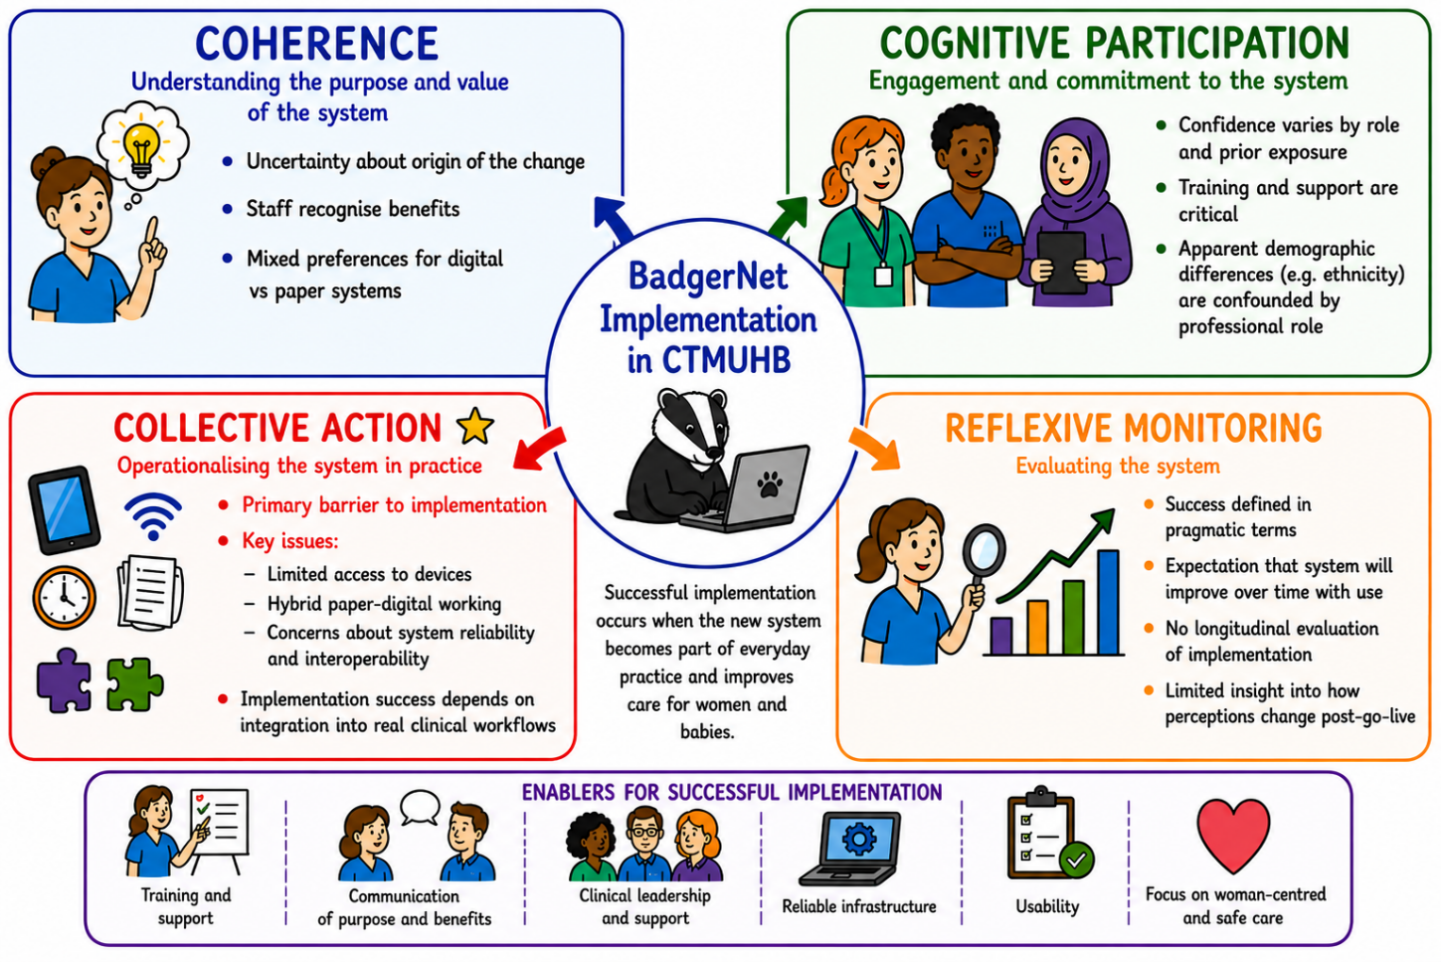
Figure 6.1: Annotated NPT Framework for BadgerNet Implementation in CTMUHB. Text provided by author, visual elements created by ChatGPT
[This figure is a visual summary of the written synthesis and does not introduce new findings; it was generated from a prompt based on the final coded themes and then manually checked against the text for accuracy.]

Key Factors for Successful Implementation

Implementation Plan for BadgerNet in CTMUHB
Building on the key factors identified in this study, successful implementation of BadgerNet within CTMUHB requires a staged, time-bound approach that explicitly addresses the organisational and operational barriers highlighted by staff. These include limited access to devices, risks associated with hybrid paper–digital working, concerns regarding system outages, and uncertainty around workflow integration. A phased implementation strategy allows these risks to be anticipated and mitigated proactively.
Phase 1: Pre-Go-Live Readiness
Prior to system launch, the focus should be on readiness assurance, ensuring that the necessary infrastructure, training, and workflow alignment are in place. Device availability must be addressed as a priority. This includes auditing existing hardware, ensuring sufficient numbers of functioning devices in all clinical areas, and confirming equitable access across staff groups. Without this, digital documentation risks becoming delayed or inconsistent from the outset.
At the same time, clear plans must be established to minimise hybrid working. Where paper and digital systems must temporarily coexist, explicit protocols should define when and how each system is used to avoid duplication and clinical risk. This is particularly important in high-acuity areas such as labour ward, where ambiguity in documentation processes could impact patient safety.
Workflow mapping is also critical at this stage. Clinical processes should be reviewed to ensure that the digital system aligns with existing patterns of care. This may involve simulation exercises or pilot testing within selected areas.
Finally, contingency planning for system outages must be in place, as these are currently commonplace in CTMUHB, with internet disruption occurring on at least a monthly basis. Staff should be clear on downtime procedures such as use of “Golden devices” and these should be tested prior to go-live to ensure familiarity and confidence.
Phase 2: Go-Live, Floorwalking and Stabilisation
The go-live period represents a phase of intensive support and rapid adaptation, where staff begin using the system in real clinical conditions. During this phase, the primary risk is not resistance but disengagement arising from practical difficulties.
To mitigate this, floorwalking support should be embedded within clinical areas. Trained superusers or digital champions should be physically present to provide real-time assistance, troubleshoot issues, and reinforce correct use of the system. This is particularly important in addressing barriers related to workflow fit, as staff require immediate support to adapt documentation practices without compromising patient care.
Device access should continue to be monitored dynamically during this phase. Any gaps identified in Phase 1 may become more apparent under real conditions, and rapid redistribution or supplementation of equipment may be required.
Hybrid working should be actively reduced during stabilisation. Where duplication persists, this should be reviewed and resolved quickly to prevent inefficient workarounds becoming embedded in practice.
In addition, system performance—including speed, reliability, and connectivity—should be closely monitored. Early identification and resolution of technical issues is essential to maintain staff confidence and prevent negative perceptions from becoming entrenched.
Phase 3: Post-Go-Live Optimisation and Embedding
Following initial stabilisation, the focus shifts toward optimisation and normalisation, ensuring that the system becomes fully integrated into routine practice. At this stage, reflexive monitoring becomes central, with ongoing evaluation of how the system is functioning in real clinical environments. Staff feedback mechanisms should be formalised, enabling users to report issues relating to workflow, usability, and system performance. This is particularly important for addressing residual concerns about workflow fit, as small inefficiencies can accumulate over time and impact overall system acceptance.
Efforts should also be made to eliminate any remaining reliance on paper systems, thereby resolving the risks associated with hybrid working. This requires both technical assurance and organisational confidence that the digital system is reliable and complete. Device access should be reviewed on a sustained basis, ensuring that infrastructure continues to meet clinical demand. Similarly, protection against outages should be strengthened through ongoing technical support and infrastructure investment.
Ultimately, successful implementation will depend on whether the system is perceived to enhance, rather than hinder, clinical work. This requires continuous alignment between technology and practice, supported by adaptive leadership and responsiveness to staff experience.
Across all three phases implementation success will be determined not by staff attitudes, but by the extent to which organisational, technical, and workflow conditions enable effective system use. A staged approach allows these factors to be addressed systematically, supporting the transition from initial adoption to sustained normalisation within CTMUHB maternity services.

Gaps and Areas for Further Research
This study identified several areas where evidence was limited:
- Long-term reflexive monitoring (post-implementation evaluation)
- Role of leadership and digital champions in sustaining engagement
- Experiences of underrepresented staff groups
- Impact on patient experience and woman-centred care
Future research should therefore include evaluation of system impact post-implementation and the exploration of patient perspectives, which were outside of the scope of this project.

Limitations
This study was designed to explore staff readiness for the implementation of a digital maternity record within CTMUHB, and its findings should be interpreted within clearly defined boundaries. While the mixed methods design strengthens the depth and credibility of the analysis, several limitations restrict the extent to which conclusions can be generalised.
First, the study is context specific. Data were collected within a single Health Board at a particular stage in the implementation timeline. Organisational culture, leadership structures, and local infrastructure are likely to influence staff perceptions, meaning that findings cannot be assumed to be directly transferable to other maternity services or healthcare settings without careful consideration of contextual differences. The study therefore offers analytical generalisation, (not statistical) contributing to understanding of implementation processes in CTM maternity services but not producing universally applicable predictions.
Second, the survey component is subject to self-selection bias. Participation was voluntary, and it is possible that respondents were more engaged, more opinionated, or more affected by the proposed changes than non-respondents. This may have led to overrepresentation of particular viewpoints, including both enthusiasm and concern. Similarly, the interview sample was relatively small and self-selected, which limits representativeness but still adds depth.
Third, the study captures perceptions at a single point in time, prior to full implementation. As such, it reflects only the anticipated impacts of the digital maternity record. Staff views may change following exposure to the system, meaning that conclusions about long-term normalisation and effectiveness remain provisional.
To address these limitations, the study employed methodological triangulation. Survey data provided a broad overview of patterns across staff groups, while interviews offered explanatory insight into how and why those patterns arose. The use of Normalization Process Theory facilitated a structured comparison across data sources, supporting the development of coherent and internally consistent interpretations. Commonalities between quantitative and qualitative findings, particularly in relation to the importance of infrastructure and workflow integration, increases confidence in the credibility of these conclusions.
Within these boundaries, the study cautiously supports the claim that maternity staff within CTMUHB are broadly supportive of digital maternity records, but that the main risks to successful implementation lie in the practical and organisational conditions required for their use. The findings should therefore be understood as specific to CTMUHB, and to maternity services. These insights can therefore inform local implementation strategy and contribute to wider theoretical understanding, but do not provide definitive predictions of implementation outcomes across other settings.

Final Conclusion
This dissertation demonstrates that maternity staff within CTMUHB are broadly supportive of the introduction of a digital maternity record and recognise its potential benefits for safety, communication, and efficiency. However, successful implementation will depend on addressing the organisational, technical, and workflow-related conditions required to embed the system into routine practice.
The NPT framework analysis has shown that the main challenge lies in collective action, particularly in ensuring that the system is supported by adequate infrastructure and aligned with clinical workflows.
Role, experience, and organisational context are the primary determinants of readiness of CTM maternity staff for the BadgerNet system.
The findings reinforce that digital transformation in maternity care is a complex organisational process requiring sustained investment in people, systems, and practice.
For CTMUHB to ensure that BadgerNet normalises quickly, the decisive investment will be the practical removal of frontline friction through reliable devices, stable connectivity, and workflow tested documentation patterns supported by visible on ward help at the point of care.

References

ABUHB. (2024). Digital Maternity Records at Aneurin Bevan University Health Board - Aneurin Bevan University Health Board. https://abuhb.nhs.wales/hospitals/a-z-of-services/maternity-services/digital-maternity-records-at-aneurin-bevan-university-health-board/
Ali, M., Cornford, T., & Klecun, E. (2010). Exploring Control in Health Information Systems Implementation.
Alotaibi, N., Wilson, C. B., & Traynor, M. (2025). Enhancing digital readiness and capability in healthcare: a systematic review of interventions, barriers, and facilitators. BMC Health Services Research 2025 25:1, 25(1), 500-. https://doi.org/10.1186/S12913-025-12663-3
Baillie, L., Chadwick, S., Mann, R., & Brooke-Read, M. (2012). A survey of student nurses’ and midwives’ experiences of learning to use electronic health record systems in practice. https://doi.org/10.1016/j.nepr.2012.10.003
Bartlett, J. E., Kotrlik, J. W., & Higgins, C. C. (2001). Organizational Research: Determining Organizational Research: Determining Appropriate Sample Size in Survey Research Appropriate Sample Size in Survey Research. Information Technology, Learning, and Performance Journal, 19(1).
Bracher, M., & May, C. R. (2019). IOS Press Ebooks - Applied Interdisciplinary Theory in Health Informatics - Applied Interdisciplinary Theory in Health Informatics (P. Scott, N. de Keizer, & A. Georgiou, Eds.). https://ebooks.iospress.nl/volume/applied-interdisciplinary-theory-in-health-informatics-applied-interdisciplinary-theory-in-health-informatics
Brynjolfsson, E. (1993). The productivity paradox of information technology. Business Computing.
CAVUHB. (2025). Cardiff and Vale University Health Board introduces new digital maternity records app - Cardiff and Vale University Health Board. https://cavuhb.nhs.wales/news/latest-news/cardiff-and-vale-university-health-board-introduces-new-digital-maternity-records-app/
Clarke, A., Adamson, J., Watt, I., Sheard, L., Cairns, P., & Wright, J. (2016). The impact of electronic records on patient safety: a qualitative study. https://doi.org/10.1186/s12911-016-0299-y
Craswell, A., Kearney, L., McAtee, J., Hadland, M., Smyth, W., & Nagel, C. (2021). Impact of Electronic Medical Records within the Maternity Environment: An Ethnographic Exploration of Midwifery Practice. Studies in Health Technology and Informatics, 284, 528–530. https://doi.org/10.3233/SHTI210788
Craswell, A., Moxham, L., & Broadbent, M. (2015). Introduction and literature review.
Cresswell, K., Associate, R., Morrison, Z., Crowe, S., Phd, M., Mrpharms, M., Robertson, A., Sheikh, A., Bs, M. B., Dch, D., & Frcp, F. (2011). Anything but engaged: user involvement in the context of a national electronic health record implementation.
Data Protection Act (2018).
DHCW. (2023a). Digital Health and Care Wales Annual Report 2023 - 2024.
DHCW. (2023b). Performance Overview Performance Summary Performance Analysis Development Of The Organisation Operational Service Delivery Detailed Social Statement Environmental Statement Financial Accountability Report Financial Performance The Accountability Report A….
Eason, K., & Waterson, P. (2014). Fitness for purpose when there are many different purposes: Who are electronic patient records for? Health Informatics Journal, 20(3), 189–198. https://doi.org/10.1177/1460458213501096
Edwards, K. (2011). Assessing the value of electronic records. Nursing Times, (107).
Fawdry, R., Bewley, S., Cumming, G., & Perry, H. (2011). Data re-entry overload: Time for a paradigm shift in maternity IT? In Journal of the Royal Society of Medicine (Vol. 104, Number 10, pp. 405–412). SAGE Publications Ltd. https://doi.org/10.1258/jrsm.2011.110153
Fragidis, L. L., & Chatzoglou, P. D. (2018). Implementation of a nationwide electronic health record (EHR): The international experience in 13 countries. International Journal of Health Care Quality Assurance, 31(2), 116–130. https://doi.org/10.1108/IJHCQA-09-2016-0136
George, J., & Bernstein, P. S. (2009). Using electronic medical records to reduce errors and risks in a prenatal network. In Current opinion in obstetrics & gynecology (Vol. 21, Number 6, pp. 527–531). https://doi.org/10.1097/gco.0b013e328332d171
Gething, V. (2019). Maternity Care in Wales-A 5 Year Vision for the Future.
Gov.Wales. (2022). Written Statement: Implementation of the Digital Maternity Cymru Programme. https://www.gov.wales/written-statement-implementation-digital-maternity-cymru-programme
Greenhalgh. (2008). Introduction of shared electronic records: multi-site case study using diffusion of innovation theory. British Medical Journal. https://doi.org/10.1136/bmj.a1786
Hawley, G., Janamian, T., Jackson, C., & Wilkinson, S. A. (2014). In a maternity shared-care environment, what do we know about the paper hand-held and electronic health record: A systematic literature review. BMC Pregnancy and Childbirth, 14(1). https://doi.org/10.1186/1471-2393-14-52
Holland, S. (2026). The path to safer beginnings in Wales A national assurance assessment of Maternity and Neonatal care and services.
Jane Eyers, E. (2021). Exploring the role of the digital midwife as leaders in the implementation and adoption of an electronic health record: protocol for a scoping review of evidence.
Jankowitz. (2017). Implementation of an accessible electronic maternity records system. Nursing Times, (2).
Kearney, L., Craswell, A., Cole, R., Hadland, M., Smyth, W., & Nagle, C. (2023). Woman-centred care and integrated electronic medical records within Australian maternity settings: Point prevalence audit and observational study. Midwifery, 123. https://doi.org/10.1016/j.midw.2023.103718
King, G., O’donnell, C., Boddy, D., Smith, F., Heaney, D., & Mair, F. S. (2012). Boundaries and e-health implementation in health and social care. http://www.biomedcentral.com/1472-6947/12/100
Kinnunen, U. M., Heponiemi, T., Rajalahti, E., Ahonen, O., Korhonen, T., & Hyppönen, H. (2019). Factors Related to Health Informatics Competencies for Nurses - Results of a National Electronic Health Record Survey. CIN - Computers Informatics Nursing, 37(8), 420–429. https://doi.org/10.1097/CIN.0000000000000511
Li, E., Lounsbury, O., Hasnain, M., Ashrafian, H., Darzi, A., Neves, A. L., & Clarke, J. (2025). Physician experiences of electronic health record interoperability and its practical impact on care delivery in the English NHS: a cross-sectional survey study. BMJ Open , 15(6). https://doi.org/10.1136/bmjopen-2024-096669
Mair, F. S., May, C., O’Donnell, C., Finch, T., Sullivand, F., & Murray, E. (2012a). Factores que promueven o dificultan la implementación de los sistemas de telemedicina: Revisión sistemática explicativa. In Bulletin of the World Health Organization (Vol. 90, Number 5, pp. 357–364). https://doi.org/10.2471/BLT.11.099424
Mair, F. S., May, C., O’Donnell, C., Finch, T., Sullivand, F., & Murray, E. (2012b). Factores que promueven o dificultan la implementación de los sistemas de telemedicina: Revisión sistemática explicativa. In Bulletin of the World Health Organization (Vol. 90, Number 5, pp. 357–364). https://doi.org/10.2471/BLT.11.099424
McCrorie, C., Benn, J., Johnson, O. A., & Scantlebury, A. (2019). Staff expectations for the implementation of an electronic health record system: A qualitative study using normalisation process theory. BMC Medical Informatics and Decision Making, 19(1). https://doi.org/10.1186/s12911-019-0952-3
Mollart, L., Irwin, P., Noble, D., & Kinsman, L. (2023). Promoting patient safety using electronic medical records in nursing/midwifery undergraduate curricula: Discussion paper. In Nurse Education in Practice (Vol. 70). Elsevier Ltd. https://doi.org/10.1016/j.nepr.2023.103653
Morgan, E. (2022, December). Written Statement: Implementation of the Digital Maternity Cymru Programme (19 December 2022) | GOV.WALES. https://www.gov.wales/written-statement-implementation-digital-maternity-cymru-programme
Ng, L., Osborne, S., Eley, R., Tuckett, A., & Walker, J. (2024). Exploring nursing students’ perceptions on usefulness, ease of use, and acceptability of using a simulated Electronic Medical Record: A descriptive study. Collegian, 31(2), 120–127. https://doi.org/10.1016/j.colegn.2023.12.006
NHS Digital. (2020). [ARCHIVED CONTENT] UK Government Web Archive - The National Archives. https://webarchive.nationalarchives.gov.uk/ukgwa/20230505034441/https://digital.nhs.uk/binaries/content/assets/website-assets/services/digital-maternity-programme/womens-digital-care-record-report-march-2020.pdf
NHS England. (2016). NHS England » Better Births: Improving outcomes of maternity services in England – A Five Year Forward View for maternity care. https://www.england.nhs.uk/publication/better-births-improving-outcomes-of-maternity-services-in-england-a-five-year-forward-view-for-maternity-care/
NHS England. (2024). NHS England » Digital maturity assessment. https://www.england.nhs.uk/long-read/digital-maturity-assessment/
NHS HRA. (2020). Is my study research? https://www.hra-decisiontools.org.uk/research/
NHS HRA. (2022). Student research toolkit - text only page - Health Research Authority. https://www.hra.nhs.uk/planning-and-improving-research/research-planning/student-research/student-research-toolkit/student-research-toolkit-text-only-page/
NHS Wales. (2024). NHS 111 Wales - Pregnancy Guide. https://111.wales.nhs.uk/livewell/pregnancy/yourantenatalcare/
NICE. (2022a). Fetal monitoring in labour NICE guideline. www.nice.org.uk/guidance/ng229
NICE. (2022b). Recommendations | Fetal monitoring in labour | Guidance | NICE.
ONS. (2021a). Language, England and Wales - Office for National Statistics. https://www.ons.gov.uk/peoplepopulationandcommunity/culturalidentity/language/bulletins/languageenglandandwales/census2021#main-languages-in-england-and-wales
ONS. (2021b). National identity, ethnic group, language and religion question development for Census 2021 - Office for National Statistics. https://www.ons.gov.uk/census/censustransformationprogramme/questiondevelopment/nationalidentityethnicgrouplanguageandreligionquestiondevelopmentforcensus2021
RCM. (2020). DGT0007 Written evidence submitted by the Royal College of Midwives. https://www.rcm.org.uk/media/3669/rcm-uk-manifesto-a4.pdf
Scantlebury, A., Sheard, L., Watt, I., Cairns, P., Wright, J., & Adamson, J. (2017). Exploring the implementation of an electronic record into a maternity unit: a qualitative study using Normalisation Process Theory. BMC Medical Informatics and Decision Making 2017 17:1, 17(1), 4-. https://doi.org/10.1186/s12911-016-0406-0
Scott, P. (2016). Mixed Methods: A Paradigm for Holistic Evaluation of Health IT. Evidence-Based Health Informatics: Promoting Safety and Efficiency through Scientific Methods and Ethical Policy, 222, 102–113. https://doi.org/10.3233/978-1-61499-635-4-102
Sheikh, A., Cornford, T., Barber, N., Avery, A., Takian, A., Lichtner, V., Petrakaki, D., Crowe, S., Marsden, K., Robertson, A., Morrison, Z., Klecun, E., Prescott, R., Quinn, C., Jani, Y., Ficociello, M., Voutsina, K., Paton, J., Fernando, B., … Cresswell, K. (2011). Implementation and adoption of nationwide electronic health records in secondary care in England: Final qualitative results from prospective national evaluation in “early adopter” hospitals. BMJ (Online), 343(7829). https://doi.org/10.1136/bmj.d6054
Smith, J., Duffy, A., & Breslin, D. (2024). The Evolution of a Digital Nurse, Midwife and Allied Health Professional Team. Studies in Health Technology and Informatics, 315, 583–584. https://doi.org/10.3233/SHTI240227
Smyth, W., Bogiatzis, M., Irving, L., Morton, J., Holland, S., & Nagle, C. (2024). ‘One size does not fit all’: Nurses’ and midwives’ opinions about using electronic medical records. Australian Journal of Advanced Nursing, 41(4), 4–13. https://doi.org/10.37464/2024.414.1205
Stalmeijer, R. E., Brown, M. E. L., & O’Brien, B. C. (2024). How to discuss transferability of qualitative research in health professions education. The Clinical Teacher, 21(6), e13762. https://doi.org/10.1111/TCT.13762
UWTSD. (2022). Research Integrity and Ethics | University of Wales Trinity Saint David. https://www.uwtsd.ac.uk/research/research-integrity-and-ethics
Welsh Government. (2019). Maternity Care in Wales-A 5 Year Vision for the Future.
Welsh Government. (2023). Digital and data strategy for health and social care in Wales. https://www.gov.wales/digital-and-data-strategy-health-and-social-care-wales-html
Welsh Government. (2024). New app to improve maternity care in Wales | GOV.WALES. https://www.gov.wales/new-app-improve-maternity-care-wales
Wynter, K., Holton, S., Nguyen, L., Sinnott, H., Wickramasinghe, N., Crowe, S., & Rasmussen, B. (2022). Nurses’ and midwives’ experiences of the first phase of the implementation of an electronic medical records system. Australian Health Review, 46(2), 188–196. https://doi.org/10.1071/AH21118

Appendices

Project Brief

Evaluation of the Perceptions of and Readiness for the Introduction of a Digital Maternity Record by the Staff of Cwm Taf Morgannwg University Health Board

Data Analysis Plan
Context and Scope
This project will explore the readiness of staff in Cwm Taf University Health Board (CTMUHB) for the transition from paper notes to digital maternity records and assess their perceptions of a digital maternity record.
CTMUHB provides maternity care for women across Bridgend, Rhondda Cynon Taf and Merthyr Tydfil. Patient records are currently held in a paper format, which are created at the 8 week booking appointment and given to the patient to hold for the duration of her pregnancy (“handheld notes”). Postnatally, the patients’ notes are collated into her main CTMUHB paper medical record and archived. Patients are expected to bring their handheld notes to all appointments, and to carry them at all times, including when travelling outside of the health board. This ensures safe care and transfer of information when patients seek care whilst out of area (for example when on holiday) (NHS Wales, 2024).
Paper-based records create a number of risks and challenges. The nature of maternity care is that things can change very quickly, and acute situations can occur without warning, endangering the safety of both mother and baby. Delays caused by not having patient information at clinician’s fingertips can therefore have catastrophic consequences. Manual record-keeping is time-consuming, which can detract from patient care and affect staff morale. Incomplete or illegible documentation hinders clinicians from making timely and well-informed decisions and can result in misinterpretation and legal challenges. Paper records are vulnerable to being lost, damaged, or destroyed, further compromising patient care. The mandate to store maternity and neonatal records for 25 years presents logistical and financial challenges which are greater with paper-based records (NICE, 2022b). Digitising maternity records also facilitates audit and research by providing standardised datasets which can be more easily interrogated than paper based records.
This project will explore the perceptions of maternity staff and service users regarding the move to a digital record. The Royal College of Midwives point out that most pregnant women are in the age range of 16-40, which is an age group who are familiar with using digital technologies on a regular basis and therefore tend to engage well with digital transformation programmes (RCM, 2020).
Welsh Government have stated the aim of electronic maternity records across Wales (Gething, 2019), and previously announced a plan for a national programme “Digital Maternity Cymru” (DMC) which aimed to produce a bespoke “All Wales” digital maternity record (Gov.Wales, 2022). However, in 2025, despite a £7million investment by Welsh government, the DMC project has folded. Instead, Welsh government has mandated that local health boards choose their own providers of digital maternity records, with instructions to present business cases to their health board executives by February 2025 with a view to roll out the chosen systems by April 2026. It is therefore no longer a matter of “if” or even “when”, but of “how” we are going to design and deliver the transition to digital records in Cwm Taf Morgannwg maternity services.
Project Aim and Research Objectives
The project aims to assess the digital readiness of CTMUHB staff for the digital record, how staff will access and utilise the application, and which features users feel are needed. Potential areas of weakness will be identified, along with solutions for making the digital record useful and usable by end users. Accessibility by staff to the necessary infrastructure will be evaluated, as will the accessibility of the application itself. The final users of the digital record will include patients, midwives, obstetricians, anaesthetists, neonatologists, pharmacists, health visitors, administrators, ward clerks, receptionists, managers and research teams (amongst others). It is not yet clear whether paramedics will have access to the record, but they should be surveyed to explore whether they perceive access as helpful or necessary and to examine which features they would want to have included. Physician’s Associates do not currently work in maternity care in CTMUHB so they would not be included.
To optimise the success and efficiency of digital systems, their design needs to be user-centred (NHS England, 2024), and therefore informed by user research (NHS Digital, 2020).It is therefore important to conduct research into what the end users need in Cwm Taf Morgannwg, in order to optimise design, function, and usability of the digital record. The aim is to identify needs, risks and opportunities regarding what the digital record contains, and how it is presented and accessed by the different end users.
Research objectives include:
- Assessing current preferences for digital records versus paper-based ones
- Identifying groups who will be disadvantaged by the move to digital records
- Evaluating digital readiness of users, and perceptions around the change
- Anticipating which aspects of the record will be most utilised, how they will be accessed, and where.
- Identifying areas of non-engagement with the change.
The ultimate aim will be to then minimise any identified risks, and strengthen weaknesses. For example, if a particular staff group is found to have low confidence in navigating a digital record, that group can be provided with focussed IT support, tutorials, or digital champions. This can also be incorporated into the design of the system, informing user-centred design. For example, if staff mostly use the record to access clinical encounter information, that can feature prominently on the landing page of the staff version.
If a particular demographic are found to be particularly resistant to the change (e.g. obstetricians), work could be done to improve engagement and attitudes to what is a government mandated change.
Data Collection and Analysis
Surveys of end users will be used to collect mostly quantitative data. In addition, questions will be included in both surveys to invite participants to provide more information that was not included in the survey answers, or to participate in additional interviews if desired, both of which would generate more qualitative data. Overall, the intention is therefore to use mixed methods. Questions will explore staff readiness for, perception of and experience of digital maternity records. They will also investigate how users use their current record and how they expect to use a digital record by asking which sections they access the most, which devices they expect to use to access digital notes, and in which locations they access/will access records. The surveys will explore perceived benefits and disadvantages of digital records by different staff groups. A mixed methods approach is appropriate to this type of project, as it gives richer insight into the issues involved in rolling out a digital initiative than could be obtained by collecting only qualitative or only quantitative data. Collecting and analysing purely quantitative data would be technically easier, giving easily measurable results for differences in perceptions, readiness and need between different staff groups. However, it would not give an opportunity to hear the worries or questions of the end users, and unless perfectly designed, risks missing out on entire areas of importance if the author does not anticipate a particular issue. By giving space for qualitative data in the form of free text survey answers and interviews, a richer set of data can be gathered. This data is more challenging to analyse and synthesize, but is important to collect if a full picture of the problems and opportunities is to be drawn.
Types of survey question will include ranking questions, Likert scale, and yes/no, and selecting all answers that apply. Although ranking and Likert scale give more detailed quantitative data than yes/no or selecting all that apply, they are also more time-consuming for the respondent, so cannot be used for all questions. Some free text answers will be available if “Other” is selected, and at the end of the survey where participants are asked if there is anything else they would like to comment on. The survey responses will provide mainly quantitative data, which will be useful to assess differences in perception, readiness and needs between staff groups or different demographics.
According to the Data Protection Act 2018:
“…the purpose for which personal data is collected on any occasion must be specified, explicit and legitimate…and must be adequate, relevant and not excessive in relation to the purpose for which it is processed. (Data Protection Act, 2018)”
At the start of the surveys and interviews, a statement will therefore be provided outlining the purpose for which the data is being collected, and how it will be stored (including for how long) and used.
Ethnicity data will be collected according to the principles set out by the Office for National Statistics, using a Welsh-focussed modification of their national census ethnicity questions. These include “mixed/multiple ethnic groups,” “Gypsy” and “Arab” as options, and specify “Welsh” first in the list of British ethnicities rather than the usual Anglo-centric tradition of stating “English” first (ONS, 2021).
The Data Protection Act describes data pertaining to racial or ethnic origin as “sensitive”, requiring “sensitive processing” (gov.uk, 2018). Demographic data will be collected pertaining to age and ethnicity to help identify whether there are differences in accessibility, usage patterns or digital readiness/poverty between different groups. According to the Data Protection Act, it is especially important that this data is optional, non-identifying, and stored and used with due care, with a clear explanation given to users regarding the nature of its use.
Data pertaining to gender, sexuality and disability will not be collected by survey, although they may be raised by participants during individual interviews.
Identifiable data will not be stored, with the exception of those staff members who provide their email address or phone number voluntarily to be contacted to participate in further interviews. Any completed paper surveys will be stored in a locked filing cabinet in a health board office and destroyed once collated into the digital database.
Survey responses will be collected during a 6 month period from December 2025 to March 2026.
Staff surveys will be emailed to staff by cascading through service managers for midwives, obstetricians, anaesthetists, neonatologists, pharmacists, health visitors, administrators, ward clerks, receptionists, managers and research teams. The Welsh ambulance service trust (WAST) would be contacted to invite any CTMUHB-based ambulance staff to participate. QR codes of the staff survey link will also be displayed in staff areas such as breakrooms and handover areas in the maternity and Emergency Departments of Princess of Wales Hospital Bridgend, Prince Charles Hospital Merthyr, and the Royal Glamorgan Hospital in Llantrisant.
Interviews will be conducted on a one-to-one basis, with audio recording if consented to by the interviewee. The recordings will then be analysed to identify themes and patterns in the responses.
See other appendices for examples of Survey and Interview questions
As discussed above, this project will utilise mixed methods of data collection to provide a rich understanding of the perceptions, readiness, needs and risks pertaining to a digital maternity record in CTMHB.
To determine the statistical significance of the quantitative data, the study will need to be adequately powered. This requires adequate sample sizes. Therefore a certain number of surveys will need to be completed within each group represented in order for it to be said that the results are statistically significant (i.e. differences or similarities have not occurred by chance). A sample size of >100 would be ideal, but the more surveys completed, the better the power of the study. Organisational significance will be assessed by whether the responders are representative of the population in question, and whether the needs or opportunities that are identified are able to be actioned by the organisation. For example, if it is found that staff are not open to a digital record, or that certain patient groups do not have access to devices or internet, those findings are significant to the organisation, which will then need to find ways to address those risks and weaknesses.
The qualitative data will need to be assessed for transferability. According to Stalmeijer et al., “Transferability is not inherent to any specific qualitative approach or design”(Stalmeijer et al., 2024). As digital maternity records have been mandated for all health boards across Wales at the same time, it would be useful if this project could be transferable for maternity colleagues in other Welsh health boards. Some elements which could be utilised to enhance the transferability for the reader are to describe the demographics of the CTMHB staff population to provide context for the reader, to highlight where the respondents differ from this population, and to include quotes from interviews in the final paper.
Saturation of qualitative data will need to be optimised. In this project, that would mean that all the main themes have been elucidated. By interviewing all participants who request it, this should be achievable. It is not anticipated that a high number will request this. Combining this with the free text survey answers will give the opportunity to identify and explore all themes pertaining to the topic.
Ethical and Information Governance Issues
According to the University of Wales Trinity St David’s (UWTSD) guidance on research integrity and ethics, ethical approval should be sought in research which involves NHS patients, and NHS staff where the research is not limited to non-sensitive questions about their personal role (UWTSD, 2022).
Working through the Health Research Authority (HRA) Student Research Kit, the first question is whether this project constitutes research (NHS HRA, 2022). According to the HRA decision tool, this project is research because the findings are hoped to be generalisable (NHS HRA, 2020). The next question in the toolkit asks whether the research is being carried out in the NHS and needs NHS approval, and as part of that asks whether patients will be involved (they will), and how they will be identified. The patients will be identified via the NHS, so the toolkit advises that this project will require approval by the HRA and HCRW. This approval will not be given until all other approvals are given, including NHS research ethics committee review, and confirmation from the site that it has the capacity and capability to support the research (NHS HRA, 2020). If this project was deemed not to be generalisable to other health boards, none of this would be needed, as it would represent a service improvement project only.
No drugs, devices or procedures are being tested, and no questions are being asked that risk causing offence, embarrassment or impact to self-esteem. There is no adverse impact of the project on animals or the environment. There are no illegal activities or deception involved. Only adults 18 and over with capacity will be included, and no vulnerable adults, children, young people, prisoners or young offenders will be included. Disclosure and Barring certificates will therefore not be needed.
The aims and methods of the research will be briefly outlined at the start of the questionnaire. It will be made clear that all data will be treated with confidentiality and not identifiable as them when published. The project would not involve any observation of participants or access to their data without their knowledge or consent. Formal feedback will not be given, but the participants will be informed that they can contact the lead investigator if they want to know the finding of the study. It will be made clear that participation is voluntary. There will be no deception or deliberate misleading or blinding of participants, and they will not be paid or rewarded for their contributions.
Written consent for participation will be integral to the surveys. Respondents will be told that they can change their mind about further participation in interviews. Participants will be given the option not to respond to the demographics questions.
As stated, data would be collected via electronic surveys via Microsoft Forms, which would be anonymous and not identifiable, except in cases where participants supply contact details in order to participate in interviews. Paper surveys will be kept in a locked filing cabinet in a locked office in the research office of CTMUHB Maternity Unit. Survey responses will be held on a secure database which is password protected and accessible only on health board machines. Personal data will be collected in the form of staff contact details (name, email or phone number) in order to perform the interviews. It will also be contained in the audio recordings, which will be uploaded to a secure health board, password protected file and deleted from the device used to record it. Special category data will be recorded in the optional demographics questions in the form of race and ethnicity questions in order to identify any disadvantaged groups. However, names and recordings of staff will be separated from their survey answers, in order to avoid associating identifying data with special category data. Survey responses will be anonymised and given study specific unique numbers unrelated to NHS or hospital numbers.
There will be no sharing of data with the university, NHS or other organisations, and the data will not be exported outside the UK. Only the principal investigator will have access to the data and will act as a custodian for the data. The anonymous data will be stored for one year after publication, and the personal data will be deleted once interviews are complete and transcribed.
Gantt Chart of Project Tasks:
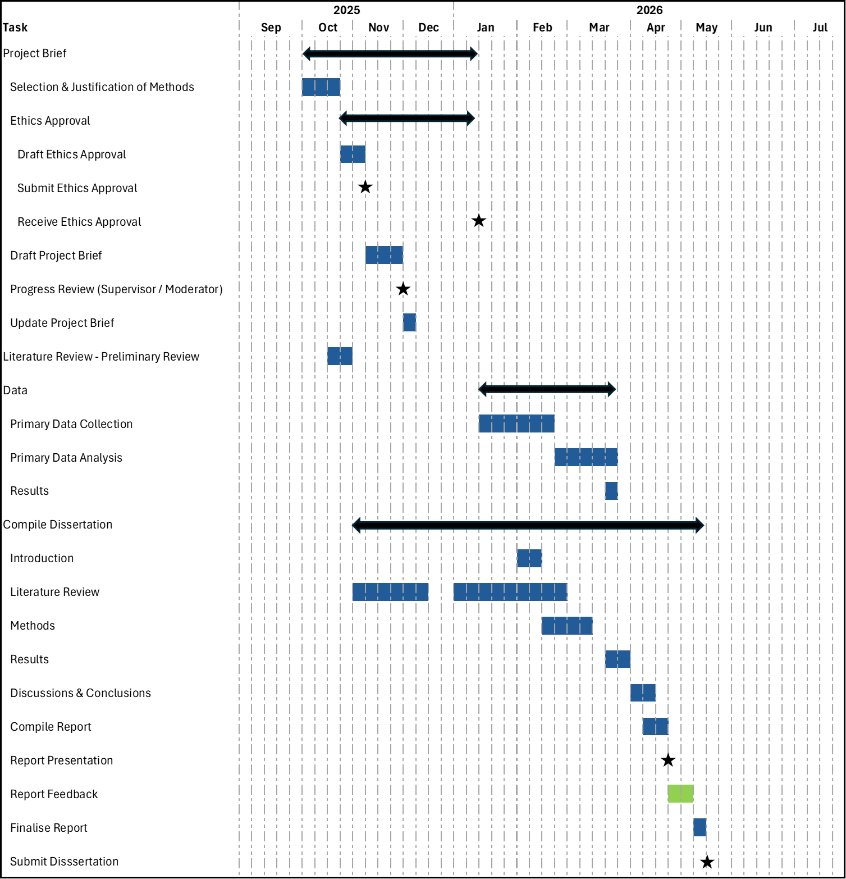

Project Brief References:
Gething, V. (2019). Maternity Care in Wales-A 5 Year Vision for the Future.
gov.uk. (2018). Data Protection Act.
Gov.Wales. (2022b). Written Statement: Implementation of the Digital Maternity Cymru Programme. https://www.gov.wales/written-statement-implementation-digital-maternity-cymru-programme
NHS HRA. (2020) Is my study research? https://www.hra-decisiontools.org.uk/research
NHS Digital. (2020). UK Government Web Archive - The National Archives. https://webarchive.nationalarchives.gov.uk/ukgwa/20230505034441/https://digital.nhs.uk/binaries/content/assets/website-assets/services/digital-maternity-programme/womens-digital-care-record-report-march-2020.pdf
NHS England. (2024). NHS England » Digital maturity assessment. https://www.england.nhs.uk/long-read/digital-maturity-assessment/
NHS Wales. (2024). NHS 111 Wales - Pregnancy Guide. https://111.wales.nhs.uk/livewell/pregnancy/yourantenatalcare/
NICE. (2022). Recommendations | Fetal monitoring in labour | Guidance | NICE.
NPT Council. (2025). Gypsy Roma and Traveller communities - NPT council https://www.npt.gov.uk/schools-and-learning/attendance-grants-and-support/attendance-and-welfare/vulnerable-learners-service/gypsy-roma-and-traveller-communities-grt/
ONS. (2021a). Language, England and Wales - Office for National Statistics. https://www.ons.gov.uk/peoplepopulationandcommunity/culturalidentity/language/bulletins/languageenglandandwales/census2021#main-languages-in-england-and-wales
ONS. (2021b). National identity, ethnic group, language and religion question development for Census 2021 - Office for National Statistics. https://www.ons.gov.uk/census/censustransformationprogramme/questiondevelopment/nationalidentityethnicgrouplanguageandreligionquestiondevelopmentforcensus202
RCM. (2020). DGT0007 Written evidence submitted by the Royal College of Midwives. https://www.rcm.org.uk/media/3669/rcm-uk-manifesto-a4.pdf
Stalmeijer, R. E., Brown, M. E. L., & O’Brien, B. C. (2024). How to discuss transferability of qualitative research in health professions education. The Clinical Teacher, 21(6), e13762. https://doi.org/10.1111/TCT.13762
NHS HRA. (2022). Student research toolkit - Health Research Authority. https://www.hra.nhs.uk/planning-and-improving-research/research-planning/student-research/student-research-toolkit/student-research-toolkit-text-only-page/
UWTSD. (2022). Research Integrity and Ethics | University of Wales Trinity Saint David. https://www.uwtsd.ac.uk/research/research-integrity-and-ethics

Ethical Review Application Form
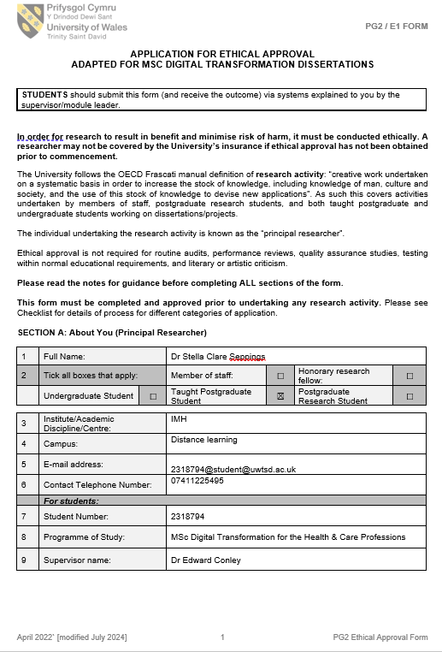
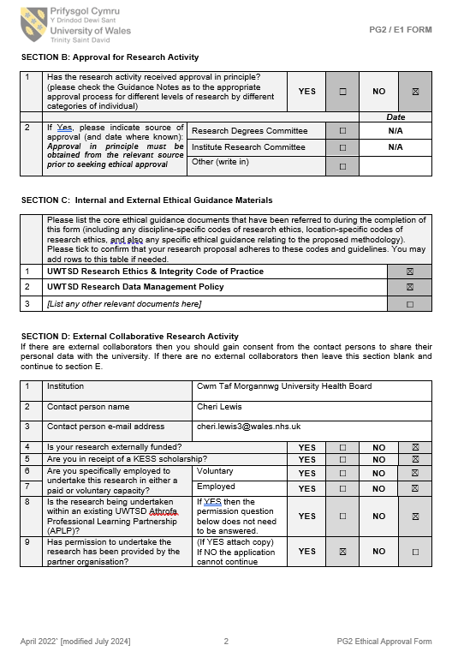

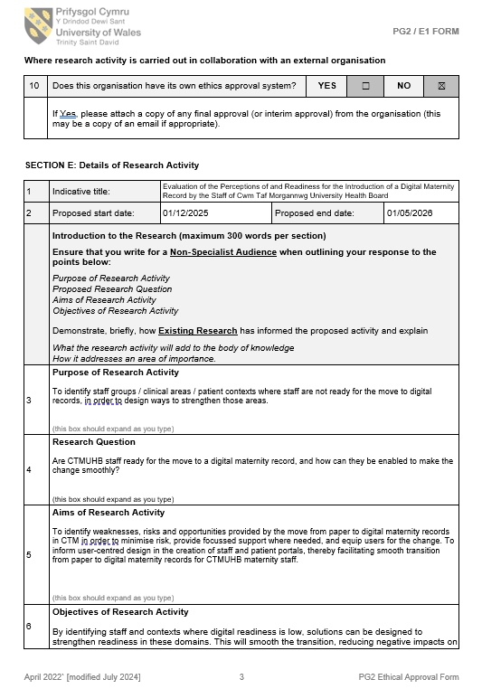
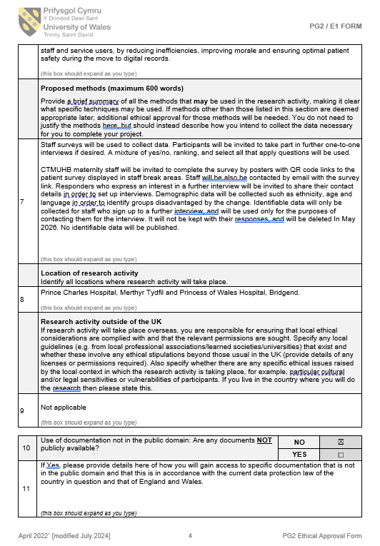
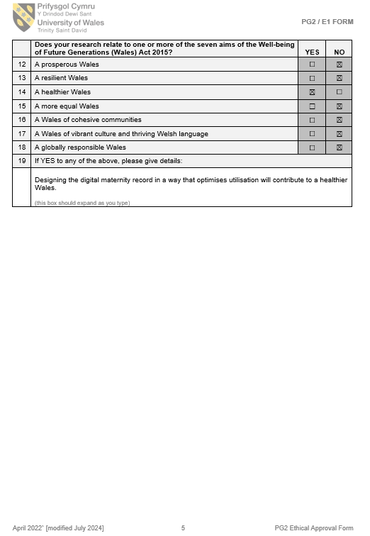

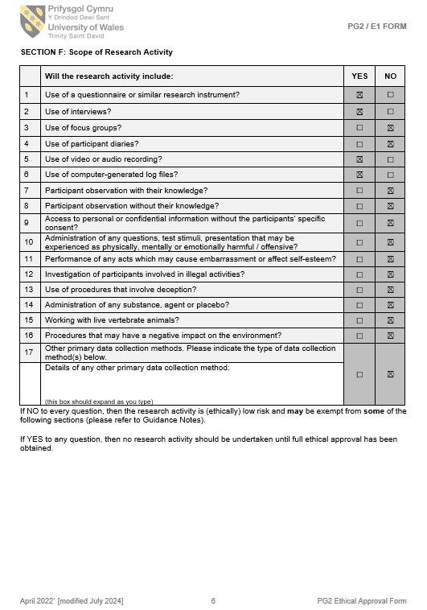


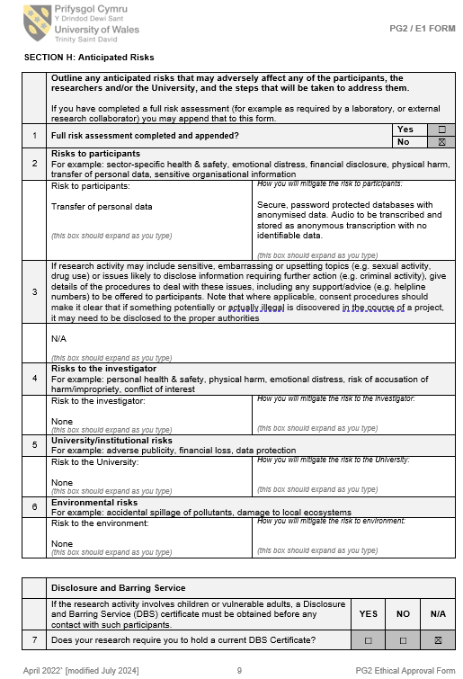



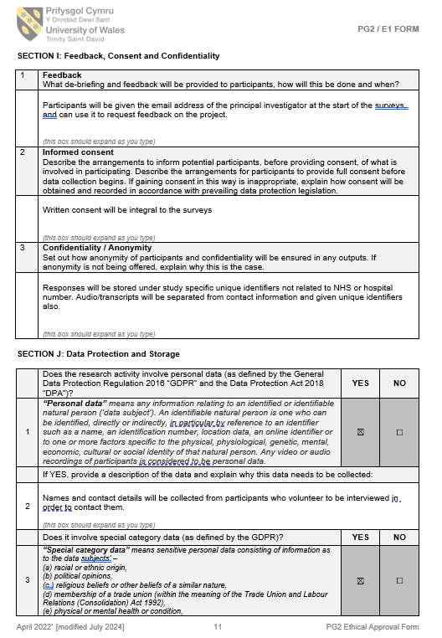
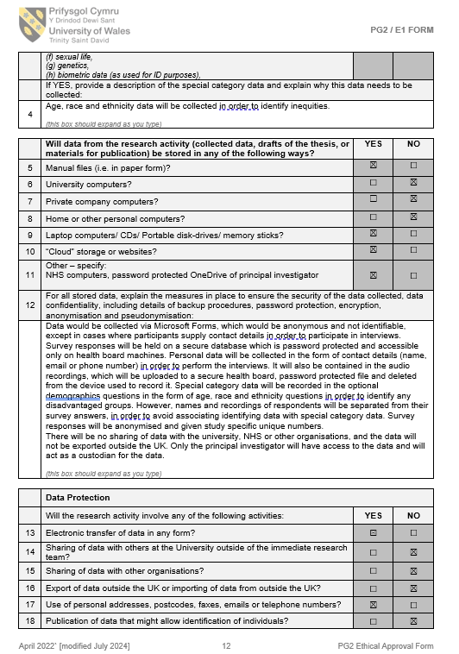

Staff Survey Questions
What is your staff role within maternity services?
- Midwife
- Obstetrician
- Receptionist/ ward clerk
- Administrator/manager
- Healthcare assistant
- Research team
- Neonatologist
- Anaesthetist
- Nurse
- Pharmacist
- Health visitor
- Paramedic
- Midwifery student
- Medical student
- Paramedic student
- Other (if Other: free text answer)
(Select all that apply)

Are you aware of the planned move to digital maternity records? Yes/No

Would you prefer patient maternity records to be:
- Digital
- Paper-based
- Mixed
- Not sure
(Select one)

How confident are you about navigating a digital maternity record? (Likert scale)
- Very confident
- Quite confident
- Neither confident nor underconfident
- Quite underconfident
- Very underconfident

Have you ever worked anywhere with digital maternity records? Yes/No/Not sure

Do you have a work device that belongs to you only?
- Mobile phone
- Laptop
- Tablet
- Other (if Other: free text answer)
- None
(Select all that apply)

Rank the following devices in order of likelihood of use to access a digital maternity record? (Ranking question)
- Mobile phone
- Laptop
- Tablet
- Other (if Other: free text answer)

Rank the following locations in order of likelihood of accessing a digital maternity record? (Ranking question)
- Home
- Base hospital
- Outlying hospital
- Community clinic
- Patients’ homes
- Ambulance
- Other (if Other: free text answer)

Rank which aspects of a digital maternity record you think you will find most useful. (Ranking question)
- Growth scans
- Results
- Appointments
- Contact details
- Safeguarding information
- Patient access to domestic violence information and contacts (eg Live Fear Free)
- Clinical encounter documentation
- None
- Other (if Other: free text answer)

Which of the following do you feel will be benefits of a digital maternity record:
- Notes won’t get lost or damaged
- Improved legibility
- Improved legal compliance (eg storage of CTGs) and reduced litigation
- Reduced administrative burden
- Eliminating the duplication effort of inputting data on both paper and digital systems
- Improved information transfer between health boards
- Enhanced real-time decision-making
- Improved communication
- Automated triage
- Automated postnatal procedures
- Increased opportunities for telemedicine
- Better informed decisions
- Enhanced interdepartmental collaboration and improved patient care co-ordination
- Reduced delays in care
- Improved patient safety
- Digital bed management will improve patient flow
- Improved data security and information governance
- Reduced carbon footprint
- Accessible safeguarding information
- Easier and more transparent audit processes
- Facilitation of research
- Cost savings
- Patient access to record
- Patients communicating with clinicians directly
- Other (if Other: free text answer)
- There are no benefits to a digital maternity record
(Select all that apply)

Which of the following do you feel will be disadvantages of a digital maternity record:
- Expense
- Could initially require duplication of digital and paper-based systems
- Patients not having access to a device
- Patients not having access to data/wifi
- Staff not having access to devices
- Staff needing to learn new system
- Patients needing to learn a new system
- System outages
- Data inputting taking longer
- Temporary staff needing log-ins
- Data security breaches
- Patients accessing their record
- Patients communicating with clinicians directly
- Other (if Other: free text answer)
- There are no disadvantages to a digital maternity record
(Select all that apply)

Is there anything else you would like to say about digital maternity records that has not been covered by these questions? (Free text answer)

Are you happy to be contacted to participate in a more detailed interview on this topic? If yes, please provide mobile phone number or email address. These will not be stored after the research is completed. (Free text answer)

The demographic data being collected in the following questions is optional, but will help us to identify and support any groups who could be disadvantaged by the introduction of a digital maternity record.

Please select your age group:
- 18-24
- 25-34
- 35-44
- 45-54
- 55-64
- >64
- Prefer not to say
(Select one)
Choose one section from A to F, then tick one box to best describe your ethnic group or background
A White
[ ] Welsh/English/Scottish/Northern Irish/British
[ ] Irish
[ ] Gypsy or Irish Traveller
[ ] Any other White background, write in
(Write in ethnic group)
B Mixed/multiple ethnic groups
[ ] White and Black Caribbean
[ ] White and Black African
[ ] White and Asian
[ ] Any other Mixed/multiple ethnic background, write in
(Write in ethnic group)
C Asian/Asian British
[ ] Indian
[ ] Pakistani
[ ] Bangladeshi
[ ] Chinese
[ ] Any other Asian background, write in
(Write in ethnic group)
D Black/African/Caribbean/Black British
[ ] African
[ ] Caribbean
[ ] Any other Black/African/Caribbean background, write in
(Write in ethnic group)
E Other ethnic group
[ ] Arab
[ ] Any other ethnic group, write in
(Write in ethnic group)
F [ ] I would rather not share this information

Semi-structured Interview Questions
Study title:
Maternity Staff Readiness for the Introduction of a Digital Maternity Record in Cwm Taf Morgannwg University Health Board: A Mixed-Methods Study of Implementation Factors
Introduction
Thank you for agreeing to take part in this interview.
The purpose of this interview is to explore your views on the introduction of the digital maternity record within CTMUHB, including the factors you think may help or hinder its successful use in routine maternity practice.
I am interested in your personal views and experiences. There are no right or wrong answers, and if there are areas that you don’t know about, that in itself will still be useful to the project. Everything you say will be treated confidentially and anonymised in the dissertation. You do not have to answer any question you do not wish to answer, and you may stop the interview at any time without giving a reason. With your permission, I would like to audio-record the interview so that I can accurately capture what you say.
Introductory questions
- What is your role within maternity services?

- Have you had any previous experience of digital maternity records?

- Do you know why we are moving to a digital maternity record now?

- What differences do you expect from the current paper-based system?

- How do you think the digital maternity record will affect your day-to-day work?

- Can you foresee any barriers to successful implementation?
For example:
- Learning a new system
- Hybrid paper and digital working
- Increased workload
- Lack of equipment
- Resistance to change
- Temporary staff access

- What do you think would make implementation easier or more successful?
For example:
- Type of training needed
- Practical support during rollout
- Better communication
- Improved hardware access
- Role-specific support
- Opportunities to give feedback
- Which area do you work in? How well do you think the digital maternity record will work in your specific area?

- What technical factors do you think will most influence whether the system works well in practice? For example:
- Device availability
- Wi-Fi or connectivity
- Speed and reliability
- Login or access arrangements
- Ease of navigation
- System outages
- Interoperability with other systems

- What organisational factors do you think will influence whether the digital maternity record is adopted successfully? For example:
- Training
- Leadership
- Communication
- Staffing levels
- Time to learn the system
- Support in clinical areas
- Superusers or digital champions

- If implementation is successful, how do you think it will look in 6 months’ time?

- Is there anything else you would like to add about the introduction of the digital maternity record that we have not discussed?

Closing words
Thank you for taking the time to speak with me today. Your views are very helpful in understanding how the digital maternity record may be introduced and embedded within routine maternity care.

