Recognition of faces following a distractor task.
1702887
University of Wales Trinity St David.

Abstract

The study was formed to prove the own-race bias hypothesis, that people can recognise faces of their own skin colour than the faces of others. In this study, the participants were shown 12 black and white faces (6 of each), and then asked to recognise and recall them on a response sheet after being shown 36 different faces. The results showed that on average more participants recognized black faces than white faces. This challenged the original hypothesis and reinforced the idea of modern society changing the way race is viewed.

Introduction

Own-race bias is the theory that describes the tendency or ability to recognise and remember the faces of a person’s own skin colour more easily than those of another skin colour. A plethora of studies have been undertaken to support this. The method of displaying an equal amount of black and white faces to test subjects, and then asking them to recall the faces they saw previously whilst adding in new faces has been adopted across studies as a way of supporting this theory (Wright, Boyd & Tredoux, 2003). This study looks to strengthen the argument for the own-race bias ideology and can also suggest whether it still continues on in the modern day. The hypothesis is that the participants were expected to identify more faces that belong to their own race.

Method

There were 29 white participants, 7 males and 22 females aged 18-60 in this study, the mean age of the participants was 27.31, with a standard deviation of 10.81. The participants were students recruited during a seminar for their Research Methods module. The within-subject study was designed so that the participants would view 12 images of black and white faces in part one, and then in part two following a brief break or distractor they would be shown 36 faces across 6 slides and then asked to recall any faces that appeared in part one. The materials used to conduct the study included a 34 slide PowerPoint presentation, a recall response sheet to record responses and their individual demographic data, and 36 images of black and white faces. The participants were provided with a consent form to verify that they consented to the experiment. Once consented, the participants were then instructed to watch the PowerPoint and remain silent throughout, additional instructions were then presented on the slides. Part one of the presentation was the presentment of the 12 initial faces on individual 2 second long slides. After this, the lecturer then provided a distractor in the form of introducing information about study for 1 minute. The participants were then instructed to look at the PowerPoint again for part two. The participants were then shown 36 different black or white faces over 6 slides, 6 faces per slide, 12 of which had appeared in part one, and were then asked to record on the response sheet the faces they recognized. After this the debrief form was then presented on screen in a group setting.

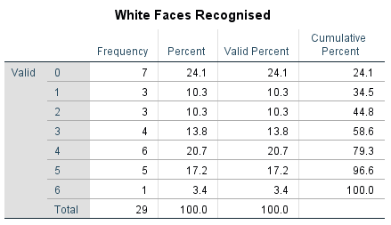
Results

Figure 1

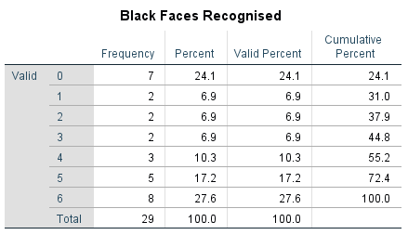

Figure 2

Figure 1 is a table gives a breakdown of the frequency of each individual score for recognition of white faces. Figure 2 is a table that gives a breakdown of the frequency of each individual score for recognition of black faces. Both tables show each individual number of faces recognised. The participants mean recognition scored lower on recalling white faces (M = 2.67, SD = 1.97), and scored higher (M = 3.34m SD = 2.42) on recalling black faces. The t-score for the experiment is t (21) = 3.12, P <0.5 (Appendix 1). The experiments null hypothesis can be rejected based on these statistics.

Discussion

The findings of the study do not support the own-race bias hypothesis that people recognise faces of their own skin colour more than they do another race. In a study with all white participants, the statistics show that more black faces were recognised than white faces. To further this, (Figure 1) shows that only one person (3.4%) was able to correctly identify all 6 correct white faces compared to the 8 people (27.6%) who recognised all 6 of the black faces. The percentage of participants who didn’t recall any correct faces was the same for both white and black faces (7, or 24.1%). More participants recalled average or middling totals (1,2,3,4) for white faces than black faces, as seen in both Figure 1 & Figure 2, however there is a higher frequency of high recognition totals (5 or 6) for black faces. Overall the mean correct recognition showed that more black faces were recognised than white faces. This counteracts the original hypothesis and can be explained by many theories.
The study did have limitations however, one important limitation being that all participants identified as the same ethnic group, white. Any future study with the implement of delving into the own-race bias theory should include participants of multiple ethnicities to garner stronger results and to gauge if race is a factor or can affect recognition. Would black people gravitate towards recognizing faces of their own skin colour like the hypothesized? An increased presence of black participants would potentially give an insight into that. Also, only 29 participants took part in the experiment, a small number in comparison with the wider population. A larger sample of participants would yield stronger results. Also, the small participant sample allows the potential for non-generalization. The group setting may also have affected how participants recalled the faces. All participants were sat together at tables where there was the potential to check their response sheet against someone else’s. The group setting may also have influenced concentration levels, in turn effecting the ability to recall faces. Perhaps in a similar future study it may be more effective to perform the experiment in a one to one individual setting. In part one of the experiment, the twelve initial faces were shown on individual slides with large images that filled each slide. In part two, the faces were presented across 6 slides with 6 images per slide, however the images were smaller than in part one. The smaller image size alongside the demand to examine 6 different faces (including new ones introduced on the slide) may hinder the ability to recall faces more so than if the faces were on individual slides exactly like in part one. Finally, the experiment debrief was delivered as a group and presented on screen, in a future study it may be recommended to use individual debrief forms to make sure all participants can equally examine and access the debrief information.

Social justice movements in the 21st century such as Black Lives Matter have given an increased spotlight on the discrimination and passing-racism black people experience today. Studies in the current social climate have suggested that being viewed as racist is a socially unattractive attribute and people will react accordingly to distance themselves from being viewed as one (Srivastava, 2005). Some participants may have deliberately concentrated more on remembering the black faces as to not appear “racist”.
To conclude, the results of this study go against the original hypothesis, more black faces were correctly recognized than white faces, and this in turn reflects the changing attitudes towards race in the 21st century. Race is very much at the forefront of social and political movements, and society is becoming increasingly aware of the often-casual discrimination or maltreatment of black people. A survey in the US in 2017 (Cohen et al.) showed all ethnicities (white, black, Latin or Asian) agreed that racism was one of the top 3 issues facing the country. A link can be made between the higher frequency of black faces recalled, and the increased spotlight on racial issues in society.

References

Cohen, C., Fowler, M., Medenica, V. and Rogowski, J. (2018). The “Woke” Generation? Millennial Attitudes on Race in the US. GenForward, 7. Retrieved from: https://genforwardsurvey.com/assets/uploads/2017/10/GenForward-Oct-2017- Final-Report.pdf [Accessed 15 Mar. 2018].
Malpass, R., & Kravitz, J. (1969). Recognition for faces of own and other race. Journal Of Personality And Social Psychology, 13(4), 330-334. http://dx.doi.org/10.1037/h0028434
Srivastava, S. (2005). "You're calling me a racist?" The Moral and Emotional Regulation of Antiracism and Feminism. Signs: Journal of Women in Culture & Society, 31(1), 29-62.
Wright, D., Boyd, C., & Tredoux, C. (2003). Inter-racial contact and the own-race bias for face recognition in South Africa and England. Applied Cognitive Psychology, 17(3), 365-373. http://dx.doi.org/10.1002/acp.898

Appendices

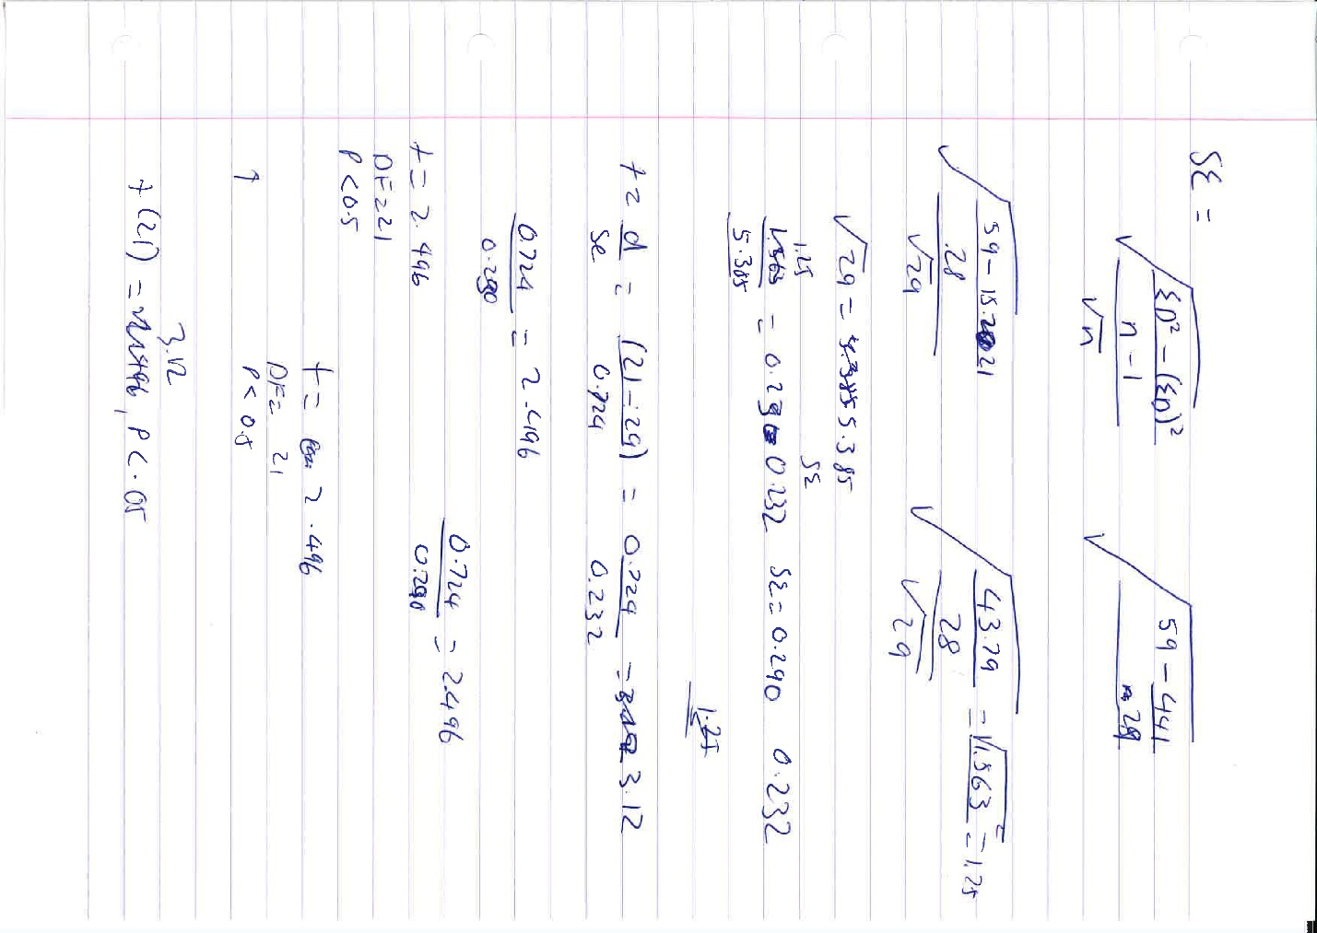
Appendix 1

