Blue, Green and Grey Infrastructure: what’s the difference – and where do they overlap?
2 Sep 2011
Written By: Prof. Robert Andoh Chief Technology Officer, Hydro International
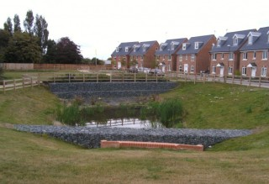
Proprietary Systems: The Confluence between Green and Grey Infrastructure in Integrated Urban Water Management
All over the world there is an increasing recognition that stormwater runoff and other wet-weather induced flows from urban catchments (eg. combined sewage overflows) are major sources of pollution into receiving watercourses resulting in water quality impairments and related adverse impacts on the ecology of streams and local receiving water bodies. These flow sources are also the primary cause of flooding and erosion.
For many years now, I have been based in the USA and research conducted in my adopted country has clearly highlighted that sediment laden stormwater runoff is the foremost cause of water quality impairments and that priority pollutants of concern such as nutrients and heavy metals tend to be associated with the finer sediment fractions.
In the US, It is the Clean Water Act that is directing progress towards achieving the desired good ecological status and those aspirations are just as passionately followed in member states of the European Union, via the EU Water Framework Directive.
Quality
In each case there’s an accepted need to improve the quality of wet-weather induced discharges from urban catchments, particularly from stormwater discharges, “Combined Sewage Outfalls and other “hot spots” such as industrial estates, garage forecourts, motorway services, recycling yards and heavily trafficked roads. The challenges of controlling and treating wet-weather induced discharges from highly urbanised catchments are not due to a lack of treatment techniques or methodologies; as a wide range of processes for water treatment are available to address the technical challenges of treating wet-weather flows to remove the pollutants of concern prior to their discharge into the environment.
Grey, Green and Blue
These techniques range from what we might call Grey Infrastructure: conventional piped drainage and water treatment systems (ie. pipes, tanks, conventional treatment systems including energy-intensive water treatment systems and processes such as membranes and reverse osmosis);
Blue Infrastructure: the use of proprietary small footprint high-efficiency devices installed and retrofitted within existing collection systems; and
Green Infrastructure: the emerging trend for systems such as Bio-filtration, ponds, wetlands, rain gardens and other natural land and plant based ecological treatment systems and processes. “Green Infrastructure” is typically seen as being synonymous with LID (Low Impact Development) (as it is widely known in the US); SUDS (Sustainable Drainage Systems); and WSUDS (Water Sensitive Urban Design).
The real challenge however, particularly in the highly urbanised catchments, is that space is usually at a premium. So though “Green Infrastructure” is attractive and the direction to go in terms of more sustainable approaches; in the urban retrofit scene, the space requirements for “Green Infrastructure” are such that they are often not feasible solutions on their own.
The Space Issue
Space constraints, particularly in the ultra-urban catchment setting, are now resulting in a re-evaluation of traditional LID and SUDS practices with an increasing recognition of the role that proprietary systems can (and have to) play in integrated urban water management. This is because of an identified need for compact (ie. small footprint), high efficiency, robust and low maintenance controls and treatment systems that can be used as part of a tool kit of integrated solutions to address the challenges of urban diffuse pollution and flooding from CSOs, Sanitary Sewer Overflows (SSOs) and stormwater runoff; in particular systems and devices that can be retrofitted into the existing urban drainage infrastructure and can also be deployed in conjunction with both Green and Grey Infrastructure to make the best of both.
This need for compact, high efficiency and low maintenance systems has long been recognised and as a result, a range of novel advanced proprietary systems based on non-conventional technologies have evolved to address these challenges. These technologies are generally characterised by being more compact and more efficient than their conventional technology surrogates. They are particularly well suited to retrofitting into existing “Grey Infrastructure” systems and are also effective in combination with “Green Infrastructure” either as pre-treatment systems to improve their efficacy and facilitate maintenance or provide space efficient treatment trains.
In future blogs I will describe case examples of the use of innovative proprietary systems here termed “Blue Infrastructure”, at the confluence of “Grey” and “Green” Infrastructure, to provide cost effective solutions to problems of flooding and pollution in a number of urban catchments; with typical cost savings of the order of 50%, being realised. In this respect the US experience offers a number of interesting examples.
One example of “Blue Infrastructure” is a novel stormwater filtration technology that was initially developed through the Small Business Innovative Research program of the US Environmental Protection Agency (EPA) by researchers at The University of Alabama under the leadership of Dr. Robert Pitt with Richard Field of the US EPA as the project officer. The system has subsequently been commercialised as a modular proprietary stormwater treatment system that is being put to work particularly in New Zealand and the USA, as an easy to maintain, cost-effective high-rate stormwater treatment system.
Upflow
The system is an advanced, novel, passive, high capacity, upflow filtration device that incorporates multiple elements of a treatment train (screening, sedimentation and high-rate filtration) in a compact modular device. Flow in an upward direction counters gravitational forces to fluidise the media allowing the entire depth of the media bed to be utilised; resulting in greatly extended filter run times. These filters have been shown to be more efficient on a unit-area basis than traditional down flow or radial flow filters; offering a smaller footprint because of their higher flow-through capacity.
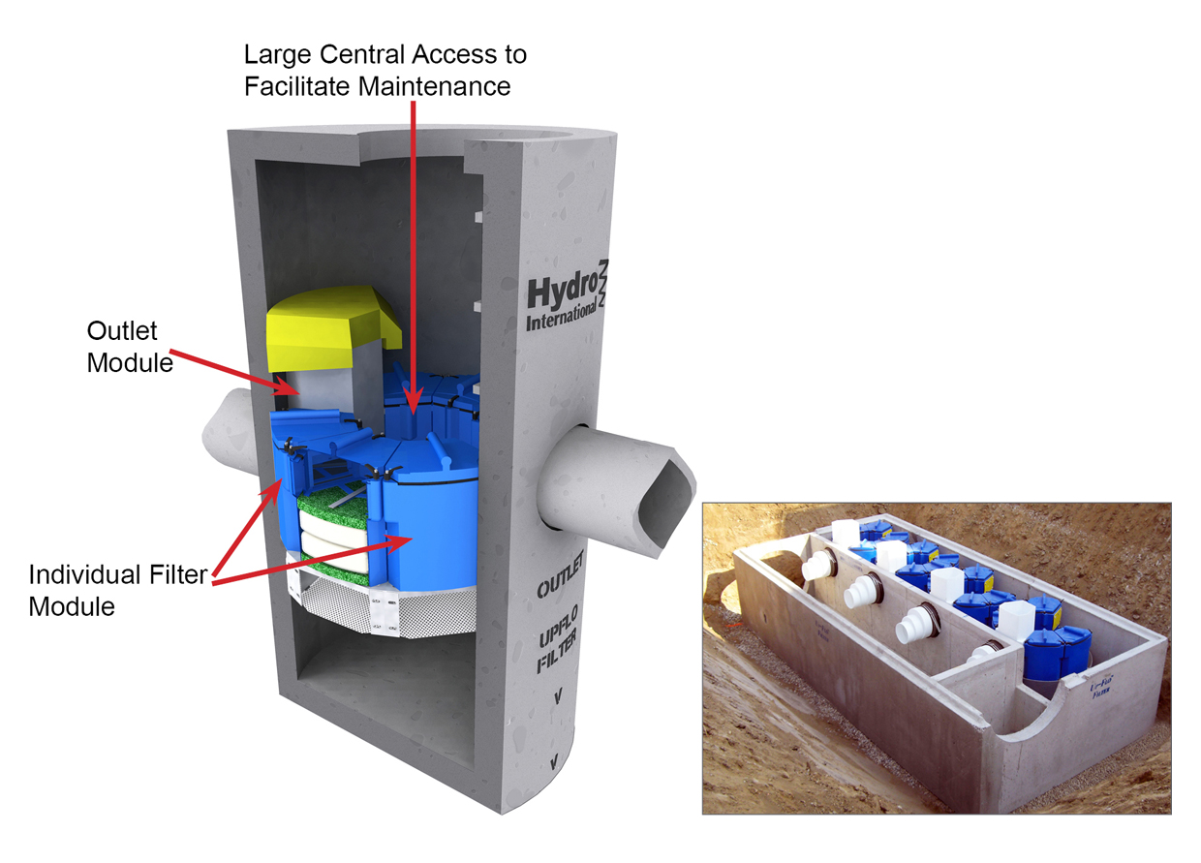
Up-Flo™ Stormwater Filter

Proprietary systems and Blue Infrastructure provide a way to facilitate the maximum use of existing infrastructure and are proving to be a “middle way solution” and an effective “bridge” between the traditional “Grey Infrastructure” and the Emerging “Green Infrastructure”. They are an essential part of the comprehensive “toolbox” of appropriate solution sets that can be tailored to suit site specific requirements in integrated urban water management. These facilitate and provide a means of addressing the adverse impacts of urbanisation in a space and cost efficient manner, whilst providing a means of maximising the existing urban infrastructure.
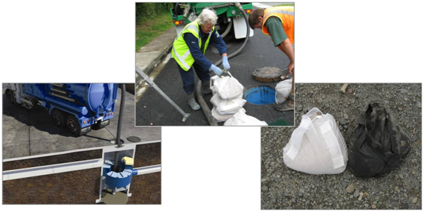
Up-Flo™ Filter Maintenance - Cleaning out the Sump and Changing Filter Media

Green vs. Gray Infrastructure: When Nature Is Better than Concrete
by  John Talberth and Craig Hanson - June 19, 2012

World Resources Institute

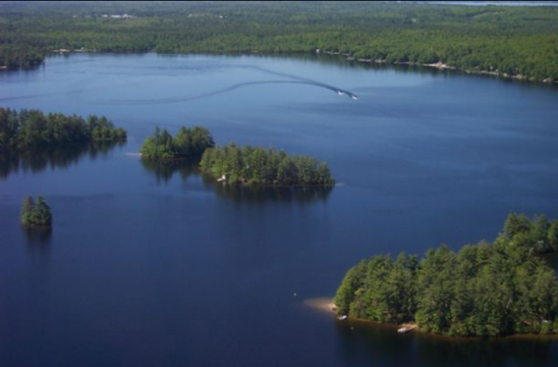
The Sebago Lake watershed provides water to Portland, Maine. Photo credit: Western Foothills Land Trust
Infrastructure is essential for economic growth. But as governments debate the future of sustainable development at theRio+20 conference, there is one infrastructure solution that can provide a good return on investment: nature.
People often don’t think of forests, wetlands, coral reefs, and other natural ecosystems as forms of infrastructure. But they are. Forests, for instance, can prevent silt and pollutants from entering streams that supply freshwater to downstream cities and businesses. They can act as natural water filtration plants. As such, they are a form of “green infrastructure” that can serve the same function as “gray infrastructure,” the human-engineered solutions that often involve concrete and steel. This example is not alone (see Table 1).
Examples of public and private investments in green infrastructure already exist. For instance, Bogotá, Columbia is pursuing upstream landscape conservation and restoration as an alternative to more conventional water treatment technologies.Ho Chi Minh City restored mangroves instead of building dikes in order to protect shorelines from storm damage. And a chemical facility in Texas built a wetland instead of using deep well injection to treat wastewater.

Costs of Green vs. Gray Infrastructure
What should be of particular interest to finance ministers, CFOs, and conservationists alike is that, in many instances, investments in green infrastructure can be much less expensive than those in gray infrastructure. For instance, New York City evaluated two schemes to manage its stormwater flows. One was a green infrastructure plan that emphasized stream buffer restoration, green roofs, and bio-swales , landscape elements designed to remove silt and pollution from surface runoff water. The other was a gray infrastructure plan involving tunnels and storm drains. The green infrastructure option presented a cost savings of more than $1.5 billion. Decision-makers in Idaho and North Carolina found similar cost savings through green infrastructure (see Figure 1).
If green infrastructure can provide comparable benefits to gray infrastructure at reduced costs, then the financial case can be made for investing in the conservation, sustainable management, and/or restoration of natural ecosystems to achieve development goals.

Analyzing Green Infrastructure’s Costs and Benefits
To help make this financial case, we need a method for evaluating green and gray costs in a manner that compares apples-to-apples and focuses on incurred expenses. Working with a number of partners, WRI developed such a “Green-Gray Analysis” approach and applied it in the Sebago Lake watershed, which provides water to Portland, Maine (check out our issue brief, Insights from the Field: Forests for Water).

WRI's issue brief, Insights from the Field: Forests and Water
The Portland Water District (PWD) currently qualifies for filtration avoidance under the U.S. Environmental Protection Agency (EPA) 1989 Surface Water Treatment Rule. This rule waives public water systems from needing to install water filtration systems so long as beneficial land use practices keep concentrations of particulates and contaminants at or below regulatory baselines. However, recent upstream development, forest clearing, and population growth may jeopardize the filtration waiver, potentially forcing PWD to install a conventional membrane filtration system--an expensive proposition.
Amidst this context, WRI and partners recently explored the economics of conventional gray infrastructure versus green infrastructure alternatives that would help retain water quality and avoid loss of the waiver. These alternatives included riparian buffers, reforestation, conservation easements, sustainability certification of future timber harvests, and upgrades to culverts or drainage pipes. Costs associated with the green infrastructure options were determined through on-site consultations, publicly available data, and geospatial analysis. We found that investing in green infrastructure options could represent a cost savings of up to 67 percent over constructing a new filtration plant (Figure 2). And that analysis was conservative. We only looked at costs to achieve one particular clean water benefit—meeting the EPA rule. We didn’t estimate the ancillary benefits of green infrastructure options, such as certified timber revenue, increased carbon sequestration, hunting and recreation opportunities, and increased property values due to conserved aesthetics. If we had done so, the net economic benefits of the green infrastructure option would have been even higher.
Uncertainty over green infrastructure effectiveness, costs, discount rates, and financing terms will impact the relative financials between green and gray for any specific project. Green won’t always be more cost-effective than gray. Nevertheless, the Portland analysis demonstrates the usefulness of a general methodology to assess cost comparisons.

Green Infrastructure and Sustainable Development
The lesson here is that instead of automatically defaulting to dikes and pipes to control flooding, we first should look at restoring wetlands. Rather than building sea walls, we need to think about conserving sand dunes and coral reefs. And before building more water filtration systems, we could first consider rehabilitating upstream watersheds. Although green infrastructure may not always be the most cost-effective approach, with a robust methodology in hand, planners can compare green to gray and identify new opportunities for investing in nature.
As planners—especially those at Rio+20— look to meet infrastructure demands of the 21st century, the lesson is clear: Think about green before investing in gray.

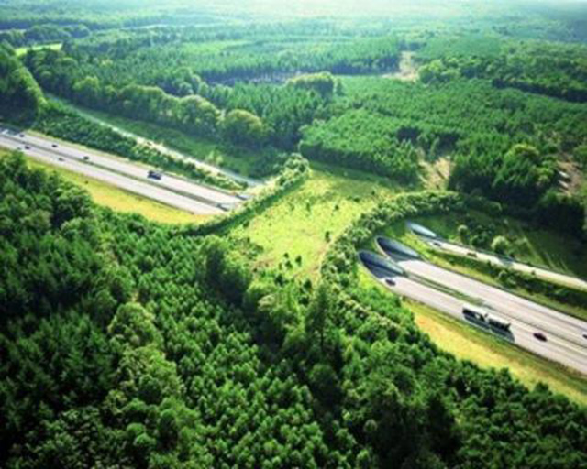
Green bridges


