From monument to meaning:
A detailed analysis of Jones’ family grave,
St. Peters Church, Lampeter.

Abstract:
This report highlights aspects of the Jones family grave by the symbolism of the roses intertwined with ivy and will show the love and united family unit. The inscription shows significance as well as the cross used to represent the family. Also, facing West proves relevance to this family.

Key words:
St. Peters Church, Lampeter. Grave of Jones family. Coachbuilder. West facing. Hebrew inscription. Symbolism of love and family.

Introduction:
This report will be exploring the iconography and the importance of it as well as the inscription, the cross itself and the reasoning behind it facing West. The focus is on a specific family grave that belongs to the Jones family in St. Peters Church, Lampeter. The grave has a simple Latin Cross with a three stepped base (Mytum, 2000). This particular grave, is on the West side of the Church against the boundary of the grave yard, down from an elm tree, facing West with an inscription on the East side on the bottom step of the stepped base. This particular style of gravestone provides space for all eight family members to be commemorated together and houses an iconography of roses bound with ivy. Four of these members are young girls who all died before the age of three. This grave has been chosen due to it facing West, the inscription and symbolism which may explain why it faces West. Mytum explores why symbolisms are so significant on gravestones and can provide reasoning as to why the particular flowers and plant of roses and ivy have been used and what the family are trying to represent in death.

Methodology:
One West facing grave was selected to examine the significance of iconography and what it can tell us. Alongside the iconography, this grave faces West towards Ffynonbedr estate in Lampeter. The fact it faces West is the original rationale behind this particular grave. In company with the iconography and West facing is the inscription on the East side; ‘For here we have not a lasting city, but we seek one that is to come’ which is an inscription from Hebrew chapter 13 verse 14. The grave consists of Jones family. Their date of deaths ranges from 1864-1971. The Jones family have a three stepped base. Around the stepped base are the names off all eight family members laid to rest in this spot.
Figure one is the side facing West and shows three, full bloom roses intertwined with ivy all bound together with what looks like a material. Each direction of the cross holds a rose and a number of ivy leaves. The binding is confined to the length of the cross. The iconography on this gravestone is another reason it was picked for the report. Figure two is the inscription below figure one and houses the ‘head of the family’, Thomas Jones. His occupation as a coachbuilder of Lampeter is stated as well as his exact date of death and age at death. On the second step is his wife, Elizabeth’s, details. Similar to Thomas, her exact date of death along with her age at death is stated. Due to it being so close to the boundary of the graveyard, it is not possible to get a head on picture. Figure three and five show the deaths of Thomas and Elizabeth’s four daughters. These two pictures face North and South respectively. Their age range at death ranges from seven months to two years but spans over a twenty-year period. Figure four exhibits the information of their only surviving child, D.J. Idris and his wife Eleanor. Going on the years of death, it is able to be determined their son was their fourth out of five born children and unfortunately, only had seven months with his younger sibling before she sadly died. He never knew his three older sisters. Eleanor is the last name to be added to the monument. From looking at the monument it is unclear if D. J. Idris and Eleanor had any children themselves. The final figure, figure seven, shows the inscription. As it is on the lowest step it is sadly degraded more than the names. With a torch, the full inscription can just about be read.
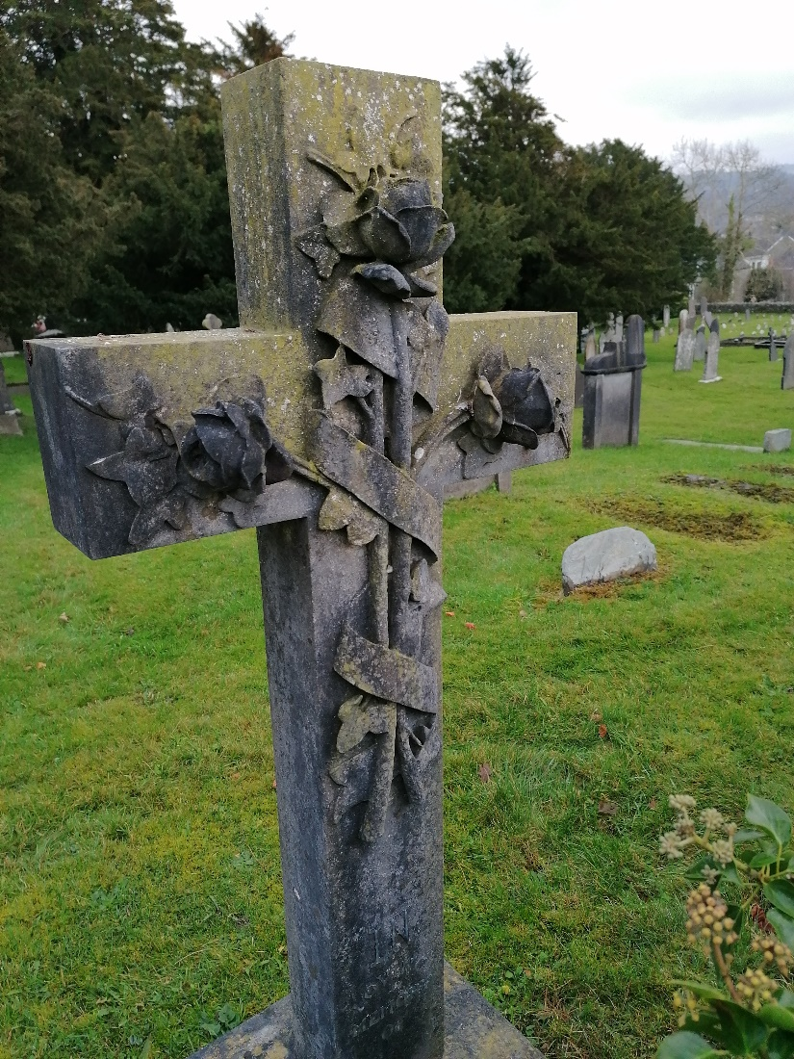Fig1.
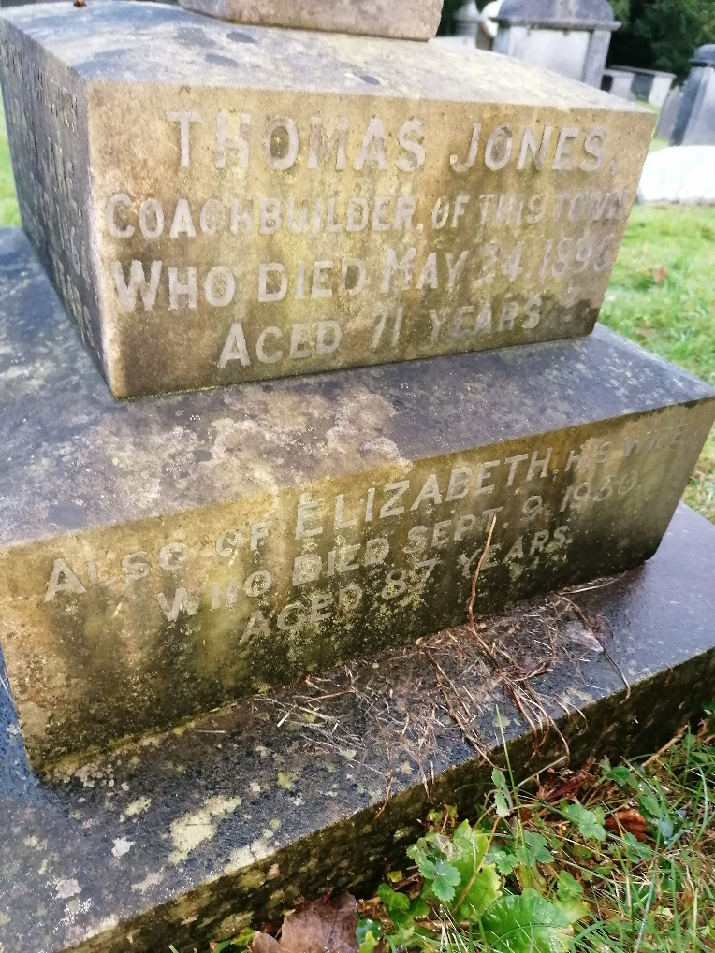Fig 2.
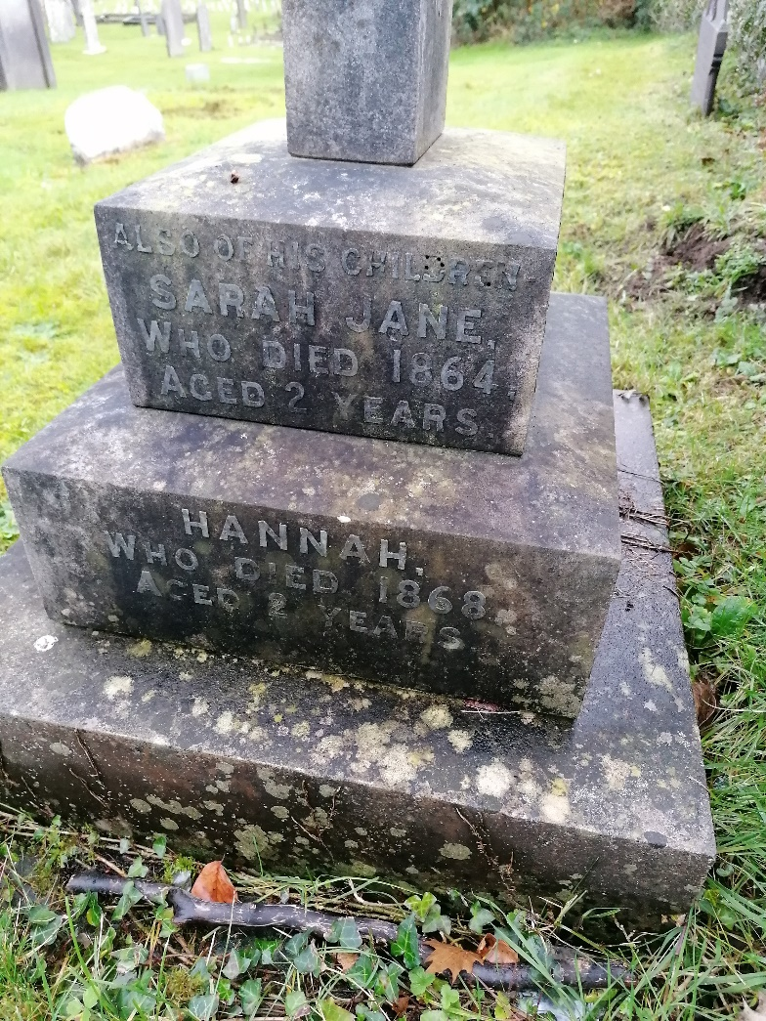Fig 3.
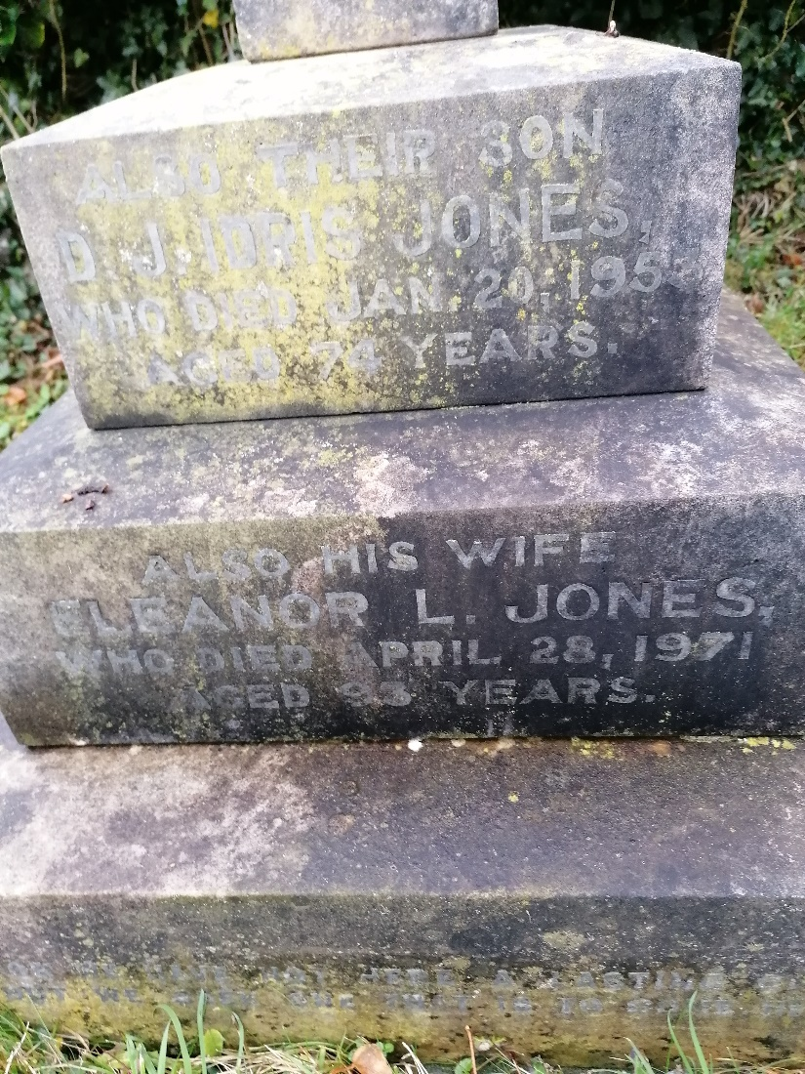Fig 4.
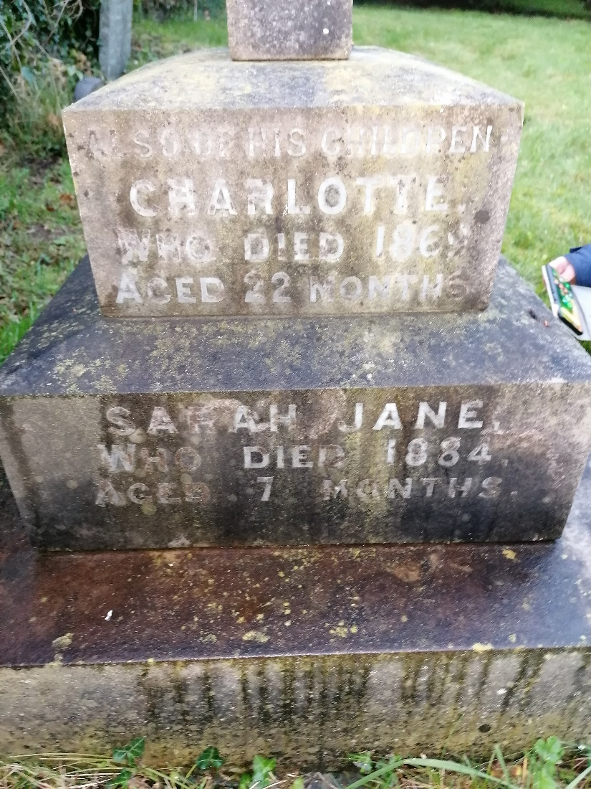Fig 5.
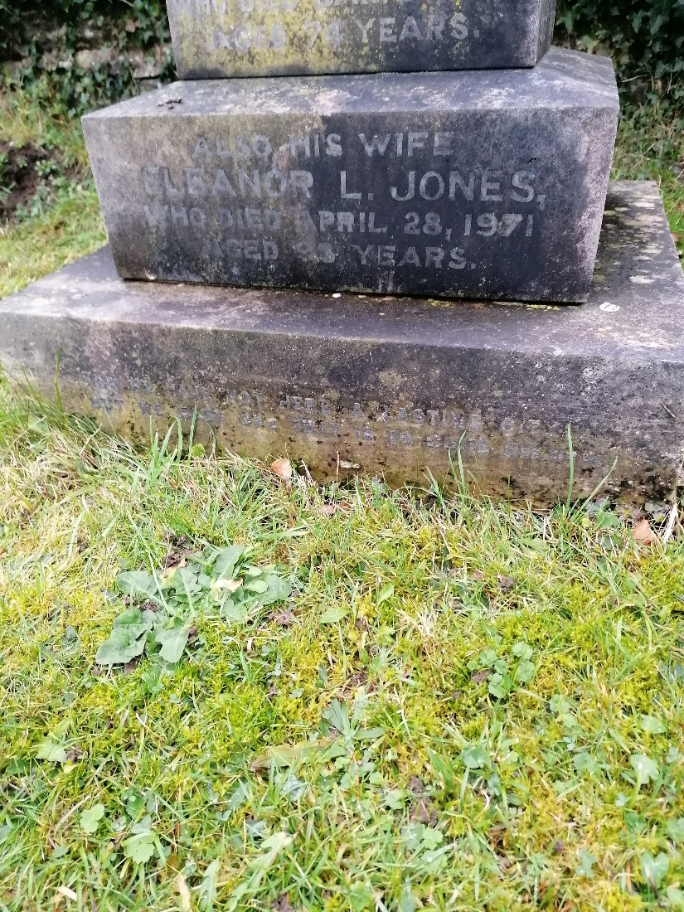Fig 6.

Discussion:
According to Mytum 2000, the gravestone used for this family, a simple Latin cross, is the most common and grew in popularity in the late 19th to early 20th century. Stone, metal and wooden crosses were all used worldwide in the 19th century, but stone was in the minority (Mytum 2004). Unsurprisingly, the wooden crosses cost less than a stone or metal cross. A popular style, especially in Britain, to add to the cross is a stepped base, but it could still be kept relatively small if desired. This cross also resembled the Christian religion and recalls the crucifixion of Jesus Christ. The sign of the cross may be an act of profession of faith (britannica 2020). The family members details are all placed on the top two steps.
The 19th century saw a vast change in iconography on headstones. The Victorian era saw flowers become one of the most common ways of expressing symbolic meanings to the deceased. The placement of flowers was often more complex than their visual appeal to mourners or visitors. They could be placed on the central panel, spread across the top of a headstone or extend throughout the text as well (Mytum 2004). When the gravestone was erected, the flowers would have held very significance importance, although now it would be difficult to know what and to whom (Hobbs 2002, Mytum 2004). Flowers could often shed light on the deceased life including their occupation, age and beliefs. Even the stage of a flower's growth holds individual meanings. For example, a bud often symbolised the death of a child, an unfulfilled life, whereas a flower in full bloom could symbolise having led a full, long life into older years (headstonesymbols 2020).
Roses symbolise love and purity and the colour would also hold significance. Unfortunately, the lack of colour limits the reasoning one can take from this particular gravestone. The number of roses is also relevant. One rose symbolizes love, two joined together signifies the strong bond of a couple while a wreath of roses represents beauty and virtue (trace.com 2014).
During the Victorian era, ivy symbolised friendship and memory. Also, as an evergreen, everlasting plant, ivy represents immortality and the eternal soul (headstonesymbols 2020). Ivy is used to convey the undying affection and faithfulness (nearsay.com 2020).
The reason behind a grave facing West varies greatly. It is common for Jewish graves to face West in preparation for resurrection. It can also be done for other religious reasons; Christians, Jewish and Muslims face West to rise facing Jerusalem or Mecca. The reasoning may be simpler and could be done for personal preference or space in the graveyard. Another reason to mention is the headstone may face West, but the body may face East as to not be stood on by visitors. Some graveyards also alternate facing East and West to provide privacy for mourners (joincake 2020). Another cause to consider is what was on the West side of the graveyard when the gravestone was erected as this may have had reference to which direction it faced.
The inscription is from the Bible. More specifically the New Testament from Hebrew chapter 13 verse 14. There are many variations of this particular inscription. This exact inscription is from the Douay-Rheims Catholic Bible and is a translation of the Bible from the Latin Vulgate into English (biblestudytools 2020). This variation of the inscription provides practical instructions for the Christian believer (bibleref 2020).
As the occupation of Thomas is on the gravestone, it is plausible to assume that it held relevance to him and the community. With the arrival of the railway in Lampeter in 1866 (Coflein 2020), it is likely Thomas being a coachbuilder was a very lucrative job and therefore he could be classed as middle class and be able to afford stone for his family grave. As the four young girls died first, it is unlikely Thomas and his wife knew how many children they would have and would survive, therefore it is a plausible explanation that the headstone was erected after the death of the girls and possibly at the time Thomas himself died. Although rose buds were often used to symbolize the death of children but not used for this family, the use of the rose is still poignant. There are three roses in full bloom on the gravestone so could be taken as one rose for each adult within the family. Without the colour of the roses, the real meaning is hard to determine. The presence of the ivy could signify the memories of the girls. No longer present, but not forgotten. Taking into consideration the binding of the roses and ivy it could be evidence of the family uniting in death and the adults protecting the children taken too soon. When buying flowers, they are often held together with ribbon, therefore it is possible the binding shown here is ribbon. From the inscription and the fact the grave faces West it is extremely plausible to suppose this family was Christian and took their religion quite serious. Although the inscription came from a Catholic Bible and West facing is common for Christian it is plausible the family were Christian as Catholicism is the largest domination of Christianity (diffen 2020).

Conclusion:
The roses and ivy strongly signify love and family, and this could have been strengthened if the reasoning for the binding was able to be determined. The style of cross, the facing and the inscription all points towards a religious family who showed unity, even in death.

Word count 1638.

Reference list:
https://www.biblestudytools.com/rhe/hebrew/13.html
Last accessed on 04/12/2020.
https://www.britannica.com/topic/cross-religious-symbol
Last accessed on 06/12/2020.
Coflein 2020. https://coflein.gov.uk/en/site/41360/details/lampeter-railway-station-lampeter
Last accessed on 06/12/2020.
https://www.diffen.com/difference/Catholicism_vs_Christianity#:~:text=Catholicism%20is%20the%20largest%20denomination,another%20branch%20of%20the%20religion
Last accessed on 06/12/2020.
https://headstonesymbols.co.uk/headstone-meanings-and-symbols/flowers/
Last accessed on 06/12/2020.
https://joincake.com/blog/why-do-graves-face-east/
Last accessed on 03/12/2020.
Mytum, Harold. Recording and analysing graveyards. (Council for British Archaeology, York, 2000).
Mytum, Harold. Mortuary Monuments and Burial Grounds of the Historic Period. (University of York, York, 2004).
https://nearsay.com/c/470923/67943/understanding-the-meanings-of-flower-symbols-on-headstones
Last accessed on 06/12/2020.
https://www.trace.com/genealogists/2015/04/flower-symbols-and-thier-meanings-on/
Last accessed on 06/12/2020.

