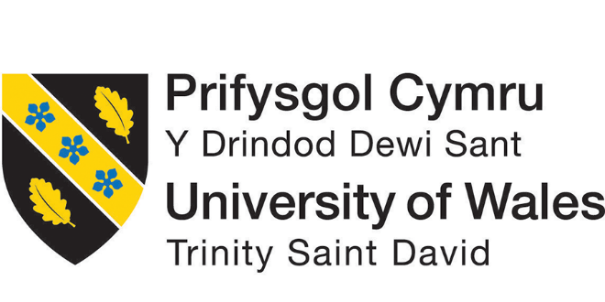

Module Title: Global Business Environment
Assessment 1

Name student: ANA BAICU
Student Number: 2012401
Module lecturer’s name: HOSSEIN SHOKRI
Module code: LCBB4005

Table of Contents

Introduction 1
Part A) The impact of the pandemic and the major forces having shaped the business environment of the fashion industry. 2
PESTLE Analysis – Major forces shaping the business environment of the fashion industry. 2
Part B) Opportunities and challenges of the crucial players of the fashion industry and how some brands have coped up in the context of COVID-19 5
SWOT Analysis 5
Porter’ Five Forces Analysis 8
Conclusion 10
References 11

Table of Figures
Figure 1::Estimated effect of the pandemic on global fashion industry sales 3
Figure 2: Cancelled and delayed orders of the UK fashion brand due to the pandemic. 3
Figure 3: Estimated evolution of COVID-19 and fashion impact 4
Figure 4: Impact of COVID-19 on the UK fashion industry 7

Introduction
The global business environment revolves around the discussion and contemporary exploration of the related and relevant forces impacting a specific business context. The module on the global business environment reflects upon an in-depth study on the impact of the coronavirus pandemic which has drastically reshaped the fashion industry along with the opportunities and challenges brought upon as a consequence of the pandemic. Furthermore, the assignment entails the befitting adaptation of those particular firms which have been able to survive during this pandemic. The business environment of the fashion industry detailing through the eye of the UK’s leading high street fashion brand, Primark within the context of the COVID-19 pandemic is the paramount impression of the report.

Part A) The impact of the pandemic and the major forces having shaped the business environment of the fashion industry.
Primark, an Irish-originated retailer providing luxurious apparel and fashion accessories, is one of the leading fashion brands around the world. Several fashion retailers had to cancel or postpone most of the orders with the surfacing of the pandemic at the end of 2019 and this has followed to the laying off the jobs of garment workers by the suppliers to mitigate their loss. Furthermore, the outbreak of the pandemic has led to the closure of the high street outlets and stores of fashion retailers all over Europe and the UK.

PESTLE Analysis – Major forces shaping the business environment of the fashion industry.
The survival of the apparel retailers would be difficult; however, the revenue of Primark increased by 4.2% to £7.8 billion on 14 September 2019, before the coronavirus dived in by the end of 2019 (BBC News, 2021). With the temporary closure of the high street outlets, Primark has to hold back its quarterly rental payments and call off the fresh orders from the suppliers. The UK government is allowing online retail as long as the responsible retailers maintain staff safety at its optimal point and therefore, online trading among the retailers has become the last resort. Following are the major forces that have shaped the macro business environment of the fashion industry:
Political Factors: Geopolitical decisions like Brexit have an essential impact on the retail industry. Primark operates its supply chain management distinctively in the UK and Europe despite the fact of making trade deals with the EU. Furthermore, the UK fashion industry might have to expend an additional £1 billion each year when the trade relations of the UK with the EU come to an end. Furthermore, the lockdown arisen due to covid-19 and subsequent challenges is likely to impact adversely on the sales of the global fashion industry, which might eventually manipulate the trends to be existing in the fashion industry.
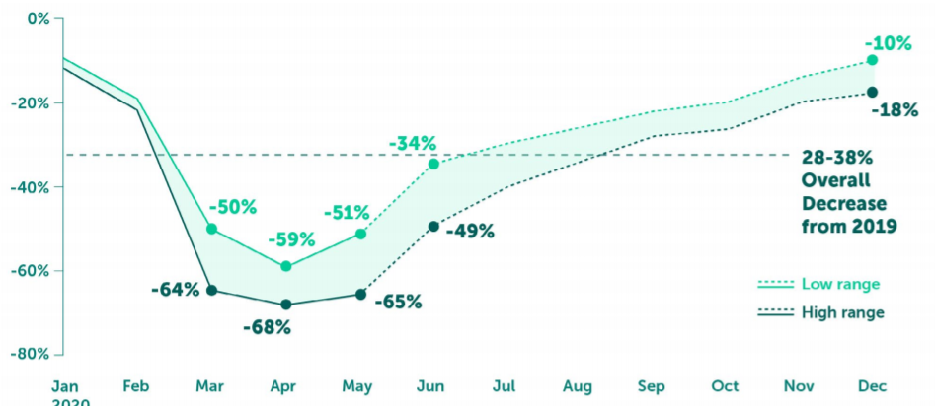
Figure 1::Estimated effect of the pandemic on global fashion industry sales
Source: (BBC News, 2021).
Economic Factors: Non-essential retailers like Primark having no online trading service, suffered the most during the coronavirus lockdown in 2020 and had to close down their 375 stores after March 22. Consequently, the revenues of the retailer dropped by 75% causing £800 million by the second quarter of 2020 (Comunian and England, 2020). The following plot reflects the cancellation of the orders worth $273 million made by Primark which is the highest among the top apparel retailers in the world.
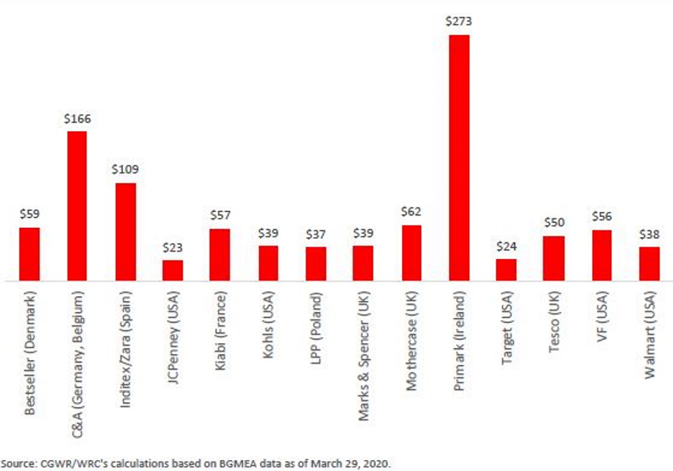
Figure 2: Cancelled and delayed orders of the UK fashion brand due to the pandemic.
Source: (The Guardian, 2021)
Sales started to rebound once physical stores were reopening by mid-July and Primark introduced new high street outlets in the UK since the shoppers spent considerably higher typical basket size than normal times the previous year. However, with the new formation of the coronavirus, lockdown from January 5, 2021, and closure of the non-essential stores only indicate major shock for Primark. The retailer is estimating above £1.8 billion of losses if the lockdown prevails till the end of March and still Primark refuses to opt for online purchase despite the undermining (The Guardian, 2021). Additionally, Primark is about to forfeit around £650 million of monthly net sales as the physical outlets are to be temporarily closed to date.
Social Factors: The retailer’s business model of the low selling price, low revenue but high magnitude remarkably attract those shoppers who can afford its apparel products and accessories at a reasonable price. The popularity of Primark’s low-price model being very acknowledged by shoppers that with the reopening of the high street stores in mid-July last year was able to bounce back its losses made during the lockdown since the average basket size was higher. Furthermore, the retailer’s value market share by the last quarter of 2020 was also simultaneous compared to that of the previous year.
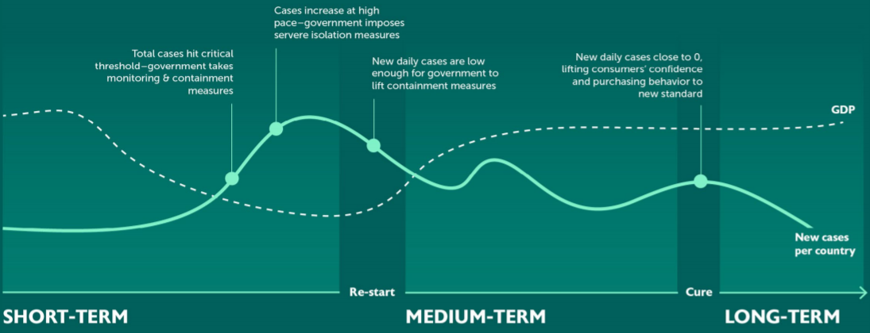
Figure 3: Estimated evolution of COVID-19 and fashion impact
Source: (Brydges, Retamal and Hanlon, 2020).
Technological Factors: Technology has enabled retailers to sell online, more specifically for cash-rich and time-poor shoppers. The online business transactions would necessitate retailers to expend on fixed maintenance costs either revenue is generated or not. Such additional costs are not conducive for retailers like Primark with a low-price model and this is why Primark is still against introducing its online business system. Therefore, technological advancement might procure a dispute of equality in the society.
Legal Factors: Primark would require to bring changes in its international trade agreements aligning with its parent company, Associated British Foods plc (ABF) with the EU registered countries and non-EU member states. Furthermore, the retailer has established an agreement for uplifting working safety in 2013 after the collapse of one of its supplier’s factories in Bangladesh.
Environmental Factors: The fashion industry is presumed to be responsible for 10% of the global greenhouse gas emissions (Brydges, Retamal, and Hanlon, 2020). Furthermore, the unstable weather conditions in the UK accelerated with Primark’s closure of 305 of its 389 global stores is only increasing the retailer’s inventory rather than generating sales or profit.

Part B) Opportunities and challenges of the crucial players of the fashion industry and how some brands have coped up in the context of COVID-19

SWOT Analysis
Strengths: Primark, always pursuing the brick-and-mortar strategy undertakes the low price, low margin intake, and high-volume business model. People with budget-friendly choices have been remarkably opting for retailers like Primark where they can buy from physical high street outlets directly. The demand for Primark is evident when the outlets reopened after the lockdown in mid-July, 2020, it was no longer before the retailer had made extreme sales by the end of September 2020 compared to that of the last year.
Weaknesses: The COVID-19 pandemic has brought lockdown all over the UK with the temporary closure of nonessential retailers. Primark had to close down its 375 high street stores including the global ones after March 22, 2020, the retailer underwent a 75 percent fall in revenues by the end of June 2020 and as a result, the sales were down by 12 percent (Srivastava and Rogers, 2021). On top of it, Primark does not hold any transactional website to operate a business online that further slowed down its path for making sales and revenues in comparison to other retailers with online trading business during the lockdown. However, the transactional website is not usually profitable for retailers like Primark with low price, low margin intake business model as online business constantly requires frequent website maintenance, monitoring, and handling, resulting in additional cost.
Opportunities: Digital outlets of fashion retailers have become the new normal for the UK fashion industry. According to a survey conducted by McKinsey, the purchasing tendency among consumers dropped by 70 to 80 percent in Europe and North America from physical outlets and 30 to 40 percent from an online purchase (Gössling, Scott, and Hall, 2020). The exposure of digital fashion shopping has paved the way for consumers to not wait for a prolonged time in the stores and also not frightened by the gathering of so many customers as shoppers can accumulate their clothes and accessories straight up for a minimum of two years. Furthermore, online sales, online live fashion shows, 3D samples have outpoured amidst the pandemic as an alternative to the brick-and-mortar outlets. Primark is way behind accommodating itself with any transactional website and online trading system to cope up with the new normal circumstance whereas the majority of the market leaders including River Island, Topshop, Zara, Marks & Spencer, and many more are approaching digitalization and its consequent windows of facilities.
Threats: The fashion industry in the UK experienced a 37.4 percent decline in the production of the clothing sector and the retails sales encountered the most startling turn down with a 43.5 percent fall in sales. Furthermore, fashion retailers around the world had to cancel and postpone their orders from their suppliers and delay their due payments to those suppliers as well. Such cancellation from one particular country, Bangladesh has been amounting to $3.18 billion worth of projects and thus led to the cut-off of approximately 4 million garment workers; consequently, brands including Primark are encountered with economic disruption for balancing the supply and demand aspects of the fashion attires and accessories (The Guardian, 2021).
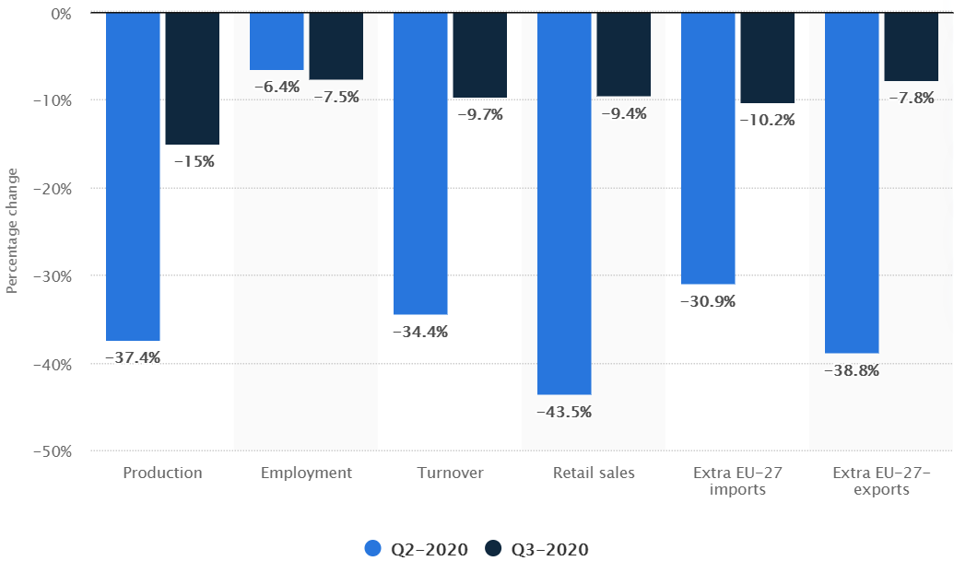
Figure 4: Impact of COVID-19 on the UK fashion industry
Source: (Statista, 2021)
The digitalization of the living fashion industry with no other options amid the pandemic has been embraced by most of the brands in the UK, even by some emerging online based and private labeled brands, designers, and boutiques, therefore redirecting the extensive competitive growth of the industry. While market key players like Marks & Spencer, Zara, John Lewis, and private labeled brands such as Meadows, Castore, Missomaa, and many more online-based designers and boutiques are opting with the online activities; Primark is still lagging in shifting its business model of bricks & mortar strategy and low price-low margin intake; creating major financial unsettling for the brand.

Porter’ Five Forces Analysis
Bargaining power of suppliers: The bargaining power of suppliers is typically low and now due to the covid-19 pandemic, fashion brands like Primark were forced to cancel their orders from the suppliers which consequently resulted in the financial and economic meltdown of these suppliers. Therefore, the bargaining power would remain low since when the situation comes in favour of the fashion brands, they would take orders from the suppliers and the suppliers would certainly want to do business with the firms.
Bargaining power of buyers: The bargaining power of buyers is significantly high since the UK fashion industry is equipped with numerous high street fashion brands, retailers, and boutique shops (Zhao and Simkin, 2011). Furthermore, consumers now have extended access to digital fashion shopping, digital fashion shows, 3D samples along with constantly evolving innovative concepts and ideas which bring multiple options available for the customers where switching cost is low as well.
The threat of new entrants: The threat of new entrants in the fashion industry is considerably low as the fashion industry is piled up with established and world-renowned brands like Marks & Spencer, River Island, Nike Plc, Zara and fashion retailers including Tesco, Asda, Sainsbury, Primark and many more. The covid-19 pandemic has globally slowed down the economic profitability of the fashion industry arising due to consumers' reluctance to purchase, the layoff of the shoppers’ jobs, UK experiencing a 34 percent decline in sales of the fashion industry.
The threat of new substitutes: The threat of substitute products is moderate to high with the rising tendency of online business, digital payment system, and modifications of ideas, designs (Little, 2018). The e-commerce, digital fashion shopping, and online business, though not fully offsetting the sales volume equivalent to sales through physical stores, however, these channels have been adopted by some of the UK fashion brands who have adapted better to the current uncertain circumstance.
Competitive rivalry: The competitive rivalry is significantly high in the context of the UK fashion industry since world-leading fashion brands like Marks & Spencer, John Lewis, Primark are in this industry. Furthermore, with coronavirus pandemic several brands have adopted innovative ideas, business models to cope up with the lockdown and closure of the physical outlets.
For instance, Duer, the denim brand arranged a digital catwalk availing photorealistic furnishes and such an idea was backed by the concept of 3D pop-up displays. Outdoor fashion brand, Regatta has furnished its business with the advent of 3D sampling, automation, virtual fairs to make the sustainable reach to customers so that they can choose their desired products (Cantoni et al., 2020). High street fashion brands, Zara organised private shopping sessions for its privileged customers and further intends to extend its premium service broadly. Furthermore, mergers & acquisitions, collaboration are experienced. British fashion designers Julien Macdonald, Halpern, Mulberry, Liam Hodges collaborated in June 2020 to set in motion non-surgical masks. Moreover, the traditional focus on high-end quality adopted by luxurious boutique Reve En Vert procured vigorous sales in May 2020, during the peak of the spread of the coronavirus, and obtained a competitive advantage over other fashion brands.

Conclusion
The module depicts the combination of the global and UK fashion industry is aligned with the coronavirus outbreak. The business environment of the UK fashion industry is typically volatile and ever since the COVID-19 broke out around the world, the fashion industry has ever come up with renewed vigor, innovative business model, creative ideas, and designs. The module has been procured to portray the current significance of the UK fashion industry moderately focusing on a global perspective simultaneous to the current pandemic. The assignment contains an exhaustive turn of phases of the UK fashion industry focusing on one specific fashion brand, Primark following the concurrent firms’ reshaping of their business phenomenon given the pandemic situation.

References
BBC News. 2021. Coronavirus: Primark sells nothing as retailers struggle. [online] Available at: <https://www.bbc.com/news/business-52365191> [Accessed 11 March 2021].
Brydges, T., Retamal, M. and Hanlon, M., 2020. Will COVID-19 support the transition to a more sustainable fashion industry?. Sustainability: Science, Practice and Policy, 16(1), pp.298-308.
Cantoni, L., Cominelli, F., Kalbaska, N. and Sádaba, T., 2020. Fashion Communication in the Digital Age.
Comunian, R. and England, L., 2020. Creative and cultural work without filters: Covid-19 and exposed precarity in the creative economy. Cultural Trends, 29(2), pp.112-128.
Gössling, S., Scott, D. and Hall, C., 2020. Pandemics, tourism and global change: a rapid assessment of COVID-19. Journal of Sustainable Tourism, 29(1), pp.1-20.
Little, T., 2018. The Future of Fashion: Understanding Sustainability in the Fashion Industry.
Srivastava, M. and Rogers, H., 2021. Managing global supply chain risks: effects of the industry sector. International Journal of Logistics Research and Applications, pp.1-24.
Statista. 2021. Coronavirus impact on the clothing industry in Europe 2020 | Statista. [online] Available at: <https://www.statista.com/statistics/1131181/coronavirus-impact-on-clothing-industry-europe/> [Accessed 11 March 2021].
the Guardian. 2021. Primark loses £800m in Covid-19 lockdowns. [online] Available at: <https://www.theguardian.com/business/2020/jul/02/primark-loses-800m-amid-covid-19-lockdowns> [Accessed 11 March 2021].
Zhao, M. and Simkin, L., 2011. An investigation of brand equity in the UK fashion industry. Oxford: Oxford Brookes University.

