BA (Hons) Business Management

Module: Management Accounting for Managers

Module code: LCBB5010
Student name : Gina Raducan
Student ID : 2232821

Table of Contents

1.Introduction
2.Cost Analysis and Business Model
3.Budgeting and Financial Planning
4.Performance Measurement and Decision-Making
5.Sustainability and Ethical Considerations
6.Conclusion and Recommendations
7.Reference

- Introduction

Leading international company Tesla, Inc. works in the battery storage, renewable energy, and electric vehicle (EV) industries. Tesla, which was founded in 2003 and has its headquarters in Austin, Texas, has developed into one of the most significant businesses influencing the shift to low-carbon transportation (Tesla, 2023). The company offers energy solutions like Powerwall, Powerpack, and Megapack in addition to the Model S, Model 3, Model X, and Model Y. With production sites in China, Germany, and the United States, Tesla employs more than 140,000 people worldwide. In a setting that is so technologically advanced and competitive, management accounting is essential for directing internal decision-making. It gives managers pertinent financial and non-financial data to support budgeting, strategy planning, cost control, and performance assessment (Drury, 2020). For a rapidly expanding firm like Tesla, management accounting tools are essential in ensuring efficient resource allocation, sustaining innovation and maintaining long-term financial stability (Kaplan and Atkinson, 2015).

- Cost Analysis and Business Model

Tesla's unique business strategy combines the production of electric vehicles (EVs), energy generation and storage technologies, and a growing software ecosystem. Sales of EVs, especially the Model 3 and Model Y, which combined account for the highest percentage of global deliveries, are the company's main source of income (Tesla, 2023a). Upgrades to the Full Self-Driving (FSD) software, subscription services, sales of regulatory credit, and energy goods like solar panels and Megapack batteries create additional revenue. With software-based revenue streams providing recurrent and scalable profitability, Tesla is able to generate larger margins than its traditional automotive rivals thanks to the convergence of hardware and software (Harvard Business Review, 2022).
From the standpoint of management accounting, it is essential to comprehend Tesla's cost structure. The company's capital-intensive operations are the primary cause of its high fixed expenses. These include long-term expenditures in research and development (R&D), battery production lines, Gigafactory building, and sophisticated robots (Ibrahim, 2022). In addition to increasing fixed cost intensity, Tesla's strategic commitment to vertical integration—where vital components like batteries and power electronics are produced internally—also promotes long-term cost reductions.
Tesla's variable costs, which include direct labour, transportation, semiconductor components, and raw materials including lithium, nickel, cobalt, and aluminium, vary according to production volume. Tesla's unit costs are directly impacted by fluctuations in the price of commodities globally. As a result, the business uses management accounting methods including variance analysis and cost-volume-profit (CVP) analysis to track changes in material costs and modify production procedures as necessary (Drury, 2020). The use of gigapress technology, which allows massive aluminium castings to replace hundreds of smaller parts, is one of Tesla's most important cost-cutting advances. This lowers labour costs, assembly times, and production complexity (Tesla, 2023a). By contrasting anticipated cost savings with initial capital investment, management accounting aids in the assessment of such efforts.
Additionally, Tesla's business strategy places a strong emphasis on economies of scale, which are attained through mass production and the expansion of factories throughout the world. Fixed costs are dispersed over more units as output rises, gradually increasing operating margins. High production volume and vertical integration provide a competitive cost advantage that helps Tesla achieve its long-term strategic goals (Kaplan and Atkinson, 2015).

- Budgeting and Financial Planning

The company's operational stability and strategic expansion depend heavily on sound financial planning and budgeting. Budgeting is not only a cost-control mechanism but also a forward-looking tool that directs resource allocation, investment decisions, and risk management for a technology-intensive and quickly expanding company like Tesla, Inc. (Drury, 2020). Instead of using rigid annual budgets, Tesla uses rolling projections and flexible budgets, which enable it to adapt to changes in raw material costs, supply chain interruptions, and foreign exchange volatility (Kaplan and Atkinson, 2015).
There have been notable year-over-year variations in Tesla's recent operating expenses. MacroTrends reports that Tesla's yearly operational costs increased to almost US$87.88 billion in 2023, up nearly 29.6% from US$67.81 billion in 2022. Both human choices and external macroeconomic variables are responsible for this sharp rise. Internal research and development (R&D) expenditures for autonomous driving systems powered by artificial intelligence and capacity expansions like new Gigafactories were boosted by Tesla (Tesla, 2023a). In addition to shortages of semiconductors and increased logistics costs, Tesla also had to deal with external inflationary pressures on the price of raw materials, including as nickel, cobalt, and lithium, which raised production costs.
From a management-accounting perspective, Tesla does variance analysis to find discrepancies and put corrective measures in place by comparing actual operational expense results to budget predictions. For example, Tesla's management looks into underlying causes and may reallocate resources or change cost assumptions when R&D or SG&A spend deviates significantly from anticipated amounts (Drury, 2020). Additionally, Tesla models various macroeconomic outcomes using scenario planning, such as a spike in material prices, a downturn in EV demand, or foreign exchange headwinds, and modifies its budgets appropriately.
Additionally, Tesla's significant capital investment decisions are strategically influenced by budgeting. Using methods like cost-volume-profit (CVP) analysis and discounted cash-flow models, Tesla's management evaluates expected cash flows, break-even timescales, and sensitivity to input cost changes when assessing new factory builds or software development programs (Kaplan and Atkinson, 2015). Tesla makes sure that its expansion plans are financially feasible in a variety of market circumstances by combining strategic planning and budgeting.
To sum up, Tesla's budgeting and financial planning function is much more than a cost-control exercise; it is a dynamic decision-support system that enables management accounting to support sustainable growth, anticipates external uncertainties, and aligns operational resources with strategic intent.

- Performance Measurement and Decision-Making
Tesla employs a broad set of financial and non-financial key performance indicators (KPIs) to guide its decision-making and monitor organisational performance. Five important KPIs are:
- Revenue Growth – Tesla reported automotive sales revenue increased by US$11.3 billion (≈17 %) in 2023 compared to 2022.

- Operating Margin / Gross Margin – The automotive gross margin declined from 28.5% in 2022 to 19.4% in 2023, largely due to lower average selling price and product mix.

- Production / Delivery Volume – Tesla delivered over 1.8 million vehicles globally in 2023, a significant year-on-year increase.

4. Customer Satisfaction / Quality Metrics – Non-financial KPI such as reliability, service response times and software update performance feed into Tesla’s strategic decisions (Tesla, 2023).
5. Sustainability Metrics – Including carbon emissions avoided, renewable energy deployed and battery recycling initiatives. Tesla’s 2023 Impact Report highlights increased energy storage deployment and emission avoidance.
Within Tesla's management accounting system, these KPIs guide strategic choices. For instance, investments in additional Gigafactory sites in Germany and Texas were justified by a significant rise in deliveries, allowing Tesla to expand production to satisfy demand. In contrast, management implemented cost-cutting measures and pricing adjustments in response to the dramatic decrease in gross margin in 2023. Tesla lowered vehicle prices to drive demand in a competitive environment, which affected profit but sought to increase volume.
Decision-making is also influenced by customer satisfaction and quality ratings. For example, Tesla boosted its Mobile Service fleet and parts inventories in response to rising dependability complaints and service centre wait times, which decreased downtime and enhanced brand value. Long-term investment decisions are also supported by the company's use of sustainability data. For example, in 2023, the energy generation & storage segment's margin increased from 7.4% to 18.9% due to lower Megapack unit costs and deployment scale, which were based on both cost engineering and the sustainability KPI.
Tesla's management accounting systems incorporate both quantitative and qualitative metrics: dashboards allow senior leadership to examine KPIs in real time, and variance analysis compares actual performance with budgeted targets (Kaplan & Atkinson, 2015). These insights influence financial decisions (capital investment, pricing strategy), strategic decisions (entry into new markets, service network expansion), and operational decisions (e.g., modification of production scheduling). Tesla connects performance measurement with its strategic purpose of sustainable growth and technology leadership through the use of a balanced set of KPIs.

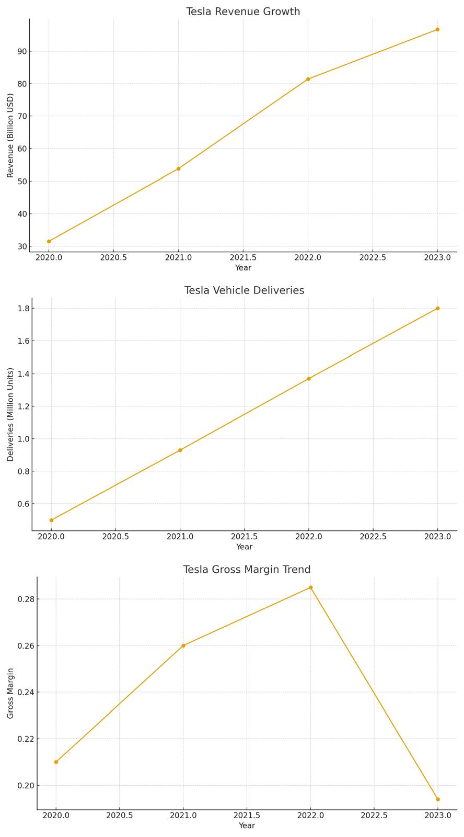
A visual representation of Tesla's recent financial and operational performance is given via the combined KPI dashboard. Between 2020 and 2023, the revenue trend shows significant year-over-year growth, which is indicative of rising demand for electric vehicles worldwide and greater production capacity. Deliveries of vehicles exhibit a similarly sharp upward trend, increasing from roughly 0.5 million units in 2020 to over 1.8 million units in 2023, demonstrating both continuous customer demand and successful capacity scaling at Tesla's Gigafactories. The gross margin trajectory, on the other hand, shows a fall in 2023 after peak margins in 2021–2022, mostly due to competitive challenges, increased input prices, and strategic price reductions. These KPIs indicate that while when taken as a whole.Tesla continues to achieve rapid volume expansion and revenue growth, margin pressures highlight the need for cost optimisation, efficiency gains and a balanced pricing strategy. The dashboard therefore supports management decision-making by identifying both performance strengths and areas requiring strategic attention.

- Sustainability and Ethical Considerations

Tesla's corporate objective is centred on sustainability, and the corporation incorporates environmental factors directly into its financial decision-making procedures. Lifecycle costing, which evaluates not only the short-term financial effects of manufacturing but also the long-term economic and environmental effects of its goods, serves as the foundation for Tesla's long-term investment strategy (Drury, 2020). Capital budgeting decisions are influenced by sustainability objectives, as evidenced by the design of Gigafactories to run on renewable energy and increase energy efficiency. For instance, significant investments in low-carbon manufacturing infrastructure, such as solar-powered facilities and sophisticated battery recycling programs, are highlighted in Tesla's Impact Report (2023b). These programs boost investor confidence and brand reputation while lowering long-term operational costs, minimising carbon emissions, and improving compliance with environmental standards.
Tesla's cost control and pricing methods are heavily influenced by ethical issues. The acquisition of raw materials like lithium, nickel, and cobalt presents a significant ethical dilemma, especially in light of worker rights issues in the mining industry. Tesla has reduced the amount of cobalt used in its batteries, increased supplier oversight, and published more public sustainability disclosures as a result of Amnesty International's (2022) research on persistent hazards in global cobalt supply chains (Tesla, 2023b). The business must carefully weigh the trade-off between adhering to morally responsible procurement policies and lower-cost sourcing possibilities from the standpoint of management accounting.
In terms of pricing tactics, Tesla has aggressively lowered prices in a number of markets during times of intense competition and economic strain. These acts pose ethical questions about market instability, consumer justice, and possible pressure on suppliers, even while they help retain market share and boost demand. Therefore, management must strike a balance between long-term sustainability and stakeholder trust and short-term competitive pricing. Transparency and refraining from actions that raise perceived worth are also necessary for ethical pricing. All things considered, Tesla's strategy shows that ethics and sustainability are integrated into the company's cost structures, investment choices, and strategic pricing policies rather than existing independently of financial decision-making.

- Conclusion and Recommendations
This study has demonstrated the critical role management accounting plays in bolstering Tesla's long-term strategic planning, operational effectiveness, and financial decision-making. The business controls a complicated cost structure that is fuelled by capital-intensive production and erratic raw material prices through thorough cost research. Tesla can react to macroeconomic shifts thanks to budgeting and financial planning, and decisions about pricing, growth, and operational enhancement are influenced by performance evaluation using financial and non-financial KPIs. Although ethical issues with supply-chain sourcing and pricing methods still exist, Tesla's dedication to long-term wealth creation is demonstrated by the incorporation of sustainability into capital investment and cost management.
Recommendations based on management accounting principles include:
1. Enhancing predictive analytics in budgeting to improve forecasting accuracy under volatile market conditions.
2. Strengthening supplier auditing and cost-transparency systems to address ethical risks in raw-material sourcing.
3. Increasing investment in high-margin software and service-based revenue streams, improving long-term profitability and reducing dependence on material-intensive production

- Reference
Amnesty International (2022) Cobalt supply chain ethics report. Available at: https://www.amnesty.org (Accessed: 20 February 2025).
Consumer Reports (2023) Electric vehicle reliability study. Available at: https://www.consumerreports.org (Accessed: 20 February 2025).
Drury, C. (2020) Management and cost accounting. 11th edn. Andover: Cengage Learning.
Google Finance (2024) Tesla Inc. (TSLA) financial data. Available at: https://www.google.com/finance (Accessed: 20 February 2025).
Harvard Business Review (2022) ‘Vertical integration in electric-vehicle manufacturing’, Harvard Business Review. Available at: https://hbr.org (Accessed: 20 February 2025).
Ibrahim, M. (2022) ‘Cost structures in electric vehicle manufacturing’, Journal of Automotive Economics, 18(3), pp. 44–59.
Kaplan, R.S. and Atkinson, A.A. (2015) Advanced management accounting. 3rd edn. Harlow: Pearson.
Macrotrends (2024) Tesla operating expenses 2010–2024. Available at: https://www.macrotrends.net/stocks/charts/TSLA/tesla/operating-expenses (Accessed: 20 February 2025).
Nasdaq (2024) ‘Tesla earnings: 6 key metrics you should see’. Available at: https://www.nasdaq.com (Accessed: 20 February 2025).
OECD (2023) Global inflation outlook report. Paris: Organisation for Economic Co-operation and Development.
SEC (2024) Tesla annual filings (Form 10-K). Available at: https://www.sec.gov/Archives (Accessed: 20 February 2025).
Tesla (2023a) Annual report 2023. Available at: https://ir.tesla.com (Accessed: 20 February 2025).
Tesla (2023b) Impact report 2023. Available at: https://www.tesla.com (Accessed: 20 February 2025).
Yahoo Finance (2024) Tesla Inc. (TSLA) key statistics. Available at: https://finance.yahoo.com (Accessed: 20 February 2025).

