Understanding Employee Engagement

1. Introduction

Effective employee engagement increases performance, results and outcomes, as a result of discretionary effort, with employees going the extra mile to ensure organisational success as part of their everyday practice (Taylor and Woodhams, 2016). Effective engagement improves staff retention, releases creativity and innovation, facilitates the management of change and improves levels of customer service, gaining a competitive advantage (Engage For Success, 2018).
- Findings
2.1 The concept of employee engagement and how it relates to other concepts

Employee engagement can be defined as a “three dimensional concept, which is discretionary” (Bridger, 2018). Khan (1990) identifies the three concepts of employee engagement as physical, cognitive and emotional commitment to an organisation. This is mirrored by the CIPD (2014), who identify employee engagement as “a combination of commitment to the organisation and its values, plus a willingness to help out colleagues”. Employee engagement relies on relationships between an employer and employees (Taylor & Woodhams, 2016), operating on an emotional or transactional level. Transactional engagement is limited and superficial, lacking commitment, whereas emotional engagement provides deeper commitment, having emotional attachment to their role, offering discretionary effort (CIPD, 2012). Discretionary effort cannot be demanded by employers (Engage for Success, 2019). Employee engagement is not contractual, therefore is controlled by the employee (Taylor & Woodhams, 2016).

Organisational commitment, job satisfaction and employer involvement are concepts that relate to employee engagement. Organisational commitment is measured by an employees’ psychological commitment and sense of belonging (Johns & Ellis, 2016). Commitment can be classified as either:

- Affective commitment has emotional commitment, committing out of choice and buying into an organisations vision and objectives, including wanting to provide good customer service to increase the organisations reputation and positively working with colleagues to achieve objectives.
- Normative commitment is when employees feels obligated to remain, morally committed as they feel they should.
- Continuance commitment is when employees remains out of a sense of having no choice, as a result of social, financial or personal motivators. (Taylor and Woodhams, 2016)

Job satisfaction is multi-dimensional and complex, influenced by organisational and personal factors including motivation (Ravari, et al., 2012). Job satisfaction does not necessarily lead to organisational commitment (Taylor & Woodhams, 2016). Job satisfaction refers to the feelings and emotions in relation to the work an employee does (Newstrom, 2007). Slattery & Slevarajan (2005) identify that “job satisfaction is a predictor of organisational commitment, suggesting that where job satisfaction occurs, there is a greater chance of organisational commitment. Vandenberg & Lance (1992) state “highly committed employees are likely to experience greater job satisfaction as they evaluate their job with a more positive cognitive framework”. This is also collaborated by Knapp, et al (2014) and Efraty & Wolfe (1988), who identify that when employees have organisational commitment, they focus on the positive aspects of their role.

Organisational identification relates to the alignment of employee and organisational interests (Taylor & Woodhams, 2016). Organisational commitment and organisational identification were concepts developed separately, however research suggests a strong relationship, with organisational identification being a determinant, leading to organisational commitment (Stinglhamber, et al., 2015).

Organisational commitment does not guarantee job satisfaction or engagement, similarly job satisfaction does not create organisational commitment (Johns & Ellis, 2016), making causality difficult to identify.

2.2 HR, leadership and cultural elements of organisations which have high levels of employee engagement, explaining the need for aligning employee engagement with the other key organisational factors

Employee engagement is a critical element of HRM (Bridger, 2018). It is imperative HR have a strategic narrative to give organisational purpose (Bridger, 2018). HR systems, policies and procedures need to be people centred to ensure high employee engagement (Mercer, 2019).

CIPD (2018) identify seven areas that contribute to employee engagement, these are pay and benefits, terms of employment, job design, social support and cohesion, health and wellbeing, work-life balance and employee voice. These should be considered when writing policies and procedures, as well as meeting organisational objectives (Bridger, 2018). HR should capture and monitor employee voice, ensuring that this is considered and actions taken to address shortfalls (CIPD, 2018).

Purcell (2010) identifies common factors that increase employee engagement including relationships and trust with management, job challenge and a feeling of satisfaction and achievement, involvement in decision making and satisfaction with pay and benefits. Policies and procedures are fundamental in providing a foundation, however effective communication between employees and managers is crucial (CIPD, 2018). HR need to ensure that they create training opportunities for management to ensure that managers’ actions are in line with organisational values (Holbeche, 2015).

Organisations which value employee engagement feel ‘engaged employees outperform others by showing heightened interest in their work and being prepared to ‘go the extra mile’ for their organisations’ (CIPD, 2008). Employee engagement is incorporated into the workforce strategy in any successful organisation (MacLeod, 2015). High levels of engagement within an organisation can enhance success. By adopting a positive employee engagement culture, organisations have increased profitability, productivity and customer satisfaction, whilst having reduced staff turnover and less health and safety incidents (CIPD, 2018).

The Macleod review (2015) identifies four enablers that drive engagement, the greater these are ingrained, the higher the engagement (Johns & Ellis, 2016).
- Strategic narrative relates to there being a ‘strong, transparent and explicit organisational culture which gives employees a line of sight between their job and the vision and aims of the organisation’ (MacLeod & Clarke, 2009, p. 33). It is vital that employees not only understand the organisational strategy, but informs organisational objectives, identifying the necessity for robust strategies to be embedded (MacLeod, 2015). Employees need to understand how their role contributes to organisational objectives, outlining the importance of communication.

- Engaging managers ‘offer clarity, appreciation of employees’ effort and contribution, who treat their people as individuals and who ensure that work is organised efficiently and effectively so that employees feel valued and equipped and supported to do their job’ (MacLeod & Clarke, 2009, p. 80). Managers are crucial to communicate the strategic vision, having the greatest influence on employee engagement (Bridger, 2018).

Douglas McGregor (1960) developed a leadership theory for behaviours at work, identifying two leadership styles. Theory X managers are formal and controlling, resulting in a non-engaged workforce. Theory Y managers are empowering, creating a positive culture where they communicate and build trust, providing an understanding of how their role contributes to organisational success. They allow employees development opportunities, creating a positive culture (Mindtools, n.d.).

- Employee voice is defines as when ‘employees’ views are sought out; they are listened to and see their opinions count and make a difference’ (MacLeod & Clarke, 2009, p. 75). A strong employee voice relies on trust between employees and managers, identifying that openness, good communication and approachability are key characteristics within leadership (Bridger, 2018). Giving the opportunity to participate within the decision making process or be heard through consultation, surveys or employee voice strategies, this provides employee value and a strong psychological contract (Engage For Success, 2018).
In order to establish employee voice, it is critical for an organisation to consider the purpose and outcome of the voice, the culture and behaviours of the voice and the structures and processes associated with the voice (Bridger, 2018).
- Integrity refers to a ‘belief among employees that an organisation lives its values, and that espoused behavioural norms are adhered to, resulting in trust and a sense of integrity’ (MacLeod & Clarke, 2009, p. 33). Integrity is ensuring the values match the behaviours (Bridger, 2018). Where the ‘say do gap’ is minimal or absent, this reinforces the organisation as an employer of choice (MacLeod, 2015).

2.3 The reasons why employee engagement is increasingly a vital dimension of HR strategy and practice and the potential benefits for different stakeholders

MacLeod (2015) suggests engagement is universally beneficial, benefitting to the individual, organisation and the country. Engaged employees are happier, healthier and more fulfilled, with increased business performance (CIPD, 2014). Employee engagement has a positive impact on organisational commitment and customer satisfaction (Harter, et al., 2002). Bridger (2018) concludes that engagement increases innovation, beneficial discretionary effort and customer retention, whilst reducing negative behaviours including sabotage.

Globalisation and advancement in technology has increased the need for organisations to remain competitive, therefore imperative that employees are engaged and working to their full potential, whilst displaying discretionary effort. Skills shortages provides a necessity to attract and retain staff. High levels of employee engagement increases loyalty and reduces staff turnover and the existing workforce are more likely to act as an advocate, promoting the organisation as an employer of choice (Johns & Ellis, 2016). HR practices and strategies therefore need to align with the complexity of workforce and changes in workplace demographics, including the need for agile working, ‘championing better work and working lives’ (CIPD, 2015).

HR practices are vital to increase engagement, creating clear job roles, flexible working, wellness packages, equality and work/life balance as well as promoting employee voice. In addition HR need to provide support, guidance and training to managers (Mercer, 2019).

Where a strong psychological contract exists, individuals provide discretionary effort, take responsibility for their role and foster a team approach, providing mentorship to others (Mortimer, 2010). The psychological contract is crucial with motivation, well-being and commitment being at the forefront of employee engagement, fostering a trusting culture (ACAS, 2012). Breach of the psychological contract can negatively impact employee commitment and performance, thus increasing staff turnover.

‘Being engaged is a positive state for an individual’ (Bridger, 2018). The current paradigm suggests positive psychology around engagement, whereby employees work harder, become more successful, leading to a happier and engaged workforce. Anchor (2011) suggests that using this paradigm results in employees never reaching self-actualisation, continually striving for new challenges. Although security and reward may attract employees initially, the motivational factors are of greater importance to retain the workforce. Anchor (2011) outlines the happiness advantage paradigm, stating when employees are happy, they work harder and become more successful. With this in mind, engagement is vital to business success (Bridger, 2018).

Organisations needs to identify where engagement is having a detrimental impact on employees as a result burnout or lack of work-life balance which impact an employee’s health and wellbeing, risking them disengaging (Wellbourne, 2011). Work intensification can also be detrimental if employers expect the discretionary, resulting in goodwill becoming an expectation. Research suggests these may contribute to low levels of employee engagement in the UK (Bridger, 2018).

In conclusion, ‘engaged employees perform better all round, working better, longer, smarter, are absent less, go the extra mile, overcome barriers and are more resilient’.(Bridger, 2018).

Employees feel increased self-worth, improved health and well-being and greater attachment, thus providing discretionary effort. The team ethos provides support and motivation to individuals, whilst supporting managers to develop their workforce (Bridger, 2018). Engaged employees take responsibility for their role and require less managing in terms of grievance and performance management. Engagement results in increased innovation and creativity, using problem solving techniques, which in turn supports managers. The psychological contract ensures effective communication, therefore providing clarity of individual, team and organisational goals. Engagement supports recruitment and retention teams as employees act as an advocate and promotes the brand. Reduced staff turnover reduces recruitment costs. Increased productivity results in improved performance, competitiveness and possible growth. Engaged employees are happier, resulting in a high level of customer service (Johns & Ellis, 2016). Finally, shareholders will gain from increased profits from shares and organisational growth.

Although studies by Purcell, Gallup and Hutchinson demonstrate how engagement increases productivity, Johns & Ellis (2016) questions the ability to demonstrate causality between engagement and profitability. Did employee engagement lead to greater profitability, creating greater reward? Or, did increased reward resulted in employee engagement, resulting in increased profitability? Bridger (2018).

2.4 Summarise key sources of engagement related data

It is vital HR focus on employee engagement strategically, embedding into everyday practice. Data enables identification of trends and best practices, driving changes of the increasingly diverse workforce. Academic research should also be used to ensure the HR service remains contemporary, creating person centred policies. (Bridger, 2018).

Around 80% of large organisations measure engagement data (Bridger, 2018), providing information from both internal and external sources. Data is collated through national/sector surveys and workforce metrics including sickness rates, staff turnover, staff satisfaction surveys, operating income data, case studies and exit interviews. Social media provides the opportunity to gain feedback in a more contemporary method (Silverman, 2014 cited in Johns & Ellis, 2016 p89).

Engagement surveys provide an insight into the employees’ feelings and the extent of engagement (Bridger, 2018), being transactional as appose to transformational (Johns & Ellis, 2016). Usually annually or biannually and seen as an opportunity for employee voice (CIPD, 2018). Additional data is required for a deeper understanding. Internal surveys provide an opportunity to identify variances between departments, jobs, working relationships, retention and culture. Organisational performance data provides a comparison of profitability in relation to levels of engagement.

Staff turnover and absence reports provide quantitative data, but in isolation cannot identify causes. Exit and return to work interviews provide qualitative data, identifying causes. Data can be affected by working conditions, health and safety, poor management practices, bullying, harassment or stress. Data allows HR to identify actions based on combining various data sources, using to rebuilding trust and the psychological contract with employees (Engage For Success, 2018).

External benchmarking data allows organisations to identify best practices and remain competitive within their sector as well as ensuring they remain the employer of choice. Bench marking data could come from other organisational data, the Labour Force Survey and bespoke surveys such as the UK Skills and Employment Survey and the Workplace Employment Relations Study. These studies provide a detailed breadth of research, although due to the frequency, can become outdated. A survey linked to an organisation would be the NHS Wales Staff Survey, allowing NHS Wales to compare engagement across specialist areas, health boards and departments.

The Engage for Success Report (2009), known as the MacLeod Report, written for the government provides an in-depth study of UK organisations that demonstrate high engagement and performance.

The CIPD commissioned the Employee Outlook Survey between 2009 and 2017, identifying trends relating to job satisfaction, employee engagement, well-being and work-life balance, line management and pressure at work. The reports also covered employee voice, skills shortages, productivity and performance management (CIPD, 2018). This was then replaced in 2018 by the CIPD UK Working Lives Survey, introducing international comparators from 2019, reducing the shortfalls of existing employee engagement data (CIPD, 2019).

The Gallup Q12 is the largest Survey with 5.4 million respondents relating to worker productivity and performance with a global perspective. Using an engagement index from responses to twelve questions, the survey identified employees were engaged, not engaged or actively disengaged (Bridger, 2018).

2.5 Recent studies on employee engagement including the extent to which gender, demographic and other factors that influence levels of engagement

The UK Working life survey identified that 56% of workers consider themselves being underpaid, with more women feeling underpaid than men. The survey identified men, those aged 18-24 and the less educated are more likely to work on temporary or zero hour contracts (CIPD, 2019).

Political and economic drivers have influenced engagement with employees stating that they had increased workload and no pay increases, devaluing the employee.
With the risk of Brexit, 48% of EU employees felt insecure, whereby employers felt that they would only retain 28% of the EU workforce (CIPD, 2019).

The UK working lives report outlined that 60% of public sector workers lacked job security, compared to 13% within the private sector. Public sector employees are more likely to be offered a development opportunity, with greater opportunities being given to the skilled workforce (CIPD, 2019).
UK employees work longer than the EU counterparts (Mercer, 2019). In the UK 63% work more hours than they would like to and 30% stated that their workload is too much (CIPD, 2019). Mid-level managers and professionals are most likely to be overworked, with 22% of workers often always feeling exhausted and 22% feeling under excessive pressure and 11% of workers feel miserable at work.

80% of employees rate the relationship with their manager positively and 91% rate positive relationship with colleagues. The main area for development in relation to social support and cohesion is that only 22% of employees feel they have useful feedback, 19% support learning and development and 19% foster team cohesion.
56% of employees have one-to-one meetings with a manager regularly and 47% have team meetings, suggesting that low-level communication is effective (CIPD, 2019).
18% if the workforce are dissatisfied with their job, fluctuating in the last decade, seeing a considerable reduction in 2010/2011. Levels of enthusiasm remained similar between men and women (Mercer, 2019).

The importance of managing work life balance has increased from 26% in 2017, 40% in 2018 and 54% in 2019 (CIPD, 2019). The global talent trend 2019 identified 20% of employees were planning to leave their employment within 12 months (Mercer, 2019). It is important to consider what makes individuals want to stay. 74% of workers feel that their work is useful to the organisation. 15 to 20% of employees state their jobs are rarely or never stimulating and 32% of workers stated that they are overqualified.

Figure 1 and 2 identify that job security is the contributory reason that people stay within the role. Other reasons vary depending on job level, gender and generation.
Figure 1 shows flexible hours, time off and health benefits are of great importance to women, whereas men rated meaningful and interesting work, development, advancement and competitive pay as being the main drivers. When considering flexible working arrangements 33% overall indicate they have difficulties in managing flexible working arrangements. (CIPD, 2019)

Figure 1- Reason to stay by gender
The Global Talent Trends Study (Mercer, 2019)
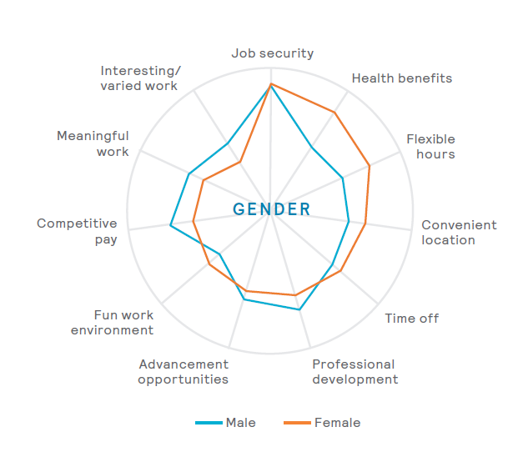

Figure 2 shows that baby boomers identify that meaningful work and compensation is a key driver whereas Generation Y see professional development and career advancement as a priority. Generation Y employees were identified as being more motivated by a fun working environment and learning, development and advancement opportunities, whereby Generation X are more motivated by flexible working and time off.
Figure 2- Reason to stay by generation
The Global Talent Trends Study (Mercer, 2019)
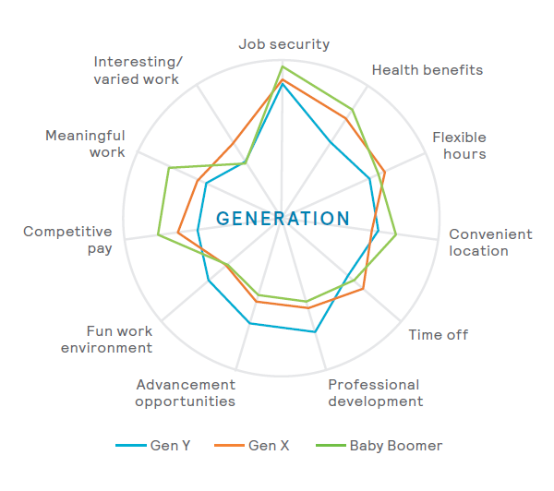
In the UK employees thrive by being recognised for their contribution, the ability to manage work life balance and having a fun work environment. Globally, the priorities are the ability to manage work life balance, recognition for contributions and opportunities to learn new skills and technologies. Within the UK and globally priorities relate to individual development whereas in other countries, priorities include meaning for work, a sense of belonging being empowered and clear direction. (Figure 3)

Figure 3- What helps employees thrive at work?
The Global Talent Trends Study (Mercer, 2019)

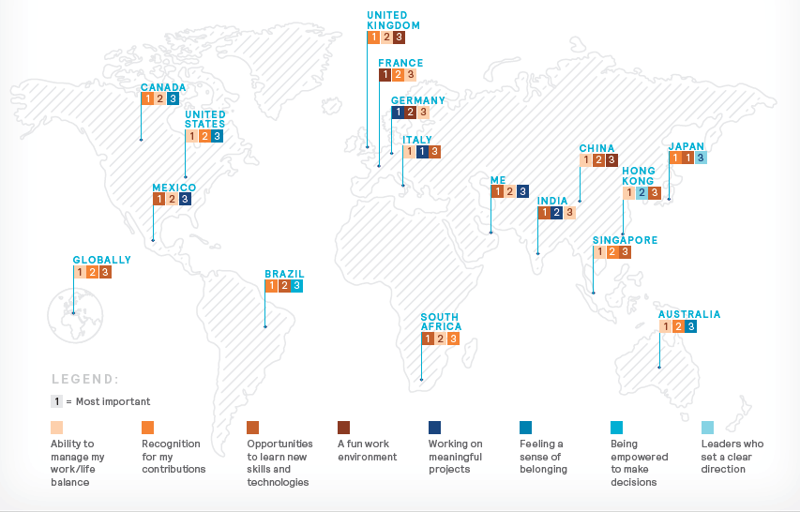

2.6 Evaluation of the future employee engagement

What may be classed as current high level engagement practices become outdated as workforce expectations change. HR practitioners need to evolve, ensuring policies and procedures meet current workforce needs. A ‘collegial approach’ needs to be adopted between organisational functions, with all functions taking responsibility for implementation of the engagement strategy (Bridger, 2018).

Organisations need to ‘consider the personal nature of engagement’ (Bridger, 2018), increasing the level of employee voice at all levels. Managers need to make time for employees, and leaders at all levels needs to strive to remove the ‘say, do’ gap, matching words and actions, unblocking the leadership barrier. Organisations need to consider technological data collection for real-time data.

Workforce expectations are changing. Burt (2018) identifies that 39% of UK employees have side hustles alongside their main role, with the expectation that this will rise double by 2030. Policies should not restrict side working, recognising how different generations want to work (Burt, 2018).

Embracing agile working will attract and retain top talent, with 53% of the workforce stating they would like to work from home (Department for Business, Innovation and Skills, 2014). Agile working increases productivity, allows for workspace utilisation and reduces the carbon footprint, it also demonstrates trust, therefore increasing the psychological contract (Plum, 2017).

Engagement strategies need to accommodate multigenerational teams (Schalk, 2019). Generation X Workers are tech savvy, but value traditional methods and need social activities to boost engagement. Generation Y workers want to re-write rules, have high expectations, focus on achievement and demand structure, with little tolerance for poor management practices (Gallop, 2017). Engagement drivers for Generation Y workers are shared values and purpose, wanting organisations to be socially and environmentally responsible, being less concerned about money. Generation Z workers are highly competitive, have technical dexterity and motivated by money, career progression and job security. Creating social interaction from onboarding is vital with Generation Z workers (Schalk, 2018). Future engagement needs adjustments in communication, interaction and connectivity, building trust and a psychological contract (Cattermole, 2014).

Finally, automation will see job loss rates up to 47% over the next 25 years (Bridger, 2018). Organisations need to embed a learning culture, supporting the retention of employees as new roles develop (People Insight 2017). With the advancement of technology, organisations need to embrace digital transformation (Groden-Morrison, 2018). Although this will engage Generation Y and Z workers, learning and development opportunities need to be available as ‘digital transformation will only work if the larger workforce is engaged’ (Groden-Morrison, 2018).

