An Investigation into the Effects of Events upon Museums within Swansea with Specific Focus upon the National Waterfront Museum
Research Methods – M5X02111K
Ruth Melton – P149238


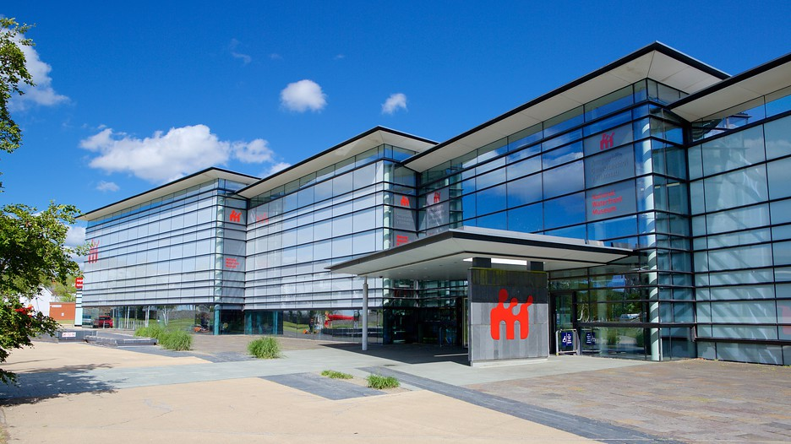
Table of Contents
1. Background & Rational 3
2. Aims and Objectives: 4
Aim 4
Objectives 4
3. Methodology 5
3.1. Philosophies 5
3.2. Approaches 7
4. Strategies 7
4.1. Interviews 7
4.2. Content Analysis 10
5. Resources 11
6. Ethics & Risks 11
7. References 13
8. Appendices 16
8.1. Appendix 1 16
8.2. Appendix 2 17
8.3. Appendix 3 18
8.4. Appendix 4 19

1. Background & Rational
Within the academic world it is widely accepted that ‘cultural tourism is the movement of people towards cultural attractions, somewhere other than their habitual place of residence, in order to obtain information and knowledge to fulfil their own cultural demands’ (Jovicic, 2016). Cultural attractions form the basis for this type of tourism and museums contribute a substantial proportion of these attractions. From April 2015 to March 2016 seventeen of the top museums in the UK including ‘the Tate galleries, National Gallery, V&A and British Museum’ accumulated ‘47.6 million’ visitors and although this number suggest stability within the museum industry this was however a drop of over 1 million visitors from the previous year (Jones, 2017) (Hargreaves, 2015). Given that this is a representation of some of the countries most popular museums and galleries it can be inferred that this decline in visitor numbers is a widespread issue amongst the majority of museums within the UK. In regards to Swansea in 2018 the Swansea Museum will have its budget cut by ‘£50000’ and although there are ‘no plans to close Swansea Museum’ this remains an ever-present threat to museums (Atkinson, 2017). This is not only evident within the UK but stretches into mainland Europe as it was revealed that ‘in Germany 10% of museums and cultural institutions face closure by 2020’ should the numbers continue to fall as they have been the UK could also see museum closures (Black, 2012, pg.4). This drop in figures may have been caused by a number of factors. Black (2012, pg.3) suggests that the UK is on the ‘cusp of a generational shift’ where the generation X and Y’s are becoming more selective with where they spend their time and museums are slipping further down in popularity. One-method museums have been using to combat this drop in visitor numbers is by hosting events and one off exhibitions. The purpose of this research task is to determine whether the hosing of events within museums and cultural institution can have a beneficial effect upon footfall, which by extension has an impact upon funding. Although research has already been conducted into the declining popularity of museums the focus of these investigations have primarily been focused in the causational reasons behind falling footfalls and these studies have also been centred in the more classical institutions of culture. The researcher feels the need to shift the focus onto establishing a method in which to increase museum popularity and to do so the researcher will be investigating the National Waterfront Museum (NWM). Comparisons will be drawn between the NWM and Swansea Museum; additionally the primary research, conducted within Swansea, will be combined with secondary research that has been conducted on the larger institutions in order to build up a fuller picture of the industry.

The £33m NWM, that opened in 2005, is one of seven national museums in Wales and overall these seven museums saw over 1.5 million visitors from the 2016/17 season however, like the major cultural institutions mentioned previously, this was a drop in comparison to the previous season were visitor numbers were over 1.6 million (BBC, 2005). As well as the drop in visitor numbers net income has also seen a decrease from 2015/16 to 2016/17 of over £14 million (Gordon & Griffiths, 2017). This demonstrates that there is a need to increase visitor numbers but in a sustainable way that is not going to drain the museums income. This explanatory study will aid in establishing whether events are one method that could be used to increase footfall.

2. Aims and Objectives:

Aim
To evaluate the impacts of events upon Swansea’s NWM and Swansea Museum

Objectives
- To evaluate the impact of events upon footfall within the NWM and Swansea Museum.
- To evaluate whether the advantages of events to museums can be created sustainably.
- To predict the future sustainable development of museums.

3. Methodology
Saunders et al (2009) defines research as ‘something that people undertake in order to find out things in a systematic way, thereby increasing their knowledge’ it can therefor be understood that academic research must be undertaken in a strategic manor. The researcher will use the research onion, developed by Saunders et al, to establish the research methodology to ensure that no stage of developing the research strategy are omitted.

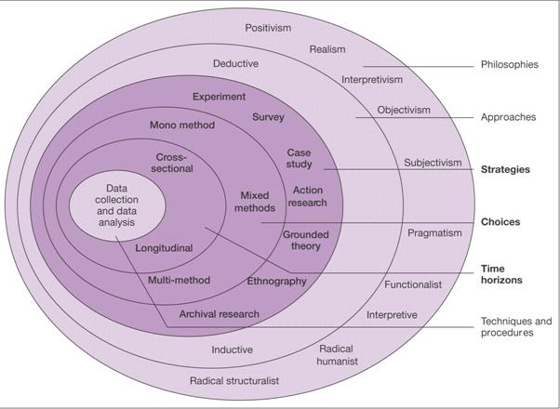
Research Onion taken from Saunders et al (2009)

3.1. Philosophies
Positivism
Positivism is ‘a framework of research’ ‘in which the researcher sees people as phenomena to be studied from the outside’ this philosophy has its advantages and disadvantages as follows.

Advantages
- The research remains objective
- Allows for a large sample size
- (Saunders et al, 2016, pg.136)

Disadvantages
- Methods tend to be inflexible and artificial
- Focuses on actions rather than reasoning
(Altinay and Paraskevas, 2008, pg.71)
Phenomenological
A phenomenological approach, on the other hand, is ‘concerned with understanding human behaviour’ and ‘focuses on the meaning rather than measurement of social phenomena’ and equally this philosophy holds advantages and disadvantages (Collis and Hussey, 2003, pg.53).

Advantages
- The qualitative data collected creates a detailed story
- Offers authentic accounts of complex phenomena
Disadvantages
- Lacks scientific rigour
- Can be descriptive and not analytical
- Generalizations are not supported by large quantities of data
(Denscombe, 2014, pgs.102-103)

The researcher will follow a primarily positivist approach as the researcher will be focusing on large scale quantitative research while including elements of the phenomenological will provide a personal quality to produces a more conclusive study.

3.2. Approaches
There are two approaches the researcher could adopt with this research, deductive or inductive. According to Loseke (2017) a deductive approach involves ‘using what already is known to determine what data to collect and what data will mean’ whereas an inductive approach involves ‘using data to develop concepts and theories’.

The researcher will use a deductive approach for this investigation due to the wealth of literature that already exists in regards to museum visitor fluctuations. A deductive approach also aligns with the positivistic philosophy that the researcher has outline will be used.

4. Strategies
By combining elements of the positivist and the phenomenological the researcher will create a triangulated approach as opposed to a mono-method approach. A triangulated approach allows for cross validation between a variety of research methods as the same result should be gained from several different research methods the researcher can be more confident with the validity of the study (Murdock, 2018).
The quantitative data element will be collated through content analysis and this will form the basis of the research project. There will also be a qualitative element to this project that will be formed through conducting interviews, which will bring greater depth to the study.

4.1. Interviews
Interviews will form the phenomenological element of this investigation and according to Easwaramoorthy and Zarinpoush ‘an interview is conversation for gathering information’ they can be conducted in multiple ways, face-to-face, over the phone, Skype (2006). As well as there being multiple physical ways to collect interviews there are also three main styles of interviews; unstructured, structured and semi-structured. Structured interview use ‘predetermined’ and ‘standardised’ set of questions referred to as ‘interviewer-completed questionnaires’ however this too ridged an approach for this research project (Saunders et al, 2016, pg.390). To generate more in-depth responses an unstructured approach could be adopted as ‘there is no predetermined list of questions’ instead ‘the interviewee is given the opportunity to talk freely’ on a topic area thus giving a detailed personal account of topics or events (Saunders et al, 2016, pg.391). However with this technique it can be difficult to manage as subjects may become easily distracted and not provide the needed information (Altinay and Paraskevas, 2008). For the purpose of this study the researcher will us semi-structured interviews conducted in a face-to-face fashion with individuals of particular significance to the case study of the NWM to provide the qualitative element of the research. Semi-structured interviews involves the interviewer having a set of topics and some ‘major questions’ ‘questions are generally open-ended in order to gain richer information’ whilst remaining on topic (Miller and Brewer, 2003, pg.167).

As the interviews will be conducted as part of a triangulated method the researcher will only carry out 5-6 20minute interviews with pertinent individuals in order to gather sufficient data. The questions will be constructed to be open-ended to allow for the in-depth responses while still allowing the interviewer to guide the discussion for this reason only 5-6 questions/topics will be created to allow time for the respondent to give an in-depth answer. For example questions see appendix 1. Although questions have been established the researcher appreciates that they will need to be piloted before the researcher undertakes and interviews with members of the public. According to Saunders et al (2016) pilot testing is a ‘small-scale study to test’ the researchers survey questions or interview checklist to ‘minimise the likelihood of respondents having problems in answering the questions’ with the aim being to improve the validity and reliability of the data that will be collected although the researcher does acknowledge that there will always be threats to reliability, be those subject or observer errors or bias (Robson, 1993).

Sampling Framework
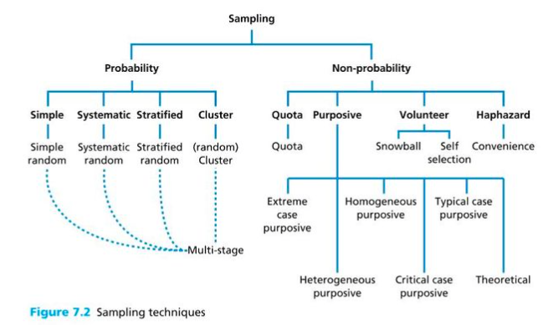

There are many variation on sampling framework as indicated from figure 7.2 (Saunders et al, 2016, pg.276) above and these frameworks are split into two overarching titles, ‘probability’ and ‘non-probability’. Probability sampling is best suited to research questions that require inferences to be on a population from a sample. Where-as non-probability sampling applies to research questions that require in-depth study to provide an ‘information-rich case study’ (Saunders et al, 2008, pgs.276-297). Due to the researcher focusing upon interviews and content analysis a non-probability framework will be adopted. Specifically a purposive sampling method will be used due to the researcher needing to conduct interviews with individuals with day-to-day knowledge of the NWM and the events that have been held there.

Analysis
Once the interviews, which will be ‘audio-recorded’ with the consent of the interviewee, have been conducted the researcher will transcribe them in order for the respondents answers to be analysed effectively (Saunders et al, 2016). Once the interviews have been transcribed the researcher will use ‘manual’ analysis by first ‘reading’ the transcripts to gain a general understanding of the answers collected. The researcher will then move to cross-reference the different interviewees responses and recurring ‘themes’ will be identified; this process will be done ‘by hand on hard-copy transcripts’ with a wide margin ‘flagging’ themes. The researcher will also use a ‘word processing packages’ to search ‘key words’ and code the transcripts through ‘indexing’ (Veal, 2006, pgs.210-213). When transcribing interviews it ‘can be useful to number paragraphs’ to ‘facilitate a cataloguing process’ (Veal, 2006, pg.212). For an example catalogue structure see appendix 2. The catalogue will display the detailed information in a user-friendly fashion the researcher will also consider creating a matrix table to display the data collected in a comprehensible manner.

4.2. Content Analysis
Content analysis, as defined by Saunders et al (2016, pg.608), is ‘a research technique for the objective, systematic and quantitative description of the manifest content of communication.’ The researcher will use this method to analyse the raw quantitative footfall statistics from the NWM, which will be provided by the researchers internal contact that the researcher has within the NWM. According to Finn et al (2000) context is key to ensure the statistics are not looked at in isolation, which may cause an otherwise unexplainable variation within the data. For example within this project the researcher will use a computer package, like excel, to cross-examine the footfall statistics with seasonality and events within the NWM to determine the correlation between the footfall and events. The researcher will begin by inputting the footfall data for 2017 into a line graph to highlight the changes that occur over the course of the year. The contexts surrounding noticeable drops and increases will then be investigated, looking specifically for national holidays and events held both within the museum and the city. For a graph example see appendix 3. Although content analysis is ‘time-consuming and labour-intensive’ it does provide more extensive data than could be collected by the researcher independently, this method also allows for complete researcher impartialness and does not require human contact therefore eliminating the human errors that can occur from surveying. Content analysis also provides a complete sample size in comparison to surveying in which the researcher must try to establish a representative sample (Saunders et al, 2016).

5. Resources
The resources that will be required to conduct this investigation will be:
- Access to the footfall statistics from the NWM that should not be an issue given the researchers connection to the NWM.
- Access to personal within the museum to conduct interviews
- A calendar of all events conducted within the NWM and Swansea across 2017.
This investigation will be highly labour-intensive, and require a large amount of time devoted to analysis however is inexpensive. To ensure time is used effectively the researcher will follow the Gantt chart shown in appendix 4.

6. Ethics & Risks
This research project is reasonably low risk as the topic area should not offend any participants nor pose any risk to the researcher or the university. Although this project is unlikely to cause offence all ‘individuals have the right to privacy’ and should not feel ‘coerced into participating’ in anything they feel uncomfortable with (Saunders et al, 2016, pg.249). Equally, although the researcher would like to record the interview to aid in transcribing the interviewee will need to give consent for the researcher to be able to do so. One problem that may arise is the NWM not granting the researcher access to the footfall statistics, which would form the bulk of the research. Should this happen the researcher will approach Swansea Museum for their statistics as the research question can still be tackled should the case study have to change. Non-response is also a risk the researcher faces however due to the connection that the researcher has within the NWM these risks this should be minimal. The researcher has also factored additional time into the Gantt chart should adaptations to the proposed research need to be made.

2200 Words

7. References
- Altinay. L & Paraskevas. A, 2008, Planning research in hospitality and tourism, Butterworth-Heinemann, Oxford
- Atkinson. R, (2017), ‘Swansea Museum under pressure to generate income following funding cut’, Museums Association - Museums Journal, [online], Available at: https://www.museumsassociation.org/museums-journal/news/28062017-swansea-museum, [accessed 31st January]
- BBC, 2005, ‘New museum and new Doctor Who’, BBC News, [online], Available at: http://news.bbc.co.uk/1/hi/wales/4562250.stm, [accessed 19th February 2018]
- Black. G, 2012, Museums in the Twenty-first Century, Routledge, Oxon
- Collis. J & Hussey. R, 2003, Business Research a practical guide for undergraduate and postgraduate students, second edn, Palgrave Macmillan Higher Education, Hampshire
- Denscombe. M, 2014, The Good Research Guide – for small-scale social research projects, fifth edn, Open University Press, Berkshire
- Easwaramoorthy. M & Zarinpoush. F, 2006, ‘Interviewing for Research’, Imagine Canada, [online], Available at: http://sectorsource.ca/sites/default/files/resources/files/tipsheet6_interviewing_for_research_en_0.pdf, [accessed 21st February 2018]
- Finn. M, Walton. M & Elliott-White. M, 2000, Tourism and Leisure Research Methods: Data Collection, Analysis,and Interpretation, Pearson Education Limited, Essex
- Gordon. M & Griffiths. A, 2017, ‘Financial Report 2016/17’, National Museum Wales, Amgueddfa Cymru – National Museum Wales, Cardiff, Available at: https://museum.wales/media/43032/Amgueddfa-Cymru-Financial-Report-2016-17.en.pdf, [accessed 5th February 2018]
- Hargreaves. J, ‘Sponsonred Museums: Performance Indicators 2013/14’, Department of Culture Media & Sport, Available at: https://www.gov.uk/government/statistics/sponsored-museums-annual-performance-indicators-2013-14, [accessed 31st January 2018]
- Jones. J, (2017), ‘The drop in museum visitors reveals a nation without aspiration or hope’, The Guardian, [online], Available at: https://www.theguardian.com/artanddesign/jonathanjonesblog/ 2017/feb/02/drop-uk-museum-attendance, [accessed 31st January 2018]
- Jovicic. D, 2016, ‘Cultural tourism in the context of relations between mass and alternative tourism’, Current Issues in Tourism, Vol. 19, No.6, pgs. 605-612
- Loseke. D. R, 2017, Methodological Thinking basic principles of social research design, second edn, SAGE Publication Inc, London
- Miller. R. L & Brewer. J. D, 2003, The A-Z of Social Research, SAGE Publication Ltd, London
- Murdock. R, 2018, ‘Advantages & Disadvantages of Triangulation Design’ [online], Classroom, Available at: https://classroom.synonym.com/advantages-disadvantages-triangulation-design-12039552.html, [accessed 21st February 2018]
- Saunders. M, Lewis. P & Thornhill. A, 2016, Research Methods for Business Students, seventh edn, Person Education Limited, Essex
- Veal. A. J, 2006, Research Methods for Leisure and Tourism a practical guide, third edn, Pearson Education Limited, Essex
- Wilson. V, 2011, ‘Research Methods: Content Analysis’, Evidence Based Library and Information Practice, [online], Available at: https://journals.library.ualberta.ca/eblip/index.php/EBLIP/article/view/12180/13124, [accessed 27th February 2018]
- Robson, C. (1993) Real World Research, Blackwell: Oxford. In Saunders, M., Lewis, P. and Thornhill, A. (2000) Research Methods for Business Students, 2nd Edition, Financial Times/Prentice Hall: Harlow

8. Appendices

8.1. Appendix 1

How would you define museum success?

How do you feel events impact the museum?
- Footfall
- Donations
- Funding

8.2. Appendix 2

Impacts of Events | Footfall |  | John | Para.2
 |  |  | Sarah | Para.4
Impacts of Events | Donations |  | John | Para.3
 |  |  | Sarah | Para.2

8.3. Appendix 3

Weekend Event
End of Long Running Exhibition

8.4. Appendix 4

 | Oct |  |  |  | Nov |  |  |  | Dec |  |  |  | Jan |  |  |  | Feb |  |  |  | Mar |  |  |  | Apr |  |  |  | May
Literature Review
Approach NWM for Footfall data
Establish Research Methodology
Create interview Questions
Pilot Interview Questions
Approach Individuals to Arrange Interviews
Conduct Interviews
Transcribe Interviews
Create Matrix Tables
Analyse Matrix Tables
Establish Methods to Analysis Footfall Data
Analyse the NWM Footfall
Create Tables and Graphs
Complete any Incomplete sections
Write up Conclusion to Question
Finalising Dissertation Format

