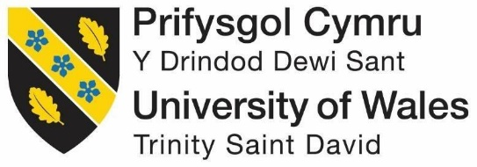

ENRIQUE TOMAS
  - STRUCTURE AND CULTURE

Module Code: LCBB4003
Assignment Title: Introducing the Modern Workplace
Module Lecturer’s Name: Dr. Gregory Cowan
Student Name: Simona Mocanu

Student ID: 1905164

Table of Contents
Introduction 3
Discussion on the Organisational Culture and Structure of Enrique Tomas and its impact on business performance 4
Conclusion 10
References 10

Introduction
Organisational culture and structure plays a crucial role in the development of successful organisation. Without effective organisational culture and structure no organisation would be able to achieve organisational objectives which are extremely important to survive in the modern day market environment. There are number of key aspects involved in developing a great organisational culture which ultimately leads to efficient work culture within an organisation. On the other hand effective organisational structure helps to build up cohesive operational plan and involve employees in the best possible manner. Enrique Tomas is a gourmet food and drink brand that started in Spain and slowly and steadily spread all across the Europe with shops in UK, France, Germany and some other countries (Naranjo-Valencia, Jiménez-Jiménez and Sanz-Valle, 2016). The organisational culture and structure of this organisation has helped to expand its market and revenue and enhance customer experience to a large extent. There are number of aspects related to successful operation of an organisation. With reference to the present company the present study would discuss the role of organisational culture and structure in improving the business performance.

Discussion on the Organisational Culture and Structure of Enrique Tomas and its impact on business performance
Organisational culture and structure of Enrique Tomas is suitable for the efficient operation of the organisation. In the global business environment especially with the arrival of globalisation organisational culture and structure has been considered as key in the development of strong work ambiance (Mullins, 2016). There is a greater need for an organisation to understand the importance of culture in order to develop a strong platform to operate in the market. There are number of concepts related to effective understanding culture especially with reference to an organisation (Valmohammadi and Roshanzamir, 2015).
Organisational culture could be defined as the different beliefs, norms based on which an organisation is operated. Based on the organisational culture the principles and operational norms are developed which largely help the organisation move on the right track. One of the fundamental theories of organisational culture is Handy’s model of organisational culture (Armstrong and Taylor, 2017). It is extremely important to focus on understanding the key frameworks put forward by the theory to understand how Enrique Tomas applies it on the business. According to the theory of organisational culture there are mainly four different types of organisational cultures like role, task, power and person cultures. The power culture defines that the power within an organisation is held by cluster of people sitting at the top (Körner et al., 2015). There are number of organisations all across the world those who believe on power culture. The power culture focuses on power and largely emphasises on distributing power in a way which would help to make organisational decision in the best possible manner. However, it has been seen that in power culture the workforce is not happy because with power the upper management tends to control the operations which brings autocracy in the operations. In the modern day organisational environment autocracy is not favorable because people want to have a friendly environment and with autocracy organisations tend to curb on that (Rosemann and vom Brocke, 2015).
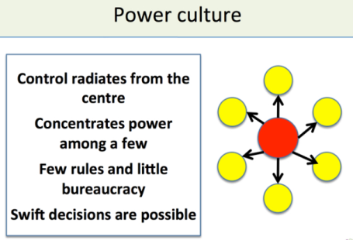
Fig 1: Power Culture (Carayannis, Sindakis and Walter, 2015)
The Role culture is mostly based on rules and regulations developed by an organisation. In this scenario the different roles and positions within an organisation understand their roles and responsibilities and tend to operate accordingly. The role culture is related to highly bureaucratic culture which means each and every person is focused on their job which relates to centralisation and power moves from positions to positions. This clearly shows lack of requirement of expert power however, develops a strong system of operation where the employees are quite aware of their roles hence, making operations easier (Jain and Moreno, 2015).
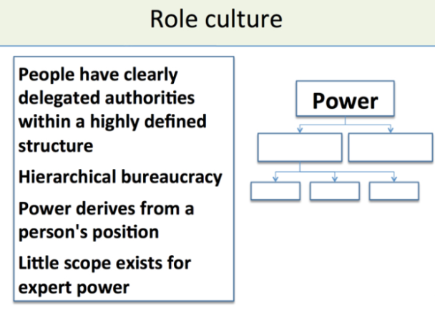
Fig 2: Role Culture (Carayannis, Sindakis and Walter, 2015)
Task culture is a highly centralised culture where each and every employee is bound to a team that is responsible to address a specific organisational problem. These are mostly found in project management teams which clearly indicate that functional departments and project teams have to collaborate at core to improve the overall operations of the organisation. For this kind of culture the employees are highly focused on tasks and don’t really have personal bonding which might even affect the business operations of the teams. In task culture the importance of tasks is paramount and hence, there’s high concentration on work (Carayannis, Sindakis and Walter, 2015).
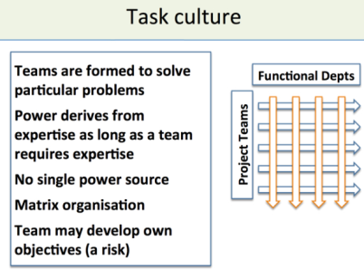
Fig 3: Role Culture (Carayannis, Sindakis and Walter, 2015)
Person Culture is a culture that is inclined towards efficient handling of individuals within an organisation. Organisations following person culture lay stress on persons and give wellbeing and welfare larger importance than anything else. This kind of culture has greater respect for people and follows friendly environment in the organisation. The people work with ownership capital which naturally improves the business operations in the best possible manner (Huczynski and Buchanan, 2013).
The organisation Enrique Tomas is named after the businessman himself. It took forty years for the company to expand in several other markets which it was successful in. however, in this case it is important to note that the organisation has been particular about the way it implements its culture which directly underpins management and leadership within the organisation. The mission and vision of the organisation is to spread love via food and its signature ham and wine has been able to maintain greater hold for the organisation (Bititci, 2016). The organisation considers the employees as its lifeline and specialises in its trade which clearly shows that the organisation has been able to implement the right culture within the organisation. The organisation has to have specialised staffs for instance a ham carver, cutters et cetera which means they all have proper roles within the organisation (Boddy, 2011). Hence, the organisation implements role culture in order to achieve the organisational objectives in the best possible manner. It could be said that effective role culture has allowed the company to drive each and every employee effectively especially with reference to individual tasks. Thus, Enrique Tomas applies the role culture in order to provide a proper environment to each and every employee for better performance. The role culture even though is individualistic in nature it doesn’t directly affect the operations because management plays an important role in managing the business (Pakdil and Leonard, 2015).
Culture and dimension have direct relationship where the cultural dimension put forward by Geert Hofstede highly relates to efficient implementation of culture. All across the world most of the leaders follow the cultural dimension pattern in order to control operational environment in the best possible manner. Most of the leaders operating in the UK firms clearly understand what drives and influence employees and accordingly implements leadership strategies to get the best possible result from the operations (Grey, 2017). As per the cultural dimension score for UK it is clear the people in UK do not believe in power concentration and hence, it has a low score on power distance index. This means that employees tend to stay together and enjoy same power. Hence, democratic leadership stands to be an extremely effective strategy implemented at Enrique Tomas. Democratic leadership takes everyone together and moves ahead which is a great way to get effective results. On the other hand individualism is another key aspect where UK scores high at 89 which shows that UK is highly individualistic in nature (Bititci, 2016). This means transformational leadership style would largely help employees from Enrique Tomas to grow and develop as individuals do not want to lose growth opportunities. Hence, applying transformational leadership is highly efficient for Enrique Tomas.
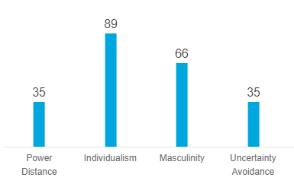
Fig 4: Cultural Dimension score UK (Maduenyi et al., 2015)
Organisational structure is the hierarchy of positions followed by an organisation. It plays a crucial role especially with reference to decision making and implementing change in the organisational operations. Organisational structure has a great impact on how an organisation performs because it lays the basic platform to build up on the organisational operations. Most of the time it is seen that organisations fail to achieve objectives because it has a confusing organisational structure which means the flow of information is poor hence, decision making is affected. Thus, for an organisation that has multiple operations in different geographic locations managing and implementing the right structure is of paramount importance (Maduenyi et al., 2015). There are different organisational structures like geographical structure, flat structure, functional structure et cetera. These structural frameworks provide a great platform for the organisation to manage its operations efficiently leading to achievement of growth and success. The geographic structure is a regional structure which works effectively for global businesses. They have bigger operations and have to manage much bigger supply chain for which divisional structure works perfectly. This is based on managing each and every division according to the region. The decision making is done mainly by the divisional head with the consent of the top management (Alasadi and Al Sabbagh, 2015).
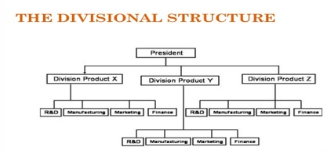
Fig 5: Divisional Structure (Jenkins and Williamson, 2015)
On the other hand the functional structure is dependent on the functional heads and flat structure is simple and flat in nature.
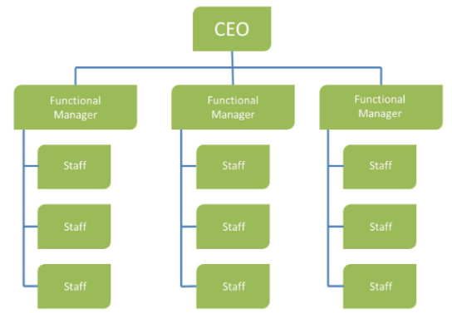
Fig 6: Functional structure (Jenkins and Williamson, 2015)
The functional organisations depend on functional departments for decision making which is effcient and faster however, there is a greater possibility of power struggle because the functional heads are responsible for decision making (Grey, 2017). On the other hand the flat hierarchical strutcure is focused on simple yet efficient decision making where the CEO of the organisation makes the decision and the mid level managers prepare strategies to execute it. According to Henry Fayol’s management theory the management is all about effecitve designing, planning, executing and controlling business activities hence, it is important to make sure the layers of the hierarchy is effectively executed (Jenkins and Williamson, 2015). For Enrique Tomas it is important to prepare organisations for regional operations hence, to be able to effecitvely manage the organisational activities play an important role. The organisation Enrique Tomas applies the functional organisational structure because it wants to compete with the immediate rivals in the market hence, time based competition is extremely important. Thus, faster decision making is needed which is ultimately effecitvely handled by the fucntional heads. There is a uniqueness in the structure which acts as strong advantage for the organisation which is the CEO of the organisation has provided efficient flexibility to the functional heads which has helped them to communicate well and manage the individual segments properly leading to better and efficient decision making (Sethibe and Steyn, 2015).
Clearly it could be said that efficient organisational culture and structure helps Enrique Tomas to make decisions faster and smoother which is extremely important for better customer service. The organisation gives paramount importance to customer service hence, aligning the organisational culture and structure helps the organisation to effecitvely manage business activities. Effective organisational culture and structure helped the managers to understand the employees within the organisation and friendly culture has emphasised on understanding their needs and wants effecitvely implementing motivational plans to communicate well with the employees (Grey, 2017). This has helped to plan objectives of the organisation and achieve them accordingly leading to greater efficiency and bette results for the organisation. Effecitve structure has not only helped to improve communication across functions but enhanced collaboration across them leading to proper understanding of long term and short term objectives and finally better financial results for the company (Jenkins and Williamson, 2015).

Conclusion
To conclude it could be said that organisational structure and culture plays an important role in the overall growth and development of an organisation which is quite visible from the performance of Enrique Tomas in the UK. The organisation applies role culture within the organisation and functional organisational structure which collaborates to enhance organisational efficiency and business performance. The company implements transformational leadership style with democratic approach to leadership which has helped to communicate well with the employees and accordingly improve customer service to achieve competitive advantage in the market.

References
Alasadi, R. and Al Sabbagh, H., 2015. The role of training in small business performance. International Journal of Information, Business and Management, 7(1), p.293.
Armstrong, M., and Taylor, S., 2017. Armstrong's Handbook of Human Resource Management Practice, 14th Edition, Kogan Page
Bititci, U.S., 2016. Managing business performance: The science and the art. John Wiley & Sons.
Boddy, D., 2011. Management: An Introduction (5th edition) Harlow: Pearson
Carayannis, E.G., Sindakis, S. and Walter, C., 2015. Business model innovation as lever of organizational sustainability. The Journal of Technology Transfer, 40(1), pp.85-104.
Grey, C 2017. A Very Short, Fairly Interesting and Reasonably Cheap Book about Studying Organizations (4th edition) London: Sage
Huczynski, A.,and Buchanan, D. 2013 Organisational Behaviour (8th edition) Harlow: Pearson
Jain, A.K. and Moreno, A., 2015. Organizational learning, knowledge management practices and firm’s performance. The Learning Organization.
Jenkins, W. and Williamson, D., 2015. Strategic management and business analysis. Routledge.
Körner, M., Wirtz, M.A., Bengel, J. and Göritz, A.S., 2015. Relationship of organizational culture, teamwork and job satisfaction in interprofessional teams. BMC health services research, 15(1), p.243.
Maduenyi, S., Oke, A.O., Fadeyi, O. and Ajagbe, A.M., 2015. Impact of organisational structure on organisational performance.
Mullins, L, 2016. Management and Organisational Behaviour 11th Edition, Pearson.
Pakdil, F. and Leonard, K.M., 2015. The effect of organizational culture on implementing and sustaining lean processes. Journal of Manufacturing Technology Management.
Rosemann, M. and vom Brocke, J., 2015. The six core elements of business process management. In Handbook on business process management 1 (pp. 105-122). Springer, Berlin, Heidelberg.
Sethibe, T. and Steyn, R., 2015. The relationship between leadership styles, innovation and organisational performance: A systematic review. South African Journal of Economic and Management Sciences, 18(3), pp.325-337.
Valmohammadi, C. and Roshanzamir, S., 2015. The guidelines of improvement: Relations among organizational culture, TQM and performance. International Journal of Production Economics, 164, pp.167-178.

