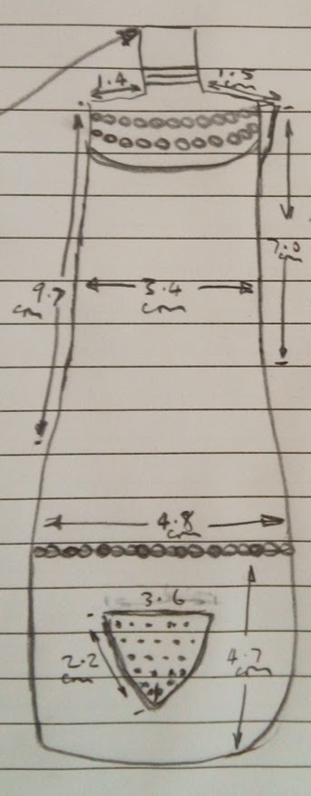
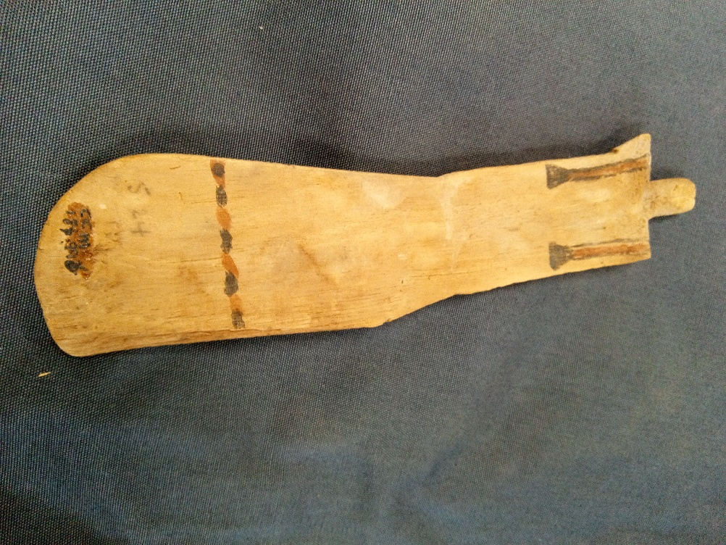
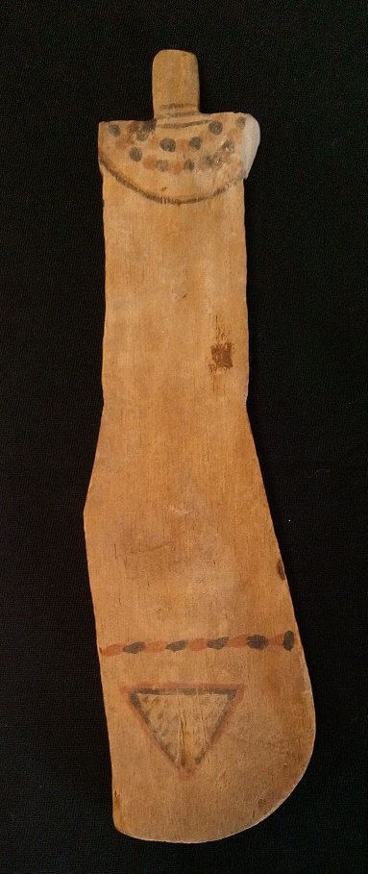
Image 1: Paddle doll, CCM187.996, Cyfartha Castle Museum, Merthyr Tydfil, (Photograph) P. Sweeney, Roderic Bowen Library, Lampeter, 2020.

Image 2: Paddle doll, CCM187.996, Cyfartha Castle Museum, Merthyr Tydfil, (Photograph) P. Sweeney, Roderic Bowen Library, Lampeter, 2020.

Paddle Doll
Cyfartha Castle, Merthyr Tydfil CCM187.996
Object type: Paddle Doll, Fertility Figurine
Material: Wood, type Unknown; Condition: Broken at the shoulders, with both arms and small strips missing from each side. One curved lower side missing approximately 0.5-1cm in width and 6-8cm in length.
Period: Unknown, (possibly XII Dynasty).
Provenance: Unknown, (Egypt, possibly Upper, possibly Theban).
Dimensions: Length 19.5cm, Width: Neck 1.2cm, right shoulder 1.4cm, left shoulder 1.5cm. Torso width 3.4cm, hip width 4.8cm. Base to ‘belt’ 4.7cm. Pubic triangle, top of 3.6cm, both sides of 2.2cm. Width (side on) 0.7cm.
Image 3: Paddle doll, CCM187.996, Cyfartha Castle Museum, Merthyr Tydfil, (Drawing) P. Sweeney, Roderic Bowen Library, Lampeter, 2020.

Object analysis by Patrick Sweeney

Object CCM187.996 was acquired by soldier and keen amateur Egyptian collector, Major Harry Hartley Southey. Upon his death, this and the other objects in this catalogue, all part of his collection, were donated to Cyfartha Castle Museum by his family.

Size and Shape
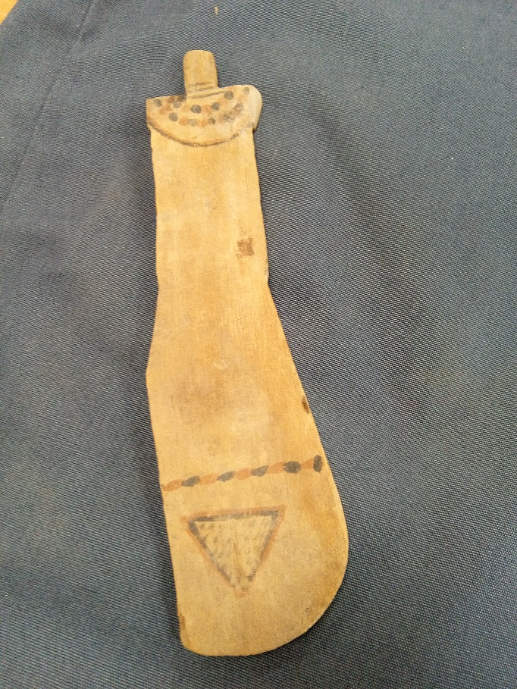
Object CCM187.996, now on to be referred to as a paddle doll, is an oblong shaped piece of wood 19.5cm in length. The narrowest point is 3.4cm wide, this gently flares to a width of 4.8cm wide at 4.7cm from the base. The paddle doll obverse side up, shows a straighter left side, this is due to damage suffered at some time in the past. It is a lightly decorated, two-dimensional piece of wood, a width of 0.7cm side on. The wood type is unknown. It has a peg/stub protruding from the top, approximately 1.2cm wide, this contributes to the anthropomorphic impression of it being human. There is damage that can be clearly seen to the shoulder area of the Paddle doll, where arms might have existed.
Image 4: Paddle doll, CCM187.996, Cyfartha Castle Museum, Merthyr Tydfil, (Photograph) P. Sweeney, Roderic Bowen Library, Lampeter, 2020.

Decoration
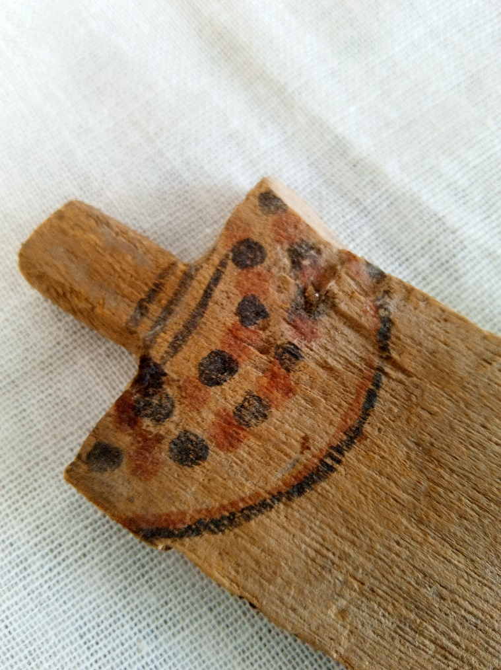
Starting with the obverse side, there are three lines across the base of the peg, descending towards the top of the torso, with a gap of 0.4-0.5cm between each. Followed by semi-circular alternating balls of colour, forming an arc from the top of the right to the left shoulder, followed by another arc of red and black balls of colour. There is a gap of 1.2-1.5cm, followed by a gently arced line of red and black,1.0-1.2cm from the top edge of the shoulder. The impression is of a necklace, red and black in colour, descending from the neck to the top of the 1.2-1.5cm wide infilled with the colour red and
chest. Ascending 4.7cm from the base, is a line of alternating red and black oblongs. 1.5-2cm’s below this is a triangle, the apex pointing to the base, top edge 3.6cm long and each side 2.2cm in length. With a red outer triangle and a black inner one. Within this are a series of faded short black lines or uneven dots. On the reverse side can be seen two faded black lines across the shoulder area descending 3-3.5cm down the back before ending with two black triangles approximately 0.4-6cm in size. 4.7cm up from the base are further alternating oblongs of red and black colour, continuing from the obverse side.
Image 5: Paddle doll, CCM187.996, Cyfartha Castle Museum, Merthyr Tydfil, (Photograph) P. Sweeney, Roderic Bowen Library, Lampeter, 2020.

The journey of interpretation
John Garstang first described the figurine as a “doll” ( Garstang, 1907, p. 152) in his excavation report from Beni Hasan 1902-3-4. Reinforcing this interpretation by adding “obviously shaped to be held in the hand” (Garstang, 1907, p. 152), and constructed and decorated by its “youthful maker or owner” (Garstang, 1907, p. 152). Garstang concludes his interpretation, by comparing it with the wooden toys “of the children of Nubia at the present time” ( Garstang, 1907, p. 152). The label of paddle is contributed by H. E Winlock in his excavations report from Deir el-Bahri 1911-1931. Winlock describes them as “thin paddles of wood” (Winlock, 1942, p. 207), after describing them as “barbarous looking” (Winlock, 1942, p. 207) and disagreeing with Garstang’s view of them as a child’s toy, before describing them as “ undoubtedly representing dancing girls” (Winlock, 1942, p.207).

Winlock as Garstang before him, attributes the paddle doll to Nubia, in his description “ they are not one whit more uncouth than a modern doll bought in 1931 at Amadeh in Nubia” (Winlock, 1942, p. 207). William C. Hayes interpretation is that the doll functions as a concubine for the afterlife. Hayes in his guide to Egypt for the Metropolitan Museum, published in 1946, describes it as “ barbarously crude” (Hayes, 1990, p. 219). Hayes continues the Nubian connection, comparing the doll’s hairstyle with those that of modern-day women in Nubia, and with the wooden doll’s for sale in the “ Nubian bazaars” (Hayes, 1990, p. 219).

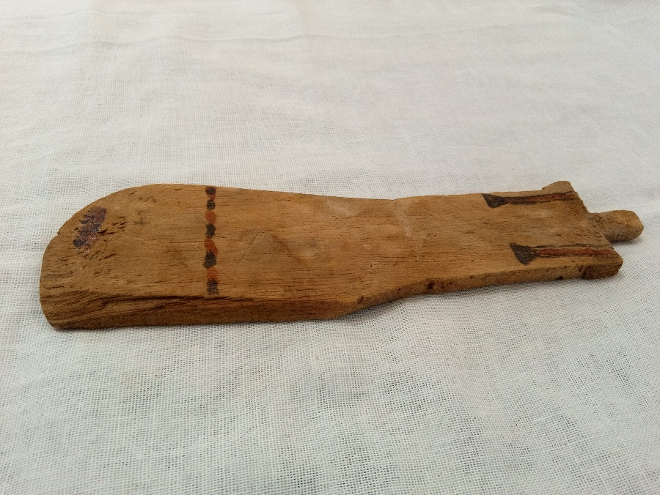
Forward to 1989, and A Tooley in her Thesis submission for a PhD, before the collation of decorative data in table 16 (Tooley, 1989, p. 308) is done. Tooley broadly categorizes the decorative styles on the obverse and reverse of provenanced dolls. Tooley concludes that the doll has two purposes, one of association, to the menat necklace and the figures associated with fertility, based upon their appearance upon the doll. The second point is of one of iconographic imagery, and how it can be linked to the cult of Hathor and ritualistic dancing for fertility (Tooley, 1989, p. 311). Wolfram Grajetzki (2009) in his description of a Theban burial from the late Middle Kingdom, emphasises the uncertainty of the doll’s function, that “five flat wooden dolls”(Grajetzki, 2009, p. 60), were found but all proposed functions are still disputed.
Image 6: Paddle doll, CCM187.996, Cyfartha Castle Museum, Merthyr Tydfil, (Photograph) P. Sweeney, Roderic Bowen Library, Lampeter, 2020.

In the journal article Paddle Dolls and Performance (Morris, 2011, p.71-103), Morris concludes “these female figurines should be interpreted as sacred performers….” (Morris, 2011, p.103). Morris uses eight points of comparison with the “Theban Khener-troupe” (Morris, 2011, p.72) female performers in attempting this. Roberto A. Diaz Hernandez in his 2017 journal article argues that the doll is a “Ritual Figurine of Fertility” (Diaz Hernandez, 2017, p. 125). He compares the features common to the dolls from tombs in Upper Egypt and dated from the “Old Kingdom to the Thirteenth Dynasty” ( Diaz Hernandez, 2017, 125), to accomplish this. He concludes that the between the textual, iconographical, archaeological and ethnological evidence available, the paddle doll was actually a “magical fertility object” (Diaz Hernandez, 2017, 126) whose purpose was to help obtain the future generation for a family and insure there would be people to perform “their funerary cult after death” (Diaz Hernandez, 2017, p. 132) to ensure their names would not be lost to oblivion. Sorensen in her book Gender Archaeology, speaks of the “fluidity of meaning” (Sorensen, 2000, p. 89), in that the custom connected with an object moves that objects “meaning through time” (Sorensen, 2000, P. 89). This can be seen from Garstang to Winlock and Hayes, each contributing to the gendered valuation, interpretation and research isolation the paddle doll is only just recently emerging from.

Image Bibliography

Image 1,2,4,5,6: Sweeney, P. (2020) Paddle Doll [photographs], Roderic Bowen Library, Lampeter, February 2020, CCM187.996, Cyfartha Castle Museum, Merthyr Tydfil.
Image 3: Sweeney, P. (2020) Paddle Doll [drawing], Roderic Bowen Library, Lampeter, February 2020, CCM187.996, Cyfartha Castle Museum, Merthyr Tydfil.

Bibliography

Garstang, J. (1907) The Burial Customs of Ancient Egypt as illustrated by tombs of the Middle Kingdom being a report of excavations in the Necropolis of Beni Hasan during 1902-3-4. London: Archibald Constable & Co Ltd.

Grajetzki, W. (2009) Burial Customs in Ancient Egypt: Life in Death for Rich and Poor. 2nd edn. Eastbourne: Gerald Duckworth & Co. Ltd.

Morris, E.F. (2011) ‘Paddle Dolls and Performance’. Journal of the American Research Center in Egypt ,47, pp.71–103.

Diaz Hernandez, R.A. (2017) ‘Paddle dolls- Ritual Figurines of Fertility’, in Miniaci, G, Betro, M, & Quirke, S. (eds.) Company of Images: Modelling the Imaginary World of Middle Kingdom Egypt (2000-1500 BC), Bristol: Peeters Publishers.

Sørensen, M, L, S. (2000) Gender Archaeology. Cambridge: Polity Press.

Tooley, A.M.J. (1989) Middle Kingdom Burial Customs a study of wooden models and related material Volume 1. Unpublished PhD thesis. University of Liverpool.

William, C, Hayes. (1990) The Scepter of Egypt a background for the study of Egyptian Antiquities in the Metropolitan Museum of Art. 5th edn. New York: Plantin Press.

Winlock, H.E. (1942) Excavations at Deir el-Bahri 1911-1931. United States of America: The Macmillan company.

