ACBA5028 –
Sustainable Development
Assignment 1: Sustainability Assessment
David Deeth (2223671)

Contents
Contents 1
List of Figures 1
1. Introduction 2
1.1 Net Zero and Sustainable Development 2
2. PART 1: Alternative Sustainable Development Frameworks 2
2.1 LETI 2
2.2 BREEAM 3
2.3 Passive House 3
2.4 OPD 3
3. PART 2: Evaluation of the Existing Project 4
3.1 Water 5
3.2 Energy 5
3.3 Transport 6
3.4 Health and Wellbeing 7
3.5 Land Use and Ecology 7
3.6 Pollution 8
3.7 Materials 9
3.8 Waste 10
3.9 Evaluation Summary 11
4. Summary 12
5. References 13
6. Appendix 15

List of Figures
Figure 1 – Saint Sannans Field Site Plan, Llanmoor Homes 4
Figure 2 – Summary Table 11
Figure 3 – LETI Small Scale Housing Archetype 15
Figure 4 – BREEAM Rating Benchmarks 15
Figure 5 – Example BREEAM Rating Chart 16
Figure 6 – TFW Bus Route 27 16
Figure 7 - Linear Economy Flow Chart 17
Figure 8 – Circular Economy Flow Chart 17
Figure 9 – List of Abbreviations 17

1. Introduction

1.1 Net Zero and Sustainable Development
The United Nation’s Intergovernmental Panel on Climate Change (IPCC) has predicted that if the global greenhouse gas emissions rise 1.5ºC over pre-industrial levels it would likely cause catastrophic climate events, such as the arctic permafrost melting, raising sea levels, and increasing levels and frequency of devastating weather events, e.g. flooding, droughts and wildfires.

Net Zero is a pathway to limit global warming from reaching the 1.5ºC threshold, and to lower greenhouse gas emissions to zero.
This pathway requires urgent worldwide action, such as development of carbon capture technologies, and a changeover to sustainable power generation and consumption.
e.g. forestry plantations, wind/hydro/solar power, reduction in fossil fuel vehicle usage.

The Environment (Wales) Act 2016 by produced by the National Assembly for Wales to promote the sustainable management of natural resources, and outline targets to reduce greenhouse gas emissions.

Part 1: Exploration of alternative sustainable building frameworks:
- Low Energy Transformation Initiative (LETI)
- Building Research Establishment Environmental Assessment Method (BREEAM)
- Passivhaus (PH)
- One Planet Development (OPD).

Part 2: Evaluate the different elements of the existing development plan and propose a more sustainable scheme utilising methods from the explored frameworks.

2. PART 1: Alternative Sustainable Development Frameworks

2.1 LETI
Establishment in 2017, LETI is a network comprised of multiple built environment professionals voluntarily working together to meet the UK’s climate change targets and reach a ‘zero carbon’ future and support the UK’s built environment transition to Net Zero Carbon.

To assist designers in creating new buildings which meet the requirements for climate change targets, LETI has published multiple guidance documents.
Starting in 2020 it with the Climate Emergency Design Guide and its supplement, the Embodied Carbon Primer; and in 2021 further guidance for: Hydrogen, Carbon Alignment, a Client Guide for Net Zero Carbon Buildings and the Climate Emergency Retrofit Guide.

LETI has also contributed towards the Net Zero Carbon Building Standard in collaboration with the Better Building Partnership group consisting of BRE, CIBSE, IStructE, RIBA, RICS and UKGBC.
(Figure 3 – LETI Small Scale Housing Archetype)

2.2 BREEAM
BREEAM is a commercial framework, but it’s holistic approach to construction has suitable framework elements for this project.

The BREEAM framework uses a rating score calculation to evaluate the whole-life sustainability of a building project’s elements of design, construction, and use, and rate them using a recognised measure of improved performance against an established benchmark.

This scoring and benchmark system allow the client and stakeholders to assess the performance of the proposed building against existing BREEAM rated buildings, with a target score of ≥ 85% = Outstanding.
(Figure 4 – BREEAM Rating Benchmarks; Figure 5 – Example BREEAM Rating Chart)

If the BREEAM framework is used from the start, designers can use the scoring system to make informed improvements to the design to achieve sustainability targets.
The framework can be implemented once the project has started, however the design changes could incur additional costs and time setbacks.

For large development projects, such as St Sannans Field, separate but similar buildings in a development can be assessed under one BREEAM rating (Guidance Note 10).

2.3 Passive House
(AKA Passivhaus)
Passivhaus is an internationally recognised energy performance standard designed to create sustainable, comfortable building with low operating costs.
It achieves these using designs that decrease a structure’s energy consumption through airtight construction design, use of high-performance insulation, and heat recovery through controlled ventilation and heat exchange units.

Architects and Designers can use the Passive House Planning Package (PHPP): an Excel-based planning tool which can be used to calculate annual heating, cooling, and energy demands based on a survey of the building’s properties and characteristics.
This allows the designers to optimally plan and design each element of the building to reach target sustainability goals and occupant comfort levels.

2.4 OPD
OPD is an objective of the “One Wales: One Planet” Sustainable Development Scheme.
It utilises Low Impact Development (LID) principals stated in Planning Policy Wales’s Technical Advice Notes (TAN) 6, such as a Land Management Plan and Ecological Footprint Analysis (EFA), to achieve exemplary sustainable standards.
A key target for OPD projects is to either enhance, or not reduce, the environmental quality of the area; and to reach zero carbon in construction and usage, or as close as possible to zero.

3. PART 2: Evaluation of the Existing Project

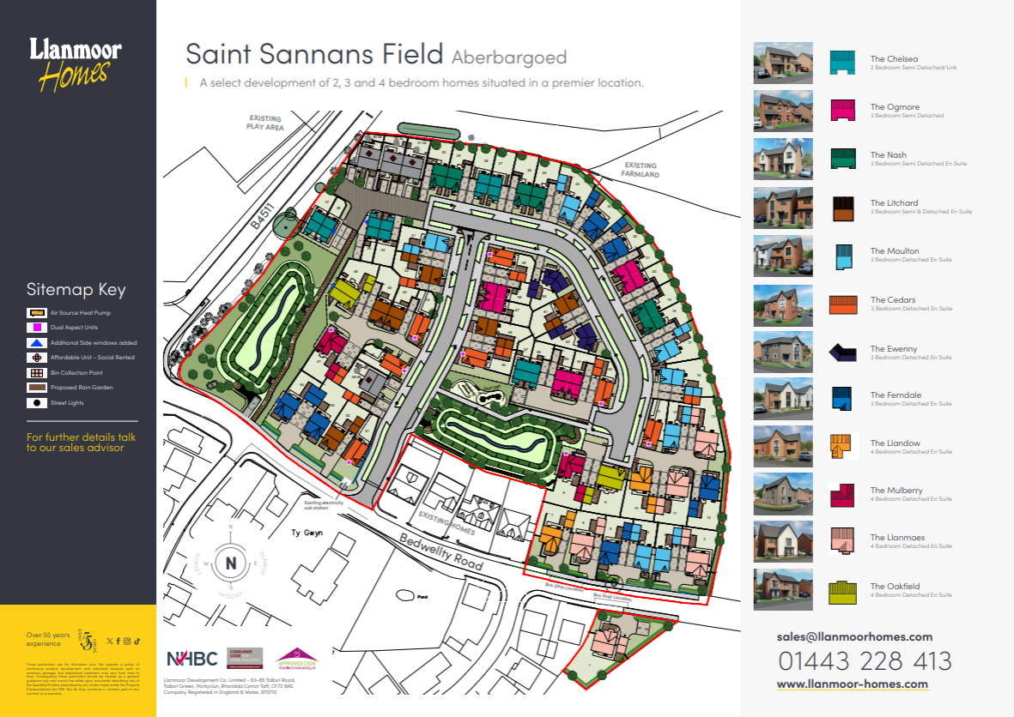
Figure 1 – Saint Sannans Field Site Plan, Llanmoor Homes

Llanmoor Homes is a well-established construction company that has been in business since 1966, with an annual turnover of £23M in 2024.
Saint Sanans Field is one of their new residential housing developments being constructed on a farmland field off the Bedwellty Road in Aberbargoed, Caerphilly.
It consists of 59 of two-, three-, and four-bedroom homes, 8 one-bedroom affordable housing apartments, two public amenity spaces, and a play area.

Although they use some aspects of sustainable building practices, St Sannans Field building designs are all traditional construction brick/block framework, and timber trussed concrete tiled roofs.

The objective of this report is to assess and critique current level of sustainability within the housing project and explore alternative designs from the explored frameworks which could achieve a higher level of sustainability.

Elements to Assess:
- Water | - Land use & ecology
- Energy | - Pollution
- Transport | - Materials
- Health & wellbeing | - Waste

3.1 Water

Current Design:
- Two public amenity spaces which double as Sustainable Urban Drainage Systems (SUDS) which aims to replicate natural drainage, reduce flooding, and increase water quality.
- Rainwater gardens on most properties.

Framework Comparison:
BREEAM:
- Low-flow fixtures, self-shut taps, and dual flush toilets.
- Water consumption monitors and leak detection systems.
PH:
- No specific criteria.
OPD:
- Rainwater retention systems for greywater usage – e.g. filling W.C. cisterns.
- Eco-friendly surface paving, e.g. permeable pavers, porous asphalt, and green parking bays – reduces thermal mass, lowers urban ‘heat island’ effect, improves stormwater runoff management, and lowers maintenance costs.

Possible Changes:
- Install systems to recycle rainwater and greywater for irrigation and flushing.
- Install water efficient WCs fixtures and smart leak detection systems.
- Use permeable paving for car parks and footpaths.

Best Framework: BREEAM
Justification:
Detailed, scalable guidance on efficient water usage and measurable performance criteria.
OPD: additional communal guidance.

3.2 Energy

Current Design:
Llanmoor’s website states all new builds are:
- Generally EPC ‘B’ rated energy efficient.
- Central Heating boilers with an EPC ‘A’ Energy rating.
- Fitted with EPC ‘A’ rated kitchens appliances and central heating boilers.
- ‘E’ rated double glazed windows and doors.
- Efficient cavity wall and loft insulation.
- Energy efficient lighting.
(Llanmoor Homes, 2023)

Framework Comparison:
BREEAM:
- Guidance for high efficiency energy usage – less thorough than PH.
PH:
- World-leading energy standards.
- Highly airtight buildings with integrated Mechanical Ventilation Heat Recovery (MVHR) units reduces heat loss and energy usage.
- Super insulation which encompasses the whole structure to reduce thermal bridging.
OPD:
- Focus on communal aspects, such as:
- PV covered parking area with electric charging points.

Possible Changes:
- Use PH level building fabric.
- Possible power supply changes:
  - PV roof panels with communal battery storage.
  - Ground or air source heat pumps
  - Communal Power Plant ownership scheme.
  - Biomass heater for more sustainable fuel source and less carbon emissions.

Best Framework: Passive House
Justification:
Rigorous energy standards and performance thresholds. “Fabric-first” approach and high airtightness levels outperform other frameworks in providing low operational costs, high energy efficiency, and reduced carbon emissions.
LETI: additional guidance on reaching net-zero targets.

3.3 Transport

Current Design:
- Situated within near proximity to larger towns and cities
(Aberbargoed: 2 miles, Merthyr Tydfil: 10 miles, Newport: 17 miles, Cardiff:19 miles).
- Close to the M4.
- Existing bus stop on Bedwellty Road, with local bus routes.
(Figure 6 – TFW Bus Route 27)
- 1 mile from Bargoed train station.
- 2-car parking bay per property: less congested roads and footpaths, accommodates for community growth.
- Electric vehicle infrastructure.

Framework Comparison:
BREEAM:
- Charging points for electric vehicles / bicycles – promoting the use of low-emission vehicles.
- Designated cycle lanes and pedestrian footpaths.
PH:
- No specific criteria.
OPD:
- Car-sharing scheme to promote shared transport costs
- Community hubs, with bus service to local towns and train stations. Updated service guides in households.

Possible Changes:
- Reduced private car usage may not be viable due to the semi-rural location, employ other strategies to help reduce the use of petrol/diesel vehicles.
- EV charging points in all properties.
- Safe foot/cycle paths and secure bicycle storage areas.

Best Framework: BREEAM
Justification:
Both BREEAM and OPD promote community lifestyle improvement schemes, better viability for walking and cycling, increasing resident’s wellbeing and lowering carbon emissions and road maintenance costs.
BREEAM provides a more detailed planning scheme for medium residential developments.

3.4 Health and Wellbeing

Current Design:
- On-site public amenity spaces. Local green space areas, (public playgrounds, Bargoed Park, Aberbargoed Grasslands natural reserve).
- Multiple local community facilities, (football clubs, Youth and Community Centre, Skate Park, Leisure Centre, Golf Club, Library, Surgery).
- Local day care primary schools.
- Coordinated with local government and primary school to ensure availability of future spaces. Possible plans for the developer to fund the required extra classroom. (James, 2023)
- Connection to superfast broadband networks.

Framework Comparison:
BREEAM:
- Broader guidance on internal living conditions: ventilation, acoustics, thermal comfort, IAQ, daylight levels, accessibility etc.
PH:
- Utilise airtight construction with MVHR units to achieve high indoor air quality (AIQ) and room comfort.
- Bespoke design of materials and orientation specific to the site location to provide comfortable living conditions and optimal energy usage all year round.
OPD:
- Less formal guidance on Health and Wellbeing
- Promotes self-sufficiency, access to natural environments and land management.

Possible Changes:
- MVHR units – improved IAQ.
- Orientated glazing and shading to allow optimal sunlight exposure.

Best Framework: PH
Justification:
PHPP analysis of the site location, building orientation and materials to maximise indoor comfort and air quality.
BREEAM: additional guidance from a holistic approach.

3.5 Land Use and Ecology

Current Design:
- Constructed on a green site, allows for greater design flexibility, reduced site clearance costs, and closer proximity to existing services.
- Original grant allowed for 76 properties, scaled back number to 67. (James, 2023)
- Landscape features built from existing stone walls.
- Variety of house types and construction materials.
- Water management and conservation strategy utilising SUDS and intergrated public amenity spaces with retained landscape features. (Llanmoor Homes, 2024)

Framework Comparison:
BREEAM:
- Detailed guidance on protecting habitats and mitigating ecological impact using qualified ecologists, biodiversity net gain metrics, and landscape management.
PH:
- No specific criteria.
OPD:
- Explicitly designed with land use and ecological biodiversity as a core principle.
- Strong focus on conservation and enhancement of existing habitats.
- Integration of on-site food production and self-sustainability practices, e.g. community garden allotments.
- Integration of more green areas, e.g. green roofs.

Possible Changes:
- Further reduction in total houses – more green areas and saved construction costs to use towards improved construction quality.
- Biodiversity areas: wildflower meadows, hedgehog highways, bird/bat boxes.
- Community allotments/gardens.

Best Framework: BREEAM
Justification:
Robust principles and qualifiable assessment tools to preserve and enhance the existing rural environment, integrating productive land use with residential housing.
OPD – additional communal guidance.

3.6 Pollution

Current Design:
- Integrated SUDS to manage surface runoff.
- Segregation of site waste and recycling of gypsum, plastic, card and timber waste.
- Waste inert material re-used where possible.
- Locally sourced materials where possible to reduce transport emissions.

Framework Comparison:
BREEAM:
- Specific guidance on mitigating water, light, and noise pollution.
- Limits production of air pollutants, such as Nitrogen Oxides (NOx), from heating and refrigerants.

PH:
- Indirect pollution reduction through building fabric and air filtering.
OPD:
- Focus on low ecological footprint.
- More suited for smaller rural developments.

Possible Changes:
- Address the previous pollution scandal in 2022 (Weinfass, 2025) and offer reassurance of changed/improved practices, particularly due to high public awareness of current water pollution issues in the UK.
- Ensure sustainable waste management and disposal during construction.
- Use low-emission plant and machinery during construction.
- Install low Nox heating units, e.g. ASHP.

Best Framework: BREEAM
Justification:
Comprehensive guidance on air, water, light, and noise pollution.

3.7 Materials

Current Design:
- Reuse of existing stone walls in landscape features
- Mix of traditional brick and block construction with modern sustainability targets.
- Sustainable and low-carbon materials:
  - Timber responsibly sourced and managed from FSC approved sustainable forests.
  - Materials are sourced from local suppliers where possible. Reducing the environmental impact of transportation.
  - Cavity wall construction blocks are made from Pulverized Fuel Ash (PFA).
- “All homes will feature our latest exterior designs and energy-efficient technologies, including Air source heat pumps for heating and hot water.” (Llanmoor Homes, 2024)

Framework Comparison:
BREEAM:
- Life-Cycle Assessment (LCA) methodology.
- Responsible sourcing.
- Whole-life embodied carbon accreditation.
PH:
- Pursues low-carbon materials, however, focuses on materials with high thermal performance and airtightness.
OPD:
- Strong focus on natural, low-embodied carbon materials from local sources.
- Less viable for large scale developments.

Possible Changes:
- Use local supplyers:
  - Insulation: Thurma Fleece
  - Welsh slate: Penderwen
- Use FSC certified timber.
- Low-carbon concrete.
- Natural insulation.
- Produce a Life-Cycle Assessment and Environmental Product Declaration (EPD) to quantify the environmental impact of the materials.

Best Framework: BREEAM
Justification:
Sustainable sourcing using life-cycle and whole-life embodied carbon assessments.

3.8 Waste

Current Design:
- Promotes recycling initiatives (tpozd, 2018)

Framework Comparison:
BREEAM:
- Utilizes Site Waste Management Plans (SWMP) for guidance on waste management, storage, and recycling.
- Reduce waste through efficient use and storage of materials.
- Residential waste storage facilities.
PH:
- No specific criteria.
OPD:
- Guidance for “close to zero waste” low-impact living, e.g. residential composting facilities.
- Less viable for large scale developments.

Possible Changes:
- Promote change from common/current linear economy to Circular economy.
(Figure 7 - Linear Economy Flow Chart)
- Adds elements: re-use, recycle, repair to form a cyclical process structure allowing for an extended material ‘lifetime’.
(Figure 8 – Circular Economy Flow Chart)
- Utilize SWMP, e.g. on-site segregation.
- Set efficiency targets, e.g. kg waste/m².
- Off-site modular construction to reduce on-site waste and transport emissions.
- Provide residential food and waste storage and disposal facilities.
- Design for end-of-life recovery – waste circularity.

Best Framework: BREEAM
Justification: Structured waste management procedures suitable for medium scale housing developments.

3.9 Evaluation Summary

Criteria | Best Framework | Justification
Water | BREEAM  + OP | Efficient water use and monitoring at estate scale.  Water collection and closed-loop cycles.
Energy | PH  + LETI | Very low operational energy and high airtightness and comfort levels.
Transport | BREEAM | Structured planning for medium/large developments.  Infrastructure for low-carbon transport.
Health and Wellbeing | PH  + BREEAM | PHPP design for optimal building layout and living conditions.  Additional holistic guidance.
Land Use and Ecology | BREEAM | Qualifiable assessment tools with measurable improvement.
Pollution | BREEAM | Comprehensive guidance on pollution reduction.
Materials | BREEAM | LCA methodology and whole-life carbon assessments.
Waste | BREEAM | Structured management for construction and operational waste.
Figure 2 – Summary Table

BREEAM:
- A broad assessment methodology widely recognized and used within the UK.
- Outstanding or Excellent certification targets / rating for water, transport, ecology, pollution, materials, waste, H&W.

Passive House:
- Highly focused on performance-based energy standards.
- Utilises PHPP for robust building design, airtight construction, super-insulation, MVHR, thermal performance and internal comfort.

OPD:
- A planning policy unique to Wales.
- Promotes biodiversity, ultra-low ecological footprint lifestyles, near-zero waste, self-sufficiency, friendly community environments, and ecological enhancement.

Overall Best: BREEAM
Although PH and OPD outperform BREEAM in certain categories, BREEAM provides the best overall guidance suitable for a medium housing development.

4. Summary

Llanmoor Development Co Limited have nearly sixty years of housing development experience and have constructed over 5000 homes across South Wales since 1966.
The company has been recognised for multiple awards and continues to strive for high quality housing designs and construction methods. (Llanmoor Homes, 2025)

Although they have put many sustainable practices in place, St Sannans Field is still a rather typical new-build development and there is large potential for improvements.

There was also the recent pollution scandal where their lack of pollution mitigation strategy, and poor maintaining measures greatly affected public relations, particularly given the high public awareness of ongoing UK-wide water pollution.

Suggestions for a more sustainable scheme using the evaluated frameworks:

BREEAM: Use as the primary overarching framework, with its guidance on: Water, Transport, Land Use and Ecology, Pollution, Materials, and Waste

PH: Passive House principles of design for Energy and H&W.
PHPP design for building fabric and in-use performance.

OPD: Support the other frameworks with ecological, social and regenerative principles.
Promote healthy livelihoods where applicable in a semi-rural environment.

By using a combined strategy along with their accumulated expertise, Llanmoor could be seen as a changed developer, who has learned the lessons of its past failures and become a pioneer of next level sustainable development in Wales.

5. References

Bioregional (2019). One Planet Living - a sustainability framework by Bioregional. [online] Bioregional. Available at: https://www.bioregional.com/one-planet-living

BREEAM (2025). BREEAM certification from BRE - BREEAM - Liferay DXP. [online] BREEAM. Available at: https://breeam.com/

Breeam Assessment UK. (2024). Blog. [online] Available at: https://breeamassessment.co.uk/blog/

Brinkhoff, T. (2021). Aberbargoed (Caerphilly, Wales / Cymru, United Kingdom) - Population Statistics, Charts, Map, Location, Weather and Web Information. [online] Citypopulation.de. Available at: https://www.citypopulation.de/en/uk/wales/caerphilly/W45000455__aberbargoed/

Ciara, B. (2022). This UK Eco Town Will Blow Your Mind! [online] Going Green Media. Available at: https://www.goinggreenmedia.com/post/this-uk-eco-town-will-blow-your-mind

Citypopulation.de. (2021). Aberbargoed and Bargoed (Ward, United Kingdom) - Population Statistics, Charts, Map and Location. [online] Available at: https://www.citypopulation.de/en/uk/wales/wards/caerphilly/W05001649__aberbargoed_and_bargoed/

Endole.co.uk. (2025). Llanmoor Development Co. Limited - Company Profile - Endole. [online] Available at: https://open.endole.co.uk/insight/company/00870710-llanmoor-development-co-limited

GOV.UK. (2019). Housing Secretary unveils green housing revolution. [online] Available at: https://www.gov.uk/government/news/housing-secretary-unveils-green-housing-revolution

Government, W. (2019). Y Cymru a Garem The Wales We Want WALES AND THE SUSTAINABLE DEVELOPMENT GOALS 2019 Supplementary Report to the United Kingdom of Great Britain and Northern Ireland Voluntary National Review of progress towards the Sustainable Development Goals 2030 Globally Responsible Prosperous Resilient Healthier More Equal Cohesive Communities Vibrant Culture and Thriving Welsh Language. [online] Available at: https://www.gov.wales/sites/default/files/publications/2019-07/supplementary-report-to-the-uk-review-of-progress-towards-the-sustainable-development-goals-2030_0.pdf

Hill, J. (2025). Developer fined for polluting Welsh river after being reported by anglers. [online] Wales Online. Available at: https://www.walesonline.co.uk/news/wales-news/developer-fined-polluting-welsh-river-30739072

HM Government (2021). Net Zero Strategy: Build Back Greener. [online] gov.uk. UK Government. Available at: https://assets.publishing.service.gov.uk/media/6194dfa4d3bf7f0555071b1b/net-zero-strategy-beis.pdf

Introduction from the One Planet Council. (n.d.). Available at: https://www.oneplanetcouncil.org.uk/wp-content/uploads/2022/09/Review-of-One-Planet-Development-in-Wales-2010-2021.pdf

James, R. (2023). 76 homes given planning permission on greenfield site. [online] Caerphilly Observer. Available at: https://caerphilly.observer/news/1019539/caerphilly-council-approves-76-new-homes-in-aberbargoed/

Janes, E. (2023). New housing development to bring a mix of private and affordable homes. [online] Caerphilly Observer. Available at: https://caerphilly.observer/news/1028428/aberbargoed-new-private-and-affordable-homes-in-2024/

Lawrence, G. (2008). What Exactly Is One Planet Living? - Reason Foundation. [online] Reason Foundation. Available at: https://reason.org/commentary/what-exactly-is-one-planet-liv/

LETI (2020). Climate Emergency Design Guide. [online] LETI. Available at: https://www.leti.uk/cedg

LETI (2020). LETI Climate Emergency Design Guide How new buildings can meet UK climate change targets. [online] Available at: https://www.leti.uk/_files/ugd/252d09_3b0f2acf2bb24c019f5ed9173fc5d9f4.pdf

Llanmoor Homes. (2023). Energy Efficiency in New Build Homes | Llanmoor Homes. [online] Available at: https://www.llanmoor-homes.com/energy-efficiency/

Llanmoor Homes. (2025). Four Bedroom New Home | The Llanmaes. [online] Available at: https://www.llanmoor-homes.com/house-type/the-llanmaes-2024/?development=34142

Llanmoor Homes. (2025). Llanmoor Homes | Our Awards and Accreditations. [online] Available at: https://www.llanmoor-homes.com/award-winning-quality/

llanmoor-homes.co.uk Look for me on site plans! → Look for me on site plans! →. (n.d.). Available at: https://www.llanmoor-homes.com/wp-content/uploads/2024/08/The-Llanmaes-42B-%E2%80%93-Llanmoor-Homes-House-Type-Leaflet-2024.pdf

Naturalresources.wales. (2025). Natural Resources Wales / Construction company fined for polluting the River Ogmore. [online] Available at: https://naturalresources.wales/about-us/news-and-blogs/news/construction-company-fined-for-polluting-the-river-ogmore/?lang=en

One Planet Development policy -extracted from TAN6 -Welsh Assembly Government. (n.d.). Available at: https://www.oneplanetcouncil.org.uk/wp-content/uploads/2014/02/One-Planet-Development-TAN6.pdf

passivehouse.com. (n.d.). Passivhaus Institut. [online] Available at: https://passivehouse.com/04_phpp/04_phpp.htm

Practice Guidance One Planet Development Technical Advice Note 6 Planning for Sustainable Rural Communities. (2012). Available at: https://www.gov.wales/sites/default/files/publications/2019-06/planning-permission-one-planet-developments-in-open-countryside.pdf

Quigley, A. (2024). Sustainable Car Park Surfaces: Eco-Friendly Options for Forward-Thinking Councils - Allmac. [online] Allmac. Available at: https://allmac.co.uk/sustainable-car-park-surfaces-eco-friendly-options-for-forward-thinking-councils/

s n a k e tote m pat h. (n.d.). Available at: https://www.llanmoor-homes.com/wp-content/uploads/2023/09/Saint-Sannans-Field-Site-Plan-August-2024.pdf

Schröder, P. and Barrie, J. (2024). How the circular economy can revive the Sustainable Development Goals. [online] Chatham House – International Affairs Think Tank. Available at: https://www.chathamhouse.org/2024/09/how-circular-economy-can-revive-sustainable-development-goals

Thermafleece british sheeps wool insulation. (n.d.). Home. [online] Available at: https://thermafleece.com/

tpozd (2018). Top Tips for Recycling - Llanmoor Homes. [online] Llanmoor Homes. Available at: https://www.llanmoor-homes.com/top-tips-for-recycling/

Tunley Environmental (2025). Leveraging EPDs for Sustainable Construction. [online] Tunley-environmental.com. Available at: https://www.tunley-environmental.com/en/insights/epds-for-sustainable-construction-tunley-environmental

Weinfass, I. (2025). Housebuilder to pay £10,000 after polluting stream. [online] Construction News. Available at: https://www.constructionnews.co.uk/legal/housebuilder-to-pay-10000-after-polluting-stream-13-01-2025/

www.propertyinvestmentsuk.co.uk. (n.d.). What is a Greenfield Site? [online] Available at: https://www.propertyinvestmentsuk.co.uk/greenfield-site/

6. Appendix

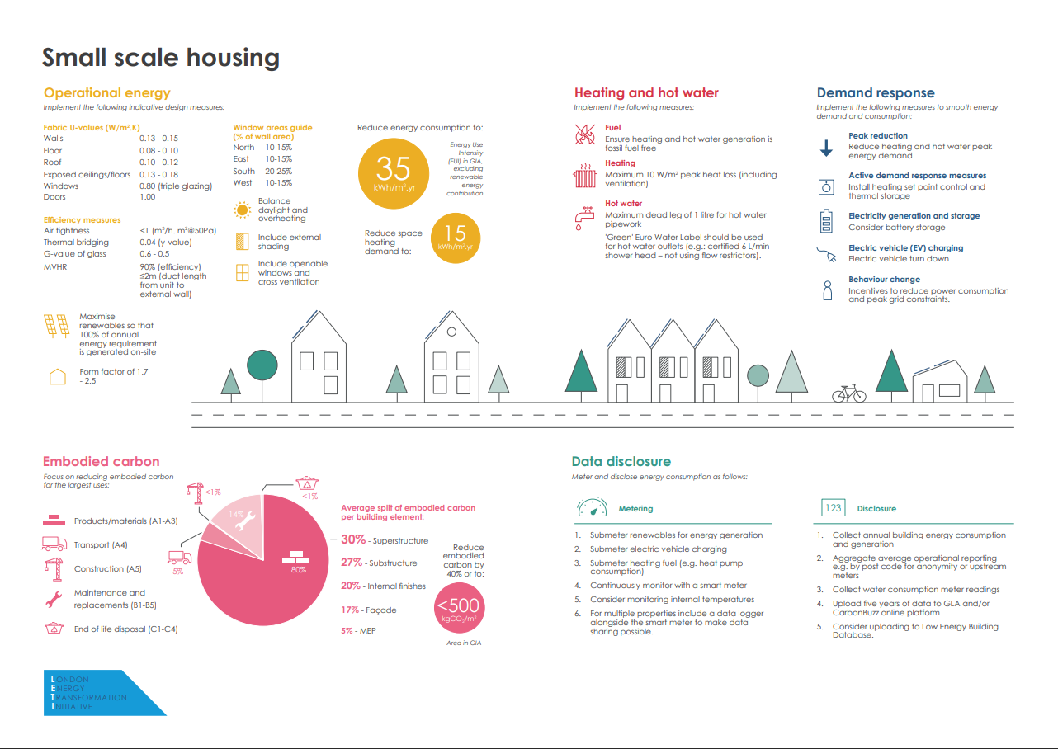
Figure 3 – LETI Small Scale Housing Archetype

A BREEAM rating is a percentage-based score from <30% to 100%, broken into 6 categories:
< 30% Unclassified Non-compliant with BREEAM, or performance below the pass threshold
≥ 30% Pass Top 75% of UK new non-domestic buildings (standard good practice)
≥ 45% Good Top 50% of UK new non-domestic buildings (intermediate good practice)
≥ 55% Very good Top 25% of UK new non-domestic buildings (advanced good practice)
≥ 70% Excellent Top 10% of UK new non-domestic buildings (best practice)
≥ 85% Outstanding Less than the top 1% of UK new non-domestic buildings (innovator)
Figure 4 – BREEAM Rating Benchmarks

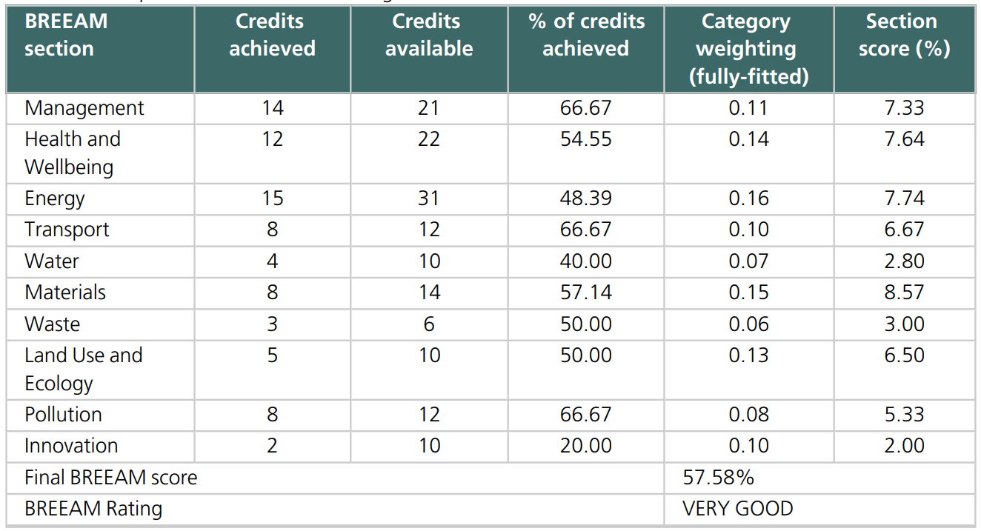
Figure 5 – Example BREEAM Rating Chart

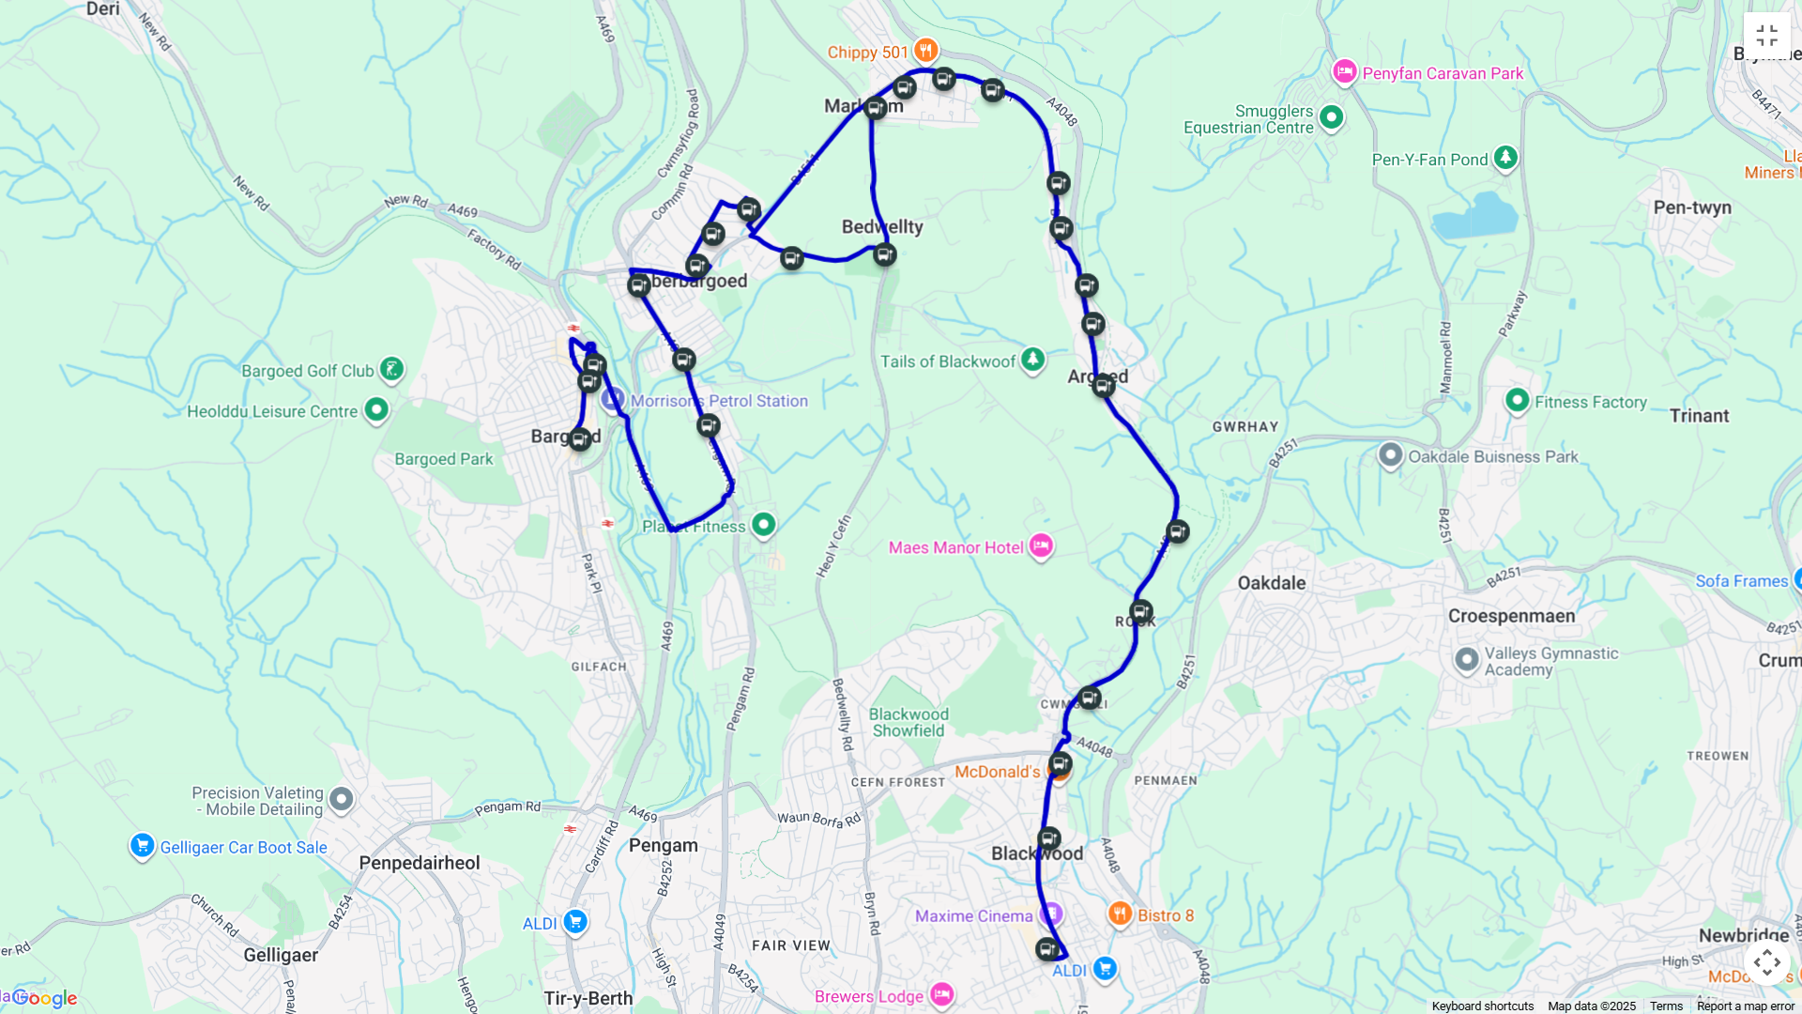
Figure 6 – TFW Bus Route 27

Take Resources

Process/Manufacture
Use
Dispose

Figure 7 - Linear Economy Flow Chart

Take Resources Sustainably

Recycle
Use
Process/
Manufacture

Repair
Reuse
Return
Figure 8 – Circular Economy Flow Chart

BREEAM | Building Research Establishment Environmental Assessment Method
ASHP | Air Source Heat Pump
EPC | Energy Performance Certificate
EPD | Environmental Product Declaration
FSC | Forest Stewardship Council
IAQ | Internal Air Quality
IPCC | Intergovernmental Panel on Climate Change
LCA | Life-Cycle Assessment
LETI | Low Energy Transformation Initiative
MVHR | Mechanical Ventilation Heat Recovery
NOx | Nitrogen Oxides
OPD | One Planet Development
PFA | Pulverised Fuel Ash
PH | Passive House
PHPP | Passive House Planning Package
SUDS | Sustainable Urban Drainage Systems
SWMP | Site Waste Management Plan
Figure 9 – List of Abbreviations

