
InDIVIDUAL BUSINESS MODEL CANVAS WITH ENTREPRENEURIAL
REFLECTION USING APPROPRIATE ACADEMIC MODEL

January 5, 2024
by Mohammed somru miah
For Charlotte joyner

BA International Hotel Management
Module Title and Code: Entrepreneurship BMIH5001

Title of the Essay: Individual Business Model Canvas with Entrepreneurial Reflection using appropriate academic models.
Student Name: Mohammed Somru Miah
Student ID: 2129682
Lecturer Name: Charlotte Joyner
Word Count for part 1: 1549
Word count for part 2: 473

Part 1 Essay: Vegan Vista
The study examines "Vegan Vista" as a hospitality firm concept utilising Business Model Canvas. The essay will defend Vegan Vista's vegan menu and explain BMC. The business aims to serve vegan food and position itself in a competitive market. Current examples and sources, especially from UK hospitality, will be used to study BMC aspects. A finished class approach BMC template is given. The goal is a well-reasoned and imaginative business model that combines sustainability, creativity, and culinary quality beyond vegan restaurant standards.
Vegan restaurant "Vegan Vista," will offer plant-based food. Vegan Vista serves appetisers, salads, mains, burgers, wraps, and desserts. Crispy Edamame Spring Rolls, Spicy Cauliflower Wings, and Avocado Lime Bruschetta promise flavour explosions (Grassian, 2020). Beetroot and Quinoa Salad with mixed greens, almonds, and citrus vinaigrette and Caesar Salad with cashew dressing are available. Delicious Chickpea and Spinach Stew with Turmeric-infused Brown Rice is the main dish. Coconut Curry Lentils are unusual and delectable. Hummus, veggies, and olive tapenade add diversity to the Mediterranean Wrap and Beyond Burger, vegan masterpieces. Vegan Vista serves guilt-free Raw Chocolate Avocado Mousse and Coconut Mango Sorbet (Similarweb.com, 2024). This vegan food is innovative and sustainable, making it tasty and unique.
Strategic partnerships inspired by successful UK companies’ fuel Vegan Vista's success. Secure and diverse supply chains are created by working with local farmers and suppliers like Riverford Organic Farmers (Foreman, 2023). This partnership supports local businesses and ensures Vegan Vista's fresh, high-quality food. Oatly partners with vegan brands to boost sales. Oatly's coffee shop and retailer partnerships have expanded its product line and created a vegan ecosystem. Collaborations' diverse ingredient base and mutual growth network benefit Vegan Vista. Successful businesses like Dishoom show that local partnerships promote community support. Unique interior design, community events, and local artists make Dishoom friendly (Plantsumo.com, 2023). Vegan Vista's eco-conscious and community-minded customers boost community engagement and provide the restaurant an edge.
Vegan Vista has a strong local ingredient supply network like Riverford Organic Farmers. Vegan Vista sources high-quality produce from local farmers and suppliers, supporting local businesses and lowering transportation emissions. Local sourcing strengthens Riverford's supply chain and attracts green customers (Waters, 2018). Vegan Vista needs its cooks. Environmentally responsible packaging suppliers. Vegan Vista uses sustainable packaging like Lush to meet clients' ideals. Eco-friendly firms follow Lush's ethical sourcing and packaging. Fresh, high-quality ingredients, local supplier relationships, and sustainable packaging make great meals. Vegan Vista promotes sustainable dining with Riverford Organic Farmers and Lush. Quality sourcing gives Vegan Vista an edge and complements its ethical and environmental target market.
Vegan Vista is competitive because of its UK-inspired values. Vegan Vista creates vivid Dishoom-inspired decor with local craftsmen. Dishoom's artistic partnerships inspired Vegan Vista's brand and client experience (Gvion, 2021). Vegan Vista follows Dishoom and Ottolenghi's trends. Dishoom, which reinvents classic food, shows how culinary trends keep customers hooked. Events and collaborations make BrewDog a community fixture and promote participation. Its community involvement and collaborations with surrounding businesses set Vegan Vista apart in a competitive market. Menu revisions, collaborations, and community involvement help Vegan Vista beat the hospitality competition.
Successful UK businesses benefit from Vegan Vista's client segmentation. Vegan Vista targets vegans and health-conscious consumers like Pret A Manger. Vegan Vista, like Pret A Manger, capitalises on the global health-conscious and sustainable lifestyle movement by delivering fresh, healthy options (Bryant, 2019). Vegan Vista helps Marks & Spencer grow. Marks & Spencer knows not all customers diet. Cooking adventurers are Vegan Vista's secondary purpose, reflecting Marks & Spencer's diversity. Vegan Vista joins Pret A Manger and Marks & Spencer in wooing vegan, health-conscious, and gastronomic customers. Vegan Vista's wider reach gives them an edge in the plant-based eating market.
Vegan Vista uses successful UK companies to show how sustainable and diverse solutions might help. Vegan Vista's gourmet menu, inspired by Ottolenghi's flavours and textures, defies vegan dining's stigma. Vegan Vista was inspired by Ottolenghi's diverse and delectable dishes to make plant-based dining tasty (Barnes, Singh and Parayitam, 2013). UK-based Riverford Organic Farmers prioritise local, high-quality foods. Vegan Vista supports Riverford's sustainability and local sourcing aims for freshness and local companies. Successful UK companies like Lush value ethics and sustainability. Lush's eco-friendly product sourcing and packaging may give Vegan Vista a restaurant edge.
Vegan Vista's consumer interaction channels are patterned after successful UK companies, showing a diverse approach can work. Vegan Vista is easy to reach with Deliveroo and online reservations. Deliveroo's smooth food delivery influences Vegan Vista's approach to meeting modern consumers' expectations for fast and user-friendly online services. Vegan Vista uses Pret A Manger-inspired social media (Swann, 2022). Pret A Manger engages customers on social media. According to Pret A Manger's online community, Vegan Vista uses social media like modern consumers. Vegan Vista may directly market on social media and online platforms. Vegan Vista's Deliveroo and Pret A Manger-inspired customer loyalty and engagement strategy gives it a hospitality advantage.
Vegan Vista shows how customisation and community-building can set you apart using customer interactions from successful UK companies. Vegan Vista, like BrewDog, wants a brand community beyond food. Vegan Vista engages customers like BrewDog's craft beer community (Warde, Paddock and Whillans, 2020). Personalisation boosts Fortnum & Mason brand loyalty and value. Vegan Vista's customer service matches Fortnum & Mason's upscale stores. Vegan Vista emulates Innocent Drinks' social media reach. Live customer interaction on social media enhances Innocent Drinks' visibility and community. Vegan Vista uses similar customer contact tactics to build loyalty and hospitality.
Vegan Vista's cost structure is based on successful UK companies, showing how judicious investments boost competitiveness. Vegan Vista, like Fortnum & Mason, employs premium ingredients. Fortnum & Mason's quality justified high prices, confirming Vegan Vista's value (Oh et al., 2021). The Fat Duck and other Michelin-starred restaurants teach chefs to maintain quality. Due to The Fat Duck's skilled staff, Vegan Vista's dining experience exceeds expectations. Vegan Vista employs Lush-style eco-friendly packaging. Environmentalism has preserved Lush's reputation. Vegan Vista's sustainability approach matches its target market's beliefs and gives it a hotel sector edge, despite initial expenditures.
Vegan Vista's revenue streams are patterned after successful UK companies, showing how diversification boosts competitiveness. Vegan Vista has a variety of food like Dishoom. The innovative, broad-appeal Dishoom food influenced Vegan Vista's menu sales strategy. Catering revenue forecasts reflect Pret A Manger's UK method (Warde, 2018). Pret A Manger's party catering business has risen. Vegan Vista is expanding like Pret A Manger into catering. BrewDog-inspired local business and event collaborations generate cash. Collaborations and events give BrewDog financial flexibility. Diversifying revenue helps Vegan Vista survive in the competitive hospitality industry.
Industry and customer dynamics inspired Vegan Vista's vegan restaurant. The global health and environmental movement encouraged veganism. Vegan Vista sells well as veganism and plant-based living grow popular. Modern consumer attitudes and industry dynamics showed vegan options were popular (Williams, 2021). Vegan food experiences grew with celebrity sponsorships. This ethical and sustainable customer trend benefited Vegan Vista. Vegan Vista's gourmet vegan status defied the boring vegan food preconception. Plant-based eating alternatives needed to be expanded due to consumer demand and new hospitality cuisine. This demand led to a diverse vegan menu that made plant-based eating delicious. The business used high-quality, local ingredients to meet modern consumer ethical and sustainability criteria. Successful UK Company Riverford Organic Farmers used local sourcing, demonstrating the benefits of local supplier ties (North et al., 2021). It keeps food fresh, promotes local businesses, and decreases transportation carbon emissions.
Sustainable ingredient procurement and packaging were prioritised as environmental responsibility grew. Lush, a sustainable UK cosmetics company, showed how ethical and eco-friendly companies can attract green clients (Neuman, Mylan and Paddock, 2019). Vegan Vista increases attractiveness by meeting gourmet market needs and improving the atmosphere. Vegan Vista caters to vegans, health-conscious people, and sustainable diners. Following the global health-conscious and eco-friendly trend is crucial to consumer retention. Vegan Vista may gain from its main purpose like UK health-conscious retailer Pret A Manger. Including culinary explorers' secondary goal shows market diversity. Marc & Spencer expanded beyond vegan groups to serve a diverse audience. Vegan Vista may adapt to changing tastes and expand its market this way. Vegan Vista's tasty vegan menu follows recent trends. Vegan Vista marketed itself as a gourmet vegan restaurant after Ottolenghi's success with plant-based flavours and textures (Marshall, 2023).
Vegan Vista's online and social media customer service reflects modern consumer behaviours. The business needs a website to accommodate reservations and Deliveroo meal deliveries. Vegan Vista wants to develop a social media community and customer loyalty like Pret A Manger (Lawo et al., 2020). Vegan Vista's menu, chef collaborations, and sustainability are influenced by industry trends and marketing. Dishoom found that local artist ties and dynamic menu revisions boost brand visibility and community participation. Like Lush, Vegan Vista is a socially and environmentally conscientious restaurant. Vegan Vista has a talented cook and local foods. Successful UK enterprises like Riverford Organic Farmers, which works with local suppliers, showed the necessity of good partnerships for a reliable and diverse food supply. Expert chefs make gourmet food at Michelin-starred restaurants like The Fat Duck. High-quality food, experienced staff, and environmental initiatives make Vegan Vista gourmet (Hirth, 2020). Excellence- and sustainability-focused Fortnum & Mason Lush demonstrated how judicious investments may increase long-term income and reputation. Despite pricing, Vegan Vista's sustainability and social responsibility attract customers.

Part 2: Reflective Essay
My in-class entrepreneurial/managerial test scores, especially the GET2 Test and Entrepreneurial Questionnaire, show my entrepreneurial and management ambitions. Gibbs Reflective Cycle will assess my responses and entrepreneurial mind-set (Bulman and Schutz, 2013). I took an in-class management and entrepreneurship quiz. The test covered labour procedures, problems, and company decisions. My replies were graded for each circumstance. This comprehensive analysis of my entrepreneurial thinking shows my decision-making, problem-solving, and leadership (Barringer and Ireland, 2018). The quiz dynamically captured my entrepreneurial and managerial mind-sets by using real-life situations.
I feel numerous sensations when I see my results. My 41 Entrepreneurial Questionnaire score shows my entrepreneurial skills. This suits my love of challenges, responsibility, and innovation. My GET2 Test shows entrepreneurial intricacy. Mixed thoughts show my strengths and prospects. Entrepreneurial complexity, strengths, and growth are highlighted. Being self-aware helps my entrepreneurial strategy (Williams, 2021).
My 67% Need for Achievement score indicates a strong drive to achieve tough goals. The Entrepreneurial Questionnaire says I like responsibility and challenge. It shows my personal and professional goals. An interesting autonomy need score of mine is 33%. Though I like responsibility and challenge, I prefer autonomy. This may be because ambitious goals require teamwork. The Creative Tendency score of 58% suggests moderate creativity. This matches my questionnaire response to explore business plans before adopting them. Innovation and informed decision-making matter (Zimmerer, 2011). Calculated Risk-taking score: 67%, suggesting I take risks cautiously. If a loan is denied, I will scale back plans and proceed without borrowing money, exhibiting strategic and risk-conscious action. 42% Locus of Control scores balance internal and external control. Others and I affect things. My flexibility and event learning may improve.
Results indicate a full entrepreneurial attitude. My appreciation for teamwork and external circumstances tempers my drive for goals and strategic risks. This entrepreneurial balance is resilient and adaptable (Mariotti and Glackin, 2010). I am a good entrepreneur because of my ambition, logic, and collaboration. Recognising self and external influences improves flexibility and foresight. This study demonstrates that a sustainable entrepreneurial approach combines personal and commercial skills.
Finally, I have diversified entrepreneurial and management styles. I take calculated risks like successful firms. My ambition, creativity, and nuanced sense of autonomy and authority make me a successful entrepreneur (Warde, Paddock and Whillans, 2020). Entrepreneurship is difficult and uncertain, but I approach success and innovation with calm and logical thought. This conclusion boosts my faith in my well-rounded entrepreneurial skills and success chances.
Goal-setting, smart risk-taking, and innovation will boost my business career. I blend autonomy with collaboration because balance is vital. Personal responsibility and teamwork are needed. Entrepreneurship is fluid, thus my plan prioritises learning and adapting (Warde, 2018). Continuous education will keep me abreast of industry trends. I will adapt to entrepreneurship. This action plan helps me use my strengths and become more entrepreneurial.

References
Barnes, N.G., Singh, B.R. and Parayitam, S. (2013). New England Indic restaurants business and culture: an exploratory empirical study. International Journal of Indian Culture and Business Management, 7(3), p.336. doi:https://doi.org/10.1504/ijicbm.2013.056212 [Accessed 28 January 2024].
Barringer, B.R. and Ireland, R.D. (2018). Entrepreneurship : Successfully Launching New Ventures. 4th ed. New York, Ny: Pearson.
Bryant, C.J. (2019). We can’t keep meating like this: Attitudes towards vegetarian and vegan diets in the United Kingdom. Sustainability, [online] 11(23), p.6844. doi:https://doi.org/10.3390/su11236844 [Accessed 27 January 2024].
Bulman, C. and Schutz, S. (2013). Reflective Practice in Nursing. 5th ed. Hoboken: Wiley-Blackwell.
Foreman, P. (2023). British Restaurant Awards Unveils Its Top 10 Vegan-Friendly UK Eateries. [online] Plant Based News. Available at: https://plantbasednews.org/lifestyle/food/british-restaurant-awards-vegan-friendly/ [Accessed 1 February 2024].
Grassian, D. (2020). The Dietary Behaviors of Participants in UK-Based Meat Reduction and Vegan Campaigns – A Longitudinal, Mixed-Methods Study. Appetite, 154(0195-6663), p.104788. doi:https://doi.org/10.1016/j.appet.2020.104788 [Accessed 30 January 2024].
Gvion, L. (2021). Vegan restaurants in Israel: health, environmentalism and mainstreaming. Food, Culture & Society, pp.1–18. doi:https://doi.org/10.1080/15528014.2021.2015941 [Accessed 29 January 2024].
Hirth, S. (2020). Food that Matters: Boundary Work and the Case for Vegan Food Practices. Sociologia Ruralis. doi:https://doi.org/10.1111/soru.12317 [Accessed 31 January 2024].
Lawo, D., Esau, M., Engelbutzeder, P. and Stevens, G. (2020). Going Vegan: The Role(s) of ICT in Vegan Practice Transformation. Sustainability, 12(12), p.5184. doi:https://doi.org/10.3390/su12125184 [Accessed 1 February 2024].
Mariotti, S. and Glackin, C. (2010). Entrepreneurship : starting & operating a small business. 3rd ed. New York: Pearson Education.
Marshall, H. (2023). Vegan Children in English Secondary Schools: Challenging Norms and Personal Impacts. chesterrep.openrepository.com. [online] Available at: https://chesterrep.openrepository.com/handle/10034/627937 [Accessed 28 January 2024].
Neuman, N., Mylan, J. and Paddock, J. (2019). Exploring (non‐)meat eating and ‘translated cuisines’ out of home: Evidence from three English cities. International Journal of Consumer Studies. doi:https://doi.org/10.1111/ijcs.12542 [Accessed 29 January 2024].
North, M., Kothe, E., Klas, A. and Ling, M. (2021). How to define ‘Vegan’: An exploratory study of definition preferences among omnivores, vegetarians, and vegans. Food Quality and Preference, [online] 93, p.104246. doi:https://doi.org/10.1016/j.foodqual.2021.104246 [Accessed 1 February 2024].
Oh, M. (Moon), Badu Baiden, F., Kim, S. (Sam) and Lema, J. (2021). Identification of Delighters and Frustrators in Vegan-friendly Restaurant Experiences via Semantic Network Analysis: Evidence from Online Reviews. International Journal of Hospitality & Tourism Administration, pp.1–28. doi:https://doi.org/10.1080/15256480.2021.1981186 [Accessed 1 February 2024].
Plantsumo.com (2023). Top 10 Vegan Restaurants, UK | Checkout our Awesome List! [online] Available at: https://plantsumo.com/vegan-restaurants-in-the-uk/ [Accessed 29 January 2024].
Similarweb.com (2024). Top Vegetarian and Vegan Websites in United Kingdom Ranking Analysis for December 2023. [online] Available at: https://www.similarweb.com/top-websites/united-kingdom/food-and-drink/vegetarian-and-vegan/ [Accessed 30 January 2024].
Swann, I.P. (2022). Beyond Vegan: Producer and Restaurant Involvement in the Mainstreaming of Plant-Based Meat. Sociology Honors Projects. [online] Available at: https://digitalcommons.macalester.edu/soci_honors/68/ [Accessed 1 February 2024].
Warde, A. (2018). Changing Tastes? The Evolution of Dining Out in England. Gastronomica: The Journal of Critical Food Studies, 18(4), pp.1–12. doi:https://doi.org/10.1525/gfc.2018.18.4.1 [Accessed 1 February 2024].
Warde, A., Paddock, J. and Whillans, J. (2020). Landscape of variety. [online] www.manchesterhive.com. Available at: https://www.manchesterhive.com/display/9781526134769/9781526134769.00021.xml [Accessed 28 January 2024].
Waters, J. (2018). A model of the dynamics of household vegetarian and vegan rates in the U.K. Appetite, [online] 127, pp.364–372. doi:https://doi.org/10.1016/j.appet.2018.05.017 [Accessed 30 January 2024].
Williams, S. (2021). The Financial Times guide to business start up 2021/2023 : the most comprehensive guide for entrepreneurs. Harlow, England ; London ; New York: Pearson.
Zimmerer, T.W. (2011). Essentials of entrepreneurship. 6th ed. Pearson Custom.

Appendix
BMC
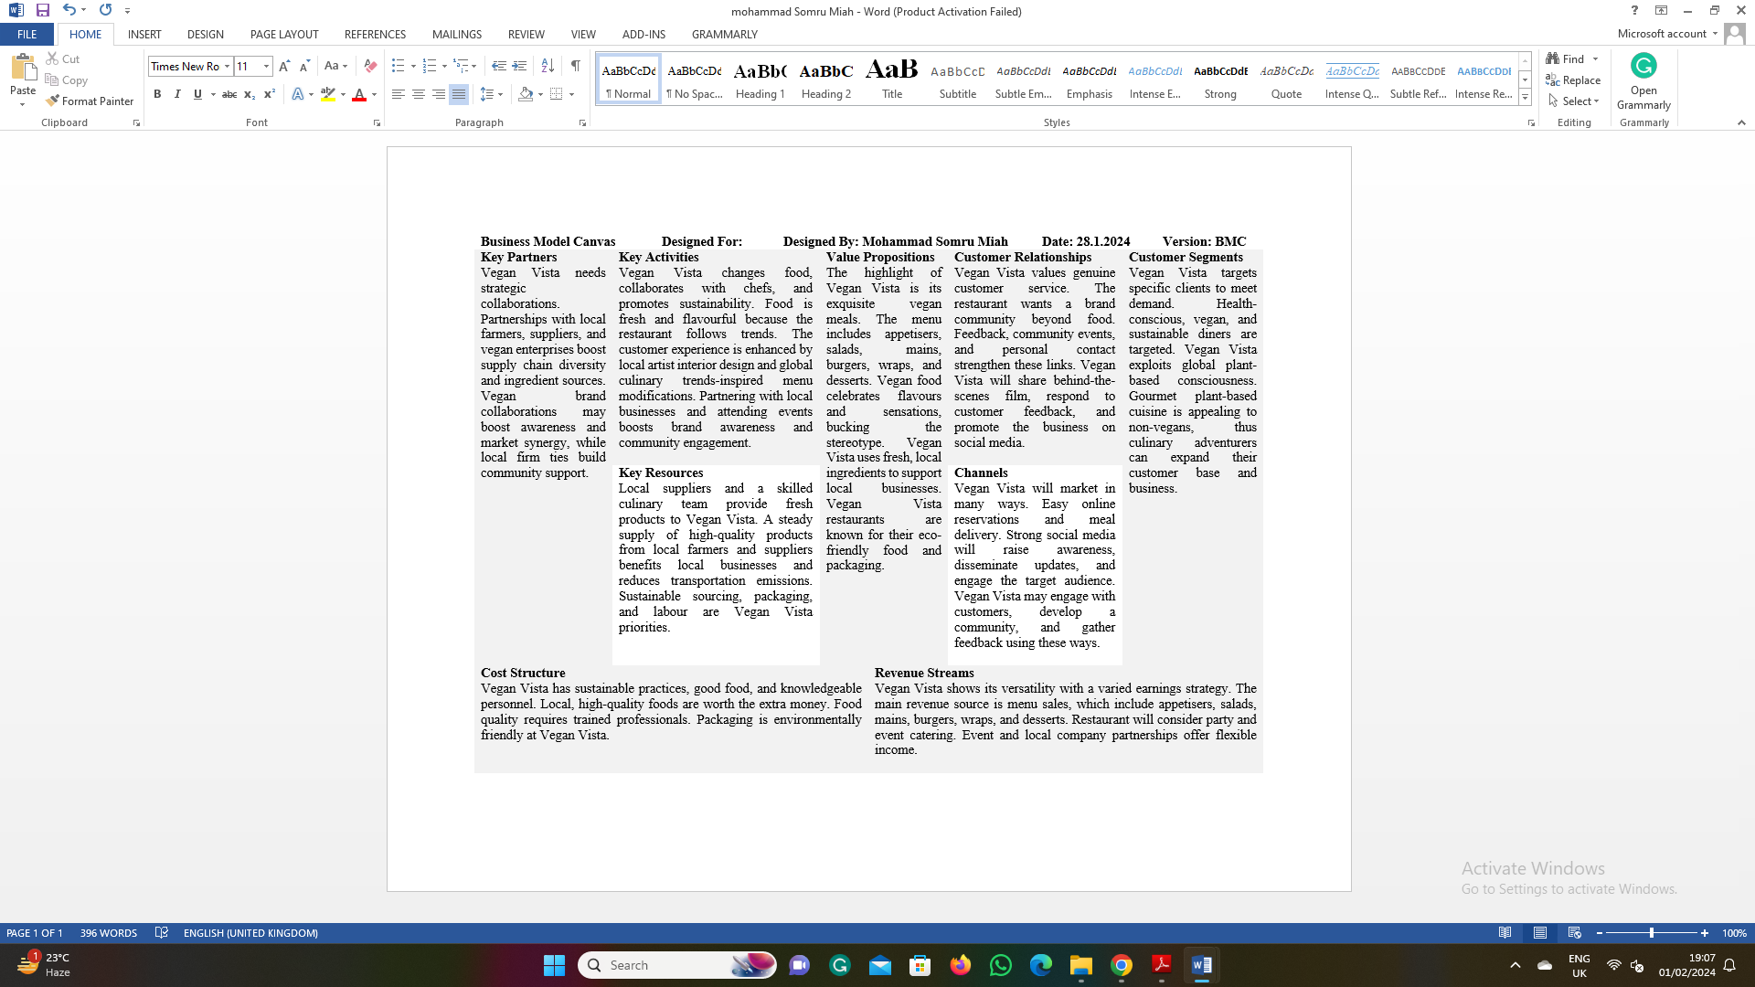
GET2 Result
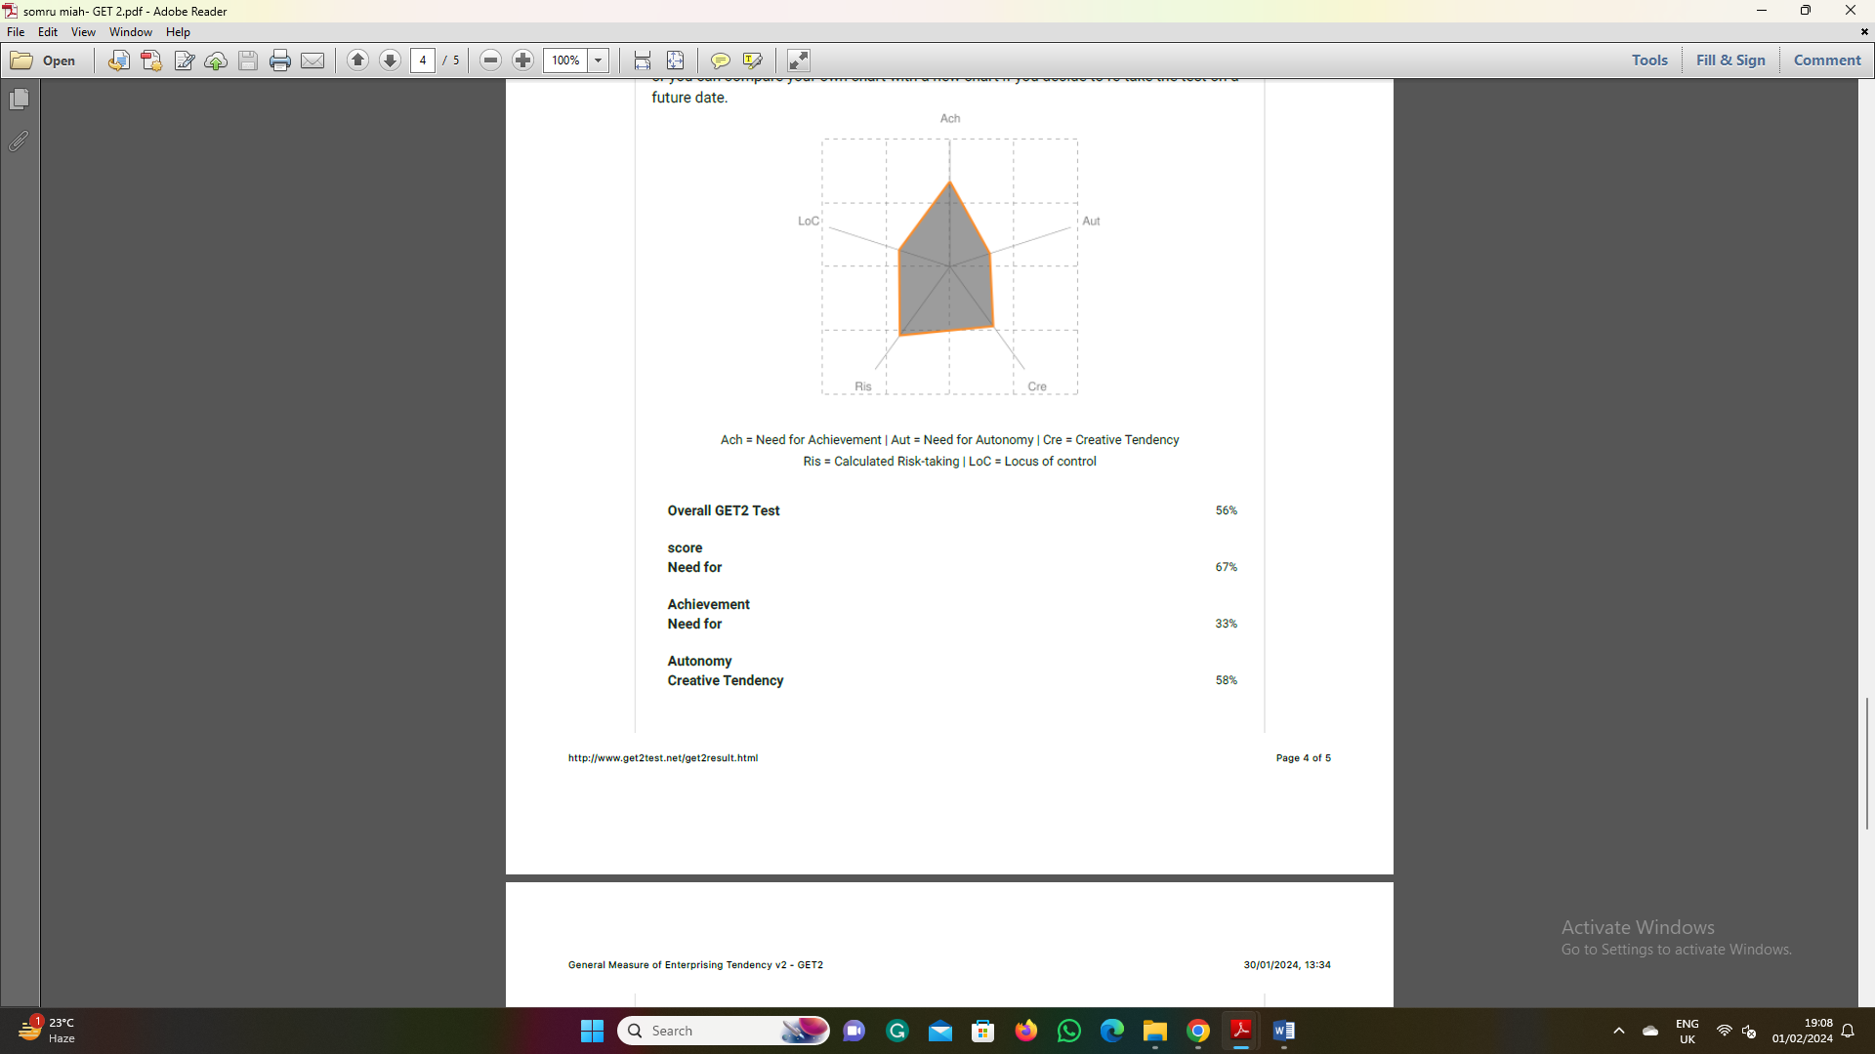
Entrepreneur questionnaire result


