

STUDENT NAME: Joyce Ebihor
STUDENT ID: 2323239
MODULE NAME: CHANGEMAKERS: BUILDING YOUR PERSONAL BRAND FOR SUSTAINABLE EMPLOYMENT
MODULE CODE : BMHP5015
LECTURER: BRIAN MASHUMBA

Table of Contents
Introduction
Reflection on Unit 1: Personal branding
Reflection on Unit 2: It’s a Small World
Reflection on Unit 3: Opportunity Knocks
Reflection on Unit 4: The Pursuit of Happiness
Conclusion
References
Appendix: Job vacancy at the Royal Trinity Hospice

Introduction
The "Changemakers: Building Your Brand for Sustainable Employment" session gives an effective lifelong experience, which is crucial for developing my personal and professional development ideas as well as practices. This study has included some major important aspects such as personal branding, networking strategy, boundaryless careers and emotional intelligence principles. The study also explained the career role models, as it helps the reader understand how to change their career path and the reasons behind their career choices. The units supported me to gain the required knowledge about changing the modern workplace by teaching resilience, continuous improvement and adaptability. This unit builds my skills more effectively and helps me to use these learned resources in future professional development. I have worked as a healthcare Assistant in the Royal Trinity Hospice, which helped me to develop my personal branding strategy. In this session, I worked mainly under the guidance of a registered nurse, where I served high-quality and compassionate physical, psychosocial and spiritual care for patients.

Reflection on Unit 1: Personal branding
During the health and social care session at the Royal Trinity Hospice, I have carried out a broader set of care and assisted in the progress as specified in the patient’s plan of care. I have also participated in the ongoing training provided by Royal Trinity to achieve the competence required for the role (Maddux, 2016). Basically, I think I am quite responsible towards my work, and I do not let any kind of activity for others to complete. During my unit work, I have experienced providing health care for patients in a health or social care setting, and recognising the requirements of a terminally ill patient, able to define empathy and understanding of the challenges experienced both by people initiating the end of life and those close to them and enjoy working as part of a nursing team. From this session, I developed an understanding of teamwork, which is my greatest strength, enabling me to adapt to any kind of environment easily.
Health and Social Care is always driving me as I grow into a healthcare family where my mother is a nurse who has always taken care of her patients. Especially during the COVID-19 pandemic situation, I experienced how my mother took care of her patients, and also took care of herself to prevent the COVID-19 virus. She is always aware of her work, and after work she takes the bath and washes her clothes in detergent to protect our families.
Health and social care assistant job brainstorming my ambition due to my eagerness to serve individuals physical and mental support for their well-being (Supported by unit materials). Healthcare assistants are playing a crucial role across society to improve the quality of life, promote social cohesion, assist the vulnerable population and are also crucial for a productive economy. After completing the BSc (Hons) in Health and Social Care degree, I can easily join the health and social care industry due to my internship.
Charlie’s motivation increased the amount of autonomy in health and social care, which increases self-awareness and supports the health care assistant to follow the policy to “choose right and refuse the treatment, such as informed consent, best interests vs the personal values (Roy, 2008).
Self-determination theory is a motivational framework that consists of competence, autonomy, and relatedness. In health and social care, this theory increases the sense of choice among the patients, feel effective and capable in their environment and also feel connected to (Huang et al. 2022)
In health and social care, the Johari window was used to improve communication and self-awareness between the parishioners and health care professionals, and this framework influenced my approach towards developing communication skills and helping the patient to feel safe (Mukherjee et al. 2023). In the open area, I was academically eligible for this post and able to take care of patients. In the blind spot, during this session, I have unintentionally irritated a patient by raising high queries. In the hidden areas, I was nervous and sometimes I felt shirked due to a lack of proper confidence and professional skills. Throughout my life experiences, I was not part of the problem-solving approach; it is also unknown to me how capable I am of handling any complexities (Arthur et al. 2005). Therefore, I felt that Mastery in applying, communicating, and understanding the significance of diversity and variation in structuring life experiences in practice as well.
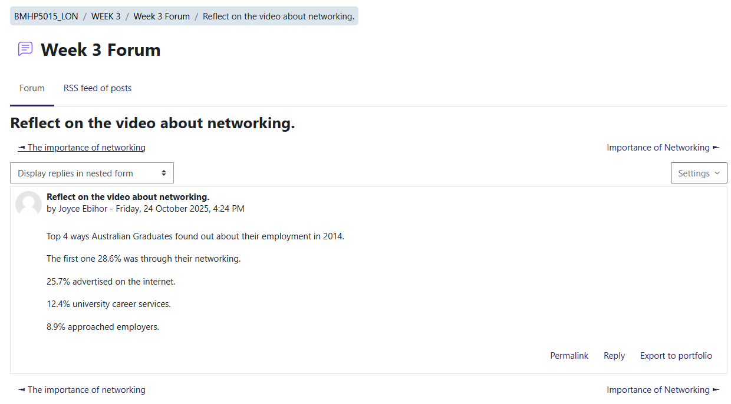
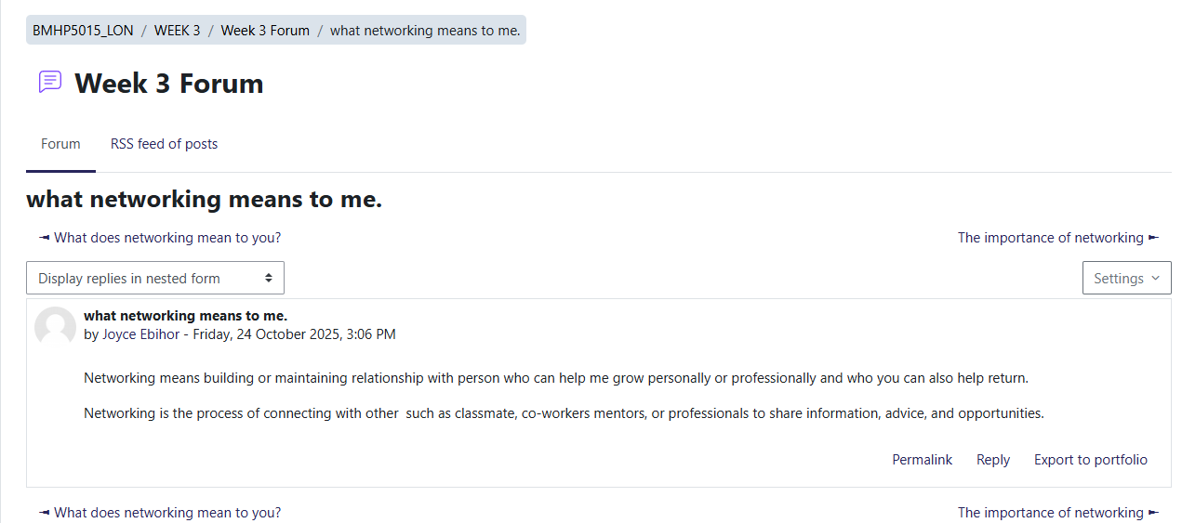
(Screenshots of online activities)

Reflection on Unit 2: It’s a Small World
Networking and making connections play a crucial role in accelerating professional growth in health and social care. Therefore, global connection, cultural competence, and diversity are interconnected with each other, vital for giving equitable and effective health and social care. I understand the value of a global connection to related health and social care, as diseases and determinants that cross national borders, such as infectious diseases, including the COVID-19 pandemic (Bury, 2013). I realised through the global connection, knowledge is also transferred, such as research, methods and best practices. The communication power of the web, which increased the knowledge and sharing as well. COVID-19 vaccination is an example of a global connection which I covered in Unit 2 (Sheikh et al. 2021). Personal characteristics (race, gender), socioeconomic factors (such as education level, and geographic location), experiences and perspectives (different worldviews, beliefs, and communication style) are the traits of diversity which help in healthcare to make patients feel they are in safe hands, increase problem solving and enhance patient outcomes (Supported by unit materials). Cultural knowledge and cultural skills expanded to include approaches like cultural humility, which involves self-reflection and a commitment to lifelong learning.
During this session, I also understood the Bureaucratic and Hierarchical concept, where the term bureaucracy refers to a complex organisation that has multilayered systems and processes (Whiting and de Janasz, 2004). On the other hand, hierarchy is a system in which people or things are put at various levels or ranks according to their importance.
My personal experience serves as an important foundation for recognising the global issue in health and social care, such as direct exposure to health crises. Living through a global health crisis, including the COVID-19 pandemic, can powerfully explain the interconnectedness of global health as well. As an illustration, a person has a low income, and a lack of proper background leads towards inequality, which causes measurable health disparities. On the other side, I also noted that across the remote areas, integration of digital tools such as telemedicine and mobile health applications is bridging the gap.
Hofstede’s Cultural Dimensions is an effective framework which helps to identify how cultural differences affect social interactions and business by contrasting a society's perspectives on hierarchy, group vs. individual focus, gender roles, risk, time orientation, and emotional restraint (Zidkova et al. 2025). In healthcare, this framework supported the healthcare assistant to communicate with the patients to make treatment decisions and health-seeking behaviours.

Reflection on Unit 3: Opportunity Knocks
Unit 3 helped to identify career opportunities and addressed the changing perspective in health and social care, which is important.
In this regard, the serendipity mindset in health and social care could be, as an illustration, a healthcare professional observing an unexpected development in a patient’s situation after a new treatment has been implemented for a different condition (Heinström and Sormunen, 2020). Health care is highly focused on the integration of technological tools to create opportunities in healthcare, such as informatics, telehealth, and electronic health records management.
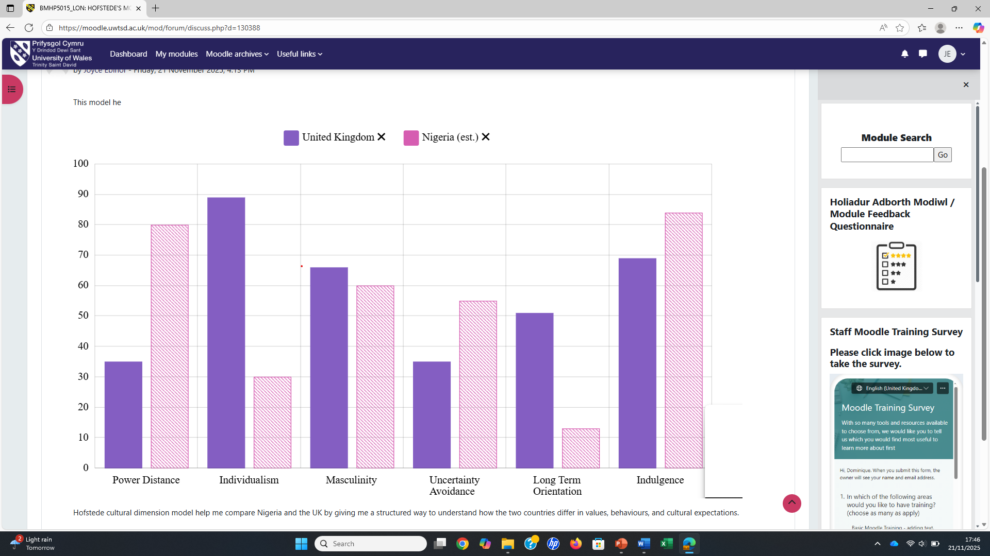

SMART Goals
Specific | Measurable | Achievable | Relevant | Time-bound
Enhanced the clinical skill | Engage in clinical activities and academic development | Obtained a certified qualification in dementia care | Improved specialised support for vulnerable clients" | Within 6 months
Developed the leadership skill | Attend the leadership activities | Participate in the online leadership and management course | Host as a leader in the group activities | 12 months
Expand the professional network | Joint relevant professional body | attending a healthcare conference | Connect with at least three new peers and a potential mentor | Six months
Increased communication skills | Attend communication skill workshops | Implement an effective active listening strategy | Seeking feedback from the mentors or the supervisor | Six months
Table 1: SMART goal
(Source: Self-developed)
During the completion of this unit, I found that Royal Trinity Hospice is highly focused on digital tool training initiatives to become a specialist in the new digital system. I also developed excellent communication skills and can work collaboratively with all members of the multidisciplinary team.
Gibbs reflective cycle has been defined in this perspective to illustrate my journey during my “Changemakers: Building your Personal Brand for Sustainable Employment” unit, which is defined as follows
Description: worked as a health care assistant and was responsible for managing a multi-professional team and coping with the demands of working on the inpatient unit at the hospice, and providing excellent patient care and understanding the needs of a terminally ill patient (Akinlotan, 2024).
Feeling: Initially, I felt nervous, but my supervisor was too kind to me and helped to manage my activities.
Evaluation: I handled the patients by following autonomy and handled them calmly.
Analysis: Initially, I felt nervous and did not understand how to communicate with them.
Conclusion: I learned excellent communication during this situation (Amir, H., Permatananda, P.A.N.K., Cahyani, D.D., Langelo, W., Rosita, R., Sajodin, S., Noprianty, R., Astuti et al. 2023).
Action plan: Taken an online course to boost my performance, such as communication.
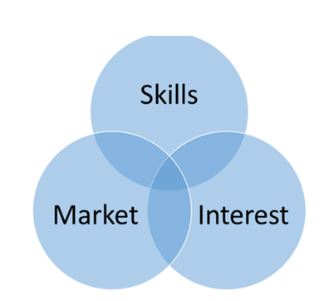
Figure 1: Individual task
(Source: Week Activities)
As an illustration of the self-determination theory, a case study has been shared (Bhatti et al. 2021). In Health and Social Care, Sheena, a 26-year-old graduate with a BSc Honours, is jumping into an important career transformation. Instead of not having direct work experience in health and social care, her role as a teaching assistant during her studies has given her valuable skills. Now, Sheena is determined to build her career in health and social care. (Supported by unit materials)” (Heinström and Sormunen, 2020).
Professional online presence in health and social care
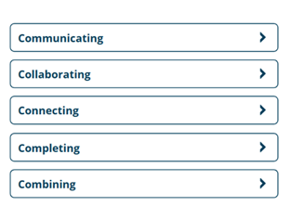
Figure 2: Five Cs
(Source: week notes)
The five Cs approach is important in health and social care for communicating and collaborating with patients (Aveyard, 2023). Therefore, this “connecting approach” helped the health care assistant to feel connected and improve the completion of work, which also increased the patient outcomes. The healthcare sector is now combining the patient care and telemedicine approach to bridge the innovation gap across remote areas (Refer to the lecture notes).

Reflection on Unit 4: The Pursuit of Happiness
The perspectives of wellbeing, resilience, and work-life balance are the major fundamentals for personal fulfilment and sustainable success. Defined by WHO, well-being is a state where mental, physical and social well-being exists and not merely the absence of conformity. On the other hand, resilience refers to the ability of an individual to accept a certain environment in the face of adversity, stress, trauma, threats or significant stressors. I have learned how work-life balance is important in professional life as it helps to meet the demands of one's professional and personal life, and also is able to increases well-being and life satisfaction. My personal and professional development has been structured by implementing the principles connected to well-being, resilience, and work-life balance. However, I sincerely include these concepts in my life, driving discernible growth and improvement (Supported by unit materials).
Based on the resilience theory, in my professional career, I found different kinds of stress or pressure, like deadlines, and unexpected challenges as well. Instead of taking this pressure as a setback, I took this as an opportunity to improve my learning excellence (Suslovic and Lett, 2024). My professional skill is not just about technical skill; it is also about managing my stress and preventing burnout.
Bandura’s theory is health and social care focused on observational learning and role modelling to teach and structure the professional behaviour and client behaviour as well (Koutroubas and Galanakis, 2022). Professionals' learning skill, behaviour, and attitudes needs to be observed by others to shape their connection with the patients in the training period.
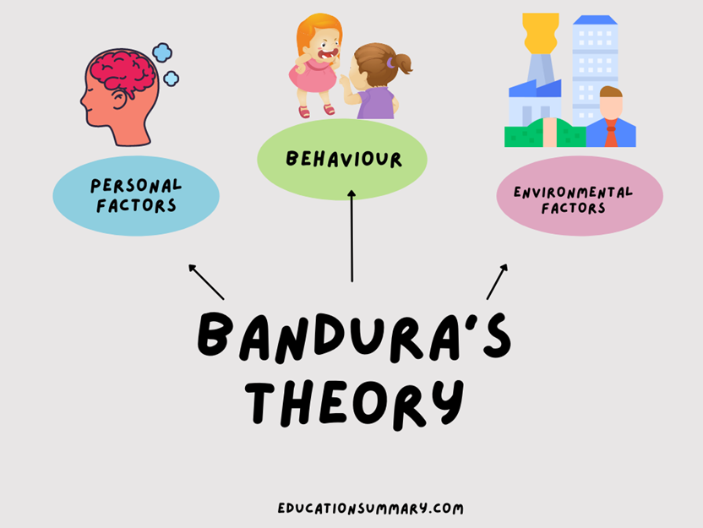
Figure 3: Bandura’s theory
(Source: Refer to the lecture materials)

Conclusion
The study concluded that in a professional career, especially in health and social care, observational training is required to shape the attitudes and behaviour of the healthcare assistants. Therefore, promoting well-being, diversity, and work-life balance is necessary in the healthcare sector to fulfil the satisfaction level among the employees, build resilience with patients and develop the patients' outcomes as well. Global connection and networking is required to share the knowledge of disease, innovation process, method and strategy for further management.

References
Akinlotan, O., 2024. Leading and managing a multidisciplinary team in health and social care: a critical and personal reflection. British Journal of Nursing, 33(12), pp.560-564.
Amir, H., Permatananda, P.A.N.K., Cahyani, D.D., Langelo, W., Rosita, R., Sajodin, S., Noprianty, R., Astuti, A., Suhari, S., Wahyuningsih, S. and Kusumawati, P.D., 2023. Enhancing skill conceptualization, critical thinking, and nursing knowledge through reflective case discussions: a systematic review. Journal of medicine and life, 16(6), p.851.
Arthur, M.B., Khapova, S.N., Wilderom, C.P. (2005) Career success in a boundaryless career world. Journal of Organizational Behavior: The International Journal of Industrial, Occupational and Organizational Psychology and Behavior. 26(2), pp.177-202.
Aveyard, H., 2023. Ebook: Doing a Literature Review in Health and Social Care: A Practical Guide 5e.
Bhatti, S., Rayner, J., Pinto, A.D., Mulligan, K. and Cole, D.C., 2021. Using self-determination theory to understand the social prescribing process: a qualitative study. BJGP open, 5(2).
Bury, M., (2013). Health and illness in a changing society. Routledge.
Heinström, J. and Sormunen, E., (2020). Serendipity as chaos or discovery-exploring the role of personality and sense of coherence.
Huang, H., Wang, H.H., Donaghy, E., Henderson, D. and Mercer, S.W., (2022). Using self‐determination theory in research and evaluation in primary care. Health Expectations, 25(6), pp.2700-2708.
Koutroubas, V. and Galanakis, M., 2022. Bandura’s social learning theory and its importance in the organizational psychology context. Psychology, 12(6), pp.315-322.
Maddux, J.E., (2016). Self-efficacy. In Interpersonal and intrapersonal expectancies (pp. 41-46). Routledge.
Mukherjee, D., Pahwa, V., Moza, B., Ujjainia, P., Kaur, K., Kaur, K. and Pathak, S., 2023. The influence of personality traits on johari window perception and self-disclosure in the workplace. International Journal of Forensic Medicine and Toxicological Sciences, 8(3), pp.100-107.
Roy, S.K., (2008) Identifying the dimensions of attractiveness of an employer brand in the Indian context. South Asian Journal of Management, 15(4), pp.110-130
Sheikh, A., Anderson, M., Albala, S., Casadei, B., Franklin, B.D., Richards, M., Taylor, D., Tibble, H. and Mossialos, E., (2021). Health information technology and digital innovation for national learning health and care systems. The Lancet Digital Health, 3(6), pp.e383-e396.
Suslovic, B. and Lett, E., 2024. Resilience is an adverse event: A critical discussion of resilience theory in health services research and public health. Community Health Equity Research & Policy, 44(3), pp.339-343.
Whiting, V.R. and de Janasz, S.C., 2004. Mentoring in the 21st century: Using the internet to build skills and networks. Journal of Management Education, 28(3), pp.275-293.
Zidkova, R., Furstova, J., Malinakova, K., van Dijk, J.P., Tavel, P. and Gulis, G., 2025. National cultural characteristics as defined by Hofstede’s dimensions and their associations with population health. BMC Public Health, 25(1), p.1879.

