Financial analysis & decision making
NAME:JATIN PARMAR
STUDENT ID NO: 1705600
MODULE TITLE: FINANCIAL MANAGEMENT(LCMB7002)
ASSIGNMENT TITLE: FINANCAL ANALYSIS AND DECISION MAKING ASSESMENT 1
LECTURER’S NAME: ISAIAH OINO

Executive Summary:
Decision making with respect to stock investment is a very complicated process as the process of decision making mainly depends upon two factors; one is the psychological factor or bias of the investor and another is the analysis of the financial performance of the shortlisted organizations that has been chosen for investment. The psychological factor mainly describes the notion of the investor with respect to his risk taking capabilities. One thing should be noted that if the investor is looking for higher return on stock then he must have a higher level of risk appetite because the higher return is always related with higher risk(Levy, 2015). There are different models that can be applied for describing the risk return trade off and if the investor is trying to choose particular level of return on the basis of the calculated risk then these models can be applied. In the present case scenario following psychological factor it can be seen that the investor is having a low risk appetite and looking for moderate rate of return, but the return must be a secured one. As a part of the decision making process in the current scenario the investor has gathered relevant information and has identified the preferred industry segment where he wants to invest and also have narrowed down to the two companies and will choose one of the alternative company for stock investment in order to fulfil his purpose of earning secured return(Fahlenbrach, 2009). However he is looking for the expert advice from the financial investor for choosing the right alternative where by investing he will be able to earn maximum return along with the minimization of the associated risk

Table of Contents
Introduction: 5
Implication of Ratio Analysis In Financial Decision Making 6
a) 6
Financial analysis of the companies 6
Description of the current financial position and comparisons (2017) 6
Analysis of historical financial position & comparison (2015, 2016) 12
b) 16
Portfolio development suggestion to the investor as per his risk attitude 16
Aspects of results from ratio analysis to be considered 16
Conclusion & Guidelines of Portfolio development 17
Risk attitude of the investor 17
Portfolio Investment suggestions: 18
Part-B: 19
Introduction: 19
Determine the Payback and the Net Present Value (NPV) of the two proposals 20
Determination of NPV 20
Determination of PAY BACK PERIOD 21
b) 22
Determine the Accounting Rate of Return (ARR) for each project 22
C) 22
Evaluation of the results of Part-a & Part-b 22
Recommendation regarding the selection of the project 23
d) 24
Critical discussion of the advantages and shortcomings of the PAYBACK & NPV techniques as ways of project appraisals 24
Disadvantage: 24
NPV 25
e) 26
The non-financial factors that need to be considered in investment appraisal process: 26
Conclusion: 27
Reference: 28
Appendix: 32

Introduction:
World Wealth Management is an asset management company that is in the business of delivering valuable advice to their HNI(High Net Worth ) clients so that they can allocate their money in the most appropriate way in the underlying assets that will form the portfolio. In other words the experts of the World Wealth Management deliver valuable advice regarding portfolio management to their clients.MR Tim Farrow is one of the HNIs of the company who is looking for some advice for portfolio investment and the investment will be done in the stocks of the chosen companies in such a way so that he will be able to earn secured return and he is also trying to make the investment in such a way so that the market volatility risk associated with the stock investment should be minimised as much as possible. Mr. Farrow has already chosen the two positive alternatives for making the investment and the chosen alternative companies are William Hill Plc & Paddy Power Betfair Plc.
The organization William Hill Plc is one of the world leaders in the betting and gaming industry and also one of the most trusted brands of the Uk betting and gaming industry. The company is the holder of the 28% market share of the industry and the largest land-based bookmaker of UK (as per 2017 data) as the organization is running around 2,342 licensed betting shops in UK. The organization is employing around 160000 employees across the globe and earned a revenue of 1711 million pound in 2017(William Hill Plc, 2018).
The organization Paddy Power Belfair Plc is developed with the merger between the Paddy Power and Belfair. The organization is among one of the global leaders in the segment of the international sports betting and gaming operator and a part of the FTSE 100 index of the London Stock Exchange. The organization employs around 7000 employees and earned an annual revenue of 1745 million GBP in 2017(Paddypowerbetfair.com, 2018).
Thus both the organizations are promising from the point of view of the financial investments and it is difficult for MR. Farrow to choose one of the organizations and MR Farrow is looking expert help from the financial advisor of World Wealth Management for choosing one of the alternatives for stock investment. The financial advisor of World Wealth Management has decided to apply the tool of ratio analysis for analysing the financial performance of the two companies for the three accounting periods so that a comparative & comprehensive picture can be drawn in front of the client so that the client can be convinced to choose one of the alternative companies for portfolio stock investment(Clemen and Reilly, 2013).

Implication of Ratio Analysis In Financial Decision Making
The tool of Ratio analysis is an essential tool for understanding the financial statements and to identify the trend of financial performance over time with respect to the business. These quantitative tools are often used to identify the positive or the negative performance trends with respect to the business when the ratios are calculated over several successive accounting periods. The trend of performance of a business help an investor to assess the average level of efficiency of the business in generation of wealth which indicates the potential capability of the business to generate return over the investment that has been invested by the share holders of the company. The ratio analysis is also capable to draw a comparative picture of financial performance for a chosen organization where the comparison has been done with respect to another company of the same industry or with the industry benchmark .Because of these advantages the ratio analysis is viewed as the most, useful tool for the purpose of investment decision making and financial planning.

a)

Financial analysis of the companies

Description of the current financial position and comparisons (2017)

Ratios related to profit generation:
In order to assess the relative potential between the two companies a discussion has been held regarding the profit generation capacity of the two companies with respect to the different profitability ratios which are “Gross Profit Margin”, “Net Profit Margin”, “ROA or Return On Asset” and the “ROE or Return On Equity”
Gross Profit Margin:
The gross profit margin with respect to an organization defines the proportion of sales revenue earned by the organization in a particular accounting period has been converted in to gross profit in that accounting period. So higher will be the ratio grater will be the capacity of the organization in converting the revenue in to gross profit and grater will be the efficiency of the company to minimise the direct cost associated with the sales that has generated the revenue(Gibson, 2011).
Now looking at the gross profit ratios of 2017 it can be seen that the gross profit margin of both the companies are almost same as the ratio is 76% for William hill plc and 77% for Paddy Power Betfair PLC. The ratios describes that so far as efficiency with respect to generation of gross profit is concerned, both the companies are equally capable.
Net Profit Margin:
The Net Profit Margin ratio describes the proportion of the sales revenue that has been converted in the net profit. The higher ratio indicates the higher capability of the company in generation of net profit and retained earnings that can be used by the company for paying dividend. Besides, a higher ratio also indicates that the EPS [Earnings per share ] with respect to the company will also be quiet high(Biddle et al.,2009) .
The net profit margin of William hill plc is 14% and that of Paddy Power Betfair PLC is ,of 12% .Therefore the net profit margin ratio indicates that the William hill plc is slightly more capable than Paddy Power Betfair PLC with respect to generation of surplus earnings as described by the ratios of 2017.
ROA or Return On Asset:
The ROA or “Return On Asset” ratio describes the percentage of the money value of the asset that has been converted in to net profit or the profit after tax. A higher ratio indicates higher efficiency with respect to the organization as the organization has managed to convert a higher percentage of the money value of the asset in to net profit after making the payment for all the necessary investments.
The ROA ratio of 2017 describes that William hill plc has managed to convert 1% of the money value of asset in to net profit where as Paddy Power Betfair PLC has managed to convert 4% of the money value of asset in to net profit. Thus in 2017 Paddy Power Betfair PLC was more efficient with respect to the generation of return over asset compared to William hill plc(Williamhillplc.com, 2017)..
ROE or Return on Equity:
The ROE or Return on Equity ratio describes the percentage of the monetary value of the investment made by the share holder has been converted in to net profit. A higher ratio for an organization indicates that the organization has a comparatively better efficiency (than the other players of the industry) in converting the investment of the shareholders in to the surplus earnings and thus to generate higher returns on the investments made in the stocks of the company(Higgins, 2012).
In 2017 William hill plc converted 22% of the total money value of the investments made in the stocks of the company, where as Paddy Power Betfair PLC converted 5% of the money value of the equity investments in the net profit. Thus in 2017 William hill plc was more capable in generating higher return over the equity investments of the company.
Ratios related to investors consideration:
Price-Earnings ratio (P/E):
The Price-Earnings ratio (P/E) is the ratio between the price per share and earnings per share (EPS) and defines that how much the new investors are ready to pay for buying the shares of a company after considering the earnings per share of the company. So higher will be the ratio grater will be the market prospect of the stocks of the organization as the investors will be ready to make higher payment for buying the stocks of the company on the basis of the existing EPS of the company(Costello et al.,2011).
The P/E ratio of 2017 describes that the investors were ready to pay 1178 pound for buying each share on the basis of the existing EPS consideration in case of William hill plc. On the other hand the investors were ready to pay only 28 pound for buying each share on the basis of the existing EPS consideration in case of Paddy Power Betfair PLC. This clearly indicates that in 2017 the stock investors clearly proffered the stocks of William hill plc as more valuable than that of Paddy Power Betfair PLC.
Price-to-Sales Ratio (P/S):
The Price-to-Sales Ratio with respect to the organization defines that how much the investors are ready to pay for each stock for 1 unit of the sales revenue earnings. Higher will be the ratio, grater will be the price or cost that the investors are ready to invest for earning 1 unit of sales. The higher ratio also indicates that the investors expect that this company has got a higher capability to make sales and to generate return over investment and that is why it is worthwhile to pay a higher price for buying the shares of that company.
The P/S ratio of 2017 describes that in case of William hill plc investors are ready to pay 57 pound per share against 1 pound sales generation for each share, where as in case of Paddy Power Betfair PLC investors are ready to pay only 3 pound per share against 1 pound sales generation. This indicates that the investors of the market clearly prefer the stocks of the William hill plc for investing and paying a high price per share as they think that William hill plc has better efficiency in sales generation as well as return on investment.
Dividend Yield Ratio:
The dividend yield ratio describes the proportion of the earnings per share that is distributed as dividend among the holders of the common stock. So higher will be the ratio grater will be the proportion of the earnings that is attributed to the common stock holders of the company. A higher ratio from the perspective of the company describes that the company has higher tendency to distribute higher proportion of the net earnings as dividend among the share holders in comparison to the other companies. Generally the companies that want to deliver secured return to the investors of the common stock distribute a higher proportion of income as dividend. That is why the stock investors who are looking for secured return often prefer to invest in the stocks of those companies that have registered a higher dividend paying trend(Wu,2010).
After considering the 2017 data, it can be seen that in this year the organization William hill plc has distributed only 46% of the earnings to the holders of the common stock where as in the same accounting period the Paddy Power Betfair PLC has distributed only 77% of the earnings to the holders of the common stock of that organization. Therefore on the basis of the 2017 data it can be seen that Paddy Power Betfair PLC is more inclined towards the distribution of the higher proportion of the net income among the share holders as secured return.
Dividend Payout Ratio:
The study of the dividend payout ratio describes on an average the fraction of the net surplus income the company is distributing among the holder’s of the common stock and the proportion of the income that is set aside for the purpose of the reinvestment for enhancing the market capitalization value of that organization. The reason behind the enhancement of the market capitalization value of a company is to enhance the market prospect of the stocks of the company so that the investors thing that the company as well as stocks will be able to generate higher return for them in near future and such kind of thinking will make the investors to pay a higher price for the socks of the company (Brown, 2012). Thus the companies that are inclined to offer growth stocks where the prices of the stocks quickly appreciate and depreciate with the market volatility often follow the trend of distributing a lower proportion of the retained income as dividend. On the other hand the companies that offer dividend stocks where the stock holders get regular secured income in the form of dividend payment are more inclined towards distributing the higher proportion of the net income as dividend to the share holders.
In 2017 the organization William hill plc has distributed 46% as dividend and kept rest of the proportion of the net income for the purpose of reinvestment. In the same accounting period the Paddy Power Betfair PLC has distributed 78% as dividend and kept rest of the proportion of the net income for the purpose of reinvestment.
Ratios related to Organizational efficiency:
When the operations of the large organizations are concerned it is often seen that a substantial portion of the total transaction are done in credit. The cash generation efficiency of an organization determines the capability of that organization to maintain a strong liquidity position and to pay cash dividend to the shareholders of the company. The cash generation capacity of a company increases with the increase in the expansion of the cash generation cycle of the company which is the difference between the debtor days[number of days needed for collecting the cash against credit sales] & the creditor days[number of days for which the credit payment can wait(Reilly and Brown,2011).A comparatively lengthier cash generation cycle indicates that the organization is holding the liquid cash (collected from the trade debtors) for a longer period before it is flowing out from the organization as creditors payment and therefore the capability of the organization is to stay solvent is higher
In 2017 for the William hill plc the debtor days, creditor days and the cash generation cycle are 16 days, 385 days and 369 days respectively. For the same accounting period the debtor days, creditor days and the cash generation cycle of Paddy Power Betfair PLC are 10 days, 301 days and 291 days respectively. So in terms of the cash generation cycle the Paddy Power Belfair PLC is slightly less efficient compared to William hill plc
Ratios related to Liquidity:
The liquidity ratios defines the holding of the most liquid assets that can be used by the organization for repayment of the liabilities that are payable with in a period of less than one year. Higher will be the ratios grater will be the efficiency of the company to meet the current liabilities without affecting the business operations [that involves payment in cash] such as dividend payment, making necessary expenditures etc(Chandra, 2017).
In 2017 the current and quick ratios of William hill plc are 0.08, which indicates that most of the current assets of the company are in the form of quick asset. On the other hand in the same accounting period the current and quick ratios of Paddy Power Betfair Plc are 2.9 and 2.38 respectively. This indicates that the liquidity position of Paddy Power Betfair PLC was much stronger than William hill plc in 2017 as the current asset holding of Paddy Power Betfair PLC was more than twice the current liability holding of the organization.
Ratios Related to Capital Structure:
Under the capital structure ratio the analysis had been made regarding the debt to equity ratio as the ratio describes the fraction of the total capital employed are made of debt and the fraction of the total capital employed made of equity. A high ratio indicates that a grater portion of the capital employed is made of debt in comparison to equity and therefore the organization is a highly levered company and the burden of debt is quiet high for the company which is not very good news for the stock investors(Damodaran,2016). Because a company with higher debt burden will use a substantial portion of the earnings for servicing the debt and therefore much lesser amount of earnings will be left for the share holders which will be reflected in the form of earnings per share and cash dividend payments.
In 2017 the debt-to-equity ratio of William hill plc was 1.2 and that of Paddy Power Betfair Plc was 0.121which indicates that the debt burden of William hill plc was much higher than Betfair Plc.The proportion of debt in the total capital employed is higher than the proportion of equity capital out of the total capital employed by Paddy Power Betfair Plc.

Analysis of historical financial position & comparison (2015, 2016)
The gross profit ratios of 2015 it can be seen that the gross profit margin of both the companies are almost same as the ratio is 76% for William hill plc and also 76% for Paddy Power Betfair PLC. The ratios describes that so far as efficiency with respect to generation of gross profit is concerned, both the companies are equally capable
The gross profit ratios of 2016 it can be seen that the gross profit margins of both the companies were almost same as the ratio was 76% for William hill plc and was 77% for Paddy Power Betfair PLC. The ratios describes that so far as efficiency with respect to generation of gross profit is concerned, both the companies are equally capable.( Fridson, and Alvarez, 2011)
The net profit margin of William hill plc was 12% and that of Paddy Power Betfair PLC was of 14% .Therefore the net profit margin ratio indicates that the William hill plc was slightly less capable than Paddy Power Betfair PLC with respect to generation of surplus earnings as described by the ratios of 2015(Paddypowerbetfair.com, 2017).
The net profit margin of William hill plc was 10% and that of Paddy Power Betfair PLC was of 0% .Therefore the net profit margin ratio indicates that the William hill plc was more capable than Paddy Power Betfair PLC with respect to generation of surplus earnings as described by the ratios of 2016
The ROA ratio of 2015 describes that William hill plc has managed to convert 8% of the money value of asset in to net profit where as Paddy Power Betfair PLC has managed to convert 26% of the money value of asset in to net profit. Thus in 2015 Paddy Power Betfair PLC was more efficient with respect to the generation of return over asset compared to William hill plc.
The ROA ratio of 2016 describes that William hill plc has managed to convert 7% of the money value of asset in to net profit where as Paddy Power Betfair PLC has managed to convert 0% of the money value of asset in to net profit. Thus in 2015 Paddy Power Betfair PLC was less efficient with respect to the generation of return over asset compared to William hill plc.
The ROE ratio of 2015 describes that in 2015 William hill plc converted 15% of the total money value of the investments made in the stocks of the company, where as Paddy Power Betfair PLC converted 213% of the money value of the equity investments in the net profit. Thus in 2015 Paddy Power Betfair PLC has shown a much higher capability with respect to generation of return over equity investment compared to William hill plc
The ROE ratio of 2016 describes that in 2016 William hill plc converted 13% of the total money value of the investments made in the stocks of the company, where as Paddy Power Betfair PLC delivered net loss to the equity investors of the company as in this year the company suffered a net loss. Thus in 2016 William hill plc were moderately capable to deliver return over equity investment, where as Paddy Power Betfair PLC failed to generate any return on equity investment in this year.
The P/E ratio of 2015 describes that the investors were ready to pay 1374 pound for buying each share on the basis of the existing EPS consideration in case of William hill plc. On the other hand the investors were ready to pay only 311 pound for buying each share on the basis of the EPS consideration of that year in case of Paddy Power Betfair PLC. This clearly indicates that in 2016 the stock investors clearly proffered the stocks of William hill plc as more valuable than that of Paddy Power Betfair PLC .

The P/E ratio of 2016 describes that the investors were ready to pay 1499 pound for buying each share on the basis of the existing EPS consideration in case of William hill plc. On the other hand the investors were ready to pay only 217 pound for buying each share on the basis of the EPS consideration of that year in case of Paddy Power Betfair PLC. This clearly indicates that in 2016 the stock investors clearly proffered the stocks of William hill plc as more valuable than that of Paddy Power Betfair PLC(De Franc et al.,2011) .
The P/S ratio of 2015 describes that in case of William hill plc investors are ready to pay 164 pound per share against 1 pound sales generation for each share, where as in case of Paddy Power Betfair PLC investors are ready to pay only 42 pound per share against 1 pound sales generation. This indicates that the investors of the market clearly prefer the stocks of the William hill plc for investing and paying a high price per share as they think that William hill plc has better efficiency in sales generation.

The P/S ratio of 2016 describes that in case of William hill plc investors are ready to pay 153 pound per share against 1 pound sales generation for each share, where as in case of Paddy Power Betfair PLC investors are ready to pay only 0.8 pound per share against 1 pound sales generation. This indicates that the investors of the market clearly prefer the stocks of the William hill plc for investing and paying a high price per share as they think that William hill plc has better efficiency in sales generation as well as return on investment (Ballestero et al.,2012).
The 2015 data shows that in this year the organization William hill plc has distributed 50% of the earnings to the holders of the common stock where as in the same accounting period the Paddy Power Betfair PLC has not distributed any dividend to the holders of the common stock of that organization. Therefore on the basis of the 2015 data the stock investors who are looking for secured income from the payment of the dividend, it can be seen that for that particular year the organization William hill plc will be the better choice for them.
After considering the 2016 data, it can be seen that in this year the organization William hill plc has distributed only 59% of the earnings to the holders of the common stock where as in the same accounting period the Paddy Power Betfair PLC has distributed only 52% of the earnings to the holders of the common stock of that organization. Therefore on the basis of the 2016 data it can be seen that William hill plc is slightly more inclined towards the distribution of the higher proportion of the net income with respect to the corresponding earnings per share (Bodie, 2009).
In 2015 the organization William hill plc has distributed 57% as dividend and kept rest of the proportion of the net income for the purpose of reinvestment. In the same accounting period the Paddy Power Betfair PLC has distributed 81% as dividend and kept rest of the proportion of the net income for the purpose of reinvestment.
In 2016 the organization William hill plc has distributed 66% as dividend and kept rest of the proportion of the net income for the purpose of reinvestment. In the same accounting period the Paddy Power Betfair PLC distributed net loss as in this accounting period the company earned net loss.
In 2015 for the William hill plc the debtor days, creditor days and the cash generation cycle are 13 days, 315 days and 302 days respectively. For the same accounting period the debtor days, creditor days and the cash generation cycle of Paddy Power Betfair PLC are 10 days, 351 days and 341 days respectively. So in terms of the cash generation cycle the Paddy Power Betfair PLC is slightly more efficient compared to William hill plc
In 2016 for the William hill plc the debtor days, creditor days and the cash generation cycle are 17 days, 354 days and 337 days respectively. For the same accounting period the debtor days, creditor days and the cash generation cycle of Paddy Power Betfair PLC are 13 days, 338 days and 324 days respectively. So in terms of the cash generation cycle there is little difference between Paddy Power Betfair PLC and William hill plc in terms of efficiency.
In 2015 the current and quick ratios of William hill plc were 0.52 and 0.45, which indicates that most of the current assets of the company are in the form of quick asset. On the other hand in the same accounting period the current and quick ratios of Paddy Power Betfair PLC are 0.82 and 0.53 respectively. Thus in 2015 the quick asset holding or the near cash holding was higher in case of Paddy Power Betfair PLC which describes the comparative stronger liquidity position of Betfair PLC.
In 2016 the current and quick ratios of William hill plc were 0.71 and 0.70, which indicates that most of the current assets of the company are in the form of quick asset. On the other hand in the same accounting period the current and quick ratios of Paddy Power Betfair PLC are 0.99 and 0.82 respectively. Thus in terms of both the ratios the Paddy Power Betfair PLC is holding the stronger liquidity position as whole for this accounting period.
In 2015 the debt-to-equity ratio of William hill plc was .93 and that of Paddy Power Betfair Plc was 7.05 which indicates that the debt burden of William hill plc was much lesser than Betfair Plc in that accounting period.
In 2016 the debt-to-equity ratio of William hill plc was .99 and that of Paddy Power Betfair Plc was 0.16 which indicates that the debt burden of William hill plc was much higher than Betfair Plc in that accounting period.

b)

Portfolio development suggestion to the investor as per his risk attitude

Aspects of results from ratio analysis to be considered
Thus looking at the profitability ratios it can be seen that there is not much difference in the efficiency between the two chosen organizations with respect to gross profit generation and net profit generation. Expect 2016, the organization Paddy Power Betfair PLC has demonstrated better efficiency with respect to the conversion of the money value of the asset in the net profit compared to William hill plc. Expect 2015 in all other accounting periods under study the William hill plc has demonstrated a better efficiency in generating higher returns over equity investment (Goyal et al.,2016).
The study of the P/E ratios for the three accounting periods[2015-2017] reveals the fact that the market investors has always considered to pay a higher price for purchasing the stocks of the William hill plc over and above the stocks of the Paddy Power Betfair PLC on the basis of the EPS considerations of the respective years.
Considering the P/S ratios of all the accounting periods [2015-2017] it can be seen that the investors are always preferring the payment of a higher price for 1 unit of sales generation for the stocks of William hill plc over and above the stocks of Paddy Power Betfair PLC as the investors think that the William hill plc has better capability in generating sales compared to Paddy Power Betfair PLC.
Considering the dividend-yield ratios of the three accounting periods (2015-2017) with respect to both the companies it can be seen that the organization William hill plc has reduced the dividend paying trend on the basis of EPS consideration gradually from 2015 onwards and the Paddy Power Betfair PLC has enhanced the dividend paying trend on the basis of the EPS consideration over years moving from 2015 onwards.
The dividend payout ratio also reflects that from 2015 onwards the organization William hill plc has distributed smaller and smaller proportion of net income as dividend. But except 2016 [as in this accounting period the business faced net loss] the organization Paddy Power Betfair PLC has distributed higher and higher proportion of income as dividend. Thus the revelations describes that on an average Paddy Power Betfair PLC has a higher tendency in comparison to the William hill plc to distribute a larger proportion of the net income as dividend.
The study of the debtor days and the creditor days and the cash generation cycle for the three accounting periods with respect to both the organizations reveal the fact that average length of the cash generation cycle of William hill plc is around 336 days (nearly 1 year) and that of Paddy Power Betfair PLC is around 319 days, which indicates that William hill plc is little more efficient in cash generation out of financial transactions.
The studies of the liquidity ratios for the three accounting periods[2015-2017] reveal the fact that on an average the Paddy Power Betfair PLC has held a comparatively stronger liquidity position and the liquidity position has improved over years starting from 2015 onwards
The study of the debt-equity ratio for the three accounting period reveals that expect 2015, the proportion of debt in the total capital employed was at a much lower level in case of Paddy Power Betfair PLC compared to William hill plc.

Conclusion & Guidelines of Portfolio development

Risk attitude of the investor

As defined earlier, in the current scenario the HNI investor is a risk-averse investor who is looking for some companies where investments will help him to earn secured return. An investor can earn two ways by investing in the stocks of the company. One way of earnings is from the appreciation of the prices of stock and another way of earnings is the receipts of the cash dividend from the stock issuing company. Generally the investors who are focused to make quick and high earnings mainly consider the way of earnings that can be generated from the appreciation in the price of stock. These kinds of inventors are the risk lover investors who generally invest in growth stocks which are having a strong market prospect as reflected by the strong P/E & P/S ratios (Elton et al.,2009). The risk factor associated which such stocks is that, these stocks are highly sensitive to the market volatility and the price of such stocks increases and also decreases very quickly with the changing market condition. In other words the price of the growth stocks can increase and also decrease very quickly and at the event of price decrese the investor has to face a huge loss. On the other hand the payment of the cash dividend to the holders of the stock out of the retained earnings generates a secured way of income for the investors. Generally it is seen that the stocks of the companies that have a lesser propensity of frequent increase and decrease (and the same time less sensitive to the market volatility) often offer cash dividends to the common stock holders of the company and these stocks are described as the dividend paying stocks(Panousi and Papanikolaou,2012). The companies with higher dividend payout ratios and dividend-yield ratios generally offer dividend stocks. However dividend payment out of retained earnings is the discretion of the company. In any year the company may take the decision of not paying any dividend to the stock holders of the company and however non payment of dividend does not lead to any kind of capital loss that happens in case of the depreciation of the prices of growth stock.
Portfolio Investment suggestions:
From the above discussion it is clear that MR. Tim Farrow the HNI client who is looking for minimization of risk while investing in the stocks of the companies should go for the organization Paddy Power Betfair PLC as the analysis of the three accounting periods revealed that this organization has a better orientation towards the payment if the cash dividends which I the most secured for m of return that can be earned from stick investment. On the other hand a stock of the William hill plc has a stronger P/E & P/S ratio which indicates that the stocks of this company are expected to increase and decrease at a faster rate than that of Paddy Power Betfair PLC. So the natures of the stocks that are offered by Paddy Power Betfair PLC are the dividend stocks and that of William hill plc are of growth stock(Avadhani, 2009).
If Mr Tim Farrow is focused on maximum minimization of the risk associated with market volatility then he should invest all the money for buying the stocks of Paddy Power Betfair PLC, but in this case he will completely lose the opportunity of making money from the appreciation of the price of stocks of the William hill plc whose market prospect is good enough.
So if Mr Tim Farrow wants to act like a moderates risk taker then he can invest a minimal proportion (any proportion from 10% to 40%) of the investment in the stocks of the William hill plc as per his risk taking capability so that he can also enjoy the positive aspect of then market volatility.
More over the organization William hill plc also pay dividends to the holders of the common stock of that company, but the analysis of the ratios has reflected a lower tendency or propensity of dividend payment with respect to that company (Levišauskait, 2010).
Thus the ultimate suggestion for portfolio investment for the risk-averse HNI investor is that out of total investment 60% to 90% investment will be in the stocks of Paddy Power Betfair PLC and 10% to 40% investment will be in the stocks of William hill plc for developing a secured return earning portfolio.

Part-B:

Introduction:
MR. Patel Mintro is already having a manufacturing business that is successfully running in LONDON, UK. MR Mintro is of thinking to make some investments for the purpose of earning some additional profits. He has already selected two projects and the information regarding the initial investment required in the two projects and the expected periodic cash flow that the two projects will be able to generate are already available to him. MR Mintro is also aware of the fact that both the projects are having a life of 6 years with some residual values. Now in order to suggest which project has the more potential and will accordingly be chosen by MR Mintro the different project appraisal techniques like NPV, PAYBACK period & ARR is being used. These project appraisal techniques are well capable to identify the project that has the most potential of generating some additional profit over and above the initial investments that is being invested in the projects. The apprising of the projects is an essential requirement as the technique identifies the project that has demonstrated the maximum profit potential(under the different capital apprising criterion) and thus will offer the profit benefit to the investor whose money remains locked as initial investment for a maximum period described as the life of the project(Le et al.,2010)

Determine the Payback and the Net Present Value (NPV) of the two proposals

Determination of NPV
The NPV or the net present value is a kind of capital budgeting technique where first of all the cumulative sum of the discounted periodic cash flows that are expected to be generated by an investment project during the predefined life of the project is being calculated .In order to calculate the net present value of the project the initial investment is being deducted from the cumulative value of the discounted cash flows. The expected periodic cash flows are being discounted for the valuation of the future cash flows with respect to the present times. Thus the NPV technique uses the idea of the time value of money. As per the NPV criterion between the two projects the project that yields a higher NPV value is always considered as favourable (Tziralis et al.,2009).
In the present scenario the two projects namely Project-A & Project-B is being evaluated. The initial investments in the two projects are 160000 & 220000 pounds respectively. Both the projects are having a life of 6 years and the expected periodic cash flows from the project are being discounted at the rate of 7%.The calculated amount of annual depreciation is being added with the periodic expected annual cash flows for the calculation of the periodic net cash flows on the basis of which the NPV has been calculated. Finally the salvage value of the respective projects are being added wit the 6th year net cash flows of the project for calculating the net cash flow for the 6th year out of the total life duration of the projects(Ginevičius and Zubrecovas, 2009 ).
Thus the NPV calculated on the basis of the calculated periodic net cash flows with a discount rate of 7% are £179040 and £239485 respectively for Project A & Project-B

Determination of PAY BACK PERIOD

The Pay Back period is another important project appraisal technique that is being used for calculating the period that a project takes to recover the initial investment made. The duration or the period that an investment project takes to recover the initial investment is an important aspect with respect to the project as longer will be the duration longer will be the period for which the investment made in the project will be locked up and higher will be the risk of the investor. Generally it is seen that the project that generates higher discounted present values with respect to the periodic cash flows manage to recover the initial investment at a much faster rate and with in a small duration or period compared to the other projects. Thus as per the payback period criterion the investment project that generates a smaller payback period is always preferred comp oared to the rest of the projects(Wang et al.,2009).

In the present scenario it can be seen that the payback period of project-B (2.32 years) is lesser than project-A (2.34 years) by an amount of 0.02 years. It should be noted that the project-B requires an investment of 220000 pound which is higher than the investment required in Project-A (£160000).But as the project-B has managed to generated higher periodic cash flows compared to that of Project-A therefore the Project-B has managed to recover the initial investments made in the project within a smaller period of time(Rogers and Duffy, 2012).

b)

Determine the Accounting Rate of Return (ARR) for each project
The ARR or the accounting rate of return can also be defined as the simple or average rate of return. The ARR describes the amount of profit, or return that can be expected with respect to an investment. For the purpose of calculating ARR, the average expected profit to be generated by an investment project is being divided by the amount of initial investment to be made to the project. Thus this capital budgeting technique does not use the concept of the time value of money. The most useful aspect of this capital budgeting techniques is that it helps an inventor to quickly asses the profitability of an investment project.
In the present scenario for the purpose of calculating the average annual profit the cumulative cash flow net of initial investments is being divided by the number of years of the life of the project. Finally the annual average profit is being divided with the initial investment for the calculation of the ARR of the project
Generally the investment with higher ARR is being preferred for investments compared to the rest of the projects as the project generating higher ARR registers a higher profit generating capability
In the present scenario it can be seen that the project –A is generating g an ARR of 28% and that of Project-B is generating an ARR of 27% .

C)

Evaluation of the results of Part-a & Part-b
Thus from the above discussion it can be seen that as per the NPV criterion the Project-B is generating a higher NPV value of £239485 compared to that of Project-A(£179040).And therefore the Project-B is more acceptable over and above Project-A as per the NPV criterion. It can be seen that Project-B is generating a higher NPV value as the expected uniform periodic cash flow generated by Project-B is higher than that of Project-A(Gotze et al.,2016).
Looking at the PAYBACK PERIOD it can be seen that the pay period is smaller in case of Project-B compared to Project-A. Therefore the Payback period suggests that the project-B should be more preferred over Project-A.
So far ARR is concerned it can be seen that the ARR generated by project-A is 28% which is just 1% higher compared to the ARR generated by Project-B which is 27%.Thus as per the ARR criterion the project-B should be preferred over and above Project-A.

Recommendation regarding the selection of the project
From the above discussions it is clear if the two projects being compared as per the NPV criterion then Project B will be preferred over Project-A as the NPV calculated on the basis of the calculated periodic net cash flows with a discount rate of 7% are £179040 and £239485 respectively for Project A & Project-B. In other words the project-B generates a higher Positive NPV value compared to project-A
When the two projects are being compared on the basis of the payback period criterion then also the project-B should be preferred over Project-A as the project B generates a smaller payback period or duration that the project takes for recovering the initial investment being made in the project(Gotze et al.,2016)..
But locking at the ARR criterion it can be seen that Project-A should be slightly preferred over project-B as the project-A has recorded a higher profit prospect with a 1% higher ARR
Thus as a whole it can be recommended that as per NPV & Pay Back period MR. Mintro should choose Project-B over Project-A. Though the ARR criterion is suggesting that Project-A is having a grater profit prospect compared to project-B, the difference is so small so that this information can be ignored and the final recommendation is that the investor MR. Mintro should choose the project –B for the purpose of investment.

d)

Critical discussion of the advantages and shortcomings of the PAYBACK & NPV techniques as ways of project appraisals

Payback period:
Advantage:
Payback period is one of the most use project appraisal criteria.
There are several advantages of using these criteria for appraising the investment project for ranking them in order of preference.
The simple process of calculation and easiness of understanding is the first and foremost reason for which the payback period is often preferred as a capital appraisal technique. The calculation process only required the inputs of periodic cash flows and initial investment to be made in the project for the purpose of calculation.
The requirement of fewer inputs requires that the calculations for the purpose of project evaluation can be done very quickly(Rentizelas et al.,2009).
The calculation of the payback period is mainly focused over the periodic cash flow or the liquidity aspect of the project which is a specific characteristic of this capital budgeting techniques that is not present in any other capital budgeting techniques.
Another important advantage of using the payback period is that it can be easily adjusted or changed when there exits uncertainty regarding the projected periodic cash flows that are going to be generated by an investment project.

Disadvantage:
The most important drawback of the payback period is that the method does not use the aspect of the time value of money and the calculation of the duration of time that will be needed by a project to recover the initial investment is done only on the basis of projected future periodic cash flows that are expected to be generated by the project.
Secondly the calculation of the payback period only considers the cash flows up to that number of period that are being required for the recovery of the initial investments. Thus consideration of the limited number of cash flows is not sufficient enough to assess the whole value of the project or the lucrative cash flows that the project may have generate in the later periods during the life of the project(Samset, 2010).
Sometimes in case of capital investment projects that require recurring investments the payback period will not be able to deliver the suitable solutions regarding project appraisal and solution

NPV
Advantage:
The most important advantage of using the NPV criterion is that the criterion uses the concept of the time value of money by calculating the present value of the periodic cash flows by discounting them with the given rate of discount or the opportunity cost of investment. The concept of time value of money suggests that the value of money declines with time and therefore the projected periodic cash flows of the future period should be considered should be considered at a discounted or reduced value for the purpose of calculation(Pasqual et al.,2013)
The NPV calculation uses the periodic cash flows for all the periods that are present throughout the life of the projects and therefore is capable to describe the cash generation capacity of the whole life of the project.
The NPV criterion clearly identifies the amount of additional value that will be added by the investment project if investment is being made in the project today. Thus the NPV criterion gives maximum importance to the aspect of risk and profitability of a project(Dixon et al.,2013)
Disadvantage:
The main drawback of the NPV criterion is that the process of calculation is very difficult as several complicated mathematical steps are to be done.
The second important drawback of the criterion is that the calculation is based on the assumption of discount rate and it is very difficult to decide over a discount rate with proper justification. If the discount rate is not being calculated properly then the calculation of present value will automatically become erroneous (Barfod et al.,2011).
It is also difficult to use the NPV criteria for apprising and comparing two projects that are having different scale of operation and having unequal project life.

e)

The non-financial factors that need to be considered in investment appraisal process:
The investment is a project also largely depends upon the following factors:
Degree of competition:
If a business is operating in an industry segment that is highly competitive then the business has to change the level of investment from time to time for changing the scale of operation. Thus if the level of competition is quite high then a project has to carry on huge recurring investments for advertisement and infrastructural change for maintaining the attraction of the customers on products and services being generated by the business and all that will reduce the cash periodic generation capacity of an investment project.
Attitude of the customers:
If the customers are not showing any interest with respect to the newly produced goods and services then it will be difficult for an investment project to generate the projected cash flow for a future period.
Skilled Workforce:
Weather a project will be able to generate the projected cash flows or not to a great extent depends upon the availability of skilled resources that is required for production of quality goods and services that can beat the market competition. If due to lack of skilled labour the business fails to generate the proper quality then sales and revenue generation up to the expected level may not be possible (Berman and Héricourt, 2010).

Conclusion:
Thus the above discussion suggests that Mr. Patel Mintro should consider both the results of the project appraisal techniques being used as well as non financial aspects for careful selection of one of the projects between Project-A & project-B.

Reference:

Avadhani, V.A., 2009. Securities Analysis and Portfolio Management. Himalaya Publishing House.
Ballestero, E., Bravo, M., Pérez-Gladish, B., Arenas-Parra, M. and Pla-Santamaria, D., 2012. Socially responsible investment: A multicriteria approach to portfolio selection combining ethical and financial objectives. European Journal of Operational Research, 216(2), pp.487-494.
Barfod, M.B., Salling, K.B. and Leleur, S., 2011. Composite decision support by combining cost-benefit and multi-criteria decision analysis. Decision Support Systems, 51(1), pp.167-175.
Berman, N. and Héricourt, J., 2010. Financial factors and the margins of trade: Evidence from cross-country firm-level data. Journal of Development Economics, 93(2), pp.206-217.
Biddle, G.C., Hilary, G. and Verdi, R.S., 2009. How does financial reporting quality relate to investment efficiency?. Journal of accounting and economics, 48(2-3), pp.112-131.
Bodie, Z., 2009. Investments. Tata McGraw-Hill Education.
Brown, R., 2012. Analysis of investments & management of portfolios.
Chandra, P., 2017. Investment analysis and portfolio management. McGraw-Hill Education.
Clemen, R.T. and Reilly, T., 2013. Making hard decisions with DecisionTools. Cengage Learning.
Costello, A.M. and WITTENBERG‐MOERMAN*, R.E.G.I.N.A., 2011. The impact of financial reporting quality on debt contracting: Evidence from internal control weakness reports. Journal of Accounting Research, 49(1), pp.97-136.
Damodaran, A., 2016. Damodaran on valuation: security analysis for investment and corporate finance (Vol. 324). John Wiley & Sons.
De Franco, G., Kothari, S.P. and Verdi, R.S., 2011. The benefits of financial statement comparability. Journal of Accounting Research, 49(4), pp.895-931.
Dixon, J.A., Carpenter, R.A., Fallon, L.A., Sherman, P.B. and Manipomoke, S., 2013. Economic analysis of the environmental impacts of development projects. Routledge.
Elton, E.J., Gruber, M.J., Brown, S.J. and Goetzmann, W.N., 2009. Modern portfolio theory and investment analysis. John Wiley & Sons.
Fahlenbrach, R., 2009. Founder-CEOs, investment decisions, and stock market performance. Journal of financial and Quantitative Analysis, 44(2), pp.439-466.
Fridson, M.S. and Alvarez, F., 2011. Financial statement analysis: a practitioner's guide (Vol. 597). John Wiley & Sons.
Gibson, C.H., 2011. Financial reporting and analysis. South-Western Cengage Learning.
Ginevičius, R. and Zubrecovas, V., 2009. Selection of the optimal real estate investment project basing on multiple criteria evaluation using stochastic dimensions. Journal of business economics and management, 10(3), pp.261-270.
Gotze, U., Northcott, D. and Schuster, P., 2016. INVESTMENT APPRAISAL. SPRINGER-VERLAG BERLIN AN.
Goyal, M., Menon, B.K., Van Zwam, W.H., Dippel, D.W., Mitchell, P.J., Demchuk, A.M., Dávalos, A., Majoie, C.B., van der Lugt, A., De Miquel, M.A. and Donnan, G.A., 2016. Endovascular thrombectomy after large-vessel ischaemic stroke: a meta-analysis of individual patient data from five randomised trials. The Lancet, 387(10029), pp.1723-1731.
Higgins, R.C., 2012. Analysis for financial management. McGraw-Hill/Irwin.
Le, T.M., Brumby, J., Rajaram, A. and Biletska, N., 2010. A diagnostic framework for assessing public investment management. The World Bank.
Levišauskait, K., 2010. Investment analysis and portfolio management. Leonardo da Vinci programme project.
Levy, H., 2015. Stochastic dominance: Investment decision making under uncertainty. Springer.
Paddypowerbetfair.com. (2017). [online] Available at: https://www.paddypowerbetfair.com/~/media/Files/P/Paddy-Power-Betfair/documents/annual-report-2017-v1.pdf [Accessed 17 Apr. 2018].
Paddypowerbetfair.com. (2018). Home. [online] Available at: https://www.paddypowerbetfair.com/ [Accessed 17 Apr. 2018].
Panousi, V. and Papanikolaou, D., 2012. Investment, idiosyncratic risk, and ownership. The Journal of Finance, 67(3), pp.1113-1148.
Pasqual, J., Padilla, E. and Jadotte, E., 2013. Equivalence of different profitability criteria with the net present value. International Journal of Production Economics, 142(1), pp.205-210.
Reilly, F.K. and Brown, K.C., 2011. Investment analysis and portfolio management. Cengage Learning.
Rentizelas, A., Karellas, S., Kakaras, E. and Tatsiopoulos, I., 2009. Comparative techno-economic analysis of ORC and gasification for bioenergy applications. Energy Conversion and Management, 50(3), pp.674-681.
Rogers, M. and Duffy, A., 2012. Engineering project appraisal. John Wiley & Sons.
Samset, K., 2010. Early project appraisal: making the initial choices. Springer.
Tziralis, G., Kirytopoulos, K., Rentizelas, A. and Tatsiopoulos, I., 2009. Holistic investment assessment: optimization, risk appraisal and decision making. Managerial and Decision Economics, 30(6), pp.393-403.
Wang, J.J., Jing, Y.Y., Zhang, C.F. and Zhao, J.H., 2009. Review on multi-criteria decision analysis aid in sustainable energy decision-making. Renewable and Sustainable Energy Reviews, 13(9), pp.2263-2278.
William Hill Plc. (2018). William Hill Today. [online] Available at: https://www.williamhillplc.com/about/william-hill-today/ [Accessed 17 Apr. 2018].
Williamhillplc.com. (2017). [online] Available at: https://www.williamhillplc.com/media/12106/wh-annual-report-2017-v2.pdf [Accessed 17 Apr. 2018].
Wu, W.W., 2010. Beyond business failure prediction. Expert systems with applications, 37(3), pp.2371-2376.

Appendix:

PART-A
Ratios related to profit generation:
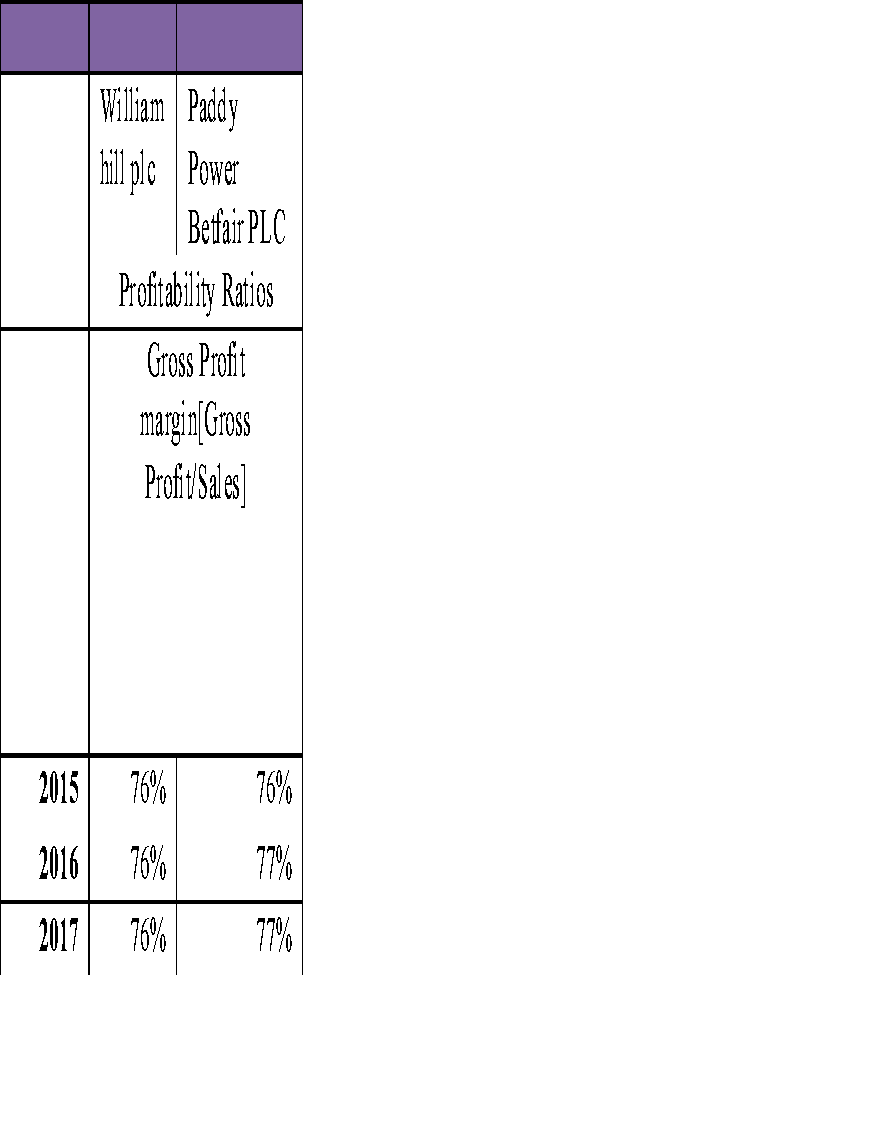
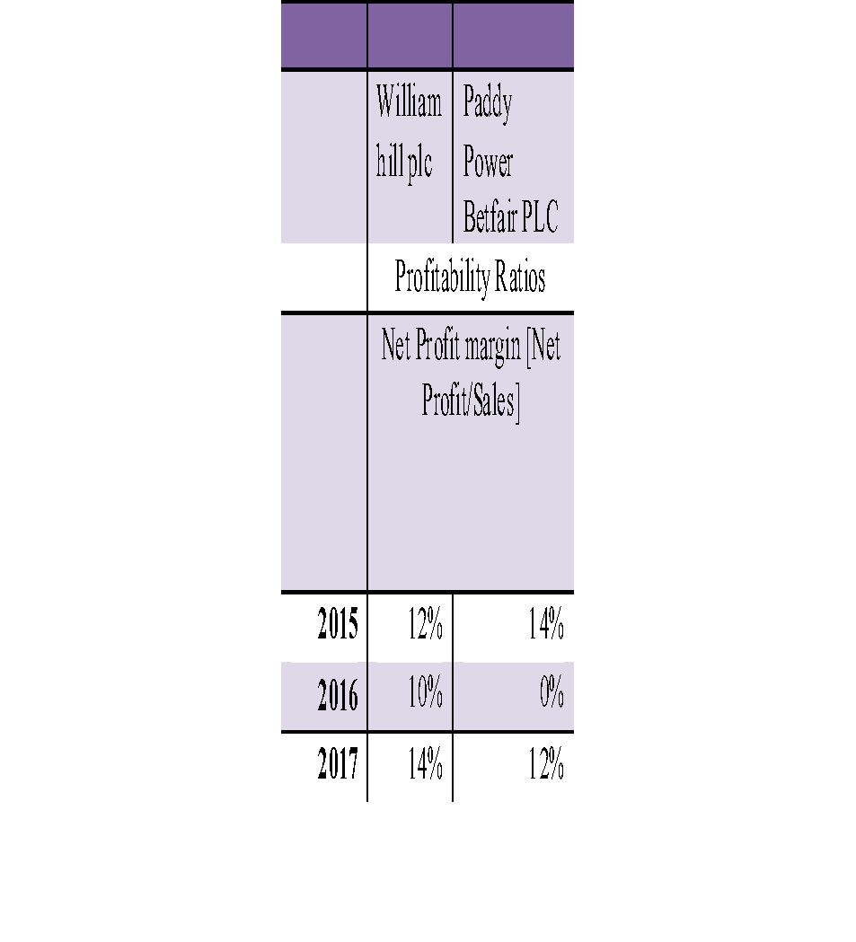

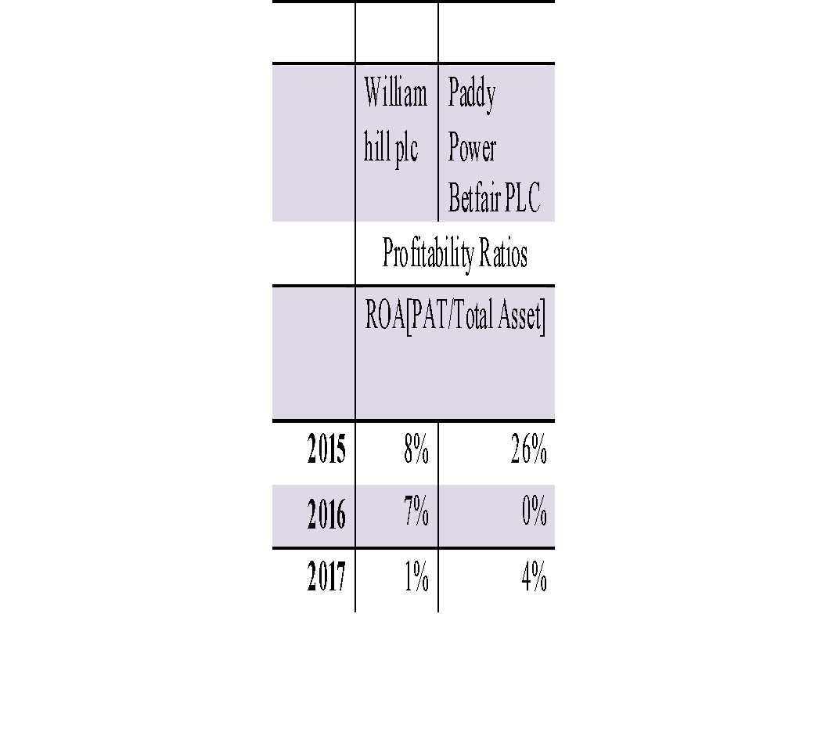

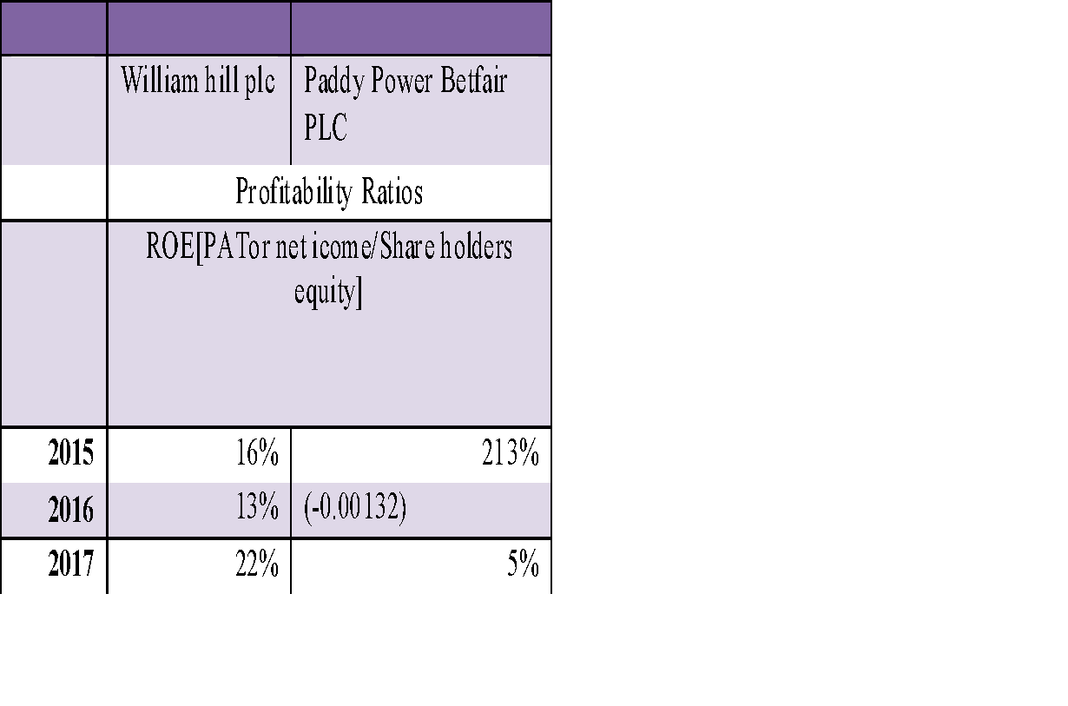

Ratios related to investors consideration:

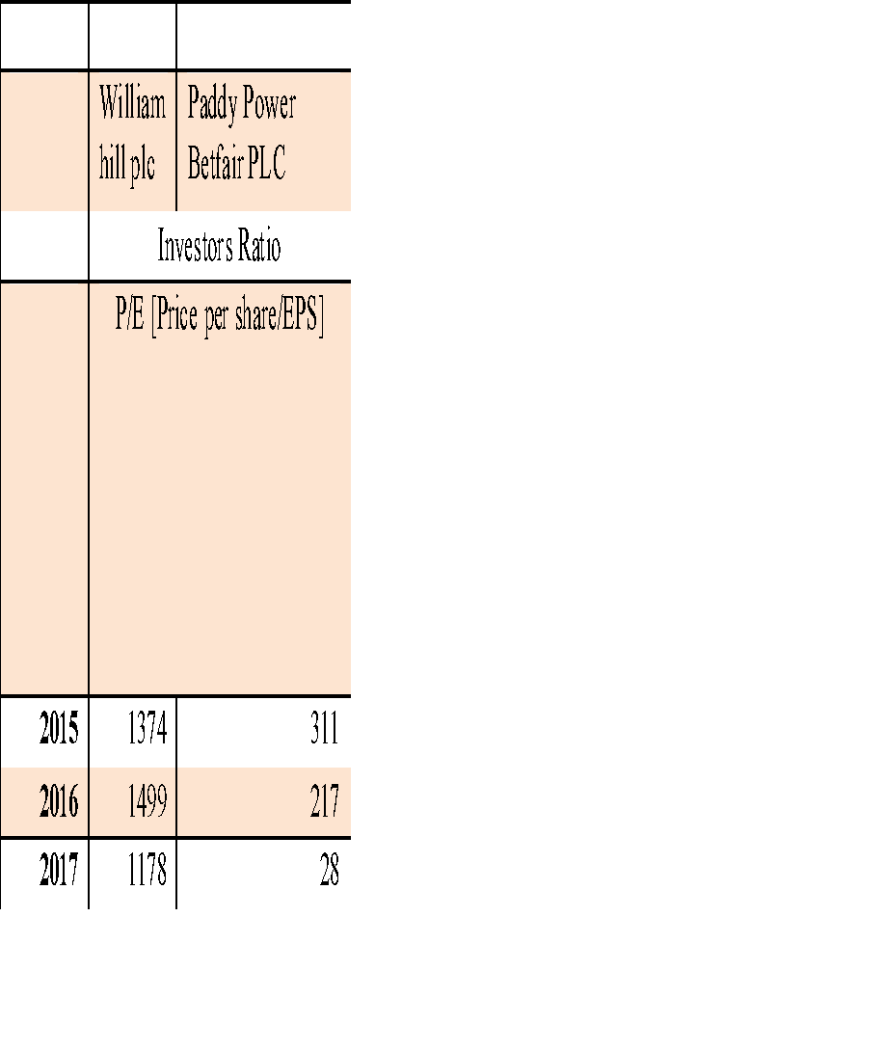

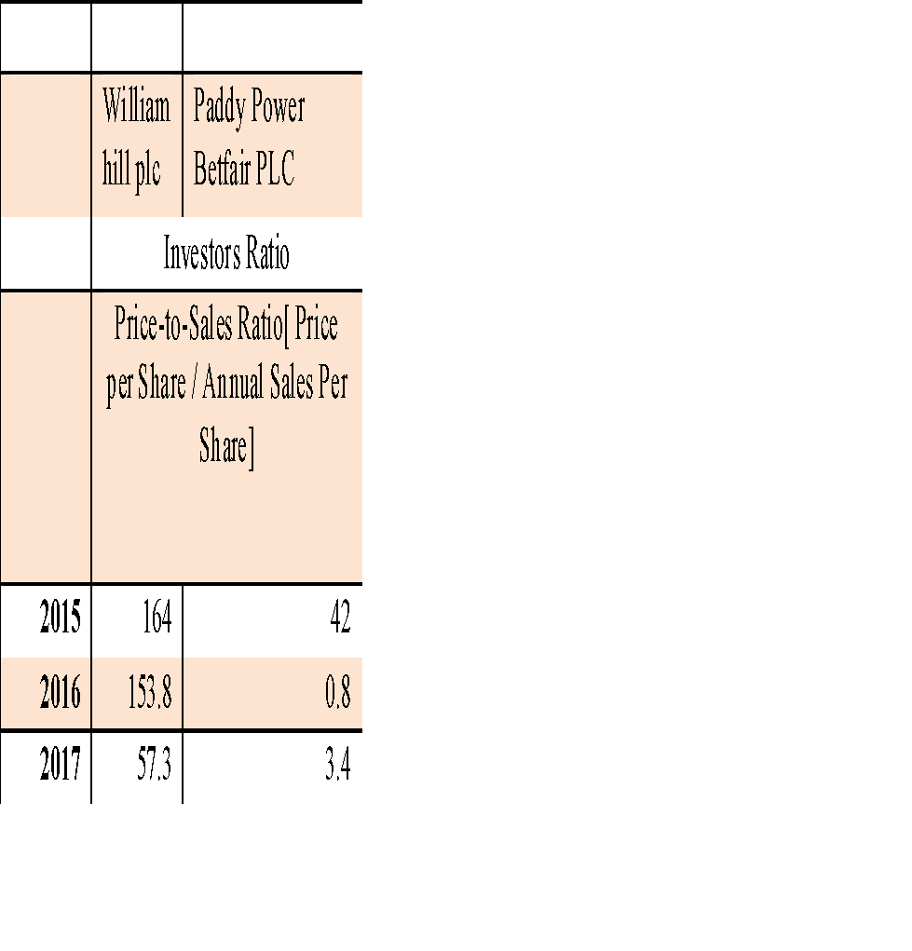

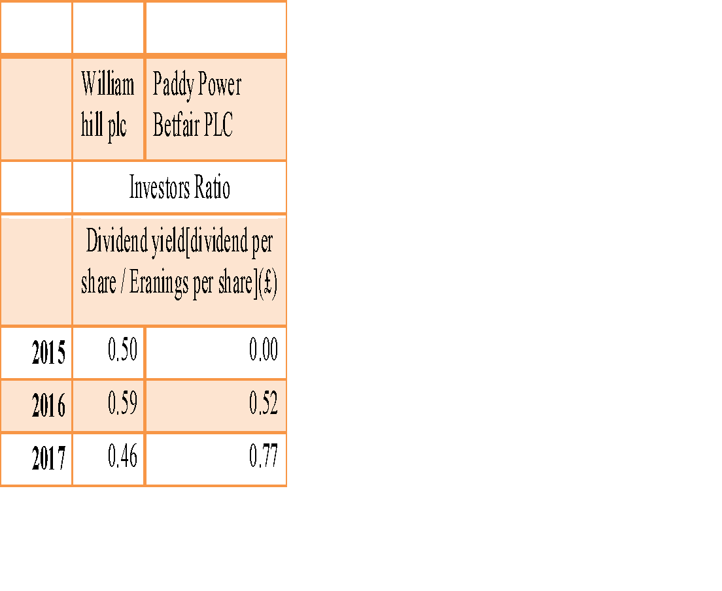

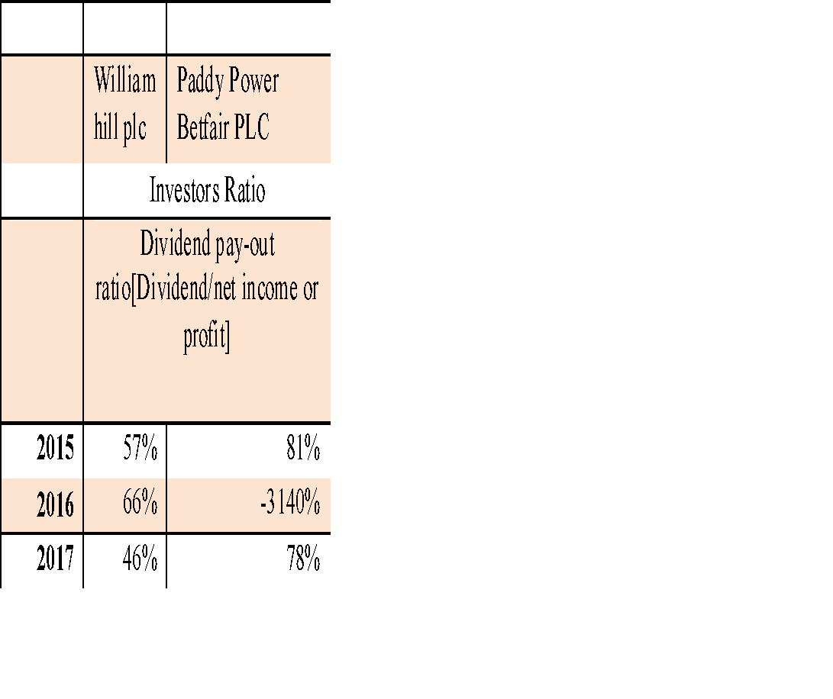

Ratios related to Organizational efficiency:
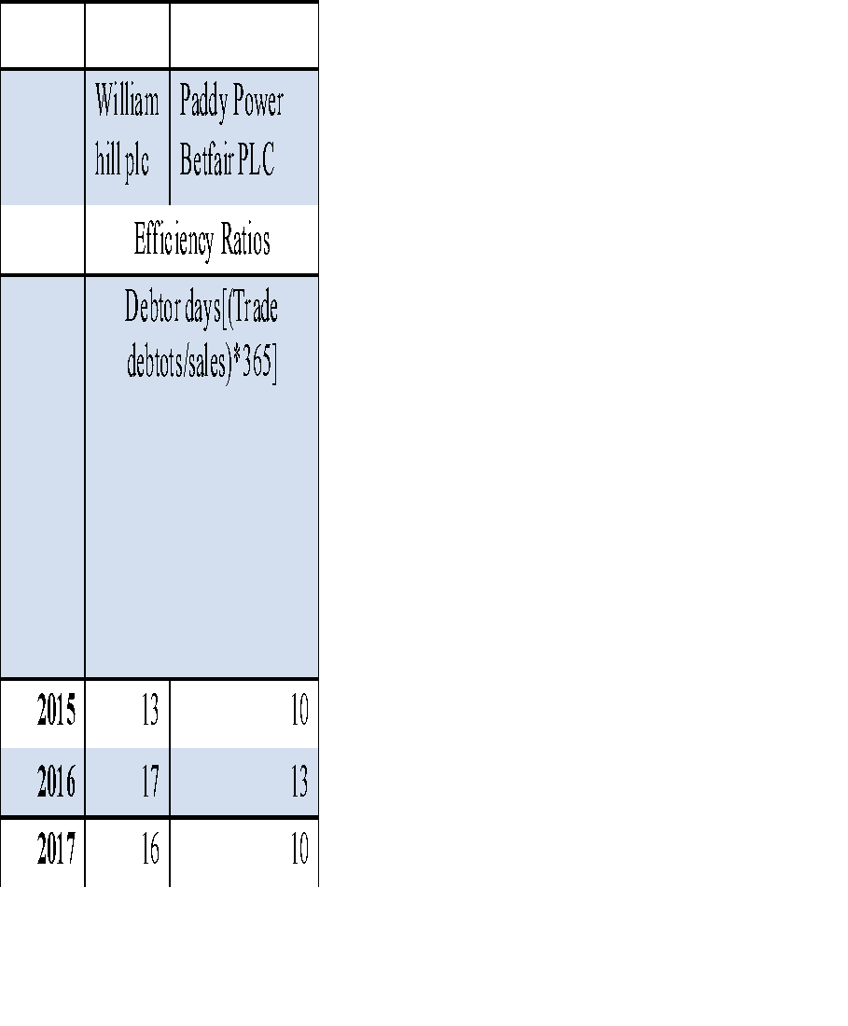

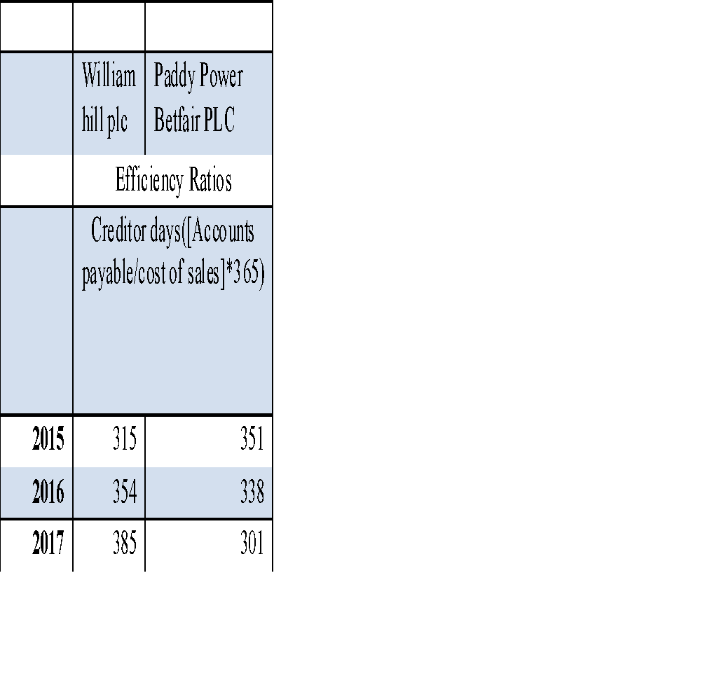

Ratios related to Liquidity:

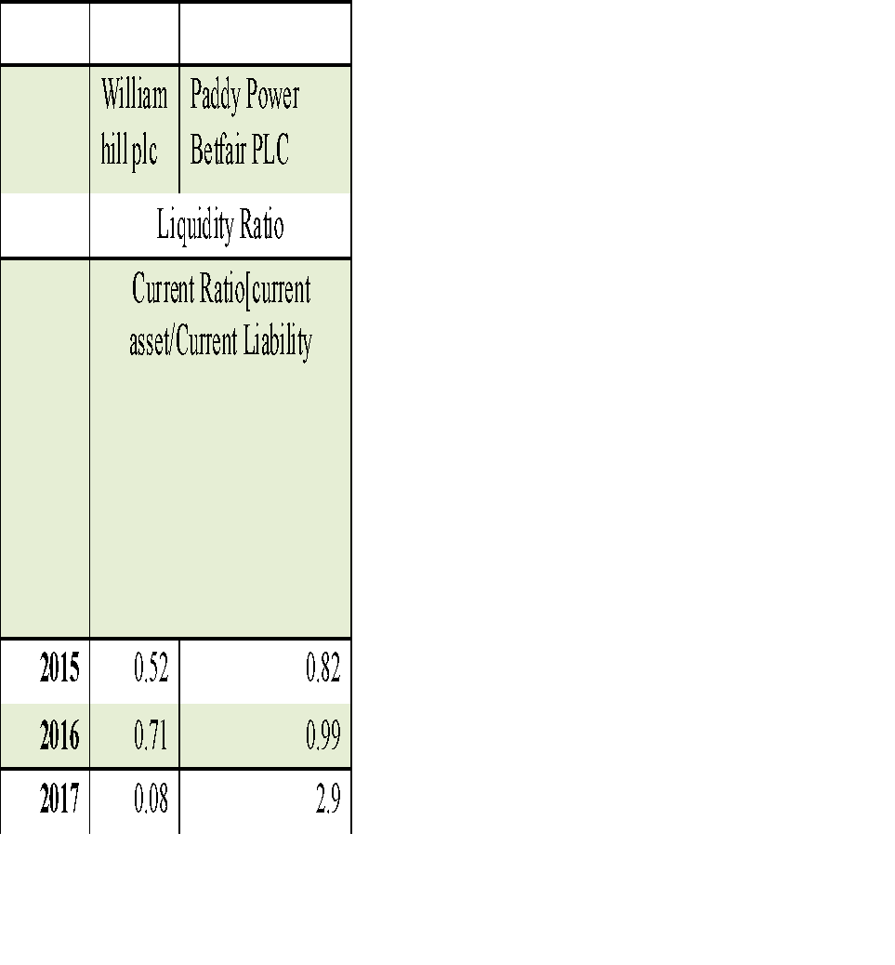

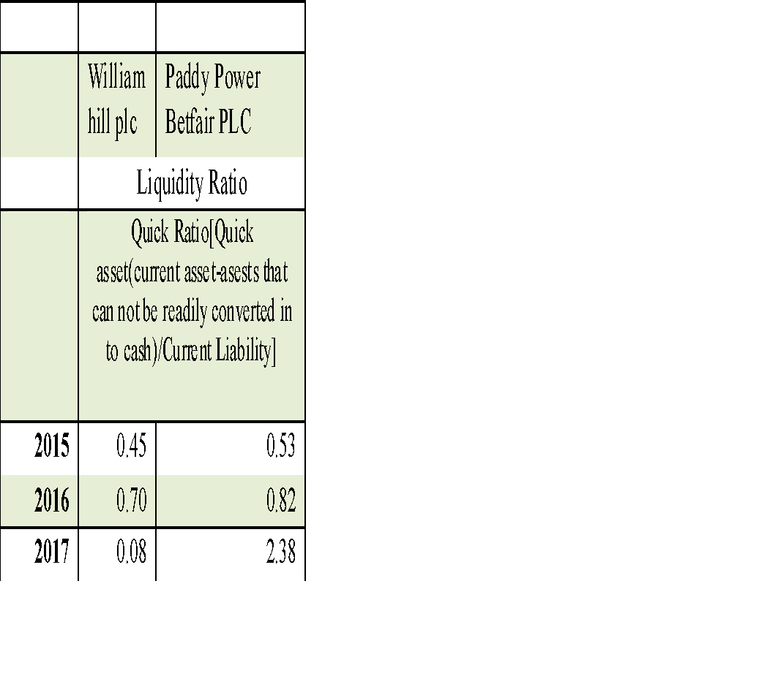

Ratios Related to Capital Structure:

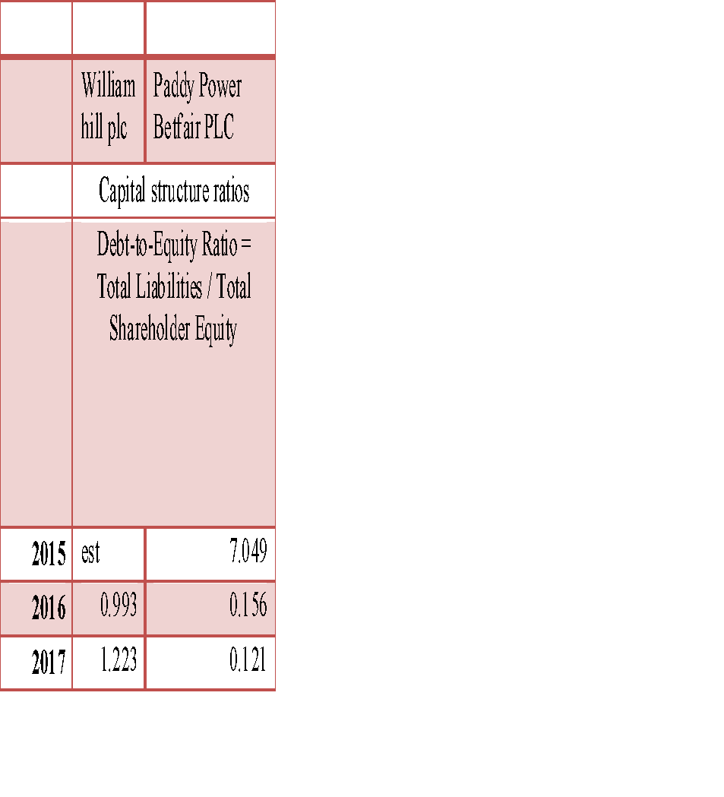

PART-B
NPV Project life-6 years life-Project-A
 |  | cash inflows(£ )
 | Initial cost(£) | year-1 | year-2 | year-3 | year-4 | year-5 | year-6 | NPV(£)
Investment(£) | 160000 | 45000 | 45000 | 45000 | 45000 | 45000 | 45000
Depreciation values(£) |  | 23333 | 23333 | 23333 | 23333 | 23333 | 23333
 |  | 68333 | 68333 | 68333 | 68333 | 68333 | 68333
Salvage values(£) |  |  |  |  |  |  | 20000
Net cash flow(£) |  | 68333 | 68333 | 68333 | 68333 | 68333 | 88333
present value calculation with cost of capital of 7% |  | 63862.928 | 59684.98 | 55780.35 | 52131.17 | 48720.72 | 58860.23 | 179040

NPV calculation-6 years life-Project-B
 |  | cash inflows(£ )
 | Initial cost(£) | year-1 | year-2 | year-3 | year-4 | year-5 | year-6 | NPV(£)
Investment(£) | 220000 | 60000 | 60000 | 60000 | 60000 | 60000 | 60000
Depreciation values(£) |  | 35000 | 35000 | 35000 | 35000 | 35000 | 35000
 |  | 95000 | 95000 | 95000 | 95000 | 95000 | 95000
Salvage values(£) |  |  |  |  |  |  | 10000
Net cash flow(£) |  | 95000 | 95000 | 95000 | 95000 | 95000 | 105000
present value calculation with cost of capital of 7% |  | 88785.047 | 82976.679 | 77548.3 | 72475.05 | 67733.69 | 69965.934 | 239485

ARR , Project-A
 |  | Net cash inflows(£ ) |  |  |  |  |  |  | (£ ) | (£,m ) | ARR
 | Initial cost(I) | yr-1 | yr-2 | yr-3 | yr-4 | yr-5 | yr-6 | Total cumulative cash flow | Average annual profit((total cumulative cash flow-initial cost)/number of years of cash flow | total asset invested in the 6 years period | Residual value
Investment | 160000 | 68333 | 68333 | 68333 | 68333 | 68333 | 88333
Cumulative  cash flow |  | 68333 | 136667 | 205000 | 273333 | 341667 | 430000 | 430000 | 45000 | 160000 | 28%

ARR ,Project-B
 |  | Net cash inflows(£ ) |  |  |  |  |  |  | (£ ) | (£,m ) | ARR
 | Initial cost(I) | yr-1 | yr-2 | yr-3 | yr-4 | yr-5 | yr-6 | Total cumulative cash flow | Average annual profit((total cumulative cash flow-initial cost)/number of years of cash flow | total asset invested in the 6 years period
Investment | 220000 | 95000 | 95000 | 95000 | 95000 | 95000 | 105000
Cumulative cash flow |  | 95000 | 190000 | 285000 | 380000 | 475000 | 580000 | 580000.00 | 60000 | 220000 | 27%

Simple Payback period :Project-A
 |  | cash inflows(£ )
 | Initial cost | year-1 | year-2 | year-3 | year-4 | year-5 | year-6 | year-7 | year-8 | year-9 | year-10 | Fraction of Payback period recovered in 8th year | Payback period calculated(yrs)
Investment | 160000 | 68333 | 68333 | 68333 | 68333 | 68333 | 88333 |  |  |  |  | 0.34 | 2.34 years
cumulated cash investment(£ ) |  | 91667 | 23333 | -45000 | -113333 | -181667 | -270000

Simple Payback period, Project-B
 |  | cash inflows(£ )
 | Initial cost | year-1 | year-2 | year-3 | year-4 | year-5 | year-6 | year-7 | year-8 | year-9 | year-10 | Fraction of Payback period recovered in 2nd year | Payback period calculated(yrs)
Investment | 220000 | 95000 | 95000 | 95000 | 95000 | 95000 | 105000 |  |  |  |  | 0.32 | 2.32 years
cumulated cash investment(£ ) |  | 125000 | 30000 | -65000 | -160000 | -255000 | -360000

Project-A , depreciation , straight-line method
 |  | £
Initial Investment |  | 160000
Life of project(years) |  | 6
Residual Value(at the end of life of the project ) |  | 20000
Rate of Depreciation |  | 17%
Annual depreciation value |  | 23333

Project-B , depreciation , straight-line method
 |  | £
Initial Investment |  | 220000
Life of project(years) |  | 6
Residuals Value(at the end of life of the project ) |  | 10000
Rate of Depreciation |  | 17%
Annual depreciation value |  | 35000

