ZARA
Student name: Antonella Palermo
Student number: 1805329
Course Title: Marketing Fundamentals
Code of the course: LCBB4004
Lecturer name: Tushara Baladran

Table of Contents
Task 1A 3
Introduction 3
Marketing MIX 3
Marketing process 3
PESTLE Analysis 4
SWOT Analysis 5
STP 6
Marketing strategies 6
Marketing concepts 7
Branding Strategies 7
Relationship Marketing 7
Ansoff Matrix strategy 8
Market penetration strategy 8
Market development Strategy 8
Product development Strategy 9
Diversification strategy 9
Stakeholders 9
Definition 10
Internal and external stakeholders 10
Communication process and impact 10
Conclusion 11
Task 1B 12
Introduction 12
Various Tactical tools of communication 12
Different promotional Strategies 12
Conclusion 12
References 13

Task 1A

Introduction
Marketing is essential for any company as it defines the competitiveness of the company in the market. In the case of this study the marketing mix and strategies of Zara will be looked into to get a better understanding of the fundamentals of marketing. This study also aims to look at the various different strategies of marketing and the stakeholders that are involved in an organisation. It further aims to find out the impact of the stakeholders on the organisation.

Marketing MIX
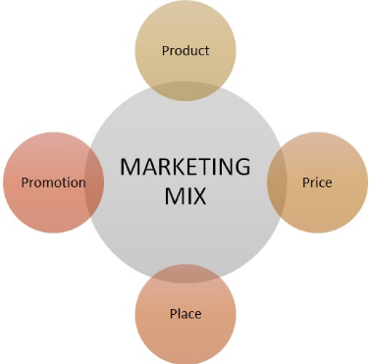
Figure 1: Marketing mix
(Source: Ameer et al. 2017)

Marketing process
The process of marketing for any company is the process by which additional value is created for customers in order to satisfy their requirements and the demand. According to Kose and Sert (2017), the process of marketing is an intricate and detailed process which first analyses the market and the finds put the needs of the consumers in the market. It further seeks to look at and implement the various different strategies that can be applied to give customers added value. The process of marketing involves of the use of certain tools such as price, products, promotions and so on (Mathews et al. 2016). These tools aid the process in creating value for the customer needs and demands.

PESTLE Analysis
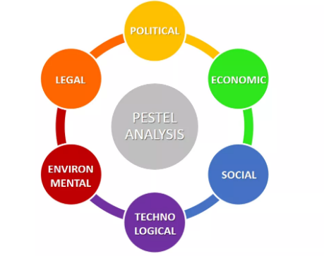
Figure 2: PESTLE analysis
(Source: Vella Bonanno et al. 2017)

PESTLE analysis is a macro environmental analysis which looks at various different factors of the environment of an organization's need it seeks provide the organisation with a better understanding of the business environment.
There may be various laws and politics surrounding a business and its environment. In the case of Zara, Brexit has posed to be major problem. As Zara is a Europe based company it has to adhere to the laws of the EU which were previously in line with that of the UK (Zhou et al. 2017). However, since Brexit the Export and Import tariffs of the UK have increased and the supply chain has become more costly which is a problem for Zara to import or manufacture its goods in the UK as the costs have risen. The economic conditions of the UK however are favourable as the GDP is rising and the inflation is falling.
The environmental aspect of PESTLE correlates to the social aspect as the organisations must adhere to the environmental policies as set out by various governments in the light of pollution, environmental preservation and the safeguarding of life (Ameer et al. 2017). Zara however, in this context is strong as it adheres to green policies and methods of production and thus as a result adheres to all the laws that are set out.

SWOT Analysis
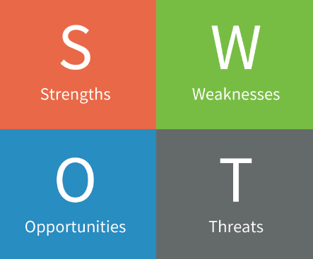
Figure 3: SWOT analysis
(Source: Wang, 2018)
Strengths
The strengths of Zara are numerous as it has a strong brand presence on a worldwide basis and also a physical one. Zara also has a strong brand value and was ranked amongst the top 60 companies by Forbes magazine. Added with these Zara also has a very strong supply chain (Wang, 2018).
Weaknesses
Zara has certain weaknesses such as its lack of advertising. Zara does not spend much on advertising activities and thus as a result the brand awareness and popularity is widespread but extremely limited. Zara also has highly generalised products and this proves to be a problem when it comes to competing in the market. The final weakness that the brand has is that of low amount of safety stock (Saraswat, 2018).
Opportunities
Zara has a host of different opportunities in the market one of them being the online commerce websites and the channel of distribution. Other opportunities also include the growing market potential and backing some of its own flagship designs (Amarkhil, 2018).
Threats
The threats that Zara faces are the lack of advertising in the light of growing competition. They also face the threat of reach which is low due to the lack of advertising.

STP

Figure 4: STP model
(Source: Created by author)
Zara also seeks to segment it products on the basis of genders and ages alongside also segmenting them season wide. Zara segments its products into seasonal collections such as the Spring-summer 2019 collection and the 2018 winter collection and so on. It targets 58% of women customers 22% of male customers and 20% children (Palmatier et al. 2016). The positioning of Zara is also done at the mid-price range which is accessible to the middle and upper middle class people of a certain society.

Marketing strategies
The marketing strategy of Zara involves using the goodwill of its parent brand in order to make efficient sales and to market its products. Zara also makes new products available within weeks of their launch whereas in comparison to its competitors take 3-6 months to do the same. According to Liu (2017), Zara also has a very strong hold in Europe as it gets most of its sales from there itself.

Marketing concepts

Branding Strategies
The branding strategy of Zara is highly intricate as it uses its own brand name but intertwines it with its parent company. This helps Zara to get advertising easily. However in the light of advertising Zara does not spend much and it instead focuses on creating a heavy brand image by directly enhancing the customer experience of its customers (Huertas-garcia et al. 2017).
Zara heavily focuses of changing and improving store layouts which help in automatically creating a brand image which lasts for a long time. According to Aqeel et al. (2017), they also seek to make their supply chain process as smooth as possible and thus Zara is able to reduce a lot of lead time which ensures that its stock is constantly moving at a high rate as compared to its competitors and this is a reason as to why Zara can launch its products faster than its competition.

Relationship Marketing
The concept of relationship marketing is in maintaining decent relationships with organisations customers. This helps in ensuring customer loyalty and effective market analysis in order to stay ahead of the competition (Alalwan et al. 2017). Zara uses this strategy of marketing in the light of creating effective customer relationships. Zara also integrates its in-store experience highly in order to engage the customer in their processes and this helps them in reinstating the value of their brand in the minds of the customers.

Ansoff Matrix strategy
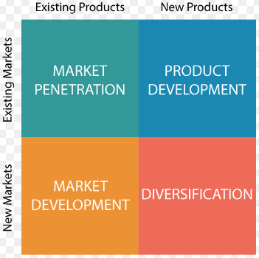
Figure 5: ANSOFF Matrix
(Source: Executestrategy.net, 2018)
The Ansoff Matrix has four different aspects:

Market penetration strategy
The market penetration strategy essentially identifies the modes by which an organisation enters the market and acquires its customers. In the case of Zara it used its extended supply chain and low factors of lead time in order to overcome the market and win against its competitors in terms of providing products (BoBo, 2017).

Market development Strategy
Zara essentially focussed on identifying its potential target groups in a certain market and then carried out its positioning and segmentation accordingly. According to Naughton (2016), it exploited the gap in the market for high school student wear and targeted young customers initially to gain popularity in the market and develop its wide customer base which it governs today.

Product development Strategy
Zara focussed on developing products effectively in order to provide the customers with what they required and demanded. The efficient analysis of the market was Zara’s most important and strong aspect as this led them to understand the various demands of customers and appropriately develop product lines which would suit the needs of the customers (Barrales-Molina et al. 2018).

Diversification strategy
The diversification strategy carried out by Zara is extremely efficient. Zara diversifies its product range every year on the basis of the aspects of the different seasons and collection. They further diversify by segregating the men’s, women's and children's ranges of products. However they do not decentralize and keep all of it under the parent brand (Shi et al. 2018).

Stakeholders

Figure 6: Stakeholders of a Company
(Source: Influenced by Fridley, 2018)

Definition
The stakeholders of a company are the people in or outside the company who have a direct stake in the functions and the outcomes of the company’s business. According to Kreger et al. (2018), the stakeholders of a company are affected directly by the profit and losses of the company and its policies.

Internal and external stakeholders
A company has a variety of different stakeholders, some internal and the others are external. According to Anwar (2017), internal stakeholders of a company include the board of directors, the managers and the employees of a company. They have a direct stake in the functioning of the company and they also make profits if the company makes profits. These stakeholders are in direct contact with the company and are affected directly.
The external stakeholders of the company are the retailers, wholesalers, customers, the shareholders of the company and the various different people who are involved with the supply chain of the company (Vella Bonanno et al. 2017). These stakeholders may not get directly affected by the company but they still get affected indirectly by the profits or losses of the company.

Communication process and impact
Zara maintains a transparent communication process with its stakeholders and thus it helps in retaining the goodwill of the stakeholders. The stakeholders also define the operations and the strategies adopted by certain company as the company is directly linked with them and seek to function according to the market demand to sustain it (Fridley, 2018).
According to Fernandez-Cavia et al. (2017), a various range of tools may include blogs, social media, e-mails and other such processes which help in the ease of communication in the industry. Tactical Communication tools provide a wide array of advantages such as providing effective feedback and methods to analyse the market and its situations (Binder, 2016). In the case of the company that we have chosen tactical communication tools are used to effectively communicate with the stakeholders of the company. These tools have helped the company in order to smoothen the process of communication alongside help in the establishment of widespread goodwill.

Conclusion
This study helps in getting a better look at the various aspects of the business of Zara and the various different marketing strategies that have been used by the company in order to promote its products and stay in the market. The study also sheds light on the various different elements of marketing and how they can be used by a certain company.

Task 1B

Introduction
This study aims to get a better look at the various different tactical communication tools that are used in the light of different organisations and seeks to reflect upon how the tools help.

Various Tactical tools of communication
Tactical communication tools are tools which help in the process of digital marketing and promotion for a certain company. Effective communication has helped our company in order to understand the attitudes of employees and other stakeholders and thus adapt effectively to the various changes in the environment.

Different promotional Strategies
The various promotional strategies of the organisation that we have studied involve the use of relationship marketing and also the use of enhancing the experience of the customers in the stores. It depends mainly on the factor of effective customer service in the environment (Calandro, 2016).
However, the company also uses other forms of promotional strategies such as the use of social media marketing which heavily influences and targets the range of customers which Zara wants to reach out to. The number of teenagers using social media is comparatively higher than that of the other customers and thus effective social media campaigns also help Zara in order to harness a large customer base (Kunwar and Misra, 2017).
This also helps us in understanding that the promotional strategies used by Zara are pretty unconventional as they do not focus on just marketing and advertising strategies in the market but adopt a much more specific approach in order to reach out to its target customers and this helps them to attain the results that they desire effectively and efficiently.

Conclusion
This reflective analysis helps us to get a better understanding of the various different strategies and tools that have been used by Zara in order to sustain their business and carry it forward. This also helps us in understanding the various different promotional strategies that Zara uses and the reasons for using the same.

References
Alalwan, A.A., Rana, N.P., Dwivedi, Y.K. and Algharabat, R., (2017). Social media in marketing: A review and analysis of the existing literature. Telematics and Informatics, 34(7), pp.1177-1190.
Amarkhil, H., (2018). Brand management that creates value to customer: the case of Zara brand. Pp. 15-16
Ameer, K., Shahbaz, H.M. and Kwon, J.H., (2017). Green extraction methods for polyphenols from plant matrices and their byproducts: A review. Comprehensive Reviews in Food Science and Food Safety, 16(2), pp.295-315.
Anwar, S.T., 2017. Zara vs. Uniqlo: Leadership strategies in the competitive textile and apparel industry. Global Business and Organizational Excellence, 36(5), pp.26-35.
Aqeel, Z., Hanif, M.I. and Malik, M.S., (2017). Impact of co-branding and brand personality on brand equity: A study of telecom sector in Pakistan. Journal of Business and Retail Management Research, 12(1).
Barrales-Molina, V., Kaynak, H. and Gutiérrez-Gutiérrez, L., (2018). The Role of Human Resource-Related Quality Management Practices in New Product Development: A Dynamic Capability Perspective.
Binder, J., (2016). Global project management: communication, collaboration and management across borders. Abingdon:Routledge.
BoBo, W., (2017). They Call It Le Big Mac: The Importance of Adapting to Local Preferences in Marketing Strategy (Doctoral dissertation, The University of Mississippi).
Calandro, E., (2016). Policy and regulatory challenges posed by emerging pricing strategies. Information Technologies & International Development, 12(2), pp.pp-13.
Executetstrategy.net, (2018). The Ansoff Matrix helps orgnisations to grow. Available at: https://www.executestrategy.net/blog/the-ansoff-matrix-helps-organizations-grow/ [Accessed on: 26 March, 2019]
Fernandez-Cavia, J., Marchiori, E., Haven-Tang, C. and Cantoni, L., (2017). Online communication in Spanish destination marketing organizations: The view of practitioners. Journal of Vacation Marketing, 23(3), pp.264-273.
Fridley, L., (2018). Improving online demand forecast using novel features in website data: a case study at Zara (Doctoral dissertation, Massachusetts Institute of Technology). Pp. 15-18
Huertas-García, R., Lengler, J. and Consolación-Segura, C., (2017). Co-branding strategy in cause-related advertising: the fit between brand and cause. Journal of Product & Brand Management, 26(2), pp.135-150.
Kose, U. and Sert, S., (2017). Improving content marketing processes with the approaches by artificial intelligence. arXiv preprint arXiv:1704.02114.
Kreger, M., Cairoli, K.S., Levy, S.C., Bertaccini, L., Cohen, R.J., Nylund, D.K. and Perkins, C., (2018). California Restorative Justice in Education: Stakeholders Finding Common Ground in Concepts and Practices. CLEARvoz Journal, 4(2).
Kunwar, P. and Misra, H., (2017). Impact of Promotional Strategies on Consumer Buying Behaviour for Apparels. IITM Journal of Management and IT, 8(2), pp.3-19.
Liu, C., (2017), May. Analysis on Marketing Strategy of Small and Medium-sized Clothing Enterprises. In 2017 International Conference on Culture, Education and Financial Development of Modern Society (ICCESE 2017). Atlantis Press.
Mathews, S., Bianchi, C., Perks, K.J., Healy, M. and Wickramasekera, R., (2016). Internet marketing capabilities and international market growth. International Business Review, 25(4), pp.820-830.
Naughton, S.H., (2016). Developing an Agile Supply Chain Model for SMEs (Doctoral dissertation, University of Liverpool).
Palmatier, R., Stern, L. and El-Ansary, A., (2016). Marketing Channel Strategy: Instructor's Review Copy. Abingdon:Routledge.
Saraswat, S., (2018). Strategies v/s Consumer Perception of Brand Zara-India. IITM Journal of Management and IT, 9(2), pp.68-80.
Shi, Y., Lim, J.M., Weitz, B.A. and France, S.L., (2018). The impact of retail format diversification on retailers’ financial performance. Journal of the Academy of Marketing Science, 46(1), pp.147-167.
Vella Bonanno, P., Ermisch, M., Godman, B., Martin, A.P., Van Den Bergh, J., Bezmelnitsyna, L., Bucsics, A., Arickx, F., Bybau, A., Bochenek, T. and Van de Casteele, M., (2017). Adaptive pathways: possible next steps for payers in preparation for their potential implementation. Frontiers in pharmacology, 8, p.497.
Wang, Y., (2018). An Exploratory Study of Brand Strategy in Fast Fashion Brand--Using Zara as an Example. In 3rd International Conference on Contemporary Education, Social Sciences and Humanities (ICCESSH 2018). Atlantis Press.
Zhou, F.Y., Li, R. and Li, B., (2017), September. Lessons and Enlightenment on the Business Failure of British M Department in Mainland China Market. In 3rd Annual International Conference on Social Science and Contemporary Humanity Development (SSCHD 2017). Atlantis Press.

