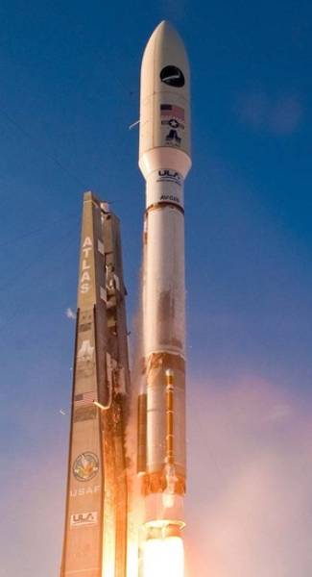
ULA Rocket Hardware Design
Advanced Computational Methods

Matthew Parry
P151377


Contents
Abstract 3
Introduction 4
Boattail Support Bracket 6
Overview 6
Material 6
Topology Optimisation 9
Topology Optimisation Methodology 11
Material Allocation 12
Grid Components 13
Static Loadings 14
Topology Region, Objective, Constraints 15
Topology Results 18
First Analysis 18
Second Analysis 19
Displacement 20
Stress 21
Strain 22
Bracket Properties 23
Conclusion 24
Recommendations 25
References 26
Table of Figures 28

Abstract
This assignment looks at topology optimisation and how it can be used to develop designs. The purpose of this project is to analyse a support bracket that is fixed to the boattail of the ULA Atlas Rocket. The bracket is used to situate the access platform. The platform is used for pre-launch activities such as loading the payload fairing of the rocket. The weight and design of the bracket has been reduced to 90% of its current weight. The topology optimisation study gives recommendations on a potential design that allows the bracket to stay attached to the boattail section of the rocket during flight. The material selection is Ultem 9085 which is a thermoplastic with properties that suit aerospace applications. Due to its additive manufacturing fabrication procedure the material can be used to produce unique profiles and structures that a topology optimisation study will generate.

Introduction
The ULA Atlas V series rocket is a replaceable launch system that began under the design of Lockheed Martin, but soon became a joint venter between Boeing and Lockheed Martin now known as United Launch Alliance (ULA, 2020).
The rocket has a modular design that must be able to adapt to various mission requirements. The Atlas V uses a common core booster, that has the potential to use five single rocket boosters with dual stage engine configuration Centaur which is responsible for ascending several different sizes of payload fairings (ULA, 2020).
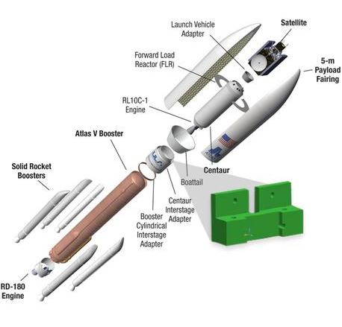
Figure 1 Atlas V 500 rocket (ULA, 2020) (Grabcad, 2016)

The Centaur is situated above the boattail. The boattail reduces the rocket's tail diameter and improves aerodynamic efficiency by way of drag reduction at the base (Rocketreview.com, 2020).
The payload fairing and boattail provide a defensive area around the spacecraft and Centaur during prelaunch operations and during the launch vehicle’s ascent (ULA, 2020).

Attached to the boattail is an internal support bracket that is used to support work platforms during the launch preparations. The bracket remains with the rocket during flight and must be light to improve payload weight during orbit (Grabcad, 2016).

FEA (Finite element analysis) is a computer-based method of analysing materials and components on how they could cope under their specified application. Almost all new aerospace applications would have first been researched using some form of FEA analysis. Topology optimisation is a numerical method that is used to optimise the material of a designed part or component. Set within agreed boundary conditions such as loadings, constraints the emphasis is to reduce the volume of material required to fabricate the component while simultaneously keeping within the components design parameters. By doing so the part becomes lighter and consequently maximising its performance (Wichita, 2017).

Boattail Support Bracket

Overview
The fundamental purpose of the boattail support bracket is to allow the work platform access to the boattail. The boattail has four large doors and provides primary access to Centaur forward adapter packages and the encapsulated spacecraft. It is here the work platform access the rocket to provide access for vital equipment aboard the rocket (ULA, 2020).

The ultimate load applied to the bracket is 2668.98 MPa. The ultimate load relates to a statistical value that is used to define a load applied to a structure where beyond this value the component would fail. The value is usually taken from the limit load and has a factor of safety of 1.5 times the limit load. Therefore, in this case if this force were to apply to the boattail bracket this would cause the material to reach its yield stress and begin to deform (Engineers Edge, 2019) (Skybrary, 2017).

Material
The boattail bracket is made from thermoplastic called Ultem 9085. This material has properties that include high strength to weight ratio, flame retardant, heat resistance with a high impact strength. Additionally, it has a yield tensile strength 47 MPa and an ultimate tensile strength of 69 MPa. Ultem 9085 meets rigorous test standards and is completely traceable which is fundamentally important to the aerospace industry. The material is often used in prototyping due to its ability to provide functioning specimens. Tooling such as end of arm tools, jigs and composite molds (Materialise, 2020).

The material is currently being used in the ULA Atlas V and Delta IV rockets in the environmental control ducting system. By utilising this material, the number of components has reduced from 140 to just 16 whilst reducing manufacturing cost by 57% (Wyman, 2015).
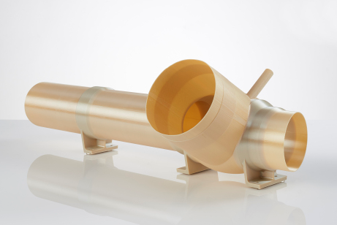
Figure 2 Environmental control ducting system (Wyman, 2015)

Ultem 9085 components can be manufactured by 3D printing and by injection moulding. Fused Deposition Modelling (FDM) is an additive manufacturing process that involves the extrusion of a material. The process involves selectively depositing the molten material to its designated location layer by layer where it cools and solidifies. The cooling process can be accelerated using a fan attached to the extrusion point of the machine. Though, warping may occur if this process is accelerated too quickly (Varotsis, 2020) (Sabic, 2020).
Effective bond between the deposited layers is crucial for an FDM printed component. When the molten thermoplastic is extruded through the nozzle, it is pressed against the previous layer. Both high temperature and pressure softens the surface of the previous layer and allows the attachment of the new layer with the previously printed coating (Varotsis, 2020).
The injection moulding process affords greater mechanical properties than that of an FDM printed component. This is due to higher porosity. The material becomes more brittle and has a lower elongation of that of an injection moulded Ultem 9085 component. The ultimate tensile strength of an injection moulded Ultem 9085 component is 89 MPa. FDM properties also depend on the built direction where if built in the XZ direction the material will benefit from a high tensile strength of that of a component built in the ZX direction (Javelin Tech, 2020) (Chuang, , et al., 2020) (Sabic, 2020).
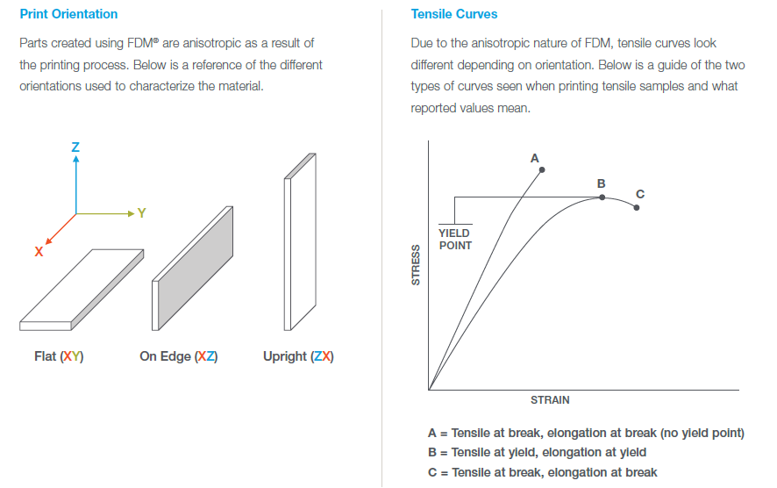
Figure 3 Ultem 9085 properties (Stratasys, 2020)

Topology Optimisation
Topology optimisation is a design method that is used to remove unnecessary material thus optimising the materials weight. The method uses mathematical techniques to improve the materials performance set against boundary conditions, constraints, and loads (Eckhoff, 2018).
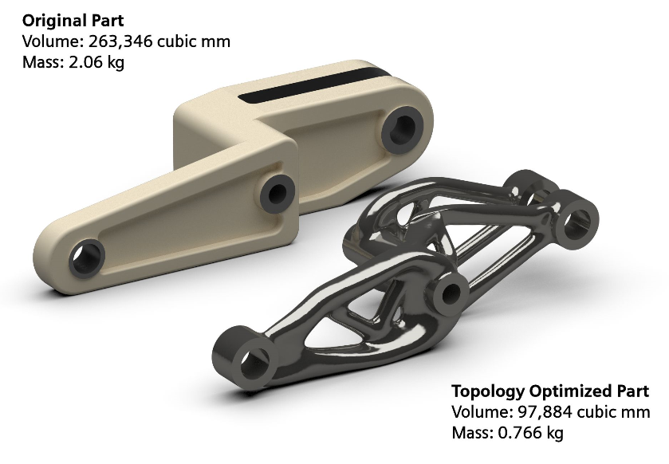
Figure 4 Topology optimisation (Eckhoff, 2018)

The additive manufacturing process generates many benefits to topology optimisation. The FDM process allows design engineers to exploit the results of a topology optimisation removing system part counts, by merging assemblies into fewer parts. Thus, reducing the development time between concept, design, manufacture, and certified component delivery. A purchase as required ratio leading to a substantial raw material cost savings as well as leaving a decisive environmental impact. Furthermore, the process can incorporate added functionality, such as manufacturing highly complex geometries that would be impracticable or very difficult to be achieved with traditional techniques (Orme, et al., 2018).
Aerospace industries rely heavily on topology optimisation to reduce the weight of components. By using this technique Airbus reduced the weight of the A380 by 1000 Kg. Any weight reduction to an aircraft ultimately leads to less fuel consumption, which is a driving factor in the aerospace industry (Eckhoff, 2018) (Leader, et al., 2018).
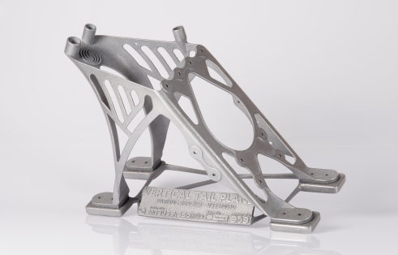
Figure 5 Airbus component (CNC Times, 2019)

Topology Optimisation Methodology
The study of the boattail bracket has been completed using both Solidworks and Design Studio. The initial part was modelled using Solidworks and then exported as a Nastran file on to Design Studio. Once modelled the first step before exporting is to assign the component with the desired mesh. For this analysis the mesh size was determined based on what Solidworks denoted as a fine mesh. This was in the region of 3.45 mm. For simplicity the mesh was rounded down to 3 mm. An advantage of using a first order mesh of this size is that there is a good mixture between run time of the simulation and how detailed the results are (Solidworks, 2019).
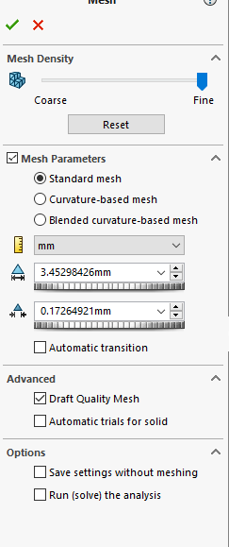
Figure 6 Mesh selection (Solidworks, 2019)

For this analysis a draft quality mesh was selected. A draft quality mesh has no mid-side nodes. This mesh is ideally used for quick evaluation scenarios and in solid models where bending effects are insignificant (Solidworks, 2019). The file is then saved as a Nastran file and opened in Design Studio.

Material Allocation
The first step of the topology optimisation is to assign the component the same properties of Ultem 9085. The date given is in imperial units and must be converted to SI units. These conversions were achieved from the Stratasys data sheet where both imperial and SI are given. The remaining unknown information was taken from the Ultem 9085 data sheet from Stratasys and Materialise. This can be seen in the table below.
Ultimate Tensile Strength | 69 MPa
Specific Gravity | 1.34
Youngs Modulus | 2240.8 MPa
Poisson’s Ratio | 0.41
Shear Modulus | 2050 MPa
Material Strength Allowable | 31.03 MPa
Figure 7 Ultem 9085 properties (Materialise, 2020) (Stratasys, 2020)
The specific gravity can be used to calculate the materials density. This can be achieved by comparing the value with the density of water which can be written as
$$ρ=1.34×1000$$
$ρ$ = 1340 kg/$m^{3}$
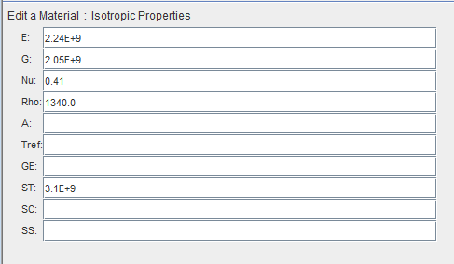
Figure 8 Ultem 9085 properties (Genesis Design Studio, 2018)

Grid Components
From this point the component must have constraints added to simulate where the part would be fixed to the boattail of the rocket. From the assignment brief and drawing, the bracket is fixed using four holes marked pattern D on the general arrangement. As this is a topology task it may be assumed that the fixings are to be secured through the same amount of material. For example, the top holes are not the same length as the bottom holes. As we are attempting to minimise the material required on the part then the bolts would be inserted the same length in all four holes. This can be seen in the image below.
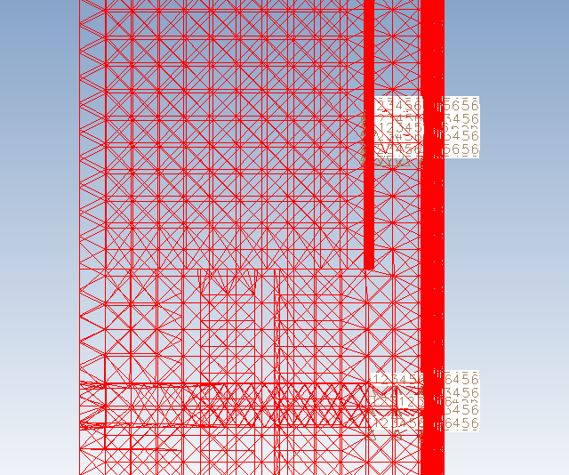
Figure 9 Constraint locations (Genesis Design Studio, 2018)

The holes are highlighted, and the appropriate nodes are selected. From this point the constraints are set ready for the required forces to be included.

Static Loadings
The force acting on the bracket is described as an ultimate load due to the work platform. As described earlier the ultimate load is the total load applied to a component past which the component will fail (Engineers Edge, 2019). Therefore, the load can be assumed to be an UDL (uniformed distributed load) as the platform is connected to the support surface of the bracket. This can be seen on the image below.
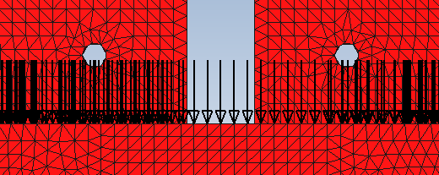
Figure 10 Forces applied as an UDL in the first analysis (Genesis Design Studio, 2018)

An additional topology study has been undertaken which will apply the force concentrated around the work platform fixings. This is because by removing the UDL and focusing the force on the holes there may be opportunity for further material reduction. The second forces can be seen in the image below.
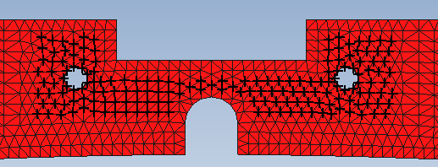
Figure 11 Forces directed towards the working platform fixings in the second analysis (Genesis Design Studio, 2018)
With the forces added to the component the number of nodes selected can be divided by the ultimate force applied. For example, if there are 900 nodes selected then this value is used to divide through 2668.93 MPa. Therefore, each node would have 2.97 MPa of force acting on the part of the component. Additionally, as stated in the brief the force is acting in the z direction, so this can be inputted in to design studio as -1 in the z direction.

Topology Region, Objective, Constraints
The analysis set points are required to simulate boundary conditions and load cases for the optimisation. The study requires further information so that the software can realise the required topology regions, objectives and constraints required to complete the study. The design brief states that there must be a minimum wall thickness of 1.016mm and that the results must show a 10% reduction in material weight from 0.45kg to 0.045kg. Additionally, the minimum edge distance surrounding the holes must be twice the diameter of the bolt holes. This information can be used in as setpoint for the topology regions and constraints.
Topology region setpoint mass Fraction of 0.1 which equates to 90% material reduction.

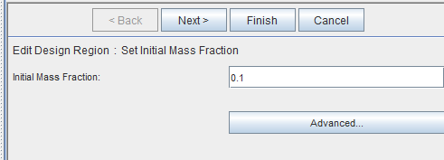
Figure 12 Topology region setpoint mass Fraction of 0.1 (Genesis Design Studio, 2018)

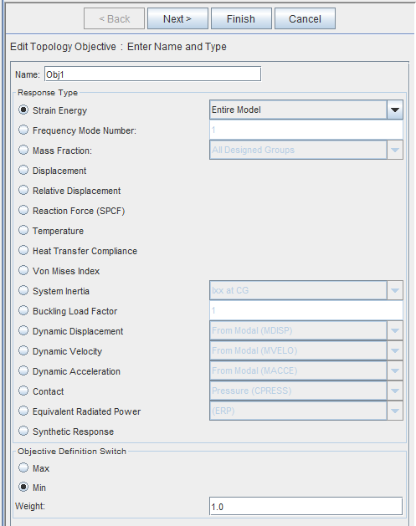
Figure 13 Topology objective (Genesis Design Studio, 2018)

The topology constraint must have an upper bound setpoint of 0.1. This is applied so the software will find 10% of the material.
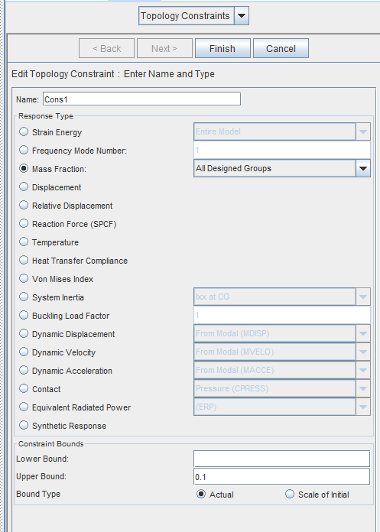
Figure 14 Topology constraint setpoint with an upper bound of 0.1 (Genesis Design Studio, 2018)

The topology constraint 1 is set to mirror about the YZ axis. Constraint 2 is set to fill inside to outside. Minimum size is double the mesh size which for this analysis is 0.006 m. The final set point is the minimum thickness which is 0.001m and relates to the wall thickness in the design brief.
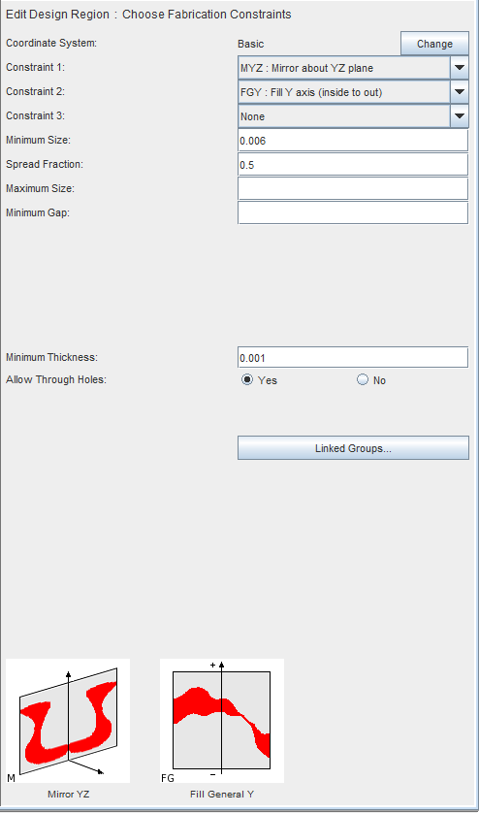
Figure 15 Topology constraint setpoints (Genesis Design Studio, 2018)

Topology Results

First Analysis
The results from the first topology study have focus the material removal around the top of the bracket. There is equal material remaining on both sides, but the forces acting on the bracket have been so evenly distributed that the software believes that the material in these sections may be removed. There is an interesting form that has developed at the lower area of the bracket. The software has removed sections from the lower part of the bracket which may suggest there was no stress acting in the area. The overall results are not good enough due to the amount of material taken from the two top bolt fixing holes.
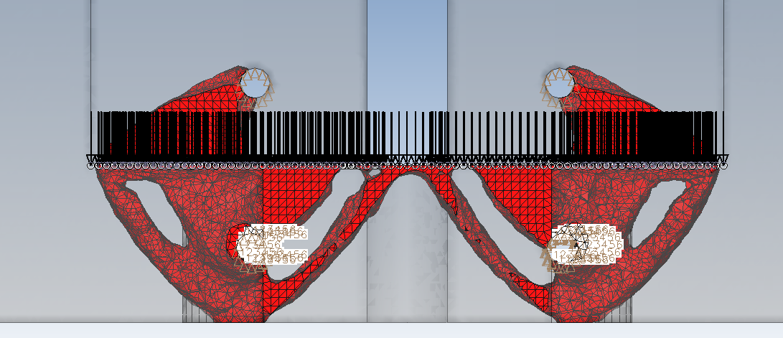
Figure 16 Topology study with UDL first analysis (Genesis Design Studio, 2018)

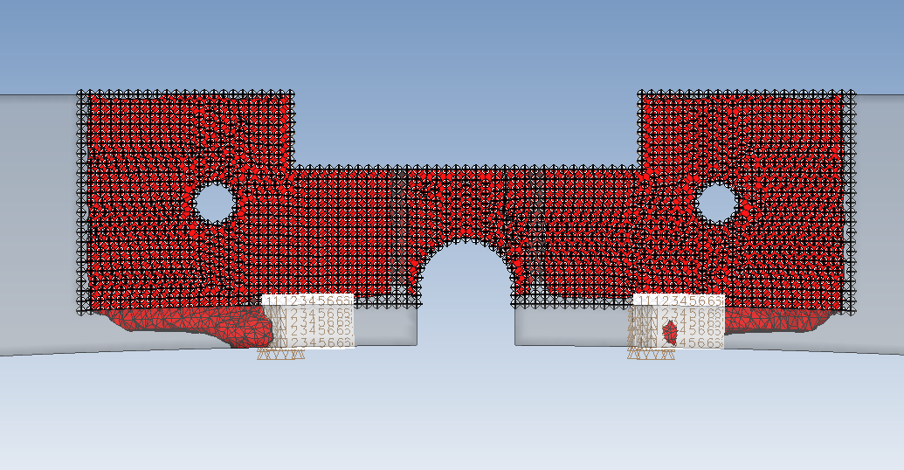
Figure 17 Topology study with UDL first analysis (Genesis Design Studio, 2018)

Second Analysis
The second topology analysis has improved the overall design of the bracket. However, there are still issues with how the bracket may function. The design brief specified that the holes must have an edge of material twice the diameter of the holes. Although this has improved from the first analysis there is still a short fall from in this study. There is no interesting geometrical shape on the second study. This could be attributed to where the forces were applied. The study has not produced a symmetrical topology result. Again, this could be down to where the forces have acted on the material.
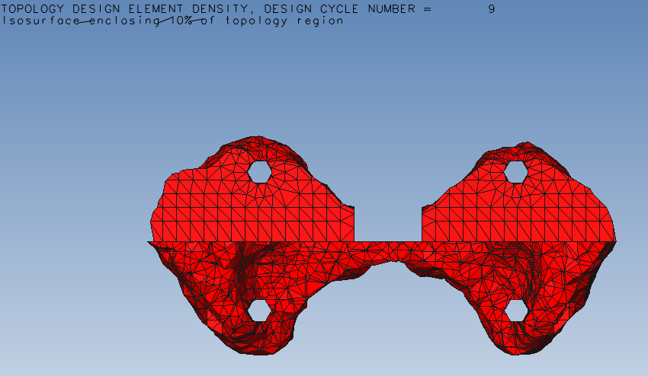
Figure 18 Topology study with concentrated forces second analysis (Genesis Design Studio, 2018)

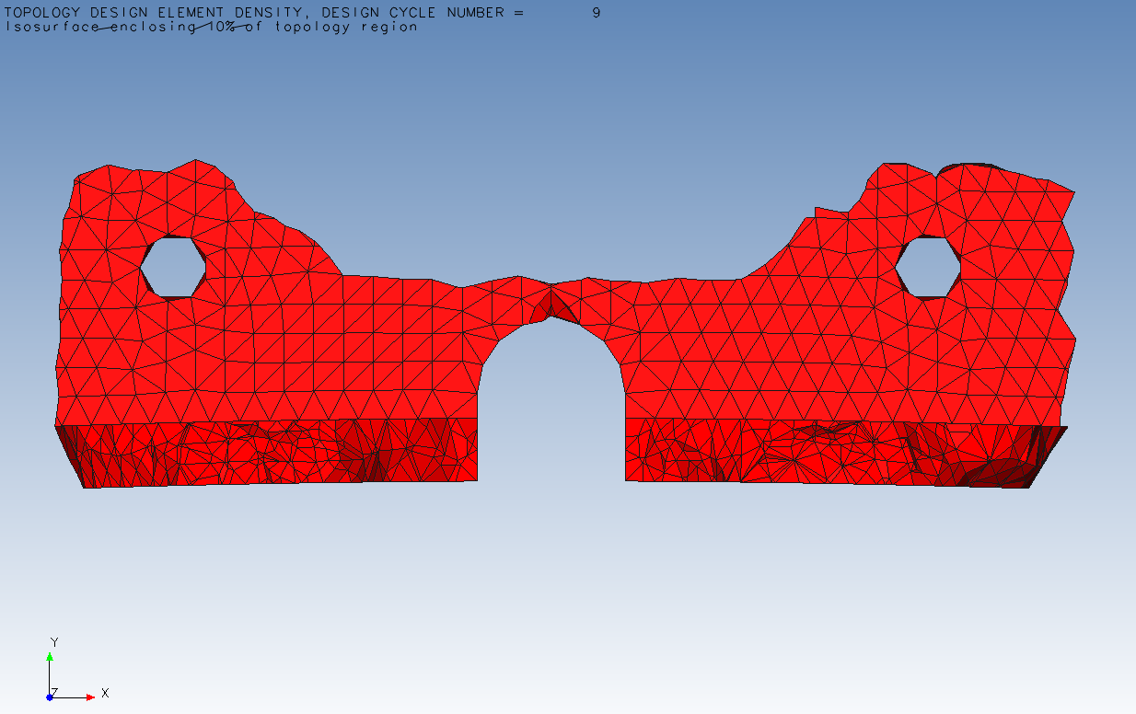
Figure 19 Topology study with concentrated forces second analysis (Genesis Design Studio, 2018)

Displacement
The displacement on the second analysis is negligible and is at its highest around 0.6mm. Though this has been exacerbated in terms of how it appears in design studio. This could be shown in this way just to make the user aware of the displacement results even if the value is low.

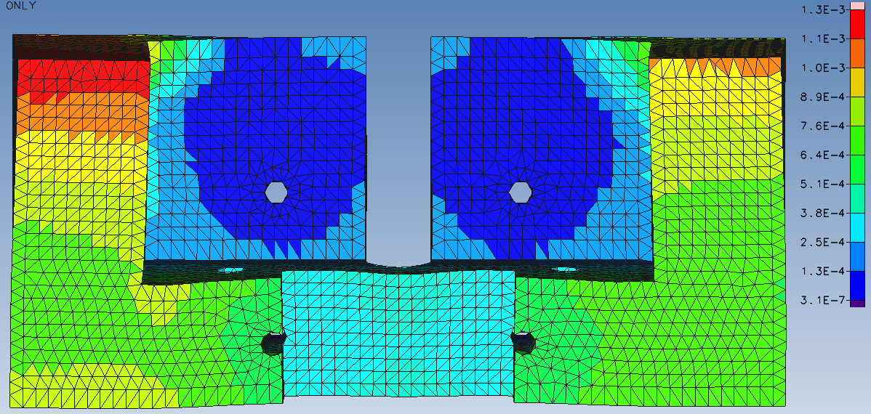
Figure 20 Displacement of bracket in second analysis (Genesis Design Studio, 2018)

Stress
The stress region on the bracket is focussed around the hole fixings on the component. The maximum stress area is around 18.81 MPa which is below the material’s yield strength of 47 MPa. The analysis stress results are of quite similar pattern to that of the topology results. Which could suggest that further optimisation could reduce the material volume and give effective results.
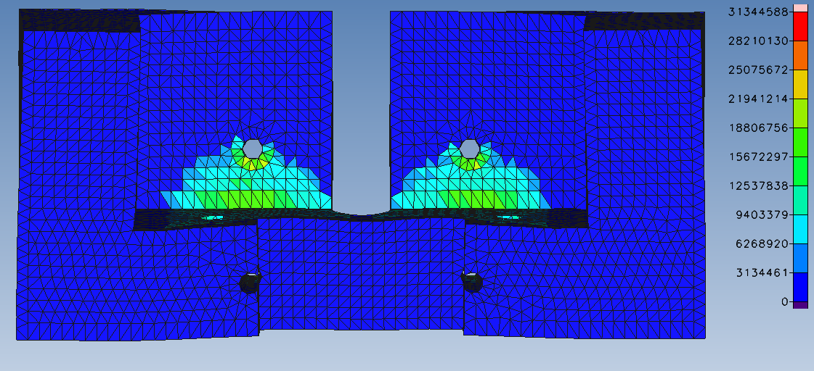
Figure 21 Stress applied to bracket in second analysis (Genesis Design Studio, 2018)
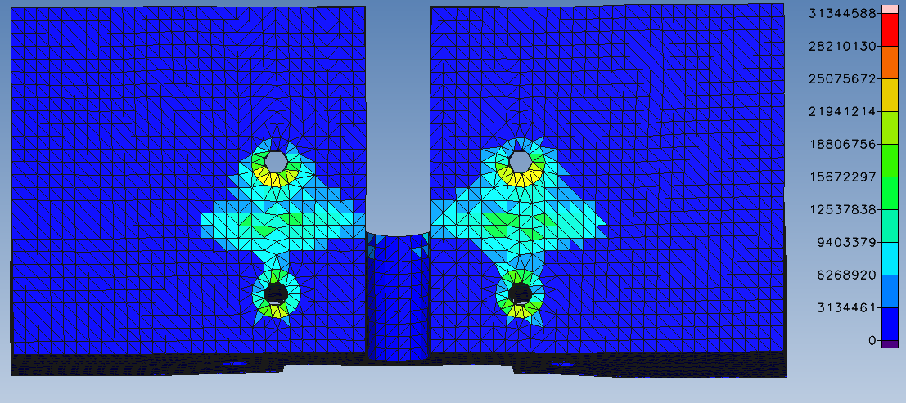
Figure 22 Stress applied to bracket in second analysis (Genesis Design Studio, 2018)
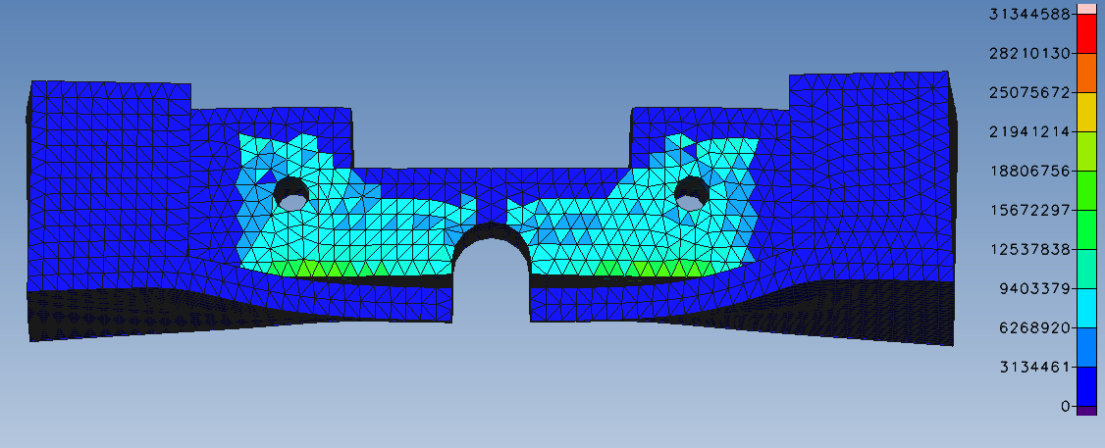
Figure 23 Stress applied to bracket in second analysis (Genesis Design Studio, 2018)

Strain
The strain applied to the bracket is extremely low and can only be seen in part of the bracket where the material was removed from the topology optimisation study. Engineering strain can be stated as the sum of deformation in the direction of an applied force that is divided by the initial length of the material. As the displacement is 0.0006m this could explain why the strain value is zero (NDT-ed, 2020).

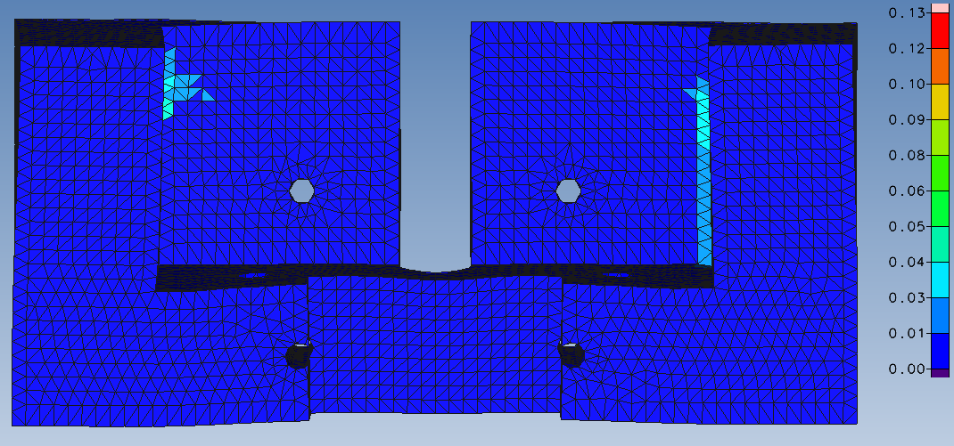
Figure 24 Strain applied to bracket in second analysis (Genesis Design Studio, 2018)

Bracket Properties

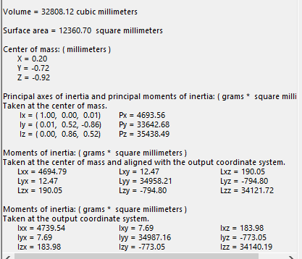
Figure 25 Mass propoerties of second topology analysis (Solidworks, 2019)
Second analysis bracket weight can be calculated by using the volume from mass properties on Solidworks. This can be calculated by multiplying the density by the volume as shown below.
$$mass=density ×volume$$
$$mass=1340kg/m^{3}×0.00003280812 cubic meters$$
$$=0.0439628808kg$$
The weight of the material is below the stipulated value of 0.045kg in the design brief.

Figure 26 Second topology analysis bracket imported in to Solidworks (Solidworks, 2019)

Conclusion
This study has looked at the ULA Atlas Rocket boattail access platform bracket and analysed the component against a pre-set of objectives to calculate, using design studio a topology optimisation analysis of the bracket. The study has returned some interesting results from both sets of analysis run. The first study employed a UDL across the bracket which did not properly give the software the correct information required to complete the study. This was due to over applying the force of the platform on to the bracket.
The second study applied the forces around access platform holes of the brackets to remove more of the material. The study did return results good enough to take forward to design the component. However, with further optimisation completed the bracket could yield additional material reductions. By comparing the results of this topology optimisation study to the winning design there are similarities in the appearance of the brackets. The weight was within the design brief as was the stress which at its highest was 18.81 MPa.
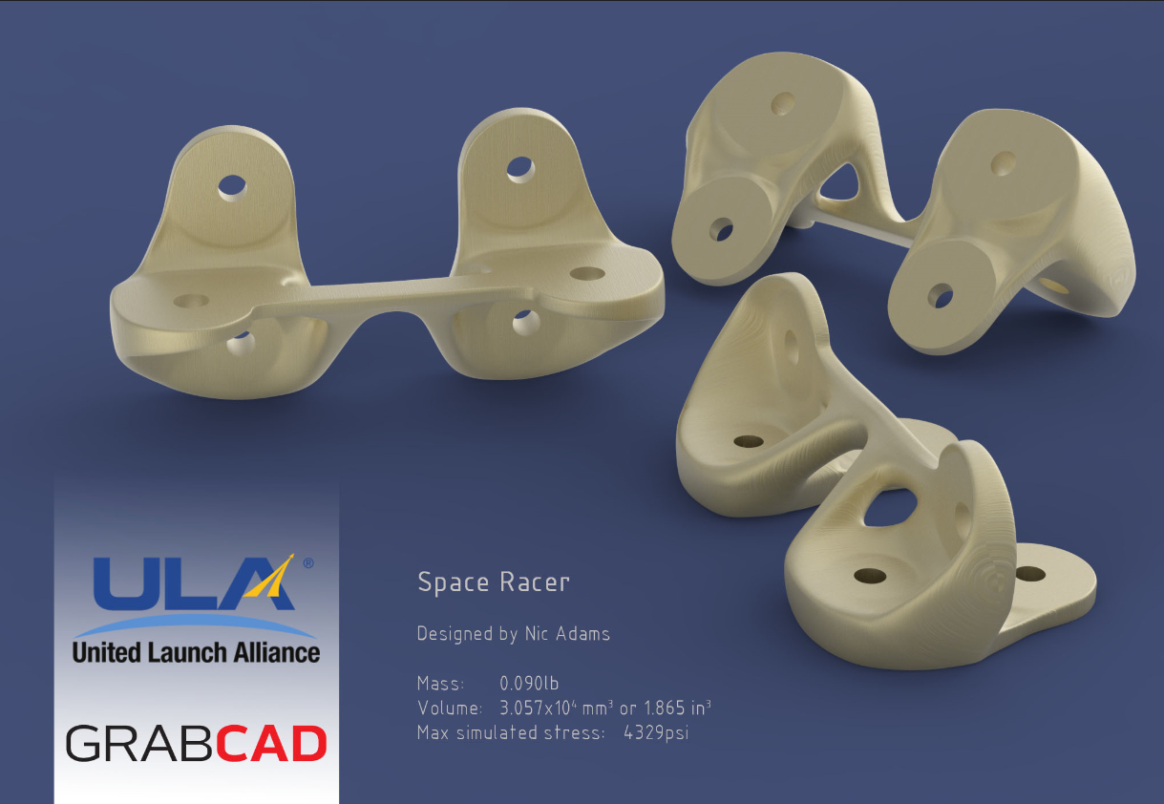
Figure 27 GrabCAD winning ULA bracket and second topology analysis (Grabcad, 2016) (Solidworks, 2019)

Recommendations
This topology study has generated an encouraging set of results with the weight and stress well within the envelope of the material and within the key points of the design brief. However, with further optimisation the results could be improved. The following recommendations could provide more favourable results and could reduce both the stress, and weight of the material.
- Mesh quality. As described earlier the mesh selected for this study was 3mm and a draft mesh quality. To improve the analysis the mesh size could be reduced and using adaptive meshing on Solidworks could provide a mesh that could further improve the topology results. H-adaptive meshing physically corrects the size of the mesh cell in areas of the model where smaller meshing is required. P-adaptive meshing adjusts the polynomial order of the mesh to improve accuracy. It also applies mesh elements up to the fifth order (Hawk Ridge Systems, 2013).
- Preserving material regions on the bracket could improve the area around the holes of the component. Design studio allows the user to group elements which are chosen by selecting mesh areas of the desired region. By using this tool, the optimisation could possibly have retained the material around the holes thus retaining two times the diameter of the holes area around the fixing points.
- Applying the forces in a more concentrated areas could also improve the results of the topology study and reduce the material required.

References
Chuang, , K. C. et al., 2020. Additive Manufacturing of UltemPolymers and Composites. [Online]
Available at: https://ntrs.nasa.gov/archive/nasa/casi.ntrs.nasa.gov/20160000203.pdf
[Accessed 14 01 14].
CNC Times, 2019. Aerospace: Sogeti - Additive Manufacturing for the new A350 XWB. [Online]
Available at: https://www.cnctimes.com/editorial/aerospace-sogeti-additive-manufacturing-for-the-new-a350-xwb
[Accessed 15 01 2020].
Eckhoff, A., 2018. Additive Manufacturing and Aerospace Industry Equal Efficiency. [Online]
Available at: https://blogs.sw.siemens.com/nx-manufacturing/additive-manufacturing-aerospace-industry-efficiency/
[Accessed 18 01 2020].
Engineers Edge, 2019. Stress Concentration Fundamentals. [Online]
Available at: https://www.engineersedge.com/material_science/stress_concentration_fundamentals_9902.htm
[Accessed 16 11 2019].
Genesis Design Studio, 2018. Genesis Design Studio, Michigan: VR and D.
Grabcad, 2016. 3-2-1 Liftoff! ULA Rocket Hardware Challenge. [Online]
Available at: https://grabcad.com/challenges/3-2-1-liftoff-ula-rocket-hardware-challenge
[Accessed 13 01 2020].
Hawk Ridge Systems, 2013. Adaptive Meshing In Solidworks Simulation. [Online]
Available at: https://hawkridgesys.com/blog/simulation-adaptive-meshing
[Accessed 17 01 2020].
Hussain, A., 2019. When should I use a second order mesh. [Online]
Available at: https://www.simscale.com/forum/t/when-should-i-use-a-second-order-mesh/25899
[Accessed 15 11 2019].
Javelin Tech, 2020. Ultem 9085. [Online]
Available at: https://www.javelin-tech.com/3d/stratasys-materials/ultem-9085/
[Accessed 14 01 2020].
khanacademy, 2019. Khan Academy. [Online]
Available at: https://www.khanacademy.org/
[Accessed 14 11 2019].
Leader, M. K., Kennedy, G. & Chin, T. W., 2018. High Resolution Topology Optimization of Aerospace Structures with Stress and Frequency Constraints. [Online]
Available at: https://arc.aiaa.org/doi/abs/10.2514/6.2018-4056
[Accessed 17 01 2020].
Materialise, 2020. Ultem 9085. [Online]
Available at: After separation, eight retrorockets located in the booster intertank compartment fire to ensure the expended booster moves away from Centaur. These eight retrorockets use solid propellants and are canted outboard. The resulting plume products consist of
[Accessed 14 01 2020].
NDT-ed, 2020. Stress and Strain. [Online]
Available at: https://www.nde-ed.org/EducationResources/CommunityCollege/Materials/Mechanical/StressStrain.htm
[Accessed 14 01 2020].
Onwubolu, G., 2013. Computer Aided Engineering Design with Solidworks. 1st ed. London: Imperial College Press.
Orme, M., Madera , I. & Gschweit, M., 2018. Topology Optimization for Additive Manufacturing as an Enabler for Light Weight Flight Hardware. Morf3D, 2(51), p. 1.
Rocketreview.com, 2020. Rocket Review. [Online]
Available at: https://www.rocketreviews.com/boat-tail-180703140820.html
[Accessed 13 01 2020].
Sabic, 2020. Ultem 9085. [Online]
Available at: https://www.sabic.com/en/products/specialties/ultem-resins/ultem-resin
[Accessed 14 01 2020].
Skybrary, 2017. Ultimate Load. [Online]
Available at: https://www.skybrary.aero/index.php/Ultimate_Load
[Accessed 14 01 2020].
Solidworks, 2019. Solidworks, Vélizy-Villacoublay: Dassault Systèmes.
Stratasys, 2020. Ultem 9085 Resin High-performance FDM PEI thermoplastic. [Online]
Available at: https://www.stratasys.com/materials/search/ultem9085
[Accessed 14 01 2020].
Thomas, S., 2019. Stress Concentrations: How to Identify and Reduce Them in Your Designs. [Online]
Available at: https://www.fictiv.com/hwg/design/stress-concentrations-how-to-identify-and-reduce-them-in-your-designs
[Accessed 16 11 2019].
ULA, 2020. Atlas V Rocket. [Online]
Available at: https://www.ulalaunch.com/rockets/atlas-v
[Accessed 04 01 2020].
Varotsis, A. B., 2020. Introduction to 3D FDM. [Online]
Available at: https://www.3dhubs.com/knowledge-base/introduction-fdm-3d-printing/
[Accessed 14 01 2020].
Wichita, K. S., 2017. Aerospace FEA Modeling Techniques. [Online]
Available at: https://www.nafems.org/events/nafems/2017/aerospace-modeling-americas/
[Accessed 16 11 2019].
Wyman, C., 2015. United Launch Alliance to Launch Atlas V Rocket with Stratasys 3D Printed Parts, Reducing Production Time and Costs. [Online]
Available at: http://blog.stratasys.com/2015/04/20/atlas-v-rocket-3d-printing/
[Accessed 14 01 2020].

Table of Figures

Figure 1 Atlas V 500 rocket (ULA, 2020) (Grabcad, 2016) 4
Figure 2 Environmental control ducting system (Wyman, 2015) 7
Figure 3 Ultem 9085 properties (Stratasys, 2020) 8
Figure 4 Topology optimisation (Eckhoff, 2018) 9
Figure 5 Airbus component (CNC Times, 2019) 10
Figure 6 Mesh selection (Solidworks, 2019) 11
Figure 7 Ultem 9085 properties (Materialise, 2020) (Stratasys, 2020) 12
Figure 8 Ultem 9085 properties (Genesis Design Studio, 2018) 12
Figure 9 Constraint locations (Genesis Design Studio, 2018) 13
Figure 10 Forces applied as an UDL in the first analysis (Genesis Design Studio, 2018) 14
Figure 11 Forces directed towards the working platform fixings in the second analysis (Genesis Design Studio, 2018) 14
Figure 12 Topology region setpoint mass Fraction of 0.1 (Genesis Design Studio, 2018) 15
Figure 13 Topology objective (Genesis Design Studio, 2018) 16
Figure 14 Topology constraint setpoint with an upper bound of 0.1 (Genesis Design Studio, 2018) 16
Figure 15 Topology constraint setpoints (Genesis Design Studio, 2018) 17
Figure 16 Topology study with UDL first analysis (Genesis Design Studio, 2018) 18
Figure 17 Topology study with UDL first analysis (Genesis Design Studio, 2018) 18
Figure 18 Topology study with concentrated forces second analysis (Genesis Design Studio, 2018) 19
Figure 19 Topology study with concentrated forces second analysis (Genesis Design Studio, 2018) 19
Figure 20 Displacement of bracket in second analysis (Genesis Design Studio, 2018) 20
Figure 21 Stress applied to bracket in second analysis (Genesis Design Studio, 2018) 21
Figure 22 Stress applied to bracket in second analysis (Genesis Design Studio, 2018) 21
Figure 23 Stress applied to bracket in second analysis (Genesis Design Studio, 2018) 21
Figure 24 Strain applied to bracket in second analysis (Genesis Design Studio, 2018) 22
Figure 25 Mass propoerties of second topology analysis (Solidworks, 2019) 23
Figure 26 Second topology analysis bracket imported in to Solidworks (Solidworks, 2019) 23
Figure 27 GrabCAD winning ULA bracket and second topology analysis (Grabcad, 2016) (Solidworks, 2019) 24

