Name | Student Number | Date | Lecturer’s Name | Your score
Waqar Ahmed | 2527077 | 25/02/2026 | Wenli Wu | To be filled by the marker  ___/40
You will have 90 minutes to complete this assessment. It is divided into three sections: note-taking, paraphrasing and writing a paragraph.
---------------------------------------------------------------------------------------------------------------------
1. Take diagrammatic notes from the passage below using the space provided:

As a student you have got a lot on your plate - academic work, social life, work commitments, career plans, relationships and finances - sometimes stress can get in the way of this juggling act. When you recognise that you have become overwhelmed with stress, adopt a few strategies to help you manage your triggers more effectively. Those strategies could include exercising; you simply need to get your heart racing, for example by going for a brisk walk or a bike ride. Another suggestion is to try mindfulness, a relaxation technique originating in Buddhism. It is used by clinicians to improve patients' physical and mental health as it can significantly lower stress levels. Thirdly, why not speak to your friends and family - they know you best and care about you the most. What is more, studies suggest that socialising with a friend just once a week can reduce your stress levels and improve your mood as much as therapy or counselling. Simple time management techniques can also help you to feel more relaxed and focused. Try creating a written schedule, breaking your tasks down into manageable chunks, planning accordingly and allocating yourself time every day to relax or socialise. Finally, an obvious but often overlooked solution: get enough sleep, as no one functions at 100% when they're tired.
Adapted from: https://www.prospects.ac.uk/applying-for-university/university-life/5-ways-to-manage-student-stress

Space for your notes (max 12 marks):
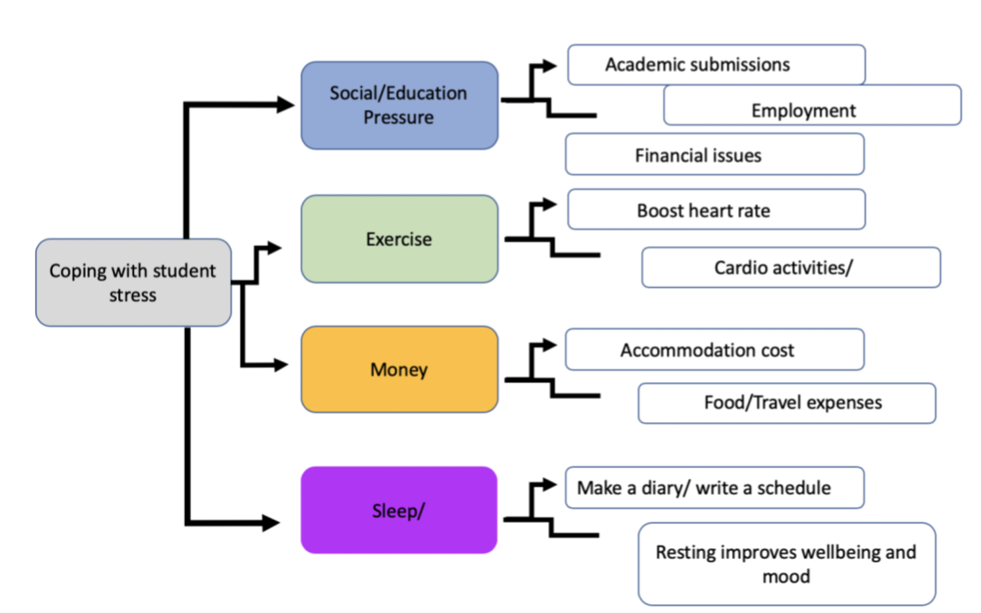

2. Paraphrase the following sentences (max 3 marks for each, max 12 marks in total):

a) Good time management techniques can help you feel more relaxed and focused.
Type here: When planning tasks ahead of time and deciding what is most important for you so you don’t have to rushed. This can also help you stay calm and relaxed.

b) Speaking to your friends and family can significantly lower stress levels.
Type here: Speaking with family and friends can make you feel good about yourself. It can also make you feel less stressed.

c) University life offers numerous opportunities for personal growth and development.
Type here: University offers you a large range of support and opportunities for growth and self-development.

d) Attending lectures regularly is crucial for understanding course material.

Type here: Attending all your classes plays an important role in understanding all your topics better and feeling more ready for your exams.

3. A-) Write 4 Strategies for managing a student budget and reducing costs while at university. (8marks)

B) In a paragraph of 8 sentences, share your personal experience of when you have used or plan to use any of these tips. (8marks)

(max 16 marks in total)

3. A | Write your strategies here.  - Set a weekly spending limit.  - Keep a record of all purchases.  - Share accommodation or expenses with other students.  - Buy second-hand textbooks instead of new ones.  4.
3.B | Write your paragraph here. Your paragraph must be written in full sentences (no bullet points) and in an academic style.  Managing your money well is important for a good university experience. Students who fail to plan their finances often struggle to cover important expenses such as rent and textbooks. In my first semester, I did not set a spending limit, which led to unnecessary financial pressure. This situation made me realise the importance of tracking my income and expenses carefully. I then decided to record all my purchases and set a weekly spending limit to avoid overspending. Additionally, I began using student discounts and buying second-hand books to reduce costs. These changes helped me manage my finances more efficiently and avoid further stress. Overall planning my finances helped me feel more stable and independent.

