William Holmes (2015755)
FSG Tool & Die ACMA6012
2D Diffusion Equation Model using the explicit finite difference method

Table of Contents
Figure Table 2
Figure table 2
1.0 Introduction 4
1.1 Report Structure 4
1.2 Aims and Objectives 4
2.0 The Governing Equation of the Problem 5
2.1 Background & importance of the heat equation 5
2.2 Mathematical Definition for 2D Geometry with No Heat Source 5
2.3 Definition of Terms 6
2.4 the numerical method is chosen to discretise the governing equation 6
2.5 First and Second Derivatives 7
Forward difference approximation 7
Backwards difference approximation 7
Central differences approximations: 8
2.6 Explicit finite difference scheme 9
3.0 Initial boundary and domain condition 10
4.0 Analytical solution 11
5.0 Code details and explanations 12
5.1 Material properties 12
5.11 Grid Spacing and Initialisation 13
5.12 Temperature Matrix Initialisation 13
5.13 Boundary Temperature Validation 13
5.14 Boundary temperature setup 13
5.15 Time-step input 13
5.16 Iterative Convergence Loop: 14
5.17 Convergence check 15
5.18 Temperature map visualisation 15
5.19 Thermal equilibrium 15
5.2 Analytical solution 15
5.21 Grid iteration 16
5.22 Fourier series calculation 16
5.23 Temperature calculation 16
5.24 Difference calculation 17
6.0 Code validation 17
7.0 Comparison of Numerical Values (Matrices) 17
Analytical Solution Matrix: 17
Numerical Solution Matrix (FDM): 17
Error Map: 18
8.0 Heatmap Visualisation 18
Relating Heatmap to Matrices: 18
9.0 Sensitivity analysis of the code results 19
9.1 Variable grid spacing 19
9.2 Sensitivity analysis of the time step 20
9.3 Thermal equilibrium tolerance 21
10.0 Limitations of the model 22
11.0 Suggested improvements and future developments 22
12.0 Conclusion 23
13.0 References 24
14.0 Appendix 25

Figure table
Figure 1- Heat Equation 5
Figure 2- Heat equation with heat source Figure 3- Heat equation without heat source 5
Figure 4- Numerical method 6
Figure 5- Forward difference approximation 7
Figure 6- 1st order derivative 7
Figure 7- Backwards difference approximation 7
Figure 8- Re-arranged backward approximation 7
Figure 9- First-order approximation 7
Figure 10- Central difference approximation 8
Figure 11- Subtracted central difference 8
Figure 12- First derivative 8
Figure 13- 2nd derivative equations 8
Figure 14- 2nd Derivative 8
Figure 15- Temporal derivative 9
Figure 16- Spatial second derivative 9
Figure 17- Grid node consideration 9
Figure 18- Fourier number & stability criterion 10
Figure 19- Initial domain condition 10
Figure 20- Initial boundary condition 10
Figure 21- Analytical solution 11
Figure 22- Code, material properties 11
Figure 23- Code, grid & temperature set 12
Figure 24- Code, boundary temp & time step 13
Figure 25- Explicit finite difference linear equation 13
Figure 26- Code, Iterative convergence loop 13
Figure 27-Code, Convergence check & Temperature map visualisation 14
Figure 28-Code, Thermal Equilibrium 14
Figure 29- Code, Analytical Solution 15
Figure 30- Analytical solution 15
Figure 31- Temperature Calculation 16
Figure 32-Code, Difference Calculation 16
Figure 33- Matrices 16
Figure 34- Error map 17
Figure 35- Analytical solution Figure 36- Numerical solution 18
Figure 37- Variable grid spacing 18
Figure 38- Grid spacing graph 19
Figure 39- Time step table 19
Figure 40- Time step graph 20
Figure 41- Tolerancing data table 20
Figure 42- Tolerancing graph 21

ACMA 6012

1.0 Introduction
This report explores the application of the explicit finite difference method (EFDM), formulated by J. Gregory and introduced by B. Taylor in 1715, to analyse the MATLAB implementation of the 2D diffusion equation model. By examining code sections and their mathematical and analytical foundations, the analysis provides comprehensive insights into the program's development and execution.

1.1 Report Structure
- Governing Equation of the Problem: Introducing the heat equation for 2D geometry, its significance, mathematical definition, and references.
- Numerical Method for Discretizing the Governing Equation: Describes the discretisation procedure, including Taylor series approximations, explicit finite difference scheme, spatial and temporal discretisation, Fourier’s number, and stability criterion.
- Initial and Boundary Conditions and Analytical Solution: This section specifies the initial and boundary conditions and introduces the analytical solution for validation.
- Code Details and Explanations: Provides snapshots and explanations of the code sections.
- Validation of the Code: Compares the EFDM thermal equilibrium temperature map with the analytical solution.
- Analysis of Code Results: Conducts a sensitivity analysis on grid spacing, time step, and thermal equilibrium tolerance, supported by academic references.
- Discussion of Model Limitations: This section covers numerical method limitations (round-off error, truncation error, complex geometry, stability) and coding limitations related to thermal equilibrium modelling.
- Suggested Improvements and Future Developments: This project investigates numerical alternatives to EFDM, handles complex geometries and unstructured meshes, and explores robust ways to model thermal equilibrium.
- Conclusion: Review the report's findings, results, and the established aims and objectives.

1.2 Aims and Objectives
- Assess the accuracy and stability of the EFDM’s performance on thermal equilibrium modelling.
- Identify coding limitation
- Conduct a sensitivity analysis on tolerancing, time step, and grid spacing
- Conduct side-by-side comparisons with the analytical solution
- Suggested improvements to the model and future developments
- Propose robust modelling solutions

2.0 The Governing Equation of the Problem
The 2D finite difference method is a pivotal numerical technique used to solve the diffusion equation essential to this analysis. The time-dependent thermal diffusion model, which employs the finite difference method, is outlined below, sourced from Croft, D.R. and Lilley, D.G. (1986). This method effectively describes the conduction of solids through the heat equation:
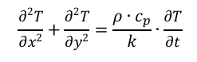
Figure 1- Heat Equation

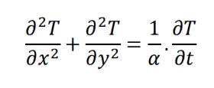
Figure 2- Heat equation with heat source Figure 3- Heat equation without a heat source

2.1 Background & importance of the heat equation
The heat equation, a partial differential equation (PDE), is fundamental in describing temperature distribution within a material over time. Its significance in heat transfer and thermodynamics, along with its wide-ranging applications in engineering, physics, and mathematics, highlights its importance. Formulated by Joseph Fourier in the early 19th century, the heat equation models heat diffusion, providing insights into both steady-state and transient thermal behaviours. This equation is crucial for designing efficient systems and predicting temperature distributions, making it essential in fields such as thermal management in electronics, climate modelling, and financial mathematics.

2.2 Mathematical Definition for 2D Geometry with No Heat Source
- T (x, y, t) represents the temperature as a function of spatial coordinates x and y and time t.
- α is the thermal diffusivity of the material.
- $\frac{∂^{2}T}{\begin{aligned}∂x^{2}\end{aligned}}+\frac{∂^{2}T}{\begin{aligned}∂y^{2}\end{aligned}}$These are the second spatial derivatives of temperature in the x and y directions, respectively.
- $\frac{∂T}{∂t}$Denotes the rate of change of temperature in time.
This equation models how heat diffuses through a material without any internal heat sources, allowing for the analysis of temperature variations over time.

2.3 Definition of Terms
T (x, y, t): The temperature field, representing the temperature at any given point in space (defined by coordinates x and y) and time t.
x: The spatial coordinate in the horizontal direction.
y: The spatial coordinate in the vertical direction.
t: Time, representing the temporal evolution of the temperature distribution.
α: The thermal diffusivity of the material, a property that quantifies how quickly heat diffuses through the material, by α= $\frac{K}{PCp}$ Where k is the thermal conductivity, ρ is the density, and cp is the specific heat capacity.
$\frac{∂T}{∂t}$ : The partial derivative of temperature concerning time, representing the temperature change rate over time.
$\frac{∂^{2}T}{\begin{aligned}∂x^{2}\end{aligned}}$: The second partial derivative of temperature concerning the horizontal spatial coordinate x, representing the spatial rate of change of the temperature gradient in the x direction.
$\frac{∂^{2}T}{\begin{aligned}∂y^{2}\end{aligned}}$: The second partial derivative of temperature concerning the vertical spatial coordinate y, representing the spatial rate of change of the temperature gradient in the y direction.

2.4 the numerical method is chosen to discretise the governing equation
The finite difference method uses Taylor series expansions to approximate the derivatives of the temperature function $T(x, y,t)$ By expanding the function T around a point. The Taylor series is a mathematical tool that allows us to represent a function as an infinite sum of its derivatives, and it is essential for deriving finite difference approximations for the first and second derivatives in the context of the heat equation.
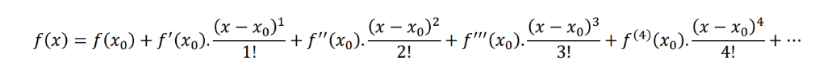
Figure 4- Numerical method

2.5 First and Second Derivatives
The Taylor series uses the first and second derivatives to approximate a function's behaviour around a specific point, increasing accuracy as more derivatives are included. The first derivative indicates the function's rate of change (slope), while the second derivative reveals its curvature (concavity). These derivatives are crucial for approximating functions and analysing truncation errors in numerical methods like the finite difference method. Higher-order derivatives help quantify errors, providing insights into the accuracy of the approximation.
According to Fundamentals of Heat and Mass Transfer (Incropera et al., 2007) and Croft and Lilley (1986), these principles are essential for understanding heat transfer calculations. The Taylor series plays a vital role in finite difference methods, which are widely used to discretise differential equations and provide accurate solutions in thermal analysis and other engineering applications.

Forward difference approximation

The forward difference considers x=x0+hx, where h is the step size (grid size).
Using the Taylor series for f(x0+h):
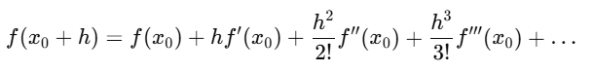
Figure 5- Forward difference approximation
Rearrange the above equation to solve for f′(x0):
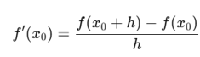
Figure 6- 1st order derivative

Backwards difference approximation

The backward difference considers x=x0−hx = x_0 - hx=x0​−h.
Using the Taylor series for f(x0−h):
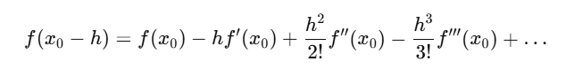
Figure 7- Backwards difference approximation

Rearrange the above equation to solve for f′(x0):
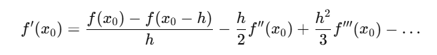
Figure 8- Re-arranged backward approximation

For a first-order approximation:
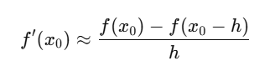
Figure 9- First-order approximation

Central differences approximations:

The central difference uses two points symmetrically around X0, 0 = X0 + h & x = X0 – h. Using the Taylor series for f(x0+h) and f(x0−h):
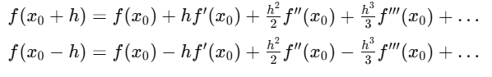
Figure 10- Central difference approximation
Subtract the two equations:
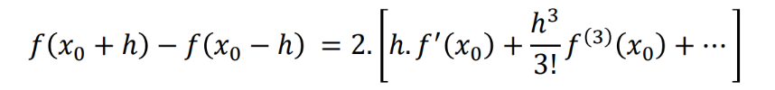
Figure 11- Subtracted central difference
For a first derivative:
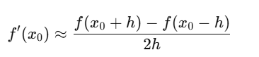
Figure 12- First derivative

Subtract the two equations for the second derivative:

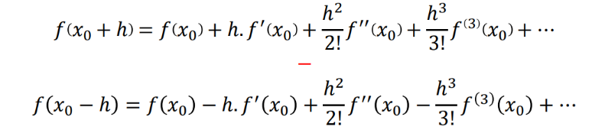
Figure 13- 2nd derivative equations

Second Derivative:
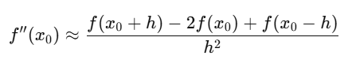
Figure 14- 2nd Derivative

2.6 Explicit finite difference scheme
Temporal derivative $\frac{∂T}{∂t}$
$T\frac{T}{p}$ Represents the temperature at location P at the current time t.
$T\frac{T}{p}$+Δ represents the temperature at the exact location PP, but at the next time step $T$+Δt.
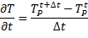
Figure 15- Temporal derivative
Smaller time steps $Δt$ Improve accuracy by reducing truncation error and the difference between the exact solution and the numerical approximation due to the method's finite precision. This reduction in error provides a more accurate approximation of the continuous time derivative. Using smaller $Δt,$ The system's temporal evolution is captured in finer detail, leading to more precise simulations. However, while smaller $Δt$ It improves accuracy but requires more time steps to cover the same time interval, increasing computational effort and resource requirements.
Spatial second derivative $\frac{∂^{2}T}{{∂x}^{2}}$ & $\frac{∂^{2}T}{{∂y}^{2}}$
Using the central difference approximation for the spatial second derivative:
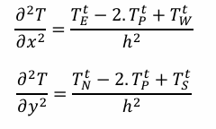
Figure 16- Spatial second derivative
Discretise spatial domain:
$TE, TW, TS$, and $TN$ Represent the boundary temperature at all four walls, as shown in the diagram below.
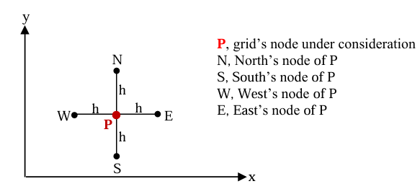
Figure 17- Grid node consideration
Uniform grid spacing ensures that the distance between successive grid points is constant. It also simplifies the application of finite difference methods through the central difference formula for the second derivative, and the forward/backward differences rely on $Δt$Being constant across the domain.
Fourier number & stability criterion
This is derived from the explicit finite differences form of the heat equation introducing Fourier’s number. Which is stated as $Fo$with the remainder of the equation enforcing the stability criterion.,
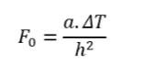
Figure 18- Fourier number & stability criterion

3.0 Initial boundary and domain condition

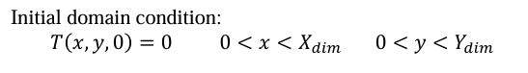
Figure 19- Initial domain condition
Initial and boundary conditions are crucial for accurate and reliable simulations. They provide a starting point and define the system's behaviour at its edges.
The boundary conditions define the temperature behaviour at the domain's edges over time. For the given problem, the temperature at the bottom edge and the top edge are set at $T0$and $-T0$
Neumann boundary conditions imply that no heat flux occurs from the left. $(X=0X=0)$ and right $(X=XdimX=Xdim)$ Edges indicate insulated boundaries, as shown in the figure below.
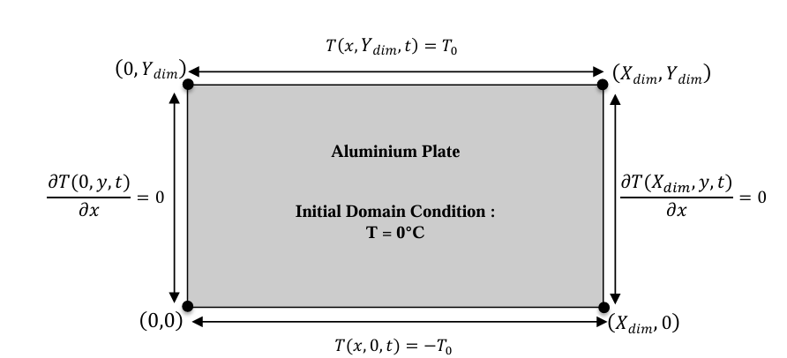
Figure 20- Initial boundary condition

4.0 Analytical solution

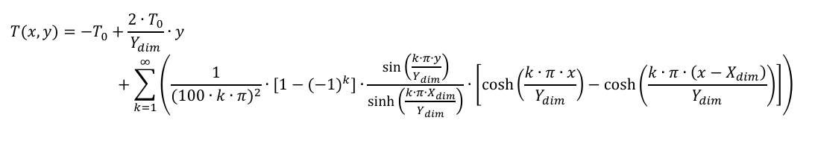
Figure 21- Analytical solution

This solution represents the temperature distribution at thermal equilibrium, satisfying the given initial and boundary conditions.
By clearly specifying the initial and boundary conditions and introducing the analytical solution, we provide a benchmark for validating the numerical code. This analytical solution represents the temperature distribution at thermal equilibrium, satisfying the given initial and boundary conditions. Its presence reassures us that our numerical code is correctly implemented and validated against this benchmark.

5.0 Code details and explanations

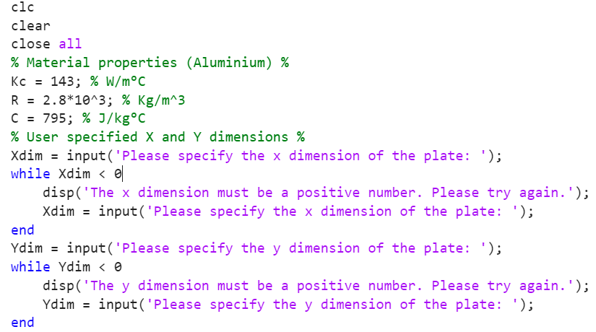
Figure 22- Code, material properties

5.1 Material properties
This section of the code initialises the material properties of aluminium and defines them. $Kc$ It then prompts the user to input the plate dimensions, $Xdim$ and $Ydim$, using thermal conductivity$, R$ as density and $C$ As specific heat capacity.
The program uses safeguarding measures to ensure valid input. These measures include while loops that repeatedly prompt users to re-enter values until positive numbers are provided, thus preventing the program from running with invalid input.

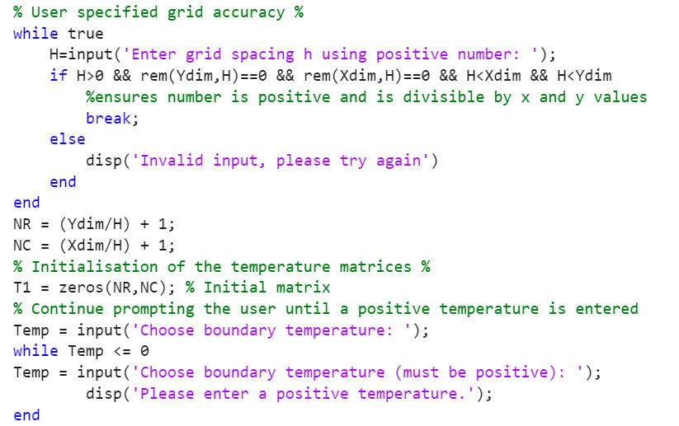
Figure 23- Code, grid & temperature set

5.11 Grid Spacing and Initialisation
The code first validates the grid spacing by repeatedly prompting the user to enter a positive value for the grid spacing, cap H. It checks that cap H is positive and evenly divides the plate's X and Y Dimensions. If all conditions are met, the loop breaks; otherwise, it displays an error message and asks for input again.
After determining a valid grid spacing, the program calculates the number of rows. $(NR)$ and columns $(NC)$ In the grid, ensure that the grid dimensions align with the plate size and chosen spacing.

5.12 Temperature Matrix Initialisation
A temperature matrix T1 of size $NR×NC$ It is initialised to zeros. This matrix represents the temperature distribution over the grid and will be updated in subsequent computations.

5.13 Boundary Temperature Validation
The program prompts the user to enter a boundary temperature (Temp) and ensures it is positive. If a negative value is entered, the loop prompts the user to re-enter until a valid temperature is provided.

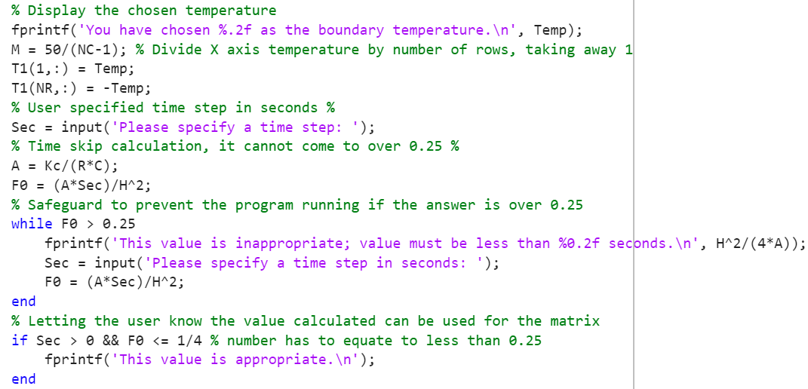
Figure 24- Code, boundary temp & time step

5.14 Boundary temperature setup
This function displays the chosen boundary temperature (Temp) to the user and updates the first and last rows of the temperature matrix. The top row (T1(1, :)) is set to Temp, and the bottom row (T1(NR, :)) is set to -Temp.

5.15 Time-step input
It prompts the user to input a time step, and a safeguard has been implemented to ensure the value cannot exceed 0.25. This is achieved by using the following equation.
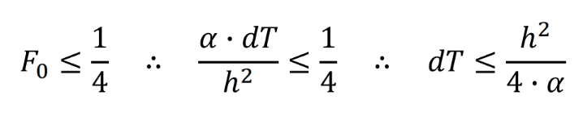
Figure 25- Explicit finite difference linear equation

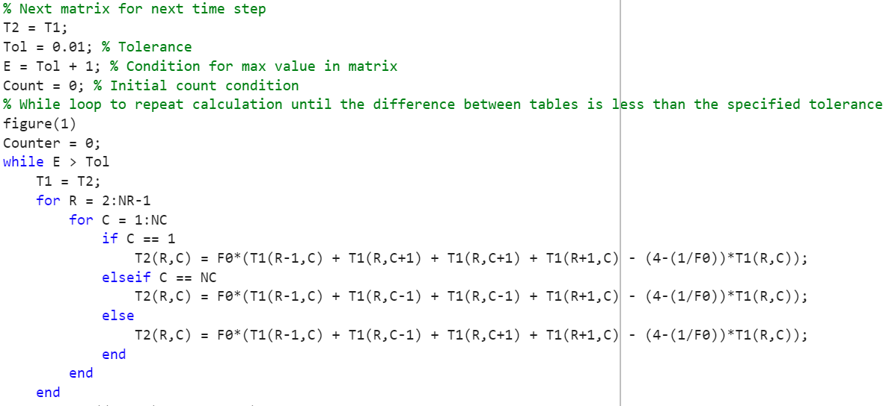
Figure 26- Code, Iterative convergence loop

5.16 Iterative Convergence Loop:
The while loop continues until the maximum difference (E) between consecutive iterations is less than the specified tolerance (Tol), indicating convergence. In each iteration, T1 is updated to the previous T2. The loop iterates over the internal nodes of the grid (ignoring boundaries) using nested loops. For each row (R) and column (C), the temperature at the node is updated based on the surrounding nodes using the finite difference formula. Specific formulas are applied if the node is on the left or right boundary $(C == 1 or C == NC)$. Otherwise, the general formula is used for interior nodes. The finite difference formula accounts for Contributions from the adjacent nodes—a stability correction factor involving F0 (previously calculated).

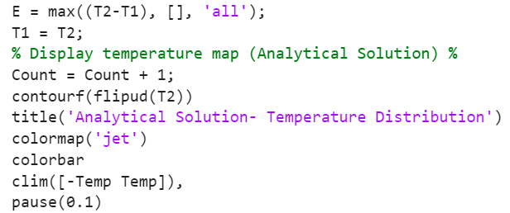
Figure 27-Code, Convergence check & Temperature map visualisation

5.17 Convergence check
Calculates the maximum difference (E) between the updated temperature matrix (T2) and the previous iteration (T1) using max (T2-T1, [], 'all'). This checks if the solution is converging to within the specified tolerance. T1=T2 prepares for the next iteration using the last temperature matrix as a baseline.

5.18 Temperature map visualisation
The count function keeps track of how many iterations are performed. The (flipud) function ensures the correct orientation on the display map, whilst contour creates a filled contour plot and (colormap) sets the colour scheme. The (clim) function ensures the setting of limits. To match boundary temperatures.

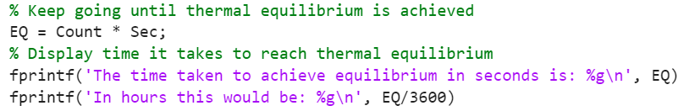
Figure 28-Code, Thermal Equilibrium

5.19 Thermal equilibrium
The thermal equilibrium time calculation is represented by $EQ= count * Sec$; following this, the prompt to the user will show the time taken to reach thermal equilibrium in seconds and hours. Using the $EQ/ 3600$ Part of the FprintF function.

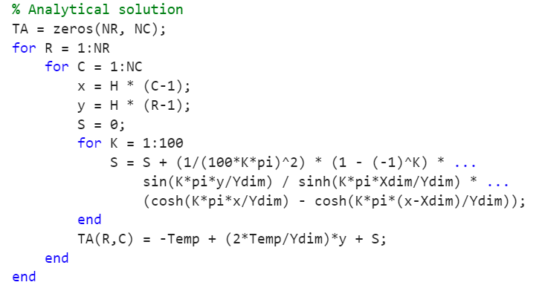
Figure 29- Code, Analytical solution

5.2 Analytical solution
TA is initialised as a matrix of zeros, with dimensions matching the numerical grid (NR rows by NC columns). This matrix will store the analytical temperature values for each grid point.

5.21 Grid iteration
A nested loop iterates through each grid point. R (row index) and C (column index) correspond to the grid's spatial location. x and y are calculated using the grid spacing (H) and indices. These represent the grid point's physical coordinates.

5.22 Fourier series calculation
Figure 30- Analytical solution
The Fourier series approximation, a meticulously calculated method, is used to compute the temperature for each grid point, ensuring high accuracy.
$S$ It is initialised to 0, representing the sum of the series. An inner loop runs for $K = 1:100$, adding terms of the series to$S$. Each term includes sinusoidal and hyperbolic functions scaled by the series index. $K$ and spatial parameters $(x, y, dx, dim$). The series accounts for the boundary conditions and the plate's thermal behaviour.

5.23 Temperature calculation
The final temperature at each grid point is computed using the series sum.$S$ And additional linear terms:
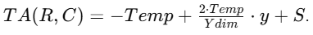
Figure 31- Temperature calculation
Temp and $Ydim$Influence the temperature gradient along the y-axis.

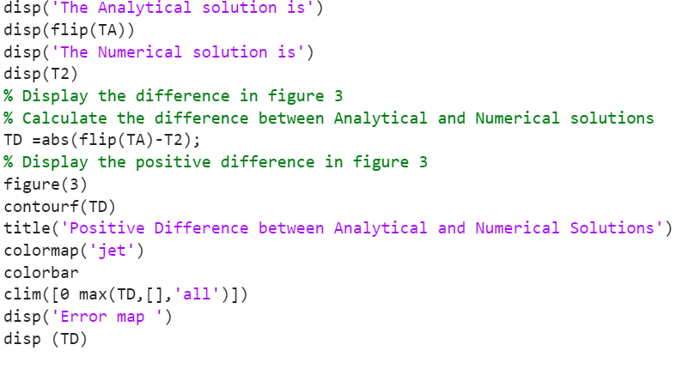
Figure 32-Code, Difference calculation

5.24 Difference calculation
The difference between the analytical and numerical solutions is computed as an element-wise absolute value: $TD = abs(flip(TA) - T2$). This ensures that only the magnitude of the difference is considered.

6.0 Code validation
To validate the code and compare the results from the explicit Finite Difference Method (FDM) with the analytical solution, we can assess the numerical values of the matrices and relate them to the heatmap visualisation of the temperature distribution.
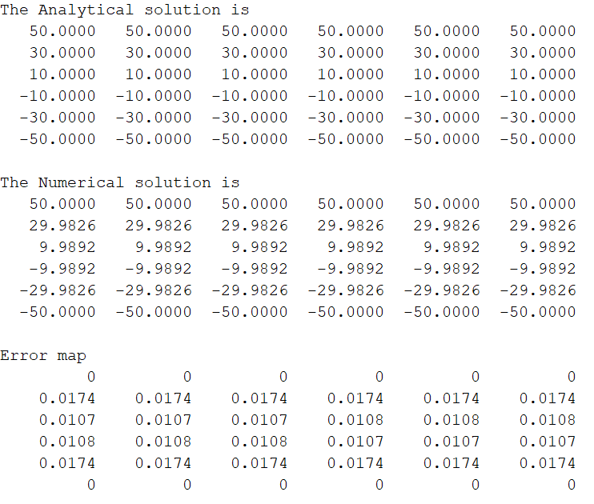
Figure 33- Matrices

7.0 Comparison of Numerical Values (Matrices)

Analytical Solution Matrix:
The values in the matrix decrease linearly across rows, starting from 50 at the north boundary and reducing symmetrically to -50 at the south boundary. This behaviour matches the expected analytical solution for a steady-state temperature distribution.

Numerical Solution Matrix (FDM):
The FDM solution closely approximates the analytical solution. However, there are minor deviations in the interior cells of the matrix. For example, in row 2, the FDM solution shows values of approximately 29.9826 compared to the analytical 30.0000. Similarly, in row 3, values like 9.9892 differ slightly from the analytical 10.0000. These differences, although small, are due to the discretisation errors inherent in numerical methods.

Error Map:
The error values are minimal, ranging from 0 to a maximum of 0.0174, indicating that the numerical solution is highly accurate. The errors are concentrated in the interior cells, while the boundary values match perfectly.
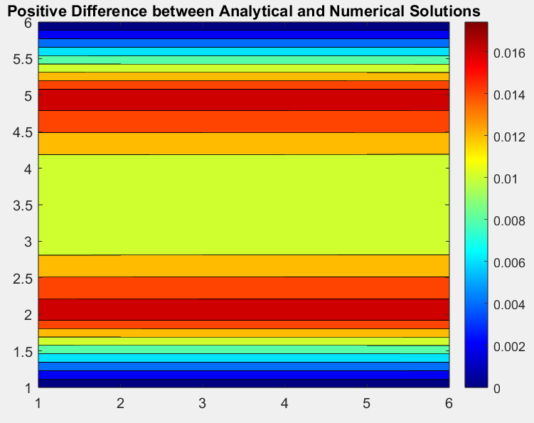
Figure 34- Error map

8.0 Heatmap Visualisation
The heatmap provides a graphical representation of the temperature distribution. The analytical and numerical heatmaps show a smooth gradient from hot (red) to cold (blue), representing the north-to-south boundary conditions. The visual difference between the two solutions on the heatmap would be negligible since the numerical errors are minimal (as shown in the error map).

Relating Heatmap to Matrices:
The heatmap accurately reflects the numerical matrix values, with slight deviations in intermediate temperatures captured as minor discrepancies. The matrices and the heatmap maintain the symmetry and boundary conditions, confirming consistency.
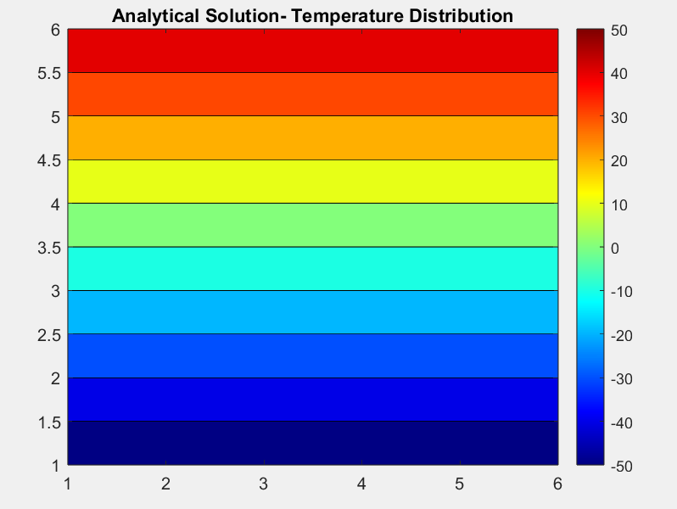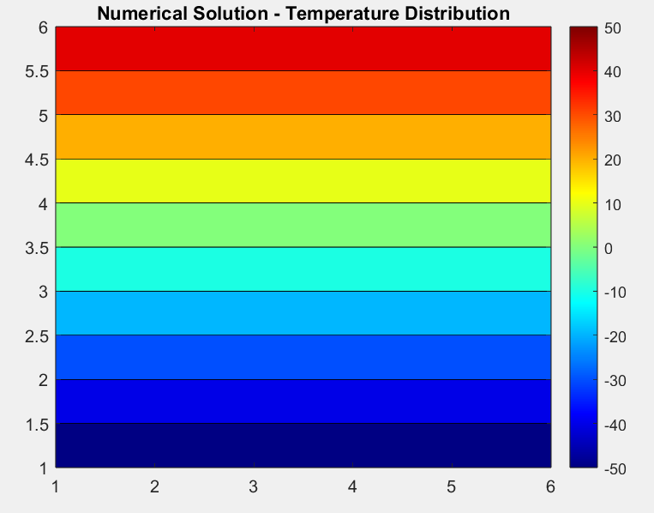
Figure 35- Analytical solution Figure 36- Numerical solution

9.0 Sensitivity analysis of the code results

9.1 Variable grid spacing
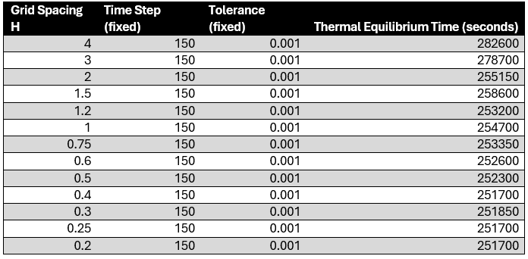
Figure 37- Variable grid spacing

Figure 38- Grid spacing graph
Fig38
Conducting a sensitivity analysis on grid spacing reveals critical insights into how this parameter affects numerical simulations. As grid spacing HH decreases, accuracy improves by capturing detailed temperature variations, but computational cost. The data shows significant improvements in thermal equilibrium time from $H=4H = 4 to H=1.5H = 1.5$, while more minor improvements occur from $H=0.6H = 0.6 to H=0.2H = 0.2$. This suggests that $H≤0.6H \backslash leq 0.6$ Offers an optimal balance between accuracy and computational efficiency (Conte & De Boor, 1980).

9.2 Sensitivity analysis of the time step
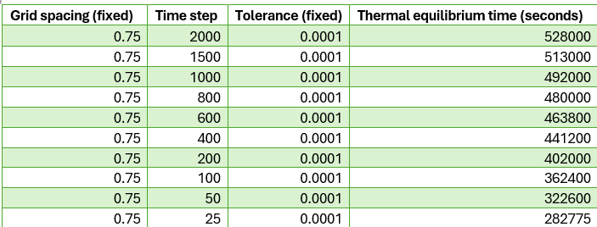
Figure 39- Time step table

Figure 40- Time step graph
As the time step $Δt$The thermal equilibrium time decreases, indicating that smaller time steps lead to more accurate and stable solutions, allowing the system to reach equilibrium faster. Smaller time steps improve accuracy by reducing truncation errors and precisely capturing the system's dynamics. However, this comes at the cost of increased computational demand due to the need for more iterations to reach the final solution. Conversely, more significant time steps reduce the computational cost by requiring fewer iterations but may lead to instability and inaccuracies due to more substantial truncation errors.
The data demonstrates substantial improvements in thermal equilibrium time as the time step decreases from 2000 to 25 seconds. Choosing a moderate time step, such as 100 or 50 seconds, for practical purposes balances computational efficiency and solution accuracy well.

9.3 Thermal equilibrium tolerance
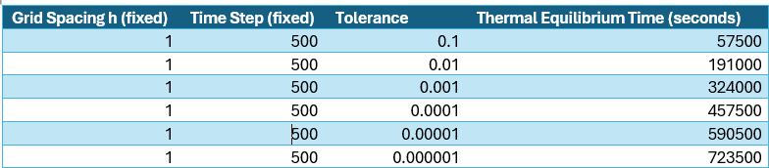
Figure 41- Tolerancing data table

Figure 42- Tolerancing graph
The "Tolerance Effect on Thermal Equilibrium Time" bar graph shows that as tolerance levels decrease, the time taken to reach thermal equilibrium increases significantly. The y-axis represents thermal equilibrium time in seconds, and the x-axis shows the tolerance levels.
Decreasing tolerance levels results in longer thermal equilibrium times. Tighter tolerances require more iterations for accuracy, increasing computational cost (Chapra and Canale, 2015). Conversely, looser tolerances reduce computational costs but may result in less accurate solutions (Burden and Faires, 2011). Data shows significant increases in equilibrium time as tolerance levels decrease from 0.1 to 0.000001. A moderate tolerance level, such as 0.001, balances computational efficiency and solution accuracy (Conte & De Boor, 1980).

10.0 Limitations of the model
Coding Limitations of Modelling Thermal Equilibrium involves several coding limitations that impact accuracy and reliability. One of the primary challenges is setting the equilibrium tolerance threshold, which significantly affects the model's performance and outcomes.
The equilibrium tolerance threshold is a critical parameter throughout the modelling process. It defines the acceptable error margin for the system to be considered at equilibrium. However, the threshold selection is often arbitrary, leading to significant variations in the results. This arbitrariness poses a challenge as different tolerance values can yield various thermal equilibrium times and temperature distributions, affecting the reliability of the simulations.
Sensitivity analysis of the equilibrium tolerance threshold reveals that the model's results are susceptible to this parameter. Small changes in the tolerance value can lead to significant differences in the time taken to reach equilibrium and the overall accuracy of the simulation. The sensitivity highlights a critical limitation in the model's coding, demonstrating that the results depend heavily on an arbitrarily selected parameter. Such dependency is not ideal, as it may lead to inconsistent and unreliable outcomes.
Improving the method for determining the equilibrium tolerance threshold is essential to address these limitations. This could involve developing more systematic and data-driven approaches to selecting appropriate tolerance values, potentially incorporating machine learning techniques to predict optimal thresholds based on data.
Additionally, further research and refinement of the sensitivity analysis can help identify the most robust and reliable tolerance settings, ensuring more consistent and accurate modelling of thermal equilibrium.

11.0 Suggested improvements and future developments
Root-mean-square error Tracking offers a measure of convergence by tracking the root-mean-square error instead of the maximum temperature difference. It ensures that the entire temperature field meets the desired accuracy, improving the model's reliability by focusing on overall accuracy rather than isolated points.
Energy-based convergence offers a robust criterion for convergence by monitoring the total change in internal energy. It accounts for the overall energy balance within the system, providing a reliable indicator of equilibrium and ensuring that the system's energy dynamics are accurately represented.
Heat Flux-Based Convergence monetises heat flux internally and at the boundaries to accurately capture heat transfer dynamics. Focusing on the actual heat flow within the system gives precise equilibrium modelling, leading to more accurate and stable simulations.
Machine Learning-Based Convergence Prediction: This approach utilises machine learning techniques to predict convergence based on historical data. It can learn from past iterations to indicate the number of iterations required for convergence. It optimises computational resources and improves accuracy, leveraging advanced data analytics to enhance the robustness of thermal models.

12.0 Conclusion
To conclude, using the explicit finite difference method (EFDM) to model thermal equilibrium within a 2D diffusion has been found to offer a solid equation platform. However, the strategy is limited in stability, complex geometry, and unstructured meshes. The accuracy and stability of the model are heavily influenced by tolerancing, time step, and grid spacing.
The sensitivity analysis revealed that the models' results are highly impressionable by modifying tolerances, which are commonly arbitrarily chosen. This dependence on an arbitrary parameter is not ideal and requires further investigation for more robust modelling approaches.

To address these limitations, exploring alternative numerical methods, such as the Finite element method and implicit finite difference, could improve accuracy and stability. More robust strategies to model thermal equilibrium include root-mean-square error tracking, energy-based convergence, heat flux-based convergence, and machine-based learning convergence prediction.
Considering these improvements and future developments, the model's reliability and applicability in various real-world scenarios can be significantly enhanced, leading to more accurate and efficient thermal management strategies.

13.0 References
  - Incropera, F.P., DeWitt, D.P., Bergman, T.L., & Lavine, A.S. (2007) Fundamentals of Heat and Mass Transfer. Wiley.
  - Fourier, J. (1822) Théorie analytique de la chaleur. Cambridge University Press (translated editions available).
  - Taylor, B. (1715) 'Methodus Incrementorum Directa et Inversa', Philosophical Transactions of the Royal Society of London.
  - Gregory, J. (1668) Geometriae Pars Universalis.
  - Chapra, S.C. and Canale, R.P. (2015) Numerical Methods for Engineers. 7th ed. New York: McGraw-Hill Education.
  - Burden, R.L. and Faires, J.D. (2011) Numerical Analysis. 9th ed. Boston: Brooks/Cole.
  - Conte, S.D. and De Boor, C. (1980) Elementary Numerical Analysis: An Algorithmic Approach. 3rd ed. New York: McGraw-Hill Education.
  - Jaluria, Y. (1986) Computational Heat Transfer. Hemisphere Publishing Corporation.
  - Iserles, A. (1996) A First Course in the Numerical Analysis of Differential Equations. Cambridge University Press.
  - Croft, D.R. and Lilley, D.G. (1986) Heat Transfer Calculations Using Finite Difference Equations. Sheffield Hallam University Press.

14.0 Appendix

clc
clear
close all
% Material properties (Aluminium) %
Kc = 143; % W/m°C
R = 2.8*10^3; % Kg/m^3
C = 795; % J/kg°C
% User specified X and Y dimensions %
Xdim = input('Please specify the x dimension of the plate: ');
while Xdim < 0
disp('The x dimension must be a positive number. Please try again.');
Xdim = input('Please specify the x dimension of the plate: ');
end
Ydim = input('Please specify the y dimension of the plate: ');
while Ydim < 0
disp('The y dimension must be a positive number. Please try again.');
Ydim = input('Please specify the y dimension of the plate: ');
end
% User specified grid accuracy %
while true
H=input('Enter grid spacing h using positive number: ');
if H>0 && rem(Ydim,H)==0 && rem(Xdim,H)==0 && H<Xdim && H<Ydim
%ensures number is positive and is divisible by x and y values
break;
else
disp('Invalid input, please try again')
end
end
NR = (Ydim/H) + 1;
NC = (Xdim/H) + 1;
% Initialisation of the temperature matrices %
T1 = zeros(NR,NC); % Initial matrix
% Continue prompting the user until a positive temperature is entered
Temp = input('Choose boundary temperature: ');
while Temp <= 0
Temp = input('Choose boundary temperature (must be positive): ');
disp('Please enter a positive temperature.');
end
% Display the chosen temperature
fprintf('You have chosen %.2f as the boundary temperature.\n', Temp);
M = 50/(NC-1); % Divide X axis temperature by number of rows, taking away 1
T1(1,:) = Temp;
T1(NR,:) = -Temp;
% User specified time step in seconds %
Sec = input('Please specify a time step: ');
% Time skip calculation, it cannot come to over 0.25 %
A = Kc/(R*C);
F0 = (A*Sec)/H^2;
% Safeguard to prevent the program running if the answer is over 0.25
while F0 > 0.25
fprintf('This value is inappropriate; value must be less than %0.2f seconds.\n', H^2/(4*A));
Sec = input('Please specify a time step in seconds: ');
F0 = (A*Sec)/H^2;
end
% Letting the user know the value calculated can be used for the matrix
if Sec > 0 && F0 <= 1/4 % number has to equate to less than 0.25
fprintf('This value is appropriate.\n');
end
% Next matrix for next time step
T2 = T1;
Tol = 0.01; % Tolerance
E = Tol + 1; % Condition for max value in matrix
Count = 0; % Initial count condition
% While loop to repeat calculation until the difference between tables is less than the specified tolerance
figure(1)
Counter = 0;
while E > Tol
T1 = T2;
for R = 2:NR-1
for C = 1:NC
if C == 1
T2(R,C) = F0*(T1(R-1,C) + T1(R,C+1) + T1(R,C+1) + T1(R+1,C) - (4-(1/F0))*T1(R,C));
elseif C == NC
T2(R,C) = F0*(T1(R-1,C) + T1(R,C-1) + T1(R,C-1) + T1(R+1,C) - (4-(1/F0))*T1(R,C));
else
T2(R,C) = F0*(T1(R-1,C) + T1(R,C-1) + T1(R,C+1) + T1(R+1,C) - (4-(1/F0))*T1(R,C));
end
end
end
E = max((T2-T1), [], 'all');
T1 = T2;
% Display temperature map (Analytical Solution) %
Count = Count + 1;
contourf(flipud(T2))
title('Analytical Solution- Temperature Distribution')
colormap('jet')
colorbar
clim([-Temp Temp]),
pause(0.1)
end
% Keep going until thermal equilibrium is achieved
EQ = Count * Sec;
% Display time it takes to reach thermal equilibrium
fprintf('The time taken to achieve equilibrium in seconds is: %g\n', EQ)
fprintf('In hours this would be: %g\n', EQ/3600)
% Display the Numerical Solution
figure(2)
contourf(flipud(T2))
title('Numerical Solution - Temperature Distribution')
colormap('jet')
colorbar
clim([-Temp Temp]),
% Analytical solution
TA = zeros(NR, NC);
for R = 1:NR
for C = 1:NC
x = H * (C-1);
y = H * (R-1);
S = 0;
for K = 1:100
S = S + (1/(100*K*pi)^2) * (1 - (-1)^K) * ...
sin(K*pi*y/Ydim) / sinh(K*pi*Xdim/Ydim) * ...
(cosh(K*pi*x/Ydim) - cosh(K*pi*(x-Xdim)/Ydim));
end
TA(R,C) = -Temp + (2*Temp/Ydim)*y + S;
end
end
disp('The Analytical solution is')
disp(flip(TA))
disp('The Numerical solution is')
disp(T2)
% Display the difference in figure 3
% Calculate the difference between Analytical and Numerical solutions
TD =abs(flip(TA)-T2);
% Display the positive difference in figure 3
figure(3)
contourf(TD)
title('Positive Difference between Analytical and Numerical Solutions')
colormap('jet')
colorbar
clim([0 max(TD,[],'all')])
disp('Error map ')
disp (TD)

