Assignment 2 – Materials Science

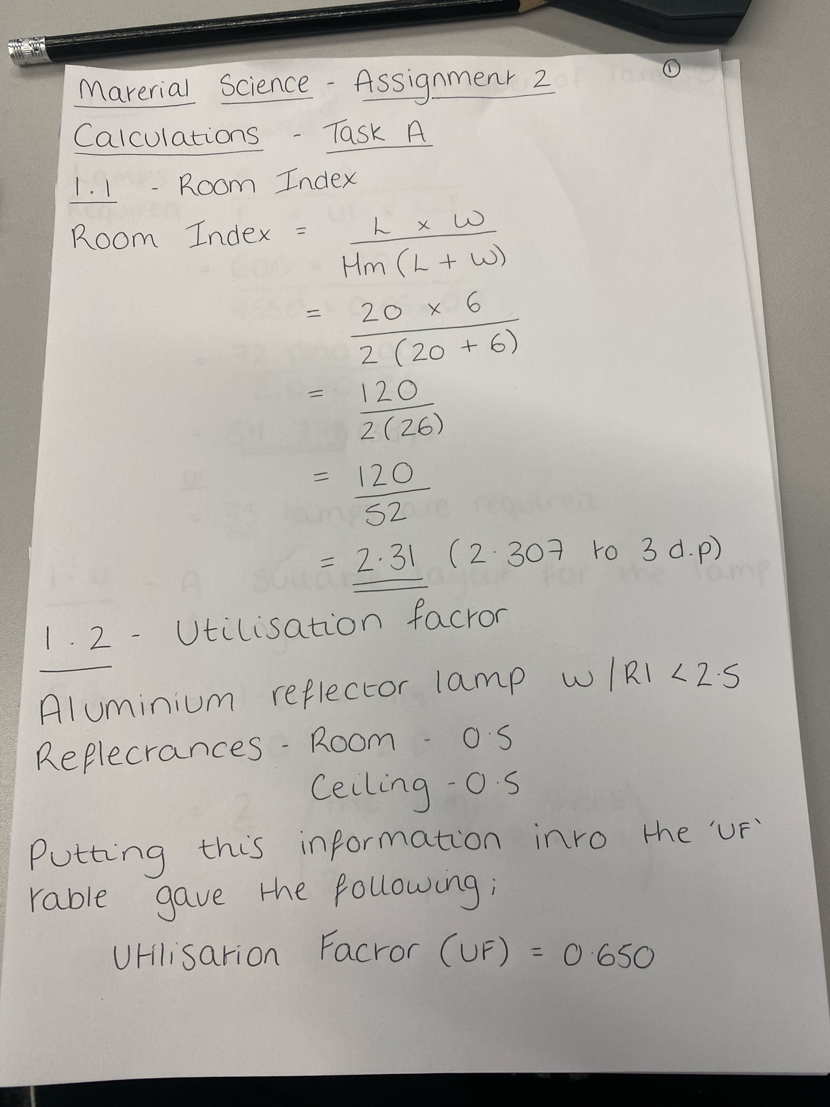

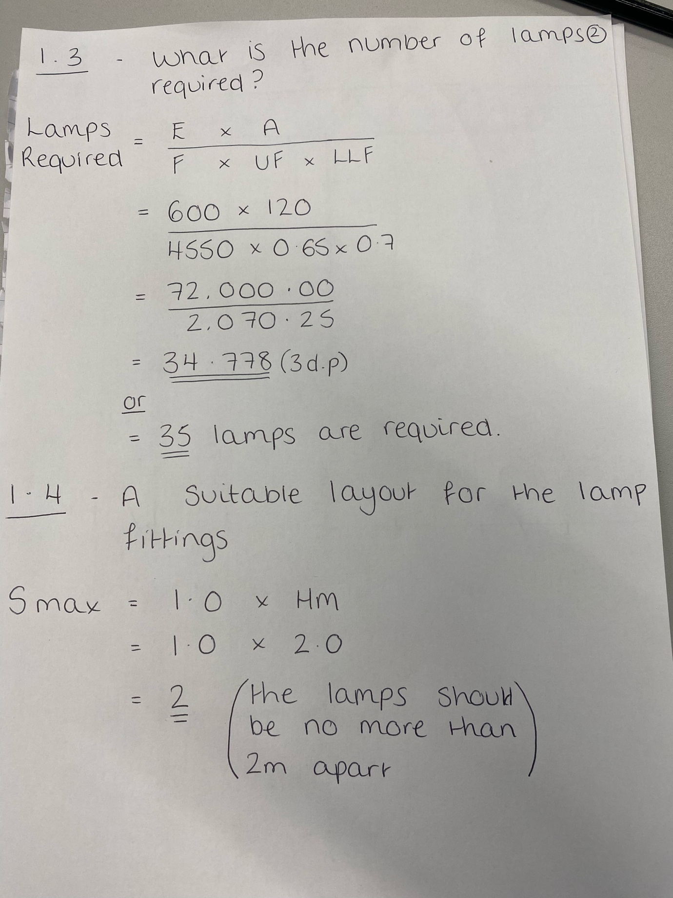

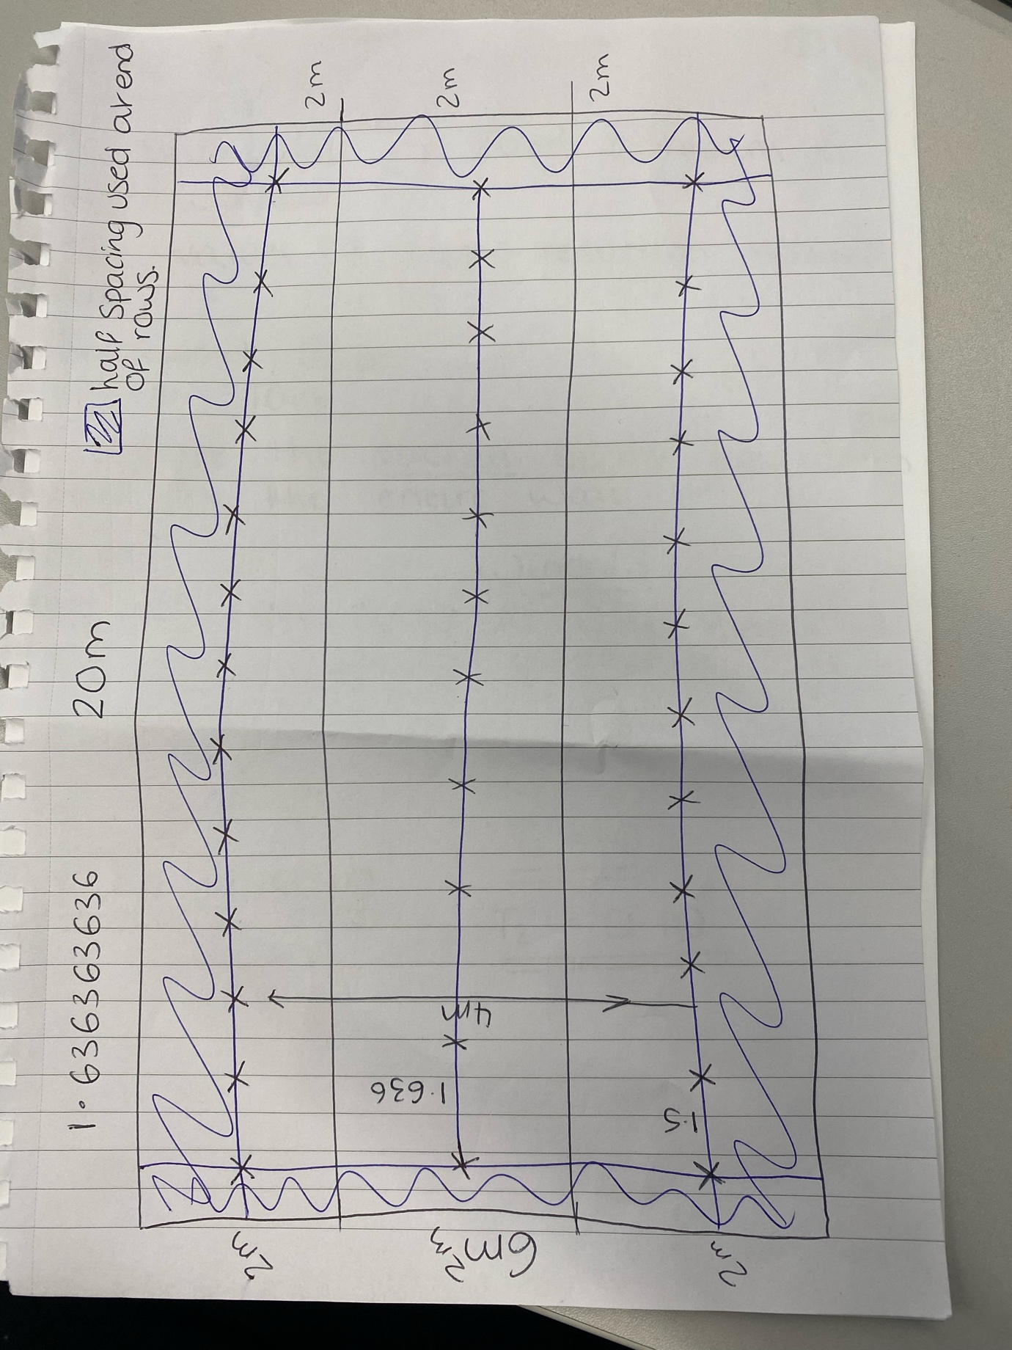

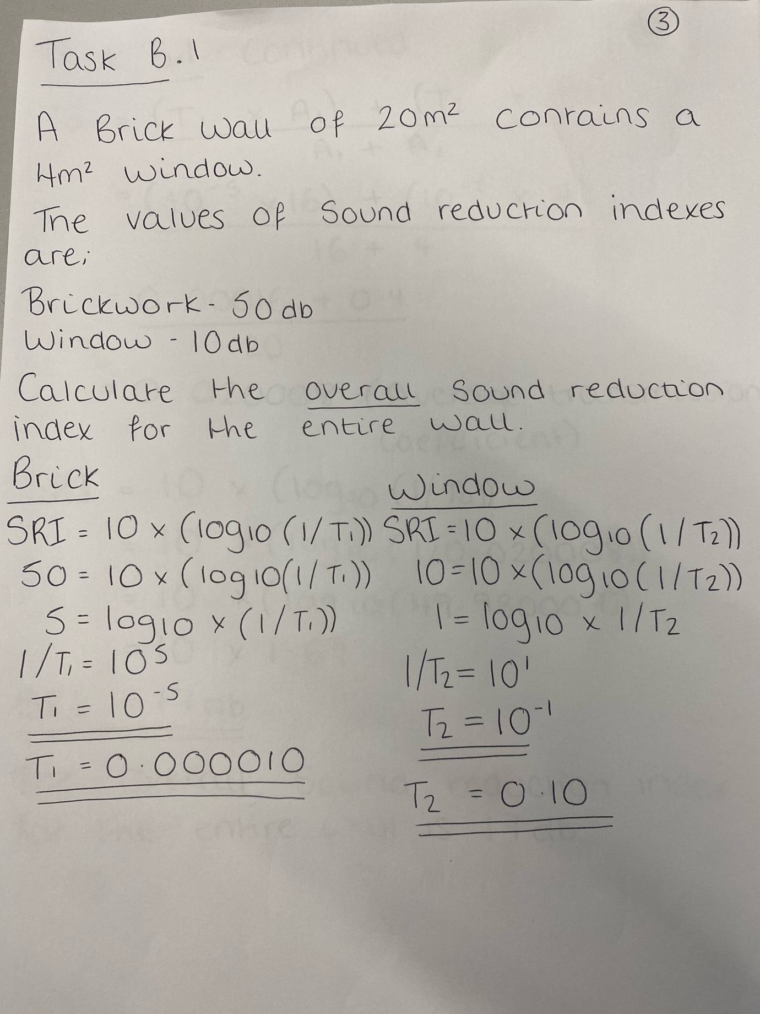

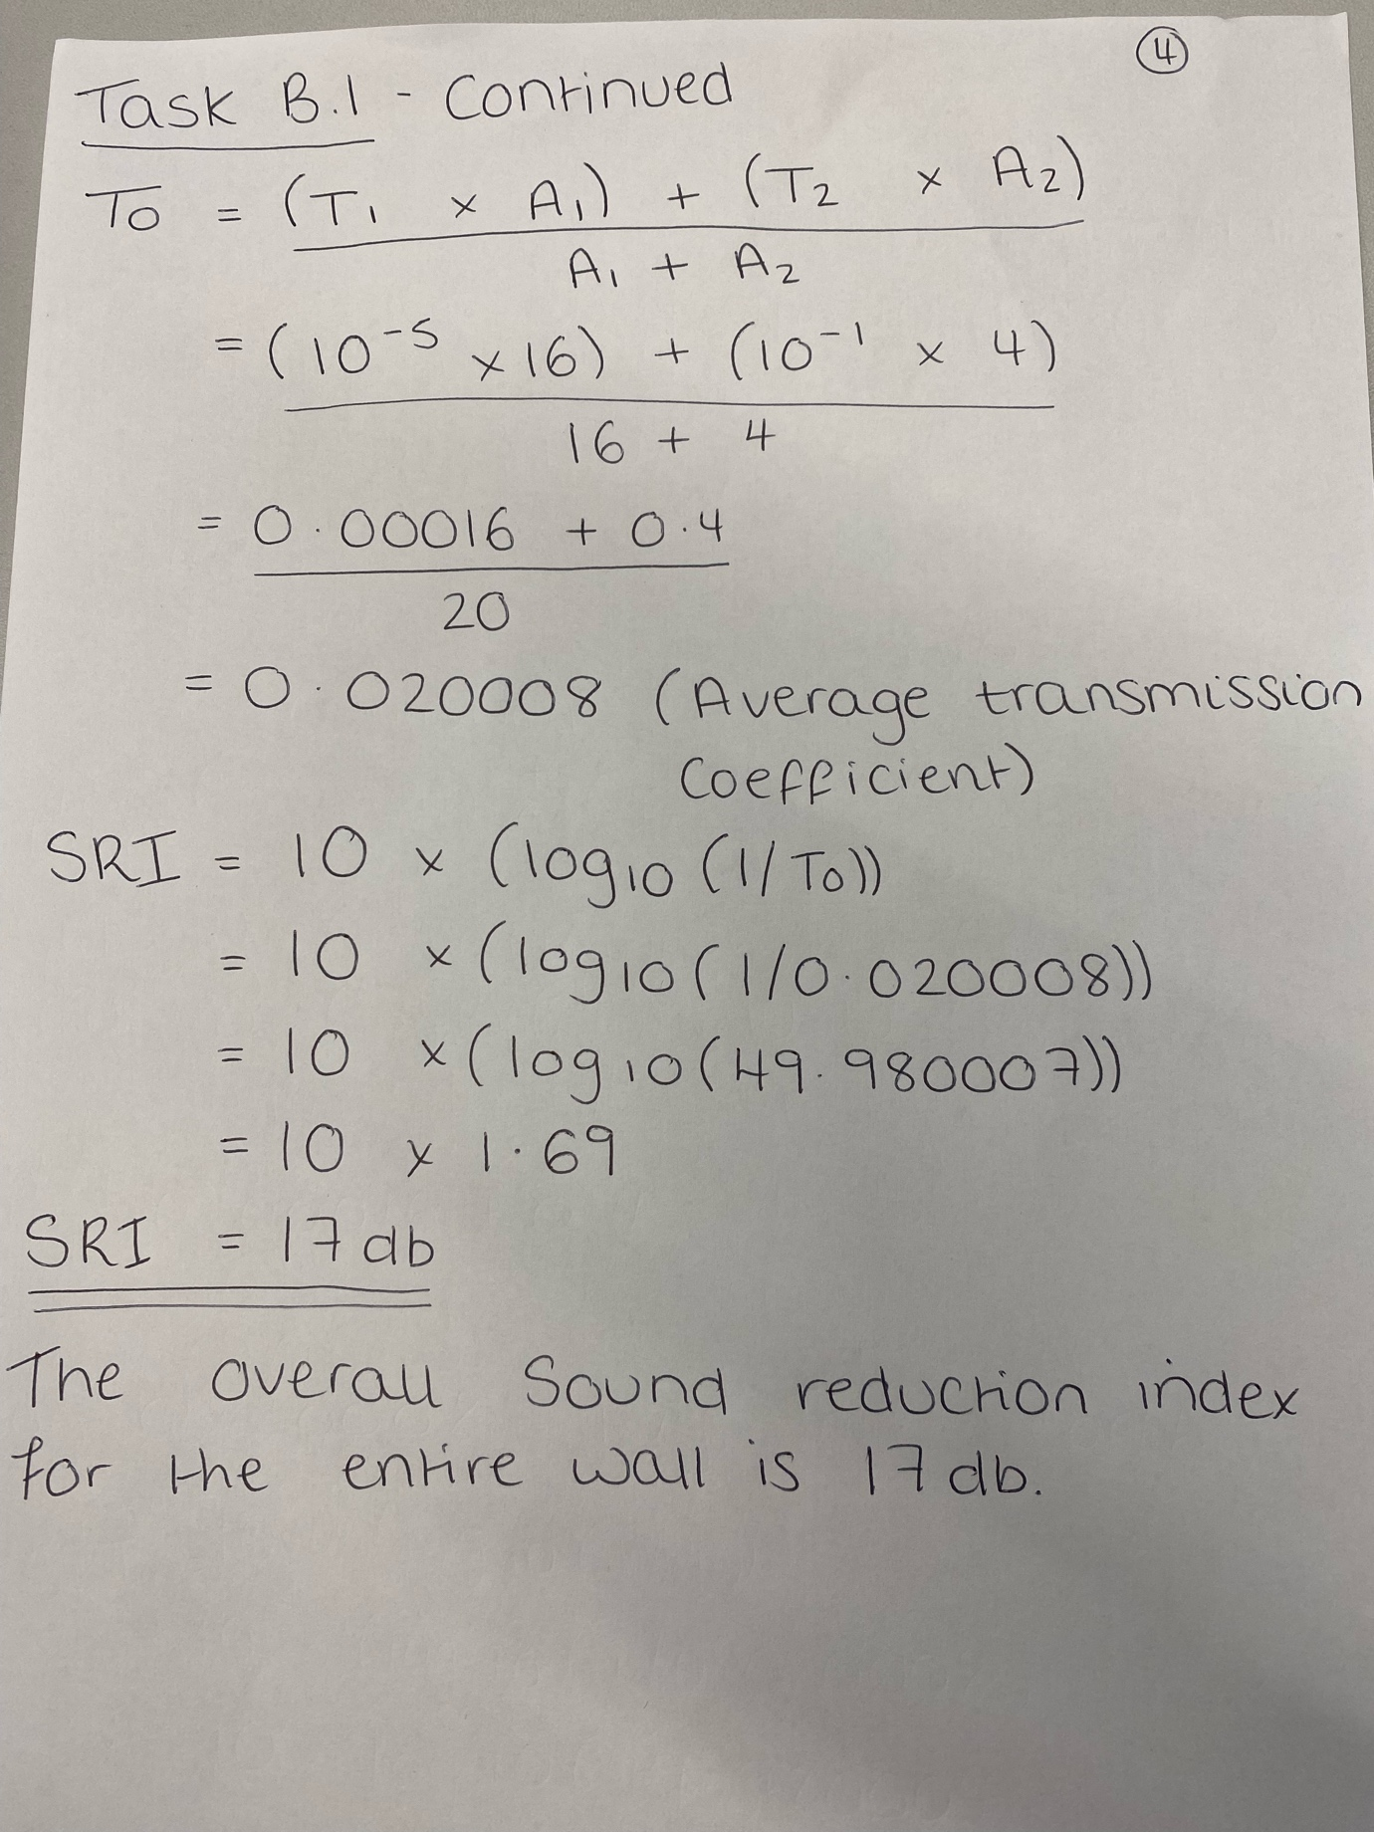

Task B Part 2

Define Frequency and Wavelength of a sound, and the implications of these in;

- A Buildings Internal Design and Services Support
- Partitions Walls Constructions Techniques
- Choice of Insulation Type

Frequency of Sound

The Frequency of a sound is the number of times the sound waves vibrate per second whilst travelling through the air. This is measured in Hertz or Hz. For example, if a sound wave vibrates 350 times per second, then the frequency would be 350 Hertz of 350Hz.

There are two main pitches which can be identified by the human ear. Low-pitched notes known as Bass are caused by low frequency sound waves, whereas high-pitched notes are known as Treble and are caused by high frequency waves.

Wavelength of Sound

Wavelength is the horizontal length of one cycle of the soundwave. If this distance is large, then the sound will have a low frequency. Wavelengths and Frequency are directly correlated with each other.

Buildings Internal Design and Services Support to battle Frequency and Wavelength

To battle the Frequency and Wavelengths of sound, the Internal components of Buildings can be designed with ‘acoustic absorbing’ padding, either on the ceilings or the walls for example, also typically loud rooms can have a separating room between rooms which are desired to be quiet. This is seen is some schools for example, having a store cupboard between two classrooms.

Party Wall Construction

Party Wall construction can massively vary depending on the required decibel levels. They can have more Brickwork or Blockwork, they could also have more cavity between the two skins, or, they can have acoustic plasterboard as well as these.

Choice of Insulation Types

Different insulation types have different acoustic tendencies. For example, ROCKWOOL have an insulation type that is specially designed to battle Frequencies and Wavelengths to provide the building with a desirable noise level.

