6/24/2021
Apostol Sotirov Sabahov
2019598
REPORT on
Models of communications
CONTENT
1.Table of content
2.Introduction
3.Main body
4.Conclusion

INTRODUCTION
I am going to start my report with description of communication:
Communication is the process of sending and receiving messages through verbal or nonverbal means, including speech, or oral communication; writing and graphical representations (such as infographics, maps, and charts); and signs, signals, and behaviour. More simply, communication is said to be "the creation and exchange of meaning."
Source: www.thoughtco.com

1.In this report I am going to explain three different methods of communication, the way they are structured, the way they work, their strengths and weaknesses.
The three models I am going to write about are:
1.Shannon – Weaver model
2.Berlo model
3. Schramm model.

These three models are similar in the way they explain communication, but they have some differences in the way information is received and the way feedback is given or seek by the sender.
In this report I will present examples of case studies and different other methods of communications failures and examples of noise and misunderstandings in passing information from sender to receiver.
We live in world in which information is becoming major part of our everyday life as business, career and even bank transactions are all passing information one person or one institution to another.
The way we communicate and methods we use are vital to our lives, as all three methods I will present are looking at this.

MAIN BODY
The first model I am introducing is SHANNON-WEAVER model. This model was created in 1948 by American mathematician Claude Shannon and Warren Weaver who was a scientist.
The principle of that model is that there is a SENDER (Information Source), ENCODER(Transmitter), CHANELL, DECODER(Receiver), RECEIVER(Destination), NOISE.
This model it is more technological than other linear models. It is also known as “mother of all models”
Advantages of this model are:
-By removing the noise, you can make communication more effective or much better.
-Two-way communication, it can be used in general communication
Disadvantages of the model are:
-Message is more important than feedback
-It is less mass or group communication and more interpersonal one.

This is the diagram that presents the model:

Source: www.communicationtheory.org

MAIN BODY
The next model of communication I am introducing is BERLO model. This model was created in 1960 by David Berlo.
The model has four components, Sender, Message, Channel and Receiver.
This model focuses on message encoding and decoding.
First are the communication skills on sender, attitude, knowledge, social system and education or culture.
Then is the message as: content of it, elements, structure, code, and treatment.
Next is the channel which include Hearing, seeing, touching, smelling, and tasting.
And finally, is the receiver with his communication skills, knowledge, attitude, social skills and system and culture.


Source: www.communicationtheory.org

When we done the case study in class about the professor and the villagers, we discover that, when the professors house went on fire and he ask the village people to help him to put the fire off, they do not understand him, as the language hi was using was completely different then language the villagers was using to express themselves, so no one understand what the professor was saying to them. As a result, his house was completely burned when could be saved if communication was successful and on the same intellectual level.
It is important to communication to happened on same intellectual, educational, or even attitude level.
Also, structure of the message should be on level that receiver should be able to decode.

MAIN BODY

The last communication method in my essay is SCHRAMM model.it was created by Wilbur Schramm in 1954.This method highlight that unless the information pass by sender it is not decoded and understand by receiver it is of no use. The importance of understanding and decoding message is vital, and process of coding and decoding is essential in effective communication.
As the case study in class last weekend show us when the story about Pedro and Maria was given to us. Pedro misunderstands Maria word for chicken with the word kitchen and if the message given to him by his wife was confirmed by Pedro that he heard kitchen, Maria will be able to correct him and therefore will be no mistake happened.
So, in this model if there is no feedback from receiver to the sender communication is incomplete and ineffective.

Graphically the Schramm model of communication can be presented like that:
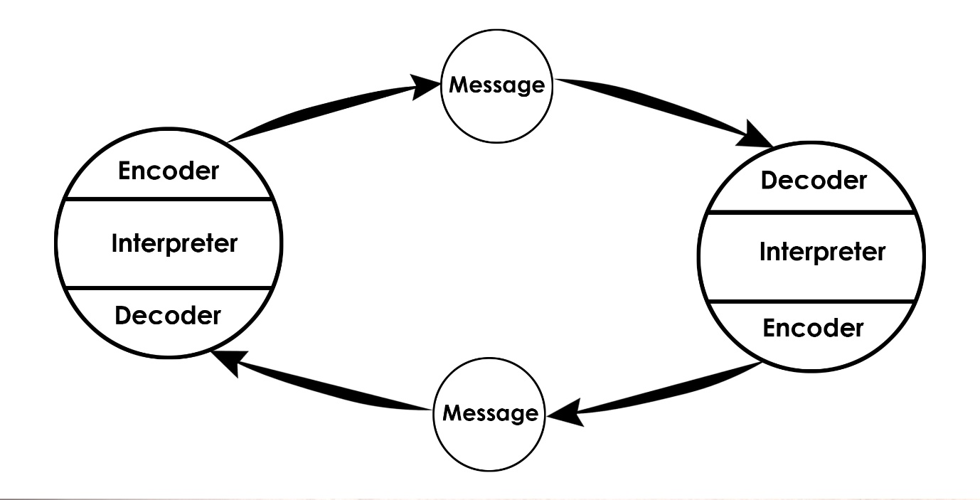
Source: www.bing.com

MAIN BODY
3.COMMUNICATION SKILLS
3.1 Verbal communication
Communication happens in many ways and forms. One of them is verbal communication, that could be described as the things we say.
Verbal communication is important tool to express your thoughts and ideas, it should be done in appropriate and understandable way for the person we speak to. Our information must be also delivered in clear, non-abusive, respectable, and meaningful speaking.
Also, we should consider our listener as different social or educational levels might require different approach to the person we communicate with. Different situations and tasks are another considerable situation in our expressions as job interview is much different then toolbox talk, I do in the morning to my workers.
Verbal communication is often if not ever supported by non-verbal one. As you try to express yourself non-verbal communication always help and contribute to your way to pass the message to the audience or person you talk to.
Simple smiles show that you are in good mood, as angry face is always something you will try to avoid. As I am going to describe in next chapter non-verbal communication is as important as verbal. Sometimes contradictions such as you say to your listener you are feeling all right, but your face expression and your body language are on very worried person clearly state to the person you talk to that you are not honest with him or her.
Going on job interview is another example I want to give, you have perfect CV, just the right one for the job, you are appropriately dress and well presented, but you do not look confident, you are sweating a lot, avoiding direct eye contact. All that showing to the interviewer that something it is not right, and he will be starting to suspect that you are not exactly what you are saying to him or her.
All that is showing that verbal communication is powerful but not enough on its own as we should consider non-verbal one as additional and as important.

MAIN BODY
3.2 Non-verbal communication
Non-verbal communication can be described as the things we do not say but express through our body language, signs, or signals. Most of the cases we communicate we use non-verbal expression as support of our speech. Human being is so used to gestures and different techniques to show his feelings, state of mind or other physical or mental states we even do not put any thoughts but just have certain way to show what we mean that is set in our mind.
Body language is one of the main things our listener is looking at when we communicate, signs of stress, uncertainty, worry and even fear clearly showing to him that even if we trying to sound confident and calm there is something wrong with the whole situation.
On opposite side if you look calm and sure of every word you say, even if you do not know half of the stuff you are talking about, your listener will not be so worried and will generally believe what you are saying.
Looking nervous on interview, applying for loan in bank, as police question you or in any situation like that will undermine what you are saying to them or even, they will become suspicious of your behaviour. Human brain is designed to tell the truth and any effort to lie is require a lot of effort and eventually will show that you are not telling the truth.

3.3 Listening

- Active listening
- Active listening involves listening with all senses. As well as giving full attention to the speaker, it is important that the ‘active listener’ is also ‘seen’ to be listening - otherwise the speaker may conclude that what they are talking about is uninteresting to the listener.
- Interest can be conveyed to the speaker by using both verbal and non-verbal messages such as maintaining eye contact, nodding your head and smiling, agreeing by saying ‘Yes’ or simply ‘Mmm hmm’ to encourage them to continue. By providing this 'feedback' the person speaking will usually feel more at ease and therefore communicate more easily, openly and honestly.
Source: www skillsyoyneed.com

In our online classes we can fully see and understand that as our lecturer it is often asking us for feedback or simply answer a question given to us is what proving we active listening our lecturer. Sometime even getting involved or asking relevant questions also shoving that we are listening what teacher is telling us.
As we do online classes it is even harder to show active listening and require us to be more pro active in class as you are normally in campus. The teacher cannot see you, therefore he does not know are you paying attention, or you are just sitting in front of computer and mentally you are not in class.

- Empathetic listening
When you are involved in communication or conversation with another person showing that you are paying attention, also being responsive and trying to understand person talking to you. Another set of quality empathic listener are wisdom, non-judgment, and trustworthiness.
Someone sharing something that is important to him means that he or her is trusting you or even rely on your advice in the mater. Everyone in his life is having moments in which re rely on advice or just someone to talk to his thoughts about something that is problem to him.
For example, you go to work, and you mate looks really worried with something, you are asking him what is going on, but re saying at the beginning there is nothing. As you reassure him that at least you can hear his problem and at least he can get it off his chest he might share with you what really bothers him.
The benefits from empathic listening are increasing productivity, problem solving and building work relations.
Understanding your opponent is important to create good communicational environment.

CONCLUSION
In conclusion I can say that in all three models of communication there are good and not so perfect practices and processes.
As the first method created SHANNON-WEAVER is the one that is used as steppingstone for other two. BERLO did understand importance of message being passed in the right way and form and SCHRAMM added that without proper response from receiver communication is incomplete.
All models are important as they lay in front of us significance and the methods to successful and meaningful communication. We as the student just becoming aware of importance of structured methods and different techniques off communication.
Understanding all different techniques and ways to communicate are base of our knowledge and developing in future career and life where communicating, listening and Verbal and non-verbal communication is essential to us if we want to develop ourselves and succeed.
REFERENCES
Active listening citation. Available at Active Listening | SkillsYouNeed .(Assessed on 25.08.2021)
Berlo communication model (1960). Available at https://www.marketing91.com/berlos-model-of-communication/#:~:text=Berlos%. (Assessed on 24.06.2021)
Berlo communication model diagram. Available at BERLO’S SMCR MODEL OF COMMUNICATION (communicationtheory.org) . (Assessed on 25.08.2021)
Communication description. Available at What Is Communication and How to Use It Effectively (thoughtco.com) . (Assessed on 26.08.2021)
Empathic listening .Available at Empathic Listening: Definition, Examples and Tips | Indeed.com . (Assessed on 26.08.2021)
Schramm communication model (1954). Available at https://www.marketing91.com/schramms-model-of-communication/#:~:text=Elements%20of .(Assessed on 24.06.2021)
Schramm communication model diagram. Available at Schramm model - Bing images .(Assessed on 25.08.2021)
3. Shannon-Weaver communication model (1948) Available at Shannon Weaver Model of Communication - 7 Key Concepts (2021) (helpfulprofessor.com). (Assessed on 24.06.2021)
3.1 Shannon-Weaver communication model diagram. Available at Shannon and Weaver Model of Communication (communicationtheory.org) . (Assessed on 25.08.2021)
APOSTOL SOTIROV SABAHOV
2019598

