Activity 2 Footprinting
Part 1 – 6

Part 1: Use Windows Command Line Utility to Gather Information

Q.1. What is the outcome of the above two ping commands? What is the
reason for the two outcomes?

These ping commands are testing the Maximum Transmission Unit (MTU) size by specifying different packet sizes using the "-l" flag. When using ping with the "-l" flag, the specified size includes the ICMP header which is 8 bytes and the IP header which is 20 bytes. The specified packet size exceeds the MTU, it will need to be split to be transmitted across the network.

Q.2. By issuing the -i command, you are setting the TTL to a certain value to
check the time span of the packet. By setting the TTL to 1, 2, 4, 5, 9 etc what
piece of information did you gather?

ping www.itsecgames.com -i 4 -n 1:
TTL expired in transit when set to 4, indicating that the packet couldn't reach its destination because the TTL was too low to cover the entire network path.
ping www.itsecgames.com -i 8 -n 1:
TTL of 8 allowed the packet to reach the destination (31.3.96.40) with a TTL value of 55. This means the packet passed through approximately 47 routers/hops before reaching the destination.
ping www.itsecgames.com -i 9 -n 1:
Setting the TTL to 9 resulted in the same successful response as TTL 8.
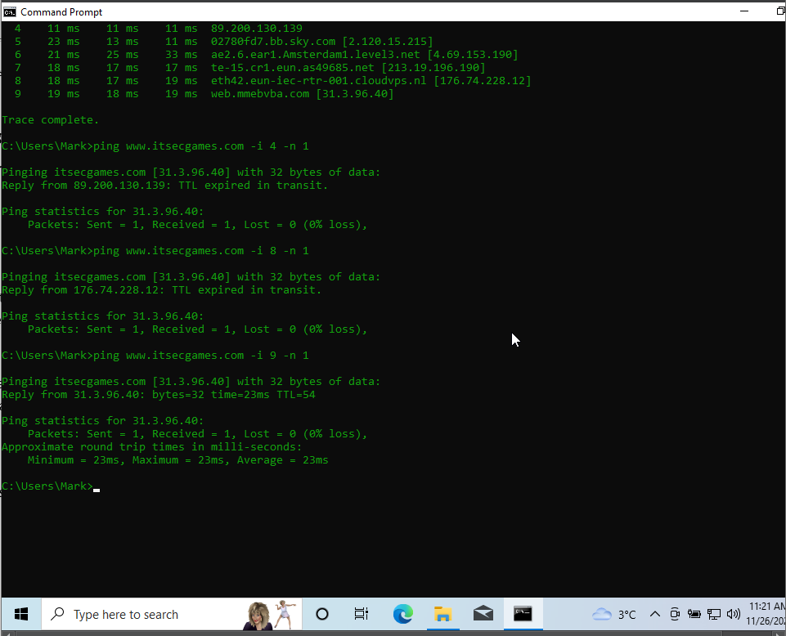

R.1. Do a research on the internet and find out what are the options, you can use with ping command and what are their functionalities with suitable example?
- -w (timeout): Sets the timeout for waiting for each reply, in milliseconds.
- -a (resolve): Attempts to resolve the IP addresses to hostnames.
- -t (continuous): Sends ping requests continuously until manually stopped.

Q.3. By issuing the above steps, you may get the records of domain from an
authoritative server. What is so important in getting the information like this?
- Troubleshooting Network Issues - troubleshoot network connectivity problems by verifying if a domain name resolves to the correct IP address.
- Verifying DNS Records - Incorrect DNS configurations can lead to website inaccessibility or misdirection.
- Security and Trustworthiness - Verifying DNS information helps in ensuring the authenticity and security of a domain. It allows users to confirm if the domain is properly configured and is resolving to legitimate servers, reducing the risk of falling victim to phishing or spoofing attacks.
R.2.How can we prevent our Infrastructure from these kinds of attack? Could you reflect your reviews in a short description with appropriate citations? Why do we get an output like this?
Firewall Configurations: Set up firewalls to restrict access to DNS servers, allowing only authorized and necessary traffic. This prevents unauthorized zone transfers and limits the exposure of DNS services to potential attackers [1].

Q.4. What information did you gather? Did you get the below result? If so, why? If not, what would be the reason for an outcome like the below one?
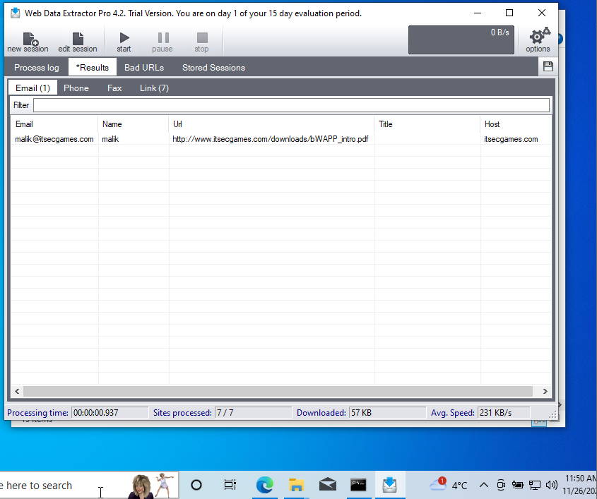
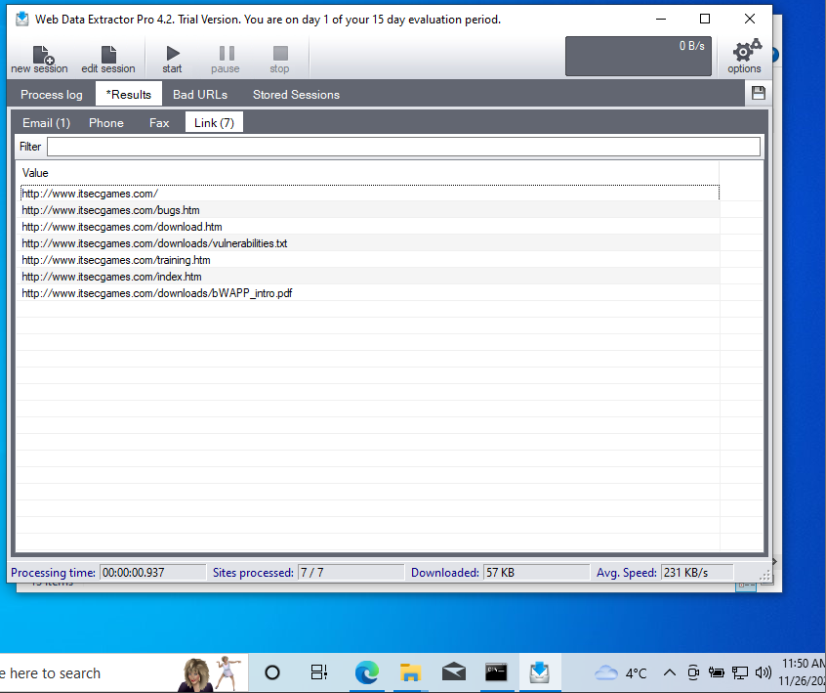

Here are the results for certifiedhacker.com

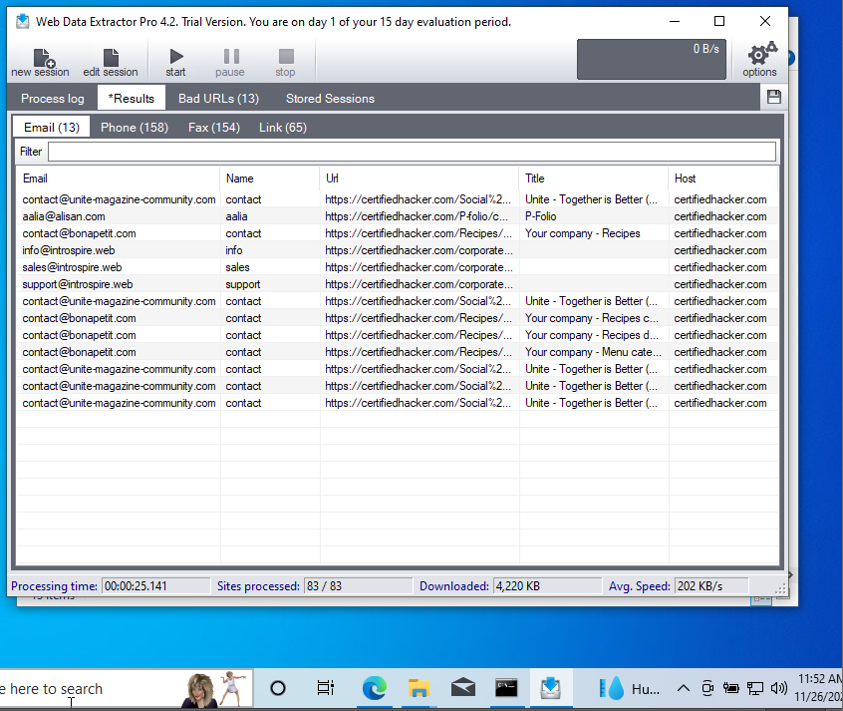
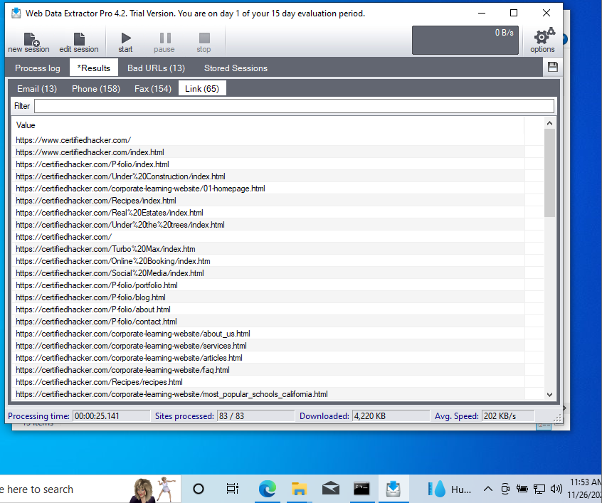

Q.5. What information did you gather?
URLS –65 Different links within the website
Telephones – 158 different telephone numbers
Emails – 13 different user email addresses

R.3. Do research on the internet and find out similar tools used? Document them with their operations, functions, and screenshots
Octoparse:

Octoparse provides point-and-click interfaces for easy web scraping. It allows users to extract data from websites by creating workflows through a visual editor.
Functions: Supports extracting various data formats (text, images, tables), handling JavaScript-rendered pages, and scheduling automatic extraction tasks.
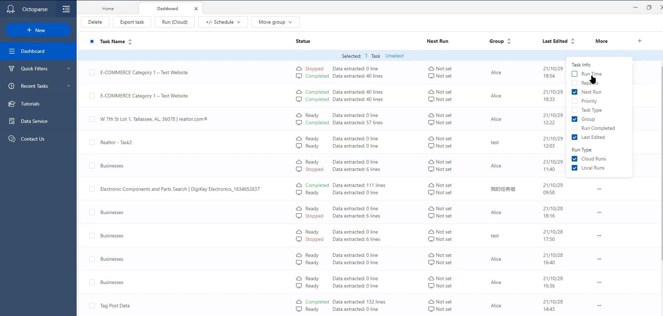

Part 3: Use Email Tracker Pro to trace and track delivered email.

Q.6. What information did you gather?
I was unable to download this software I tried multiple links but could not get it running, I did however watch multiple videos on how it preforms and read articles on what it is capable of.
Opening: The software is able to track the status of an email to see whether or not it has been opened in including times of opening.
Location: Able to see where an email has been opened based on users IP.
Links clicked: The software is able to see how many times the links have been clicked within the emails.
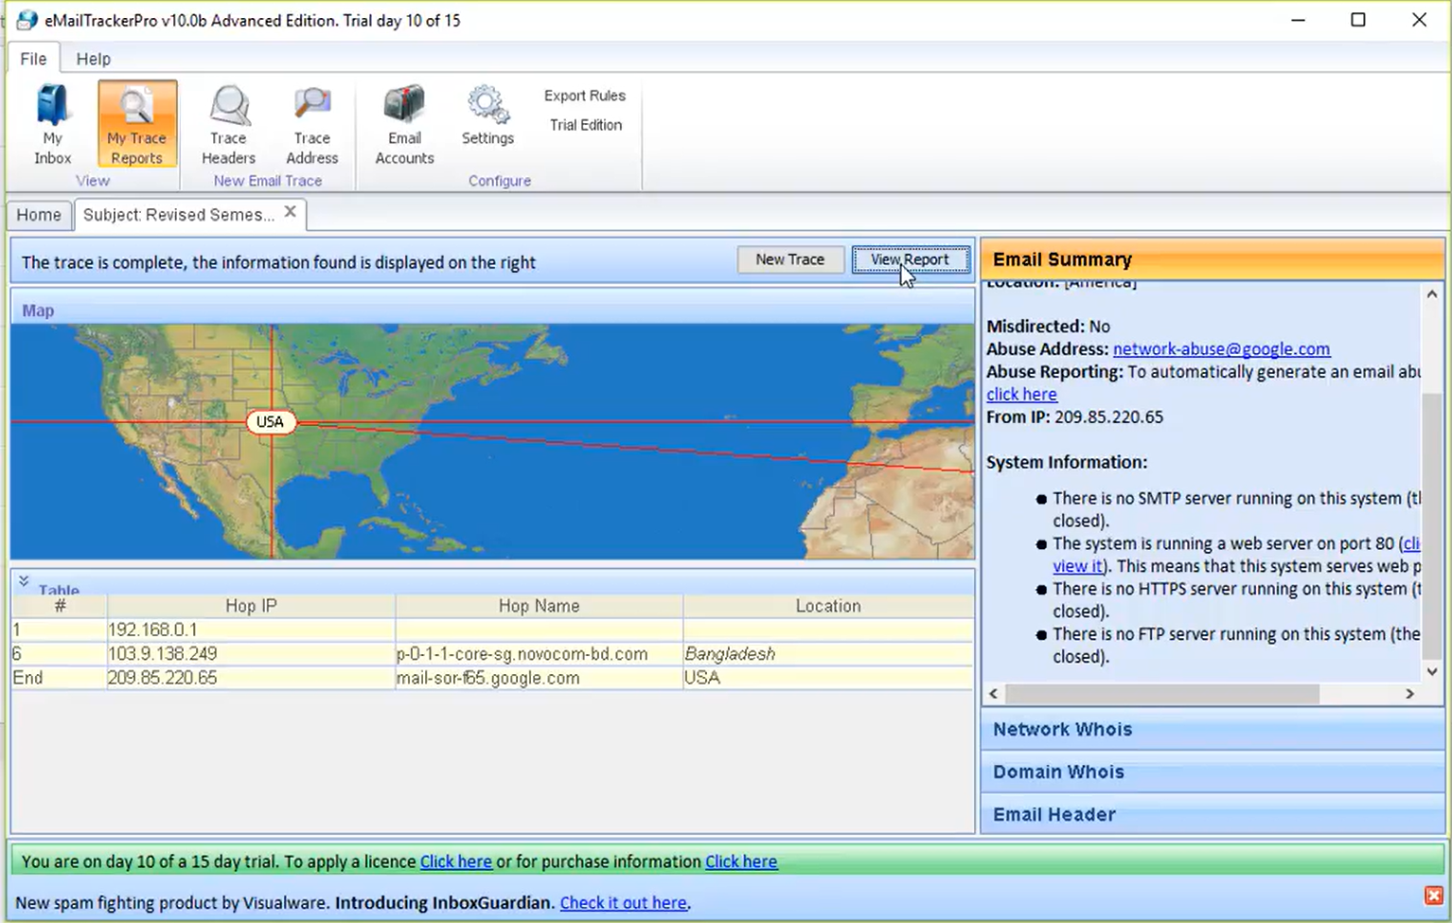The above is not my image taken from a YouTube video to provide an overview of how the software looks[2].

R.4. Do research on the internet and find out similar tools used? Document
them with their operations, functions, and screenshots.
- YesWare - Email tracking and analytical tool integrated with Gmail and Outlook.
Functions: Tracks email opens, link clicks, attachment views, and provides analytics on recipient engagement.
- Mailtrack - Operations: Mailtrack is a browser extension for Gmail that adds tracking capabilities to emails sent through Gmail. It provides functions to track email opens with double checkmarks (similar to WhatsApp) and provides real-time alerts.

Part 4: Use TCP View tool to identify the processes running on a Machine.

Search internet for TCPView Software. List out the websites which offers a download. Which website/ link do you think is safe to download the software? Why?
Looking through the google search for TCPView software the things to check to confirm a URL is safe are HTTPS at the beginning of the link and also if the link is a well known company for example a good place to download TCPView would be the following link: https://learn.microsoft.com [3].

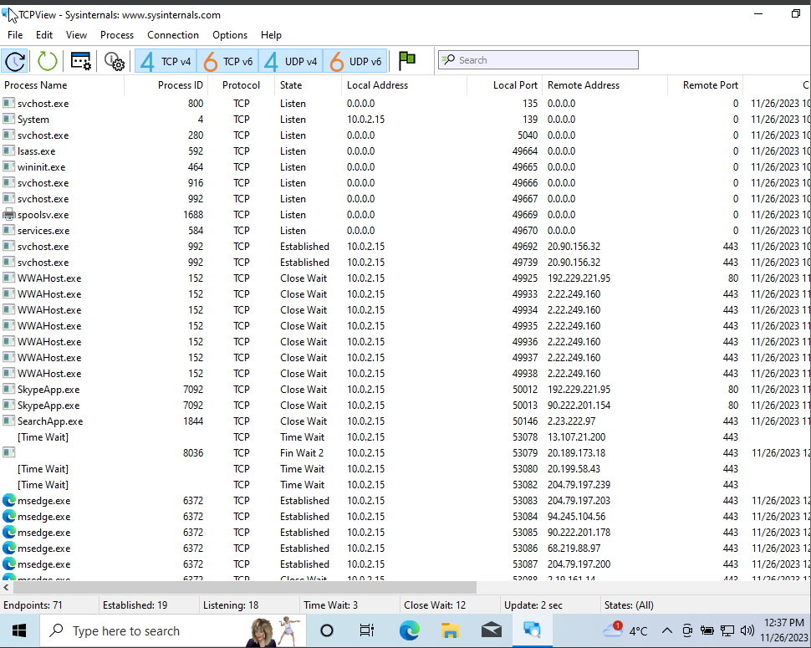

How many Endpoints are listed? 71 Endpoints
How many are Listening? 18 Listening
How many Endpoints are Established? 19 endpoints are established

You could see a lot of colours highlighting in the tool. What is represented by the colours?
Close a process (my choice would be the web browser) and see what happens?

Green: Indicates active connections.
Red: Represents connections that are in the process of being closed or terminated.
Gray: Indicates that the connection is either idle or not currently active.

When terminating “msedge.exe” it closed the browser that was open in the background.

Part 5: Use Sublist3r tool to enumerate subdomains of Websites using OSINT
Tried a lot of different trouble shooting methods but still unable to download Sublist3r keep getting the following error message.
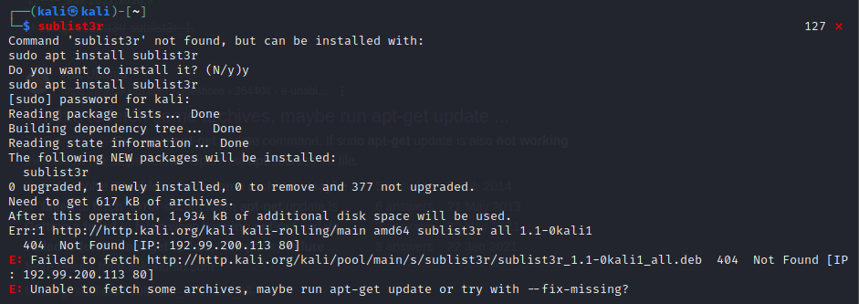
R5. Do research on the internet and find out similar tools used? Document them with their operations, functions, and screenshots.
Amass – This is a versatile enumeration tool that uses multiple techniques for gathering subdomains it has a variety of functions such as brute force and scarping and also supporting data sources DNS and API’s all of which are used to discover subdomains.

Part 6: Use Recon -ng too

R.6. Do research on the internet and find out the purpose, functionality of this tool. In relation to this tool, find out what Market place is?
Recon-ng is an open source recon framework which is primarily used for gathering information, reconnaissance, and web-based open-source intelligence (OSINT). This tool is used by various cybersecurity roles such as penetration testers and researchers.
One of the tools functionalities is to automate the process of reconnaissance and data gathering by preforming specific tasks such as social media profiling and email harvesting.
The marketplace in relation to Recon-ng is a central repository used for modules such as plugins or add-ons and which allow for data collection and reporting the market place holds various modules that are created by users and a community of people that share their skills to provide a wide range of modules for Recon-ng.
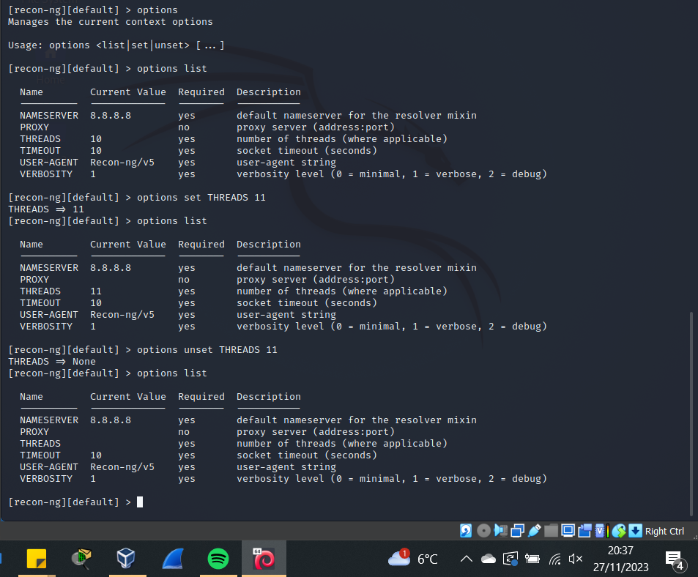

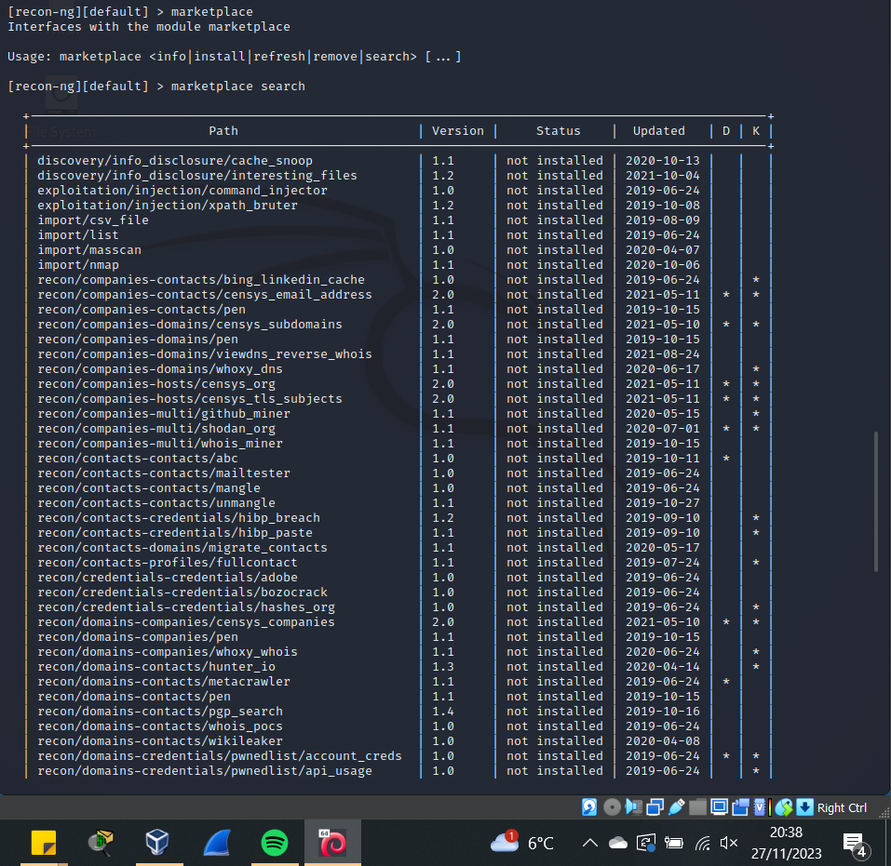
R.7. Do research on the internet and find out other modules to find out more hosts. Document them with their operations, functions, and screenshots.
Fingerprint Open Network FOFA – Is a search engine for internet connected devices which searches for hosts, domains, and IP addresses.
Censys – Provides scanning and monitoring and retrieves information about hosts, protocols, and exposed services on the internet.

Overall Reflection
- Understanding on the activity –
Very good activity understood all aspects of it sometimes the steps were hard to follow as mentioned above with Sublist3r not working.
- Understanding about various tools used –
Yes understood all the various tools and their uses.
- New/ Similar tools you identified and used –
Found interesting tools that were similar to the ones used which was fun to play around with.
- Compare and Contrast the tutorial tools with your identified tools –
Yes comparing the tools its interesting to see the slight differences and similarities.
- Rate yourself: How confident are you to do footprinting and reconnaissance activity ethically? –
Not too confident but with practice I believe I can get the hang of these tools and use them ethically.
- Any other Troubleshooting Steps, you need to share –
Not at this time.

References
[1] NIST, "Special Publication 800-81-2: Secure Domain Name System (DNS) Deployment Guide," National Institute of Standards and Technology, Gaithersburg, MD, USA, Dec. 2018. [Online]. Available: SP 800-81-2, Secure Domain Name System (DNS) Deployment Guide | CSRC (nist.gov). Accessed on: 26/11/2023
[2] M.i. Jamil, “eMailTrackerPro tracking an e-mail,” YouTube 2018, Available: eMailTrackerPro tracking an e-mail - YouTube. Accessed on: 26/11/2023
[3] “TCPView v4.19” Available: TCPView for Windows - Sysinternals | Microsoft Learn Accessed on: 26/11/2023

