
BUSINESS DEVELOPMENT PROPOSAL
Strategic Renewable Energy Business Development at the Adani Group
Path B: Business Plan for an Existing Company
Module: Business Development Proposal | Level 7 | LCMB7037
Programme: Master of Business Administration
Student name: Faijanali Irfan Saiyed Student ID: 2525946
Supervisor: Trinh Nguyen Thi Ngoc
Academic Year: 2026/27
Approx. target word count: 2,500 words

Acknowledgement
In the process of working on this business development proposal, I wish to acknowledge the help received in the area of research. Open source information was used to evaluate the Adani Group, which included annual reports.
Declaration
This proposal was written for academic purposes and has used secondary sources that have been cited in the reference list. Public statements of the company and other relevant sources are duly acknowledged, and claims are taken as evidence.

Table of Contents
1. Introduction, aims, objectives and opportunity 4
1.1 Company Description 4
2. Methodology and methodological choices 5
3. Market research, validation and business development plan 6
3.1 Business Model and strategic positioning 7
3.2 Marketing and sales strategy 8
3.3 Operations and implementation controls 8
3.4 Human-resource capital allocation and performance management 9
3.5 Reflection 9
4. Risk management 10
5. Implementation timeline and reflection 12
6. References 14
Appendix 16

1. Introduction, aims, objectives and opportunity
The Path B Business Development Proposal assesses the possibility for growth within Adani Green Energy Limited (AGEL) – which is the renewable energy arm of the Adani Group. The title of this Path B Proposal is “Renewable Energy 2030: Scale, Storage and Reliability”, and looks at ways AGEL can make its renewable energy platform more reliable and differentiated from others through use of solar and wind generation, hybrid power generation, battery storage, digital operations, and PPAs. It is not just about adding more generation capacity, but doing so in a way that ensures the quality and reliability of such capacity meets with customer needs, grid availability, financing standards and ESG considerations.

1.1 Company Description
AGEL had an operating capacity of 14,243 MW as of 31 March 2025, in 12 Indian states. In that fiscal year, the income generated through power supply was ₹9,495 crore, while EBITDA was ₹8,818 crore (Adani Green Energy, 2025a). To provide the numbers in terms of a financial interpretation more relevant to the UK market, this amounts to roughly £748 million and £695 million respectively at the mid-market exchange rate on 30 September 2026 of £1 = ₹126.9 (Wise, 2026). It should be noted that this calculation is for illustrative purposes only as exchange rates can vary. Due to the size of the current platform, the issue of business development is mostly that of disciplined growth.
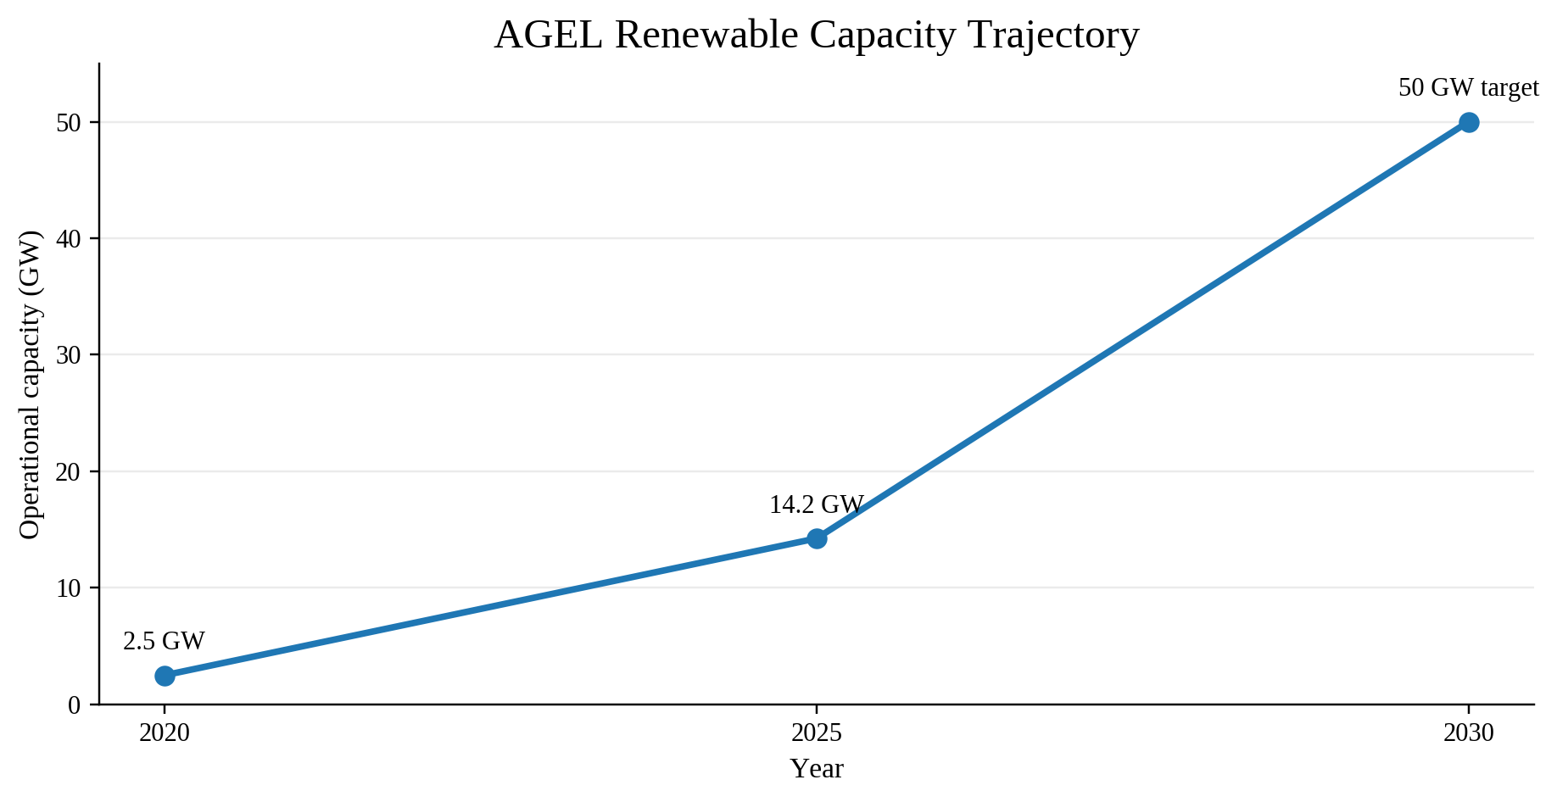
Figure 1. AGEL renewable-capacity trajectory.
Source: Adani Green Energy (2025a).
However, apart from reinforcing support for further investments, the external market environment makes it necessary to be selective. According to the International Energy Agency (IEA, 2025), 83% of all power-sector investments in India in 2024 were made in clean energy. Moreover, the Ministry of New and Renewable Energy (MNRE, 2025) showed the installed capacity in renewables at 253.96 GW in India as of November 2025, while the Central Electricity Authority (CEA, 2023) outlined a renewable purchase obligation growth path to reach 43.33% in 2029-30. These data suggest the existence of a sizable addressable market, but do not eliminate the problem of execution barriers. They may cause delays in the receipt of funds and/or lower the profitability of projects.

2. Methodology and methodological choices
Methodologically, secondary data alone are employed in this assessment of the business development opportunity. No primary interviews nor surveys have been conducted; thus, it is neither attempted to infer any undisclosed consumer sentiment nor estimate any project economics. Rather, corporate reports, government publications and regulatory materials, industry insights, and the strategic management literature are synthesised into a pragmatic evaluation process intended to assess viability within existing market conditions, financial capabilities, competitive dynamics and regulatory constraints. This methodological approach is justified for an initial business development opportunity appraisal because it provides scope to examine the opportunity within prevailing realities without hypothesising upon non-public information.
Firstly, the source triangulation method involves drawing upon multiple information types and sources to corroborate findings and uncover possible conflicts. Internal sources include the corporate material for AGEL, documenting capacity, performance history, strategic positioning, and capability claims. Government and regulatory sources provide information for validating the size of the market opportunity, energy policy and systems infrastructure provisions. External industry evidence supports investment trends and storage requirements, whereas the literature review draws on strategic theory and practice to inform selection of key business planning tools, specifically Market Validation, Competitor Assessment, the Business Model Canvas, Risk Analysis, and Key Performance Indicators. Comparisons across these sources minimise reliance on the company perspective and enable discovery of any discrepancies prior to strategy formulation.
Secondly, the study adopts a descriptive and analytical methodology in lieu of experimental methods. As the objective entails formulating a strategic implementation approach, and not testing any interventions, the methodology does not seek to quantify any causal relationships, nor is any new product, service offering or innovation deployed experimentally. Therefore, this assessment describes the contemporary strategic environment, analyses its relevance to AGEL's positioning and potential opportunities, and translates insights into specific recommendations for an actionable implementation strategy using validated market information, competitor analysis, business models, and risk evaluation.
Thirdly, a 12-month timeframe for planning purposes is chosen. While too brief a timeframe focuses excessively upon execution at the expense of strategic institutionalisation of planned capabilities, a significantly longer timeframe necessitates extensive extrapolations based upon unreliable forecasting assumptions concerning future energy tariffs, interest rates, technology costs, and regulatory regimes. Thus, a 12-month planning period is adopted, allowing piloting, scaling and embedding of the proposed capabilities, whereas the 2030 thematic timeframe pertains to long-term strategic intentions rather than predictions.

3. Market research, validation and business development plan
Analysis of secondary market data indicates a high-growth, high-capital requirement opportunity. According to the International Energy Agency (2025), 83% of investments in India's power sector in 2024 were made towards clean energy. As per MNRE (2025), renewable power capacity stood at 253.96 GW as of November 2025. Per projections by the CEA (2023), there would be growing purchase obligations for renewables up to 2029-30. All this points towards sustained demand for increased renewable generation capacity. Nevertheless, the key validation metric transcends mere growth trends – namely, whether the added capacity may be feasibly grid-connected, contracted, financed and operated predictably. The answer justifies a selective growth strategy over mere capacity growth. The table below summarizes market validation metrics and associated business implications:
Table 2. Market validation signals and business implications. Sources: International Energy Agency (2025); Ministry of New and Renewable Energy (2025); Central Electricity Authority (2023); Adani Green Energy (2025a).
Market signal | Evidence | Business implication | Priority
Investment | 83% of Indian power-sector investment went to clean energy in 2024 (IEA, 2025). | Scale renewable generation and selected storage. | Very high
Installed capacity | 253.96 GW of renewable capacity by November 2025 (MNRE, 2025). | Maintain a high-quality project pipeline. | Very high
Policy demand | 43.33% renewable purchase obligation indicated for 2029-30 (CEA, 2023). | Increase contracted renewable supply. | High
Storage | CEA identifies storage as important for variable renewable integration. | Develop BESS/PSP selectively where economics and grid needs support it. | Very high
C&I demand | AGEL reports utility and corporate renewable contracts (AGEL, 2025a). | Grow premium dependable-power offers. | High

3.1 Business Model and strategic positioning
The market validation evidence is presented in Table 2. Some of the most significant implications are the development of storage, the preservation of a high-quality pipeline of projects, and the increase in contracted supply. Storage is crucial since the production of solar and wind is intermittent. The Battery Energy Storage System (BESS) can help shift electricity through time, while the Pumped Storage Project (PSP) can provide duration flexibility depending on the appropriate location and investments. Such solutions cannot be implemented automatically for all projects; they have to be applied where it will be useful from the standpoint of reliability, exposure reduction, contracted product provision, or improvement of economics.
The AGEL business model, therefore, has to change from selling renewable capacity to selling renewable electricity with reliable performance. The value proposition of the company has to consist of the use of solar, wind and hybrid generation along with chosen BESS or PSP systems, digital monitoring, and disclosure of ESG information. Potential customers are utilities, industry, commercial businesses and data centres that consume considerable amounts of electricity and need reliable low carbon electricity. Long-term Power Purchase Agreement (PPA) remains important as the source of revenue visibility, but the contracts have to be structured by clear performance obligation, availability, settlement, and force majeure clauses.
The recommended Business Model Canvas consists of six interlinked components in accordance with the logic that is explained in Whittington et al. (2023). First, the key partners are governmental organizations, grid operators, lenders, partners in engineering, procurement and construction, operations and maintenance, and technology providers. Second, the key activities are the assessment of resources, development of projects, grid connection, construction, installation, operation and dispatching of the storage systems, predictive maintenance and contract management. Third, the key resources are the land, development rights, grid access, capital, engineering capabilities and data. Fourth, the customer relationships have to be managed by key account teams and performance reporting instead of only transactional tendering. Fifth, the channels have to be utility procurement procedures, C&I contracting and digital business-to-business engagement. Sixth, the revenues should be generated by PPAs and C&I contracts, and also the flexibility or storage service revenues where possible. The idea is to transform reliability and transparency into a product feature.

3.2 Marketing and sales strategy
Both marketing and sales must adopt an account-based strategy. The recommended positioning is “reliable and scalable renewable energy provider” based on facts and not on general promotions. For acquisition, focus must be on customers where a firmed supply of renewable energy is a commercial opportunity. For the utility market, the key areas would include scalability, contracted availability, readiness of grid and delivery assurances. For the C&I segment, customer communication must be around reliable renewable energy supply, transparent contracting and ESG reporting. For data centers and other reliability critical customers, the key points for the sale would be continuity, forecasting and storage-based supply.

3.3 Operations and implementation controls
The implementation model consists of four operation gates. The first one is the opportunity screening, which includes land, renewable resource, grid access, customer demand and initial economics. The second gate is commercial and technical due diligence, which includes the off-take structure, transmission needs, equipment availability, permitting and risk sharing. The third gate is controlled construction and commissioning, which is milestone-driven in terms of schedule, quality, safety and cost. The fourth gate is operations driven by data, which ties together generation forecasts and storage dispatch, outage forecasts, curtailment and financial dashboards. Digital operations are already reported by AGEL, hence the proposal builds on existing capabilities rather than making assumptions about a brand-new technology platform.

3.4 Human-resource capital allocation and performance management
Human resource allocation should be more concerned with building specialist capability than growing numbers. Renewable engineering will still be required for design and yield estimation, but there will need to be further focus on expertise in storage, grid connection, energy market, data science, health and safety, and ESG assurance. There could be a storage and grid centre of excellence, and training could help in the application of predictive analytics and evidence controls. Recruitment needs to go along with internal development since future success relies on knowledge retention in a growing portfolio of projects.
The suggested performance framework needs to stay practical. The proposed one-year measures should be an increase of 20% in the number of qualified target accounts, client retention at more than 95%, assurance of 100% of key ESG indicators, an increase in portal users by 25%, and completion of the agreed pilot projects to reliability and return thresholds. These are management proposals, not AGEL suggestions. The reason for setting up those milestones is to have quantifiable touchstones for learning. A pilot not meeting the established threshold has to be either redesigned or put on hold.

3.5 Reflection
Competitive analysis supports differentiation through capability, not price. ‎‎Reliance Industries is expanding its solar, batteries, and hydrogen business lines; ‎JSW Energy maintains its growth trajectory of renewables generation and ‎storage; and NTPC and NTPC Green boast extensive renewable pipelines. ‎Competitiveness is high, evidenced by public reports pointing to fierce ‎competition for projects, clients, funding and technical expertise (Reliance ‎Industries, 2025; JSW Energy, 2025; Adani Green Energy, 2025a). Thus, the ‎proposal is directed towards leveraging current operational capacity in ‎relation to dependable resource supply. AGEL should target hybrid generation, ‎Pivot Power's storage-enhanced PPAs and advanced Digital Operations & ‎Maintenance Management. It is not assumed that competitors remain inert, but ‎that this proposal draws upon measurable capabilities for improvement. ‎
Financial discipline follows from AGEL’s present capacity. For FY2024-25, ‎power supply revenue at ₹9,495 crore equates to £748m, EBITDA of ₹8,818 ‎crore equals £695m (30 Sept 2026 exchange rate); operating cashflow ‎stands at ₹8,364 crore (£659m) against CAPEX of ₹24,776 crore (£1.95bn) ‎(Adani Green Energy, 2025a; Wise, 2026). The difference reveals the ‎unsustainability of dependence on internal operational cash generation. ‎Each project must clear a stage-gate investment assessment based on ‎contracted revenue, financial modelling, anticipated returns, downside cases, ‎grid connection schedule, and ESG compliance requirements. There is thus an ‎explicit connection between identifying market opportunities and executing ‎successful projects: proof of demand does not necessarily justify all ‎investments.
Overall, the proposal envisages selective scaling, deployment of ‎storage technologies only where they solve a specific problem, development ‎of digitised operations management capability and safeguarding funds ‎through rigorous investment gates. Its strategic rationale appears in Figure 2, ‎linking generation to storage, client-oriented products, digital ‎management, and ESG compliance. In this way, there is created a logical ‎framework for translating market demand into revenue streams, yet ‎leaving room to halt, restructure or postpone projects failing criteria.
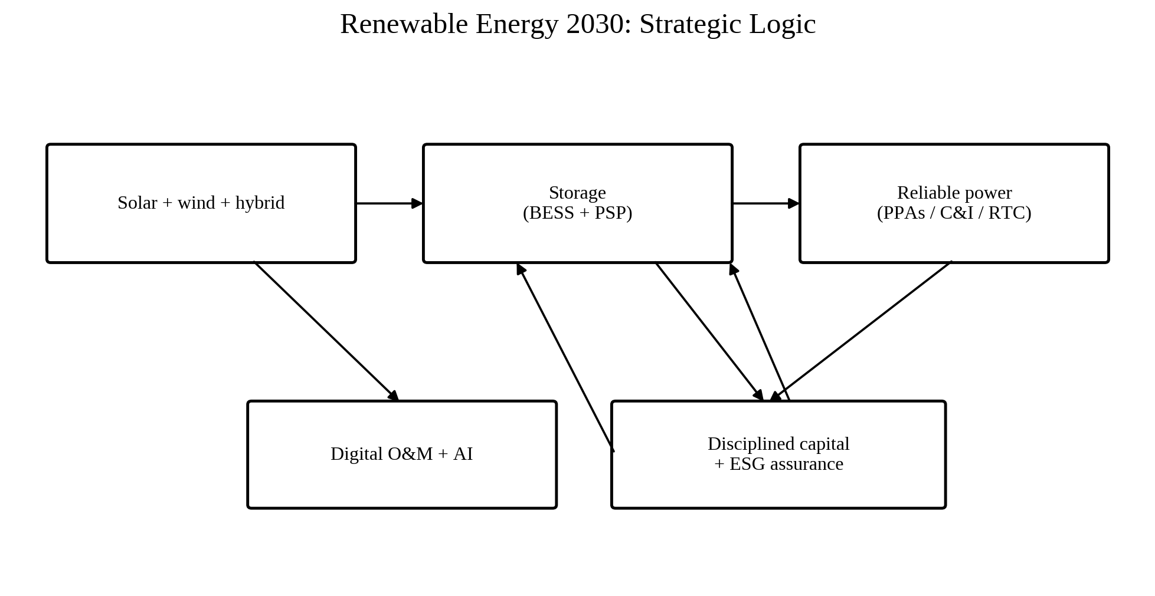
Figure 2. Strategic logic linking generation, storage, reliable customer products, digital operations and capital discipline. Source: Author synthesis.

4. Risk management
Major risks identified include Financial and Interest Rate Risk, Operational Risk, Grid Connection Risk, Supply Chain Risk, Community and Land Risk, and ESG Risk and Disclosure Risk. Financial and Interest Rate Risk is high, given the requirement for massive upfront capital investment and revenue generation depending on a long operational period, mitigated through stage-gate approvals, portfolio diversification, sensitivity analysis, and periodic DSCR monitoring. Grid Connection Risk is material, since delay could jeopardise the ability to monetise the asset, with the risk reduced via pre-development grid due diligence and milestone-contingent expenditures.
Supply chain disruptions may impact module, turbine, battery, and other key equipment supplies. Dual-sourcing strategies for materials or components are advised when feasible, alongside identification of long-lead time components at the outset, and contingency arrangements for critical pieces of machinery. Community and Land Risks necessitate consultation and grievance procedures at a localised level to mitigate potential risks to project timelines caused by outstanding disputes; storage technology and performance risks must be mitigated via pilot projects, performance warranties and rigorous post-installation testing. For ESG and Disclosure Risks, robust evidence trails and assurance procedures consistent with SEBI (2023) BRSR Core requirements will facilitate accurate reporting within India's listed company context. The risk management methodology does not stop with probability-impact matrices, but rather specifies ownership, triggers, mitigation measures and periodic reviews of all material risks, with escalation procedures for entering the high-risk zone prior to additional investment commitments.
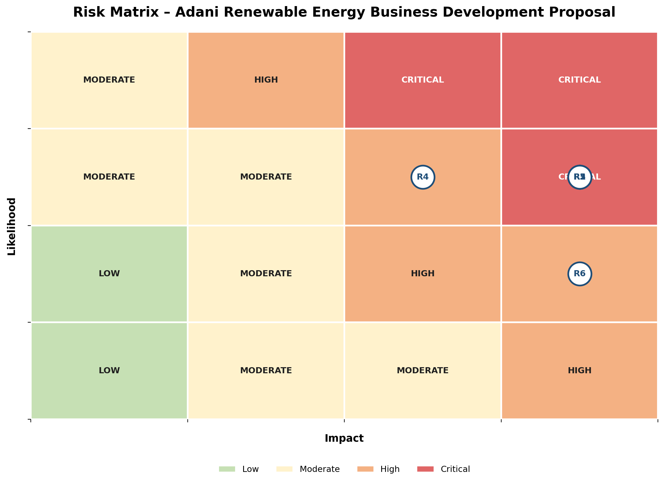
Figure 5. Risk matrix. Source: Author synthesis.

5. Implementation timeline and reflection
Deployment must be managed over the course of twelve months. Months 1-2 will involve diagnostics of the pipeline in terms of geographical location on grids; power purchase agreements ("PPAs"); customer engagement potential; storage requirements; finance assumptions; and ESG considerations. Months 3-5 will trial a solar-plus-storage, or hybrid commercial & industrial ("C&I"), proposition, measuring both operational and customer metrics. Months 6-9 will roll out only those projects meeting the requisite technical, commercial and financial thresholds, along with scaling digital operation management and monitoring systems. Months 10-12 will institutionalise governance via executive-level dashboards; assurance practices; storage governance; and repeatable investment gates. Figure 6 illustrates this sequence and distinguishes between experimentation and scale-out stages.
This project has afforded reflection upon how the nature of renewable energy business development is equally concerned with discerning and sequencing investments as market expansion. The methodology adopted is demonstrative of this assertion through triangulated company, regulatory, market and strategy data. The proposed twelve-month plan subsequently transforms data points into pilots; key performance indicators; risk mitigation measures; and investment gates.
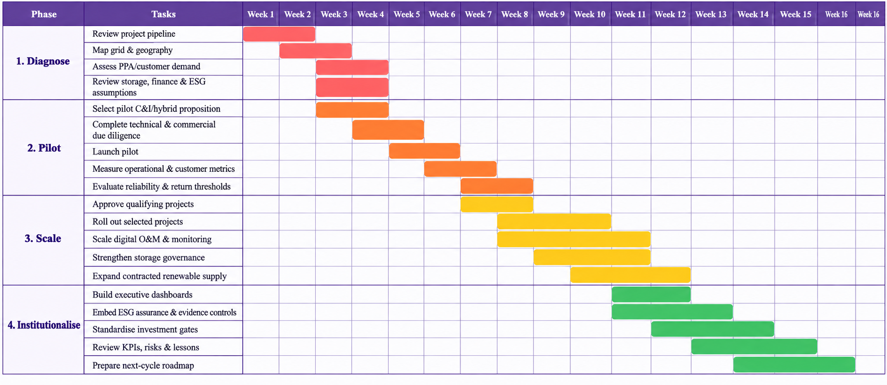
Figure 6. Indicative 16-Week implementation roadmap. Source: Author synthesis; management proposal, not announced company guidance.
The model links market pull with operations, finance, discipline and execution. However, public proof cannot substitute for due diligence. Proof-of-concept pilot studies and assurance need to guide implementation.

6. References

Adani Green Energy Ltd. (2025a) Integrated Annual Report 2024-25. Available at: https://connect.adani.com/annual_report/2025/agel/ (Accessed: 22 September 2026).
Adani Green Energy Ltd. (2025b) FY25 results: operational capacity grows 30% YoY to 14.2 GW. Available at: https://www.adani.com/newsroom/media-releases/adani-green-surpasses-usd-1-billion-in-ebitda (Accessed: 22 September 2026).
Central Electricity Authority (2023) National Electricity Plan 2022-32, Volume I: Generation. Available at: https://cea.nic.in/wp-content/uploads/notification/2023/06/NEP_2022_32_FINAL_GAZETTE_English.pdf (Accessed: 22 September 2026).
International Energy Agency (2025) World Energy Investment 2025: India. Available at: https://www.iea.org/reports/world-energy-investment-2025/india (Accessed: 22 September 2026).
Ministry of New and Renewable Energy (2025) Renewable Energy Capacity in 2025. Available at: https://nghm.mnre.gov.in/admin/uploads/176794038987418Press_Release_Renewable_Energy_Capacity_in_2025.pdf (Accessed: 22 September 2026).
Securities and Exchange Board of India (2023) BRSR Core - Framework for assurance and ESG disclosures for value chain. Available at: https://www.sebi.gov.in/legal/circulars/jul-2023/brsr-core-framework-for-assurance-and-esg-disclosures-for-value-chain_73854.html (Accessed: 22 September 2026).
Reliance Industries Ltd. (2025) Annual Report 2024-25. Available at: https://www.ril.com/ar2024-25/ (Accessed: 22 September 2026).
JSW Energy Ltd. (2025) Integrated Annual Report 2024-25. Available at: https://www.jsw.in/jsw-energy/annual-reports/ (Accessed: 22 September 2026).
IFRS Foundation (2023) IFRS S1 General Requirements for Disclosure of Sustainability-related Financial Information. Available at: https://www.ifrs.org/issued-standards/ifrs-sustainability-standards-navigator/ifrs-s1-general-requirements/ (Accessed: 22 September 2026).
IRENA (2024) Renewable Energy Statistics 2024. Available at: https://www.irena.org/Publications/2024/Jul/Renewable-energy-statistics-2024 (Accessed: 22 September 2026).
Whittington, R., Regnér, P., Angwin, D., Johnson, G. and Scholes, K. (2023) Exploring Strategy. 13th edn. Harlow: Pearson.
Wise (2026) British pound sterling to Indian rupees historical exchange rate, 30 September 2026. Available at: https://wise.com/in/currency-converter/gbp-to-inr-rate/history/30-09-2026 (Accessed: 1 October 2026).

Appendix
WEEK-BY-WEEK IMPLEMENTATION PLAN (WEEK 1–16)
Week | Phase | What will be done | Expected output / evidence | Progress checkpoint
Week 1 | Diagnose | Review project pipeline, locations and grid-access status. | Diagnostic baseline | Baseline signed off
Week 2 | Diagnose | Assess PPA/off-take, customer potential, storage needs, finance and ESG. | Screening criteria | Screening complete
Week 3 | Pilot | Select pilot opportunity and complete technical-commercial due diligence. | Pilot shortlist | Pilot selected
Week 4 | Pilot | Design solar-plus-storage / hybrid C&I proposition and requirements. | Pilot proposition | Proposition approved
Week 5 | Pilot | Start pilot and establish operational and customer metrics. | Pilot underway | Pilot launched
Week 6 | Scale | Evaluate pilot against technical, commercial and financial thresholds. | Gate decision | Gate decision
Week 7 | Scale | Move qualifying projects into controlled rollout and milestone plan. | Scale-up plan | Rollout approved
Week 8 | Scale | Scale digital O&M, forecasting, storage dispatch and monitoring. | Digital O&M rollout | Digital O&M live
Week 9 | Scale | Track reliability, curtailment, risks and financial/KPI dashboards. | Scale review | Scale review
Week 10 | Institutionalise | Set executive-level dashboards for project, customer, finance, risk and ESG. | Executive dashboard | Dashboard live
Week 11 | Institutionalise | Strengthen assurance practices and ESG evidence trails. | Assurance framework | Assurance ready
Week 12 | Institutionalise | Formalise storage governance, testing, warranties and escalation. | Storage governance | Governance approved
Week 13 | Institutionalise | Embed repeatable investment gates and approval controls. | Investment-gate process | Investment gates embedded
Week 14 | Institutionalise | Build specialist capability in storage, grid, analytics, safety and ESG. | Capability actions | Capability actions started
Week 15 | Institutionalise | Review KPIs, thresholds, lessons and corrective actions. | Improvement plan | Lessons recorded
Week 16 | Institutionalise | Complete management review and prepare next-phase roadmap. | Next-phase roadmap | Roadmap approved

