Welcome to ECAY4003 Academic Study Skills

Session 1 | 26/09/2023 | 9-12 | On Campus | Introduction to the Module
Session 2 | 26/09/2023 | 1-4 | On Campus | Planning for your Assessments
Session 3 | 02/10/2023 | 10-11.30 | Online | Assessment Tutorial
Session 4 | 03/10/2023 | 9-12 | On Campus | Referencing and Plagiarism
Session 5 | 03/10/2023 | 1-4 | On Campus | Credible References
Session 6 | 09/10/2023 | 10-11.30 | Online | Assessment Tutorial
Session 7 | 10/10/2023 | 9-12 | On Campus | Academic Presentations
Session 8 | 10/10/2023 | 1-4 | On Campus | Guest Speaker: Alison Evans (Library)
Session 9 | 16/10/2023 | 10-11.30 | Online | Assessment Tutorial
Session 10 | 17/10/2023 | 9-12 | On Campus | Learning Re-Cap
Session 11 | 17/10/2023 | 1-4 | On Campus | Learning Re-Cap
Session 12 | 23/10/2023 | 10-11.30 | Online | Assessment Tutorial

Keyboard shortcuts for Microsoft Word 2016 for Windows
This article shows all keyboard shortcuts for Microsoft Word 2016.
Notes:
- If a shortcut requires two or more keys at the same time, the keys are separated by a plus sign (+). If you have to press one key immediately after another, the keys are separated by a comma (,).
- The shortcuts in this article refer to the U.S. keyboard layout. Keys for other layouts might not correspond exactly to the keys on a U.S. keyboard.

Frequently used shortcuts
This table shows the most frequently used shortcuts in Microsoft Word.
To do this | Press
Go to "Tell me what you want to do" | Alt+Q
Open | Ctrl+O
Save | Ctrl+S
Close | Ctrl+W
Cut | Ctrl+X
Copy | Ctrl+C
Paste | Ctrl+V
Select all | Ctrl+A
Bold | Ctrl+B
Italic | Ctrl+I
Underline | Ctrl+U
Decrease font size 1 point | Ctrl+[
Increase font size 1 point | Ctrl+]
Center text | Ctrl+E
Left align text | Ctrl+L
Right align text | Ctrl+R
Cancel | Esc
Undo | Ctrl+Z
Re-do | Ctrl+Y
Zoom | Alt+W, Q, then tab in Zoom dialog box to the value you want.

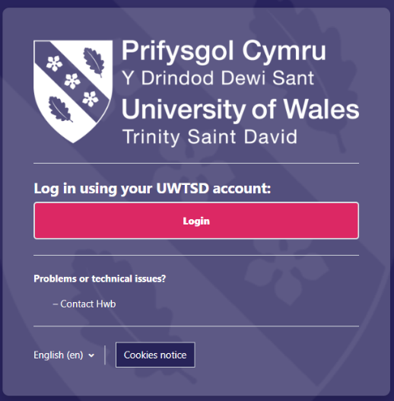
Navigating Moodle

Log into Moodle with your student number and password.

On your personalised Moodle Page, you will find all of the modules that you are enrolled in*
*Please be aware that the image below is for illustration and the modules that you are enrolled in may be different
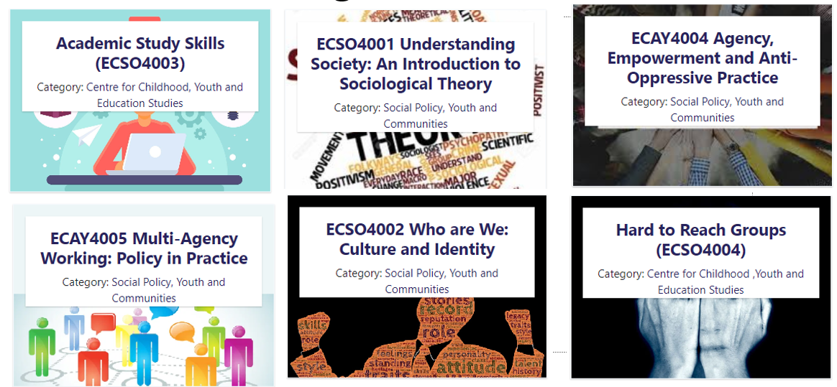
You will also find the Social Empowerment Group Homepage
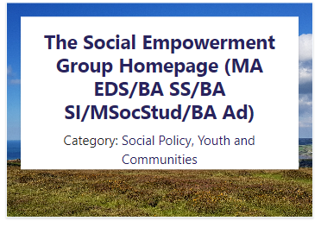
Here you will find:
- Information about your timetable
- Referencing Information
- Student Bursaries
- Programme Hoodies
- Assessment Questions and Submission dates
- Programme Announcements

Your Moodle Page: Lecturer Information
At the top of each Moodle page, you will find information on the Lecturer who will be the lead on the module, alongside their contact details and their hours of work.
- You are able to contact us at any time of the day or night, however UWTSD policy means that we will not be able to reply out of our normal working hours.
- But don’t Panic, Student support is available via the HWB or IT Services.
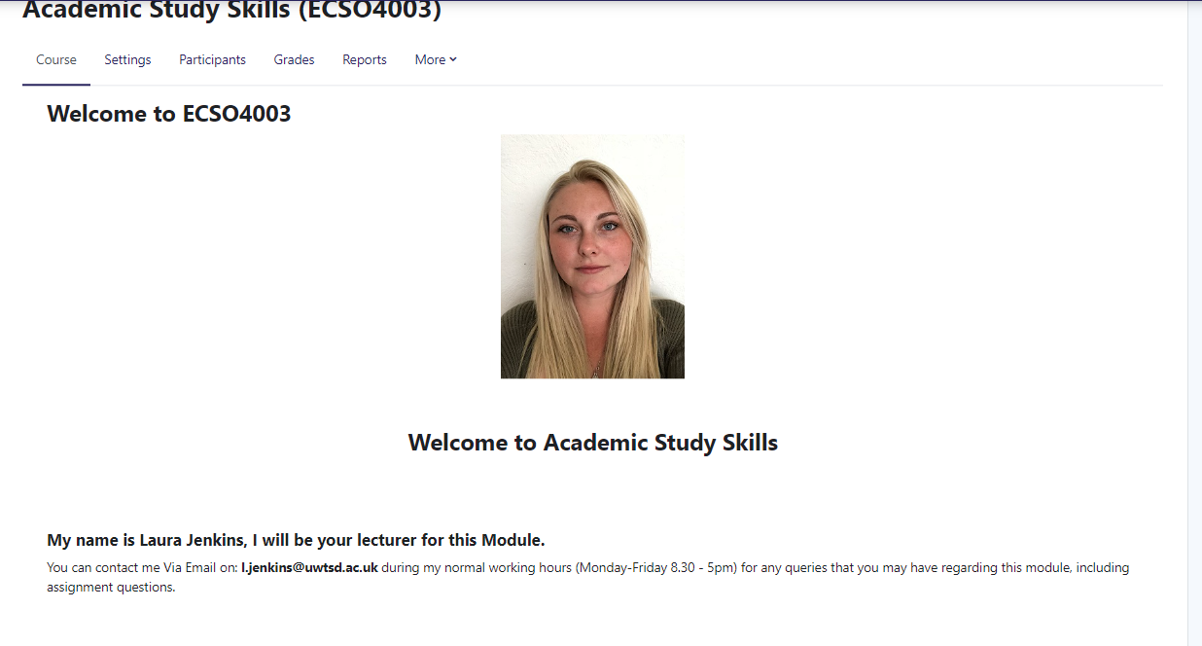

Assessment Specification
Information about your assignments can be found under the ‘Assessment Submission Links’ Theme
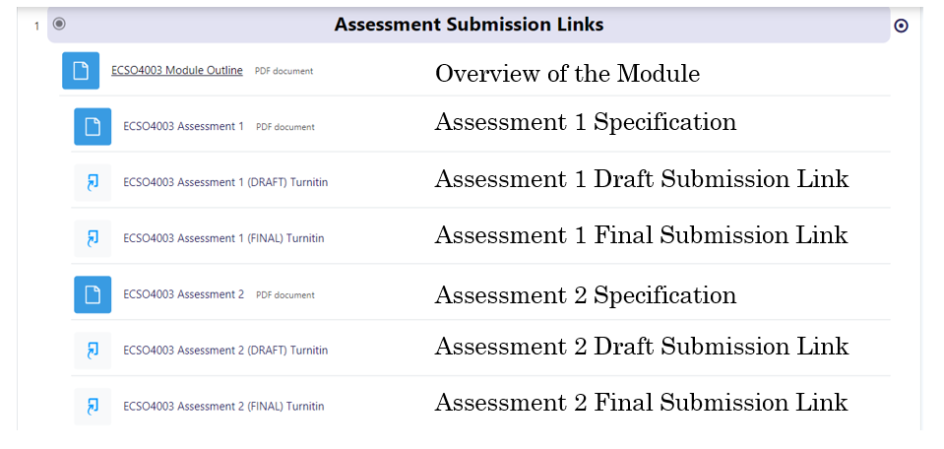

Uploading to Turnitin
It is best practice to upload your submission to DRAFT first
- This will generate your similarity %
- You can upload to the DRAFT as many times as you like
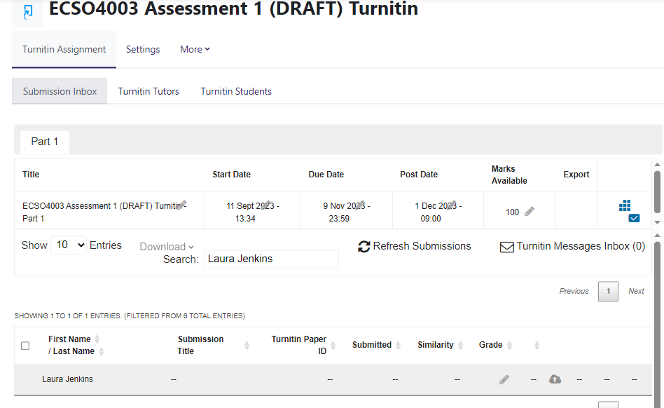
In your submission link you will see your name in the ‘greyed out’ background.
- You will also see a cloud with an upwards arrow.
- Click on this link to submit your finished assignment

You will then be able to submit your assignment.
- You will be asked to NAME your submission
- Remember that when you name your submission, this will be viewed by your tutors, moderators and external moderators.
- To submit your work, you can either DRAG AND DROP the file directly into the submission box, or alternatively click ‘add submission’ and find the file that you want to submit.
- For your final submission, ensure you upload the correct one.
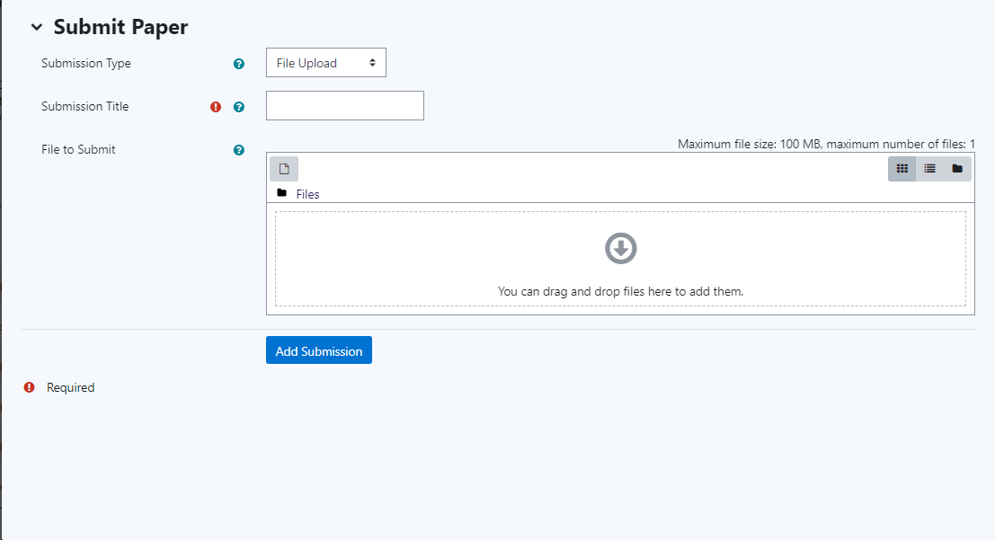
- Once you are satisfied with your FINAL draft, you can use the same process to submit to the Turnitin FINAL link

- Be aware that you can ONLY SUBMIT ONCE.
- If you do accidently submit to the wrong link, you need to Email your tutor immediately.
  - Your tutor will make a decision based on each individual case for the removal of incorrectly submitted work.
  - It is not guaranteed that your submission will be removed.

Academic Essay Structure

- Introduction (Approx 10%)
  - What is going to be included within your essay
    - Write this last
- Main body (Approx 80%)
  - Description of group/individual
    - Paragraph
  - What challenges do they face within society?
    - Paragraph
    - Example in practice
  - Why do they face these challenges
    - Paragraph
    - Include theory
  - Is your group/individual represented in policy/legislation
    - Paragraph
    - Include policy/legislation
- Conclusion (Approx 10%)
  - Paragraph
  - A summary of what you have included in your main body

Exemplar of How to Plan and Structure an Academic Essay

Name:
Student Number:
ECSO4003
Assessment 1:
Describe some of the challenges faced by an individual/group in today’s society.
- Choose an individual/group linked to your area of interest/degree include:
  - a Reference List
  - intext citations and reference predominately from Research Articles
  - citations from academic texts/books
- At least:
  - 1 x government legislation online
  - 1 x image online
  - 1 x general website
  - 3 x research articles
(The reference list is NOT included in the 1,500 word count).
No contractions: don’t shouldn’t wouldn’t – should be in full do not, should not, would not.

Introduction
Tell the reader which group/individual you are focusing on.
Indicate the context of the group/individual e.g., a range of challenges that they may face.
Tell the reader that you will focus on one challenge/barrier in this submission. (references throughout)
Main Body of the Submission
Description of group/individual
- Define and reference the characteristics of the group/individual – you may use legislation, definitions, statistics and research papers to do this. (References throughout)
What challenges do they face within society?
- Clearly articulate the barriers/challenge you are going to consider in detail.
- Give an example in practice (references throughout)
Why do they face these challenges?
- Now explore this specific challenge in detail. What it is? Why does this happen?
- Include theories (references throughout)
Is your group/individual represented in policy/legislation?
- Then statistics/profile of individuals who have this issue.
- Then consider why this might be the case.
- And consider the long-term impact for that individual; what’s it like to live that life?
- Consider possible solutions or interventions which might help. (references throughout)
Conclusion
So what? Resume of what you have found out (some references)
Who cares? Who does this impact upon, and does it matter? Some references
What next? So what needs to change? This maybe your proposition to effect future change

Reference List:

Key Points
This individual has been given a pseudonym ‘Janet’ to ensure anonymity and confidentiality.
Describe the main characteristic of the individual ‘Bob’!

Harvard Referencing - Grab Sheet
Books
Name of Author(s) - Surname, Comma, Initial, Full stop
Year of Publication — in (brackets). if many editions/dates — use most recent year
Title of Book— Including any 'subheadings'
Edition - if relevant
City of Publication — Always a City — Never a Country publisher — Usually detailed specifically inside first page following "Published by..."
Journal Article
Name of Author(s) - Surname, Comma, Initial, Full stop
Year of Publication — in (brackets)
Title of Article - in 'inverted commas'
Journal Name — in italics
Volume — if present
Issue — if present
Page Number(s)

Website
Name of Author(s) - Surname, Comma, Initial, Full stop
(Year of Publication) — in (brackets). if no date present use current year
Title of Web Page - in italics
Available at - URL address
Accessed on date — in (brackets).
And remember when it comes to Citations...
Cite when you write
Always put in brackets what you wouldn't say out loud!
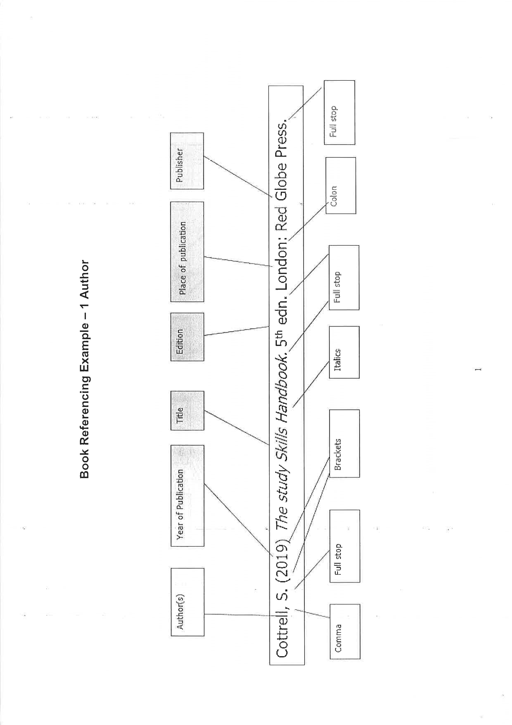
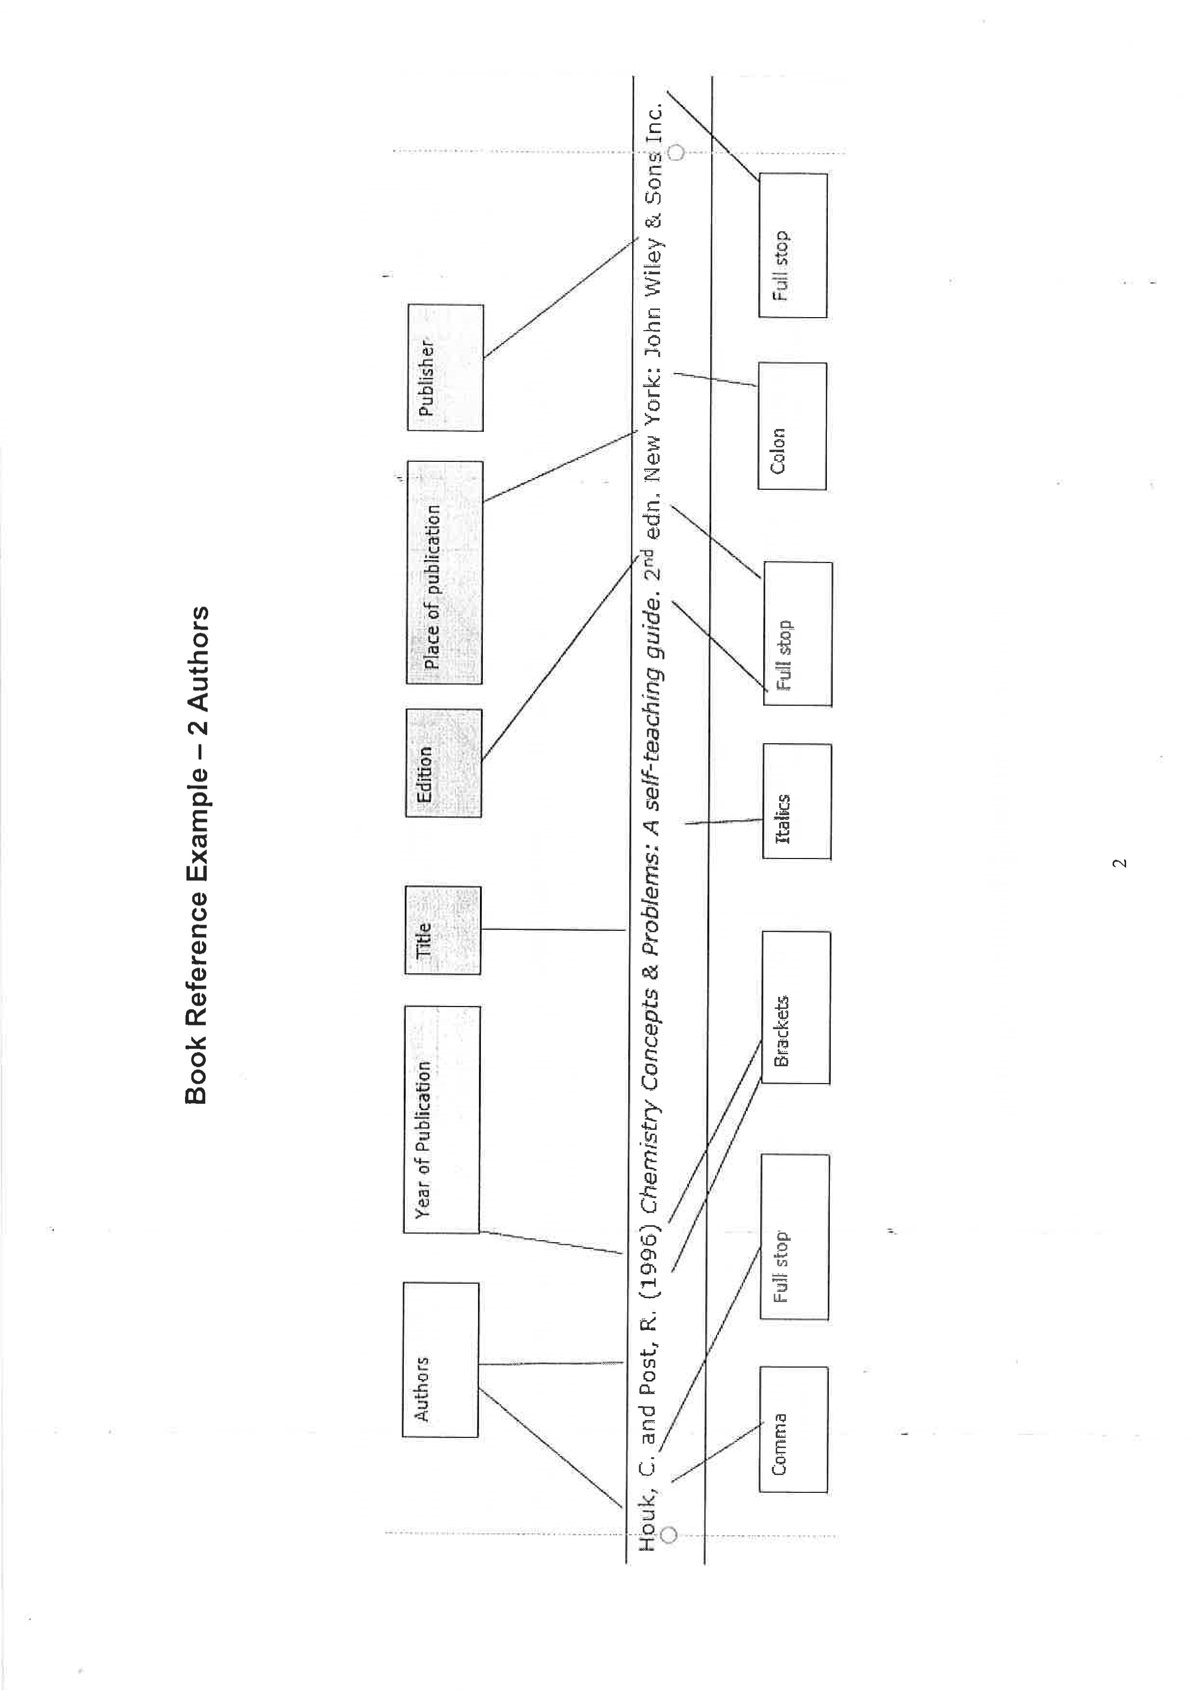

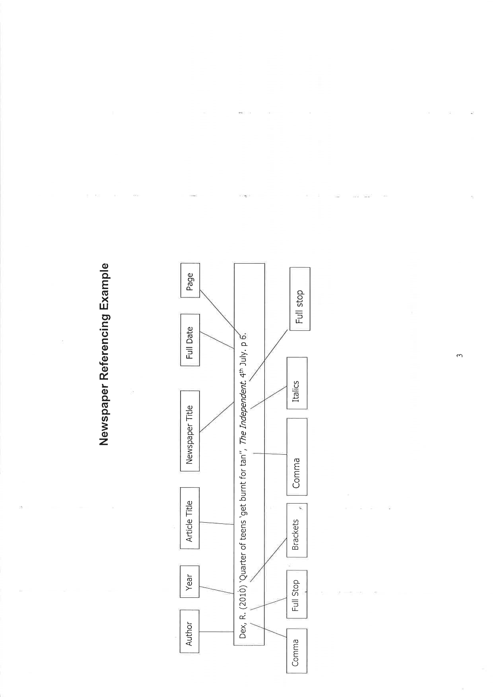

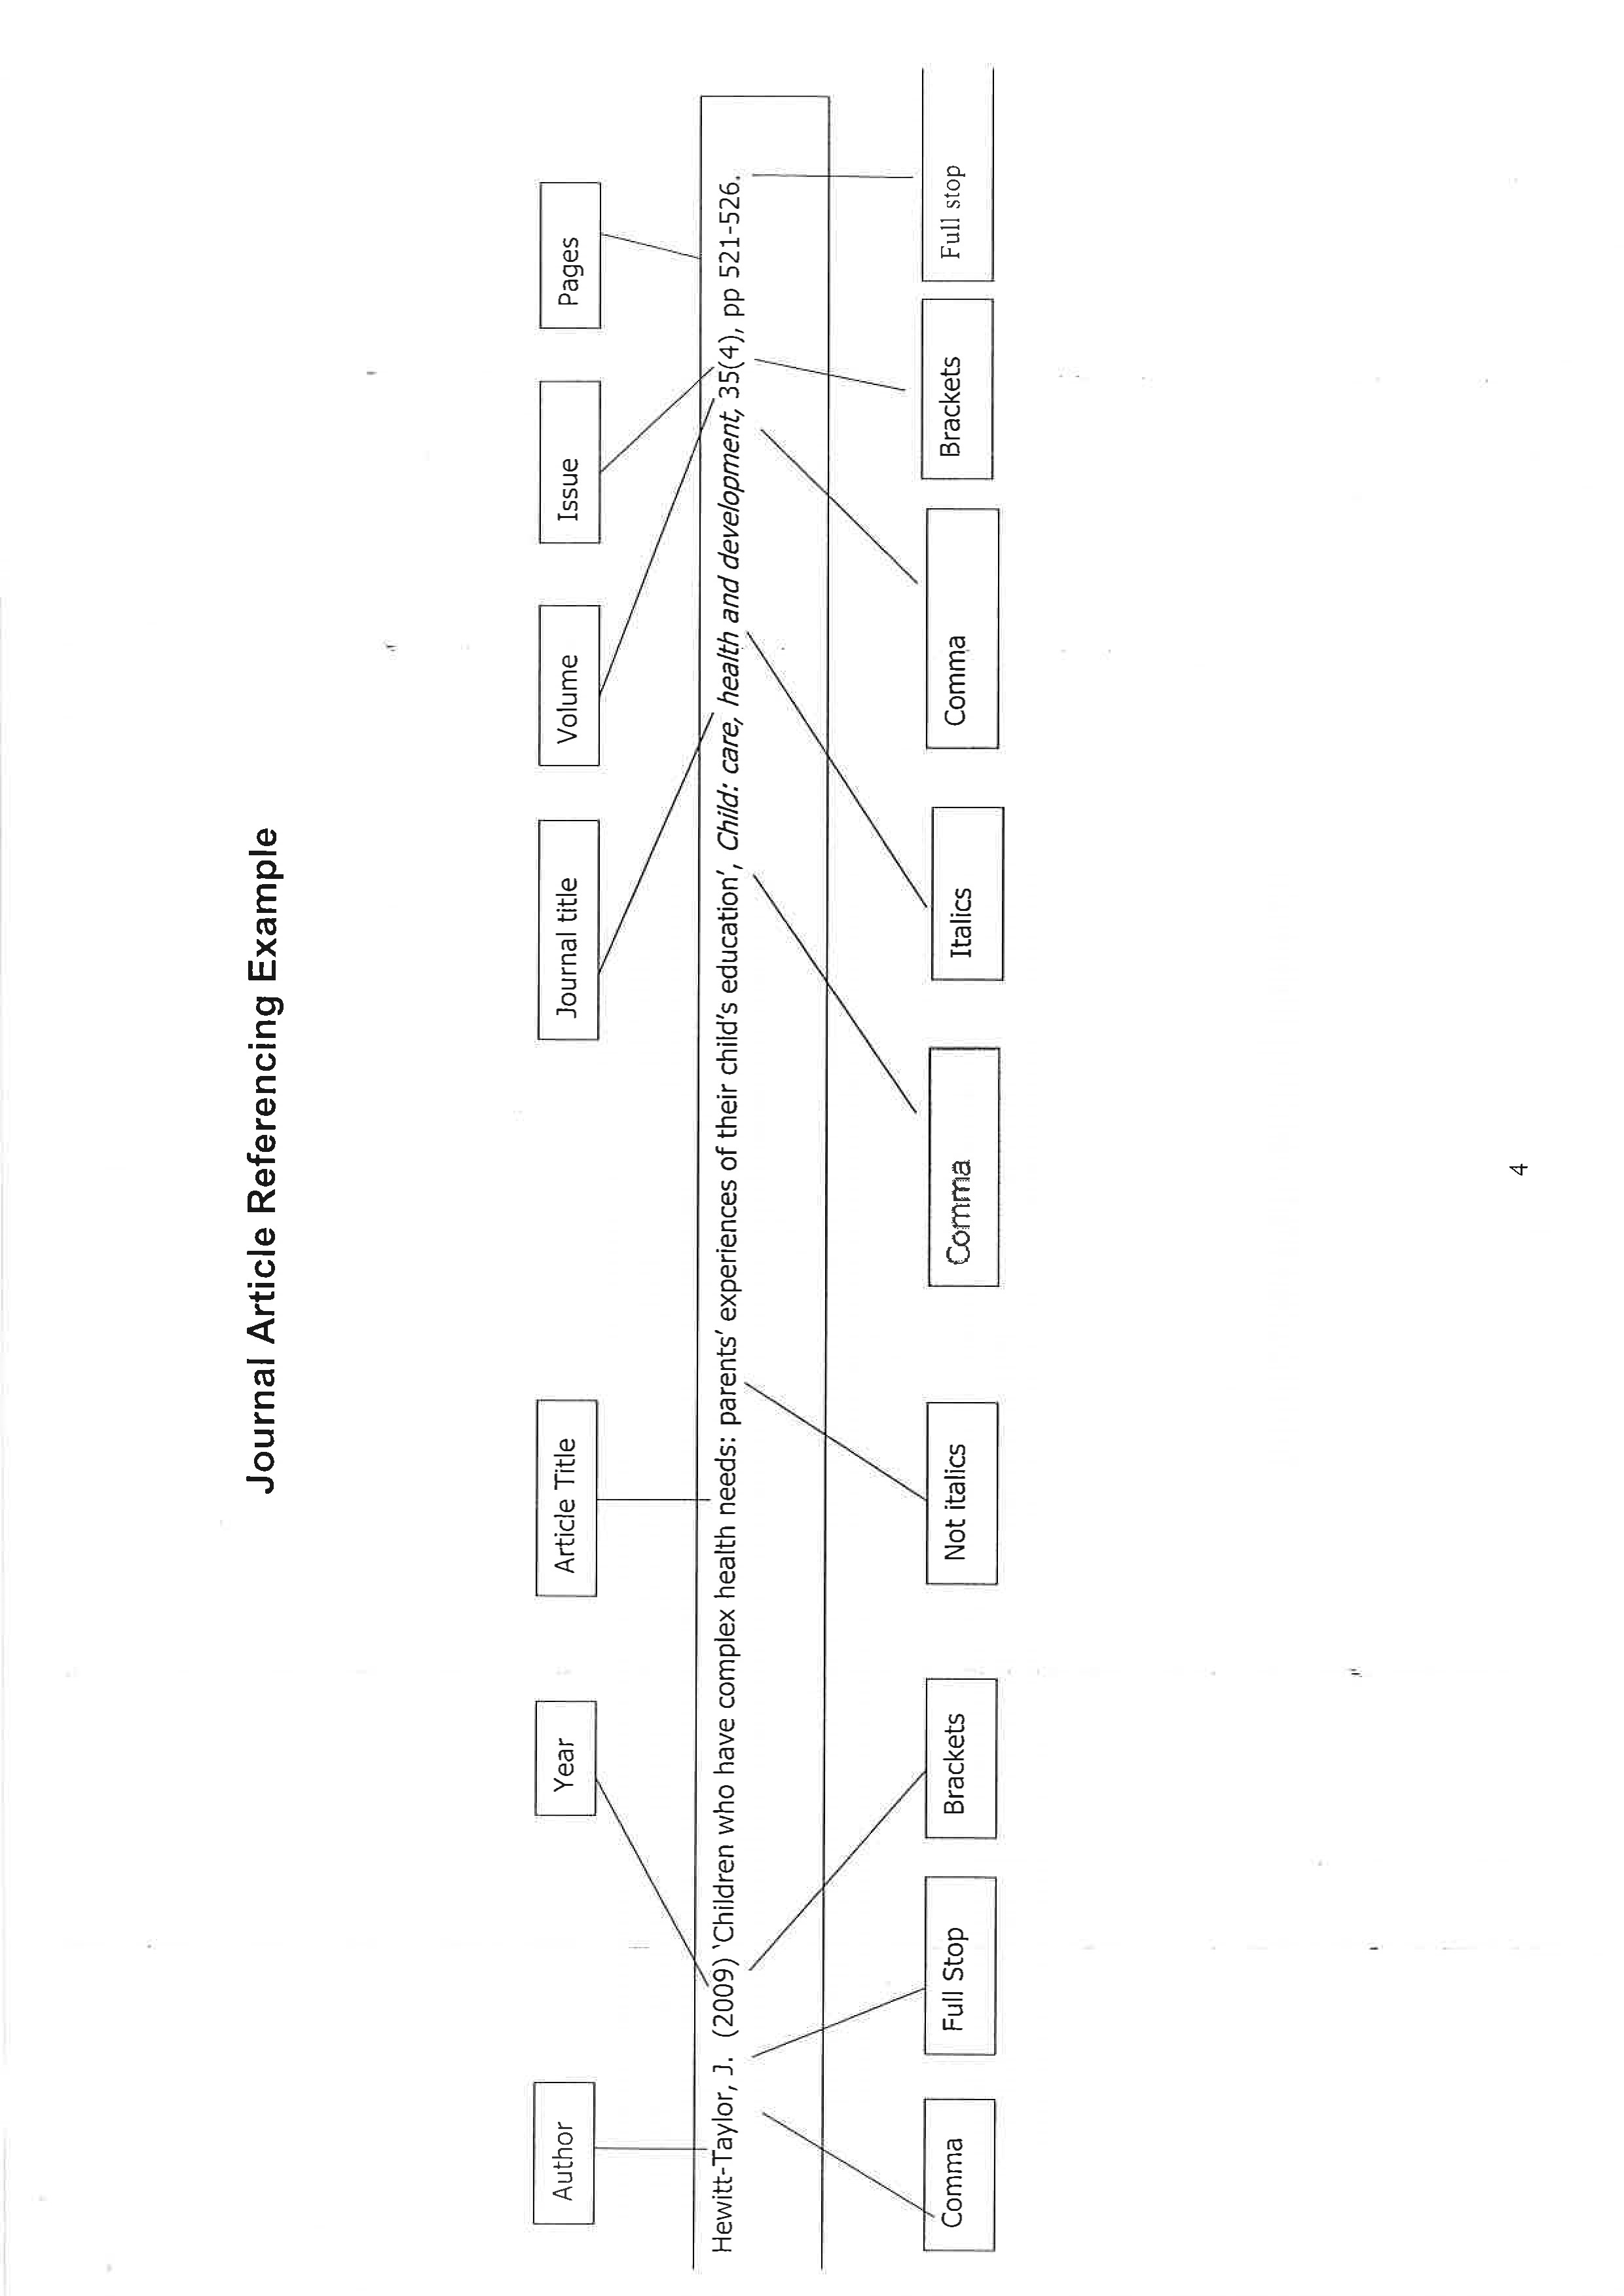
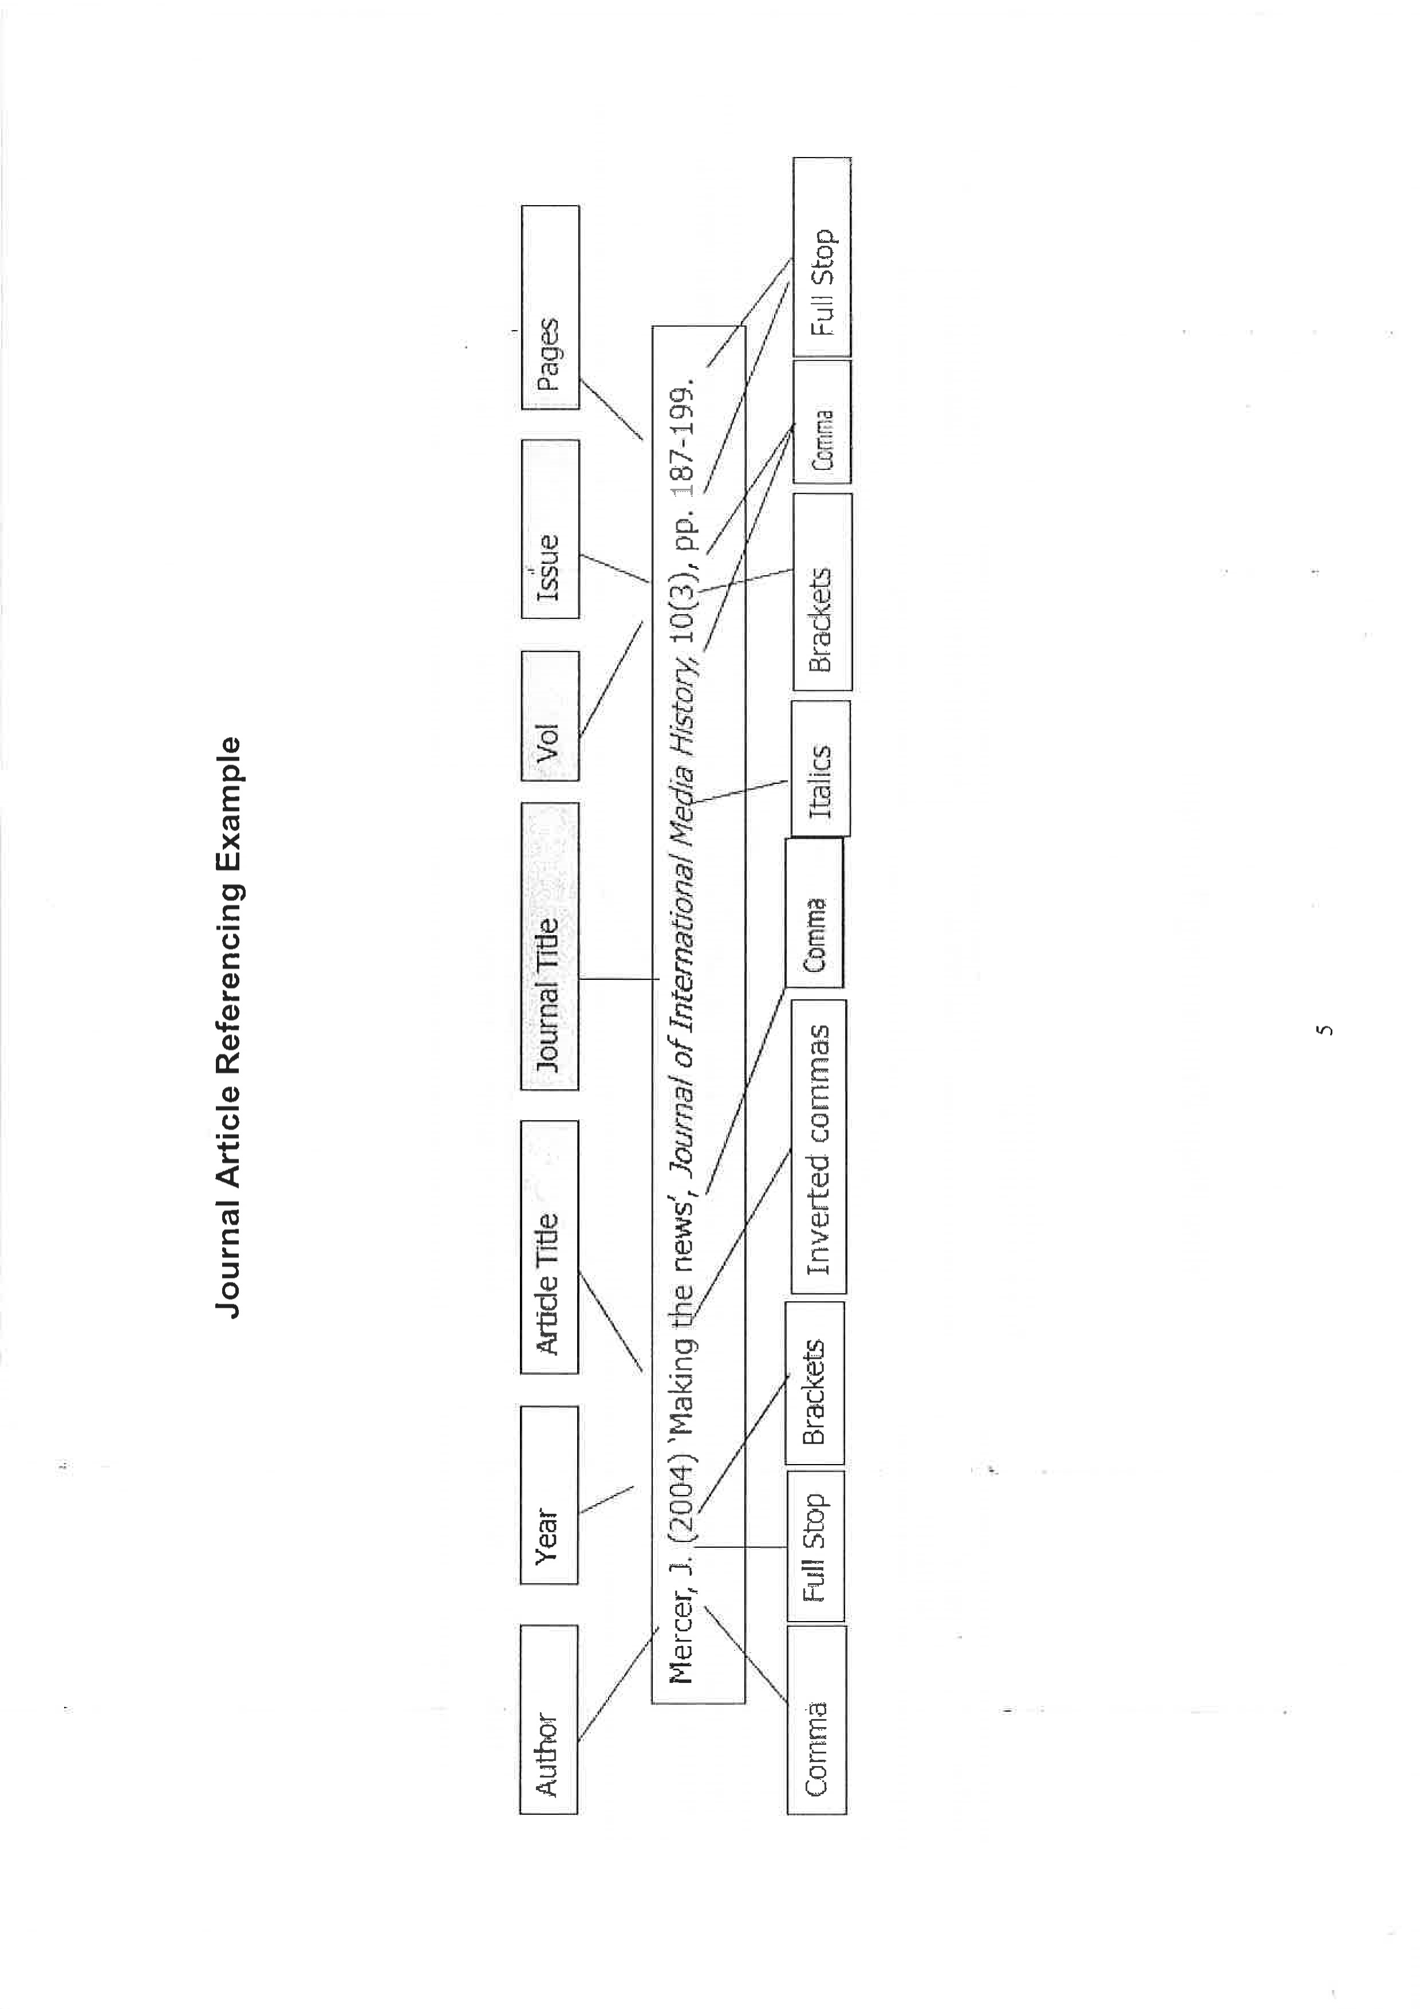
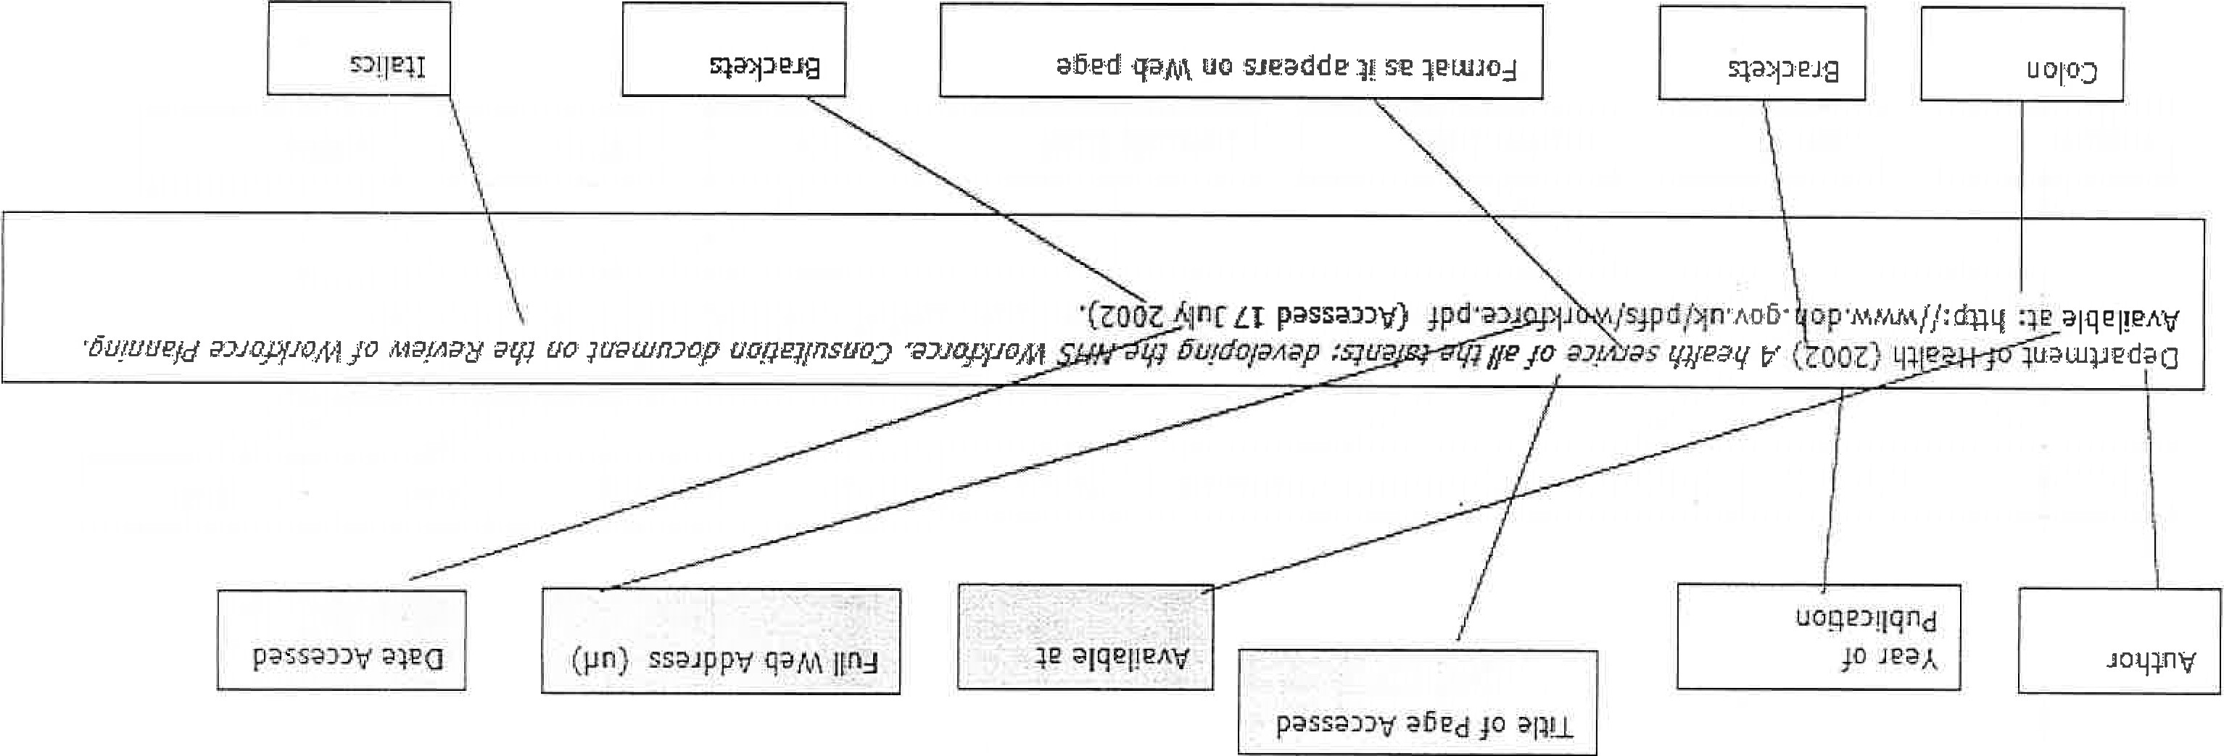

Using and referencing Images

Find the image you want to use online.
- You could find an image from:
  - A google search.
  - A webpage
    - Charity Website
    - Government Website
    - Online Article
- These could include:
  - Photographs
  - Statistics
  - Comic strips
  - Think about what is relevant to your article, is it important? Does it highlight your point?
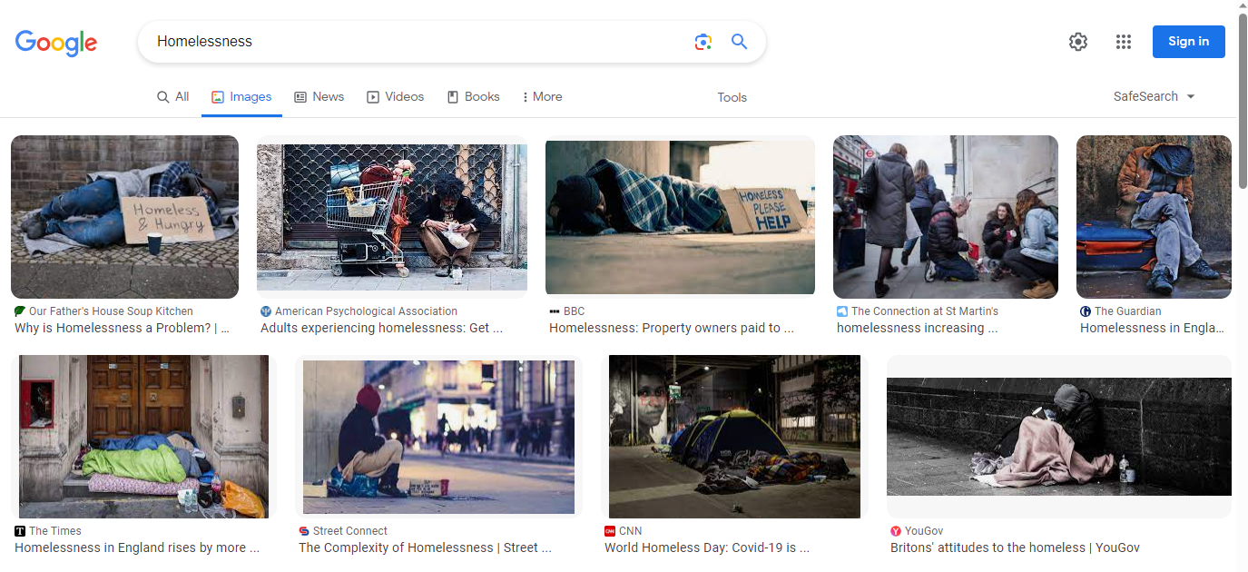
Once you have found the image that you want to use/best illustrates your point:
- Click on the image to take you to the website that it originates from.
  - This allows you to accurately reference the image.
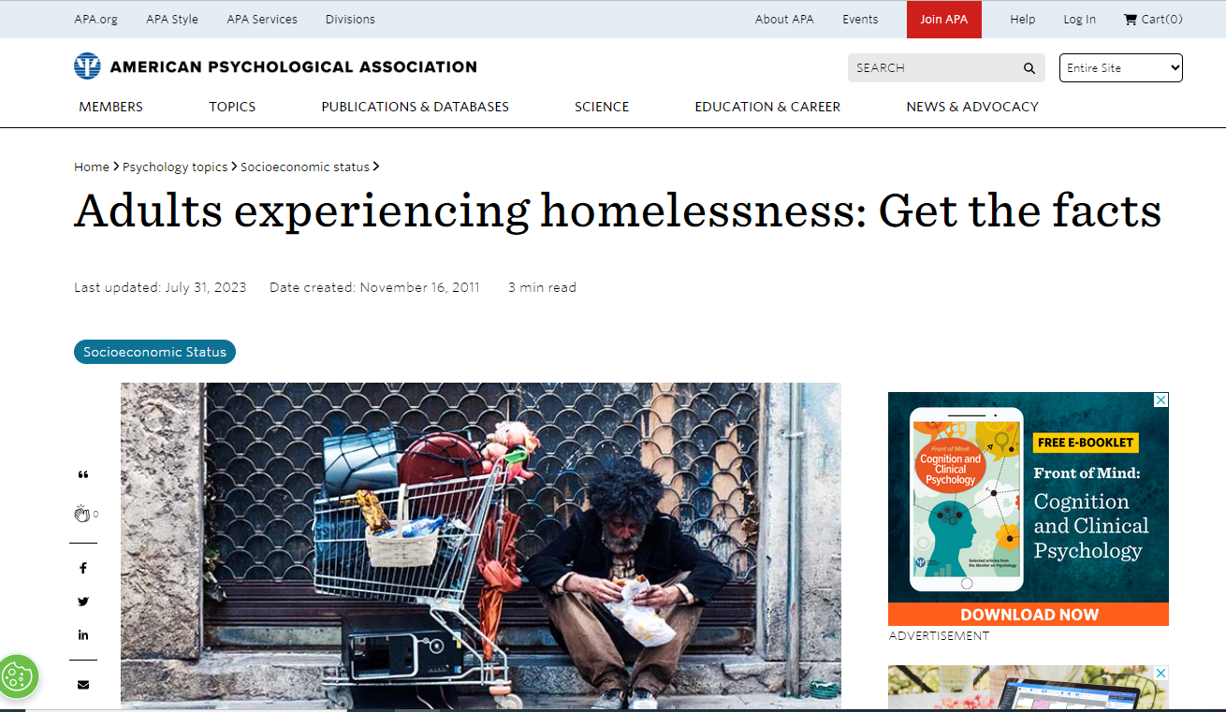
From this website we can see:
- The NAME of the website: American Psychological Association
- The DATE the article was published: 2011
- The NAME of the Article: Adults Experiencing Homelessness: Get the Facts
- The WEB ADDRESS for the article: Adults experiencing homelessness: Get the facts (apa.org)
- The date that we accessed the article: Todays date
Copy and paste the image into your document or PowerPoint.

Image Citation
- Paste your image into the centre of your document
- Place your citation underneath your image:

(American Psychology Association, 2011)

Image Reference
- If using an image within your academic assignment, this still needs to be in your reference list
Reference List
American Psychological Association (2011) Adults Experiencing Homelessness: Get the Facts Available at: Adults experiencing homelessness: Get the facts (apa.org) (Accessed: 12/09/2023)
Augner, C. and Hacker, G. (2012) ‘Associations between problematic mobile phone use and psychological parameters in young adults’, International Journal of Public Health, 57(2), 437-441.
Barak, A. and Grohol, J. (2011) ‘Current and future trends in internet-supported mental health interventions’, Journal of Technology in Human Services, 29, 155–196.
Berzine, S., Singer, J. and Chan, C. (2015) Practice Innovation through Technology in the Digital Age: A Grand Challenge for Social Work, Columbia: AASWSW.
Cantor, M. (2006) ‘No information about me without me: Technology, Privacy and Home Monitoring’, Technology Innovations and Aging, 30(2), 49-53.

Exemplar of Referencing Structure

Cottrell, S. (2019) The Study Skills Handbook. 5th edn. London: Red Globe Press
Flanagan, C., Jarvis, M. & Liddle, R. (2019) AQA Psychology for A level: Year 1 & AS. 2nd Edn. Essex: Illuminate Publishing
Goode, R., Krone, H., McKendrick, E. & Jeffrey, W. (2007) Transnational Commercial Law: Instruments and Commentary. 2nd edn. Oxford: OUP Oxford
Houlk, C. & Post, R. (1996) Chemistry Concepts and Problems. 2nd edn. New York: John Wiley & Sons Inc

