Art… is real sorcery

Link to blog

https://cianwestcouk.wordpress.com/art-is-real-sorcery/

Text piece

‘The common room, like the other house common rooms, is decorated in House colours (blue and bronze silk wall hangings, in this case, and a midnight-blue carpet decorated with stars). The room is wide, circular, and very airy, with a domed ceiling painted with stars to match the carpet, and walls with graceful arched windows that provide a spectacular view of the surrounding mountains. There are bookcases, tables, and chairs, and opposite the entrance is another door leading to the dormitories. Beside this door is a plinth on which stands a life-size statue in white marble of Rowena Ravenclaw wearing her diadem’[1]

The Text

The text I chose to approach the project was of the Ravenclaw Common room description from Harry Potter: And the Deathly Hallows. I decided on this text as the text wasn’t too overly descriptive where it would not let me have my own creative freedom with the design and lay out.

I also saw an opportunity to try and create something with more grandiosity, and I felt I could be over the top with each factor of the scene as the text was quite basic in its description.

At first, I wanted to try and find something in the Witcher books but had a difficult time finding anything that I could use for the text piece. After that I went down the road of horror books. This did not come to fruition either. I did try and find something in the Stephen King classic ‘IT’ but such as the Witcher I had no luck. My thoughts then turned to more children’s authors and hence Harry Potter.

Mood Boards

When approaching my mood boards, I started by pulling out key words from the text –

- Wide and circular
- Graceful arched windows - blue and bronze silks
- Ceiling is domed – painted with stars
- Blue carpet
- Tables and chairs
- Bookcases
- Statue opposite the door.

I have created several mood boards, each one detailing certain aspects of my scene, from which I have taken elements that stand out to me. I approached mainly with a gothic style in mind as that really spoke to me, and I really enjoyed the aesthetic of everything. My final design took elements of this, but I moved to adding additions of modern curves and simple lines, hoping to bring together past and present worlds.

Some mood boards have less images than others as I enjoyed researching some elements more, but they still detail the atmosphere and setting I wanted to achieve.

Concept designs

I have drawn out concept designs of each aspect of my room. The bookcases, chairs, tables, the room itself etc. I needed to think of shape and size for each object/aspect. I stuck to the same colour for each material. The material being wood as I wanted the room to feel as though set in an old school room or large stately home hall, castle.

I enjoyed using curves throughout my designs as it feels a lot more sleek and well crafted, and a lot of care went into the creation of the objects.

I found the drawing challenging as it was mostly done digitally, and I find it quite difficult currently to create smooth lines. I am using a tablet to create designs, using my finger to draw out the objects. I do not use my Apple pen for the outlines as I don’t feel I can control it as well. I have used the Apple pen for other areas such as the colour fill.

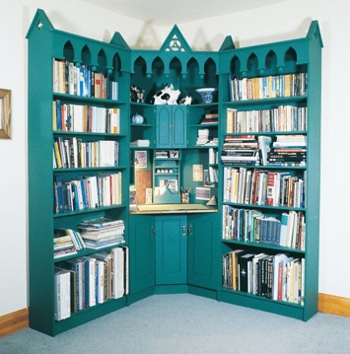
Bookcase

I used gothic style bookcases as references. I wanted to go for an ornate and extravagant style that feels over the top.

I enjoyed being creative and being a little over the top with the small details like the bevelling and extruding. I also enjoyed creating the depth of the bookcase.

I started with extruding a rectangle with added subdivisions to get the shelves of the bookcase. Then I extruded the top and bevelled to get the curved shape. I created the side pieces by extruding the sides out then dragging the top line of the extruded cube to create a ramp. I then bevelled, extruded then bevelled once more. I made the glass by duplicating the face from the back of the top compartment then editing the material.

I found trying to recreate the bevelled effect of one of the side pieces difficult in terms of symmetry. I created the glass effect on the bookshelves by upping the transparency in the material editor.

Chair

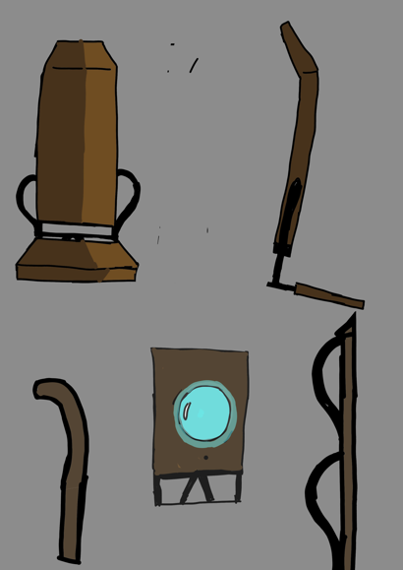
I started with a cube and flattened it to create the base of the chair. I then added a subdivision down the middle so I could manipulate the sides easier.

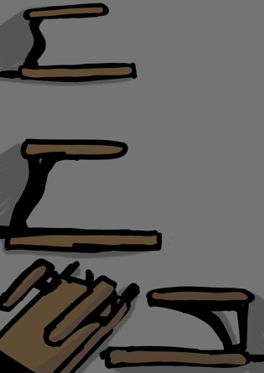
From there I pushed the sides in to create slants in the seat. I added edge loops to the arrow shaped back of the base and extruded them outward to create two thin cuboid poles. I then added an edge loop to one of the ends of the cuboid poles and extruded it out to connect it to the other.

I bevelled the arrow shape of the chair base to create a smoother curve. From here I added more square shaped edge loops at the end of the square frame so I could extrude them upwards to make the connecting cuboid poles of them an actual backrest of the seat. I did the same as the first extrusion and connected one side to another and then extruded the face so I could get the backrest. I added one more edge loop near the top of the backrest and then curved those extra faces backwards.

Lastly, I created a sphere and cut it in half. I connected the half sphere to the bottom of the chair and made the points that connected to the bottom of the chair more prominent.

At first, I was going to make a legged chair but with more extravagance to hit home with the wizard theme, but as I was getting closer to doing the legs of the chair, I decided to scrap that idea and try and approach that was more magical with a floating chair concept.

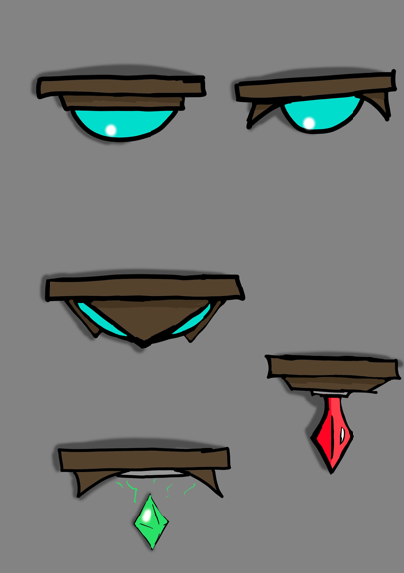
I wanted to create a crystal ball at the bottom of the chair as a kind of source for its power. Then when in the scene I could make the chairs float. This adds more mystery/magic to the overall theme and scene. I ended up making the crystal a purple colour as it fits the theme of ‘wizardry’ a lot more.

Table

When creating the table for my scene I initially investigated more gothic style furniture as that is what has inspired me with the look of everything.

However, wanting to bring together past and present and wanting to stick with the idea of floating furniture, similarly with the chair, I looked over some different designs that I felt could work for the table.

When creating the table, I created a cube and flattened it, adding subdivisions and continuing to shape it into what I wanted. I added some bevelling to the corners too.

I wanted the outcome of the table to look a little more interesting, so I decided to add some pole shaped objects to the underneath and curve them outward to add a little bit more interest.

Drawers

The drawers were the easiest to make as it was a straightforward process of only using a cube, edge loops and some extrusions. I tried using the multi-cut tool but had difficulty, so the edge loops replaced that. I extruded the legs and the drawer handles. One thing that could have been done better was not using as many edge loops and figuring out how to properly use the multi-cut tool, as the clean up of removing unwanted lines is a tedious process. The result works, fits the room as it is inoffensive but could have been a little more magical.

Arched windows

At first, I was settled on creating some extravagant looking windows to fit the scene, but when attempting to create them I ran into a problem. I couldn’t figure out how to cut a hole into the wall in the shape of my window frame. This led me to trying a variety of workarounds that didn’t go anywhere so I finally settled on just manipulating the wall to serve as the frame. The outcome works, but it feels too basic and blocky from what I originally wanted to achieve. I created the glass by using the outer walls face and upping the transparency. The outcome of this works but a more fleshed out window frame would have been better.

Statue

As stated in the text, there is a stature in the room, in front of the entrance. I could not make a statue in my piece as I do not have enough experience currently in Maya. If I were able to, I would have liked to create the bust of a man, as a way of showing the status of that man in correlation to the Ravenclaw House.

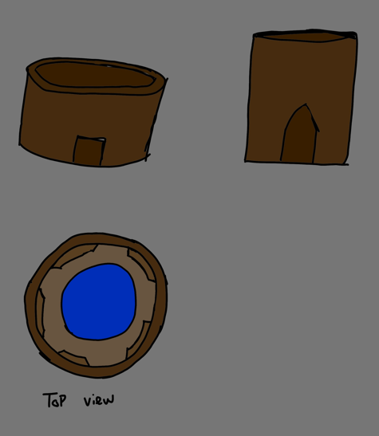
The room

In the text, the room is described as wide and circular. So, after researching for my mood boards, that is what I started with as part of my original plan. I created a simple disc and extruded it to thicken it, then extruded it upwards to get the walls. I used the multi-cut tool to create the shape of the door and then removed those faces. I then started going around the room and adding depth to the walls by pushing them inward slightly, creating a panel effect. I also pushed the top faces of the walls outward and bevelled them to create some more depth too.

I wanted to do more with the room as it felt somewhat bland, so I decided to colour it. I made the floor midnight blue as stated in the text but kept a ring of brown like the walls to feel like a wood effect.

I created the domed ceiling by creating a basic sphere and deleting the bottom half and hollowing it out. I then placed it accurately on to the room and manipulated the scale slightly, so it sat comfortable on the walls. I projected a night sky onto the ceiling to be faithful to the text and felt the outcome worked well. It is subtle but when noticed, adds a lot.

When placing all the furniture around the room I wanted to make it feel like it is was being used, that is why the chairs aren’t all in the same position/place. I wanted to fill out the room and to give off the feeling that there are multiple students that use the room.

Camera

When animating the camera, I wanted it to move as a person would entering a room for the first time. Therefore, I used motion that follows someone curious of their surroundings, looking at everything in the room from left to right and up and down. As the ceiling is black to show the stars, it is incredibly difficult to tell it is a domed ceiling. This is one area I would investigate for future projects.

Animation

I wanted to create a magical atmosphere with the animation for this piece. I made the chairs float by animating them bobbing up and down, also turning them to face the camera as it passes them. As the camera looks down from the ceiling, we see the drawer ‘dance’ down from the sky to give more personality to the overall animation. I didn’t want to overdo it with too many moving parts, so I stuck with those elements. After rendering the video, I found that it darkened the video, losing the star effect on the ceiling, therefore making me render it multiple times and adjusting the lighting to get what I wanted. The most difficult aspect was making the stars on the ceiling visible, but in the end, I got what I wanted after researching. After this I took my animation into Premiere Pro and slowed down the entering of the room and the camera looking up to the ceiling. I did this to make the stars even more visible.

Conclusion

In all, I believe the outcome of this piece is successful for one of my first attempts with Maya animation, and I am even more so proud of the modelling aspect. From the bookcases to the chairs, I learned a lot when it came to the basics and the fundamental tools of modelling. This does not mean I did not struggle and there are areas I want to improve, such as the windows, and certain areas of the room itself. Another area I feel could have been improved on is the colouring/texturing, but this is due to my inexperience in that field but with time I hope to improve.

References

[1]"Ravenclaw Common Room – Harry Potter Lexicon", Harry Potter Lexicon. [Online]. Available: https://www.hp-lexicon.org/place/hogwarts-school-of-witchcraft-and-wizardry/ravenclaw-tower/ravenclaw-common-room/. [Accessed: 22- Apr- 2022].

Link to blog

https://cianwestcouk.wordpress.com/art-is-real-sorcery/

