Museum Visit Report
Title: A report on the arguments for removing monuments, artefacts, or buildings to keep them safe in a museum.
Outline: A report exploring the arguments on whether a monument, building, or artefacts should be moved from its current situation to a place that may be better suited for it in a historical context, for preservation purposes, or education.
Introduction: In the modern-day, pollution, human interference, and the passage of time cause the artefacts of the past to degrade quicker and become harder to preserve. As such, a question arises, should we move these artefacts, be them large constructions like buildings, monuments, or artefacts to a museum or better position for safekeeping?
For museums: The arguments for moving artefacts into museums are varied and have value in their presentation. These arguments tend to follow a protectionist and educational point of view as having an artefact kept indoors, or at least in an area where historians can watch its degradation more closely, will allow it to remain much further into the future (Caple, C., 2012) and be more accessible to the public (Larrabee, E. (ed)., 1968).
Protection and preservation: In today’s world, there are more and more ways for artefacts, monuments, and buildings to be destroyed with the main two being from human interference and the weather. Due to this, there is an argument to be made for removing these historic objects and placing them into a museum, be it one similar to the British Museum or an open-air style museum where the object can then be watched over more easily, especially if it is a larger item, similar to a building.
In the case of the Dead Sea Scrolls, they were first removed in 1947 without the knowledge of preservation that we have today (Israel Antiquities Authority (2021)). As such, they have experienced much deterioration from the climate, human handling, and transportation. Due to the delicate nature of the scrolls, and the fact that they were found in the caves of the Judean desert, for further preservation it is necessary for them to be held in a museum or similarly natured laboratory where they can be closely examined in attempts to slow the degradation process and digitize them for future use. This is even more important as they provide an insight into the Hebrew Bible at the time, as well as other documents that we are unable to gain knowledge from anywhere else. If they were to be kept in the caves where they were found, then the chance of destruction becomes even greater than it already is as treasure hunters, animals both domestic and wild, and the changing climate could lead them to be lost forever. This is proven more so by the way they were found with a shepherd throwing a rock and destroying one of the pots they were kept in (Israel Antiquities Authority, 2021; Cohen, 2018).
There are also the monuments known as the Elgin Marbles and Parthenon Sculptures taken by Lord Elgin from the Parthenon in Athens between 1801-05 (British Museum, 2021 a). Over the 2,500 years of their existence, they have seen many wars and rulers in Greece, and it is in part due to Lord Elgin bringing half of the remaining sculptures (roughly 25% of the original number) to Britain (British Museum, 2021 a), that they still exist and can be observed and documented today. With the advance of the Nazi war machine into Greece and their appropriation of all forms of artefacts and artworks that they partook in, it is quite possible that the Germans would have taken some, if not all, of the remaining Marbles and hidden them in places which are yet to be found, if the art had not yet been destroyed (Papademos, A., 1946.).
With this, it is a requirement that those marbles were to be kept in a museum so as to protect them from both further damages by war and thieves. If they were to be placed back into the Parthenon, then there is a greater chance that tourists, thieves, the weather, and perhaps animals, could cause greater damage to them which would result in the already broken artefacts becoming even more degraded, especially as the building is in need of repairs (Pruitt, 2019; Skarlatos, 2013).
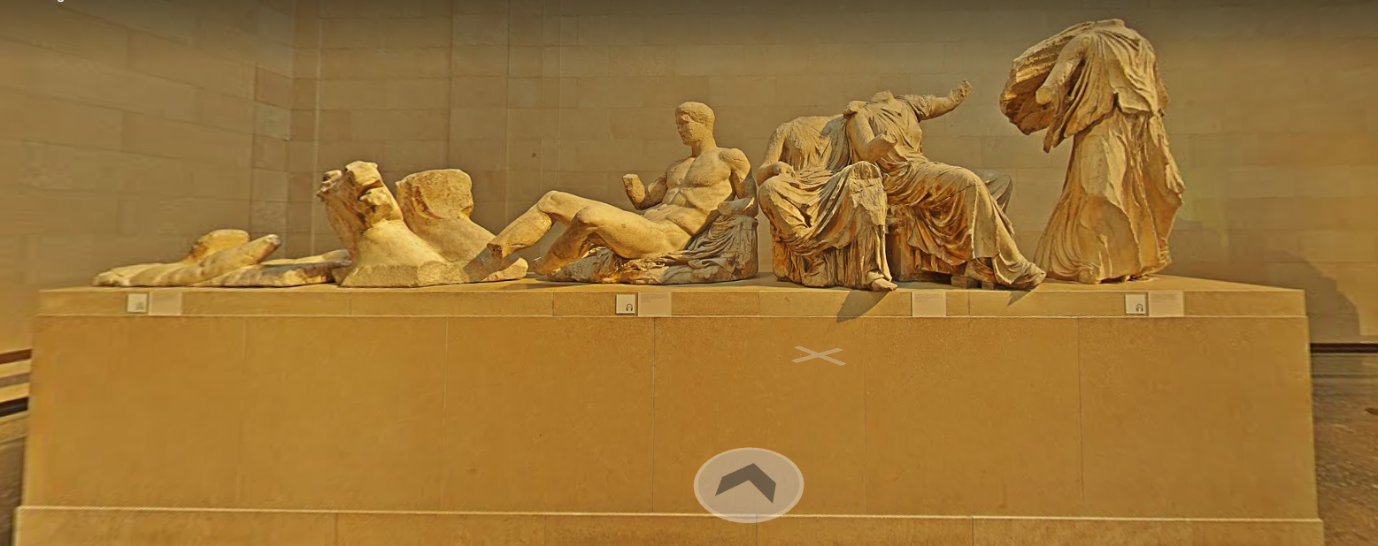
Figure 1: “Parthenon Statues” from the British Museum, [online] Available at: British Museum, London, United Kingdom — Google Arts & Culture a (Accessed: 2nd October 2021)
Education: By moving an artefact into a museum, it becomes easier to present it to a wider audience and tell them about its story, especially young children who will often partake in a field trip and be given questionnaires to fill out as they move around the museum. They may also put on clothing and pretend to be a person from the period, learning how they would have acted at certain points in a cultural time where armour, clothing and replica weaponry may be put out on a table. A great way to help teach children, and adults as well, is to allow them the hands-on approach where they can partake in a setting that is similar to how those they are learning about would have lived in, instead of requiring their full imagination when donning a Roman Gladius or Medieval Chain Maille (Jackson, 2005). When paired with facts such as the date, and the number of soldiers in a formation, a good teaching environment is created where you do not realize you are being taught, Horrible Histories (Deary and the BBC, 2009) is a good example of this with Rattus Rattus holding True and False signs up, and the songs the actors often include in the television show.
In terms of statues, having the Elgin Marbles in the British Museum allows for tour guides to deliver a greater presentation as they can retain consumer focus for longer than if they were outside in the Parthenon as well as allow the visitors to wander around and take in the information and details at their own pace without worry of interruption of rain or heat exhaustion (British Museum, (Aphrodite) for example, as they can provide greater information with placards, audio devices, QR Codes and museum staff (Proctor, 2021; Chan, 2021).
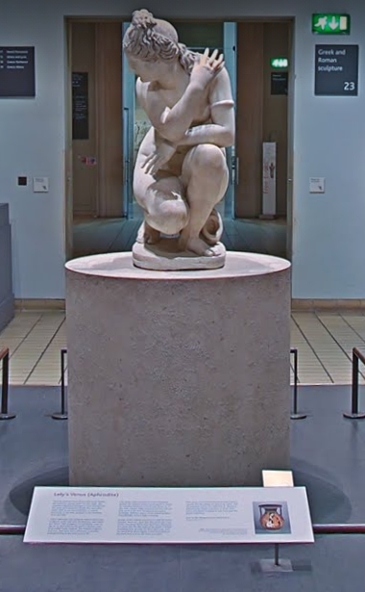
Figure 2: “Lety’s Venus (Aphrodite)” from the British Museum, [online] Available at: British Museum, London, United Kingdom — Google Arts & Culture b (Accessed: 2nd October 2021)
Against museum:
There are also reasonable arguments on why an artefact should not be moved into a museum. While some points do tend to follow the same basis as those for museums, they have different reasoning behind the protectionist and educational point of view while also having greater historical importance on keeping them there, such as those found in a town or important area to a region which will have greater historical and cultural importance by staying where they are.
Cultural Importance: Stonehenge is one of these cultural and historical monuments which do not make sense to move into a museum. Due to the size of the stones that make up the monument, it would be highly difficult to remove, relocate, and present the stones in a place that works to their benefit, especially as they align with the summer and winter solstice (BBC, 2011). To move the site to a different area or indoors would take away its context and authenticity of life left over from the early Britons that we can still experience in today’s world. As such, the better idea is to make a museum around the stones, much like English Heritage has done. English Heritage allows for people to have 45 minutes to walk around and experience Stonehenge freely, while historians can study the whole area in the situation that it was left (English Heritage, 2020). While it could be useful to dig up the whole area of Stonehenge, the destruction of the site would result in public outcry as it is a cultural gathering site on the days of the solstice. Already the A303 has created this problem as it removes the authenticity of the area somewhat as the road makes what should be a tranquil area much noisier and damages the local ecosystem that the early Britons would have experienced at the site (English Heritage, 2020; Historic England 2015).
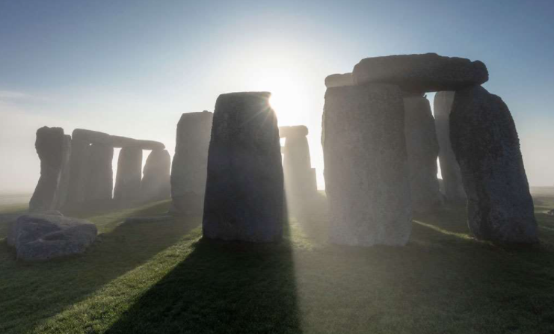Figure 3: “Stonehenge” [online] Available at: Stonehenge Stone Circle Experience | English Heritage (english-heritage.org.uk) (Accessed: 2nd October 2021)
Historical Importance: Similar situations to Stonehenge are the still afloat museum ship of HMS Belfast on the Thames River and the sunken war grave and memorial of the USS Arizona in Pearl Harbor. HMS Belfast, instead of being decommissioned and scrapped, was turned into a museum due to its significance of having fought from the Second World War through to the Korean War (Johnson, 2021). Due to its large size, being a ship designed for war, it would not be possible to place it into a museum itself, but it being one of three remaining ships from D-Day, it has great significance to British and World History. This lends itself to be a unique case as due to it being able to house people, it can then be a place of education on Naval Practices and how situations in the wars went. Similar to English Heritage with Stonehenge, the Imperial War Museum has taken on HMS Belfast to preserve it and help show the history around it with an authentic piece of Wartime history, even if it is not presented in a situation where museumgoers are taken to sea (Imperial War Museum, 2021 a; Imperial War Museum, 2021 b).
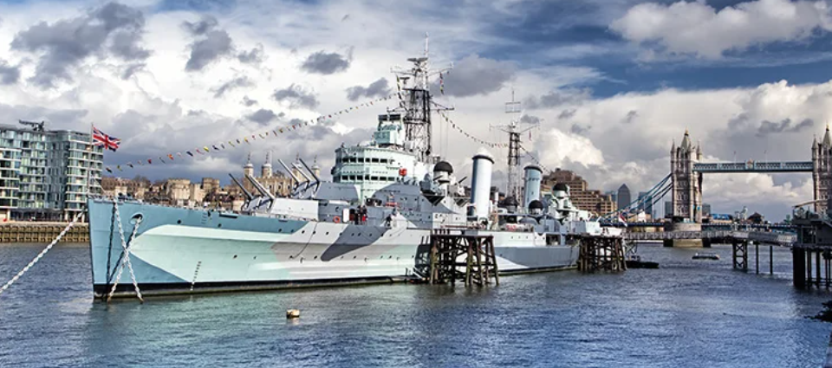Figure 4: “HMS Belfast” [online] Available at: HMS Belfast - History and Facts | History Hit (Accessed: 2nd October 2021)
USS Arizona on the other hand is situated on the floor of Pearl Harbour. It is unable to be lifted due to structural integrity and lack of desire to do so as it was made into a war memorial both during and after the Second World War. Now it sits as a reminder of the lives lost and the effects of the attack on pearl harbour in the USA (World War Wings, 2021; National Park Service, 2018). Despite not taking part in the fighting, USS Arizona has great historical importance as it represents how the power of a militarily strong nation can be crippled in one attack. It also sits as a grave to those who died in the attack on Pearl Harbour, both on Hawaii and in the USS Arizona itself, thus having greater importance historically as a way to keep their memory alive.
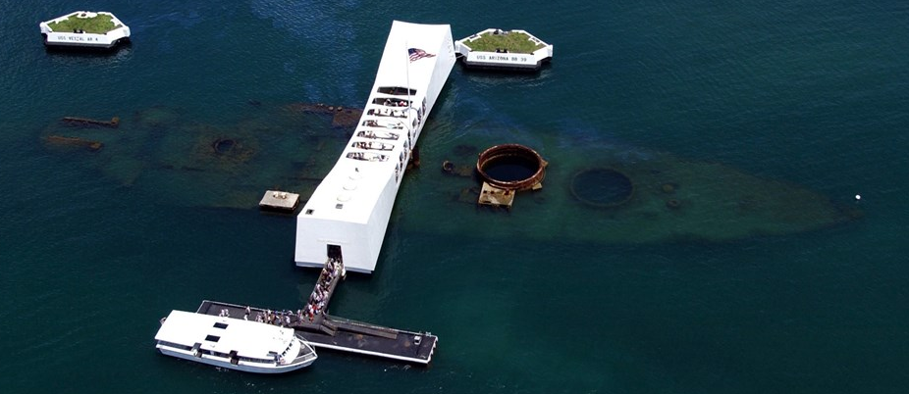Figure 5: “USS Arizona Today” [online] Available at: USS Arizona - Pearl Harbor National Memorial (U.S. National Park Service) (nps.gov) (Accessed: 2nd October 2021)
Comparison: The arguments for why a monument should or should not be placed in a museum have been discussed. Both sides have good positions to make their claims, those for placing items into a museum often focus on the protection and educational aspects as we have seen with the Elgin Marbles requiring greater protection due to the limited nature of the remaining sculptures while the Dead Sea Scrolls also need to be placed into a museum as they offer information into how people lived thousands of years ago.
However, the size of certain artefacts, like metal ships, are too large to be placed in a museum and thus it is better to leave them where they lay or float and preserve them that way. The cultural importance also comes into play here as while the Elgin Marble debate is its own source of discussion, Stonehenge is of great cultural importance to the people of Wiltshire and the UK as a whole as it is a link to the heritage of the Celts and how they perceived time.
Conclude: Overall, each artefact, monument, or structure’s own situation should be taken into consideration on whether or not to place it into a museum. Aged scrolls that are easily destructible possess a greater need to be placed into a museum but a metal ship that is still seaworthy should be left to float as it is in little to no need to be repaired.

Bibliography:
BBC, 2011., Summer Solstice. [online] Available at: BBC - Religions - Paganism: Summer Solstice (Accessed: 29th September 2021)
British Museum, 2021a. ‘The Parthenon Sculptures’. [online] Available at: https://www.britishmuseum.org/about-us/british-museum-story/contested-objects-collection/parthenon-sculptures (Accessed: 30th September 2021)
British Museum, 2021b. ‘Greece: Parthenon 447–432 BC’. [online] Available at: https://www.britishmuseum.org/collection/galleries/greece-parthenon (Accessed: 30th September 2021)
British Museum, 2021c. ‘view of the Elgin Marbles’. Google Arts and Culture [online] Available at: British Museum, London, United Kingdom — Google Arts & Culture (Accessed: 30th September 2021)
Caple, C., 2012. Preventive conservation in museums. Routledge. Available at: Preventive conservation in museums. - Durham Research Online (Accessed 1st October 2021)
Cohen, J., 2018. ‘6 Things You May Not Know About the Dead Sea Scrolls’. History. A&E Television Networks. [online] Available at: https://www.history.com/news/6-things-you-may-not-know-about-the-dead-sea-scrolls (Accessed: 1st October 2021)
Deary, T., & BBC., 2009. Horrible Histories. Available at: BBC iPlayer - Horrible Histories (Accessed 1st October 2021)
English Heritage, 2020a., Stone Circle Experience. [online] Available at: Stonehenge Stone Circle Experience | English Heritage (english-heritage.org.uk) (Accessed: 28th September 2021)
English Heritage, 2020., Stonehenge & A303. [online] Available at: Stonehenge and the A303 Joint Response | English Heritage (english-heritage.org.uk) (Accessed: 28th September 2021)
Historic England, 2015., Stonehenge and the A303. [online] Available at: Stonehenge and the A303 | Historic England - YouTube (Accessed: 28th September 2021)
Imperial War Museum, 2021a., Families at HMS Belfast. [online] Available at: Families at HMS Belfast | Imperial War Museums (iwm.org.uk) (Accessed: 29th September 2021)
Imperial War Museum, 2021b., Visit HMS Belfast. [online] Available at: Visit HMS Belfast - Plan Your Visit | Imperial War Museums (iwm.org.uk) (Accessed: 29th September 2021)
Israel Antiquities Authorities, 2021. ‘The Leon Levy Dead Sea Scrolls’. [online] Available at: https://www.deadseascrolls.org.il/learn-about-the-scrolls/introduction?locale=en_US (Accessed: 1st October 2021)
Jackson, A., & Leahy, H. R. (2005). ‘Seeing it for real?…?’—Authenticity, theatre and learning in museums. Research in Drama Education: The Journal of Applied Theatre and Performance, 10(3)
Johnson, L., 2021. HMS Belfast [online] Available at: HMS Belfast - History and Facts | History Hit (Accessed: 29th September 2021)
Larrabee, E. (ed)., 1968. Museums and Education 21 (1). Smithsonian Institution Press. Available at: Museums and Education - Google Books (Accessed: 1st October 2021)
Nancy Proctor, head of mobile strategy and initiatives at the Smithsonian
National Park Service, 2018., USS Arizona. [online] Available at: USS Arizona - Pearl Harbor National Memorial (U.S. National Park Service) (nps.gov) (Accessed: 30th September 2021)
Papademos, A., 1946. Ministry of religions and national education address of antiquities and historical monuments, damages from war antiquities and occupation armies in Athens. National printing house. [online] Available at: https://greeceandworld.blogspot.com/2012/03/8000-ancient-greek-artifacts-stolen-by.html (Accessed: 1st October 2021)
Pruitt, S., 2019. How the Ancient Greeks Designed the Parthenon to Impress – And Last. History. [online] Available at: How the Ancient Greeks Designed the Parthenon to Impress—And Last - HISTORY (Accessed: 1st October 2021)
Sebastian Chan, head of digital, social and emerging technologies at the Powerhouse Museum
Skarlatos, T., 2013. Amid Greek austerity, plunder of priceless treasures. BBC. [online] Available at: Amid Greek austerity, plunder of priceless treasures - BBC News (Accessed: 1st October 2021)
World War Wings, 2021., Real Reason Why USS Arizona Was Not Raised When Other Ships Were. [online] Available at: Real Reason Why USS Arizona Was Not Raised When Other Ships Were - World War Wings (Accessed 30th September 2021)

