

  - Enterprise & Innovation Group Project
  - Module CODE: ACDA5003
  - lecturer: James Williams
  - Individual Report
|Ruzy Aktar | 16/03/2020| Student ID: 1708215

Introduction
As a group the student has been asked to contribute to writing a New Product Business innovation plan. The group has been asked to write their individual roles, which eventually will be unified to one. This student will be going ahead and completing this task by writing her role which falls in the field of ‘The Market and Competitors’ and contributing to the development of the website.
The Market and Competitors
As this student’s role has been in the marketing field she has done some research to firstly find out what is a market and competitors. Because growing a business without acknowledging any competitors is a dangerous field in the market. Market research can stop a business from crashing and prepare individuals for what’s to come.
The student researched online as well as attending a talk called start up work shop introduction to marketing (for business). This was interesting for the student as she had learnt about customer touch points for online and offline business. As well as competitors how, important it is to get to know them and do research.
Few images below showing that this student has researched her field.
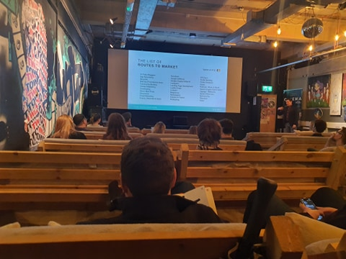
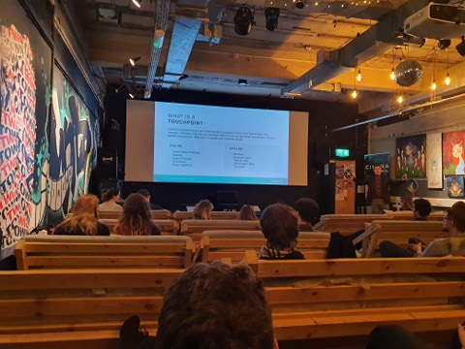

Analysing the industry including relevant statistics. Is there a market for the Product?
Market research covers gathering data and analysing information for targeted market. For J&J fitness the student has conducted some, desk research this is done by using existing data and information from the internet from our competitors and the fitness industry that is our target audience.
The fitness industry in the united states has been growing quite high, being one of the leading countries with obesity and bad health. But ‘over 54 million Americans paid gym membership fees in 2014, and the second year in a row actual visits to the gyms exceeded 5 billion. The average member visited their club over 100 times. Memberships have grown 18.6% between 2008 and 2014, and the trend continued in 2015. In the United States there were 34 thousand fitness centers – an increase of 6.4% over 2013. 2014 revenue of $24.2 billion was also a sharp 7.4% increase over $22.4 billion in 2013.

According to the Bureau of Labor Statistics, these fitness and recreational sports centers employed 533,200 people in 2014, and jobs are expected to grow 8% by 2024. Globally there are over 180,000 fitness clubs, estimated to have earned $84 billion from their 145 million members.
The student has looked at these statistics and has conclude that the fitness industry is always growing and more than a billion customers will invest their time and money into services that can help an individual. This is why this student is confident J&J Fitness will be able to get their targeted audience as customers will want an app that can improve overall health. With a reasonable price.

Competitors, similar products, their price and USP
The student has researched the competitors for J&J Fitness. There are 4 main competitors myfitnesspal, Gymshark, My Protein and Bodybuilding.com.
Firstly, the student has looked into myfitnesspal, they offer a range of features,
- Set a daily calorie goal (free)
- Custom Carbs, Fat and Protein Goals (free)
- Quick Add Calories (free)
- Nutrient Dashboard
- Food Analysis
- File Export
- Calorie Goals by Meal
But the student has noticed out of most features only 3 are available to be free. It is £8.14 monthly and £40.74 yearly for a premium membership. Where as J&J Fitness it is free to use every feature apart from the competing feature which is £14.99. This feature is to compete against individuals globally and to win prizes. This is to motivate individuals to be fit almost like a fitness game but will real life progress that is the outcome. Myfitnesspal have also teamed up with underarmour to sell merchandise e.g. clothing. One women’s legging cost £45.00, that is almost the amount it cost for a yearly membership.
J&J Fitness will be collaborating with another fitness company to invest in J&J and sell items. Gymshark sell women’s leggings between £30 - £50 which is a lot, but they do have a gift card feature which is good for presents as well as youth discount. Their clothing is always good quality for being squat proof just overpriced. However, being very expensive they have celebrity fitness gurus who wear these items which makes Gymshark a huge competitor.
My protein, would be considered as a competitor because of how cheap their products are overall. Their clothing for women leggings goes by £20.99. the student has noticed that’s half the price from the other two. And as far as their nutrition products go they range from £7-£30, all depending what size individuals want. They also have bundles that are £40+. The student’s goal is to make them collaborate with J&J and be able to sell their items on the app. This is a decision the student has based on how cheap the membership is as well as making merchandise very affordable. They also always have promotional offers e.g. 50% off.
Bodybuilding.com is mainly focusing on the supplement’s side, they are very big in the body building industry and it is important to see how much their products are and how J&J can also do as good as them but make items more affordable. Each product ranges from £14-£40, without any discount. They’re products aren’t for everyone as the key ingredient is to make you gain weight. This is something the student has thought about for J&J to bring in body building fanatics. So, this needs to be taken into consideration on how as an individual she can price match and bring in the best quality.
J&J fitness biggest competitor is myfitnesspal. Myfitnesspal unique selling point, compared other fitness industries, are that they distinguish their brand as an online monitoring/ tracking application. Whereas the other companies e.g. Gymshark boddybuiling.com only sell fitness products and clothing.

Pest framework and SWOT
‘PEST and SWOT are closely related approaches to business analysis’[2]. Pest stands for political, economic, social and technological influences on a business. SWOT stands for situational analysis tool , used by high leaders in a company. This includes assessing strengths, weaknesses, opportunities and threats.
PEST main aim is to focus on the external environmental factors which may affect a business.
Email marketing currently is a big way to promote products. When a user signs up on the app with email or website. This directly opts in customers to always have promotional offers and discounts for users to redeem. This is a fast and automatic way to get users attention. Devices are used in everyday life mobiles are a huge part of a social daily life. A user will always see notifications on their phone for when a promotional offer is being put out; this is ideal for J&J fitness.
Websites are a huge platform to promote products, offers, details, reviews, photos, and videos, this allows J&J fitness to engage on potential customers.
J&J fitness will also be using social media as it is a one of the biggest places to catch potential customers and get them interested. Social media is a place for engaging with not just random posts but potential business marketing.
PEST aims and factors is to focus on exchange, economic conditions as well as monetary policy. However, the social factors are distribution , consumer demographics and trends. If J&J fitness where to investigate the technological factors , this would mean looking at factors that include availability of technology that would affect the business. J&J fitness will be looking at software to create the app and the website, these are necessities when it comes to marketing products especially when an app is being created.
SWOT assess strengths and weaknesses and any opportunities or threats that may occur while creating and organizing a business and cooperate strategy.

Below is a SWOT table reviewing current analysis for J&J fitness app, there are still developing and changing factors for the app but this is so far the student has looked into to improve for the final release for the product.

STRENGTHS | WEAKNESSES
- Low cost – software is free to download.  - Strong relationship with colleagues.  - Website and App having no difficulties creating it.  - Team members are trained to develop this product and website. | - Time consuming – coding for app needs to be perfect.  - Product quality – it is not fully accomplished.  - Website privacy
OPPERTUNITES | THREATS
- University support  - Consumes to moving to online shopping.  - Customer loyalty program  - Can cater to individual needs | - Competitors  - Strong global competition  - Loyalty with collaborating  - Tax  - Delivery problems

Development / website
The student has contributed towards the website along side of Habib Muin and Lloyd Johnson. This student is studying HND Web Development and has the skills to make a basic html and php website. She has contributed towards the home page, program and the sign-up page. So far this is the prototype not all features have been added but the most basic pages are done.

The homepage consists of a banner which is a slide show. It has the name of the app on there and a simple motivational quote.



The coding used to make this is shown below. The coding shows the text that is put into the banner and the height and width for both images used to make the images fit. It is all based inside a container.
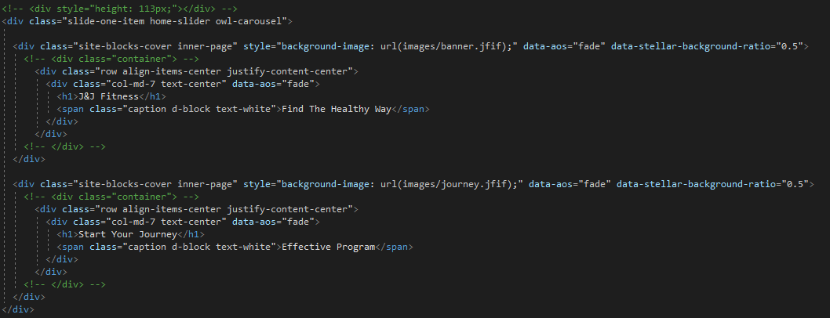

Next the student has created a simple sign up page. This sign up page still needs development, but this how far the student has come across. Customers are bale to sign up with other social media accounts or make a new account from scratch.
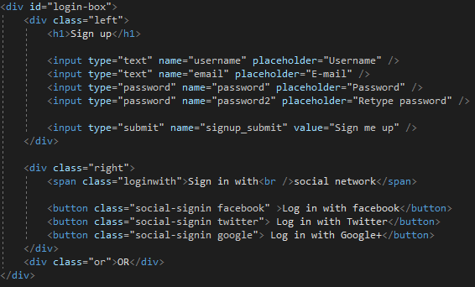
Placeholder attribute is needed with text inputs such as URL, search and password. A place holder defines the expected value of an input field. And the student has added buttons.

When the development is finished the student might change this into a php file where student has thought about using a data base to save passwords in order for user logins to work. Data base has been created but the student just needs to link this.
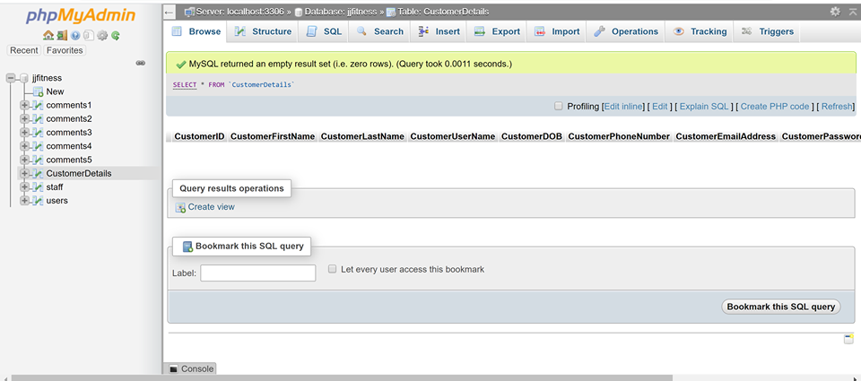
This is the outcome of how it looks.
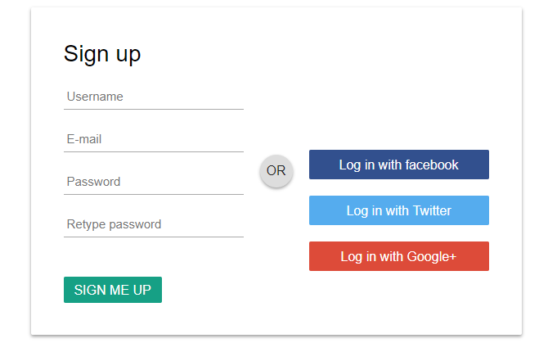

The program page is about what J&J fitness can help with. The layout is the same apart from including buttons with personal trainer icons. And a button asking customers to join the program.
There are many programs, body building, boxing and much more. Below is a screenshot of the code and the outcome of how it looks.

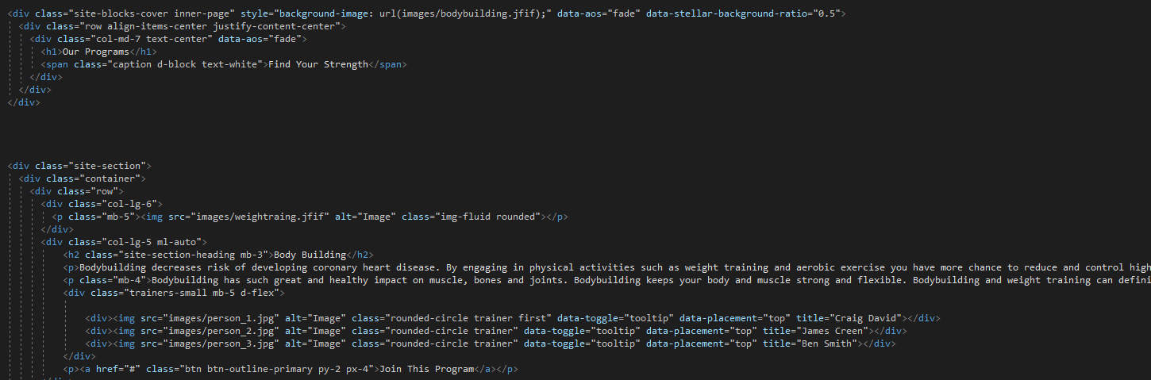



- https://www.franchisehelp.com/industry-reports/fitness-industry-analysis-2020-cost-trends/
- https://smallbusiness.chron.com/relationships-between-pest-swot-10083.html

