Ryan Thomas
1704067
08/05/2018
PJDP

Today, the affect climate change has on the environment is a constant debate between politicians and scientists. The underlying facts that CO2 and deforestation have a direct cause and effect to rising of sea levels and increased temperatures, are denied by many including a number of very important political figures today. This skepticism of global warming has created a major concern for those most impacted by such catastrophes and for those directly affected because of where they live. Not only does it affect us a species, but animals are also directly affected as a result of our actions. When it comes to animals, global warming is not the only aspect that we create that has affected them and their ecosystems. The creation of plastics and micro-fibers, has severely impacted animal habitats, especially in the oceans, which has been littered with plastic waste created by humans. Global warming, deforestation, and human waste are all things that have equally gained attention to those who seek to change it, but not necessarily in such a political way. To tackle the ever-developing problem, artists all over the world have attempted to create works of art that identify, address, and document the problem. These artists have used many creative ways to exhibit this issue. These artists have used actual glaciers, parts of plastic and other waste, and other objects associated with the current environmental crisis. To personally help focus on these problems, I have curated an exhibition of works of art by these artists that have gone the mile to express what they believe should be directly addressed immediately whether that may involve issues directed to the melting of glaciers or the effect plastic has had on nature. All of these works of art, have been be placed in a significantly important fashion that is creative, yet equally politically and scientifically powerful to create a sense of mind opening to the current environmental concerns that face us today.

In an exhibition attempted to help combat the problem, I have decided to curate it into three main rooms; each one covering a different theme and idea that is crucial to the exhibition. These main themes being: global warming, human waste, and climate change deniers. Of course the most significant theme, global warming, is approached by presenting the effect humans have ultimately had on the environment in the past 20-50 years, but also the fact that there are constant deniers of the fact that humans have had a direct impact to current occurring problems on our environment will be also be a theme within the exhibition. The other theme being human waste and its destruction of the many habitats and ecosystems all over the world. Most of the pieces in the exhibition are produced by like minded artists who hope to believe that their artwork will help create awareness to the ever growing problem we face today, but that’s not necessarily true. Although most of the work was done by creative artists, NASA being the biggest outlier, has created many pieces of work, that display glacial melting since the time we first put up satellites. Most of the pieces are creatively significant but others have addressed the problem in a scientific and much more formal manner when it comes to attempting to tackle the problem we have created; in total there are six pieces of art. I believed that global warming was very important so I chose to have two different kinds of installations to really show different effects it can have on the environment. In the exhibition, you can see that not only does globing warming have a major key role but so does humans plastic waste with three installations from two different artists. Then lastly with a smaller, yet still vital role, the theme of climate change skepticism will have just one but still very important installment to the exhibition.

The building is situated with the largest of the rooms, a square room consisting of two large installments for the theme to do with global warming. The first artist’s work to be displayed is not only, familiar with ice but actually works with icebergs. Not only is Olafur Eliasson important to this exhibition because of his knowledge on exactly how global warming is changing our planet. Olafur Eliasson is an Icelandic-Danish artist known for sculptures and large-scale installation art, employing elemental materials such as light, water, and air temperature to enhance the viewer’s experience. His work, “Ice Watch”, a circle of icebergs with a circumference of twenty metres, is not only overly simple but is also a very smart title. The title, does not give away all the clues, but does hint to the main question of its context: “How much time on this watch until the glaciers have gone?”. This piece creates the critical main question that will be important for visitors to think about for the duration of their time at the exhibition, which is exactly why it has been placed first. Also in the same room, but not necessarily a work of art, is a projection of NASA’s satellite images which convey before and after photos of glacial ice. Not only do these photos show the effect of melting glaciers, but other important factors such as the effects of hurricanes, flooding, and urbanization have had on the earth. All these tie into the theme that global warming is an ever growing concern and this piece does a fantastic job of showing the sublime effects that it is having on the planet. Although the next piece moves away from the theme of global warming but into the equally important effect that human waste has had on the environment and how that is creating a large cause for concern. The next two pieces by Luzinterruptus, really allow you think of the scale, that plastic has had in our oceans. He’s used thousands of plastic bottles that were once scattered across the shorelines of our oceans to create two pieces that may inspire people to stop using or limit their use of plastic bottle waste. Not only that but the work may help to inspire to the limited use of plastic bags as well. The name “Labyrinth of Plastic Waste” and “Island of Plastic” are both very well thought out, both referring to how vast the plastic problem is in the world and hinting to the possibility we could actually build an island or labyrinth from the amount of plastic we have in our oceans. Not only do these two pieces work to create that vision, but an unnamed artist from Brazil also attempted to create the same ideology by doing something similar. This artist created two incredibly large fish emerging from the ground, both made entirely thousands of plastic bottles from Rio. This came at critical time however. This work was created just before the 2014 World Cup, a time when Rio had to show that it could be environmentally clean and friendly enough to host such an event. By doing this piece, not only did it help to give awareness to waste, but it showed Rio’s initiative to become greener. The last piece within the exhibition does not conform with the main theme that their are physical environmental concerns but ones that are more psychological. Despite the facts, many politicians still believe that climate change is a hoax. This comes at a time when change is needed most at a political level to really help the environment but politicians like President Trump still believe it to be a scam. The last piece in the show, is a stream of 100+ tweets from the current president that all state that climate change is false. This slideshow of all the tweets helps to make people aware that skepticism at such a high level of government exists and we should also be doing our part to discourage this ignorance.

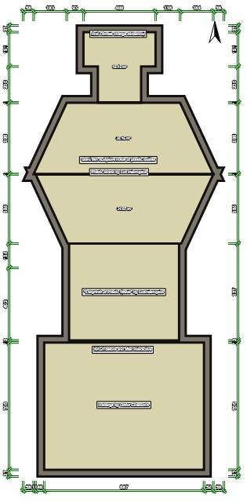
- Trump Tweet Slideshow

- “Plastic Island” & Giant Bottle Fish

- “Labyrinth of Plastic Waste”

- Interactive NASA Environmental Changes

- “Ice Watch”

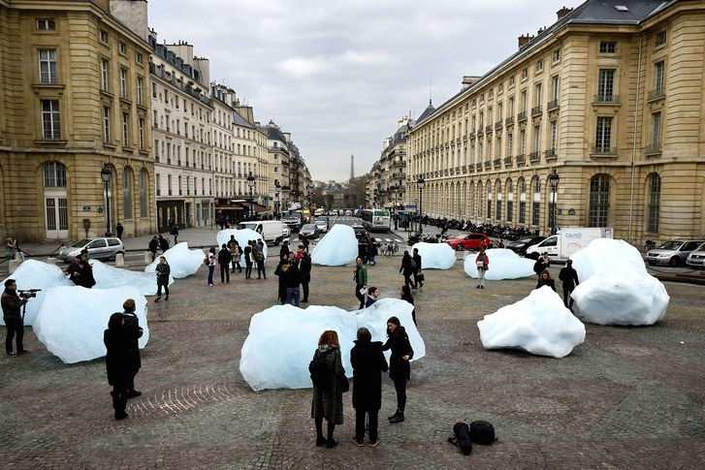
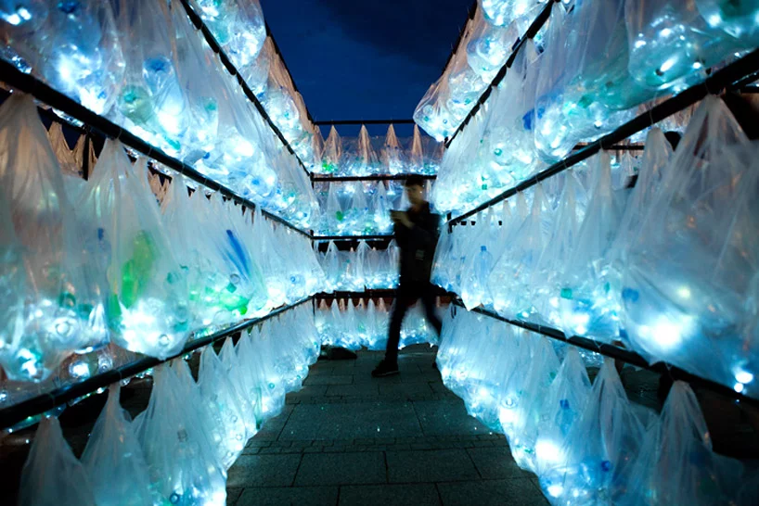
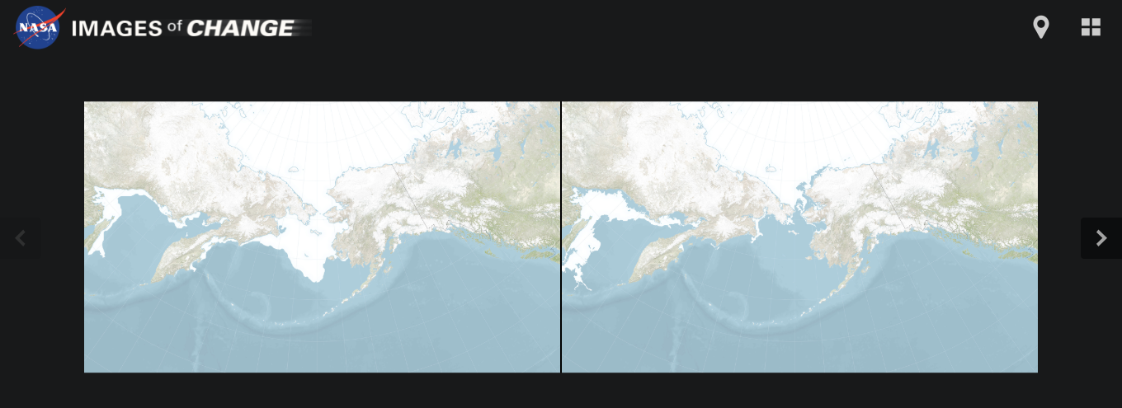

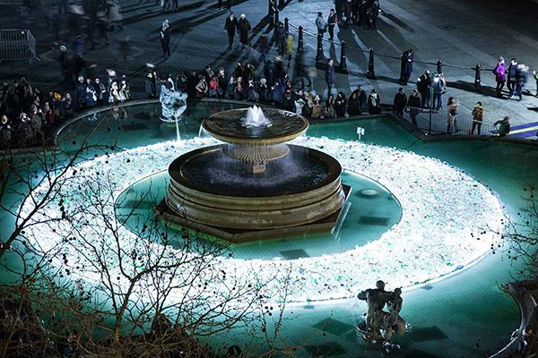
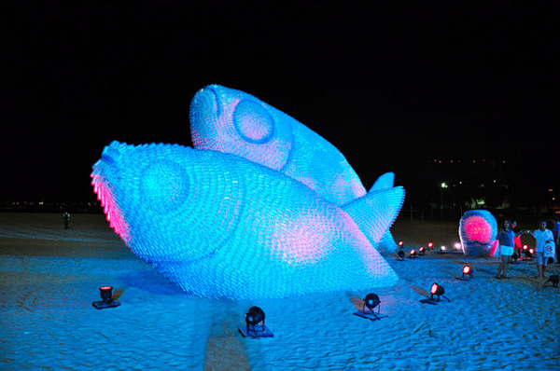

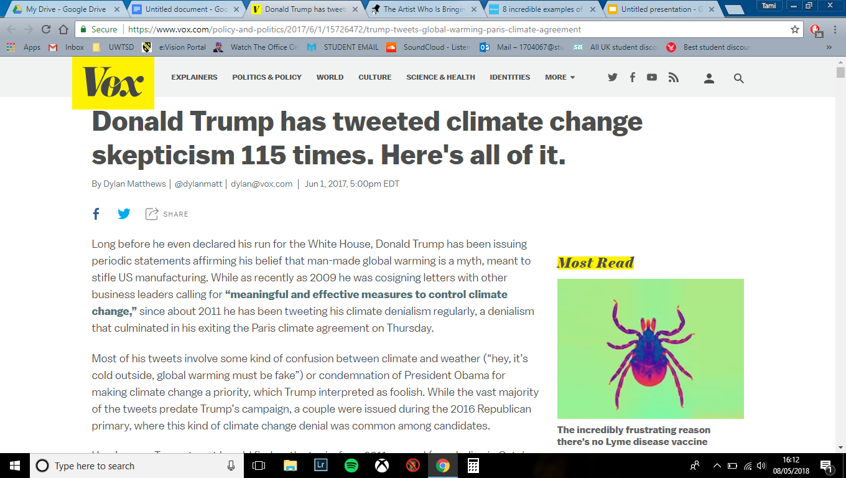

Works cited:

“8 Incredible Examples of Plastic Bottle Art and Installation.” UPCYCLIST, 23 Feb. 2018, www.upcyclist.co.uk/2018/02/plastic-bottle-art-installation/.
Brooks, Katherine. “18 Green Artists Who Are Making Climate Change A Priority.” HuffPost UK, HuffPost UK, 6 Dec. 2017, www.huffingtonpost.co.uk/entry/environmental-art_n_5585288.
“Chris Jordan - Exposing Consumeristic Culture.” Widewalls, www.widewalls.ch/environmental-artists/chris-jordan/.
“Climate Change Causes: A Blanket around the Earth.” NASA, NASA, 10 Aug. 2017, climate.nasa.gov/causes/.
“Climate Change: Images of Change: Bering Sea Ice at Record Low.” NASA, NASA, climate.nasa.gov/images-of-change?id=646#646-bering-sea-ice-at-record-low.
“Climate Change: Images of Change: Bering Sea Ice at Record Low.” NASA, NASA, climate.nasa.gov/images-of-change?id=646#646-bering-sea-ice-at-record-low.
Matthews, Dylan. “Donald Trump Has Tweeted Climate Change Skepticism 115 Times. Here's All of It.” Vox, Vox, 1 June 2017, www.vox.com/policy-and-politics/2017/6/1/15726472/trump-tweets-global-warming-paris-climate-agreement.
Nield, David. “Last Time Carbon Emissions Were This High, The Dinosaurs Went Extinct.” ScienceAlert, www.sciencealert.com/carbon-emissions-now-higher-than-they-ve-been-since-the-dinosaurs-went-extinct.
Nodjimbadem, Katie. “Does This Sculpture Depict a Coral Reef Collapsing or Recovering?” Smithsonian.com, Smithsonian Institution, 1 Jan. 2016, www.smithsonianmag.com/arts-culture/spiral-shaped-coral-reef-sculpture-is-collapsing-or-recovering-180957676/.
Zarin, Cynthia. “The Artist Who Is Bringing Icebergs to Paris.” The New Yorker, The New Yorker, 19 June 2017, www.newyorker.com/culture/culture-desk/the-artist-who-is-bringing-icebergs-to-paris.

