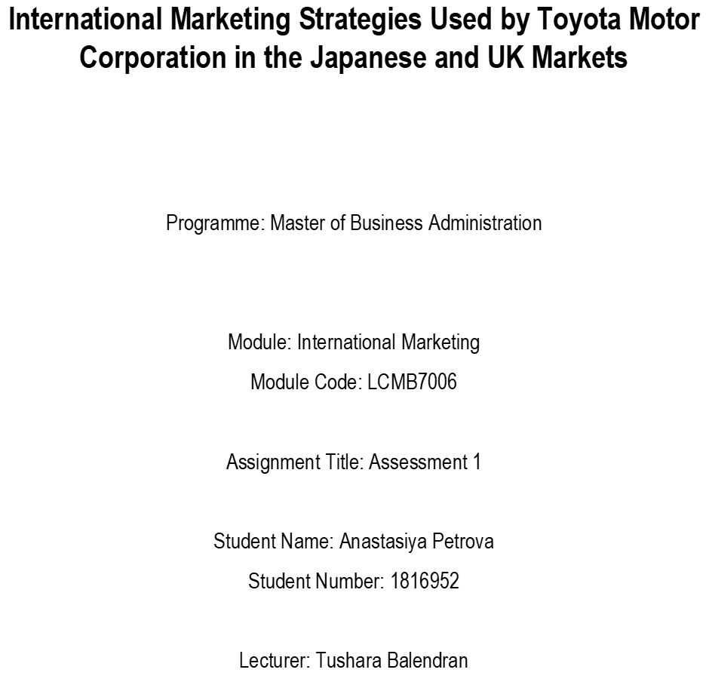

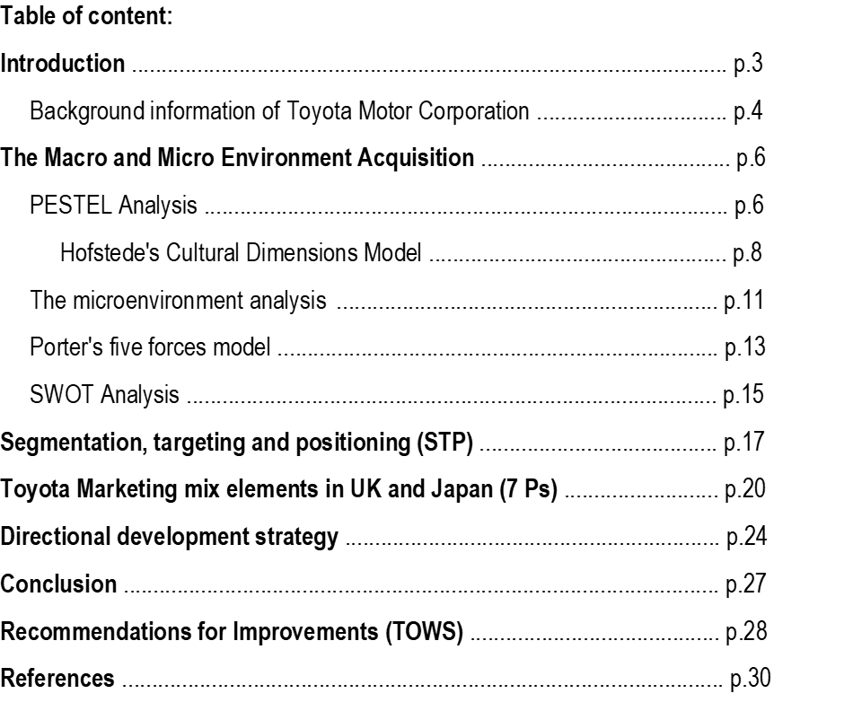

Introduction
International marketing involves selling services and goods outside local markets, away from a company's domestic audience (Czinkota, Ronkainen and Cui, 2022). Ideally, it is an international trade as a company expands its brands and territories to increase brand awareness, develop the global audience and allow company growth. Companies engaging in international marketing are exposed to various opportunities, and threats as operations in each country differ. Therefore, market research must conduct to understand the country to utilise the best strategies for better performance (Kotabe and Helsen, 2022). Toyota Motor Corporation is among the companies that engage in international marketing; however, the company's strategies differ from country to country.
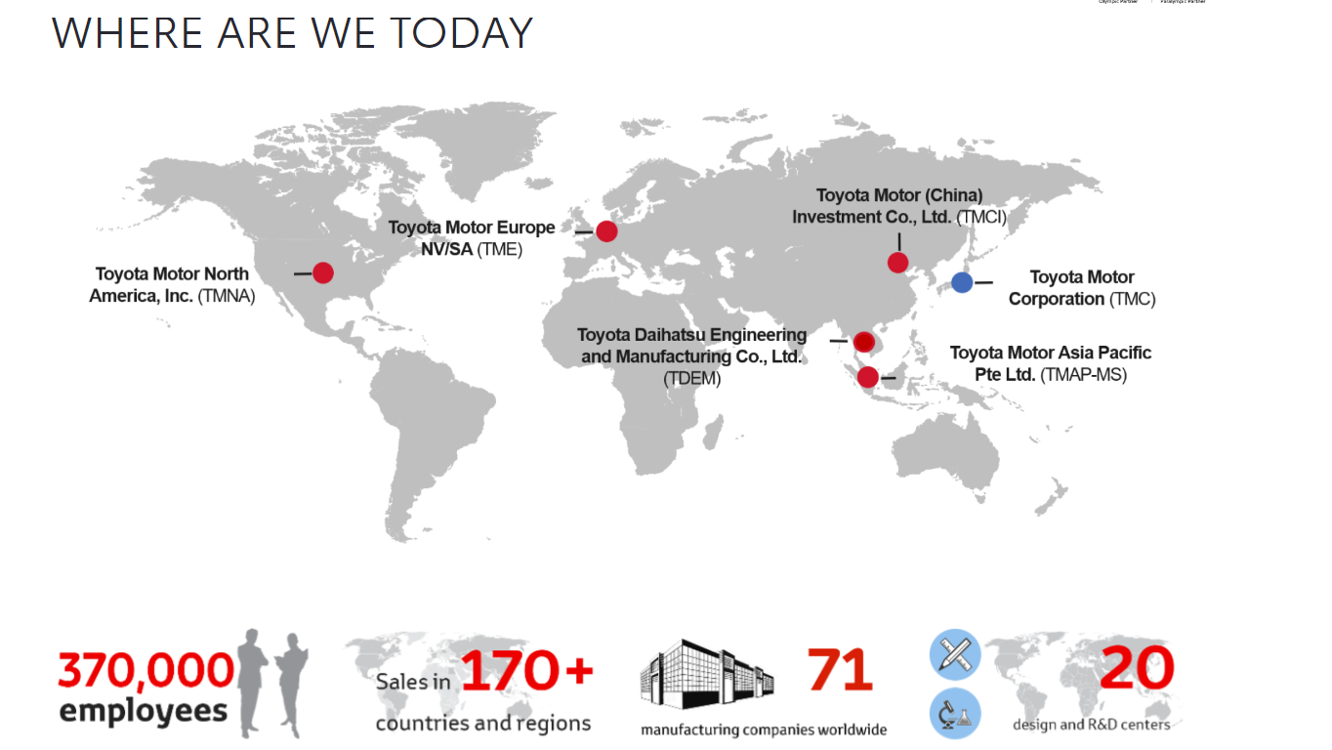
Source: Toyota-Europe (2021)
This report aims to discuss the differences experienced in the company's marketing strategies between the UK, a host country, and Japan, the home country, based on the external and internal environment analysis. The report covers the concept of macro and micro acquisition, the market entry methods, the marketing mix elements, segmentation, targeting and position, and a directional development strategy for the company. Furthermore, after reviewing the growth options, the report offers recommendations that the company can focus on to expand markets, product range, and customer base, which helps increase sales and better market performance.
Background information of Toyota Motor Corporation
Toyota Motor Corporation is a Japanese automotive manufacturer whose headquarters are based in Japan (Toyota-Europe, 2021). The company is a multinational with operations in various countries and is ranked among the most prominent manufacturers, as it manufactures over 10 million vehicles annually (Statista, 2022).
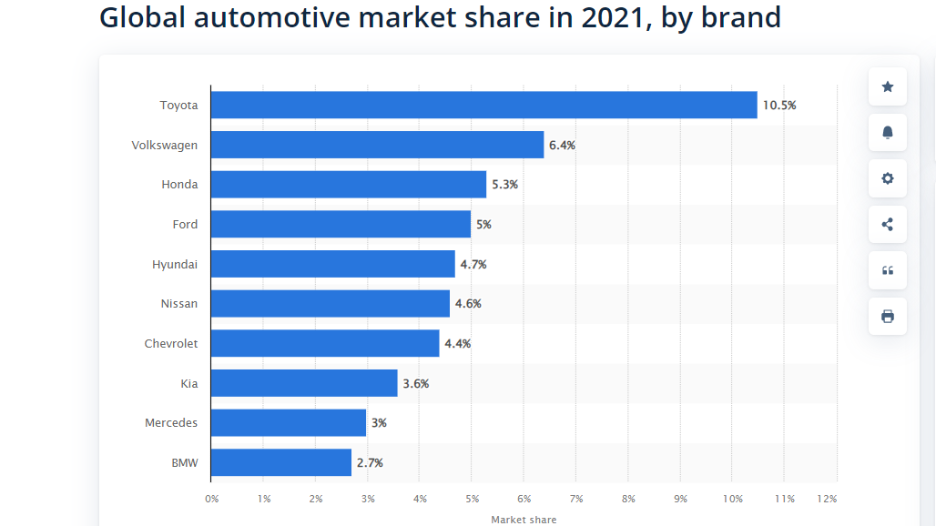
Source: Statista (2022)
The company had over 366,000 employees at the time of the report published in 2021. Toyota's success in the automotive industry is due to its culture focusing on continuous improvement and respect for people. The company also follows a culture of teamwork, respect and Kaizen. (Toyota-Europe, 2021). The company's mission is to lead the future mobility society and enrich lives with the responsible and safest ways of moving people. The company's vision is to be the most successful and respected enterprise that delights customers with a range of products and solutions using the best technology in the automobile industry (Global Toyota, 2021)

Toyota Philosophy
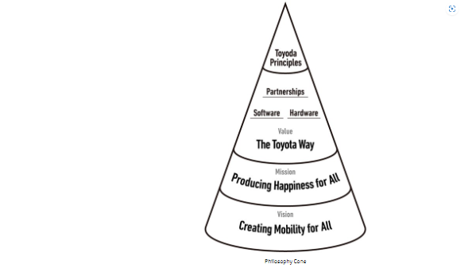
Source: Global Toyota, (2021)
The components stemming from the mission statement are improving lives with products that exceed expectations and enhancing accessibility. Toyota designs its cars according to the needs of its customers by region and preferences. Moreover, upon customer request, the company offers customised products, thus securing a good reputation and competitive advantage in the sector. Toyota strives to provide only the best according to the global standards of automobile quality, which makes them a reliable manufacturer, constantly improving the quality of products for its customers. In addition to quality, customer experience is associated with product price, which is the company's other competitive advantage.
Toyota Global Vision
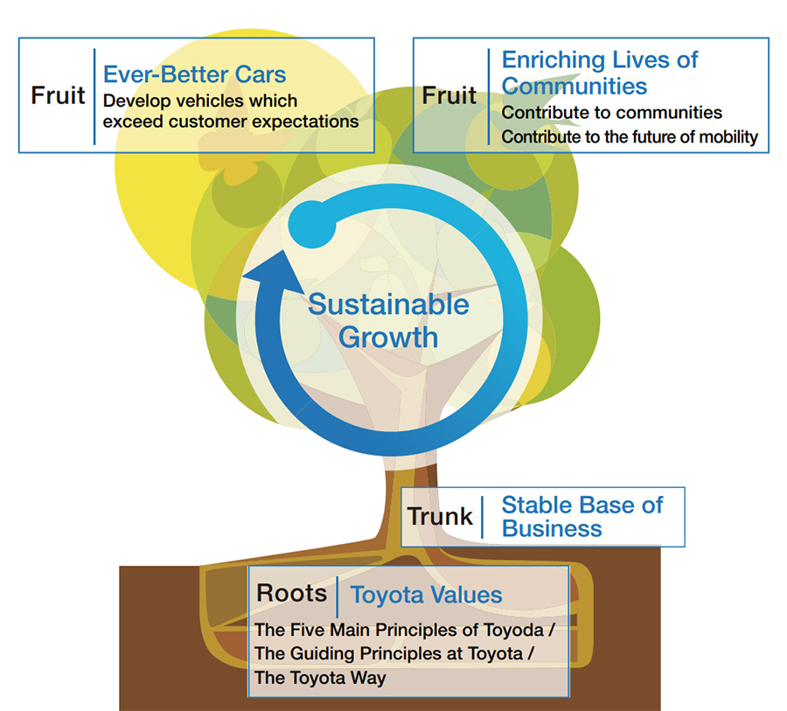
Source: Global Toyota, (2021)
The vision statement reflects the long-standing status that Toyota has adhered to since its founding. It shows how the company uses its resources and leadership position to ensure Sustainability and establish itself as a top automaker (Harrington, 2016, p.391). The elements related to this vision statement are:
Strive to be most successful by overcoming challenges in the sector;
Instilling respect through the most creatively designed vehicles, not limited to them, but even beyond them, which reveals the degree of interaction and influence on society;
Market dominance - through the avant-garde design of its cars, the company influences the car market.
Toyota's core values are "Integrity, Customer Satisfaction, Quality and Safety" (Global Toyota, 2021). These values describe the essential elements the company ensures its smooth functioning and success in achieving goals and objectives.
Goals for Sustainability at Toyota
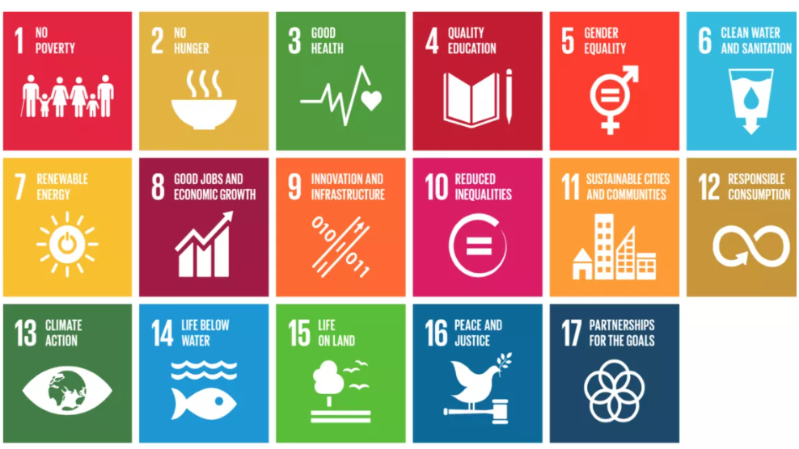
Source: Toyota-Europe (2022)
The Macro and Microenvironment Acquisition
PESTEL Analysis
PESTEL analysis is a model that helps analyse the factors that externally affect the environment, yet the companies have no control over them. However, the analysis does not cover all the factors affecting a company as its aspects are restricted to the external environment and do not consider any internal factors. Analysing individual factors helps organisations make better business decisions when building and implementing their marketing strategies (Sousa, Castañeda-Ayarza, 2022). Below is an analysis to discuss the similarities and differences between UK and Japan, where Toyota operates.
Political factors: Brexit hurts the company's operations in the UK because they are limited in imports and exports after leaving the EU. Another aspect that challenges the company is the raw materials used in production (Hong and Park, 2020). In the UK, where Toyota operates, the political environment is stable, and the government supports eco-friendly vehicles with tax relief for these cars.
In Japan, the company is negatively affected as it has volatile relations with Russia, North Korea and China because it is associated with ASEAN and the G8. The disputes are regarding resources, which is challenging for the company to run smoothly. Politically, the country is stable (BBC, 2020).
Political stability in both countries favours the company as it can conduct its operations without political challenges.
Economic factors: The UK is also ranked among the world's largest economies, meaning it has a larger GDP, which benefits Toyota's operations. When the economy is stable, demand for products and services increases, which helps the company. However, the pandemic has led to inflation in the UK, reducing sales levels.
Toyota car sales in the United Kingdom (UK) from July 2014 to December 2019
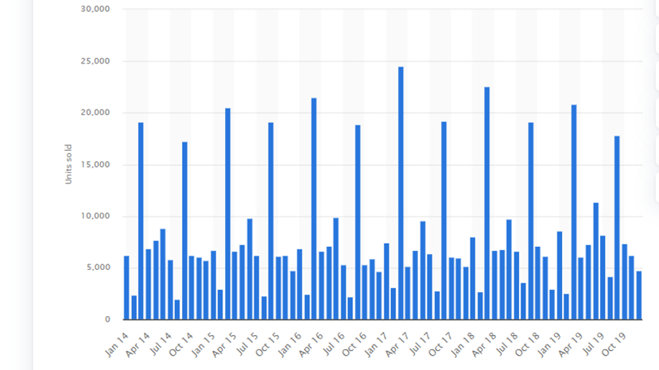
Source: Statista (2020)
Japan is among the largest economies in the world (Tan et al., 2018). This aspect benefits the Toyota company as it can utilise economies of scale in its production process, facilitating its success. However, due to the pandemic, the Yen is weaker, suggesting that business is negatively affected and unfavourable for Toyota.
The figure below - reflects the adverse impact of the economic factor, mainly due to the pandemic in both countries, resulting in a decline in the company's sales.
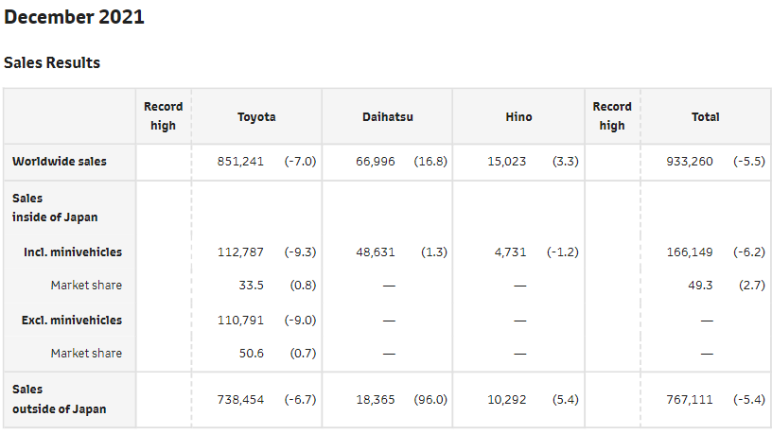
Source: Global Toyota (2022)
Social factors:
Japan has over 125 million people (Worldometer, 2022). The increased population benefits Toyota as a larger population means more customers seek the company's services. Therefore, the company is happy to make more sales in Japan. Similarly, the UK's larger population will be more than 74 million by 2039. Consumers of various goods and services are increasing, which benefits Toyota as there is more demand. However, in both countries, Toyota is accused of producing defective cars with defective safety issues, which is unfavourable for the company because it ruins its reputation (Toyota Motor Corporation, 2022).
Hofstede's Cultural Dimensions Model
According to Hofstede, as argued by Simon and Varghese (2018), national culture influences organisational culture. Hofstede's model identifies six cultural dimensions that affect corporate culture and behaviour. International companies are not geographically limited, and therefore, they operate and work with people from different cultures. Hofstede's cultural dimensions model helps deal with interactions between cultures (Minkov and Kaasa, 2020), and the advantage it provides is the understanding of differences in cultural and civilisational aspects. However, its disadvantage is that it is outdated because the dimensions do not provide enough knowledge about different social cultures and subcultures. Below is an analysis of the Japanese and British cultures where Toyota operates through this model.
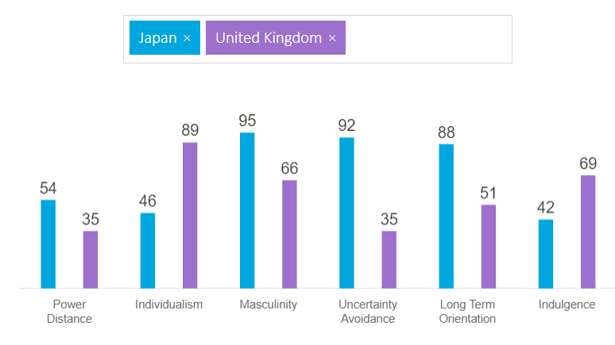
Source: Hofstede Insights (2022)
Power distance: this refers to the perceived power inequality in a country. In Japan, the power distance is 54, while in the UK, the distance is 35. It depicts that Japan has a high-power index; thus, in Toyota company, some stakeholders have a more formal authority than others.
Individualism Vs collectivism: A collectivist culture expects strong collaboration among the teams, that is, working in teams and groups, while individualistic cultures expect and allow people to work independently to attain success (HofstedeInsights, 2022a). The UK has a high level of individualism at 89, whereas Japan has a lower level at 46. These imply that Toyota Japan allows people to work more in teams, unlike the UK, which will enable people to work as individuals.
Masculinity Vs Femininity: Feminine cultures advocate for equality and cooperation among the people. On the flip side, masculinity encourages cultures whereby there is a meritocracy and performance-based pay. Masculinity in Japan stands at 95, while in the UK, it is 66 (HofstedeInsights, 2022b). It means that the UK advocates more equality. Thus, employees are treated fairly and equally at Toyota company, unlike in Japan, where employees are treated based on their performance.
Uncertainty avoidance: It refers to how a culture focuses on managing risks. Employees can have a higher degree of freedom and creativity when there is a low uncertainty avoidance level. According to HofstedeInsights (2022b), Japan has a rate of 92 while the UK has a rate of 35, which means that Toyota gives its employees more freedom in the UK. Unlike in Japan, the company's employees are guided by strict employee codes, and minimal deviation from company laws is expected.
Long-term orientation: Cultures with a long-term orientation focus on making creative decisions and engaging in innovations to attain long-term results. On the other hand, those in the short term are conservative and avoid making such decisions as their aims are only short-term (HofstedeInsights, 2022a). Japan has a long-term orientation rate of 88 while the UK has a rate of 51, meaning that Toyota in Japan engages more in strategies which can promote long-term benefits, unlike in the UK.
Indulgence Vs Restraint: Indulgence is the degree to which a society focuses on satisfying human needs. Companies with an indulgent culture provide more amenities to ensure employees are satisfied, improving productivity. Japan has a lower rate of 42, implying that its culture is restrained, while the UK has an indulgence of 69 (HofstedeInsights, 2022b). As such, Toyota UK offers more benefits to employees and ensures that their needs are taken care of, unlike Toyota's operations in Japan. It is evident from this analysis that Japan and the United Kingdom have different cultures and organisational environments.
The differences in the national cultures of the two countries invariably reflect on the business culture. A smooth running of the business requires prior research to find similarities and a clear understanding of differences. Hofstede's model helps to overcome cultural barriers or to break them so that it becomes possible to build a normal business environment.
Technology factors: The UK has the leading research and development institutes, which facilitate the use of technology in the country. On the other hand, Japan has advanced telecommunication systems, making operations more straightforward. These aspects make it easier for the company to manufacture and sell its products (Morgan and Liker, 2020), and the factor is favourable. For example, the company is set to produce innovative hybrid cars in Japan. However, in Japan and the UK, the company incurs more costs to keep up with technological trends, reducing its profitability but increasing its competitiveness and image.
Legal factors:
Japan is guided by the laws set by the European Union. On the other hand, the UK is driven by its rules because it exited the European Union. Even so, both countries are guided by laws which help the company operate legally. Some of these laws include minimum wage rates, copyrights, and employment acts, which make the operations favourable. However, non-compliance with the laws affects the company as it is exposed to penalties (Chen, Lawell and Wang, 2020). For instance, Toyota Japan was accused of having faulty mechanisms in the cars, leading to the company spending 1.2 billion dollars to settle the case (Muller J.,2014).
Environmental factors:
Globally, companies are becoming more committed to sustainable practices as customers are now aware of the importance of maintaining the environment. Like other companies, Toyota is making efforts to commit to Sustainability in both Japan and the UK. In the UK, Toyota has announced an environmental challenge it aims to meet by 2050, which includes zero CO2 emissions, optimised water use, recycling and creating a society in harmony with nature (Toyota UK, 2022). In Japan, the company is committed to adopting a green policy that minimises pollution, recycles waste, and uses resources efficiently (Toyota Corporation, 2022). Ideally, Japan and the UK have similar initiatives to sustain the environment through various environmental challenges, which benefits the company as it builds its reputation.
The PESTLE analysis presents similarities in the barriers arising from the political and economic factors that the company should consider when building its strategies for more predictability and flexibility. In addition, similarities in legal and technological aspects and environmental factors provide freedom and opportunities that businesses can take advantage of to ensure their growth, profitability and competitiveness. To maximise its profitability, Toyota prefers regions with rapid economic growth. The company's sales are not as affected by the social and cultural differences between the two countries as, for example, the food service business. Increasing public awareness of environmental issues has prompted Toyota to focus on producing and improving its environmentally friendly green and hybrid vehicles.
The micro-environmental analysis
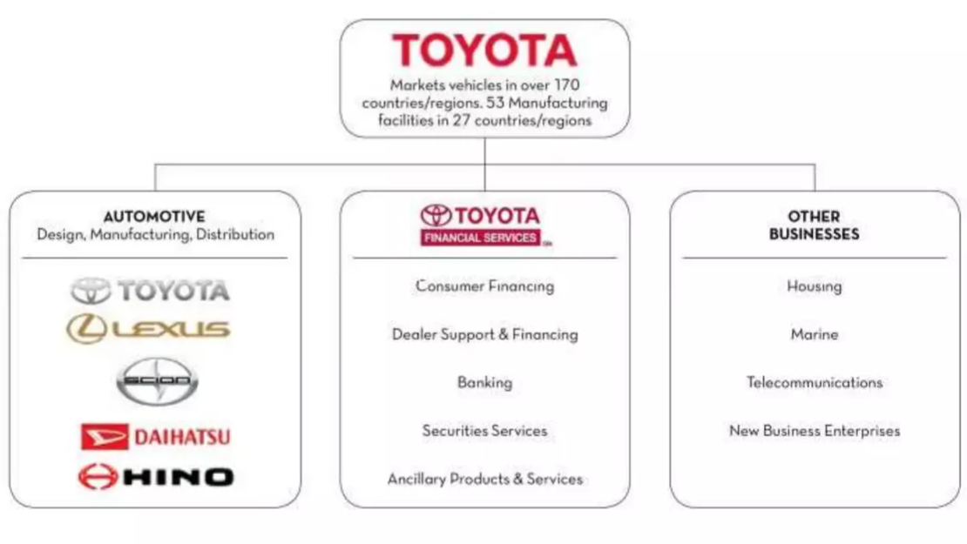
Source: Kumari P (2017)
The microenvironment focuses on the factors affecting the company from its internal environment (Hamilton and Webster, 2018). The analysis concerns the suppliers, the customers, the distributors, competitors and the public.
Suppliers: Toyota has a good relationship with the suppliers to ensure that what is supplied is quality as it impacts production. The companies have suppliers around the globe who provide the raw materials. The company has two plants in the UK with about 800 suppliers who supply both plants (Toyota UK, 2022). In Japan, the company's headquarters, over 500 suppliers are working within Europe, and the company has established an effective network with them through its supply chain management systems.
Customers: They directly affect the company as their needs dictate what it can produce. Toyota researchers focus on understanding and finding out the customers' needs (Ondeng, 2022). For instance, the researchers confirmed that in Japan and UK, the customers want cars with less fuel consumption and the company focused on producing such. Also, the customers give feedback from the company's website concerning the services, which helps the company know how to improve to meet the expectations and needs.
Distributors: Toyota mainly relies on dealers to distribute its products in Japan and UK, among other countries around the globe. In Japan, the company has about 5000 dealers who promote the products (Toyota Motor Corporation, 2022). There are approximately 150 dealers in the UK (Toyota UK, 2022). The company has established long-term contracts with the dealers to ensure constant dealership and selling of the cars, among other related products and services.
Competitors: These are companies which pose a rivalry threat to the company. The company monitors its competitors to understand what they are doing so that it sets better strategies which can help it attain a competitive advantage within the markets. In the UK, Toyota's competitors are Ford motors and Volkswagen, while in Japan, the company's competitors are Suzuki, Mazda, and Honda (Toyota Motor Corporation, 2022). Through competitor monitoring, Toyota finds opportunities that it executes before the competitors. For example, the idea of hybrid cars.
Public: Toyota focuses on maintaining a good public image to uphold its reputation (Global Toyota, 2021). The company has a good relationship with the media in both countries, which helps build and maintain a good reputation.

Porter's five forces model
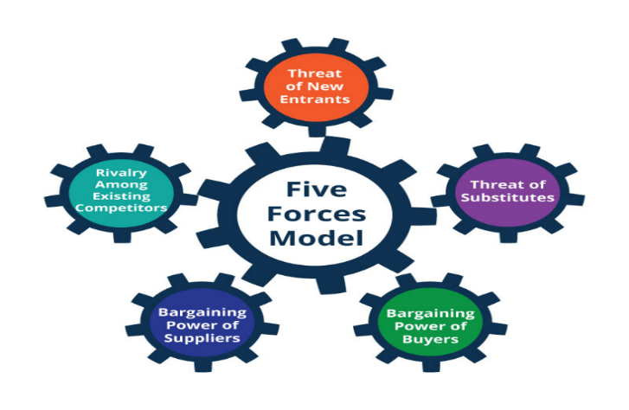
Source: Platinium Pro (2021)
Bruijl D and Gerard HT (2018) state that Professor Michael Porter created the five forces framework and published it in 1979. The same authors argue that the framework uses an outside-in perspective to identify certain powers according to a specific business situation. The five forces framework analyses five forces influencing the microenvironment of the organisation's industry. The market structure in which the organisation operates affects the strategic behaviour of other market participants. For example, a company's market success strongly depends on its competitive strategy. The framework helps the organisation understand which actors in the relevant industry have the most power and set the rules. In addition, the company gets an insight into the dynamics of the industry as whole and potential future changes.
Porter's five forces framework covers the threat of potential new entrants, the threat of substitutes, rivalry intensity, the bargaining power of buyers, bargaining power of suppliers, with an explanation as follows:
The threat of new entrants – Low
In Japan, the threat of new entrants is low because the company already has an established position. Therefore, more resources are needed to enter and develop the market. Similarly, strength is weak in the UK. It is because for any company to match with Toyota, it has to use more resources and capital, which is impossible to achieve. At the same time, the competition is intense and dominant among the established players (Dobbs M, 2016). Toyota's competitive advantage is its substantial presence in different segments, brand recognition, and extensive company size.
The threat of substitutes – Medium
The threat of substitutes is moderate in both Japan and the UK, and this is because there are substitute products that customers can use. For example, customers may choose to use the used car market. As mentioned above, Toyota can cut costs more effectively than its competitors. With this advantage, Toyota reduces the price difference between its cars and those of used cars. Therefore, the company's threat from the used car market is minor (Ondeng, 2022).
Rivalry Intensity - High
Rivalry in the UK and Japan is high (Toyota Motor Corporation, 2022). Strong competitors such as Audi, Mercedes and BMW operate in the automotive industry and offer the same products as Toyota. In addition, competitors offer cars with high safety standards, for example, Renault. Toyota's positioning as a company offering the safest cars is in threat. Therefore, the pressure of rivalry is stronger, and despite a good cost reduction strategy, this does not provide serenity to the company.
Bargaining power of buyers - Medium
In the United Kingdom and Japan, the number of customers is high, and the number of cars produced by the company is also high. Because of this, customers may switch from Toyota to other companies producing the same products. In response, the company offers innovative, environmentally friendly and safety-enhanced products. In 2021, Toyota reported passenger car sales of 82,748 units, a 13.8% increase compared to 2020 during the pandemic (Toyota UK, 2021). In addition, rising fuel prices are driving customer demand for more fuel-efficient cars, such as Toyota's offering. However, switching costs are lower, and buyers have more bargaining power.
Supplier Power – Low
Toyota has a strong relationship with suppliers, one of its competitive advantages. Effective monitoring of the supply chain helps the company reduce suppliers' power. After the company partnered with the Chinese company Geely and entered the Chinese market (Shirouzu N. and Sun Y., 2018), Toyota had the opportunity to cooperate with Chinese suppliers, who will most likely offer lower prices than European ones. Therefore, Toyota is in the advantageous position of setting the circumstances, not its suppliers.
Analysis of the five forces framework presents similarities in the strategies used by Toyota in the two countries. The company uses the same process to enter both the home country and the host country: export - joint venture - greenfield investment. The company relies on its competitive strategies, focusing on low product cost, security and customer needs, but without underestimating its competitors. There is a difference in the supply chain, where Japan has a significant expansion advantage due to its contacts and operational presence in the Chinese market.
Advantages and Disadvantages of the Model
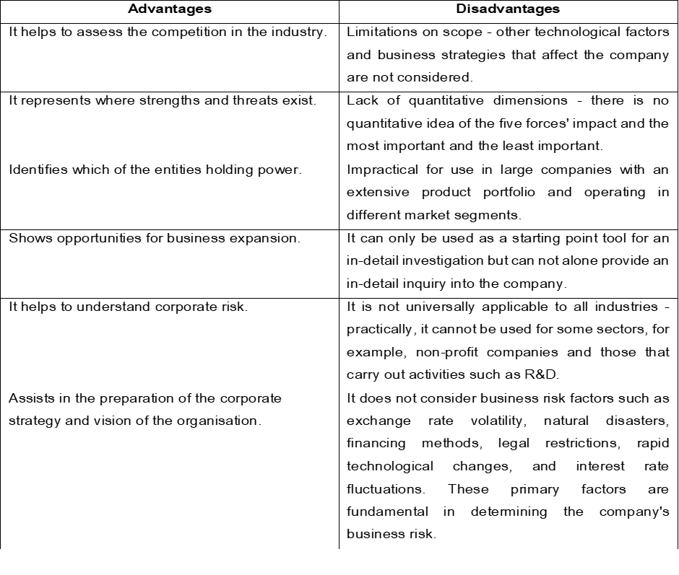
Source: Kotabe, M.M. and Helsen, K. (2022)
SWOT analysis
A SWOT analysis is a model that helps analyse a company's strengths and weaknesses, opportunities and threats. Furthermore, the model is divided into two categories: internal factors, with the scope of strength and weakness, and external factors, with the scope of opportunity and threats (Benzaghta et al., 2021). An advantage of the model is that it analyses the company's current state and helps plan its correct strategies. However, the tool has the disadvantage of objectivity. Below is an analysis of Toyota Corporation in Japan and the UK.
Source: Global Toyota (2022), Nkomo T (2019), Toyota Corporation. (2022)
Based on the opportunities presented for the company, Toyota can diversify into other regions in the UK. Currently, the company has only two plants and can consider having more to increase its products. Within Japan, the company can consider utilising its research and development to ensure it obtains creative ideas on how to be innovative to manufacture cars which meet and exceed customer satisfaction. It helps increase demand and sales for the company in both countries. Concerning the company's weaknesses, competition in both countries can be countered through quality. Henry (2021) explains that the company will attract more customers, even from its rivals, by producing quality products and offering better customer services.
As a leader in production, sales and research in the automotive industry, the company aims to transition from traditional fossil fuels to clean energy. The company's 'The Toyota Way' operating philosophy is its greatest strength; therefore, the promise of a cleaner future is also its most incredible opportunity. However, a revision of the rigid organisational hierarchy is needed, which will allow the organisation to adapt quickly to new challenges. The rise of Tesla is one of the biggest threats facing the company. Rapid technology deployment, enhancements, and application expansion can help Toyota overcome these weaknesses and threats.
Regarding the rising fuel prices in the UK, the company can consider advising its clients on the best ways they can save on fuel to enable them to use the cars even with the high prices, as it is a factor affecting the entire country. In Japan, the company will consider increasing awareness creation about the company to attract more customers even if the Yen is weak. It will help attract more customers to the company.
Segmentation, targeting and positioning Strategies
According to Schlegelmilch (2022), STP is a strategic approach in which a company divides the market into segments, targets the best-fit audience for the products and services and positions its products to appeal to the targeted segments. Hanlon (2022) claims that based on the output results of STP, the marketing mix and strategies for positioning the offered products according to the segment are developed. STP allows companies to check that every opportunity to reach, interact and engage customers is being used.
STP marketing model
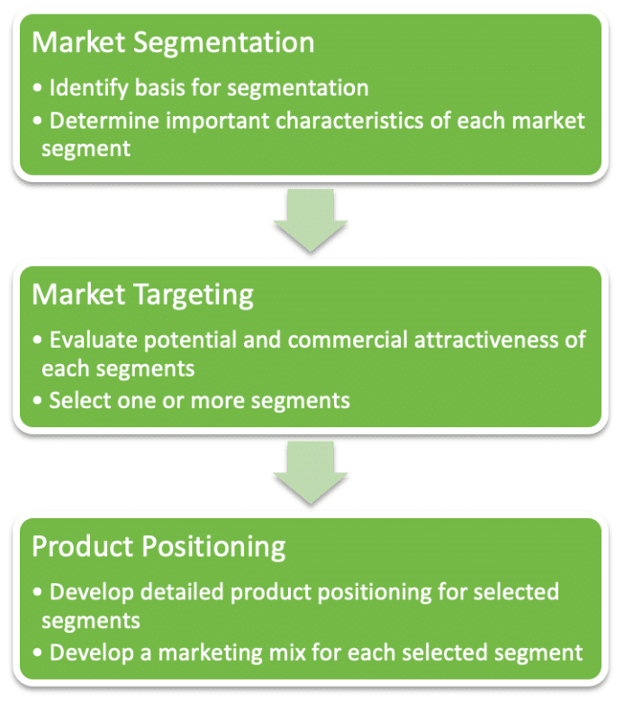
Source: Hanlon A, (2022)
STP benefits companies by identifying the most valuable types of customers and being able to develop products and services that suit them. It also allows the company to engage target groups to understand their needs and preferences. However, the model increases costs as the company has to undertake more to understand its specific market and customers (Schlegelmilch, 2022).
Segmentation: In market segmentation, various characteristics are categorised into four dimensions, including demographic, geographic, psychographic and behavioural, as shown in the image below.
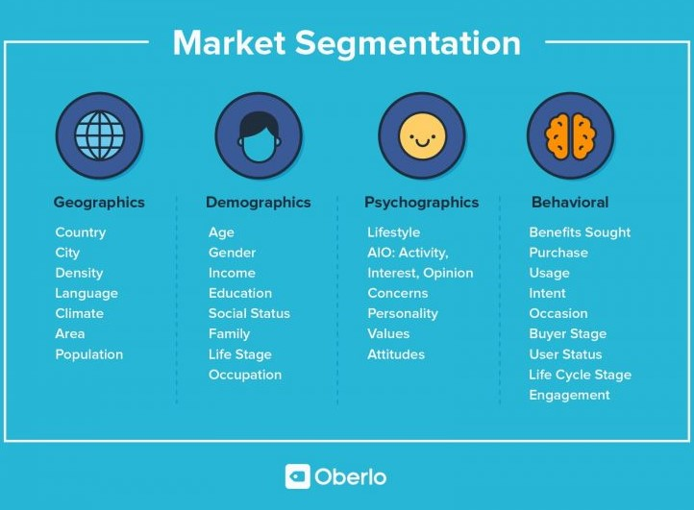
Source: EBCG (2021)
Regarding geography, the company is represented and operates on five continents where it offers its products. In both countries, the segmentation is aimed at people with low incomes (Aygo, Yaris and Auris), middle incomes (​​Parodo and C-HR) and high incomes (sports models such as GT86 and Altus). The target market in Japan is mainly aimed at the upper class, while in the UK, it is aimed at both middle and upper-class people. Regarding behaviour, Toyota UK targets people keen on environmentally friendly and more fuel-efficient cars, while in Japan, the company focuses mainly on young people. In both countries, the company segments its market to target those who understand the importance of Sustainability and thus buy from sustainable companies (Toyota Motor Corporation, 2022).
Targeting: This involves evaluating the market segment's attractiveness to select the best segment for the company to focus on. Companies use different targeting strategies to attract customers; some are differentiated, undifferentiated, and concentrated (Camilleri, 2016). Toyota uses a differentiated strategy in the UK and Japan to attract customers. With a differentiated approach in the UK, the company focuses on middle-income earners and those between the ages of 30 and 50 looking for quality, durable, reliable, sustainable and innovative vehicles. In Japan, Toyota target the pioneers, high-class high-income earners. For example, the company introduced the Scion to help target young people.
Positioning: Positioning helps companies reach customers by strategically placing themselves where they provide easy access to products and services. The main objective is to increase brand awareness, expand market shares, and increase customer retention and sales (Camilleri, 2018). Recognising the profile of the target groups and using the resources provided by the company, dealers position their centres so that the demographics and psychographics of the company meet. All this contributes to stimulating sales. The factors that support the positioning process are the differentiating components of the product, the channels and the company's image. The organisational's approach is based on the strategies strengthening the Four C's - customer, convenience, communication, and cost. In this regard, differentiators show differences based on how they treat consumers—Toyota positioning itself in online and offline platforms. The company has physical stores in Japan and the UK, where people visit showrooms to purchase or use its services. According to Statista Research Department (2020), there are 177 car dealerships in the Toyota franchise network in the UK.
Toyota Market Share
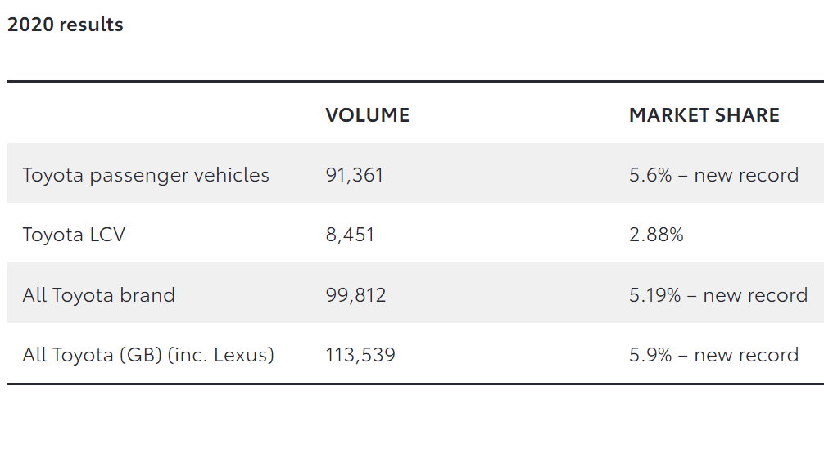
Source: Toyota UK (2021)
The company has websites in each country that allow interaction between the company and customers. Additionally, Toyota strategically markets itself by participating in shows that promote the brand. For example, in the United Kingdom, the company sponsors the Olympics. Another way the company builds the brand and positions itself in the market is by regularly placing the message in the path of consumers through media channels such as television, newspapers, magazines, advertisements, and billboards. This tactic is used in both Japan and the UK.
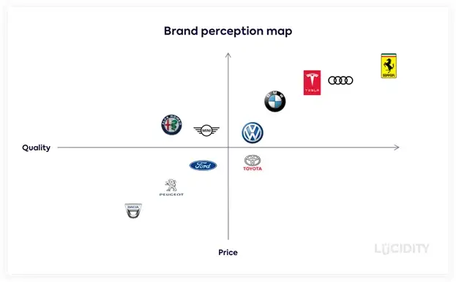
Source: Lucidity
In 2021, ENEOS Corporation and Toyota Motor Corporation agreed to explore the production and use of CO2-free hydrogen jointly. Also included in the agreement is the construction and operation of a CO2-free hydrogen refuelling station for Woven City and fuel cell electric vehicles (FCEVs) manufactured by Toyota. The deadline for the project is 2025 (Global Toyota, 2022). A repositioning strategy will strengthen competitiveness, market positioning, customer interest and brand image.
Toyota adapts its products and operations to the needs of consumers in each country. This strategy helps the company to perform well in the international market. In addition, the strategy increases employees' creativity because they have to find new marketing models and supply chains and develop new technologies. At first glance, there are similarities between the two countries in terms of targeting, where Toyota uses a differentiated strategy. Moreover, the company uses the same strategy in positioning. The differences between the two countries are in terms of targeting, where the company focuses on middle-income class earners in the UK, while in Japan, the focus is on high-class income earners.
Toyota Marketing mix elements in UK and Japan (7 Ps)
According to The Economic Times (2022), the marketing mix is ​​a set of actions and strategies that allow the company to promote its brand and products in the market. The marketing mix includes seven elements (7 P's) significant for a company to offer its services and products to customers. These elements are products, price, promotion, place, physical evidence, process and people (Thabit and Raewf, 2018). These elements differ from country to country as companies use strategies that meet the needs of people in different regions. Toyota uses different marketing mix strategies in the UK and Japan as follows:
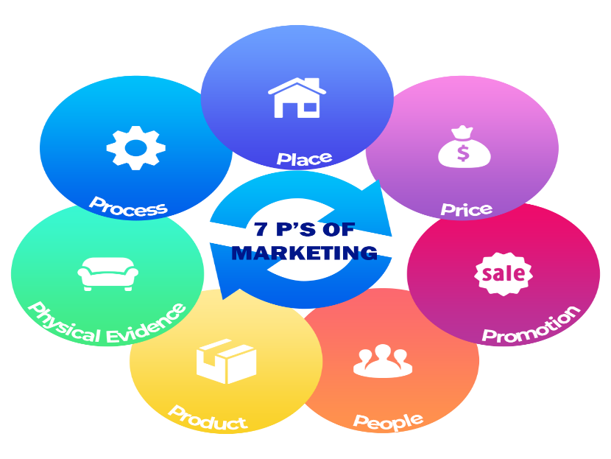
Source: Professional Academy, (2022)
Product: Toyota provides its customers with tangible (cars) and intangible products (warranties, insurance). The high quality of the vehicles that the company sells in the market makes them so desirable. The nineteen available car models are further broken down into different categories, such as Passenger, which includes small, medium and large vehicles (Aurion, Yaris, Camry, Tarago, Corolla and Rukus); SUV and 4WD (Kluger, Rav4, Parado and Landcruiser 200); Hybrid (Prius and Camry); Commercial (HiAce, Coaster, Landcruiser 70 and HiLux). Toyota uses the "pull" strategy, making cars meet customer requirements. (Toyota Corporation, 2022).
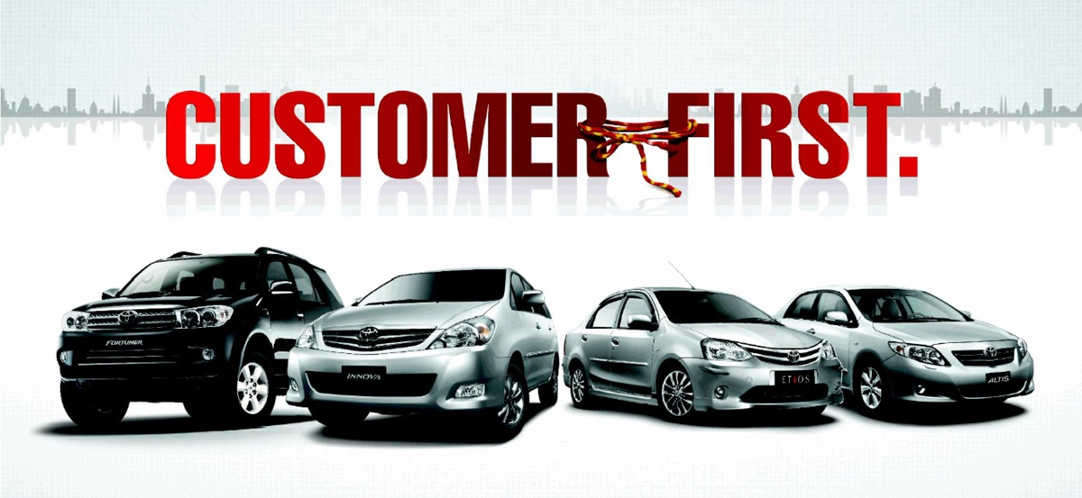
Source: Avada, (2022)
In addition, the company also offers vehicle parts. In terms of intangible products, financial services, guarantees, roadside assistance, car services and insurance are offered. For example, extended warranties offer different mileage coverage options (36,000 to 100,000 miles). Toyota's main priority is customer interest, which is at the top of the list. Therefore, the focus of Toyota's research centre is on gathering data on consumer expectations. The company created the Hybrid product line in response to rising fuel prices.
Price: Each product's price depends on its size, design, and quality, among other features. Companies use pricing strategies such as penetration, cost, and value-based marketing to price their services and products. In the UK, Toyota uses a market-oriented pricing strategy, allowing the company to set prices based on market conditions, including competition. In Japan, Toyota uses value-based pricing (Toyota Corporation, 2022).
Furthermore, it will enable the company to price the products based on their design and size. For example, the strategy allows the pricing of high-end cars such as Lexus and Scion. To ensure its competitive advantage in the market, Toyota uses low prices and differentiation based on quality, technology and design in both analysed countries.
Place: Market entry modes are how a business enters a new market. Various factors influence companies' market entry methods. External factors influencing entry modes are country risks, trade barriers, and socio-cultural distance between home and host countries (Kotabe and Helsen, 2022). For example, Toyota Corporation entered the British market because of fewer trade barriers. At the time of entry, the host country is part of the European Union, which facilitates access.
On the other hand, internal factors that influence entry modes include firm size, countries of production and consumption. Mainly the size of the organisation determines the entry. For example, a large company may use direct investment to have more control, while a smaller company may use methods such as exporting or franchising. Toyota improves and updates its production capabilities and efficiency through regular investments totalling around £2.75 billion in its UK plants - the vehicle plant in Burnaston and the engine plant in Deeside Industrial Park. It guarantees the competitiveness of the factories. Toyota and Lexus' strong marketing, sales, after-sales service and customer relations have consolidated the UK's position as one of Toyota's strongest European markets. In 2020, the company rose to 15th in the Sunday Times 100 Best Companies to Work for the survey (Toyota UK 2021).
Export: The method is considered traditional and applied to reach foreign markets (Mariadoss, 2022). It does not require investment in a foreign country. In addition, expenses incurred in exporting are considered marketing expenses. Exporting has the advantage that it involves low entry risks and is also fast. The lower control can be noted as a disadvantage of this method. Toyota exports its cars to various countries around the world. Some countries that receive Toyota's exported cars include the Philippines, Thailand, and Africa.
Franchising: With this method, a company (franchiser) grants another franchisee the right to use its brand name to sell services and products (Mariadoss, 2022). The franchisee is responsible for overseeing all the operations; however, it has to operate as per the franchiser's business model —Toyota franchises through dealerships. In the UK, the company has over 150 dealers, as aforementioned. This method is advantageous as it involves lower costs and risks. However, it has the disadvantage of the franchisee expanding and becoming a competitor. Companies see globalisation as a means to explore new markets and increase brand positioning (Gillespie and Swan, 2021). For example, Toyota is entering the UK market to expand its domestic and European customer base. Other benefits of globalisation include access to newer markets, access to new talent, economic growth promotion, labour and resources exploitation, and increased global cooperation. The disadvantage of globalisation is increasing competition.
Toyota company uses both online and offline channels in Japan and the UK, similar to the two countries. The company has websites where customers can obtain all the information and place orders for a product of their choice. Equally, the company distributes offline. It uses both direct and indirect strategies in offering its products. Directly, the company engages with its customers to make transactions. Indirectly, the company has obtained dealers who help distribute its products and services (Toyota Motor Corporation, 2022).
Promotion: These are the different methods a company uses to create awareness about a company's products and services (Harsono R, 2016). Various methods, such as direct sales, advertising, public relations, sponsorship, digital marketing and billboards, are used to promote company services and products (Ferrell et al., 2021). In the UK, Toyota primarily uses television and magazine advertisements and sponsorships to promote its products. On the other hand, Toyota uses a word-of-mouth strategy to advertise in Japan, which is different from the UK. This method is primarily used to persuade customers to make purchases (Winardy et al., 2021). Along with personal sales in Japan, Toyota also uses advertisements and sponsorships to promote its cars.
To attract customers' attention, the company resorted to using catchy slogans, for example, 'Moving Forward' and 'Let's Go Places'. In addition to this, the company offers some promotional schemes such as advance payment discounts for example. Toyota reaches more customers by promoting shows; for instance, on the show "The Block", they offer a chance for someone to win a car and promote a Yaris model.
People: These employees use their skills and expertise to offer services and facilitate production activities. Employees differ in a company's production plant regarding numbers and how they are encouraged. For instance, in the UK, Toyota has 3800 employees, whereas the company has 366283 employees in Japan (Toyota Motor Corporation, 2022). These employees use their skills and experience to offer services and facilitate production activities. Employees vary across a company's manufacturing plant in terms of number and how they are promoted. For example, Toyota has 3,800 employees in the UK, while the company has 366,283 employees in Japan. The similarity between the two sides in terms of personnel is that there are skills in sales, product information, data collection, order taking and financial insurance (Toyota Motor Corporation, 2022).
Physical evidence refers to a company's aspects that distinguish it from other companies. In different regions, the physical evidence of companies also differs, and a company may have more premises in one area and fewer in another. Toyota has two manufacturing plants in the UK (Toyota UK, 2022), while Japan has sixteen plants. In each country, the company also has a website that helps to determine the operations in the selected region.
Process: It includes the activities that take place from production to the provision of the services (Išoraitė, 2016). Methods vary based on the number of employees, available resources, and employee experience, among other factors. Toyota focuses on making its processes efficient to deliver better and more timely services. In both the UK and Japan, the company uses various systems such as supply chain management and customer relationship management to ensure service effectiveness and efficiency, which is another similarity between the two countries (Ondeng, 2022)
Directional development strategy
According to Grant (2021), directional development strategy refers to the strategic direction and options that a company can follow to develop further. After analysing the current environment, the company needs to assess the available opportunities and the direction in which it can develop. The Ansoff Matrix is ​​a growth model that includes strategies an organisation can focus on to grow. With the help of the model, the available options can be evaluated as well as their risk levels, making it easier to choose the most suitable options. A disadvantage of this model is that it ignores the concept of competition, thus not emphasising how companies can oppose competition. The tool has advantages because it is easy to discuss possible strategic options, assess risk, and understand (Johnson et al., 2020).
Ansoff Matrix
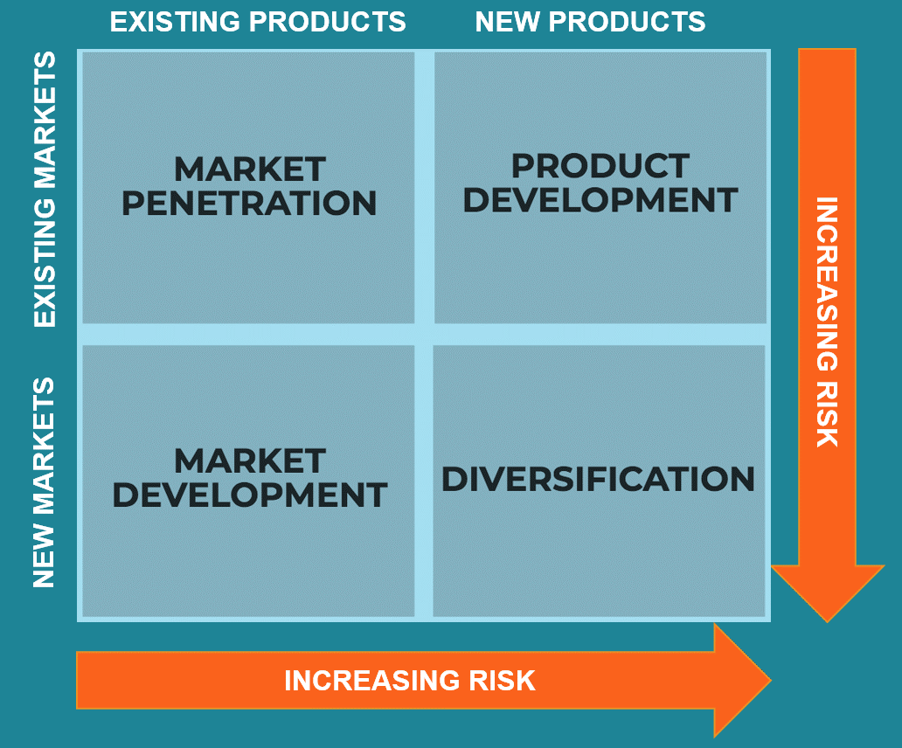
Source: Daft, (2015)
Market penetration. Since its inception, one of Toyota's vital intensive strategies has been market penetration. The company is creating a global distribution network to sell its products globally. Based on this and a reasonable cost leadership strategy, sales growth is achieved, providing profitable growth for the organisation. Since Toyota is already an established name in the industry, entering new markets is not a significant barrier because it does not pose as much risk. However, care is needed when implementing a market penetration strategy. It is necessary to approach the implementation of the customer retention strategy with greater emphasis due to the great competition for customers. The company should allocate additional costs to improve product quality, service and promotions. This risk must be measured so that it pays off. Otherwise, shareholders may lose the value of their shares and employees may lose their jobs.
Market development. This strategy involves selling the company's products in new markets and reaching new customers. There are regions in the UK and Japan where the company has a weaker presence. The company must focus on presenting its products in such markets to increase sales (Ansoff et al., 2019). Also, the company can focus on developing markets to increase the number of customers. Toyota should consider this strategy as it involves moderate risks – the products are well known, but a thorough analysis of new markets is required. The company has achieved its goals of broad penetration of the market with established dealer networks; for this, it is focused on the other two strategies - ensuring expansion and increasing sales.
Product Development. Toyota's strategy is to introduce new rapid product innovations to provide its customers with safer and more efficient cars (Ansoff et al., 2018). To fulfil this goal, the company continuously invests in R&D, which expands its product portfolio. Moreover, Toyota is also investing in automated driving technology. This strategy strengthens the products' competitiveness and attractiveness and reinforces its position as an innovative brand.
Diversification. Diversification can be concentric, horizontal, vertical or conglomerate (MasterClass, 2022). What distinguishes Toyota from its competitors in terms of gaining market share, who use the same marketing strategy in different regions, is that the company applies a specific strategy according to the specifics of each market. Organisations use this strategy to increase competitive advantage and profit, improve company image, optimise changes, optimise resources, and prevent failure. Toyota's concentric and horizontal diversification encompasses financing products and services related to the organisation's core business. In terms of its core business, the company applies fuel diversification by developing clean energy vehicles for small families, hybrids for mid-range cars, and long-distance commercial vehicles with fuel cells. Toyota uses the listed strategies in both the UK and Japan. The difference is that the company engages in other activities that exemplify conglomerate diversification in Japan. These are activists outside of the leading business. This strategy reduces the risk of failure (MasterClass, 2022). Toyota has successfully used diversification as a promotional element that reinforces the company's success. Negative criticism from environmentalists and other activists falls on the company's core business. Diversification is skilfully used by the company, for example, with the production of biodegradable plastic by Toyota Bio. Another example is the medical support services offered by Toyota Roof Garden and Good Life Design. In this way, the diversification waved to mitigate the negative criticisms while developing good relations with society.
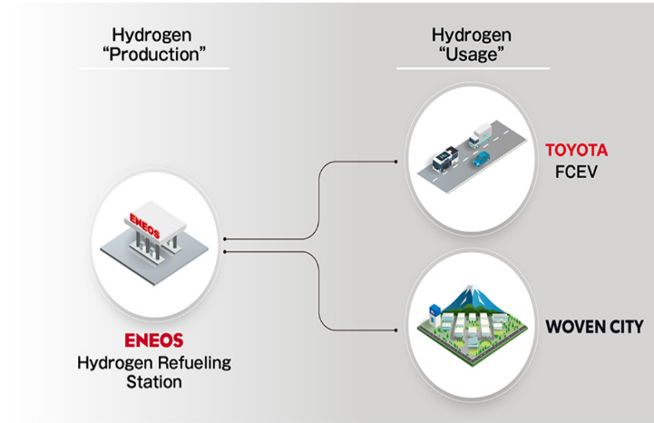
Source: Global Toyota (2022)
Conclusion
In summary, before engaging a company in international marketing and building marketing strategies, it is essential to understand the macro and micro environments in which the company operates. The analysis helps to identify the current state of the company. For the report, the analysis is based on various models such as PESTLE, SWOT, Hofstede's cultural dimensions, Porter's five forces, segmentation, targeting and positioning, as well as elements of the marketing mix. The report also reviewed the growth options that the company can focus on to grow further. Of the four growth options discussed, Toyota should prioritise a diversification strategy that differentiates it from competing brands in the UK and Japanese markets. Through this strategy, the company can explore newer markets with newer products. This aspect helps expand the customer base, increase sales and register better performance, therefore, taking a leading position in the markets. Toyota's marketing strategies enable it to secure its market share by providing different models of cars that suit the customers' tastes, needs and demands. Using unique and distinct marketing strategies with a customer focus according to different geographical locations helps Toyota fulfil its marketing objectives.

Recommendations for Improvements
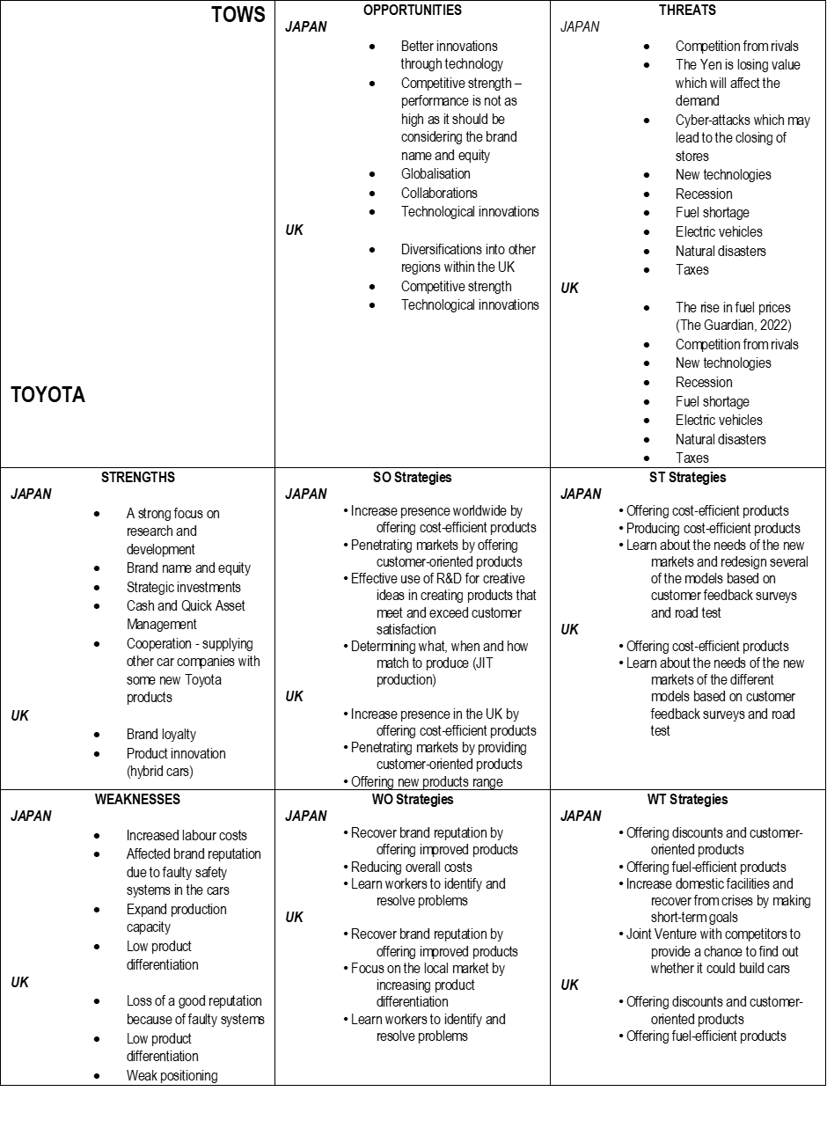
Created by the author of the report

Toyota can improve its marketing strategies in terms of segmentation by creating target segments for high-net-worth customers or wealthy customers. The strategy should include producing custom-designed brands for unique customers only. The market for expensive cars in the UK is increasing because the wealthy class is rising, and people in this segment like to stand out in the type of cars they use. By developing this marketing strategy, Toyota will increase the diversification of its brands, customer list and profit. The development of this strategy will meet the needs of customers and the market, which will lead to the brand image.
Increased investment in EV and driverless car innovation will spark the interest of new innovation-driven customers. The company's forward-thinking investments in automotive innovation can provide a competitive advantage over other competitors in the automotive market.

References:
- Ansoff, H.I., Kipley, D., Lewis, A.O., Helm-Stevens, R. and Ansoff, R. (2018), Implanting strategic management, Springer, pp. 311-336, 3rd ed
- Avada, (2022), Toyota Marketing Strategy: The Pride of Japanese Quality, Avada. Blog
Available at: https://blog.avada.io/resources/toyota-marketing-strategy.html#toyota-4ps-marketing-mix
Accessed: 29.11.2022
- BBC (2020), Japan country profile, BBC [online]
Available at: https://www.bbc.co.uk/news/world-asia-pacific-14918801
Accessed: 12.11.2022
- Benzaghta, M.A., Elwalda, A., Mousa, M.M., Erkan, I. and Rahman, M. (2021), SWOT analysis applications: An integrative literature review, Journal of Global Business Insights, 6(1), pp.55-73
Available at: https://digitalcommons.usf.edu/cgi/viewcontent.cgi?article=1148&context=globe
Accessed: 19.11.2022
- Bruijl D and Gerard HT (2018), The relevance of Porter's five forces in today's innovative and changing business environment, Researchgate [online]
Available at: https://www.researchgate.net/profile/Gerard-Bruijl/publication/326026986_The_Relevance_of_Porter%27s_Five_Forces_in_Today%27s_Innovative_and_Changing_Business_Environment/links/5c14165c299bf139c7593f03/The-Relevance-of-Porters-Five-Forces-in-Todays-Innovative-and-Changing-Business-Environment.pdf
Accessed: 18.11.2022
- Czinkota, M.R., Ronkainen, I.A. and Cui, A. (2022), International marketing, Cengage, 11th ed. [online]
Available at: https://books.google.co.ke/books?hl=en&lr=&id=BkxVEAAAQBAJ&oi=fnd&pg=PP1&dq=Czinkota,+M.R.,+Ronkainen,+I.A.+and+Cui&ots=oXbkuMZX0O&sig=lRm0-oOF8yyEeiecUGcMFmz-tdM&redir_esc=y#v=onepage&q=Czinkota%2C%20M.R.%2C%20Ronkainen%2C%20I.A.%20and%20Cui&f=true
Accessed: 12.11.2022
- Daft, R. (2015), Organisation Theory and Design, Cengage Learning, 12thed
- Dobbs, M. (2016), Guidelines for applying Porter's five forces framework: a set of industry analysis templates, Competitiveness Review, 24(1), 32-45.
- EBCG (2021), 4 Benefits of Customer Segmentation in your Sales Department, [online]
Available at: https://www.ebcg.com/benefits-of-customer-segmentation-in-sales-department/
Accessed: 20.11.2022
- Ferrell O.C., Hartline M., Hochstein, B.W. (2021), Marketing strategy, Cengage Learning
- Gillespie, K. and Swan, K.S. (2021), Global Marketing, Routledge, 5th ed
- Global Toyota (2021), Toyota Philosophy, Global Toyota, [online]
Available at: https://global.toyota/en/company/vision-and philosophy/philosophy/?padid=ag478_from_right_side
Accessed: 12.11.2022
- Global Toyota (2022), Sales, Production, and Export Results for 2021 (January - December), Global Toyota [online]
Available at: https://global.toyota/en/company/profile/production-sales-figures/202112.html
Accessed: 12.11.2022
- Global Toyota (2022), ENEOS, Toyota, and Woven Planet Collaborate to Facilitate CO2-free Hydrogen Production and Usage for Woven City and Beyond, Global Toyota, [online]
Available at: https://global.toyota/en/newsroom/corporate/36977466.html?_ga=2.250450182.1216713557.1669582166-1865555624.1667518460
Accessed: 22.11.2022
- Hanlon A. (2022), The segmentation, targeting, positioning (STP) marketing model, Smart Insights, [online]
Available at: https://www.smartinsights.com/digital-marketing-strategy/customer-segmentation-targeting/segmentation-targeting-and-positioning/
Accessed: 20.11.2022
- Hamilton, L. and Webster, P. (2018), The international business environment, Oxford University Press, 4th edition
- Harrington, H. J. (2016), Vision/Goals. The Innovation Tools Handbook, Volume 1: Organisational and Operational Tools, Methods, and Techniques that Every Innovator Must Know, CRC Press, Taylor & Francis Group, p.391.
- Harsono, R. (2016), The Impact of Marketing Mix (4p's) on Customer Loyalty Towards Toyota Avanza, IBuss Management, 4(1)
Available at: http://publication.petra.ac.id/index.php/ibm/article/viewFile/5329/4910
Accessed: 22.11.2022
- Henry, A. (2021), Understanding strategic management, Oxford University Press
- Hong, P. and Park, Y.W. (2020). BREXIT: Case of Japanese Firms. In Rising Asia and American Hegemony (pp. 167-175). Springer, Singapore.
- Hofstede Insights (2022), COUNTRY COMPARISON, [online]
Available at: https://www.hofstede-insights.com/fi/product/compare-countries/
Accessed: 16.11.2022
- HofstedeInsights (2022a), The 6-D Model, [online]
Available at: https://hi.hofstede-insights.com/national-culture
Accessed: 16.11.2022
- Hofstede Insights (2022b), Japan vs the UK, [online]
Available at: https://www.hofstede-insights.com/country-comparison/japan,the-uk/
Accessed: 16.11.2022
- Johnson, G., Whittington, R., Regnér, P., Angwin, D. and Scholes, K. (2020), Exploring strategy, Pearson, 12th ed
- Kotabe, M.M. and Helsen, K. (2022), Global marketing management, John Wiley & Sons, 9th ed
- Kumari P (2017), Toyota Product Strategy, Slide share, [online]
Available at: https://www.slideshare.net/Priyankakumari288/toyota-product-strategy
Accessed: 20.11.2022
- Mariadoss, B.J. (2022), Core principles of international marketing, MARIADOSS [online]
Available at: https://opentext.wsu.edu/cpim/chapter/7-1-international-entry-modes/
Accessed: 22.11.2022
- Minkov M, Kaasa A (2020), A test of Hofstede's model of culture following his own approach. Cross Cultural & Strategic Management, Cross cultural & strategic management, Vol.28(2), p.384-406, Emerald Publishing
Available at: https://librarysearch.uwtsd.ac.uk/discovery/openurl?institution=44WHELF_UWTSD&vid=44WHELF_UWTSD:44WHELF_UWTSD_VU1&aulast=Minkov&id=doi:10.1108%2FCCSM-05-2020-0120&auinit=M&atitle=A%20test%20of%20Hofstede%27s%20model%20of%20culture%20following%20his%20own%20approach&sid=google
Accessed: 16.11.2022
- Morgan, JM, Liker, JK (2020), The Toyota product development system: integrating people, process, and technology, Productivity press, New York, 363 pp, 212/686-5900
Available at:
https://www.ame.org/sites/default/files/target_articles/06-22-4-BR_Toyota_Prod_Dev_Sys.pdf
Accessed: 16.11.2022
- Muller J. (2014), Toyota Admits Misleading Customers; Agrees To $1.2 Billion Criminal Fine, Forbes [online]
Available at: https://www.forbes.com/sites/joannmuller/2014/03/19/toyota-admits-misleading-customers-agrees-to-1-2-billion-criminal-fine/?sh=3ee2451b6c1e
Accessed: 16.11.2022
- Nkomo T (2019), Analysis of Toyota Motor Corporation, dspace.vnbrims.org, [online]
Available at: http://dspace.vnbrims.org:13000/jspui/bitstream/123456789/2458/1/Toyota%20Case%20study.pdf
Accessed: 18.11.2022
- Ondeng, T.O. (2022), Case Study Critical Analysis for Toyota Motor Corporate Strategy, Researchgate, [online]
Available at: https://www.researchgate.net/profile/Tonny-Ondeng/publication/363659699_Case_Study_Critical_Analysis_for_Toyota_Motor_Corporate_Strategy/links/63287c8f071ea12e36467016/Case-Study-Critical-Analysis-for-Toyota-Motor-Corporate-Strategy.pdf
Accessed: 18.11.2022
- Platinium Pro (2021), Porter's Five Forces Analysis: Assessing The Competitive Environment, Platinium Pro
Available at: https://www.planiumpro.com/blog/porters-five-forces-analysis-assessing-the-competitive-environment/
Accessed: 18.11.2022
- Professional Academy (2022), Marketing Theories – The Marketing Mix – From 4 Ps to 7 Ps, [online]
Available at: https://www.professionalacademy.com/blogs/marketing-theories-the-marketing-mix-from-4-ps-to-7-ps/#
Accessed: 20.11.2022
- Shirouzu N. and Sun Y. (2018), Toyota says in talks with Geely on cooperation in hybrid vehicle tech, Reuters, [online]
Available at: https://www.reuters.com/article/us-china-autos-toyota-geely-idUSKCN1LM15O
Accessed: 18.11.2022
- Schlegelmilch, B.B. (2022), Segmenting targeting and positioning in global markets. In Global marketing strategy, Springer, (pp. 129-159)
- Simon SM, Varghese K (2018), Assessment of organisational culture in construction–A case study approach, 26th Annual Conference of the International. Group for Lean Construction, Research Gate, [online]
Available at: https://www.researchgate.net/profile/Manna-Simon/publication/326466362_Assessment_of_Organizational_Culture_in_Construction_-_A_Case_Study_Approach/links/5b59e596458515c4b249e9e2/Assessment-of-Organizational-Culture-in-Construction-A-Case-Study-Approach.pdf
Accessed: 16.11.2022
- Sousa GC, Castañeda-Ayarza JA (2022), PESTEL analysis and the macro-environmental factors that influence the development of the electric and hybrid vehicles industry in Brazil, Elsevier, [online]
Available at: https://scholar.google.co.uk/scholar?output=instlink&q=info:SXzOzWuVa9EJ:scholar.google.com/&hl=en&as_sdt=0,5&scillfp=5045228074056492822&oi=lle
Accessed: 12.11.2022
- Statista (2022), Global automotive market share in 2021, by brand, Statista [online]
Available at: https://www.statista.com/statistics/316786/global-market-share-of-the-leading-automakers/#:~:text=In%202021%2C%20the%20ranking%20of%20the%20world%E2%80%99s%20largest,Volkswagen%20Group.%20New%20trends%20in%20the%20auto%20industry
Accessed: 12.11.2022
- Statista (2020), Toyota car sales in the United Kingdom (UK) from July 2014 to December 2019, Statista [online]
Available at: https://www.statista.com/statistics/300413/toyota-car-sales-in-the-united-kingdom/
Accessed: 12.11.2022
- Statista Research Department (2020), number of car dealerships in franchise networks* in the United Kingdom (UK) in January 2014 and January 2017, Statista, [online]
Available at: https://www.statista.com/statistics/312034/size-of-car-dealership-networks-in-the-united-kingdom-uk/
- Thabit, T. and Raewf, M. (2018), The evaluation of marketing mix elements: A case study, International Journal of Social Sciences & Educational Studies, 4(4)
Available at: https://www.researchgate.net/profile/Thabit-Thabit/publication/324923406_The_Evaluation_of_Marketing_Mix_Elements_A_Case_Study/links/5aeb827a458515f59981df6e/The-Evaluation-of-Marketing-Mix-Elements-A-Case-Study.pdf
Accessed: 22.11.2022
- The Economic Times (2022), What is 'Marketing Mix', [online]
Available at: https://economictimes.indiatimes.com/definition/marketing-mix
Accessed: 22.11.2022
- Toyota-Europe (2021), Toyota in the World: our global operations, Toyota-Europe [online]
Available at: https://www.toyota-europe.com/world-of-toyota/this-is-toyota/toyota-in-the-world
Accessed: 12.11.2022
- Toyota Motor Corporation (2022), Global Operations: Facilities: Profile: Company, Toyota Motor Corporation Official Global Website, [online]
Available at: https://global.toyota/en/company/profile/facilities/manufacturing-worldwide/japan.html
Accessed: 16.11.2022
- Toyota Corporation. (2022), Sustainability, Toyota Motor Corporation Official Global Website, [online]
Available at: https://global.toyota/en/sustainability/
Accessed: 16.11.2022
- Toyota Motor Corporation (2022), 75 Years of Toyota, Toyota Motor Corporation Official Global Website, 75 Years of TOYOTA, List of Dealerships in Japan, Toyota Dealers
Available at:
https://www.toyota-global.com/company/history_of_toyota/75years/data/automotive_business/sales/dealerships/japan/toyota.html
Accessed: 16.11.2022
- Toyota Motor Corporation (2022), Global Operations: Facilities: Profile: Company, Toyota Motor Corporation Official Global Website
Available at: https://global.toyota/en/company/profile/facilities/manufacturing-worldwide/japan.html
Accessed: 16.11.2022
- Toyota (2022), What are Toyota's mission and vision statements? [online]
Available at:
https://support.toyota.com/s/article/What-are-Toyotas-Miss-7654?language=en_US
Accessed: 16.11.2022
- Toyota UK, (2021), Toyota Achieves Historic Top Ranking for UK New Car Sales in September, [online]
Available at: https://media.toyota.co.uk/toyota-achieves-historic-top-ranking-for-uk-new-car-sales-in-september/
Accessed: 18.11.2022
- Toyota UK (2022), Sustainability & Environment: Discover Toyota [online]
Available at: https://www.toyota.co.uk/discover-toyota/sustainability
Accessed: 16.11.2022
- Toyota UK (2021), Company Background, [omline]
Available at: https://media.toyota.co.uk/wp-content/uploads/sites/5/pdf/1618251066ToyotaCompanyBackgroundv2.pdf
Accessed: 20.11.2022
- Toyota UK (2021), Toyota Achieves Record UK New Car Market Share, [online]
Accessed: https://media.toyota.co.uk/toyota-achieves-record-uk-new-car-market-share/
Accessed: 20.11.2022
- Toyota-Europe (2022), Sustainability at Toyota, [online]
Available at: https://www.toyota-europe.com/sustainability
Accessed: 16.11.2022
- Winardy, I., Purba, P.Y., Chaniago, C., Andika, A. (2021), The Positive Impact of Product Quality, Price, and Promotion on Purchasing Decision of Toyota Innova Cars, International Journal of Social Science and Business, [online]
Available at: https://ejournal.undiksha.ac.id/index.php/IJSSB/article/view/35512
Accessed: 22.11.2022
- Worldometer (2022), Japan population, [online]
Available at: https://www.worldometers.info/world-population/japan-population/
Accessed: 16.11.2022
- Zahra Z. (2019), What are the 7 Ps of the marketing mix, and how should it be used? linkedin.com
Available at: https://www.linkedin.com/pulse/what-7ps-marketing-mix-how-should-used-zahra-zahedi/
Accessed: 20.11.2022

