BMSP6006
Strategies for Resilience and Prosperity
GLENN BEHENNA
REPORT

Content
Executive summary ……………………………………………………………………………………………. Page 2
- Introduction…………………………………………………………………………………………………. page 2
1.2 Objectives and policies…………………………………………………………………………………. page 3
Structure……………………………………………………………………………………………………………… page 4
The future of Asda………………………………………………………………………………………………. page 5
Reputation………………………………………………………………………………………………………… page 5
Main findings……………………………………………………………………………………………………. page 5
Competitive strategy………………………………………………………………………………………… page 6
Porter’s five forces……………………………………………………………………………………………. page 7
Internal stakeholders of Asda…………………………………………………………………………….. page 8
Bowman’s clock………………………………………………………………………………………………….. page 10
Pestle analysis……………………………………………………………………………………………………… page 11
Swot analysis……………………………………………………………………………………………………….. page 13
Five generic competitive strategies……………………………………………………………………… page 15
Conclusion……………………………………………………………………………………………………………. page 15

Executive summary
. This report examines the business and competitive strategies of Asda to see how sustainable the company is and how resilient they are to outside competition. To do this it uses several analysis tools, including SWOT, PESTLE, Porter’s Five Forces, Bowman’s Clock, and a Stakeholders analysis.
  - Introduction
  - Company background
In the 1920s, the Asquith family owned a butcher's shop in West Yorkshire, which expanded to seven shops. Asquith’s two sons Fred and Peter were very much involved with the family business and later became co-founders of Asda. Later, being joined by Dairy Farmers Limited and a new company was formed in 1949, putting Arthur Stockdale as its new managing director of Associated Dairies and Farm Stores Limited. In the 1960s, the son of Arthur Stockdale created the Craven Dairies brand for cafes and cake shops. Sir Noel Stockdale then later became the second co-founder for the future Asda. The first-ever Asda was up and running on the 3rd of May 1965, with over 80,000sq ft, making it the largest supermarket in the UK. The name Asda is an abbreviation of Asquith and Dairies. In 1966 Asda then became the first food store to sell other merchandise and took £30,000 in its first week operating. In 2012 Asda launched its first click-collect service. In 2013 the first petrol station was launched, and the first click-collect lockers were installed. In 2015 Asda's 50th birthday was celebrated, and its 600th store was opened. In 2020 Asda was having discussions with many private investors looking to exploring a partnership to expand its growth but had to pause this to focus on the Covid -19 pandemic. (Asda group ltd 2010) It was listed on the London Stock Exchange in 1999
.
This report aims to analyse ASDA’s competitive and business strategies to evaluate how well the company is doing in terms of sustainability and resilience.

1.2 Objectives and Policies
Identify Asda’s business strategies.
Asda has made firm plans to focus on the customers as of failure plans to merge with Sainsbury’s. Asda’s strategy will remain consistent as always, winning with good price for their customers, while providing a high-quality customer experience, and while having a good driving force with good customer care. Asda has continued to grow with food and clothing, as well as removing 6500 tonnes of plastic from their stores, while making sure they have the right people in the right place at the right time. (Rigby 2019)

- Evaluate Asda’s business strategies
Asda’s main operations will consist of the retail of food, clothing, and other general merchandise, along with other services. Asda's strategic objective is to provide a high-quality product, surpass customers desires, and to reduce the cost. They also have additional sustainability objectives in place to reduce environmental impact by reducing operational costs simultaneously. (ASDA Group Ltd ,2013).
Asda has now developed a growth strategy with expanding physically and online while reducing their overall operation costs, while identifying a need to innovate and expand with a new range, expanding the brand's identity, while being part of Walmart they also benefit from researching the development within other subsidiaries. (Asda Group Ltd ,2010).

Structure
Walmart purchased Asda in 1999, demonstrating a strategy with growth by achievement; with this, Asda has made the most of its core capabilities by providing good quality, low-cost products to obtain market share. It has now become the second-largest brand supermarket within the UK. With Asda being a subsidiary of Walmart, Asda has certain benefits, mainly IT expertise benefiting from development and research from its parent company Walmart.

Walmart would also benefit from adopting the best practices that were developed from Asda with their online shopping. (Walmart 2014). Walmart members can also take advantage of the intercompany loans that would provide internal financing opportunities.
Asda has 500 stores within the UK, with a range of supermarkets, to supercentres. This range was designed to meet the needs of their customers within different levels (Asda group ltd, Euromonitor international 2014) with implemented price guaranteed, safeguarding consistent prices across all Asda stores. This will then challenge other high-end brands of smaller supermarkets.
With the peak competition accepting the offer that Asda’s potential new owners would sell 27 petrol stations to push the deal over the line. Within October the ISSA brothers, billionaires and a private backer TDR capital did agree a £6.8billion deal and buy the chain of supermarkets from Walmart.
When the deal was completed within this year, it would have still needed an approval from the CMA after this had raised some concerns back in April that with this takeover this could lead to a higher price in petrol consisting of 36 locations for motorists.

The Future of Asda.
The billionaire brothers that are responsible for Asda’s £6.8billion takeover are now forward planning on opening 300 convenience stores within their petrol stations.
Mohsin and Zuber Issa would like to roll out “Asda on the move”, within their EGgroupafter a successful trial, says the Sunday times. (Asda2021)
The brothers now own around 400 petrol stations and have now introduced convenience stores in to 5 of their forecourts.
In October 2020 the first Asda on the move opened in Walsall,
For the first time in 2 years TDR capital with a deal saw supermarkets return the majority to UK ownership.

Reputation
Asda also influenced the status, with their parent company in the US, and was the first UK retailer introducing black Friday in 2013. This was then repeated in 2014 by many supermarkets to allow low-cost goods to be taken advantage of by their customers that saved many people money. (Asda group LTD2013)
1.3 Drucker (2006) always believes that all managers should, above all else be leaders, he would encourage flexible and collaborative approach, rather than strict hours and discouraging innovation.

2.0 Main findings

2.1This section will provide a more detailed analysis of ASDA’s competitive and business level strategies by using a number of strategy analysis tools: SWOT, Bowman’s Clock, Porter’s 5 forces and a Stakeholders analysis:

Competitive strategy

Competitive strategy  Keeping ahead of the competition.  Pricing to partnerships,  Tracking moves  Investments  publications | Market and sector intelligence  Keeping track on what is happening within your sector.  Capitalize on new trends  Innovation’s | Innovation and Disruption  Always be ahead to make your move to disrupt your industry and capture early market shares
Sales enablement  Move quickly on deals  Knowing when to approach  Getting your message across  Train employee’s faster | Procurement intelligence  Generate sustainable value  Within your business and stakeholders, take action on all categories, suppliers, and markets | Environmental, social, and governance (ESG)Intelligence  Keep a good view on sustainability within self-serve, and enable focused sustainability

BUSINESS LEVEL-STATEGY Pytlik J (2019)
Differentiation | Cost Leadership
Focused differentiation | Focused leadership

When thinking about a business level strategy you will need to think ahead about things like,
- Who your customers are?
- What sort of product your customer will need?
- How to satisfy your customers’ needs within your company?
Cost leadership will be about company price based on other businesses to get the best price for good value.
Differentiation strategy is about making your product stand out from other companies something that makes them unique and stand out from the crowd while keeping good customer service.
Focused differentiation is a company that will only focus on a small scale or a particular group of clients, this would also include small scale advertising, like online only.
Focused leadership this would be a company that would compete with price, but also choosing a small area of the market and making their product unique. (Avada2021)

2.2 This report will consider Asda’s business level and competitive strategies. Farooq (2018) explains that a competitive strategy is a long-term plan of action that will give the company an edge over its rivals. This involves having a higher return of investment.
A business level strategy is an in-depth plan that includes the aims and policies of a company. It looks at how to make sure customers have good value while balancing a advantage over rival companies. (Pytlik,2019).

Porter’s Five Forces (2021)
Potter’s five forces is what is used within a company to analysis competition within a business, this will draw from industrial organization, economics to originate the five forces that will control the competitive intensity, the attractiveness or lack of within an industry with regards to profitability. (Michael 1979).

COMPETITIVE
RIVALRY
SUPPLIER
POWER

THREAT OF
SUBSTITUTION

BUYER
POWER
THREAT OF
NEW ENTRY

Image 1

This report will consider Asda’s business level and competitive strategies. Farooq (2018) explains that a competitive strategy is a long-term plan of action that will give the company an edge over its rivals. This involves having a higher return of investment.
A business level strategy is an in-depth plan that includes the aims and policies of a company. It looks at how to make sure customers have good value while balancing a advantage over rival companies. (Pytlik,2019).

Internal Stakeholders of Asda
The stakeholders of Asda are there to examine both internal and external, to see how well Asda aims to communicate with the stakeholders, while being one of the largest supermarkets within the UK, with over 140,000 people working within their stores, Asda has promised to up their hourly pay by 18p per hour by 2020, (Wood 2019). But despite this there has been a dispute over new contracts involving 12,000 of their employees’ causing criticism.

- Executive Board
- Employees
- Managers
- Shareholders

External Stakeholders of Asda
Asda will serve 19 million customers on a weekly basis, but with this Asda needed to improve on their customer satisfaction as this supermarket was rated the worst for online deliveries in which, survey (Morley 2010). with this Asda has come a long way with online deliveries since covid-19 and have doubled their delivery slots to accommodate more customers. Asda have a lot of competition with Tesco as they are the market leader and are well ahead of Asda with their market shares. And the competition between Asda and Sainsbury’s to occupy 2nd position is an absolute fierce. And other competitors like co-op, Morrisons, Waitrose, Lidl, Iceland, and Aldi. Asda have a good number of suppliers; however, this has caused criticism. Asda was accused of rarely complying with the grocery supply code of practice (Butler2017).

- Customers
- Suppliers
- Creditors
- Competitors
- Pressure groups
- Local communities
- Government

Bowman’s Clock
1, Low price & low added value
1111
2, Low price
8, Loss of market share

3, Hybrid

7, Monopoly pricing
4, Differentiation

6, Risky high margins
5, Focused differentiation

Image 2
Asda’s strategy is for low price and was the first retail companies to offer a price promise in 2010 by announcing the Asda price promise guarantee, saying they would beat other supermarkets by 10%. Since then, other companies like Sainsbury and Waitrose and now Tesco have followed suit. (Burnley 2020).
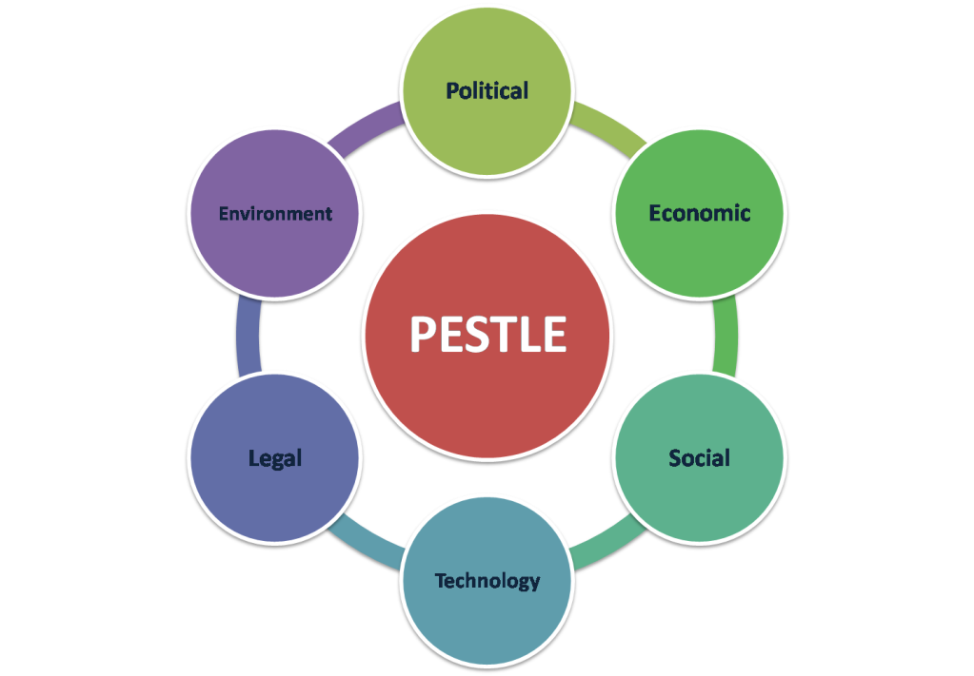
Image 3(google).

PESTLE analysis is completed for an examination of the external environment of ASDA

Political
- Asda has had a change of direction when doing business, with the political decisions will help to explore the regions that was not reached before.
- But on the negative side this can be passed from one leader to another.
Economic
- With the economic factors that are related to the economy within the UK. This has seen a flat quarter for 2019 with a growth rate of 0.5%.
- With the government consumption and the private consumption did increase however by 1.7% in 2019
- Asda has been affected by this factor both negatively and positively.
Social
With the social factors and the development of society in the change of trend and preference, Asda is enjoying the benefits to do with change regarding social media
- The younger generation have more money to spend this has helped Asda with their customer base, as most of the population are young and with that are the target market for Asda
Technological
- Technology as it is today, is changing day by day, and with this many businesses have been affected, business’s that have already been using up to date technology are already ahead of the competition.
- 6.4 billion is spent every year by the UK government to help towards science and technology to benefit the consumer and make it more beneficial.
- Asda would always need to keep funds for the constant changing of technology in order to be the best in the market
Legal
- Asda like any other company have to abide by law, to things like employment law, consumer law, etc. that has been set by the government, this is to protect the rights of the consumer.
- This can sometimes have a negative effect on the business operations, where some lews expect employees to work a specific time, so as a company they cannot exploit their potential.
Environmental
- Many companies are more concerned with the environmental issues, as with the government will make these legislations to protect the environment.
- AS a result of this Asda has now become one of the UK’S sustainable companies
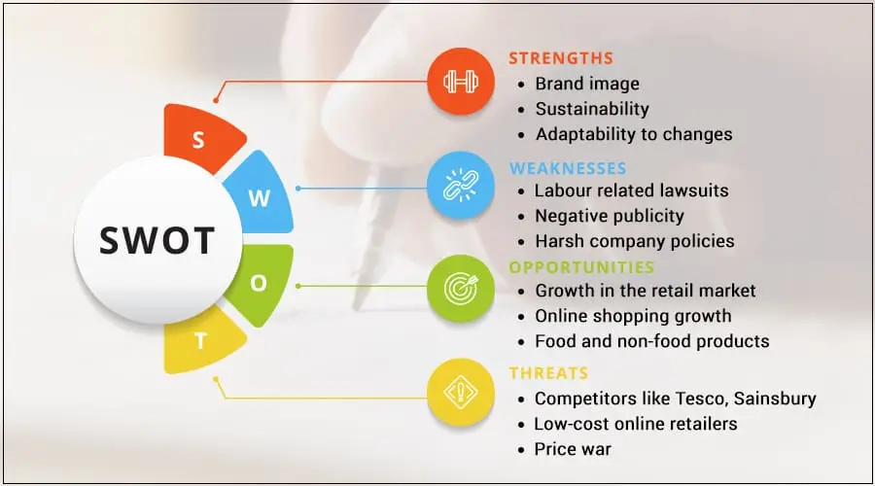
Image 4 (google).

SWOT analysis of Asda to investigate the internal environment

2.3 strengths
- Asda now have a wide range of product services that include financial support.
- Asda is known for their amazing marketing campaigns.
- Keeping in touch with customers though social network- including customer feedback.
- Asda takes responsibility thought corporate social responsibility (CSR) initiatives.
- Asda as a company now have 150.000 employees working within 500 stores.
- The Asda brand has gone from strength to strength though many achievements.
- Asda has got stronger by using online services with their customers.

Weakness
- Asda’s has failed with their performance for online services
- Asda has limited variety of their products within their store
- Asda’s location is not strategically planned as there are many areas that are not covered by Asda

Opportunities
- Asda as a company have a big opportunity to expand by opening more stores, with express stores with strategic locations.
- Asda has the opportunity to expand their stores into Europe where they can tap into new market areas and new customers.
- Issa brothers are opening many more Asda petrol stations
Threats
- Keeping the price down when going against other retailers.
- Maintaining the pressure of low prices.
- Keeping up with the changing of policies and various governments (MBA2020).
- Covid-19 has had a big in packed on sales of Asda products.

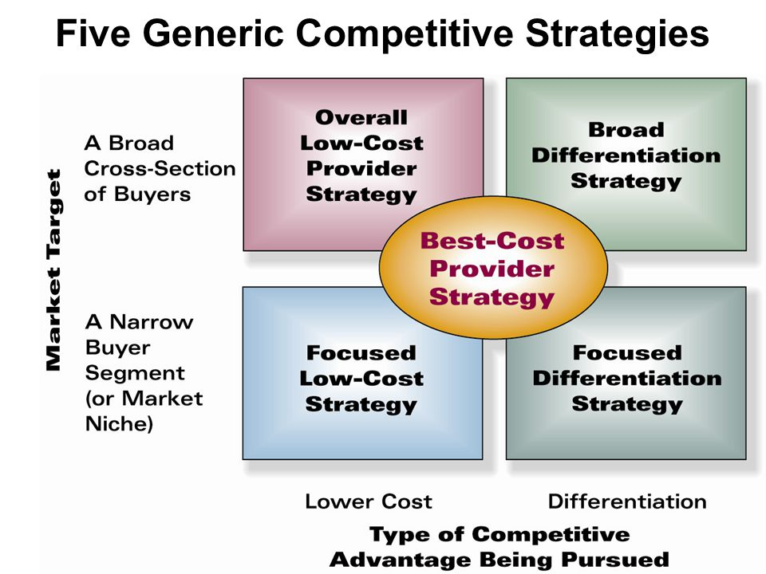

Image5 (google).

- Conclusion
Within this report it shows how Asda as the biggest supermarket in the UK can overcome all obstacles to keep the price down for their customers and give good value for money, Asda has also overcome the Covid-19 by providing more than double their online delivery slots to accommodate their most venerably customers. And what strategies they have used and what works best for them as a company.

References and Bibliography

Asda group ltd. (2013, 31st December). Report and Financial statement. Available at:
http://companycheck.co.uk/company/01396513/ASDA-GROUP-LIMITED.( Accessed on 9th October 2021).
ASDA Group LTD. (2010). All about Asda, Retrieved from Asda Group. Available at:
http://your.asda.com/system/dragonfly/production/2012/01/04/125919568.Allaboutasda (accessed on 9th October 2021).
Asda (2021) Announces transformation proposals in response to changing shopping habits. Available at:
Asda announces transformation proposals in response to changing shopping habits (Accessed on 18th November 2021)
Burnley R (2020). A message from Asda CEO. Available at
https://corporate.asda.com/a-new-chapter-in-delivering-great-value-for-uk-shoppers (Accessed on 19th October2021)
Butler, S. (2017) Asda is named worst supermarker in treatment of suppliers. Available at:
https://theguardian.com/2017/jun/26/asdasupermarket-suppliers-walmart-morrisons (Accessed on 25th October2021).
Caramela S (2018) 4 ways to implement peter Drucker’s theory of management. Available at
How to Implement Peter Drucker's Management Theory - businessnewsdaily.com (Accessed on 18th October 2021)
Farooq, U (2018) What is competitive strategy? Available at
https://www.marketingtutor.net/what-is-competitive-strategy (Accessed on 18.10.21)
Google images (2021). Available at
Google (accessed on 26th October 2021).
MBA skool team (2020). Asda swot Analysis, competitors & UPS. Available at
https://www.mbaskool.com/brandguide/lifestyle-and-retail/2040-asda.html (Accessed on 21st October2021).
Michael E Potter, how competitive forces shape strategy. Available at:
Harvard business review, may 1979(vol 57,no2), pp137-145.(Accessed on 25th October2021).
Morley.K. (2019) Asda rated worst supermarket for online deliveries in Which? Survey, Available at:
https://www.telegraph.co.uk/news/2019/02/22/asda-rated-worst-supermarket-online-deliveries-survey (Accessed on 25th October 2021).

Rahman M (2019).howandwhat stakeholders of Asda(An analysis of Asda’s stakeholders). Available at
https://howandwhat.net/stakeholders-asda-analysis-asdas-stakeholders/ (Accessed on 19th October 2021).
Potter’s five forces of competitive position analysis(2021). Available at
Porter’s Five Forces of Competitive Position Analysis (cgma.org) (Accessed on 18th October 2021)
Pytlik (2019) What is business level strategy? Available at
https://tracktime24.com/Blog/business-level-strategy ( Accessed on 18.10.21)
Rigby C, Asda puts its focus firmly on the customer (2019). Available at
Asda puts its focus firmly on the customer - Customer - InternetRetailing (Accessed on 18th October 2020)
Walmart, (2014), Walmart 2014 Annual Report, Retrieved from Walmart Investor Relations. Available at:
http://stock.walmart.com/annual-reports (Accessed on 9th October 2021).
Wood, Z. (2019) Asda announces pay rise as contract row continues, Available at:
Https://www.theguardian.com/business/2019/announces-pay-rise-as-contract-row-continues (Accessed on 25th October2021).

