

“EFFECT OF PERFORMANCE APPRAISAL SYSTEM ON EMPLOYEE MOTIVATION: A QUANTITATIVE STUDY”

Student Name: Khushi Patel
Student ID: 2416327
MBA international Business [2025-26]


Master’s Degrees by Examination and Dissertation
Declaration Form.
I, Khushi patel, declare that this dissertation has been composed by myself, that the work contained herein is entirely my own except where explicitly stated otherwise in the text, and that this work has not been submitted for any other degree or qualification, in whole or in part, except as specified.

Signature: ………………………………............................

Date: …03/02/26……………………………............................
- 1 -

Acknowledgement
I would like to express my sincere gratitude to all those that have contributed to this research. Firstly, I would like to acknowledge the guidance and support I have received from my supervisor, Dr. _______ throughout the research process. I am also grateful to the participants who took the time to share their insights and experiences, without whom this research would not have been possible. Lastly, I would like to thank all of my colleagues, friends and family that supported me in various ways during the course of this study.

Abstract
The research has provided details regarding the importance of performance appraisal methods in improving the motivation level of the employees. In addition, the investigation has also included details regarding the challenges associated with the appraisal techniques such as biasness and demotivation that has reduced its acceptability among the workers. The research has included the use of secondary qualitative methodology that has helped in improving the accuracy of the investigation process. The finding and discussion chapter help to analyse the results through thematic coding by analysing the nature of research. The development of themes is based on appraisal accuracy, employee satisfaction, employee engagement, feedback mechanism, rewards, training and recognition. The finding chapters exact the overall results by drawing out conclusions that have its linkage with research objectives. The conclusion chapter provides a proper summarisation of the research topics that help future research to explore further. The proper recommendation includes strengthening transparency through Performance appraisal, implementing continuous feedback and enhancing improvement in rewards and recognition.

Table of Contents
Chapter 1: Introduction 10
1.1 Background 10
Figure 1.1: Employee performance appraisal 11
Figure 1.2: Revenue of Tesco 12
1.2 Problem Statement 12
Figure 1.3: Sales Value of BP Plc 13
1.3 Research Aim and Objective 13
1.4 Rationale and Significance 14
1.4.1 Research rationale 14
Figure 1.4: Employees of Amazon 14
1.4.2 Research significance 15
1.5 Scope and Limitation 15
1.5.1 Research scope 15
Figure 1.5: Employee turnover rate 16
1.5.2 Research limitation 16
1.6 Structure of Dissertation 16
Table 1.1: Structure of Dissertation 17
Chapter 2: Literature Review 18
2.1 Introduction 18
2.2 General Overview of the Literature 18
2.2.1 Conceptual Foundations and Importance of Performance Appraisal Systems 18
Figure 2.1: Revenue of Unilever 19
Figure 2.2: Walmart employee statistics 20
2.2.2 Relationship Between Performance Appraisal Practices and Employee Motivation 20
Figure 2.3: Employee Income of Amazon 21
Figure 2.4: Employee retention in Microsoft 22
2.2.3 Key Performance Appraisal Factors Influencing Employee Motivation 22
2.2.4 Challenges and Limitations of Current Performance Appraisal Systems 24
Figure 2.5: Engagement rate Google 25
Figure 2.6: Jobs for Female Workers 27
2.2.5 Organisational Implications of Ineffective Appraisal Practices 27
Figure 2.7: Sales of BP Plc 27
2.2.6 Strategic Approaches to Improve Performance Appraisal and Enhance Employee Motivation 28
Figure 2.8: Workforce ethnicity in Amazon 30
2.3 Theoretical Framework 30
Figure 2.9: Key aspect of goal setting theory 32
Figure 2.10: Equity Theory 33
Figure 2.11: Revenue of Tesla 34
2.4 Conceptual framework 35
Figure 2.12: Conceptual framework 35
Table 2.1: Discussion summary 37
2.5 Conclusion 38
Chapter 3: Methodology 39
3.1 Introduction 39
Figure 3.1: Saunders research onion 39
3.2 Research design 39
3.3 Data collection method 40
Table 3.1: Exclusion and inclusion criteria 41
3.4 Data sources used in research 41
3.5 Data analysis and about linking process 42
3.6 Limitation 42
Table 3.2: Limitations of Secondary Qualitative Methods 43
3.7 Ethical consideration 43
3.8 Summary 44
Chapter 4: Finding and Discussion 45
4.1 Introduction 45
4.2 Thematic analysis 45
Table 4.1: Theme coding 46
Table 4.2: Colour coding 47
Table 4.3: Generation themes 48
Figure 4.1: Performance review 49
Figure 4.2: Human resource satisfaction index 49
Figure 4.3: Revenue of Aston Martin 51
Figure 4.4: Employee Revenue of Amazon 52
Figure 4.5: level of employee motivation 53
Figure 4.6: Sales Growth of Sainsbury 55
Figure 4.7: 360 degree feedback adoption rate 56
4.3 Finding 57
4.4 Discuss of linking finding with research question 60
4.4.1 Findings Related to Research Question 1 60
4.4.2 Findings Related to Research Question 2 60
4.4.3 Findings Related to Research Question 3 60
4.4.4 Findings Related to Research Question 4 61
4.5 Summary 61
Chapter 5: Evaluation 62
5.1 Introduction 62
5.2 Evaluation of key comparative analysis with existing literature 62
5.2.1 Accuracy and Reliability of Performance Appraisal Systems 62
Figure 5.1: Brand Value of Beverage Companies 63
5.2.2 Discussion on the factors influencing the quality of the performance appraisal initiatives of companies 63
5.2.3 Role of Feedback and Goal Alignment in Performance Management 64
Figure 5.2: Benefit associated with employee feedback 65
5.2.4 Reward and Recognition Structures on Motivation 65
Figure 5.3: Tesco investing on Colleagues 67
5.2.5 Appraisal-Related Stress, Demotivation, and Workforce Implications 67
Figure 5.4: Brand Value of Tesco 68
5.3 Implication of key finding 68
5.3.1 Practical implication 68
5.3.2 Theoretical implications 69
5.4 Summary 69
Chapter 6: Conclusion 70
6.1 Summary of the Study 70
6.2 Conclusion Based on Research Objectives 70
6.3 Recommendations for Practice 72
6.3.1 Recommendation 1: Strengthen Transparency and Accuracy in Performance Appraisal Systems 72
6.3.2 Recommendation 2: Implement Continuous Feedback and Goal Alignment Mechanisms 72
6.3.3 Recommendation 3: Integrate Balanced Reward and Recognition Structures 72
6.4 Recommendations for Future Research 73
References 74

List of Figure
Figure 1.1: Employee performance appraisal 11
Figure 1.2: Revenue of Tesco 12
Figure 1.3: Sales Value of BP Plc 13
Figure 1.4: Employees of Amazon 14
Figure 1.5: Employee turnover rate 16
Figure 2.1: Revenue of Unilever 19
Figure 2.2: Walmart employee statistics 20
Figure 2.3: Employee Income of Amazon 21
Figure 2.4: Employee retention in Microsoft 22
Figure 2.5: Engagement rate Google 24
Figure 2.6: Jobs for Female Workers 25
Figure 2.7: Sales of BP Plc 26
Figure 2.8: Workforce ethnicity in Amazon 28
Figure 2.9: Key aspect of goal setting theory 29
Figure 2.10: Equity Theory 30
Figure 2.11: Revenue of Tesla 31
Figure 2.12: Conceptual framework 32
Figure 3.1: Saunders research onion 36
Figure 4.1: Performance review 45
Figure 4.2: Human resource satisfaction index 45
Figure 4.3: Revenue of Aston Martin 47
Figure 4.4: Employee Revenue of Amazon 48
Figure 4.5: level of employee motivation 49
Figure 4.6: Sales Growth of Sainsbury 50
Figure 4.7: 360 degree feedback adoption rate 52
Figure 5.1: Brand Value of Beverage Companies 58
Figure 5.2: Benefit associated with employee feedback 60
Figure 5.3: Tesco investing on Colleagues 61
Figure 5.4: Brand Value of Tesco 62

List of Table
Table 1.1: Structure of Dissertation 17
Table 2.1: Discussion summary 34
Table 3.1: Exclusion and inclusion criteria 38
Table 3.2: Limitations of Secondary Qualitative Methods 40
Table 4.1: Theme coding 42
Table 4.2: Colour coding 43
Table 4.3: Generation themes 44

Chapter 1: Introduction

1.1 Background
In the current competitive era, employee efforts determine individual performance by showcasing satisfaction regarding jobs which enhance transparency in business. The development of the well-structured appraisal system enhances employee motivation by ability to provide constructive feedback in enhancing organizational objectives. As stated by Lin et al. (2024), employee motivation and performance appraisal are interrelated based on performance appraisals, constructive feedback and encountered growth that aligns with long term business goals.
The “employee performance management” software growth tends to rise about 3.67% with its market volume US$6.62bn by 2030 (Statista, 2025). The demand of the enterprise performance management software rises through efficient financial planning and automated processes to manage business performance. For example, Unilever enhances the performance evolution of the employees by using AI tools “Work Well”, as 75 % of employees feel valued in the workplace by adoption of technology which enhances productivity (Vorecol, 2025). The shift encounters transformation in business through continuous feedback which enhances career. The employee performance appraisal encounters overall profit of the business by indicating market competition and its adjustment in managing performance. In 2026, the profit of enterprises tends to rise about 40.2% in 2026 related to adjustment in managing performance of employees (Peng, 2022). The shift in increasing “cloud-based appraisal” has showcased substantial growth which is more reliable for effective planning and through analysis self -improvement of employees.

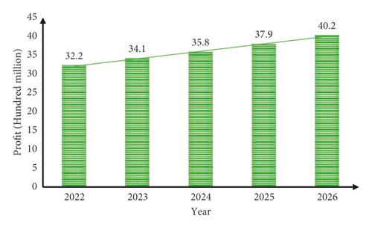

Figure 1.1: Employee performance appraisal
(Source: Peng, 2022)
Performance appraisal is an important aspect that helps organisations in strengthening its employee relationships. As stated by Murphy and DeNisi (2023), the performance appraisal tools assist organisations in developing a proper understanding regarding the skills of its workers, that also improves its operational productivity. The organisations have emphasised on adopting appraisal methods for enhancing the engagement level of its workforce. For example, Tesco has invested £3bn in developing initiatives such as the “Kickstart Scheme” that has provided work experience to around 1000 university students in 2025 (Tesco Plc, 2025). The programme has helped the retail company in improving its goodwill among the customers. Tesco has enhanced its revenue from £3200m in 2016 to £6400 in 2024 (Kivilahti, 2024). The improvement in the business income has helped the company in achieving financial stability.
On the other hand, M&S has also invested around $2m in developing platforms such as “My Choices” that has helped the organisation in reviewing its employee performances in 2024 (Businesswire, 2024). The initiative has also assisted the fashion company in improving its operational quality significantly. M&S has also enhanced the hourly wages of its workers from £14.20 in 2024 to £14.90 in 2025 (Grocery Gazette, 2025). The improvements in the financial income and provision of skill development initiatives has helped M&S in enhancing its goodwill among its employees.
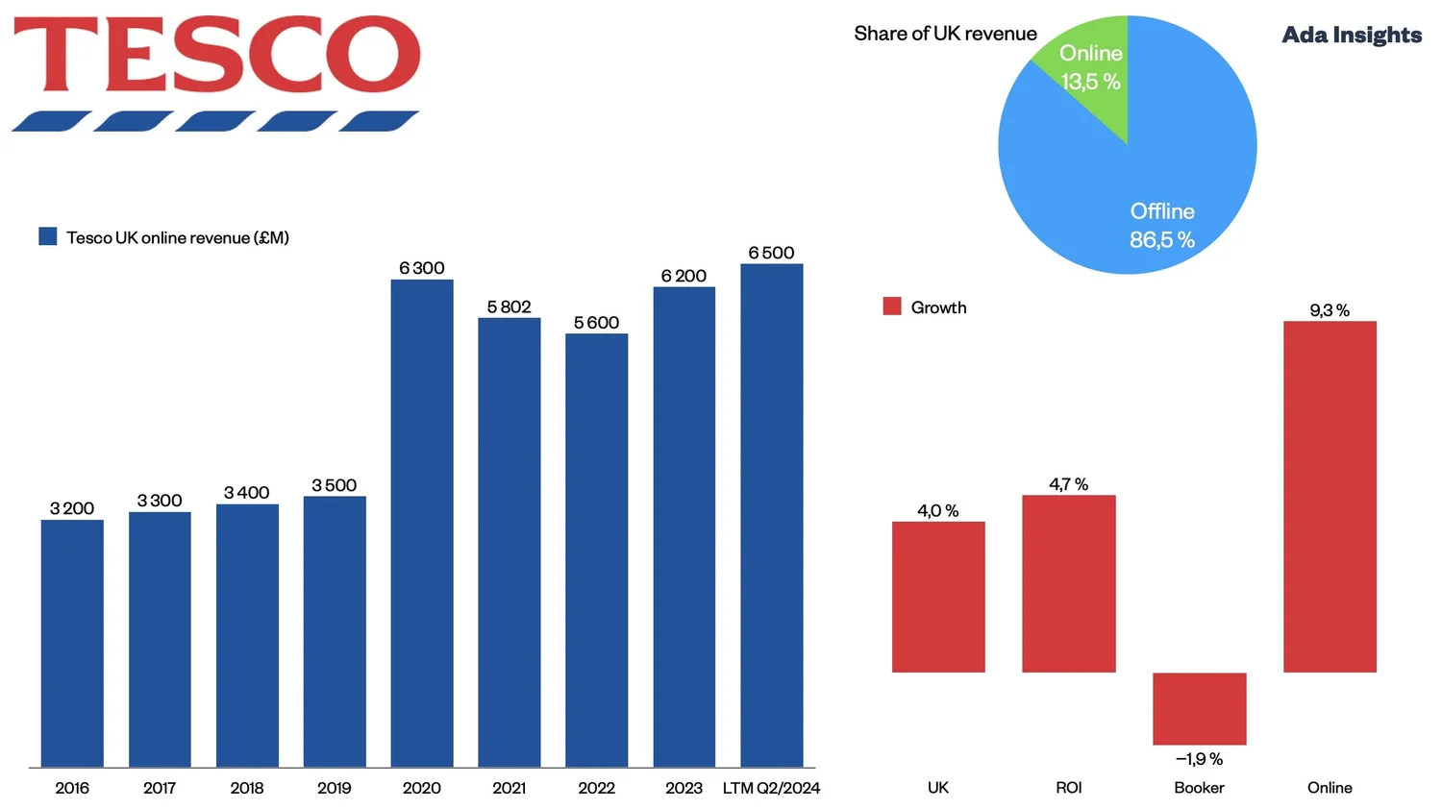

Figure 1.2: Revenue of Tesco
(Source: Kivilahti, 2024)

1.2 Problem Statement
The performance appraisal system has been designed to showcase employee performance through informed decision making. The employee motivation and PAS have its massive disconnection in enhancing job satisfaction by the ability to showcase its varied consequences. Many organisations faced challenges in adoption of the appraisal system which hamper overall productivity of business. The reason for disconnection leads to lower productivity by decreasing morale value in managing the working environment. For example, Tesco addresses changes in performance appraisal systems through efficient “360-degree feedback” showcases efficient progress and professional growth (Tesco, 2025). The key issues in managing performance appraisal are lack of transparency, unclear goals and misalignment in managing career. This has its massive impact on addressing organisational challenges which in term decreased motivation of employees.
The reduction in motivation has been a critical issue associated with the performance appraisal methods that has reduced its popularity among the workers. For instance, BP Plc has implemented 4700 job cuts with the intent to reduce its operational costs in 2025. The layoff has adversely affected the productivity of its employees (Race, 2025). BP Plc has reduced its sales value from £2500m in 2021 to £1900m in 2025 (Market Screener, 2025). The reduction in the revenue has also reduced the competitive advantage of the oil company over other organisations. Overall, the implementation of job cuts has reduced the motivation level of the workers.
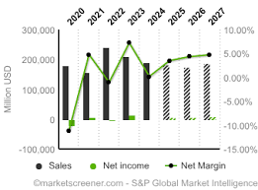

Figure 1.3: Sales Value of BP Plc
(Source: Market Screener, 2025)

1.3 Research Aim and Objective
Research Aim
The research aim is to analyse the performance appraisal systems in employee motivation with identifying appraisal factors in organizational settings to enhance overall key performance.
Research objective
- To analyse key relations associated with performance appraisal practices and employee motivation levels in organisational practice.
- To explore the aspect of performance appraisal factors potentially impact motivational activity within the employees of organisations.
- To analysis about key challenges faced by employees due to attribution of the current appraisal system in organisation.
- To develop the effective recommended strategies in improving the appraisal process for enhancing employee motivation.

Research question
RQ 1: What is the relationship between performance appraisal practices and employee motivation levels within the organizational context?
RQ 2: Which specific performance appraisal factors most significantly employee motivation?
RQ 3: What challenges do employees experience as a result of the current appraisal system in the
organization?
RQ 4: What strategies can be implemented to improve the appraisal process and enhance Employee motivation?

1.4 Rationale and Significance

1.4.1 Research rationale
The research is important as it provides a critical evaluation on the performance appraisal initiatives adopted by companies for improving its organisational harmony. For example, Amazon has developed a reward system such as “AwardCo” that has helped the organisation in recognising the contribution of its workers towards its operational growth in 2025 (Amazon, 2025). The initiative has helped the organisation in improving its brand loyalty among its workers. Amazon has enhanced its workforce from 148000 in 2021 to 150000 in 2025 (Bosze, 2024). The availability of skilled staff has assisted Amazon in improving its service quality effectively. On the other hand, the investigation has also discussed the challenges associated with the utilisation of the employment appraisal techniques, such as the absence of motivation among the workers. The inclusion of detailed analysis regarding the impact of appraisal methods on employee performance has enhanced the viability of the research work.

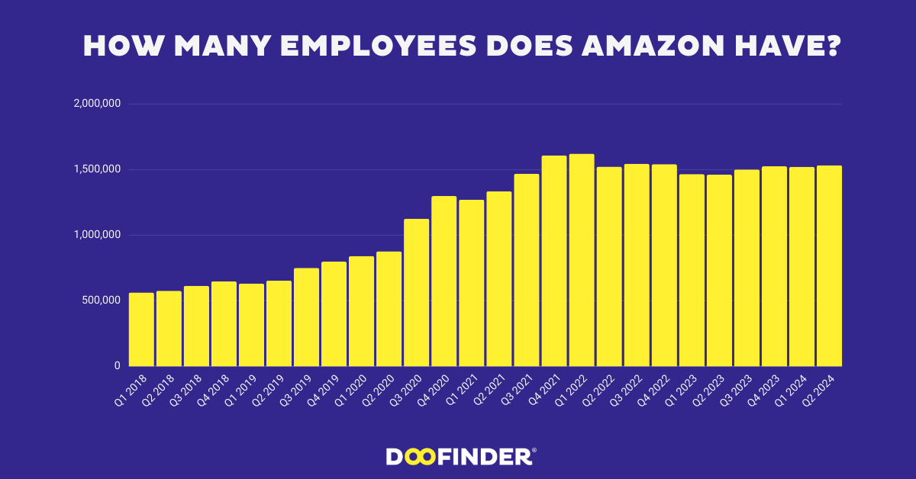

Figure 1.4: Employees of Amazon
(Source: Bosze, 2024)

1.4.2 Research significance
The research is significant by serving proper guidance in managing organisation which enhance employee engagement by addressing positive outcomes in enhancing operational efficiency. The appraisal has its massive linkage with motivation and job satisfaction by relying on employee centric approaches in achieving business goals. The fairness and transparency in organization motivate employees by serving consistent feedback which enhances employee engagement. The “360 Degree feedback market” is projected to reach about $1.23billion during 2025 by showcasing its reach of 10.6% which enhances employee engagement (Fortune, 2025).The appraisal system encounters proper career growth by serving proper training to the employees which is more reliable in achieving organisational goals. The research serves proper evidence regarding motivation of employees in handling uncertain situations and emphasizing more on employee needs which

showcases career progression. This in term showcases employee engagement by showcasing its better contribution which in term enhances employee reach.

1.5 Scope and Limitation

1.5.1 Research scope
The key scope of research is highly focused on analysing the trend of appraisal systems that are helpful to the motivational level of organisation among employees. In addition, this research also examines different scope of appraisal practice in reshape of motivational levels supported by global organization. As a result, a strong motivational level also be helpful to improve retention in organisations to sustain long term growth effectively. For instance, the average employee turnover rate in North America is 20%, indicating a consistent challenge for organisations in retaining talent, with 3.3 million employees resigning in January 2025 (Gimbal, 2025). Hospitality and retail record the highest turnover at around 70%, largely due to seasonal work and lower wage structures, while healthcare follows at 32%, driven by workload pressure (Gimbal, 2025). The finance and insurance sector reports 18.6%, technology 13.2%, and manufacturing 9.3%, showing relatively stronger workforce stability. Overall, this report is effectively analysing the key trend analysis appraisal of different sectors that diversified turnover rate for long term growth.
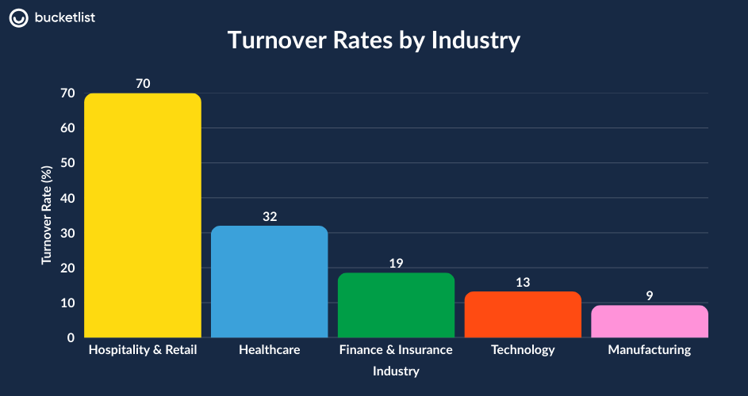

Figure 1.5: Employee turnover rate
(Source: Gimbal, 2025)

1.5.2 Research limitation
The research work has provided limited focus on the performance appraisal techniques adopted by organisations that have reduced the quality of the evaluation process. On the other hand, the investigation has also adopted the use of secondary qualitative methods, that has reduced the quality of the information that has been included in the analysis programme. The adoption of techniques such as thematic analysis lowers the inclusion of real-time data in the research work, which hampers the viability of the evaluation activity. Overall, the limitations mentioned above have reduced the research quality of the topic.

1.6 Structure of Dissertation
Chapters | Discussion
Introduction | This chapter provides clear aims and objectives associated with the research, significance, background which help in serving relevant information in achieving business outcomes.
Literature Review | The Literature Review helps in providing proper information by evaluating essential sources in encountering weakness and strengths. The identification of gaps are carried out and explained further.
Methodology | The chapter utilizes a secondary qualitative method by showcasing proper alignment with research objectives.
Data analysis | This section provides proper information through thematic analysis by ability to generate themes to draw out conclusions.
Findings and Discussion | The section helps in drawing out factual knowledge by connecting results with research objectives and addressing comparison with literature.
Conclusion and Recommendation | The provide proper summarisation of the study and recommendation in achieving actionable insights

Table 1.1: Structure of Dissertation

Chapter 2: Literature Review

2.1 Introduction
The literature review chapter is most significant to analyse key appraisal facts that are highly contributing about the influencing parameters of the appraisal system, in organization. It also explores the key appraisal practices procurement associated with workplace behaviour and its contribution towards improving motivational outcomes among employees. In addition, this chapter also interconnects with empirical studies for better consolidation of the theoretical view associated with the appraisal system in a detailed manner. It further evaluates strategies proposed in prior research to enhance appraisal effectiveness and strengthen employee motivation.

2.2 General Overview of the Literature

2.2.1 Conceptual Foundations and Importance of Performance Appraisal Systems
The performance appraisal system has been considered as an important tool that has helped organisations in enhancing the skills of its workers. According to Firdaus et al. (2024), the techniques help companies in improving the knowledge of the workers that also assist in improving its productivity. In addition, the method also improves the engagement level of the workers that in turn reduces the occurrence of production delays for the companies. The organisations have emphasised on adopting performance appraisal methods for strengthening its worker relationships. In addition, the adoption of the performance appraisal method also assists companies in improving its organisational harmony and developing teamwork in its business environment. The enhancement in the team efficiency also helps companies in ensuring timely completion of operational projects that also increases its goodwill among the customers (Yang, Ma and Li, 2023). Overall, the inclusion of the appraisal system has helped companies in achieving financial stability and brand growth effectively. On the contrary Li (2023) stated that traditional approaches are also abruptly reduced to configuring and updating industry competitiveness in an effective manner. For example, Unilever has invested $3.5bn in developing platforms such as “UniVoice” that has helped the organisation in monitoring the progress of its workforce in 2024 (Unilever, 2025). The initiative has helped the retail company in enhancing its product quality and improving organisational harmony. For example, Unilever has enhanced its revenue from €45000m in 2021 to around €5500 m in 2024 (Market Screener, 2025). The improvement in the financial income has helped in enhancing the employee productivity of the country. In addition, the performance appraisal system also helps organisations in developing a proper understanding of the skills of its workers that also enhances the decision-making activities of the organisation. For example, Aston Martin has invested $40m in developing infrastructures such as “ARM Driver Academy” that has helped the company in enhancing the digital knowledge of its workers in 2025 (Aston Martin, 2026). The initiative has assisted the organisation in strengthening its worker relationship and improving operational productivity effectively.

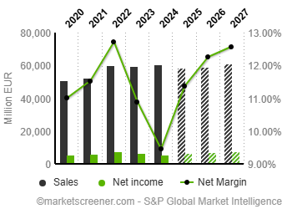

Figure 2.1: Revenue of Unilever
(Source: Market Screener, 2025)
In addition, performance appraisal systems are most necessary to evaluating key performance levels of an organization to better identify key skills gaps. It is also able to support strong organization development with intricate future needs for organization. For instance, the global data analytics market is also valued at $69.54 billion in 2024 with a market CAGR growth rate of about 28.7% (GVR, 2024). Hence, this market outreach also enables essential growth of the market by 2030 with an acquired value of $302.01 billion. Hence, this scenario abruptly impacts the employee retention position of the organization with a greater need for the technological base of the employee. As a result, Google is generally adopting a data-driven appraisal model supported by OKRs to improve productivity with assured goals alignment of current demand of data analytics. On the other hand, retail giant Walmart also uses a digital appraisal dashboard that also be helpful to maintain strong employee retention value of 2.1 million in consecutive year of 2024 (Market.US, 2024).
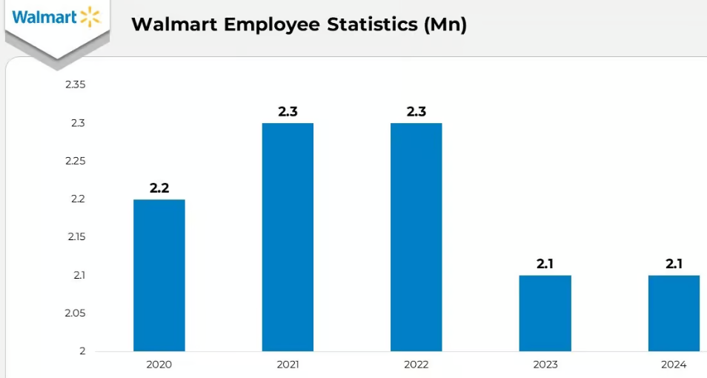

Figure 2.2: Walmart employee statistics
(Source: Market.US, 2024)

2.2.2 Relationship Between Performance Appraisal Practices and Employee Motivation
Performance appraisal techniques have a significant impact on the employee relationship of the organisation. As stated by Ullah et al. (2021), the adoption of the method helps companies in developing loyalty among the workers that also assists the enterprises in ensuring the timely completion of business projects. On the contrary, Peng (2022) stated that the performance appraisal techniques have also helped companies in strengthening their worker relationships. The companies have focused on adopting a reward system with the intent to improve its goodwill among the workers. For example, Amazon has invested $100m in developing platforms such as “NectarHr” that has helped the organisation in recognising the contribution of its employees in business projects in 2024 (Amazon, 2025). As a result, it is also helpful to manage the key interventions for recognition that improve employee retention in organisations. Further, it is also to ensure more effective and fair prioritisation of employee recognition procedures for maintaining long-term retention in organisations. The initiative has also helped the e-commerce company in improving the productivity of its workers. Amazon has enhanced the value of its employee revenue from $5bn in 2004 to around $150bn in 2025 (Saxena, 2024). The enhancement in the profits has assisted the company in improving its goodwill among the staff. Hence, this growth also be illustrated about storing organisational strategy towards maintaining better workforce utilisation with adhere towards fair recognition policy. On the other hand, lack of fair policy implementation directly reduces the morale value of employees with reduced workforce productivity in organisations. Hence, this is to improve the key determination of employee resilience and ensure more successive growth in organisation.
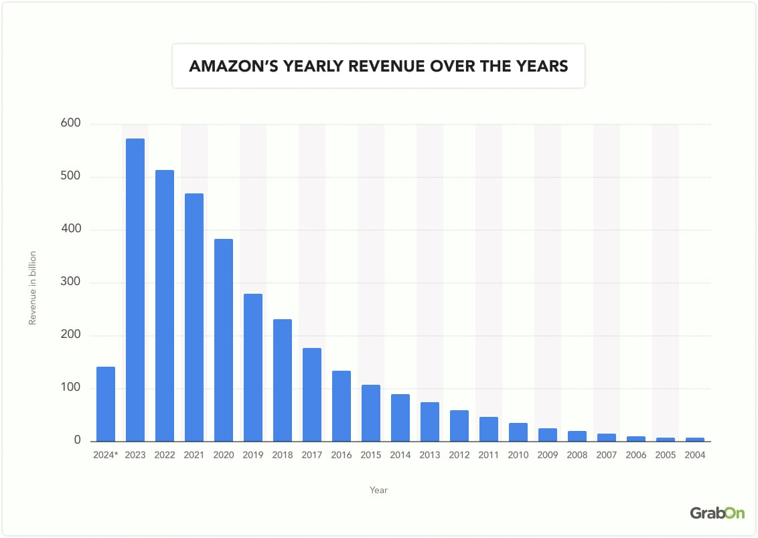

Figure 2.3: Employee Income of Amazon
(Source: Saxena, 2024)
In addition, performance appraisal practices play a critical role in shaping employee motivation by influencing perceptions of fairness, recognition, and career growth. As per the view of Farin et al. (2023), the use of structural appraisal systems can also be helpful to improve productivity of organizations with long term growth. For instance, Microsoft has also used a continuous feedback model since 2023 for recognising key employee issues and increasing employee engagement score effectively. Hence, use of feedback model also be beneficial for retaining new talent in prioritising operational excellence and ensure higher retention towards managing employee base in organisation. It is also to improve the key organisation base with reducing hiring cost pattern managing batter inflow position. On the contrary Kalogiannidis et al. (2025), also stated that a highly appraisal system is most effective for restricting managerial flexibility, creating excessive bureaucracy in organization. Hence, a steady growth since 2019 with 5.68% rise with acquire a total of 228,000 employees by 2025 also indicates a strong commitment toward managing employee growth in the organization (Tajammul Pangarkar, 2025). As it is also effective to improve retention capacity of organization. Overall, the Deloitte report also illustrates that enhancement of coaching time associated with senior and junior employees 25 hours per year will also be helpful to raise the 10% performance rating in an effective manner.
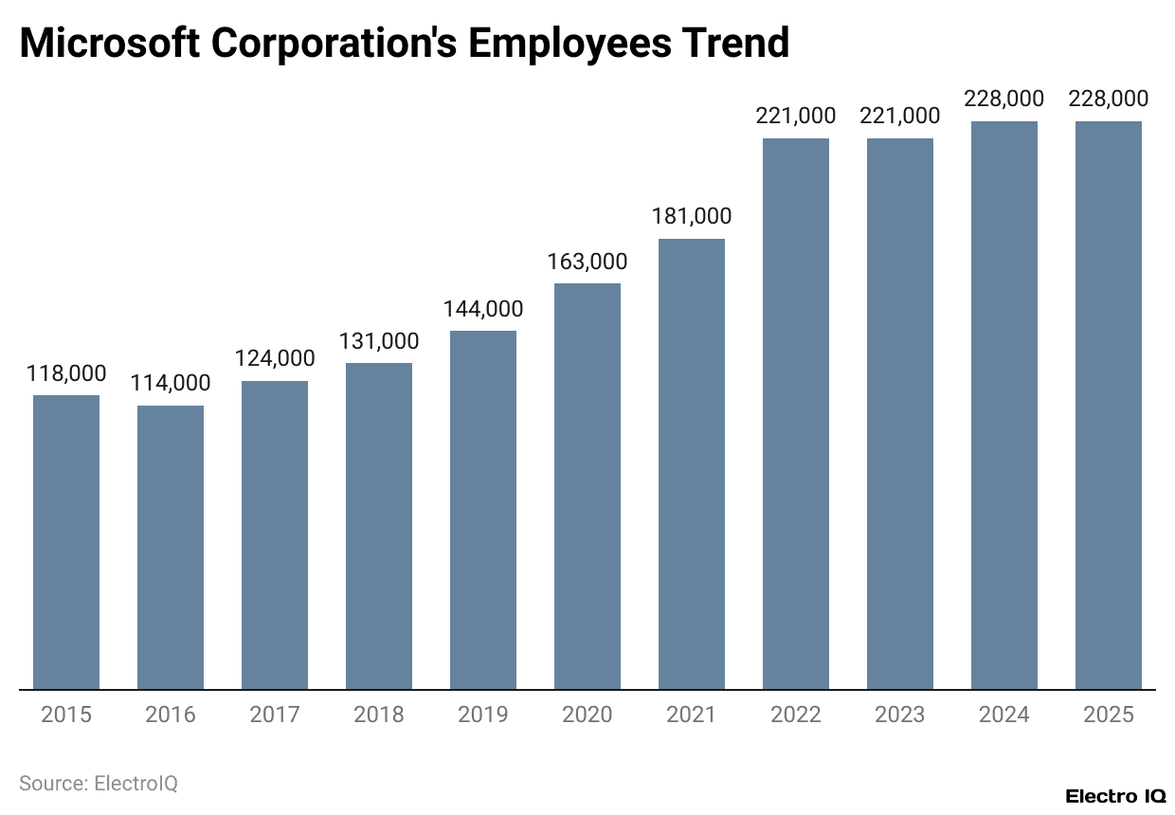

Figure 2.4: Employee retention in Microsoft
(Source: Tajammul Pangarkar, 2025)

2.2.3 Key Performance Appraisal Factors Influencing Employee Motivation
The fair compensation and positive work environment is the most necessary performance appraisal factor that abruptly impacted employee motivation cavity in organization. As per the view of Akanmu, Panatik and Shahrin (2025), the use of effective appraisals ensure future growth that boost the moral value of employees with higher engagement rates in organisations. On the other hand, the organisations also adopt appraisal techniques for enhancing the leadership qualities of the workers, that also strengthens the staff relationship of the company.
On the other hand Setyawati, Woelandari and Rianto (2022), promotion, career development and training is more reliable to improve work performance of the organisation through intrinsic achievement and recognition. This intrinsic achievement has been addressed through improving skills of employees leading to higher productivity in the organisation which encounters clear growth. It has been addressed that 24% of the profit margin rises due to companies investment on training which in turn enhances overall retention rate (Gutierrez, 2019). This retention is due to engagement of the skilled worker which is more responsible for developing ROI of business. For example, Walmart covers the cost associated with CDL by the ability to invest $4,000 to $5,000 and signing bonuses for the hired employees (Baertlein and McLymore, 2022). As stated by Hamzah and Matkhairuddin (2022) the extrinsic feedback provided to employees by ability to follow consistent organisational rules which enhance employee motivation. Continuous feedback, leadership opportunities For example the uprising of employee retention up 3.17 % from 2023 reflects confidence in performance and future prospects in Microsoft. The shifting of total 81,000 staff in product R&D (up 12.50 %) also suggests appraisals favour creative and high‑value work (Tajammul Pangarkar, 2025). Further, another important appraisal factor are One‑time cash bonuses, generous benefits, unlimited PTO, and educational support helpful for improving employee growth with higher motivational activity in employees. Hence, this structural orientation also provides more value to employees and ensures greater productivity quality performance standard in organization. Overall, These patterns indicate that consistent growth, especially in innovation‑oriented roles, along with rewards and benefits in organization
Communication has been considered as an important factor that has helped organisations in enhancing the motivation level of its workers. According to Alkhatib (2025), the companies adopt communication techniques for enhancing its worker relationship that also improves the productivity of its staff. The organisations have stressed upon developing platforms for ensuring smooth flow of business information to the employees. For instance, Tesco has invested $50m in developing programmes such as “Zendesk” that has helped the workers in communicating personal and professional issues to the management authorities in 2024 (Tesco, 2024) The initiative has also helped the supermarket company in developing organisational loyalty among its workers. On the other hand, BP Plc has collaborated with Axios worth $4m for developing platforms such as "Smart Brevity” that has helped the organisation in acquiring knowledge regarding its employee productivity in 2024 (Li, Trencher and Asuka, 2024). The availability of storing communication techniques has helped companies in overcoming market uncertainties.

2.2.4 Challenges and Limitations of Current Performance Appraisal Systems
Employee dissatisfaction is one of the major appraisal system issues that abruptly impacted the current performance measurement value of the organisation. According to Joo, Kong and Atwater (2024), gender and diversity disparities also impact the employee retention system of the organization. For instance, 65.9% of employees were men and Latinx employees held only 4.3% of U.S. leadership roles. More rapid examples of organization into more than 70 offices with 200 cities also make gaps in the feedback appraisal system (Pangarkar, 2025a). As a result, employees are also reduced with a rapid rate of 0.44% with an approximate value of 183,323. On another hand, frequent complaint rate is another major issue associated with employees that reduce appraisal system advocacy in organization (Yang, Ma and Li, 2023). For instance, DXC technology firms in the UK also face this kind of issue about employee complaints regarding lack of consideration of career progression in the organisation (Glassdoor, 2024). Hence, this issue directly aligns with promotional gaps and lack of effectiveness in managing employee retention policy in organisations. The redundancy of carrier plan also be reduce moral value of employee directly make influence negative of internal working environment effectively. Overall, carrier progression initiative is most necessary to acquire optimal growth and ensure better employee retention position of organisation effectively.
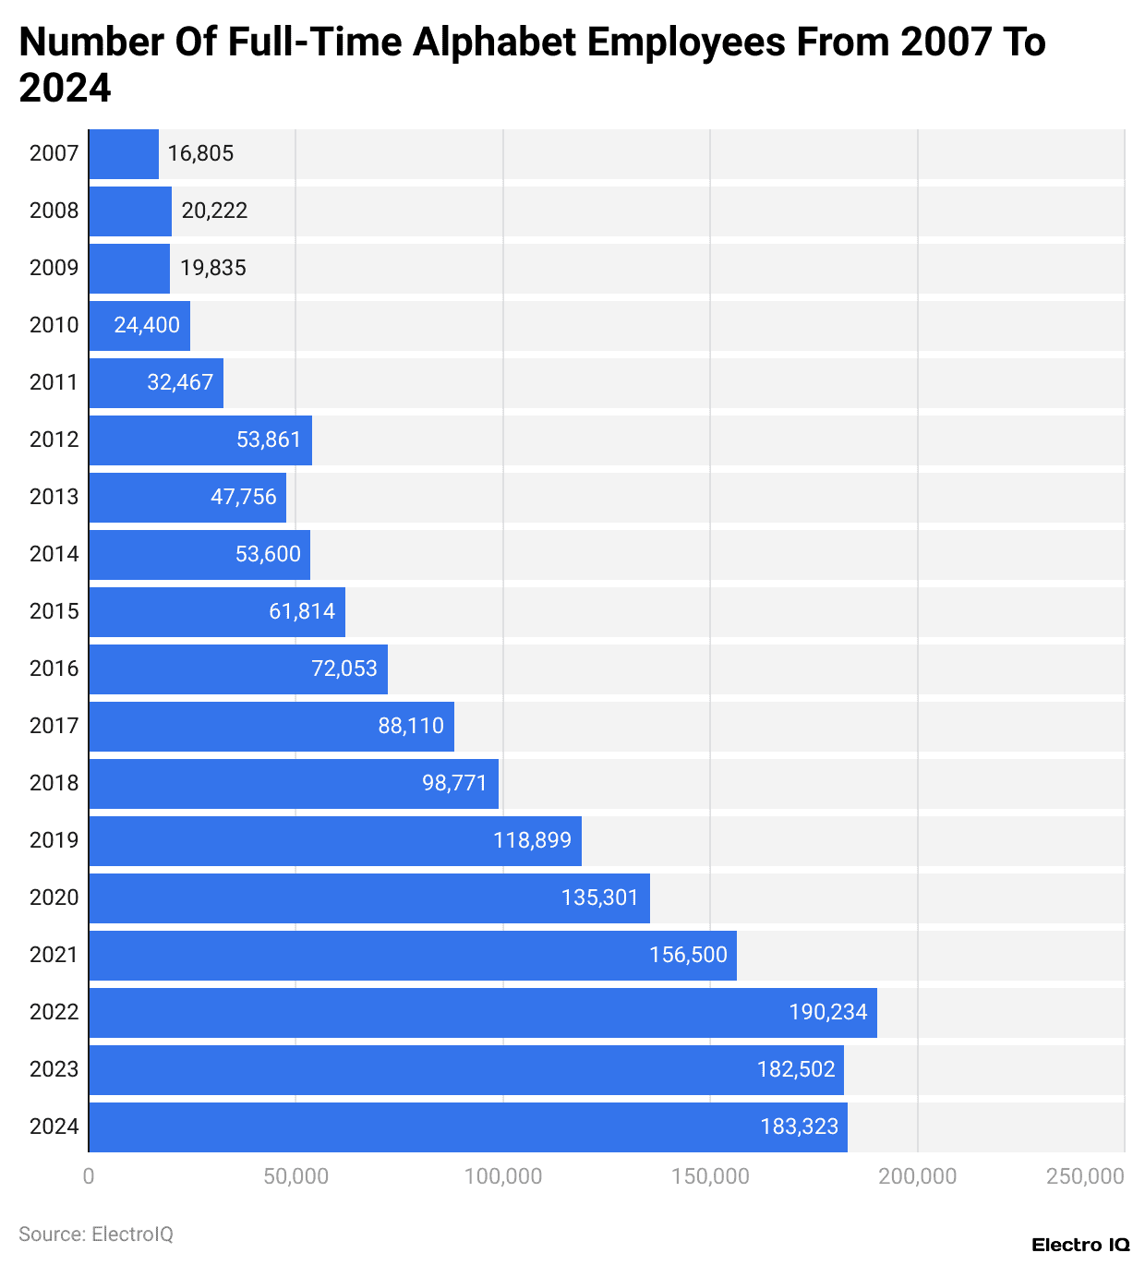

Figure 2.5: Engagement rate Google
(Source: Pangarkar, 2025a)
Gender bias has also been considered as a critical issue that has hampered the efficiency of the performance appraisal techniques of the organisation. In companies such as Microsoft, around 26% of the leadership roles have been provided to female workers (Richter, 2025). On the other hand, 24% of technical jobs in Facebook have been achieved by women employees in 2025 (Richter, 2025). The absence of adequate employment opportunities has reduced the engagement level of the female workforce of organisations. The fair gender diversity index also effectively improves the key scenario of employment and maintains a more balanced internal environment in organisations. However, relatively low proportions also indicate persistent structural and cultural barriers among team management of organisations. In addition, the existence of layoffs has also been a challenge that reduced the popularity of the appraisal system among the workers. For example, Apple Inc has implemented 300 sales job cuts to reduce its operational cost in 2025 (Reuters, 2025). These abrupt job cuts also have a key impact on the managerial system of employees and directly influence the maintain balance of infrastructure to better acknowledge the working environment. Overall, the enhancement in employment losses has reduced the productivity of the workers.
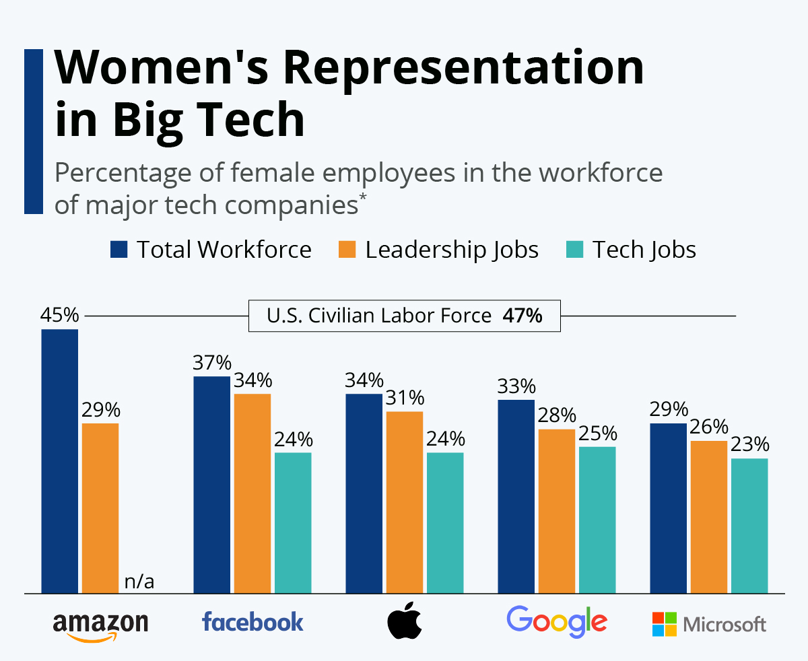

Figure 2.6: Jobs for Female Workers
(Source: Richter, 2025)

2.2.5 Organisational Implications of Ineffective Appraisal Practices
The absence of appraisal practices has reduced the goodwill of the organisation among its employees. For instance, the wage value of BP Plc has been reduced to £5.4m due to the lowering of its manufacturing expenses in 2024 (Davies, 2025). The reduction in the employee incentives has also hampered the productivity of the organisation. BP Plc has reduced its sales value from $250000m in 2023 to around $150000m in 2024 (Market Screener, 2024). The lowering of the income has also hampered the financial growth of the organisation. On the other hand, Shell Plc has also reduced the value of its hourly wages from $15 in 2023 to around $13.5 in 2024 (Nasralla, 2025). The reduction in the employee income has reduced the engagement level of the workers and also hampered the product quality of the organisation. In addition, Shell Plc has also implemented 500 job cuts with an intent to reduce its operational cost by $3bn in 2024 (Financial Times, 2026). The adoption of the layoff strategy has also hampered the worker relationship of the company that has hampered its product quality significantly.
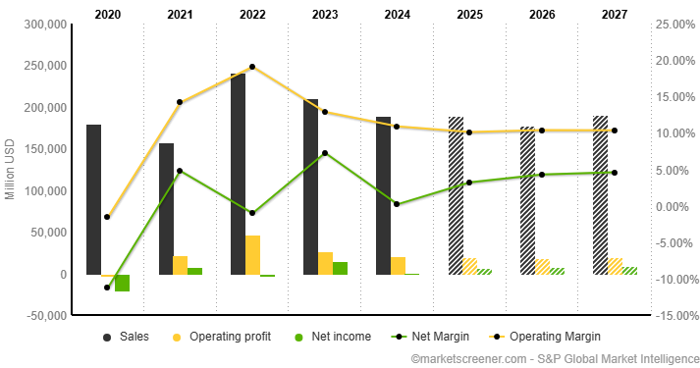

Figure 2.7: Sales of BP Plc
(Source: Market Screener, 2024).
The organization implementation towards managing key employee motivation through different appraisal systems also ensures high reliance on productivity performance. However, deprivation of appraisal directly impacts the operational revenue structure of the organization effectively (Hamidi, 2023). In addition, the absence of a proper reward system also reduces the goodwill of the organisation among its workers. The decline in the appraisal initiatives also reduces the engagement level of the employees that in turn lowers the productivity of the company. For instance, Meta’s extensive employee benefits and diverse workforce have significant implications for organizational performance and employee motivation. On the contrary it is also ascertained that formal appraisal also be less pressure abstained among employees with reducing burnout rate from organization (Guzaiz, 2025). Thus, employees of Facebook (Meta) also be face valued due to the key organizational implications such as perks like on-site clinics, free meals, $2,000 bonuses, wellness reimbursements, comprehensive health coverage, and generous parental leave (SEO, 2024). The absence of the perks mentioned above has reduced the efficiency of the workers that has hampered the service quality of Meta significantly. In addition, the company has also implemented 600 job cuts with an intent to include robotics in its business operations in 2025 (Wagner, 2025). Hence this key implication of Meta also be helpful to maintain a strong employment base of about 22.2% growth from previous year progression. Also, fair division of workforce policy enables more strategic implication for organizations towards maintaining resolution regulatory enforcement standards (SEO, 2024). Thus, women hold 35% of executive roles, minorities 32%, and 44% of the workforce is female. Also enhancing organizational structural criteria for expedition will enable long term growth. The availability of gender equality in the work environment has helped organisations in ensuring smooth execution of its business operations.

2.2.6 Strategic Approaches to Improve Performance Appraisal and Enhance Employee Motivation
The availability of a flexible reward structure has helped companies in evaluating its employee performance and improve its product quality. According to Muhammad et al. (2025), the existence of appraisal schemes helps organizations in enhancing the motivation level of its workers and also ensures timely completion of business projects. On the other hand, the enhancement in employee motivation has helped companies in overcoming market issues (Iqbal et al., 2019). The companies have emphasised on adopting reward schemes for improving the skills of its workers. For example, Sainsbury has invested $20m in developing platforms such as “MySainsbury” that has provided incentives to employees on achieving sales targets in 2024 (Searles, 2025). The initiative has also assisted the organisation in improving its worker relationship and also enhancing its product quality.
As stated by Imran, Ghazwan and Firmansyah (2024), enhancing motivation of employees has been addressed through adoption of inclusive performance, personalised development model and “real-time recognition”. The personalised development plan enhances employee performance by ability to align with the individual goals. This helps employees to enhance engagement by servicing proper clarity in achieving career ambition. On the other hand (), Equity, Diversity and Inclusion is more reliable to enhance transparency and fairness in the workplace which leads to a high rate of hiring. For example, Unilever serves employees with “equal pay” opportunities by servicing clear reward policies which have its massive contribution in maintaining an inclusive culture. In managing the global workforce, equality among women is about $28 trillion in 2025 by showcasing its massive influence in driving changes in business (Unilever PLC, 2023). Thus, transformation in performance focuses on future oriented development which encounters personal growth of employees.
The improvement of appraisal capability is also helpful to enhance employees through use tailoring strategies in maintaining workforce realties. Thus, wage rescheduling in following different aspects such as peak hour product and slow product criteria also enable the engagement rate of employees more effectively. For instance, Amazon’s peak-season hiring of 250,000 employees in 2024, combined with a minimum wage of US$18/hour, flexible scheduling, and healthcare eligibility after 90 days. As this interrogation of specialized benefits assure a higher retention capability in peak hours season of Amazon. In addition organizations also benefit through adoption of diverse growth segments in the workforce such as including 31.9% White, 26.1% Black, and 16.6% Asian employees. On the other hand, Tesla will maintain diversity in workforce engagement towards better static formulation of appraisal systems. As this proportion also be issued 80% male, 22% female, 51.5% White, 23.7% Hispanic/Latino for maintaining bias culture in internal workforce management (Dey, 2024).
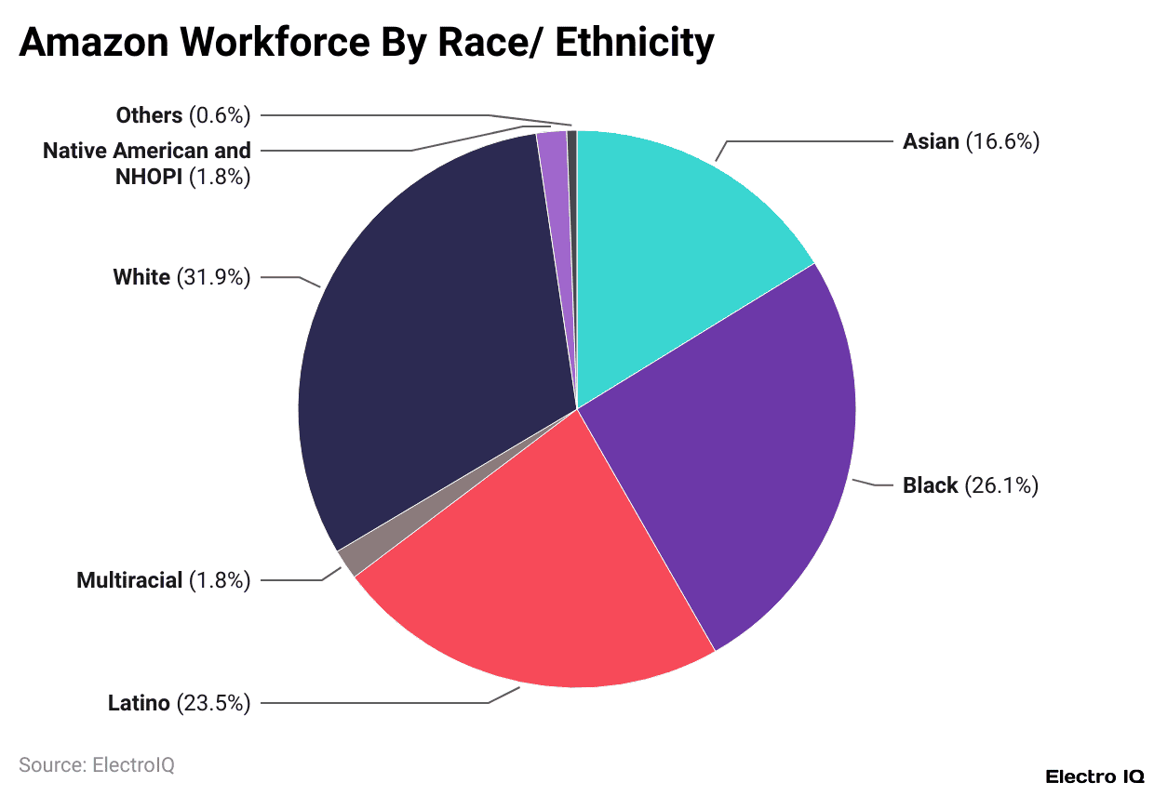

Figure 2.8: Workforce ethnicity in Amazon
(Source: Dey, 2025)
Critical Summary
The performance analysis system has helped organisations in improving the engagement level of the workers. In addition, the technique has also provided the opportunity to the organisations in monitoring the contributions of its workers in completing its business projects. On the other hand, the adoption of the performance analysis initiative has also raised bias issues among the company that has also lowered the engagement level of the workers. Overall, the inclusion of the analytical process has helped organisations in improving its worker relationships.

2.3 Theoretical Framework
Goal-Setting Theory
The goal setting theory was fully developed by Locke and Latham in 1990 with the illustration that employees are highly compatible as key environments of clear, specific, and challenging goals regarding organization (Raju, 2021). In development of appraisal systems, measurement of KPI and target value for separate employees helpful for identification of individual growth performance triggers for organization. Hence, this appraisal base system also highly acknowledges individual growth performance through use of goal setting theory aspect in improving performance relevance effectively. For example, Amazon is also using this concept by converting one-third of seasonal employees into permanent roles to strengthen the structure of the organization. In addition, the organisation has also invested $2.5bn in developing the “Amazon Technical Apprenticeship Programme” that has helped in providing digital training to university students in 2024 (Galetti, 2025). The initiative has helped the e-commerce company in improving its brand loyalty among the customers. Also, the key prioritisation of existing workforce to convert into permanent roles improves the motivation level of employees to meet proper KPI standards and establish work performance. For example, Coca-Cola has increased its permanent workforce from 65000 employees in 2024 to 69000 workers in 2025 (Statista , 2025). The enhancement in the staff volume has helped the beverage company in improving its product quality and enhancing operational goodwill among the customers. In addition, the improvement in the workforce has also assisted Coca-Cola in acquiring a competitive advantage over other organisations. Overall, it will also strengthen the performance system with ensuring engagement during peak seasons.
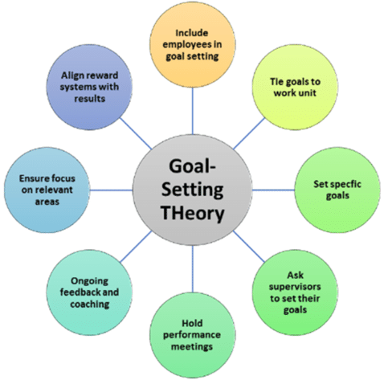

Figure 2.9: Key aspect of goal setting theory
(Source: Raju, 2021)
Equity Theory
The equity theory is an important technique that helps organisations in enhancing its workplace harmony and ensuring smooth execution of business operations. According to Chen et al. (2023), the framework emphasises on the inclusion of fair incentive structure and growth opportunities in the organisational structure of companies for enhancing the engagement level of its employees. The elements of this theory help to assess the appraisal served to the employees based on accessing their performance through salary increment and formal recognition. This in term enhances transparency in the organisation by ability to deal with inequality in the workplace. The compensation provided to the employees include non-monetary and monetary rewards that are designed to attract right talent which in term encounter work-life balance. The long waiting hours in the work leads to high rise of salary by serving career development and promotional opportunities which leads to increases in job satisfaction in achieving organisational commitment through constructive feedback.
The organisations have stressed upon including developmental programmes for improving the working knowledge of its staff. Hence, the appraisal base activity also ensures better harmonisation towards governing employee appraisal proposals which make biased decisions in business operations. For example, Tesco has invested $50m in developing the “Leadership Development Programme (OPTIONS)” for improving the communication level and digital skills of its workers in 2025 (Tesco, 2023). The initiative has also assisted the organisation in enhancing the leadership qualities of its workers. Overall, the adoption of the equity theory has helped companies in improving loyalty among its workforce.
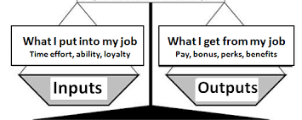

Figure 2.10: Equity Theory
(Source: Joy, 2018)
Expectancy Theory
The expectancy theory is an important aspect that helps companies in developing a proper understanding regarding the financial and non-financial requirements of its workers. According to Hunter, Ferreira and Prochaska (2025), the framework emphasises on providing information regarding the needs of the organisation and its workers that also improves the organisation harmony of the company. The acquisition of the knowledge regarding the expectations of the workers also assists companies in reducing the occurrence of operational delays effectively. As this structural governance also be helpful to maintain appraisal based activity with acknowledgement of employee growth disparity for better retention in an effective manner. For example, Tesla has increased the hourly wages of its workers from $14 in 2023 to $15.5 in 2024 (Reuters, 2024). The enhancement in the incentive value has also helped in improving the employee productivity of the organisation. Tesla has enhanced the value of its revenue from $11.8bn in 2017 to around $97.7bn in 2024 (Roadgenius, 2024). The improvement in the business income has helped the organisation in acquiring a competitive advantage over other organizations. In addition, Tesla has invested $13m in developing the “START Programme” that has helped the organisation in improving the communication and leadership skills of young employees in 2025. The availability of the initiative mentioned above has helped the organisation in improving its goodwill among the workforce.
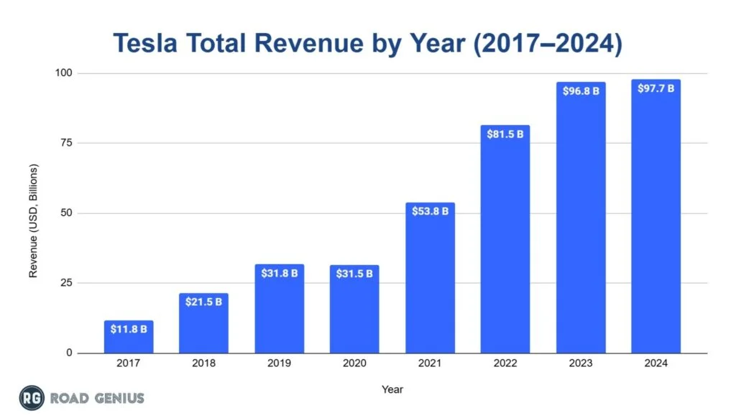

Figure 2.11: Revenue of Tesla
(Source: Roadgenius, 2024)
Critical summary
Based on the above discussion, the goal-setting theory has helped workers in developing small targets and enhancing individual productivity for the organisation. On the other hand, the inclusion of equity framework has assisted companies in providing equal growth opportunities for workers with an intent to improve its organisational harmony. In addition, the use of expectancy theory has helped organisations in meeting the financial and operational needs of its workers.

2.4 Conceptual framework
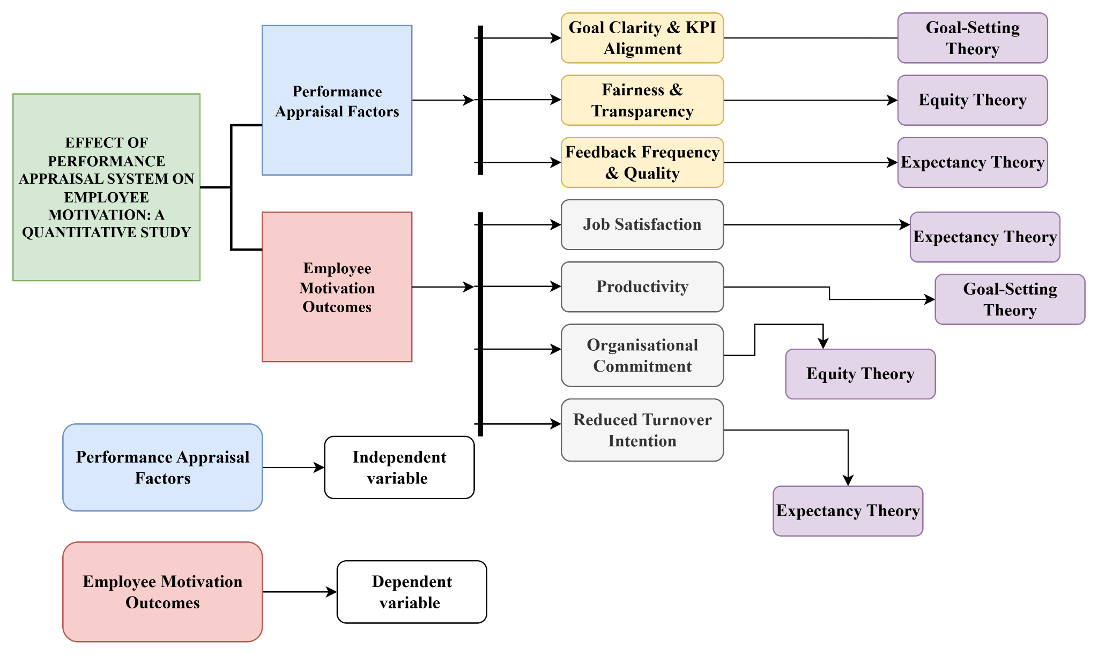

Figure 2.12: Conceptual framework
(Source: Self-developed)
As per the above figure, employee motivation and appraisal techniques have been considered as important aspects that have helped organizations in monitoring the progress of its employees. On the other hand, job satisfaction, operational transparency and feedback mechanism has also assisted companies in improving the engagement level of its workers. In addition, the existence of theoretical frameworks such as the Equity, Expectancy and Goal-Setting Models has helped the employees in developing a proper understanding regarding the initiatives undertaken by enterprises for improving individual productivity. The theories have also discussed the organisational commitment of the companies towards the development of its workers.
Article | Summarising literature
(Hamidi, 2023) | The article generally summarizes that appraisal systems also improve job satisfaction rate and improve behavioral setting in a global manner. It highlights that fair, accurate evaluations enhance motivation and satisfaction, while biased appraisals reduce commitment. It underscores HRM’s role, organizational culture, and the importance of effective appraisal systems, especially in the public sector.
(Chen et al. 2023), | The article provides details regarding the importance of equity theory for enhancing employee relations of the organisation. In addition, the study also provides details regarding the initiatives adopted by companies such as incentive structure for enhancing the productivity of the workers.
(Muhammad et al., 2025) | The study shows that fair performance appraisals significantly improve employee satisfaction and performance at Nigeria’s Teachers Service Commission. In addition, finding appraisal fairness partially mediates this relationship, highlighting the need for transparent, well-structured appraisal policies to strengthen motivation, engagement, and organizational effectiveness.
(Joy, 2018) | As per the discussions in the concerned article, the adoption of the quality theory has helped companies in enhancing organisational harmony in its business environment. The improvement in the working conditions has also assisted organisations in improving its productivity.
(Vuong and Nguyen, 2022) | The article also revealed the negative consequences of direct impact of decision making approaching an organization. Hence, higher management in internal organizations also causes indulgent pressure among employees. As it recognises lower retention rate in organization with impacting productivity of organisation.
(Joo, Kong and Atwater, 2024), | The article provides details regarding the importance of including gender diversity techniques for ensuring smooth completion of business operations. In addition, the study also focuses on enhancing employment opportunities for male and female employees with an intent to improve organisational productivity.
(Woerkom and Kroon, 2020) | Strengths-based performance appraisal also be helpful to focus on with better managing, appreciating, and developing employee’s qualities in line with the company goals. Hence, use of self determination theory can also be rectified so that individual performance measures also be better acknowledged about KPI rate of organization.
(Raju, 2021) | The article discusses the importance of the goal setting theory for employees to achieve professional growth. On the other hand, the article also emphasises on the need to develop a flexible work environment for enhancing operational productivity.
(Canet-Giner et al., 2019) | Performance appraisal significantly s innovative behavior by linking individual goals to organizational objectives. Hence, this collaborative approach with measuring employee perception also be helpful to consistency in HRM systems strengthening clarity, feedback, and expectations.
(Alkhatib, 2025) | The article helps in providing information regarding the importance of strengthening employee communication for organisations to ensure timely completion of business projects. On the other hand, the study also focuses on improving communication of organisations for improving worker productivity.

Table 2.1: Discussion summary
(Source: Self-developed)
Critical summary
This section discusses the conceptual framework assisted with the topic by addressing a clear link with performance appraisal system with employee motivation with showcasing proper setting with goal setting, expectancy and equity theory. The outcome of the dependent variable has been addressed through external rewards, intrinsic satisfaction and willingness to achieve organizational goals. Thus, perceived fairness has a positive impact on employee satisfaction related to job. This section provides proper analysis by linking it with research objectives by showcasing positive impact of performance appraisal system, employee motivation and constructive feedback enhance employee engagement. The core finding showcases that clarity and fairness is more responsible for appraisal by showcasing positive impact of employee motivation.

2.5 Conclusion
Based on the key context it is also concluded that an effective appraisal system is also helpful to manage the better employee engagement rate in organizations. Hence, the global organizational aspect also revealed that the use of seasonal employee scenarios and diversified strength of employees towards permanent segments also improve the motivational level of employees. Thus, existing employees also get an opportunity to enable higher positions in the organization. Further, perks and allocated health segments and reduced absenteeism are also one of the most important factors that increase employee management with a strength based appraisal system.

Chapter 3: Methodology

3.1 Introduction
The research method is the process of interpreting and analysing data that have categorized based on secondary results. The Saunders research onion helps in serving comprehensive knowledge related to research topic by right uses of research method, philosophy, research design and data collection process by showcasing significant effects regarding employee motivation which enhance job satisfaction.
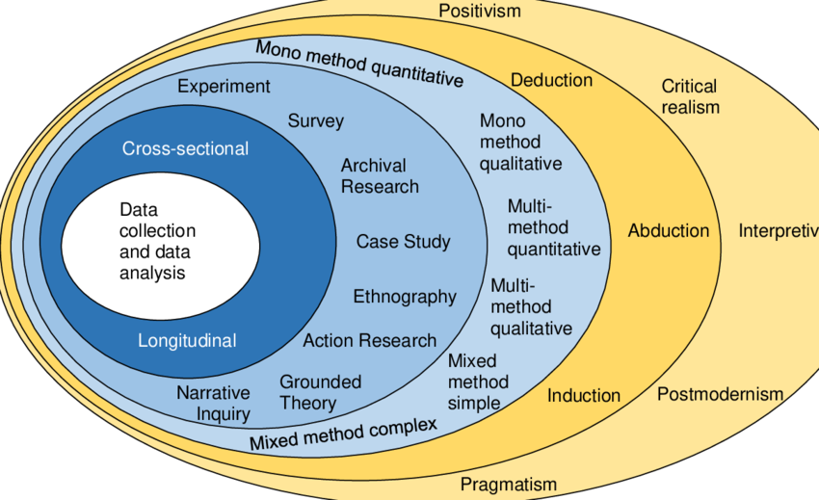

Figure 3.1: Saunders research onion
(Source: Hendry, 2022)

3.2 Research design
Research design helps to analyse data that address through accessing research objectives to showcase cohesive research processes in research insights (Khanday and Khanam, 2023). The impact of research design helps to analyse errors which encounter reliability and validity by

reduction of bias. For this research, the exploratory research design is more reliable that has its massive alignment with research objectives by ability to analyse the nature of research. As stated by Saka, Chinagozi and Joe (2023), exploratory research design is flexible to address unclear problems. The uses of this selected research design help to verify research questions by showcasing flexibility. The use of interpretivist research philosophy helps in providing potential results that address participants' perspectives (Pervin and Mokhtar, 2022). On the other hand, the adoption of the interpretivism research philosophy also helps in providing information regarding the social contribution of the topic that also enhances the quality of the research work. The expansion of the database also improves the quality of the investigation process that increases the goodwill of the evaluation process. The selection of this philosophy showcasing constructive results by uncovering an overall complex process to gather meaningful insights. The inductive research approach is more reliable for this research by the ability to develop new theories that have its proper alignment with research (Mohammed, 2024). In addition, the inclusion of the inductive research approach also helps in enhancing the database of the investigation process by providing generic and specific information regarding the topic. On the other hand, the technique also enhances the accuracy of the research by utilising updated information regarding the topic. This selection of this chosen approach, design , and philosophy is more reliable to analyse the relationship among performance appraisal with employment motivation by relying on feedback, transparency and feedback. This in term enhances self-efficacy by showcasing its alignment with employee motivation.

3.3 Data collection method
For this research, the secondary qualitative data collection process is more relevant to address clear expectations in analysing individual alignment with work. The secondary data collected for this research follow exclusion and exclusion criteria which are associated with the research topic (Wickham, 2020). The data collected for this research are from authentic sources that have proper DOI number, relevant to the research topic and acknowledgement of the author are addressed throughout the research. The authentic data sources are addressed based on re-analysing data that have its ability to achieve research objectives which have its massive relevance to encounter validity of research. The inclusion criteria is followed throughout the research by ability to analyse

data through efficient interpretation. Although, the uses of annual reports, newspaper, and government reports are used throughout the research which are not more than 10 years old.

Inclusion Criteria | Exclusion Criteria
- The publication of the articles taken from 2015 which have its proper relevance in achieving objectives. | - The publication of the article before 2015 has not been used in the research by encountering its credibility in the market.
- Article without subscription are taken by following reliability after marriage | - The subscription based articles are excluded due to ineffective data accessibility and authenticity by focusing on development of employees through intrinsic motivation.
- Journal and Articles have its direct relevance by addressing perceived needs of the performance appraisal system which enhance career development | - Journals and articles excluded from this research due to its lack of relevance.
- Article written in English are included for this research | - Articles written in other languages are excluded which hamper reliability.
- Journal have proper DOI number, author name, publication date by encountering its relevance related to research topic | - Journals having no DOI number, author name and publication date are not included in the research.

Table 3.1: Exclusion and inclusion criteria
(Source: Self-developed)

3.4 Data sources used in research
Data sources are an important aspect that helps in enhancing the quality and viability of the research work. According to Li et al. (2021), the method involves the inclusion of critical information regarding the topic that ensures timely completion of the investigation process. The data source involved in the current research includes journal articles from publishing houses such as “ResearchGate, MDPI and ScienceDirect”. In addition, information has also been included from newspapers such as “The Economic Times and The Guardian”. The keywords associated with the topic for finding the articles are performance appraisal, employee motivation, job satisfaction, employee engagement, productivity, organisational commitment and goal setting activities. The different sectoral reports, news paper, journals, annual reports of the company are used to analyse the employee performance and HR policies in the organisation. The published journal provides proper evidence related to appraisal served to employees based on their performance. The availability of diversified data sources has helped in enhancing the quality of the research work.

3.5 Data analysis and about linking process
For this research, the thematic analysis is more reliable to analyse the relationship among employee motivation with Performance appraisal. As stated by Ahmed et al. (2025), the thematic analysis helps in showcasing a flexible approach by ability to draw out meaningful insights. The development of the themes have been addressed through “Braun and Clarke's” process by showcasing overall findings associated with research questions. The application of thematic analysis systematically analyses the pattern of the qualitative data that address based on accessing user experiences and opinion to gather insights. It helps to address changes by ability to analyse consumer perception through familiarising with data, generating code, searching for themes and through efficient reviewing by showcasing proper efficiency of data. The generation of the themes have its proper linkage with research objectives through generating codes which enhance accessibility through insight generation. This enhances overall flexibility by reviewing themes and showcases rigorous finding through quality assessment of data through efficient data extraction. The selection of the theme has been addressed through uses of colour coding tables which have been categorized based on frequency. The data collected for this research serve different benefits

that are highlighted based on different colour to analyse the motivational impact on performance of employee and process-oriented people enhance accuracy.

3.6 Limitation
Limitations | Description
Absence of Real-Time Data | The inclusion of secondary qualitative methods reduces the existence of real-time information such as consumer responses that has an adverse impact on the quality of the investigation process. In addition, the absence of primary information also lowers the accuracy of the analytical process effectively.
Inclusion of Generic Information | The adoption of secondary qualitative techniques enhances the database of the investigation process that also reduces the availability of critical information regarding the topic. Overall, the absence of accurate information also lowers the quality of the investigation process.
Absence of statistical data | The secondary qualitative method includes the use of descriptive information regarding the topic and provides limited information regarding the application of financial data about the topic. Overall, the absence of statistical information has reduced the accuracy level of secondary methods in the investigation process.

Table 3.2: Limitations of Secondary Qualitative Methods
(Source: Self-developed)
Justification for including Secondary Data
The secondary qualitative data emphasises on including reliable information regarding the topic from journal articles that also improves the authenticity of the investigation process. In addition, the inclusion of secondary information also provides detailed analysis about the performance appraisal methods that also enhances the quality of the research work. Overall, the use of the techniques mentioned above has improved the viability of the investigation process.

3.7 Ethical consideration
- The research has involved the use of authentic information from journal articles such as ScienceDirect, MDPI and Frontiers for improving the quality of the investigation process.
- The investigation has also adopted the guidelines of the Copyright Act 2012 for ensuring smooth completion of the research work.
- The research work does not include any information that causes harm to the sentiments of any section of the society.
- The analysis also causes no harm to any living beings that has also improved the goodwill of the investigation process.
- The investigation has also included information from newspaper articles such as “BBC, Guardian and Economic Times”.

3.8 Summary
The inclusion of the secondary qualitative method has helped in providing a detailed discussion on the importance of the performance appraisal system in enhancing the engagement level of employees. Overall, the use of secondary techniques has helped in improving the quality of the investigation process significantly. From the overall analysis, it has been addressed that the adoption of the secondary sources is more suited by use of exploratory research design, Indicative research approach and interpretivist research philosophy have been used to analyse the impact of employee performance that varies based on appraisal served to them. Copyright Act, proper acknowledgement and informed consent of the author are followed throughout the research.

Chapter 4: Finding and Discussion

4.1 Introduction
This chapter discusses the results that are addressed through thematic analysis by ability to analyse the overall trends of the data. The finding chapter interprets the data in a logical manner by linking it with research objectives and literature which showcases its direct outcome. The relevance of discussion chapters help to interpret raw data through uses of Braun and Clarke's process which is more reliable to carry out significant results. The discussion chapter interprets the result by examining the significance of linkage and connecting it with research questions. The broader significance of findings with its relevance to research objectives are discussed through practical contribution.

4.2 Thematic analysis
Objectives | Authors’ Name | Extract | Coding
Objective 1 | (Idowu, 2017)  (Lalwani , 2024) | “Performance appraisal is a widely discussed concept in the field of performance management”.  “In today’s competitive business landscape, understanding and addressing the factors that contribute to employee satisfaction is crucial for organizational success and the overall well-being of employees”. | - Appraisal accuracy  - Employee satisfaction
Objective 2 | (Akanmu, Panatik and Shahrin, 2025) | “Employee engagement is an important subject in management theory and practice. Despite lacking a trustworthy standard, the idea, theory, influencing factors, and outcomes of employee engagement continue to diverge greatly” | - Employee Engagement  - Management Practices
Objective 3 | (Urbancová, Vrabcová and Pacáková, 2024)  (Elrayah and Semlali, 2023) | “This study contributes to theory and practice by confirming that feedback from employees is a tool for their stabilisation. The managerial implications include the finding that effective feedback settings help prevent conflicts in organisations”.  “Human resource management (HRM) functions, such as recruitment, selection, training, and rewards, have been affected by these environmental forces”. | - Employee Feedback Mechanism  - Organisational Conflict  - Rewards and Training  - Recruitment and Selection
Objective 4 | (Subramaniam et al., 2024) | “The high volume of interactions and resultant stress lead to employee burnout, impacting attendance and performance and contributing to a high turnover rate among staff”. | - stress

Table 4.1: Theme coding
(Source: Self-developed)
Colour | Representation
Red | Less important factors
Yellow | Moderately important factors
Green | Most important factors

Table 4.2: Colour coding
(Source: Self-developed)
Codes | Themes
- Appraisal accuracy  - Employee satisfaction | Effectiveness of Performance Appraisal Systems in Organisational Practice
- Workforce Motivation  - Employee Engagement | Performance Appraisal Practices on Employee Motivation
- Structured Work Planning  - Recognition | Role of Goal Setting and Performance Feedback in Enhancing Motivation
- Perceived fairness  - Transparency of criteria | Fairness, Transparency, and Objectivity in Performance Appraisal Processes
- Financial rewards  - Promotion opportunities | Impact of Reward and Recognition Linked to Appraisal Outcomes
- Stress  - Demotivation | Employee-Perceived Challenges of the Existing Performance Appraisal System
- Technology-enabled appraisal  - Appraiser training | Strategies for Improving Performance Appraisal Systems to Enhance Employee Motivation

Table 4.3: Generation themes
(Source: Self-developed)
Theme 1: Appraisal accuracy and Employee satisfaction: Effectiveness of Performance Appraisal Systems in Organisational Practice
In the current competitive era, the Performance appraisal system has its massive alignment in achieving organisational objectives through continuous feedback. As stated by Idowu (2017), the adoption of “360-degree performance appraisal” is the more important appraisal system that has its wider popularity in the larger organisation. The uses of these tools help to streamline the appraisal process of employees by serving potential feedback.
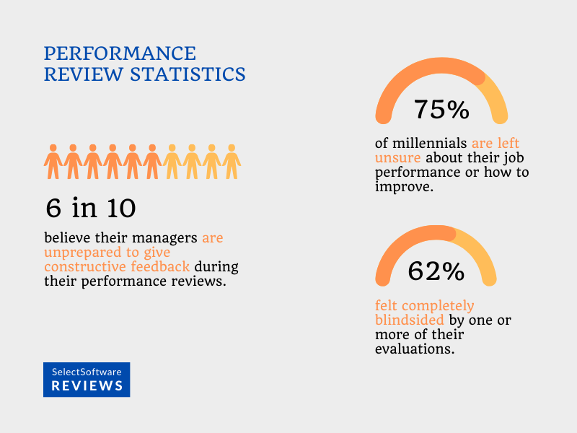

Figure 4.1: Performance review
(Source: Johnivan, 2023)
It has been found that 75% of the millennium addressed improving job performance and 6% of the people provided constructive feedback in verifying performance (Johnivan, 2023). On the other hand, Etalong and Chikeleze (2022), the appraisal accuracy encountered through the rewards mechanism by serving employees with performance-based compensation and monetary rewards enhance transparency. As stated by Lalwani (2024), the employee satisfaction at the workplace is based on job security, managing workload and organisational development. The effective appraisal system enhances employee satisfaction by ability to set clear goals and serve for compensation based on analysing their performance. For example, Asda serves employees with rewards through use of “Asda Rewards app” and serves instant discounts by shopping either online and offline (Asda, 2026). The availability of a flexible reward system has helped the retail company in improving its goodwill among the workers. Overall, the existence of a motivated workforce has assisted Asda in enhancing its product quality and strengthening its customer relationships that has also improved the competitive advantage of the organisation over its competitors.

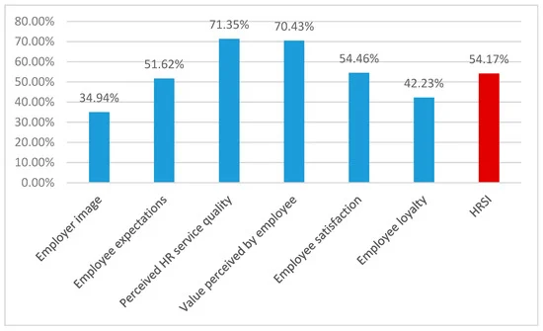

Figure 4.2: Human resource satisfaction index
(Source: Strenitzerová and Achimský, 2019)
The above graph reflected that 54.46% of the responses are based on employee satisfaction that address based on analysing wages served based on assessing their performance. The appraisal accuracy has been addressed through use of “multi-factor feedback” and through numeric rating which enhance employee satisfaction. Thus, accurate appraisal is based on skilled training provided which encounters organisational success.
Theme 2: Work motivation and Employee Engagement: Appraisal Practices on Employee Motivation
The availability of performance appraisal techniques helps organisations in enhancing the productivity of its workers. According to Akanmu, Panatik and Shahrin (2025), the improvements in the workforce enhancement practices also increase the motivation level of the workers that also ensures smooth completion of business projects. The companies have emphasised on including performance appraisal initiatives for strengthening its employee relationships. On the other hand Akanmu, Panatik and Shahrin (2025), effective appraisal practices enhance employee motivation through recognition, feedback and through growth opportunities. This by feeling them valued which have its massive alignment with in achieving company’s objectives. The acknowledgement and achievement by boosting the morale value of employees and sustaining actionable feedback which encounter organisational success.
For example, Aston Martin has developed the “Aston Martin Technical Academy” that has helped the organisation in providing machine learning training to its staff in 2024 (Aston Martin, 2025). The initiative has helped the automobile organisation in improving its product quality. Aston Martin has increased its revenue from £500m in 2020 to around £1500m in 2024 (Market Screener, 2026). The availability of a skilled workforce has helped the company in improving its product quality and overcoming market competition. On the other hand, organisations have also focused on utilising performance appraisal methods for enhancing the engagement level of its workers. BP Plc has increased its hourly wage value from $15 in 2023 to $15.5 in 2024 (Butler, 2025). The improvement in the financial income has helped the organisation in improving its brand loyalty among the workers.

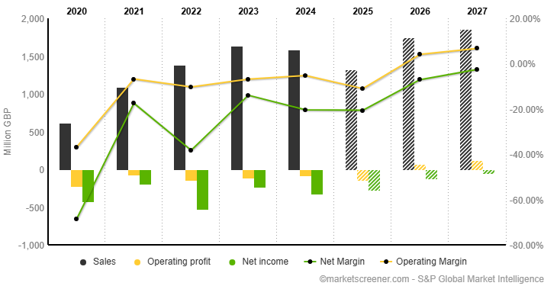

Figure 4.3: Revenue of Aston Martin
(Source: Market Screener, 2026)
Theme 3: Structured Work Planning and Recognition: Role of Goal Setting and Performance Feedback in Enhancing Motivation
The availability of feedback is an important aspect that helps organisations in improving its communication quality with its workers. As stated by Urbancová, Vrabcová and Pacáková, (2024), the aspect assists companies in developing a proper understanding regarding the issues and requirements of its workers involved in a business project. In addition, the inclusion of the feedback platforms also helps companies in developing a proper understanding regarding the strength of its employees relationships that also enhances its organisational harmony. The improvement in the popularity of the feedback platforms also helps in enhancing the productivity of the workers and the organisations. The enterprises have focused upon adopting feedback techniques for ensuring improvement in its organisational harmony. For example, Amazon has developed the “Amazon Connection” platform that has helped the organisation in monitoring the

progress of its workers regarding technical and financial skills in 2025 (LinkedIn, 2026). The availability of the feedback platform has helped the e-commerce company in improving its loyalty among the workers. Amazon has enhanced its per-employee revenue value from $359671 in 2018 to around $376908 in 2023 (Cuofano, 2024). The improvement in the business income has helped Amazon in achieving a competitive advantage over other organisations. On the other hand, companies have also focused on including a structured planning process for ensuring smooth completion of its business operations. For example, Tesco has reduced its working time by 1 hour with the intent to improve the productivity of its workers in 2025 (Grocery Gazzete, 2025). The enhancement in the work quality has helped companies in improving its popularity among the workers.
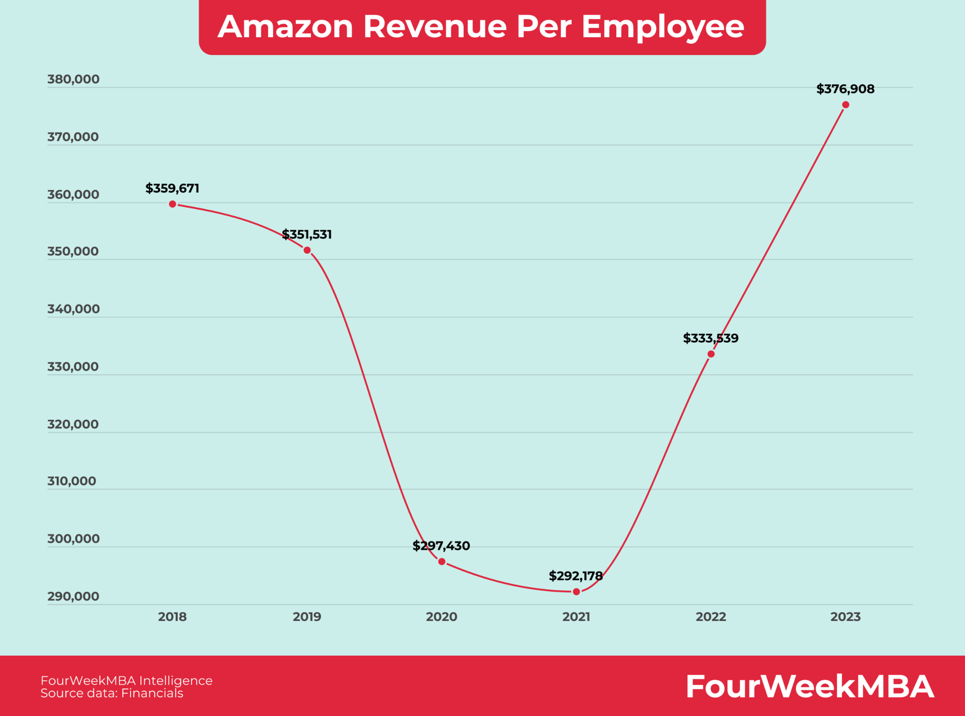

Figure 4.4: Employee Revenue of Amazon
(Source: Grocery Gazzete, 2025).

Theme 4: Perceived fairness and Transparency of criteria: Fairness, Transparency, and Objectivity in Performance Appraisal Processes
In the rapid changing era, organisations to analyse the performance evaluation of employees enhance transparency and fairness through open communication and serving equitable opportunities which encounter growth. As stated by Muhammad et al. (2025), the appraisal fairness has been addressed through analysing employee performance and work satisfaction which in term drive employee engagement. The inclusion of equality within the appraisal system also provides opportunities for employees to enhance individual productivity that also increases the productivity of the organisation. In addition, it also improves the competition level of the workers that increases the business growth of the organisations that provides a competitive advantage to the company. On the other hand Na-Nan et al. (2020), fairness showcases the positive responses and behaviour of the employees towards work which leads to increased trust and keeps employees engaged.
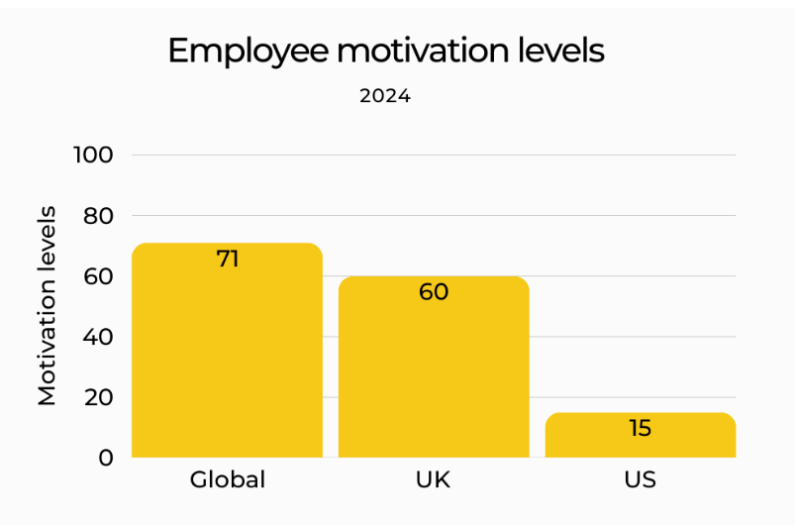

Figure 4.5: level of employee motivation
(Source: HIGH5, 2025)
The below graph reflects the level of employee motivation in 2024, as among 60% of the workers are highly motivated in the UK and 15% in the US and the global average rate is about 71% (HIGH5, 2025). Although the gender differences varies based on assessing their work flexibility, as 39% of female employees have high employee motivation as compared to 35% of male employees. For example, Tesco serves employees with competitive pay with 9.1% increases on retail colleagues in the UK and hourly wage rate is about £11.02 (Sings it, 2024). Thus, this perceived fairness leads to low turnover which showcases high employee engagement.
Theme 5: Financial rewards and Promotion opportunities: Impact of Reward and Recognition Linked to Appraisal Outcomes
The enhancement in the employee income assists companies in improving its popularity among the workers. According to Elrayah and Semlali (2023), the inclusion of financial incentives helps in enhancing the engagement level of the staff that also enhances the productivity of the organisation. The strengthening of the appraisal structures also improves the relationship of the staff and organisation. As stated by Jo and Shin (2025), the financial rewards boost the overall productivity of the organisation through clear effort which in term encounters career growth. The technology company serves achievement to the employees by serving "Innovator of the month” and provides creative contribution in showcasing innovation of business. Thus, transparency has its significant impact in managing employees by showcasing fairness in encountering continuous learning. For example, Sainsbury has developed the “Nectar Scheme’ that has provided a performance bonus worth £1500 to its employees in 2025 (Sainsbury, 2025). The improvements in the incentive structure has also enhanced the staff productivity of the retail company. Sainsbury has increased its sales growth from 3% in 2023 to 3.5% in 2024 (Market Screener, 2026a). The improvement in the employee income has helped in strengthening the financial condition of the organisation. On the other hand, organisations have also adopted promotion schemes for ensuring improvement in the engagement level of its workers. For instance, Tesco has enhanced the value of its employee wages by £180m in 2025 (Sings it, 2025). The improvement in the financial income has helped the retail company in increasing the productivity level of its workforce significantly.

Overall, the adoption of a flexible incentive structure has helped organisations in improving the engagement level of its workers in business projects.
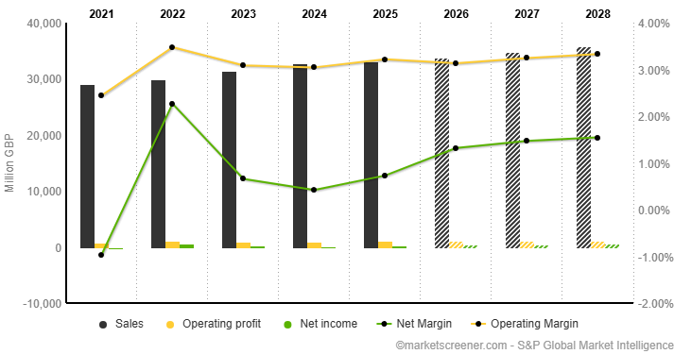

Figure 4.6: Sales Growth of Sainsbury
(Source: Market Screener, 2026a)
Theme 6: Stress and Demotivation: Employee-Perceived Challenges of the Existing Performance Appraisal System
Stress and motivation are key factors that abruptly impact the employee retention challenges associated with organisation (Subramaniam et al., 2024). In large organisations appraisal outcome is the most significant factor that is directly linked with pay increments, bonuses, and promotion decisions, increasing pressure on employees. The increase in the demotivation level also reduces the engagement level of the workers that has an adverse impact on the productivity of the organisation. The existence of stress among the employees also hampers performance quality of the workers in the company that also lowers the professional growth of the individuals. For instance, the Performance Improvement Plan (PIP) is generally a direct contribution of Amazon for improving employee appraisal outcomes effectively. In 2024, Amazon employed approximately 1,532,000 employees globally, with 1,521,000 employees in Q1 2024, increasing to 1,532,000 employees in Q2 2024 (Bosze, 2024). However, lack of employee prevention strategy

also prolonged the reduction in the employee base within a higher rate. Thus, in Meta, total employee base was also cut down with more than 10000 employees in the financial year 2023-2024 due to restructuring issues in the organisation (Paul and Balu, 2023). Hence, lack of retention strategy is directly harming the employee base with reduced product captivity in an effective manner. Maintaining a proper appraisal base system reduces the key internal working environment and builds resilience for long term growth of organisation. Overall, this factor ensures a higher success rate with reduced internal bias in the organisation and making a stable employee base.
Theme 7: Technology-enabled appraisal and Appraiser training: Strategies for Improving Performance Appraisal Systems to Enhance Employee Motivation
The performance appraisal system includes constructive criticism and positive feedback which in term boost employee engagement by driving improvement in employee performance. As stated by de Araújo et al. (2024), enhancing performance appraisal systems have been addressed through static reviews, continuous feedback models prioritising growth of employees. On the other hand, Nawaz et al. (2024), the adoption of technology enabled strategies is more effective to gather real time feedback of employees through uses of AI to encounter efficient personalization which enhances efficient career journey. Microsoft through uses of "Microsoft Glint platform” by serving feedback by showcasing opportunities and strengths through self-assessment (Microsoft, 2024). This in term enhances functionality by fostering its growth in order to enhance self-awareness. Although, enhancing transparency in the organisation by linking it with "learning management system" through continuous evolution. The technology appraisal tools are “360 Degree feedback automation”, “AI Analytics” and through uses of the cloud platform.
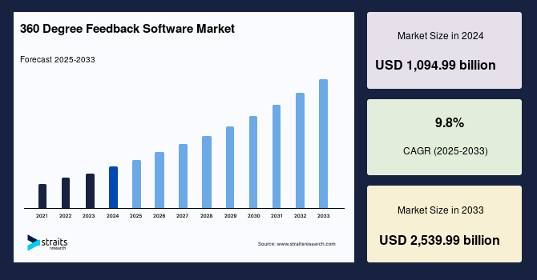

Figure 4.7: 360 degree feedback adoption rate
(Source: Warade, 2024)
The market size of 360 degree feedback software is about USD 1,094.99 with its growth rate 9.8% (Warade, 2024). The growth of the 360-degree feedback software market enhances employee development by reduction of high turnover. For example, Walmart uses the “Me Walmart app” to analyse employee performance and feedback which is more reliable for efficient career progression (Walmart, 2025). The uses of this app help to analyse customer feedback by quickly responding with the task which enhances productivity of the organisation. The digital workshops and simulation-based training” enhance employee motivation through personalisation by servicing rewards which is more effective in achieving organisational goals. The uses of technology and trained appraisers provided to the employees enhance transparency by addressing its commitment towards organisational success.

4.3 Finding
Based on the key finding from theme 1 it is also illustrated that application of transparent appraisal systems in organisations is beneficial to enhance employee satisfaction base for long term growth. The use of key methods such as “360-degree feedback and multi-factor evaluation” are most effective to explore balanced performance insight in generating better transparency of working progress of employees. It is also to present a fair progression status among employees and increasing international working environment competition among employees. In addition, the

inclusion of the performance appraisal method also improves the employee relationship of the company that also increases its product quality. The enhancement in product quality also improves the goodwill of the organisation among its customers and increases its brand loyalty significantly. Overall, increasing this appraisal base on multi-source appraisal also job security and goal clarity among employees.
As per the analysis provided in theme 2, employee engagement is an important technique that has helped companies in enhancing its organisational harmony. In addition, the organisations have also provided training infrastructures for improving the skills of its workers with an intent to increase its operational productivity. The infrastructural development has also assisted organisations in improving the skills of its workers and improving product quality. In addition, the availability of a skilled workforce has helped organisations in overcoming market competition and achieving operational stability. The inclusion of training platforms has also improved the worker relationship of the organisation. On the other hand, companies have also improved the financial income of its workers for increasing the individual engagement level in its business operations. For example, BP Plc has enhanced its wage value for rewarding the contribution of its workers in its manufacturing activities. The improvement in the employee engagement level has assisted organisations in increasing its product quality.
The discussions provided in theme 3 provides details regarding the importance of feedback processes in improving the relationship of the organisation with its workers. In addition, the evaluation also assists in identifying the initiatives adopted by companies in developing a proper understanding regarding the requirements of its workforce. For example, Amazon has acquired platforms such as “Amazon Connection” that has helped the company in improving its communication quality with its workers. The inclusion of the digital initiative has also helped the retail company in improving the productivity of the workers and promote digitalisation in its business operations. In addition, The adoption of the feedback platforms also assists organisations in developing a proper understanding regarding the requirements of its workers. Overall, the improvement in the feedback mechanism has helped companies in enhancing the productivity of its workers and strengthening organisational harmony.

The key finding from theme 4 also revealed that fairness and transparency are the most significant criteria that effectively improve the engagement level of employees. It is also to develop mutual trust for improving open communication strategy among employees in maintaining transparency positional criteria among organisations. The impact of fairness enhances employee trust by feeling valued and drives feedback which enhance organisational performance. The adoption of the multi-source techniques such as employee motivation level which enhance transparency in business. The team member communicates with the peers to enhance improvement in the appraisal process by addressing its alignment with job satisfaction. The inclusion of organisational examples such as the fair pay structure of Tesco also revealed that high transparency in maintaining employee standards in organisation. Further, performance linked reward support also be helpful to generate bias organisation structural growth based on performance level of employee. Overall, fairness and transparency are critical to ensure bias structural appraisal among employees for long-term growth.
Based on the analysis provided in theme 5, the improvements in the incentive structure has helped companies in increasing its brand loyalty among the workers. The companies have also enhanced the wages of its workers for ensuring smooth execution of its business operations. For instance, Tesco has increased its wage value with an intent to improve the engagement level of its workers in 2025. The improvement in the wage structure has also increased the financial income of the employees of Tesco. In addition, the availability of a reward system has also helped the organisations in improving the engagement level of its workers. The enhancement in the motivation level of the employees has also ensured the smooth execution of business operations for the organisations. On the other hand, the analysis has also discussed that promotion opportunities have also helped companies in improving the quality of their business projects. Overall, the availability of employee growth initiatives and flexibility in the incentive structure has helped organisations in improving its productivity.
From the theme 6, it has been addressed that employee perceived appraisal is becoming more challenging due to stress, poor feedback and demotivation in work which in term decrease the morale value of employees. This in term has its negative impact towards employees by slowing down intrinsic motivation which in term leads to rise in disengagement address through continuous feedback. Unavailability of employee prevention strategy and ineffective employee development

due to poor feedback reduced the engagement level of employees which encounter high turnover. The employee's perceived challenges have been addressed due to perceived unfairness, ineffective transparency, and negative feedback which in term affect the overall morale value of the employees. The impact of these challenges in term hampers the overall trust among employees by unfairly judging or engaging due to ineffective feedback. This in term hampers overall productivity and growth of the organisation due to demotivation in work.
This in term leads to prolonged cut down of employees at Meta due to high rises of restructuring issues which in term reduce the overall development opportunities of employees.
Based on the evaluation in theme 7, the adoption of digitalisation has helped organisations in strengthening its performance appraisal activities. The inclusion of platforms such as “AI Analytics and 360-degree feedback automation” has assisted companies in monitoring the progress of its workers effectively. The adoption of the digital techniques has helped the organisation in improving the goodwill of the workers among the organisation. In addition, the use of feedback techniques has helped companies in developing a proper understanding regarding the progress of the workers. On the other hand, organisations have also focused on improving the involvement of the workers in its business operations. For example, Walmart has developed “My Walmart Application” that has helped the organisation in monitoring the progress of its workforce. Overall, the inclusion of digitalisation has helped companies in improving their employee performance effectively.

4.4 Discuss of linking finding with research question

4.4.1 Findings Related to Research Question 1
The key finding also demonstrated strong positive relation with increasing performance appraisal directly influencing employee motivational status in organisational context. Thus, incorporation of multifactorial recognition and 360-degree feedback evaluation also increase the satisfaction level of employees. Also, inclusion of performance linked reward systems develops intrinsic motivation level of employees with channelising productivity of organisation. The key eminent organisation such as BP Plc, Tesco and Amazon also poses performance linked appraisal that turndown in growth with more value associated with positional status in industry.

Hence, key findings also reveal that fair, and transparent performance appraisal positively s employees that meet research question criteria 1.

4.4.2 Findings Related to Research Question 2
Based on the information in the findings section, employee engagement and motivation are the two important factors that affect the performance appraisal initiatives of the organisations. In addition, the organisations have also adopted the use of feedback platforms for acquiring accurate knowledge regarding issues of its workforce. On the other hand, the inclusion of a flexible incentive structure has also assisted the organisations in strengthening its worker relationships significantly. The inclusion of the training and performance bonus initiatives has helped the organisation in improving its productivity. Overall, the factors mentioned above have helped in meeting the requirements of research question 2 of the investigation process.

4.4.3 Findings Related to Research Question 3
From the research question 3, it has been addressed that employees encounter significant challenges in handling current appraisal through emotional stress, demotivation, and feedback delays. The impact of these challenges leads to high employee turnover which affects the high career development opportunities of them. The impact of toxic team culture reduces collaboration among employees which affects overall productivity of employees. The lack of retention strategy leads to encounter disengagement which leads to high turnover due to deficit in appreciation and toxic work culture. Thus, the key finding has its major linkage with research question 1 which have been met and justified.

4.4.4 Findings Related to Research Question 4
As per the discussions in the findings section, the inclusion of digital platforms such as “360-degree feedback automation” has helped the organisations in monitoring the employee contributions in its business operations. On the other hand, companies such as Walmart have developed the “My Walmart Mobile Applications” that has helped the organisation in providing financial assistance to its workers in 2025. The availability of diversified digital platforms has helped organisations in acquiring a skilled workforce significantly. Overall, the above discussions have helped in meeting the requirements of research question 4 of the investigation process.

4.5 Summary
It has been summarised that finding and discussion chapters provide proper analysis related to raw results by ability to achieve research objectives. The performance appraisal boosts employee motivation by becoming transparent in setting clear goals through reward, feedback which in term enhance career development opportunities. The challenges associated with the performance appraisal system are stress, demotivation and employee retention which hamper the overall productivity of the organisation. The adoption of the performance appraisal tools provide real -time feedback to strengthen growth opportunities of the employees which enhance productivity. The adoption of a flexible rewards system and improving appraisal capacity is more effective to enhance employee engagement.

Chapter 5: Evaluation

5.1 Introduction
The evaluation chapter systematically addresses the outcome of the results through uses of secondary data collection process through systematic analysis. The main aim of this chapter is to determine the unexpected consequences through efficient planning and intervention. In this chapter, the key comparison of existing literature with finding are justified based on achieving research objectives. From there the overall findings associated with research topics are discussed in detail depending on data analysis. The linkage with dependent and independent variables are discussed in order to encounter factual outcome. The finding sections are justified based on theoretical and practical implications which showcase future enhancement.

5.2 Evaluation of key comparative analysis with existing literature

5.2.1 Accuracy and Reliability of Performance Appraisal Systems
The availability of a performance appraisal system has helped organisations in monitoring the activities of its workers. According to Alkhatib (2025), the availability of proper communication techniques helps organisations in strengthening its employee relationships. The improvement in the brand loyalty of the companies among the workers also assists in ensuring smooth execution of the business operations. On the contrary, Polat, Eskici and Şen (2025) stated that the enhancement in authenticity of the performance appraisal techniques also helps in increasing its popularity among the employees. The companies have focused on improving the engagement level of the employees with the intent to improve its productivity. For example, Coca-Cola has developed the “ServiceNow” platform that has helped the organisation in improving the quality of its delivery operations in 2025. The initiative has assisted the beverage company in enhancing its product quality. Coca-Cola has increased its brand value to around $98716m in 2025 (Market.US, 2025). On the other hand, Pepsi has enhanced its business value to $17986m in 2025 (Market.US, 2025). Hence, this increasing service quality is directly influencing the better operational activity due to the proper maintenance of key performance indicators among employees of the organisation. Thus, it is also necessary for organisations towards maintaining the effectiveness of fair recognition in the internal environment. Hence, this approach also improves key employees

and maintains better productivity in the organisation. The improvement in the service quality has helped Coca-Cola in acquiring a competitive advantage over other organisations. Overall, the availability of accurate performance appraisal techniques has assisted companies such as Coca-Cola in enhancing the skills of its workforce.
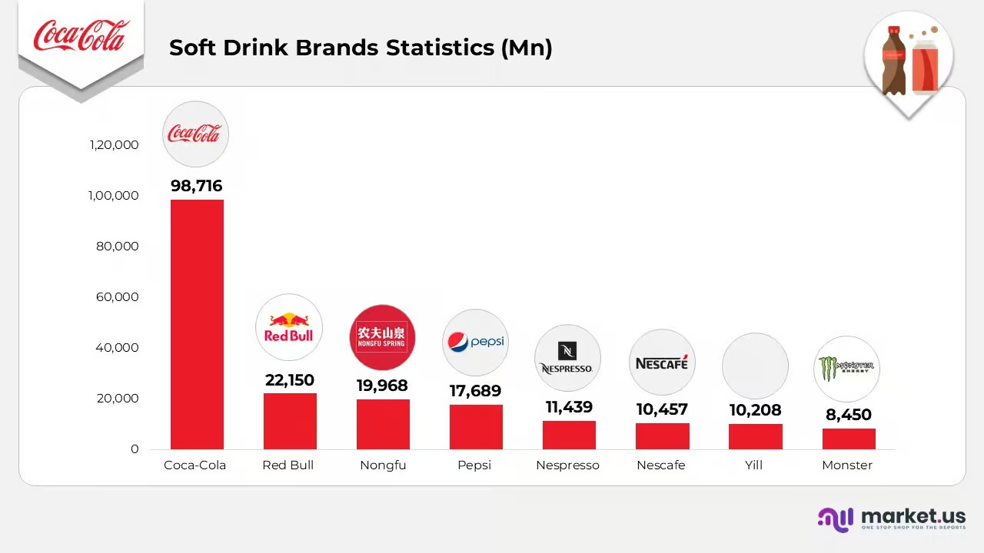

Figure 5.1: Brand Value of Beverage Companies
(Source: Market.US, 2025)

5.2.2 Discussion on the factors influencing the quality of the performance appraisal initiatives of companies
The key factor of influencing performance appraisal systems is directly by organisation process and management transparency that has a positive impact among employees. As per the view of Martins (2024), manager apprehension is most significant for practising affecting appraisal systems in organisation. For instance, a survey of 400 human resource managers also revealed that 97% of organisations conducted performance appraisal for maintaining integrity in business with maintaining positive work performance. On the contrary authors Hamidi (2023), also revealed that lack of accurate assessment in performance appraisal negatively s organisational stability in maintaining employee retention organisation. For instance, Infosys is also criticised by employees

due to the lack of predictability of the appraisal system that enables growth among the employee base (Aithal, Diana and Satpathy, 2024). However, the implementation of continuous feedback mechanism effectively improves lower morale of employees and ensures attrition rate in Infosys. On the other hand, a survey revealed that 40% of managers do not have any recognized data potentiality towards analysing employee key performance productivity for making categorisation of employee base appraisal (Johnivan, 2025). Hence, employee base appraisal also improves potentiality towards getting recognition reward and making a better position in future. In addition, this recognition makes additional benefits among employees towards better career growth and transitional benefits in career. Thus, appraisal-based system recognition is highly effective in inductive management potentiality for fair representation of a predictive database of employees. Overall, focus on fair transparency improves retention capacity of employees by engaging more progression in a competitive market.

5.2.3 Role of Feedback and Goal Alignment in Performance Management
The goal alignment and feedback is more relevant for maintaining the performance of employees by achieving better results for the employees in achieving organisational accountability. As stated by Van der Hoek, Groeneveld and Kuipers (2018), the goal setting among team members boosts engagement among employees by addressing its massive contribution towards in work preventing misalignment. On the other hand Farin et al. (2023), the adoption of a structural appraisal system helps to reduce bias by serving equitable reward evaluation which encounter overall career professions. For example, IBM serves employees with “AI-augmented programs” and serves themes with customised learning which enhance career development opportunities to respond with employee needs (Teigen, 2025). The impact of feedback reduces the fear of employees by analysing the growth mindset of employees and accessing skills which enhance productivity. The goal alignment and feedback work closely by showcasing its linkage by aligning with goals in achieving company objectives. The impact of this unified direction enhances overall productivity of the organisation by reduction of misaligned tasks through an effective improvement process. This has its massive impact in achieving productivity of the organisation by showcases employees alignment with work and helps employees to stay connected by responding to employee retention.

In contrast to Drouvelis and Paiardini (2021), the modern organisation in answering employee performance serves with incentives which in term enhance developmental opportunities by serving significant feedback. For example, GSK uses “One80” reviews to analyse the performance of the team by ability to verify out right talent and their performance by serving rewards and encountering success (GSK, 2026). It has been addressed the manager feedback enhances employee engagement by addressing turnover 14.9% (Saini, 2023). The quality of feedback matters on improving the performance of employees that address based on analysing the workplace environment. Thus, this combined power is the continuous loop which encounters ongoing development that have its alignment with company goals.
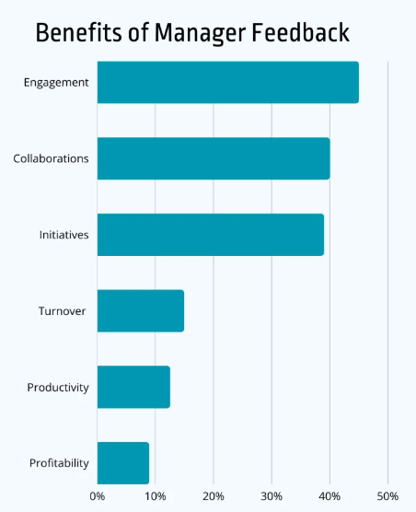

Figure 5.2: Benefit associated with employee feedback
(Source: Saini, 2023)

5.2.4 Reward and Recognition Structures on Motivation
Recognition structure and rewards enhance employee motivation which increases employee engagement by serving employees with bonus and development opportunities through efficient personalisation. As stated by Imran, Ghazwan and Firmansyah (2024), an appreciation system and sustainable recognition help to improve motivation of employees through emotional engagement. In addition, the provision of rewards also improves the financial status of the workers that increases the engagement level of the employees. The enhancement in the loyalty of the workforce also improves the product quality of the organisation and enhances its competitive advantage over other companies. The availability of flexible reward structure also increases the organisational harmony of the company. The strength of the appraisal system has been addressed through appreciation, enhancing autonomy, emotional engagement and long-term commitment which results in reduction of turnover. In contrast to Bardach and Murayama (2024), the extrinsic motivation addresses a continuous learning process which is more beneficial to address through knowledge acquisition. The rewards motivate employees through accurate competition of tasks which enhance career development opportunities of employees. For example, Tesco investing £12.64 for employees which trends to rise high in 2025 by serving them with a balanced package which enhances colleague engagement (Tesco, 2025). Tesco in 2025 removed discount allowance in its shopping by adoption of club cards through substantial investment. On the other hand Ryan and Deci (2020), the intrinsic motivation is the internal rewards provided to the employees which is more effective in achieving business goals through peer recognition. In addition, intrinsic motivation also ensures internal rewards recognition associated with based on work profile in organisation. Thus, fair recognition is beneficial for boosting employee confidence and improving internal work culture effectively. The financial rewards provided to the employees drive short term improvement by solely relying on rewards which enhance employee engagement and accountability in business. Thus, the recognition and rewards provided to the employees enhance productivity of employees through high rate of job satisfaction based on accessing team contribution.
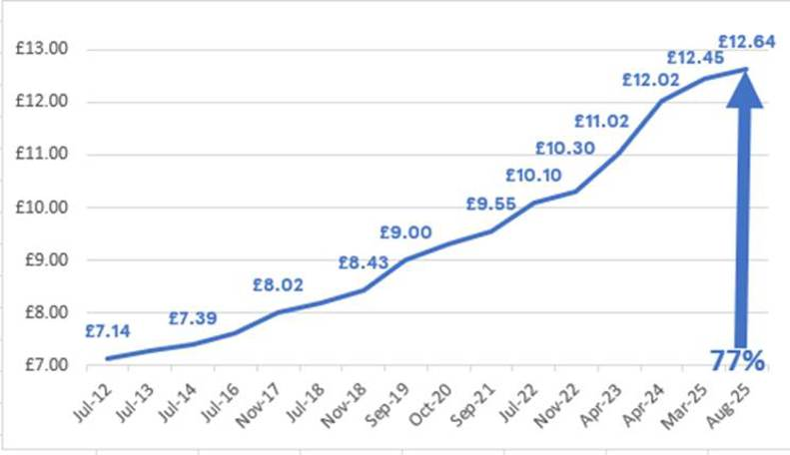

Figure 5.3: Tesco investing on Colleagues
(Source: Tesco, 2025)

5.2.5 Appraisal-Related Stress, Demotivation, and Workforce Implications
The existence of demotivation has been a critical issue that has hampered the popularity of the performance appraisal techniques among the employees. As stated by Hamidi (2023), the availability of a demotivated workforce has an adverse impact on the operational productivity of the organisation. The lowering of product quality due to organisational uncertainty also reduces the brand growth of the organisation. On the other hand, Aung, Santoso, and Dodanwala (2023) stated that the increase in work stress also lowers the productivity of the workers that hampers the goodwill of the organisation. The decline in the motivation level among the workers also reduces the engagement activities of the employees. For example, Tesco has reduced its employee bonus value by 10% in 2025 (Masud, 2025). The lowering of the incentives has hampered the goodwill of the retail company among the workers. Tesco has reduced its brand growth by 7.7% in 2024 (LinkedIn, 2026). The lowering of the revenue value has also hampered the financial stability of the organisation. On the other hand, the existence of appraisal stress has also reduced the operational efficiency of the employees. For example, Tesla has implemented 3500 job cuts to reduce its operational cost and enhance business profits in 2025 (Al Jazeera, 2024). The occurrence

of layoffs have reduced the goodwill of Tesla among the workers, which has also hampered its productivity.
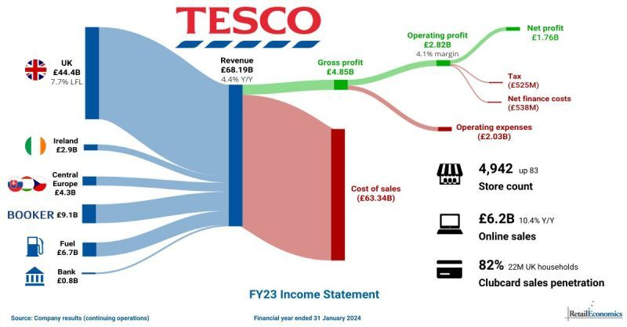

Figure 5.4: Brand Value of Tesco
(Source: LinkedIn, 2026)

5.3 Implication of key finding

5.3.1 Practical implication
The practical implication of the findings helps in developing a proper understanding regarding the diversified performance appraisal methods adopted by the organisation for improving the skills of its employees. For example, PepsiCo has developed initiatives such as “360 degree Feedback” that has helped the organisation in monitoring its worker performance in 2025 (PR Newswire, 2025). The improvement in the employee capabilities has helped PepsiCo in enhancing its product quality. On the other hand, the finding section has also provided information regarding the financial initiatives adopted by organisations for improving its staff relationships. For instance, Coca-Cola has implemented the “WeCare Platform” that has helped the organisation in improving the social performance of its workers in 2024 (The Coca-Cola Company, 2025). The initiative has helped the beverage company in improving its product popularity among the customers that has also increased the brand loyalty of the organisation.

5.3.2 Theoretical implications
In the competitive era, employee motivation in reshaping through analysing performance of the individuals which enhance transparency and fairness encounter career growth. The application of equity theory, goal setting and expectancy theory is more reliable for analysing the impact of performance appraisal which enhances employee motivation. The elements of the goal setting theory help in achieving challenging situations through constructive feedback by showcasing its alignment with organisational objectives. Ineffective motivation and lack of clarity has its massive alignment in managing organisational goals. The employees who serve high performance are rewarded in terms of strength and accuracy to sustain in the market. The transparent appraisal strengthens productivity of the organisation by verifying the overall efforts served by the employees. The element of the expectancy theory suggests employee motivation by showcasing relationships among employees with organisations based on assessing employee needs. Thus, appraisal implementation, design and perception have its massive alignment with employee engagement.

5.4 Summary
Based on the key context it is also concluded that performance appraisal is most effective to improve the key engagement rate of employees and enable long-term growth. Hence, different organisation key examples such as Coca-Cola, IBM, and GSK also highlight that organisational performance directly s employee productivity rate in organisations. Thus, organisations focus on managing a higher employee retention base through assessment by managers also better predictable fair growth with less bias. However, inconsistent assessment directly impacts fair growth patterns and reduces the morale value of employees. Overall, continuous feedback mechanism most suitable for preceding with better transparency to diverse employee associates in organisation.

Chapter 6: Conclusion

6.1 Summary of the Study
This chapter provides a proper summarization of the research topic that has been explored further by highlighting overall finding through interpretation of results. The report aims to state the reason behind the topic and adoption of actionable insights that improved in future research by showcasing major limitations. In this chapter the research objectives are met and justified by the ability to meet goals. The recommendations associated with improving performance appraisal systems are discussed in detail which has been improved further. The appraisal provided to their employees through rewards which have been influenced through fairness, The inequalities in rewards distribution have its negative impact on employee productivity by addressing intensifying competition in managing performance. The persistent challenges arise due to ineffective designing of appraisal and ability to verify out high performance individuals in achieving organisational objectives. Employee satisfaction arises from the appraisal by showcasing its fairness which encounters productivity.

6.2 Conclusion Based on Research Objectives
Based on the above analysis, performance appraisal techniques are an important aspect that help organisations in improving the skills of its workers. In addition, the method also assists companies in enhancing the engagement level of the workers that increases its operational productivity. The organisations also emphasise on developing training infrastructures for improving its employee growth. For example, BP Plc has developed platforms such as “Smart Brevity” that has helped the organisation in monitoring the participation of its workers in the business operations. The adoption of the initiative has also helped the organisation in improving its productivity significantly. On the other hand, the performance appraisal techniques also assist organisations in providing rewards for employees that increase the productivity of the workers. The availability of incentives and bonuses has improved the engagement level of the workers for the organisations. Overall, the above analysis has helped in meeting the requirements of research objective 1.
Based on the overall analysis, it has been addressed that transparency, goal setting, and continuous improvement have its massive importance to keep employees engaged through clear

communication. The impact of this factor has its massive linkage with recognition and rewards by serving employees with financial recognition which encounter positive outcomes that enhance increases in loyalty through efficient skill development. The employees are provided with proper compensation based on accessing the dedication towards work which in term leads to rise high engagement rates. The participation of employees has its massive connection in serving rewards by addressing its alignment in achieving organisational goals. The skill development of the employees is provided with positive outcomes leading to high development opportunities which encounter effectiveness in organisation. The development of “demand-oriented appraisal” provided to employees which have its positive impact in encountering effectiveness of organisation. Thus, this analysis also meets objective 2 associated with maintaining the potentiality of transparency in the appraisal system effectively.
As per the evaluation provided in the research work, the absence of motivation has been a critical issue associated with performance appraisal techniques that has reduced its popularity among the organisations. In addition, the occurrence of layoffs and pay cuts have also hampered the engagement level of the workers that has also lowered the productivity of the company. On the other hand, the existence of gender bias has also reduced the accuracy and authenticity of the performance appraisal mechanism among the employees. The enhancement in the biasness has adversely influenced the work environment of the company that has also reduced its product quality. In addition, the absence of incentive structure has also lowered the engagement level of the workers that has also hampered the product quality of the organisation. Overall, the above discussions have helped in meeting the requirements of the research objective 3 of the investigation process.
Based on the above evaluation, the inclusion of digitalisation has helped organisations in improving the quality of its employment appraisal techniques. For example, the use of a 360-degree feedback mechanism has helped the companies in developing a proper understanding regarding the operational issues of the employees. In addition, the initiative has also assisted the companies in acquiring knowledge regarding the financial and nonfinancial requirements of the workers. The adoption of the feedback techniques has helped companies in strengthening its employee relationships that has also improved its operational productivity. On the other hand,

employee collaboration has also been a viable technique that has helped in improving the authenticity of the performance appraisal tools for the organisations. Overall, the above discussions have helped in meeting the requirements of research objective 4 of the investigation process.

6.3 Recommendations for Practice

6.3.1 Recommendation 1: Strengthen Transparency and Accuracy in Performance Appraisal Systems
The inclusion of more predictive analytics in the build-up appraisal system is also helpful for organising better acknowledgement among employees. In addition, inclusion of digital platforms such as HR analytics dashboards, and cloud-based appraisal software are also effective in tracking real time data insight in an effective manner (Ahmić and Ćosić, 2025). Hence, with use of HR analytics dashboard development of automated performance tracking ensures accuracy with collection of evidence in appraisal systems. Further, it will also reduce bias of manual error and ensure more transparency in the organisational system.

6.3.2 Recommendation 2: Implement Continuous Feedback and Goal Alignment Mechanisms
The adoption of a feedback system has helped companies in acquiring accurate knowledge regarding its employee growth. For example, Tesco has invested $20m in developing platforms such as “Zendesk” that has helped the company in monitoring the progress of its workers in 2025 (Tesco, 2025b). The adoption of the digital initiative has helped the retail company in improving its operational productivity. On the other hand, Asda has developed an “Asda Ethics Team” that helps in evaluating the financial requirements of its workers in 2025 (Asda, 2026). The inclusion of the digital feedback platforms has helped companies in improving its goodwill among the workers.

6.3.3 Recommendation 3: Integrate Balanced Reward and Recognition Structures
The proper maintenance of a balancing structure between rewards and recognition is also helpful towards maintaining its stability and detention of employee retention base effectively. The inclusion of intrinsic and extrinsic rewards recognition in balance rewards structure is necessary for maintaining stable balance structure effectively. Hence, in intrinsic structure development of

recognition, career development, learning opportunities also be helpful for employees to make new attenuation in organisation (Choudhary, Dada and Singh, 2025). As a result, it will also support its carrier path and ensure better choice towards retention in organisation. In another hand, bonuses and pay progression directly contributed to extrinsic progression to ensure resilience with employee engagement.

6.4 Recommendations for Future Research
The future research will provide information regarding performance appraisal linkage with employee motivation through adoption of the human centric approaches. Enhancing reliability of the research, the incorporation of primary quantitative research method is more suited which enhances validity of research. The adoption of AI-driven predictive analysis helps to access feedback of employees by relying on future productivity in reduction of burnout. The surveys have been conducted to analyse the performance of employees which have been beneficial to get exact results to enhance validity of the research. Further, the employees from the different organisations are served with rewards that are discussed in future research. The uses of the literary processed trusted sources are included for this research topic to carry out recent information related to the research topic. The future research enhances reliability by utilising larger samples which are more reliable to enhance generalisability and research quality.

References
Ahmed, S.K., Mohammed, R.A., Nashwan, A.J., Ibrahim, R.H., Abdalla, A.Q., Ameen, B.M.M. and Khidhir, R.M. (2025). Using Thematic Analysis in Qualitative Research. Journal of Medicine, Surgery, and Public Health, [online] 6(6), p.100198. doi: https://doi.org/10.1016/j.glmedi.2025.100198.
Ahmić, A. and Ćosić, M. (2025). Digital human resource management influence on the organizational resilience. Organization Management Journal. Doi: https://doi.org/10.1108/omj-09-2024-2299.
Aithal, S., Diana, S. and Sat Pathy, C.P.D.J. (2024). Infosys: A Pioneer in HR Innovation. [online] ResearchGate. Doi: https://doi.org/10.5281/zenodo.13941761.
Akanmu, M.D., Panatik, S.A.B. and Shahrin, R. (2025). The influence of performance appraisal practices on employee engagement at higher education institutions of Malaysia. Cogent Business & Management, 12(1). Doi: https://doi.org/10.1080/23311975.2024.2442093.
Akanmu, M.D., Panatik, S.A.B. and Shahrin, R. (2025). The influence of performance appraisal practices on employee engagement at higher education institutions of Malaysia. Cogent Business & Management, 12(1). Doi: https://doi.org/10.1080/23311975.2024.2442093.
Akanmu, M.D., Panatik, S.A.B. and Shahrin, R. (2025). Thief performance appraisal practices on employee engagement at higher education institutions of Malaysia. Cogent Business & Management, 12(1). Doi: https://doi.org/10.1080/23311975.2024.2442093.
Al Jazeera (2024). Tesla to lay off more than 10 percent of staff worldwide amid falling sales. [online] Al Jazeera. Available at: https://www.aljazeera.com/economy/2024/4/16/tesla-to-lay-off-more-than-10-percent-of-staff-worldwide-amid-falling-sales.
Alkhatib, G. (2025). To Communicate or not to Communicate: That is the Problem. Procedia Computer Science, 256, pp.1871–1878. Doi: https://doi.org/10.1016/j.procs.2025.02.328.
Amazon (2025). Awards Integration Solution | Amazon Business. [online] @AmazonBusiness. Available at: https://business.amazon.com/en/partners/awardco [Accessed 17 Nov. 2025].
Amazon (2025). Nectar HR | Amazon Business Partner Solutions. [online] @AmazonBusiness. Available at: https://business.amazon.com/en/partners/nectar-hr [Accessed 3 Dec. 2025].
Asda (2026). Asda.com - Online Food Shopping, George, & more. [online] www.asda.com. Available at: https://www.asda.com/rewards.
Aston Martin (2025). Skills | Racing. Green. [online] Astonmartin.com. Available at: https://www.astonmartin.com/en/corporate/sustainability/investing-in-people/skills [Accessed 6 Jan. 2026].
Aston Martin (2026). Supercharged | Track Experience. [online] Astonmartin.com. Available at: https://www.astonmartin.com/en/experiences/supercharged [Accessed 9 Jan. 2026].
Aung, Z.M., Santoso, D.S. and Dodanwala, T.C. (2023). Effects of demotivational managerial practices on job satisfaction and job performance: Empirical evidence from Myanmar’s construction industry. Journal of Engineering and Technology Management, [online] 67(1), p.101730. Doi: https://doi.org/10.1016/j.jengtecman.2022.101730.
Baertlein, L. and McLemore, A. (2022). Walmart boosts industry-leading U.S. trucker pay to $110,000, starts retraining program. Reuters. [online] 8 Apr. Available at: https://www.reuters.com/business/retail-consumer/walmart-boosts-industry-leading-us-trucker-pay-110000-starts-retraining-program-2022-04-07/.
Bardach, L. and Murayama, K. (2024). The role of rewards in motivation—Beyond dichotomies. Learning and Instruction, [online] 96(1), p.102056. Doi: https://doi.org/10.1016/j.learninstruc.2024.102056.
Bosze, A. (2024). How many employees does Amazon have? (2024). [online] www.doofinder.com. Available at: https://www.doofinder.com/en/statistics/how-many-employees-does-amazon-have.
Bosze, A. (2024). How many employees does Amazon have? (2024). [online] www.doofinder.com. Available at: https://www.doofinder.com/en/statistics/how-many-employees-does-amazon-have.

Businesswire (2024). First Insight Expands Partnership with M&S to Drive Digital Transformation and Customer-Centric Growth Across All M&S Clothing & Home Categories. [online] Businesswire.com. Available at: https://www.businesswire.com/news/home/20241211425664/en/First-Insight-Expands-Partnership-with-MS-to-Drive-Digital-Transformation-and-Customer-Centric-Growth-Across-All-MS-Clothing-Home-Categories.
Butler, S. (2025). BP to scrap paid rest breaks and most bank holiday bonuses for forecourt staff. [online] the Guardian. Available at: https://www.theguardian.com/business/2025/dec/05/bp-to-scrap-paid-rest-breaks-bank-holiday-bonuses-petrol-station-workers-living-wage [Accessed 6 Jan. 2026].
Canet-Giner, T., Redondo-Cano, A., Saorín-Iborra, C. and Escribá-Carda, N. (2019). Impact of the perception of performance appraisal practices on individual innovative behaviour. European Journal of Management and Business Economics, ahead-of-print(ahead-of-print). doi: https://doi.org/10.1108/ejmbe-01-2019-0018.
Chen, Y., Zhang, Z., Zhou, J., Liu, C., Zhang, X. and Yu, T. (2023). A Cognitive Evaluation and equity-based Perspective of Pay for Performance on Job performance: a meta-analysis and Path Model. Frontiers in Psychology, [online] 13(13), pp.1–26. Doi: https://doi.org/10.3389/fpsyg.2022.1039375.
Choudhary, J., Dada, M. and Singh, J. (2025). Effect of Career Advancement Opportunities, Training and Development Programs and Corporate Culture on Employee Loyalty of Alibaba in China. International journal of advanced business studies, 3(Special Issue 1), pp.135–148. doi: https://doi.org/10.59857/ijabs.1175.
Cuofano, G. (2024). Amazon Revenue Per Employee. [online] FourWeekMBA. Available at: https://fourweekmba.com/amazon-revenue-per-employee/.
Davies, R. (2025). BP cuts boss’s pay by 30% after company misses profit targets. [online] the Guardian. Available at: https://www.theguardian.com/business/2025/mar/06/bp-cuts-bosss-pay-by-30-after-company-misses-profit-targets.
de Araújo, M.L., Caldas, L.S., Barreto, B.S., Menezes, P.P.M., Silvério, J.C. dos S., Rodrigues, L.C., Serrano, A.L.M., Neumann, C. and Mendes, N. (2024). How to Evaluate the Effectiveness of Performance Management Systems? An Overview of the Literature and a Proposed Integrative Model. Administrative Sciences, [online] 14(6), p.117. doi:https://doi.org/10.3390/admsci14060117.
Dey (2024). Available at: https://electroiq.com/stats/how-many-people-work-at-amazon/ [Accessed 2025].
Dey, M. (2025). How Many People Work At Tesla? Statistics And Trends (2025). [online] Electro IQ. Available at: https://electroiq.com/stats/how-many-people-work-at-tesla/.
Drouvelis, M. and Paiardini, P. (2021). Feedback Quality and Performance in Organisations. The Leadership Quarterly, 33(6), p.101534. doi:https://doi.org/10.1016/j.leaqua.2021.101534.
Elrayah, M. and Semlali, Y. (2023). Sustainable Total Reward Strategies for Talented Employees’ Sustainable Performance, Satisfaction, and Motivation: Evidence from the Educational Sector. Sustainability, 15(2), p.1605.
Etalong, T.A. and Chikeleze, F.O. (2022). The Impact of a Performance Appraisal and Reward System on Employee Workload Delivery. Global Journal of Human Resource Management, 10(3), pp.51–58. doi:https://doi.org/10.37745/gjhrm.2013/vol10n3pp5158.
Farin, P.M., Wisdom AK Akwari, Eyamba Edem Ededem and Bassey William (2023). Performance Appraisal and Organizational Performance. IIARD INTERNATIONAL JOURNAL OF ECONOMICS AND BUSINESS MANAGEMENT, 9(1), pp.100–105. doi:https://doi.org/10.56201/ijebm.v9.no1.2023.pg100.105.
Financial Times (2026). Financial Times. [online] @FinancialTimes. Available at: https://www.ft.com/content/1a7ca002-bb65-4d18-a769-ee155466d724.
Firdaus, Suryani, E., Reny Nadlifatin and Aris Tjahyanto (2024). Enhancing Organizational Culture and Productivity through Innovative Performance Appraisal: A Design Science Research Approach. Procedia computer science, 234, pp.1128–1136. doi:https://doi.org/10.1016/j.procs.2024.03.108.
Fortune (2025). 360 Degree Feedback Software Market Size & Growth [2032]. [online] Fortunebusinessinsights.com. Available at: https://www.fortunebusinessinsights.com/360-degree-feedback-software-market-104481.
Galetti, B. (2025). How Amazon is upskilling 50 million people for the future of work. [online] Aboutamazon.com. Available at: https://www.aboutamazon.com/news/workplace/amazon-future-of-work-skills-jobs-training.
Gimbal, O. (2025). Employee Retention Statistics: A Deep Dive into Loyalty and Turnover. [online] Bucketlist. Available at: https://bucketlistrewards.com/blog/employee-retention-statistics/.
Glassdoor (2024). Available at: https://www.glassdoor.com/Reviews/DXC-Technology-London-Reviews-EI_IE1603125.0%2C14_IL.15%2C21_IM1035.htm
Grocery Gazette (2025). M&S unveils biggest ever investment in retail pay. [online] Grocery Gazette - Latest Grocery Industry News. Available at: https://www.grocerygazette.co.uk/2025/03/05/ms-investment-retail-pay/.
Grocery Gazzete (2025). Tesco trials reduced opening hours as staffing costs soar. [online] Grocery Gazette - Latest Grocery Industry News. Available at: https://www.grocerygazette.co.uk/2025/06/02/tesco-reducing-opening-hours/.
GSK (2026). Life at GSK | GSK India. [online] india-pharma.gsk.com. Available at: https://india-pharma.gsk.com/en-in/careers/lifeatgsk/.
Gutierrez, K. (2019). Mind-blowing Statistics that Prove the Value of Employee Training and Development. [online] Shiftelearning.com. Available at: https://www.shiftelearning.com/blog/statistics-value-of-employee-training-and-development.
Guzaiz, D. (2025). The relationship between burnout and employee outcomes: the moderating role of performance appraisal satisfaction and organisational commitment -ORCA. Cardiff.ac.uk. [online] doi:https://orca.cardiff.ac.uk/id/eprint/180439/1/Doaa%20Guzaiz_PhD_Thesis_CorrectedVersion_01August%202025_1851419.pdf.
GVR (2024). Data Analytics Market Size, Share & Growth Report, 2030. [online] www.grandviewresearch.com. Available at: https://www.grandviewresearch.com/industry-analysis/data-analytics-market-report.
Hamidi, A.B. (2023). The Impacts of Performance Appraisal on Employee’s Job Satisfaction and Organizational Behavior. Ilomata International Journal of Social Science, [online] 4(3), pp.466–480. doi:https://doi.org/10.52728/ijss.v4i3.876.
Hamidi, A.B. (2023). The Impacts of Performance Appraisal on Employee’s Job Satisfaction and Organizational Behavior. Ilomata International Journal of Social Science, [online] 4(3), pp.466–480. doi:https://doi.org/10.52728/ijss.v4i3.876.
Hamzah, N.M. and Matkhairuddin, S. (2022). Extrinsic Rewards and Job Satisfaction among Employees in RISDA Selangor. e-Academia Journal, 11(2), pp.201–213. doi:https://doi.org/10.24191/e-aj.v11i2.20444.
Hendry, R. (2022). Figure 4: The Research Onion (Saunders et al, 2019, p. 174). [online] ResearchGate. Available at: https://www.researchgate.net/figure/The-Research-Onion-Saunders-et-al-2019-p-174_fig3_365295541.
HIGH5 (2025). Employee Motivation Statistics [2025]: What Really Drives Workplace Performance? [online] HIGH5 Strengths Test. Available at: https://high5test.com/employee-motivation-statistics/.
Hunter, H., Ferreira, R.J. and Prochaska, J.M. (2025). Applying expectancy theory of motivation and transtheoretical model of behavior change to mitigate employee resistance to organizational change in nonprofit organizations: A theoretical framework. Journal of Human Behavior in the Social Environment, pp.1–17. doi:https://doi.org/10.1080/10911359.2025.2548916.
Idowu, A. (2017). (PDF) Effectiveness of Performance Appraisal System and its Effect on Employee Motivation. [online] ResearchGate. Available at: https://www.researchgate.net/publication/320490099_Effectiveness_of_Performance_Appraisal_System_and_its_Effect_on_Employee_Motivation.
Imran, U.D., Ghazwan, M.F. and Firmansyah, F. (2024). The Effect of Recognition and Appreciation on Employee Motivation and Performance. Economics and Digital Business Review, [online] 6(1), pp.1–18. doi:https://doi.org/10.37531/ecotal.v6i1.1890.
Imran, U.D., Ghazwan, M.F. and Firmansyah, F. (2024). The Effect of Recognition and Appreciation on Employee Motivation and Performance. Economics and Digital Business Review, [online] 6(1), pp.1–18. doi:https://doi.org/10.37531/ecotal.v6i1.1890.
Iqbal, M.Z., Akbar, S., Budhwar, P. and Shah, S.Z.A. (2019). Effectiveness of performance appraisal: Evidence on the utilization criteria. Journal of Business Research, [online] 101, pp.285–299. doi:https://doi.org/10.1016/j.jbusres.2019.04.035.
Jo, H. and Shin, D. (2025). The impact of recognition, fairness, and leadership on employee outcomes: A large-scale multi-group analysis. PLOS ONE, [online] 20(1), p.e0312951. doi:https://doi.org/10.1371/journal.pone.0312951.
Johnivan, J.R. (2023). The Latest Performance Management Statistics HR Leaders Should Know - SSR. [online] www.selectsoftwarereviews.com. Available at: https://www.selectsoftwarereviews.com/blog/performance-management-statistics.
Johnivan, J.R. (2025). 85 Must-Know Performance Management Statistics for HR in 2025. [online] Selectsoftwarereviews.com. Available at: https://www.selectsoftwarereviews.com/blog/performance-management-statistics?utm_source=chatgpt.com.
Joo, M.-K., Kong, D.T. and Atwater, L. (2024). Gendered implications of organizational gender diversity for voluntary turnover: human resource practices as strategic levers. The International Journal of Human Resource Management, pp.1–43. doi:https://doi.org/10.1080/09585192.2024.2428328.
Joy, M.M. (2018). (PDF) Organisational Behaviour - T1 MBA - KTU Syllabus. [online] ResearchGate. Available at: https://www.researchgate.net/publication/323695129_Organisational_Behaviour_-_T1_MBA_-_KTU_Syllabus.
Kalogiannidis, S., Kalfas, D., Michail Chalaris, Konstantinos Spinthiropoulos and Fotios Chatzitheodoridis (2025). Evaluating the Effectiveness of Performance Appraisal Systems in Enhancing Employee Performance. A Case Study of Greece. WSEAS TRANSACTIONS ON BUSINESS AND ECONOMICS, [online] 22, pp.234–252. doi:https://doi.org/10.37394/23207.2025.22.23.
Khanday, S.A. and Khanam, D. (2023). THE RESEARCH DESIGN. [online] ResearchGate. Available at: https://www.researchgate.net/publication/368257495_THE_RESEARCH_DESIGN.
Kivilahti, A. (2024). Online grocery driving growth for Tesco in the UK. [online] Ada Insights. Available at: https://adainsights.com/blog/online-grocery-driving-growth-for-tesco-in-the-uk.
Lalwani, M. (2024). A Study of Employee Satisfaction at Workplace. Shanlax International Journal of Management, 11(S1-Mar), pp.194–200. doi:https://doi.org/10.34293/management.v11is1-mar.8042.
Li, L., Novillo-Ortiz, D., Azzopardi-Muscat, N. and Kostkova, P. (2021). Digital Data Sources and Their Impact on People’s Health: A Systematic Review of Systematic Reviews. Frontiers in Public Health, 9(9). doi:https://doi.org/10.3389/fpubh.2021.645260.
Li, M., Trencher, G. and Asuka, J. (2024). The clean energy claims of BP, chevron, exxonmobil and shell: A mismatch between discourse, actions and investments. PLOS ONE, [online] 17(2). Available at: https://journals.plos.org/plosone/article?id=https://doi.org/10.1371/journal.pone.0263596.
Li, Y. (2023). Theof Top-Down Mode and Bottom-up Mode to National Innovation and Entrepreneurship. Journal of Innovation and Development, [online] 2(3), pp.158–161. doi:https://doi.org/10.54097/jid.v2i3.7640.
Lin, D., Trairong Swatdikun, T., Lakkanawanit, P. and Issayeva, G. (2024). The Impact of Performance Appraisal and Employee Motivation on Employee Performance: Early Career Teaching Professionals. doi:https://doi.org/10.2139/ssrn.5034361.
LinkedIn (2026). LinkedIn. [online] Linkedin.com. Available at: https://www.linkedin.com/posts/jaykmr_lastdaysatamazon-leadership-workplaceculture-activity-7360688081798127616-GpX9 [Accessed 6 Jan. 2026].
Linkedin (2026). Richard Lim on LinkedIn: #tesco #grocery #retail | 35 comments. [online] www.linkedin.com. Available at: https://www.linkedin.com/posts/richard-lim-42527726_tesco-grocery-retail-activity-7190673716731617282-Ygn1.
Market Screener (2024). MarketScreener. [online] MarketScreener. Available at: https://in.marketscreener.com/quote/stock/BP-PLC-9590188/finances/.
Market Screener (2025). BP PLC. [online] MarketScreener UK. Available at: https://uk.marketscreener.com/quote/stock/BP-PLC-9590188/.
Market Screener (2025). UNILEVER PLC. [online] MarketScreener India. Available at: https://in.marketscreener.com/quote/stock/UNILEVER-PLC-9590186/.
Market Screener (2026a). J Sainsbury plc: Financial Data Forecasts Estimates and Expectations | SBRY | GB00B019KW72 | MarketScreener. [online] uk.marketscreener.com. Available at: https://uk.marketscreener.com/quote/stock/J-SAINSBURY-PLC-9590189/finances/.
Market Screener (2026b). MarketScreener India. [online] MarketScreener India. Available at: https://in.marketscreener.com/quote/stock/ASTON-MARTIN-LAGONDA-GLOB-46472778/finances/.
Market.US (2024). Walmart Statistics and Facts. [online] Market.us. Available at: https://market.us/statistics/e-commerce-websites/walmart/.
Market.US (2025). Coca-Cola Statistics and Facts. [online] Market.us. Available at: https://market.us/statistics/food-and-beverage-companies/coca-cola-company/.
Martins, I. (2024). Performance Appraisal Techniques And Their Effects On Organizational Growth. 2(01), pp.18–31. doi:https://doi.org/10.63922/ijeter.v2i01.694.
Masud, F. (2025). Tesco to raise wages by 5% but scrap Sunday bonus. [online] 17 Mar. Available at: https://www.bbc.com/news/articles/cy0d10426y1o.
Microsoft (2024). Viva Glint 360 feedback program overview. [online] Microsoft.com. Available at: https://learn.microsoft.com/en-us/viva/glint/setup/360-overview.
Mohammed, S.S. (2024). Deductive and Inductive Research. [online] ResearchGate. Available at: https://www.researchgate.net/publication/384971734_deductive_and_inductive_research.
Muhammad, M., Suleiman, W., Mamun, M.A.A., Jewel, R.M. and Mozumder, M.A.S. (2025). Mediating effect of appraisal fairness between the relationship of appraisal satisfaction and employee performance appraisal: a case of Bauchi State Teachers Service Commission, Nigeria. Cogent Business & Management, 12(1). doi:https://doi.org/10.1080/23311975.2025.2450297.
Muhammad, M., Suleiman, W., Mamun, M.A.A., Jewel, R.M. and Mozumder, M.A.S. (2025). Mediating effect of appraisal fairness between the relationship of appraisal satisfaction and employee performance appraisal: a case of Bauchi State Teachers Service Commission, Nigeria. Cogent Business & Management, 12(1). doi:https://doi.org/10.1080/23311975.2025.2450297.
Muhammad, M., Suleiman, W., Mamun, M.A.A., Jewel, R.M. and Mozumder, M.A.S. (2025). Mediating effect of appraisal fairness between the relationship of appraisal satisfaction and employee performance appraisal: a case of Bauchi State Teachers Service Commission, Nigeria. Cogent Business & Management, 12(1). doi:https://doi.org/10.1080/23311975.2025.2450297.
Murphy, K.R. and DeNisi, A.S. (2023). New approaches to dealing with performance management: getting rid of performance appraisals is not the answer. IIM Ranchi journal of management studies, 2(2), pp.143–158. doi:https://doi.org/10.1108/irjms-09-2023-0074.
Na-Nan, K., Kanthong, S., Joungtrakul, J. and Smith, I.D. (2020). Mediating Effects of Job Satisfaction and Organizational Commitment between Problems with Performance Appraisal and Organizational Citizenship Behavior. Journal of Open Innovation: Technology, Market, and Complexity, 6(3), p.64. doi:https://doi.org/10.3390/joitmc6030064.
Nasralla, S. (2025). Shell profit drops by almost a third on lower prices, but beats expectations. Reuters. [online] 31 Jul. Available at: https://www.reuters.com/business/energy/shell-profit-drops-by-almost-third-lower-prices-beats-expectations-2025-07-31/.
Nawaz, N., Arunachalam, H., Pathi, B.K. and Gajenderan, V. (2024). The Adoption of Artificial Intelligence in Human Resources Management Practices. International Journal of Information Management Data Insights, [online] 4(1), pp.1–11. doi:https://doi.org/10.1016/j.jjimei.2023.100208.
Pangarkar, T. (2025a). How Many People Work At Google? Statistics, Facts And Trends (2025). [online] Electro IQ. Available at: https://electroiq.com/stats/how-many-people-work-at-google/.
Paul, K. and Balu, N. (2023). Meta to cut 10,000 jobs in second round of layoffs. Reuters. [online] 14 Mar. Available at: https://www.reuters.com/technology/facebook-parent-meta-lay-off-10000-employees-second-round-job-cuts-2023-03-14/.
Peng, J. (2022). Performance Appraisal System and Its Optimization Method for Enterprise Management Employees Based on the KPI Index. Discrete Dynamics in Nature and Society, 2022(1), pp.1–12. doi:https://doi.org/10.1155/2022/1937083.
Peng, J. (2022). Performance Appraisal System and Its Optimization Method for Enterprise Management Employees Based on the KPI Index. Discrete Dynamics in Nature and Society, 2022(1), pp.1–12. doi:https://doi.org/10.1155/2022/1937083.
Pervin, N. and Mokhtar, M. (2022). The Interpretivist Research Paradigm: A Subjective Notion of a Social Context. [online] ResearchGate. doi:https://doi.org/10.6007/IJARPED/v11-i2/12938.
Polat, Ş., Eskici, G.T. and Şen, H.T. (2025). A validity and reliability study of the performance appraisal motivation scale in a Turkish sample. BMC Nursing, 24(1). doi:https://doi.org/10.1186/s12912-025-03671-z.
PR Newswire (2025). PepsiCo Announces Priorities to Enhance Shareholder Value and Provides Preliminary 2026 Financial Outlook. [online] Yahoo Finance. Available at: https://finance.yahoo.com/news/pepsico-announces-priorities-enhance-shareholder-213000768.html.
Race, M. (2025). BP to Cut 4,700 Jobs to Reduce Costs. BBC. [online] 16 Jan. Available at: https://www.bbc.com/news/articles/ckgy3ve1q69o.
Raju, V. (2021). Figure 2-Goal Setting Theory Model. [online] ResearchGate. Available at: https://www.researchgate.net/figure/Goal-Setting-Theory-Model_fig3_355862656.
Reuters (2024). Tesla increases wages for staff at German gigafactory by 4%. [online] Reuters. Available at: https://www.reuters.com/business/autos-transportation/tesla-increases-wages-german-gigafactory-by-4-2024-11-05/.
Reuters (2025). Apple cuts jobs across the sales team. Reuters. [online] 24 Nov. Available at: https://www.reuters.com/business/apple-cuts-jobs-across-its-sales-organization-bloomberg-news-reports-2025-11-24/.
Richter, F. (2025). Infographic: Women’s Representation in Big Tech. [online] Statista Daily Data. Available at: https://www.statista.com/chart/4467/female-employees-at-tech-companies/?srsltid=AfmBOoqVymLPlIB8n6e5idEv8cfFHTMCAPsLmSVIg6meNnGESj4oMYKc [Accessed 3 Dec. 2025].
Roadgenius (2024). Tesla Sales | Global Statistics 2024. [online] Road Genius. Available at: https://roadgenius.com/cars/ev/statistics/sales-by-automaker/tesla/.
Ryan, R.M. and Deci, E.L. (2020). Intrinsic and Extrinsic Motivation from a self-determination Theory perspective: Definitions, theory, practices, and Future Directions. Contemporary Educational Psychology, [online] 61(1), pp.1–11. doi:https://doi.org/10.1016/j.cedpsych.2020.101860.
Saini, M. (2023). 40+ Employee Feedback Statistics and Trends [2025]. [online] Jobstik. Available at: https://jobera.com/employee-feedback-statistics/.
Sainsbury (2025). UK Quality Food Awards | The longest-running, most prestigious food awards in the UK. [online] Qualityfoodawards.com. Available at: https://uk.qualityfoodawards.com/QFA2025/en/node/newsarticle-sainsbury-s-energy-tariff-offers-fresh-incentives-with-bonus-nectar-points-and-price-cap-guarantee?type=NewsArticle [Accessed 6 Jan. 2026].
Saka, R., Chinagozi, O.G. and Joe, O.N. (2023). Exploratory Research Design in Management Science: A Review of Literature on Conduct and Application. International Journal of Research and Innovation in Social Science (IJRISS), 7(4), pp.1384–1395. doi:https://doi.org/10.47772/ijriss.2023.7515.
Saxena, E. (2024). Amazon Statistics 2025: Market Share, Usage, & Revenue - GrabOn. [online] GrabOn’s Indulge - Online Shopping Tips, Buying Guide, Savings. Available at: https://www.grabon.in/indulge/tech/amazon-statistics/.
Searles, K. (2025). Sainsbury’s rewards staff with 5% pay rise after Christmas lift - InternetRetailing. [online] InternetRetailing. Available at: https://internetretailing.net/sainsburys-rewards-staff-with-5-pay-rise-after-christmas-lift/.
SEO (2024). How Many People Work at Meta (Facebook)? Statistics & Facts (2024). [online] seo.ai. Available at: https://seo.ai/blog/how-many-people-work-at-meta.
Setyawati, N.W., Woelandari, D.S. and Rianto, M.R. (2022). Career Development, Motivation and Promotion on Employee Performance. East Asian Journal of Multidisciplinary Research, [online] 1(9), pp.1957–1970. doi:https://doi.org/10.55927/eajmr.v1i9.1453.
Singsit (2025). Tesco boosts staff wages with £180m investment plan. [online] Retail Insight Network. Available at: https://www.retail-insight-network.com/news/tesco-investment-wages-staff/.
Singsit, J. (2024). Tesco to raise store employee pay by 9.1% with £300m investment. [online] Retail Insight Network. Available at: https://www.retail-insight-network.com/news/tesco-staff-investment-uk/.
Statista (2025). Coca-Cola employees 2024| Statista. [online] Statista. Available at: https://www.statista.com/statistics/254562/coca-colas-number-of-employees-worldwide/?srsltid=AfmBOopfjphIxLLRNHLreI1l043ZaRpQuX6R0TFccyt2_Qsf_Uc4dOOv [Accessed 9 Jan. 2026].
Statista (2025). Enterprise Performance Management Software - Worldwide | Forecast. [online] Statista. Available at: https://www.statista.com/outlook/tmo/software/enterprise-software/enterprise-performance-management-software/worldwide?srsltid=AfmBOor5uwqza67hntIR3K_-TdA8kidL8pKU3PFF6aUpm0qSJuim9_lN [Accessed 17 Nov. 2025].
Strenitzerová, M. and Achimský, K. (2019). Employee Satisfaction and Loyalty as a Part of Sustainable Human Resource Management in Postal Sector. Sustainability, [online] 11(17), p.4591. Available at: https://www.mdpi.com/2071-1050/11/17/4591.
Subramaniam, S.H., Wider, W., Cloyd, J., Lim, K.Y., Jiang, L. and Prompanyo, M. (2024). Key factors influencing long-term retention among Contact Centre employee in Malaysia: a Delphi method study. Cogent business & management, 11(1). doi:https://doi.org/10.1080/23311975.2024.2370444.
Tajammul Pangarkar (2025b). How Many People Work At Microsoft? Statistics And Trends (2025). [online] Electro IQ. Available at: https://electroiq.com/stats/how-many-people-work-at-microsoft/.
Teigen, P. (2025). Designing engaging employee experiences that deliver tangible results. [online] Ibm.com. Available at: https://www.ibm.com/think/insights/designing-engaging-employee-experiences-change-management.
Tesco (2022). Tesco Help Desk Story | Zendesk India. [online] Zendesk. Available at: https://www.zendesk.com/in/customer/tesco/ [Accessed 3 Dec. 2025].
Tesco (2023). Career development and opportunities. [online] Tesco Careers. Available at: https://www.tesco.com/careers/en-IN/our-culture/why-work-here/career-development-opportunities?srsltid=AfmBOopfh7xw_Oo83O8p_E48i8t1dXCpx-PzUOOP4H1FcQ1G5doRUJMO [Accessed 3 Dec. 2025].
Tesco (2025). HRM - Tesco | PDF | Performance Appraisal | Employment. [online] Scribd. Available at: https://www.scribd.com/document/104917232/HRM-Tesco.
Tesco (2025a). Reward & benefits. [online] Tescoplc.com. Available at: https://www.tescoplc.com/sustainability/colleagues/reward-benefits.
Tesco (2025b). Tesco Help Desk Story | Zendesk India. [online] Zendesk. Available at: https://www.zendesk.com/in/customer/tesco/.
Tesco Plc (2025). Tesco confirms commitment to Kickstart scheme. [online] www.tescoplc.com. Available at: https://www.tescoplc.com/tesco-confirms-commitment-to-kickstart-scheme/.
The Coca-Cola Company (2025). Coca-Cola Employees Volunteer to Pack & Donate Food Parcels | Coca-Cola Middle East. [online] Coca-cola.com. Available at: https://www.coca-cola.com/xf/en/media-center/blue-collar-support-wecare-initiative-coca-cola.
Ullah, Z., Ahmad, N., Scholz, M., Ahmed, B., Ahmad, I. and Usman, M. (2021). Perceived Accuracy of Electronic Performance Appraisal Systems: The Case of a Non-for-Profit Organization from an Emerging Economy. Sustainability, 13(4), p.2109. doi:https://doi.org/10.3390/su13042109.
Unilever (2025). Engaging with Stakeholders. [online] Unilever. Available at: https://www.unilever.com/sustainability/responsible-business/engaging-with-stakeholders/.
Unilever PLC (2023). Gender equality and women’s empowerment. [online] Unilever. Available at: https://www.unilever.com/sustainability/equity-diversity-and-inclusion/gender-equality-and-womens-empowerment/.
Urbancová, H., Vrabcová, P. and Pacáková, Z. (2024). Communication from below: Feedback from Employees as a Tool for Their Stabilisation. Heliyon, [online] 10(7), pp.e28287–e28287. doi:https://doi.org/10.1016/j.heliyon.2024.e28287.
Van der Hoek, M., Groeneveld, S. and Kuipers, B. (2018). Goal setting in teams: goal clarity and team performance in the public sector. Review of Public Personnel Administration, [online] 38(4), pp.472–493. doi:https://doi.org/10.1177/0734371X16682815.
Vorecol (2025). How can artificial intelligence enhance the effectiveness of performance evaluation software? [online] Psico-smart.com. Available at: https://blogs.psico-smart.com/blog-how-can-artificial-intelligence-enhance-the-effectiveness-of-performance-evaluation-software-154809.
Vuong, T.D.N. and Nguyen, L.T. (2022). The Key Strategies for Measuring Employee Performance in Companies: A Systematic Review. Sustainability, 14(21), pp.1–21. doi:https://doi.org/10.3390/su142114017.
Wagner, K. (2025). Meta Cutting Roughly 600 AI Jobs as Company Aims to Move Faster. [online] Bloomberg.com. Available at: https://www.bloomberg.com/news/articles/2025-10-22/meta-cutting-roughly-600-ai-jobs-as-company-aims-to-move-faster [Accessed 9 Jan. 2026].
Walmart (2025). Systems. [online] Systems. Available at: https://public.walmart.com/content/wal-paper/en_in/lod/learning/home-office-academy/people-academy/core/systems.html.
Warade, P. (2024). 360 Degree Feedback Software Market Size, Share & Growth Report by 2033. [online] Straitsresearch.com. Available at: https://straitsresearch.com/report/360-degree-feedback-software-market.
Wickham, R. (2020). Secondary Analysis research. Journal of the Advanced Practitioner in Oncology, [online] 10(4), pp.395–400. doi:https://doi.org/10.6004/jadpro.2019.10.4.7.
Woerkom, M. van and Kroon, B. (2020). The Effect of Strengths-Based Performance Appraisal on Perceived Supervisor Support and the Motivation to Improve Performance. Frontiers in Psychology, [online] 11(1). doi:https://doi.org/10.3389/fpsyg.2020.01883.
Yang, J., Ma, J. and Li, L. (2023). The Relationship between Performance Appraisal Interval and Employees’ Proactive Working Behavior – Analysis Based on time-gain Effect and time-loss Effect. Frontiers in Psychology, 14(1213547). doi:https://doi.org/10.3389/fpsyg.2023.1213547.
Yang, J., Ma, J. and Li, L. (2023). The Relationship between Performance Appraisal Interval and Employees’ Proactive Working Behavior – Analysis Based on time-gain Effect and time-loss Effect. Frontiers in Psychology, 14(1213547). doi:https://doi.org/10.3389/fpsyg.2023.1213547.

