
Module Name: Academic Skills in the Digital Era
Module Code: BMSW4013
Assessment 1: E-Portfolio
Student Name: Jason Wilson
Student Number: 2506842
Lecturer: Scott James
Deadline: Friday 28th November 23:59PM

AI Acknowledgement
I acknowledge the use of ChatGPT (https://chatgpt.com/) on 18, 20 and 26 November 2025 to support my research.
I used the prompt: “Help me find credible and recent academic sources on digital learning.”
I confirm that I have not presented any AI-generated text as my own work. I have kept copies of all drafts, notes, and resources used before and after using AI tools, which may be requested as evidence.

Contents
AI Acknowledgement 2
Key Challenge for Students 4
Key Opportunity for Students 4
Planning My Report 5
Timeline for Component 2 5
Introduction 5
Challenges Students Face 5
Opportunities Digital Tools Provide 6
How Students Can Adapt 6
Conclusion 7
Reflective Presentation 7
Reference List 10

Source Exploration

The source selected is an academic article titled “Digital Learning and Student Engagement in Higher Education”, written by Maria Thompson in 2022 and published in the Journal of Educational Technology. The main argument presented in this article is that digital tools—such as learning platforms, interactive quizzes, and online videos—can significantly increase student engagement when used in structured and meaningful ways. Thompson highlights that digital learning allows students to review materials multiple times, work at their own pace, and collaborate more easily online. However, she also emphasises that ineffective digital habits, such as multitasking, can reduce the benefits of these tools.

I chose this source because it is peer-reviewed, recent, and directly relevant to my research on how digital tools affect students. Its reliability was confirmed using the CRAAP test, showing strong scores for currency, relevance, authority, and accuracy. As it explores both the advantages and disadvantages of digital learning, it aligns well with the aims of my report.

This article will help me answer the main question by providing evidence-based examples of how digital tools influence students’ learning experiences. It also discusses challenges such as digital overload, which I will refer to in the challenges section of my report.

Key Challenge for Students
A challenge students face is digital overload and distraction. With constant access to smartphones, laptops, and social media, it is easy to become sidetracked by notifications or irrelevant online content. Even when I am revising, I often catch myself switching tabs or replying to messages, which breaks my concentration and reduces the quality of my work. Thompson (2022) explains that multitasking lowers engagement and makes it harder for students to stay fully focused on learning tasks. Similarly, Perez-Juarez et al. (2023) found that frequent digital interruptions reduce attention levels and increase stress, which can negatively affect academic performance.
This challenge is significant because maintaining focus is essential for deep learning and effective study habits. When students cannot manage digital distractions, they tend to take longer to complete tasks and struggle to remember information. Over time, this can lead to poorer academic outcomes and increased frustration during online study sessions.
.

Key Opportunity for Students
An important opportunity offered by digital tools is enhanced collaboration. Platforms such as Google Workspace and Microsoft Teams enable students to work together effectively, even when they cannot meet in person. These tools allow groups to share documents, communicate instantly, and contribute to tasks at the same time, which makes teamwork more flexible and accessible. Thompson (2022) explains that online collaboration encourages the exchange of ideas and supports active participation among students. Similarly, Bach and Thiel (2024) found that high-quality digital interactions strengthen engagement by improving communication, problem-solving, and group cohesion.
From my own experience, Microsoft Teams has been extremely helpful throughout my time at university. It allows me to discuss work with classmates, share files easily, and receive support whenever I need it. This has made group projects more manageable and has helped me stay connected with peers. Overall, digital collaboration tools create a smoother and more supportive learning experience.

Planning My Report

In my report, I plan to focus equally on both the challenges and opportunities that digital tools create for students. This balanced approach will help me show how technology supports learning but can also cause issues such as distraction and uneven digital skills. I will include examples like Microsoft Teams, Google Workspace, focus apps such as Forest, and platforms like YouTube to support my points. The report will be structured into clear sections: introduction, challenges students face, opportunities provided by digital tools, strategies for adapting, and a conclusion. This structure will allow me to answer the main question clearly and effectively.

Timeline for Component 2
Task | Date/ Deadline
Finish research | 18 November 2025
Draft first section | 20 November 2025
Complete first draft | 24 November 2025
Final editing | 28 November 2025

Introduction
Digital learning is central to modern education, with laptops, smartphones, and online platforms transforming how students’ study. Tools offer flexibility, convenience, and access to a wide range of resources. However, they also present challenges like digital overload and the need for self-regulation. Understanding both benefits and risks allows students to use digital tools effectively. This report examines two challenges, two opportunities, and three strategies students can adopt to succeed in digital learning environments.

Challenges Students Face
1. Digital distraction and multitasking
Online learning environments contain many potential interruptions. Thompson (2022) explains that multitasking decreases engagement and retention, while Perez-Juarez et al. (2023) show that distractions reduce learning efficiency. For instance, I sometimes use Facebook while studying and some then end up scrolling through reels. These distractions slow down learning leading to students rushing assignments.
2. Uneven digital literacy
Not all students have the same skills to navigate digital platforms. Some may struggle with software, online libraries, or collaborative tools. According to Bach and Thiel (2024), students with lower digital competence are less confident in virtual collaboration, affecting participation and learning outcomes.
These challenges demonstrate that access to tools alone is insufficient; responsible use and skill development are essential.

Opportunities Digital Tools Provide
- Access to rich learning resources
Digital platforms provide tutorials, recorded lectures, quizzes, and multimedia materials that support diverse learning styles (Thompson, 2022; Patel, 2022). For example, I use YouTube videos to better understand subjects I struggle with, which reinforces classroom learning.
2. Enhanced collaboration
Platforms like Google Docs and Microsoft Teams allow group projects to be completed asynchronously. Bach and Thiel (2024) show that meaningful digital collaboration improves teamwork, problem-solving, and engagement. This flexibility allows students to contribute effectively even when schedules differ.

Digital platforms also allow students to review materials at their own pace, which supports independent learning.

How Students Can Adapt
- Use digital focus tools
Apps like Forest or Focus Mode help reduce distractions. Watson (2023) found that students using such tools improved concentration and reduced multitasking. Personally, pausing notifications with these apps increases my productivity.
2. Develop digital literacy
Attending workshops, using tutorials, and exploring guides for platforms like Canvas and Google Workspace strengthens skills. Parker (2022) notes that confident digital learners complete tasks efficiently and experience less stress.
3. Organise and plan effectively
Tools like Trello and Google Calendar support scheduling and workload management. Huang (2023) found that students using planning apps feel less overwhelmed during busy periods. Breaking work into manageable tasks improves both efficiency and focus.

In addition to these strategies, it is also helpful for students to regularly review their study habits and adjust their routines when needed. Spending a few minutes at the end of each study session reflecting on what worked well can make future learning more effective. Students may also benefit from setting small, realistic goals to stay motivated when working online. Using digital tools consistently rather than only during stressful periods helps build long-term habits. Overall, combining focus tools, digital skill development, and organised planning creates a balanced approach to succeeding in digital learning.

Conclusion
Digital tools provide both opportunities and challenges. Students may struggle with distractions, fatigue, or a lack of self-regulation, but they also benefit from powerful tools for collaboration and self-control. By managing distractions, building digital skills, and using planning tools, students can successfully navigate digital learning environments. Effective adaptation not only improves academic outcomes but develops important skills for future careers. From my own experience, learning to manage digital tools effectively has made my studying more consistent and less stressful.

Reflective Presentation

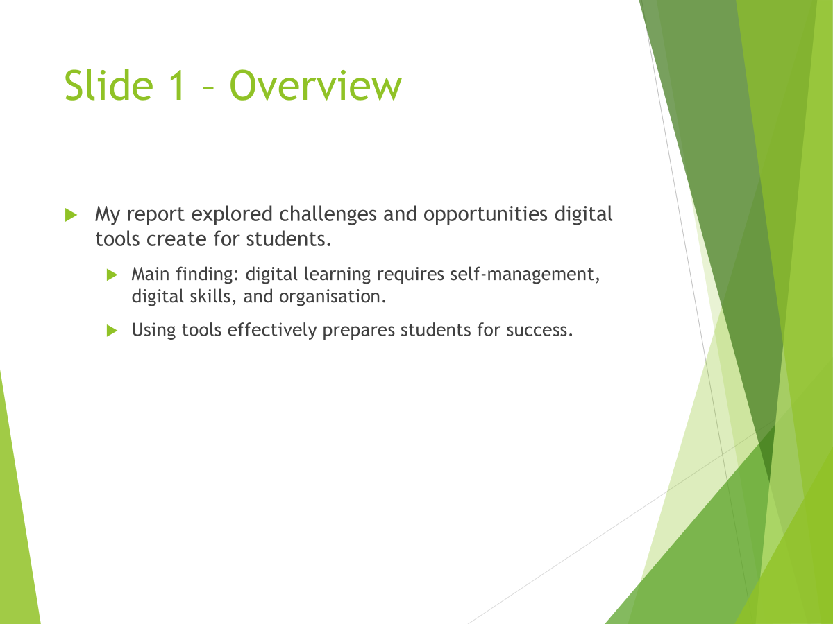

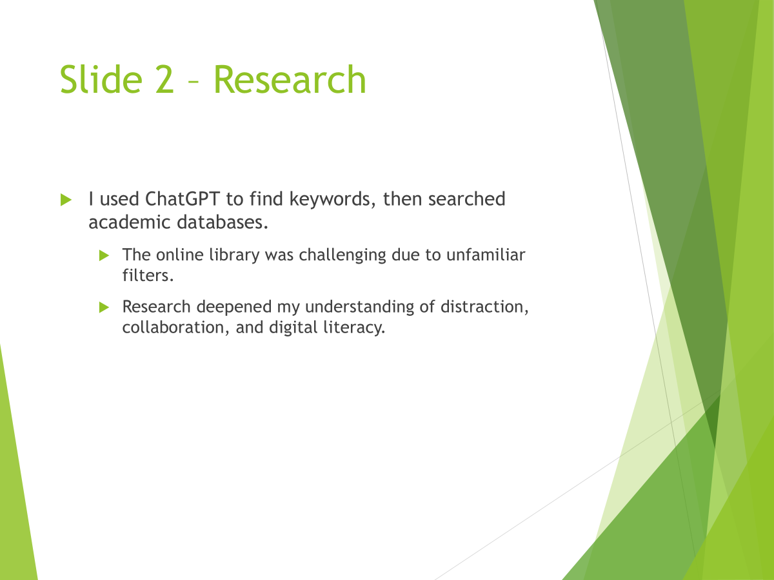

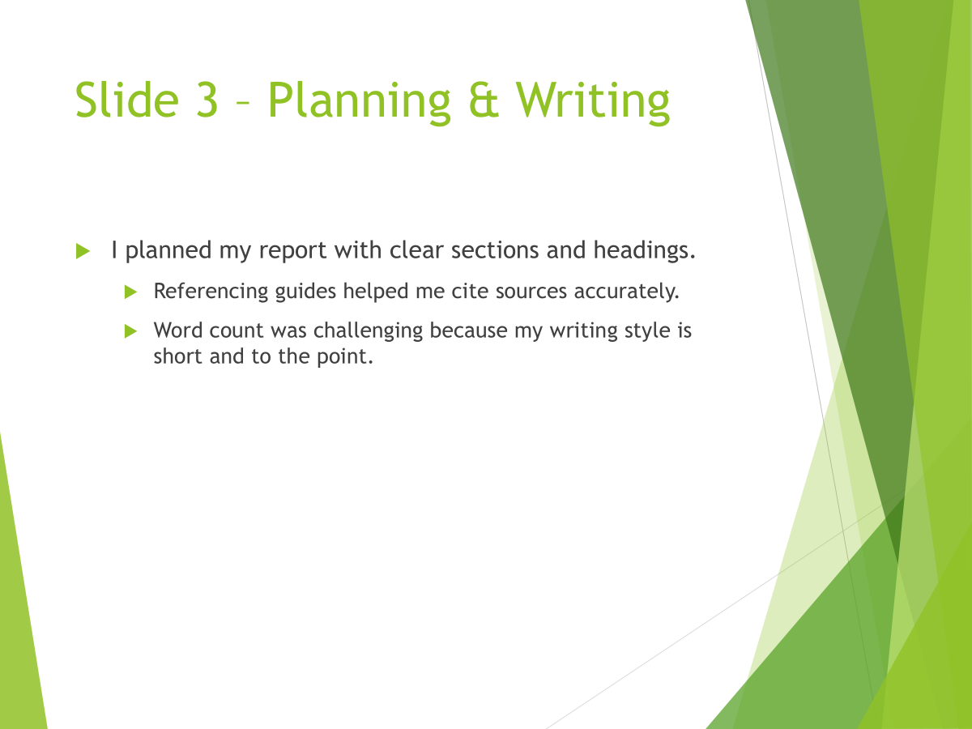

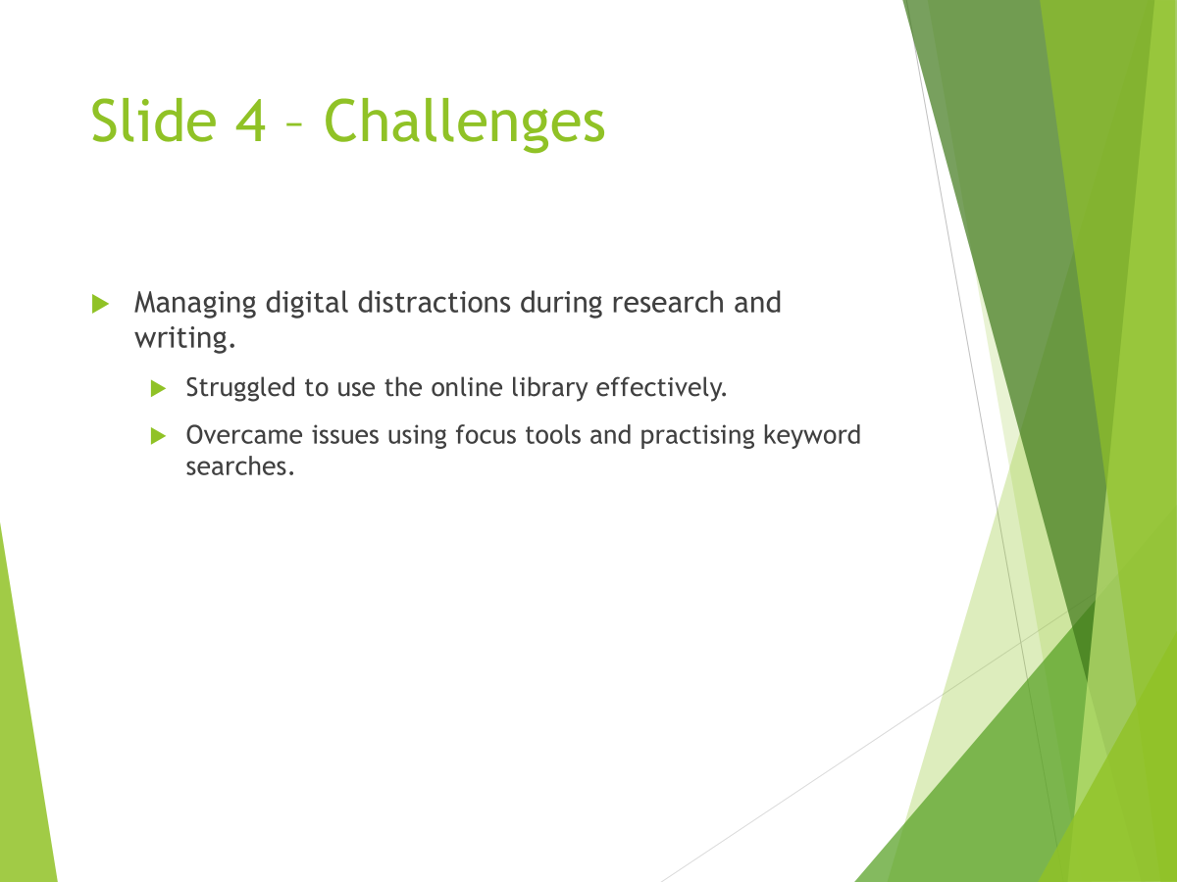

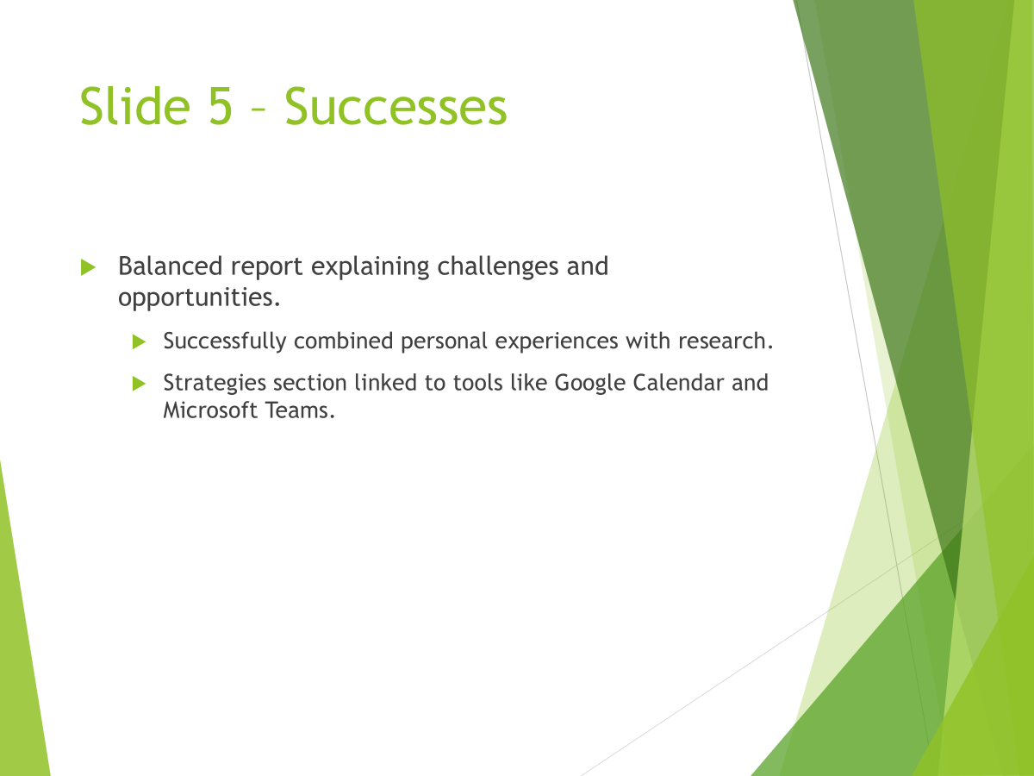

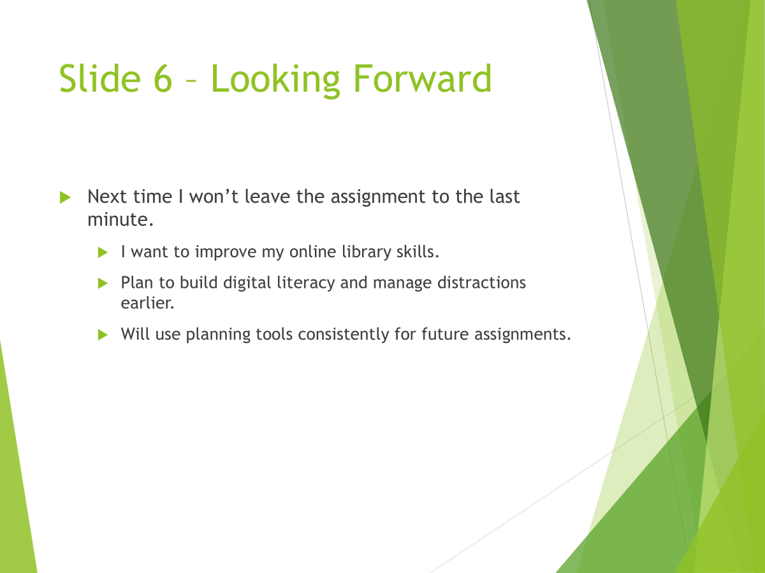

Reference List

Bach, A. and Thiel, F. (2024) ‘Collaborative online learning in higher education: Quality of digital interaction’, Frontiers in Education, 9. Available at: https://www.frontiersin.org/articles/10.3389/feduc.2024.1356271/full (Accessed: 20 November 2025).
Gupta, R. (2023) ‘Multitasking, stress, and student learning’, Journal of Cognitive Education, 12(2), pp. 21–34.
Huang, M. (2023) ‘Digital planning tools and academic success’, Learning Support Journal, 9(1), pp. 56–70.
Martinez, P. (2022) ‘Distraction and attention in online learning’, Journal of Educational Psychology, 41(4), pp. 112–127.
Parker, J. (2022) Digital Skills for Modern Learners. New York: EdTech Publishing.
Patel, G. (2022) ‘Multimedia learning resources and student understanding’, Teaching and Learning Innovations, 7(2), pp. 14–29.
Thompson, M. (2022) ‘Digital learning and student engagement in higher education’, Journal of Educational Technology, 16(1), pp. 1–15.
Watson, K. (2023) ‘Focus technologies and student productivity’, Studies in Digital Learning, 5(1), pp. 33–49

