Design and Implementation of a Relational Database System

Oliver Richards

Contents
Introduction 2
Entity Relationship Diagram 3
Logical Design 4
Microsoft Access Implementation 7
User Side 7
Admin Side 9
Conclusion 12
Bibliography 12

Introduction
This report will cover the planning and creating of a database system for a small handmade jewelry business called ‘Craft Gem’. A robust database solution is required to improve efficiency and organisation. First an Entity relationship diagram will be made, then the logical design in the form of a database dictionary where the fields of the tables will be defined. Then, the database will be created in Microsoft access and functionality for users and customers will be implemented.

Entity Relationship Diagram
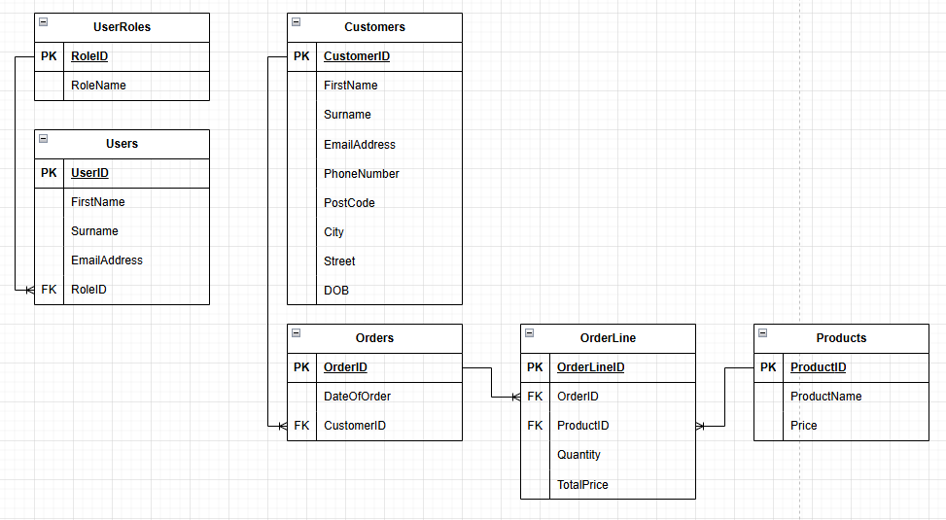
Figure 1 - Entity Relationship Diagram first draft

An Entity Relationship Diagram ERD is a blueprint for a database used to map out every entity (Users, Products) and their attributes which are the data fields for these entities. Then, relationships are used to show the entities connect between each other. [1] Shown above in figure 1 is the first draft created for the ERD for the database. Craft Gems requirements were manageable inventory, customer information, and recording orders. On the right side of the diagram, there is a customer entity with a one-to-many relationship, meaning that, one customer can make many orders [2]. At first it may seem that a products table could be linked directly to the orders table, however this would mean only one product could be on each order and this would make tracking orders with multiple items difficult. Therefore, an OrderLine table has been used with OrderID and ProductID (The unique identifier in both these tables). This means that each order can now have multiple products under it. On the left, there is a User Roles table with a one-to-many relationship with a User table, this is for admin and user privileges for the program. When creating an ERD, it is important to only have one-to-many relationships as having one-to-one, or many-to-many can cause issues and inconsistencies in data. [3]

Logical Design
To aid in creating the database, a data dictionary can be used. This is a documentation of all the metadata which will exist in the database, these are things such as data types, default values, validation rules, and whether the field is a primary or foreign key or neither. [4]This is important as it helps improve consistency, error reduction, and more organized development. Shown below in figures 2 and 3 is the data dictionary which was used for assistance with creating the complete database. In this case, no validation rules or text was required, however for improvement in the future, some fields could be slightly changed to have validation rules which would prevent any incorrect data being added.
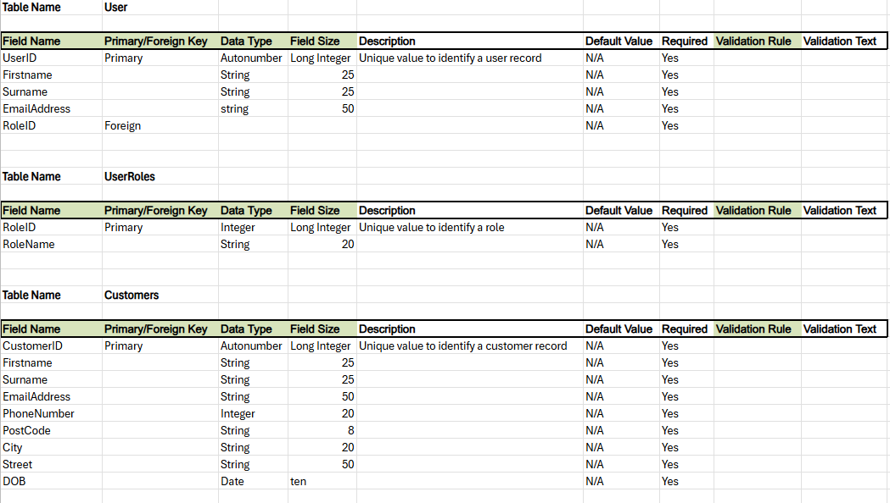
Figure 2: Data Dictionary
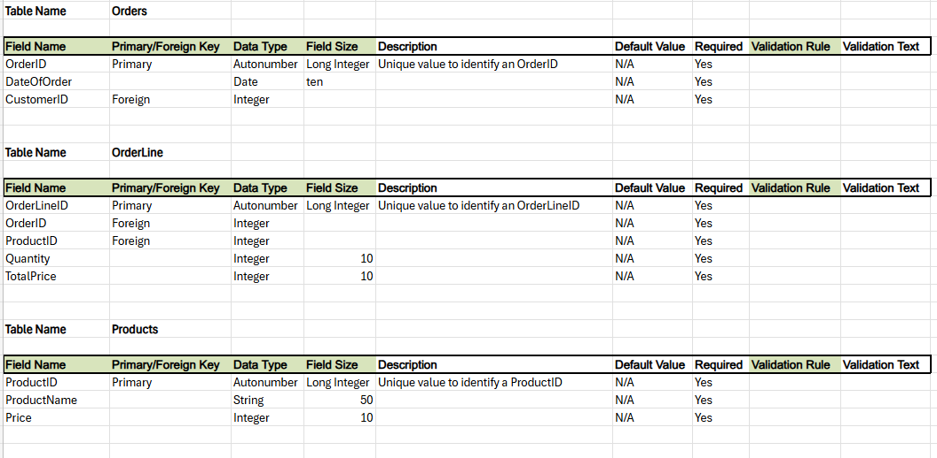
Figure 3: Data Dictionary
Using the initial ERD draft and the data dictionary, the database could be made in Microsoft access with little likelihood of errors. Shown in figure 4 is the list of tables and in figure 5 is the relationship diagram.
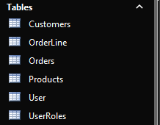
Figure 4: List of tables
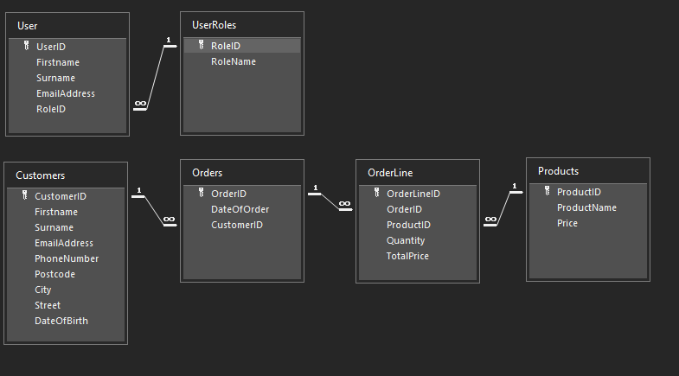
Figure 4: Final Entity Relationship Diagram
Database normalization is the process of designing a database in a way that reduces redundancy, eliminates anomalies, and improves data integrity. [5] First normal form requires no data to be within a field e.g. tasks = ‘1, 2, 3, 4’. This can be simply fixed by having a separate table for tasks. Second normal form must have first normal form and also have no partial dependencies. This can be seen in figure four between the Products and Orders table as ProductName and Price depend only on ProductID so the OrderLine table separates these and stops violating second normal form. Finally, third normal form requires second normal form as well as eliminating transitive dependencies. This means that any non-primary key fields must not depend on any other non-primary key fields. If ProductName and Price were within the OrderLine table this would be violated as they depend on ProductID. Fourth normal form also exists which means using no multi-values dependencies, however, is a lot less commonly used. In some cases, denormalization is needed as although it means violating the rules of normalization, it will still work fine and improve overall performance. [6]

Microsoft Access Implementation
Once the database was in place, the next step was to create forms and reports to give functionality to Craft Gems site with a menu-driven interface. In Craft Gems requirements, easy navigation and access to view things such as current orders and customer information were requested. Having a simple and easy-to-navigate menu is important as it does not require a lot of cognitive load as users can stay focused on the simple UI without the need to figure it out. This therefore means that tasks can be completed quicker with less chance of error or getting lost in UI. [7]
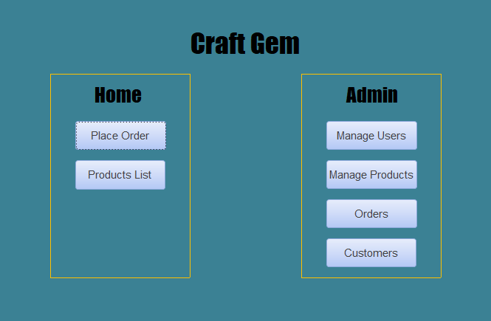
Figure 5: Craft Gem Navigation Page

User Side
With the benefits of a simple navigation page taken heavily into consideration, the above (Figure 5) was created. A ‘home’ section for users with the ‘user’ role and an admin section which will only appear for users with the ‘admin’ role prevents users with incorrect privileges from viewing or editing data which is sensitive to the business. To further improve this, a login page which requests user credentials should be added.
On the user’s side, access to place an order is given (figure 6) as well as a report which lists all products that the business supplies (figure 7). These are navigated using accesses ‘open form/report’ expression.
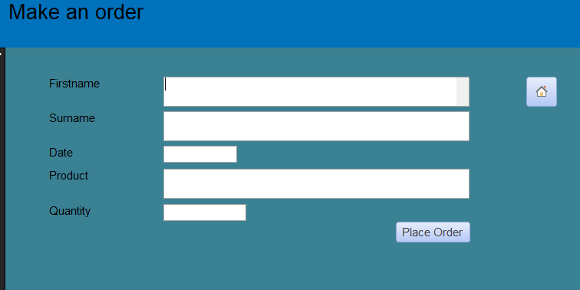
Figure 6: Make an Order Form
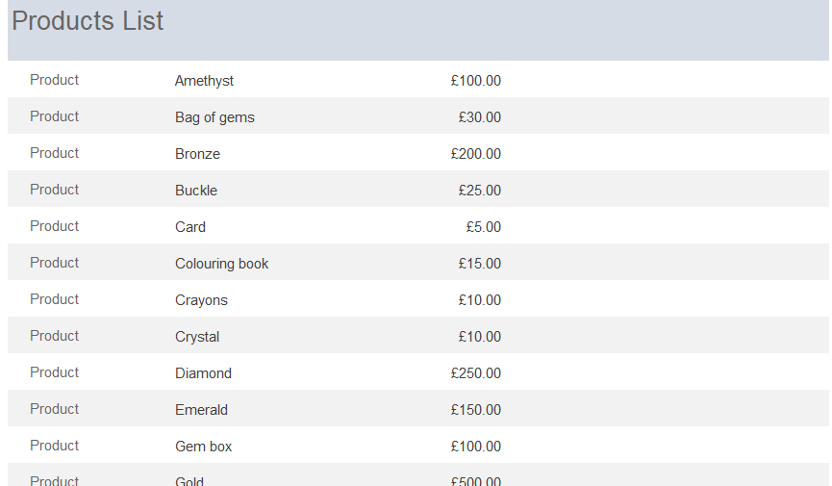
Figure 7: Products List Report
The place or form is created using the form wizard, it uses the Customers, Orders, OrderLine, and Products tables. When ‘Place Order’ is clicked, a new order is created and information inputted to the form is added to the database. Although being able to place an order is useful and important for main functionality, it would also be useful for a customer to edit or cancel their order should they need to. So that a customer knows what is available to order, the products list was created, and it also lists the pricing information of each product. This was made using the report wizard and only queries the Products table as there is no need to query any other entities. Although customers can find what products are available and enter what they desire, they may forget the product name when going to the make the order form, it would be useful to implement a dropdown in the form rather than having to type in the product. It helps to have a cognitively fluent design as this means the user will have to think less when using the application leading to promoted user satisfaction. [8]

Admin Side
The first option for users with admin privileges is to manage all users. This would likely be used by whoever is in charge of the Database system, as shown in figure 8 below there are options to search through each user and modify each field in the record. Within this form there are multiple ways to find a specific user. First a combo box has been used which drops down each user and once selected that record will fill all fields. There is also a ‘Find User’ button where a specific name can be searched in a pop up. As well as these, records can be updated and even deleted.
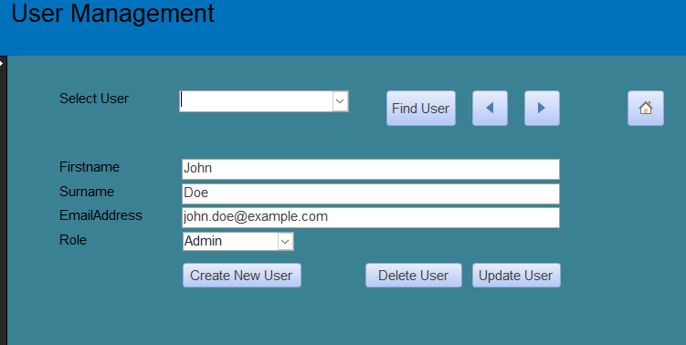
Figure 8: User Management Form
This form queries the Users table using the form wizard; however two queries have been made for both of the combo boxes. The first, which is the select user combo box only has one column, also off of the Users table which pairs the first and surname of each record in the table as shown below in figure 9
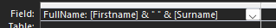
Figure 9: User Dropdown Query
Then for the Role combo box, a simple query is used which just pulls back the Role Name field as shown below. This is so that it is more readable for the user as otherwise they would have to type in the specific role ID which is easily forgettable.
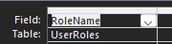
Figure 10: Role Dropdown Query
The next option for admins is to manage all of Craft Gems products. This form has the same layout as the manage all users form, however it includes an option to generate a report based on the product which has been selected. In the example below (Figures 11 and 13) Gold is selected in the dropdown and the query (Figure 12) is run to get the value in the dropdown which the report is based on.
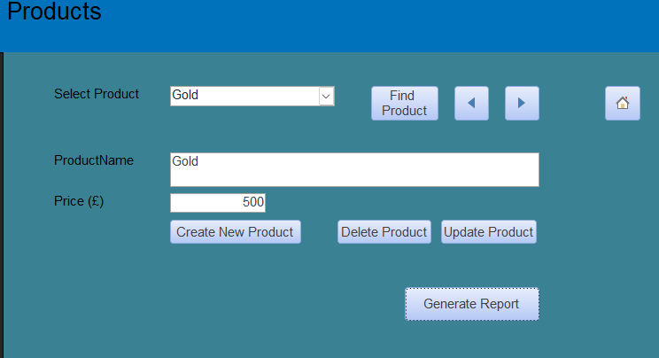
Figure 11: Product Management Form
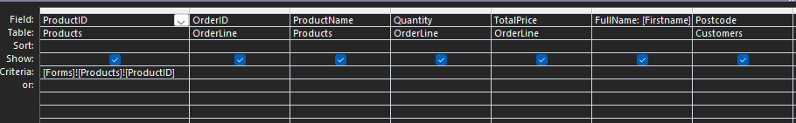
Figure 12: Query for creating the specified Product Report
As can be seen in the criteria row of the ProductID, it takes the ProductID of the value in the dropdown
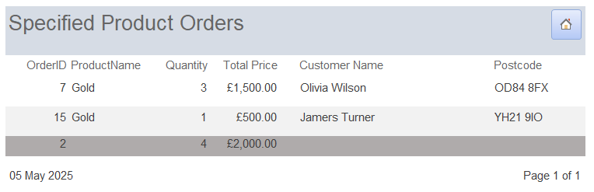
Figure 13: Specified Product Report
The final two options for a user with admin privileges are both reports. The first report (Figure 14) shows all the current orders that have been made as well as the total quantity of stock ordered and the total cost of all orders.
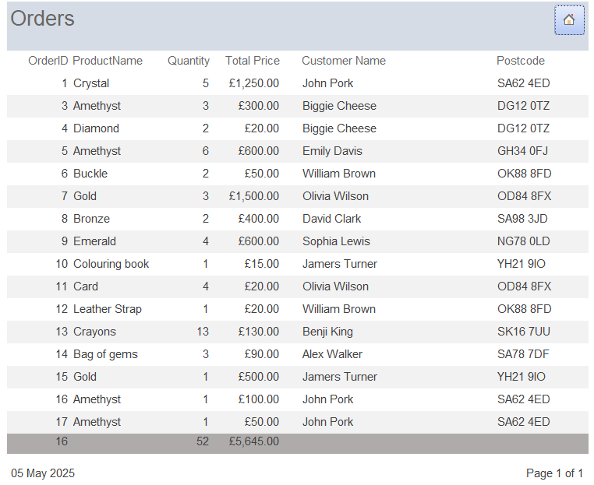
Figure 14: All Current Orders Report
It is built on the same query as the specified product report, except without the criteria of whatever has been selected in the product management form.
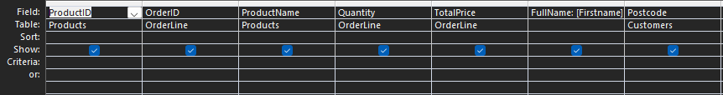
Figure 15: All Current Orders Query
The final report (Figure 16) is a simple report which queries the Customers table of all fields and displays these on the report. This will be useful for finding quick documentation of customer records.
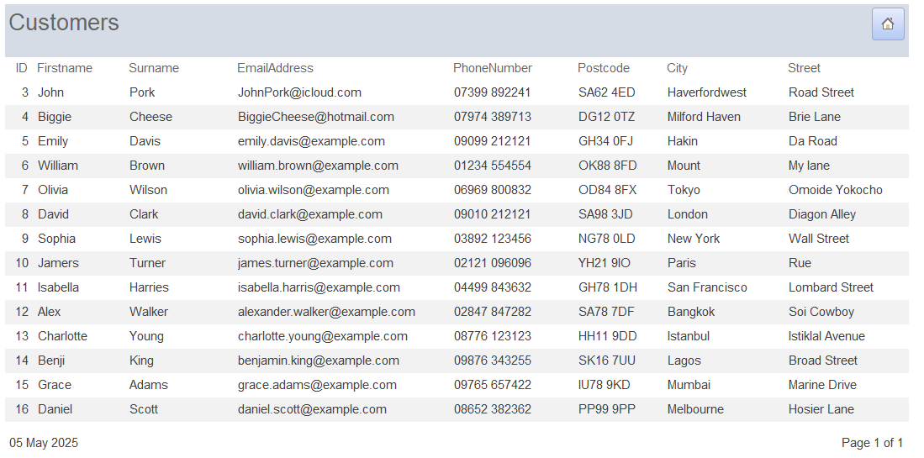
Figure 16: All Customers Report
Some functionality that would improve the admin side of the application would be to have a customer management table as well as an order management table. These would be beneficial as currently, if a customer were to mistake their order, or enter their information incorrectly there is no way to change this other than directly on the table, which is bad practice and may not be simple for anybody untrained in how to edit these.

Conclusion
To conclude, this application has a simple and easy to use interface, perfect for cognitive fluency and productivity. It also has useful reports for easy documentation specifically for orders as well as customers. To improve, more functionalities could be given to the user’s side, as they lack the ability to change the saved information or cancel orders. Lastly although adding a login page would require further database design, this would mean admin and user privileges would be separated.

Bibliography

[1] | Visual Paradigm, "What is Entity Relationship Diagram (ERD)?," Visual Paradigm, [Online]. Available: https://www.visual-paradigm.com/guide/data-modeling/what-is-entity-relationship-diagram/;WWWSESSIONID=6A759042DCF189E6149B63C3485EB1C6.www1. [Accessed 5 May 2025].
[2] | GeeksforGeeks, "Relationships in SQL - One-to-One, One-to-Many, Many-to-Many.," Geeks for Geeks, [Online]. Available: https://www.geeksforgeeks.org/relationships-in-sql-one-to-one-one-to-many-many-to-many/. [Accessed 5 May 2025].
[3] | Tutorials Teacher, "Tables Relations in SQL Server: One-to-One, One-to-Many, Many-to-Many," Tutorials Teacher, [Online]. Available: https://www.tutorialsteacher.com/sqlserver/tables-relations. [Accessed 5 May 2025].
[4] | M. Knight, "What Is a Data Dictionary? Definition and Benefits," DataVersity, 13 March 2024. [Online]. Available: https://www.dataversity.net/what-is-a-data-dictionary/. [Accessed 5 May 2025].
[5] | Leapcell, "The Three Normal Forms in Database and Why You Might Ignore Them," Medium, 20 April 2025. [Online]. Available: https://leapcell.medium.com/the-three-normal-forms-in-database-and-why-you-might-ignore-them-30a4bdfaf45c. [Accessed 5 May 2025].
[6] | R. Awati, "What is denormalization and how does it work?," techtarget, July 2024. [Online]. Available: https://www.techtarget.com/searchdatamanagement/definition/denormalization. [Accessed 5 May 2025].
[7] | J. Rehman, "Advantages and disadvantages of menu driven interface," IT Release, 2 July 2018. [Online]. Available: https://itrelease.com/2018/07/advantages-and-disadvantages-of-menu-driven-interface/. [Accessed 5 May 2025].
[8] | T. Walker, "Why Simple Website Design is The Best: The Scientific Reasons," cxl.com, 20 December 2022. [Online]. Available: https://cxl.com/blog/why-simple-websites-are-scientifically-better/. [Accessed 5 May 2025].

