Sustainable Hospitality and Tourism Management (BMIH 5006)-Report

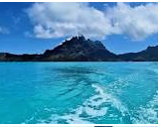

Name of student: Andrea Lee
Student Number:2108011
Assignment 1
Title: Destination Management Plan: Bora Bora (Sustainability for the Hospitality Industry)
Name of Lecturer: Miss Kathryn Roberts

Table of Contents
Cover Page……………………………………………………………………………….0
Table of contents…………………………………………………………………………1
Executive Summary…………………………………………………………………......2
Introduction……………………………………………………………………………….3
Methods/Findings……………………………………………………………………....3,4,56,7
Discussion…………………………………………………………………………………8
Recommendations………………………………………………………………………….9
Conclusion……………………………………………………………………………………9

References………………………………………………………………………………9,10
Appendices…………………………………………………………………………………,11,12,13,14,15,16
Diagram 1 denotes the 3 pillars of Sustainability.
Diagram 2, denotes the determinants of the Destination Management Systems
Diagram 3, denotes. Doxey Irridex the way locals feel about tourism development.
Diagram 4, denotes. Butlers Destination Area Life Cycle (TALC)
Diagram 5, denotes. Mixed Doxey and Butler Tourism Destination life cycle.

Executive Summary
1.This report reflects the understanding of how Integre which is a destination Management company in Bora Bora looks at its Destination Management plan, it is aligned to Sustainability measures and practices for now and the future which embedded and culturally Polynesian.
2. It includes the 3 pillars of sustainability which represents the 3 p’s, people and the planet and profit by the Brundtland Commission Report (1987).
3.The pillars are supported by a specific activities and objectives and Bora Bora is a member of the Environmental Sustainability Governance (ESG, 2019) which is as International standard ISO 14001 on the Environment, Energy saving efficiency plan, waste reduction and resource such as cost effectiveness and Budget control how well the Bora Bora have done for that year and the vision.
4. Intertwined the future and will also embed the 10 principles of Sustainable Tourism to the United Nations Sustainability Development Programme (SDGs).

5 10 principles of sustainable Tourism (sdg.un.org/goals)
1.Certify and Monitor Scientifically Everything must be certified by use and monitor scientifically by the United Nations world Tourism Organisation.
2.Cultivate the Workforce to cultivate a multinational work force of speaking and international Languages by guest and employees.
3.Prioritise communities to put communities first so they can have their democratic say.
4.Align visitors to bring an awareness to tourism of an attraction destination Bora Bora. The volume of tourism at one given time.
5.Protect Heritage-The protection of the French Polynesia culture, Art, designs and cuisine by the locals, employees and Expats.
6.Protect Nature-To protect the environment land, sea and ocean preservation and conservation. They include wildlife, birds, tropical fishes, marine life, flora and fauna of the ocean’s floor. such as sharks and stingray which is a must for water sports and can be seen under floor from the water bungalows. Parks and museums. Bora is naturally safe from earthquakes and tsunamis and is usually dry, but the wet months are April to November.
7.Produce and consume Responsibly to adopt stringent recycling policies and standards, non-use of plastics, rubbish and debris and promote a more circular economy and get rid of plastics by 2025.
8.Calibrate Infrastructure should be sourced locally to prevent carbon footprints and net zero carbon emissions and locally sourced teak for the flooring and construction of the under Bungalows in Bora Bora in the Polynesian designs. 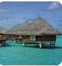

Introduction
6 Bora Bora is the perfect place on earth, a small south Pacific Island northwest of Tahiti in the French Polynesia.
7 Surrounded by a sand fringed motus(islet) and a turquoise lagoon protected by coral reef.
8A destination of unblinding beauty and spectacle
9They are many other hotels in Bora Bora, such as the Royal Bora, Bora and St Regis Bora, Bora Resort.
10It is well known for scuba diving, paddleboarding and snorkelling and many other water sports among the coral reefs.
11It is among the many comforts and graciousness of the Polynesian architecture and cuisine.
12It is set in a series of turquoise lagoons and sunny tropical climate all year round. It is splayed in a coconut palm and pandumus in a blended setting.
13There are three island that make up Tahiti and hence Bora Bora the biggest and the language spoken is Polynesian French Japanese and English and may other international languages.
14There are four to six restaurants owned by each hotel on the Island with a vast variety of culturally cooked meals, light meals, and snacks and to exude our experience on the sun scorched beach.
15Languages spoken by the hotel staff are Polynesian French, Japanese and other international languages.
16The currency use is Franc. It is frequented by many honeymooners and people of influence looking for relaxation, because this is a high-cost destination area.

Method and Findings
17 The 3 sustainability pillars used by Bora Bora. This is looked after by the Destination Management company Integre. with a culture of the Living Manna and the also reflect the 3 p’s of sustainability which are planet, people and profit, assist with the corporate Travel Planning of an originating city and a destination.

Economic-
18The tourism industry forms 85% of the French Polynesian Island Bora bora economic revenue income, secondly fishing and thirdly farming. Economically the Four Seasons as stewards of the ecosystem is a sustainable hotel which looks at how the hotel is managed and preserving the planet for the future generations. They are passionate regarding leaving the world better than they found it and make a positive one. There is industry collaborations and partnerships. This comprise of trade and boost local businesses, employment generation, Revitalisation of traditions, customs and craft, cultures and histories. New development with the aim to boost profitability and sales for the hotels and taxes, fees and revenues for the government.
Environment
19According to the United Nations World Tourism Organisation (UNWTO) “the main destination of a tourism trip is defined as a place visited that is central to the decision to take a trip and is closely related associated with the purpose of the trip.”
20Tourism consists of 1.4 Bn. Bora Bora are committed to preserving the environment and regenerating environment and leaving positive impact on local community, The environment should be kept clean including the ocean and seas and free of pollution and debris. This protects the flora and fauna of the ocean and protect fish and marine life. 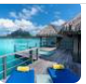
21Tourism attracts many visitors to a destination and impact the area positively and negatively. The people of Bora Bora are cautious about littering the land space since it is a tourist hotspot, not so about ocean and seas large quantities of rubbish are being dumped in the sea and this cause debris and make the water unclean. The are lots of recycling and water conservation projects to make the water clean for consumption.
22Positively protect environmental conservation, Water drainage in coastal area and sewage are being built. “Since 2008 no new hotel is built in this region but are regularly renovated every five years in order to maintain a high standard for the tourism sector”. (Lepresle 2017) Bora Bora rely on cruise ships, boats, helicopters tours, buggies, bicycles public and private for transportation as there no buses, for getting arounds inland and outbound to connect to big cruise liners and flights. There is the planting of coral reefs on coral frames on the Island.
23 Negatively, Cruise Ship pollution are a big problem to the seas and oceans. They used heavy oils such as Bunker fuel mixed with sulphur for carriage 5,000 times more deadly than gasoline with are pollutes to air which is moderately polluted and water. (World Air Map) There are from the laundry, pools, photo labs, spas, and medical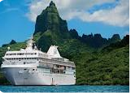
facilities. There are many secret pools for employees and a morgue for older guest who may fall ill and die during the cruise ship tour. The sewage from one cargo ship is equivalent or can fill 50 swimming pools per week and it must go somewhere and usually release before it reaches a port. Sewage must be dumped 3 nautical miles or 12 miles from shore. There are many international and ocean laws.
24There many eating and drinking on cruise ship and even by crew members which result in a lot of rubbish and debris, and this becomes a problem for the environment. They seek to minimise the carbon footprints and save in water conservation, energy and air. In the Bali cooking oil is made into Biofuel and donate food waste to feed animals. It is almost impossible to get a refund on Cruise ships.
25There are 79 reported fires on board cruise ship since 2005 which could result in the boat being sunk and put a lot of pressures on the captain, staff and families. Crew members are usually outside of the US because would put up with the 100 hours work week and long hours. There are many outbreaks of disease on Cruise since 2014.

26Overcrowding or unbalance tourism due to the large volume of Tourists which will result in the congestion of traffic by tourist boats during normal hours which makes them frustrated and angry and may want to move out of the area. In Bora Bora small boats are used to transport passenger to the hotel from the Bora Bora International airport. They are then escorted in buggies to their hotel rooms. Bicycles are used to get around the property if requested. the employment indicated they are a multi cultured community of which they, speak Polynesian, French Japanese and many other languages.
27Socio-Economic-Socially people are looking for work, and opportunities to make a livelihood since 2019. This is the way the community and the employees of the hotels make a living from this Hotel industry due to the influx of tourism to the area, the wider communities and globally. Many employees are from the local communities and. There are locals who sing, perform dance, fire dance and perform ceremonies to entertain the guests on the island. There are farmers who plant coconuts, pandumus, pineapples, herbs and vegetables. They are coastal fishing of sharks and stingray which are eaten by the local and international guest.

28Destination Auditing
- Geographical Analysis-this indicates the viability of the Bora Bora Region.
- Visitor satisfaction-to see it’s the tourist or visitor priority destination choice.

- Community survey-to see the reaction of the resident and the infrastructure available or to be improved.
- Assessment of destination carrying capacity-Looks at the carrying capacity and how many visitors are allowed at one time.
- Environment impact Assessment-This can be positively or negatively. This influence Tourism.
- Economic impact assessment This can be positively or negatively.
All this were taken in account before the new hotel were built in 2019.This is enforced by the (ESG) in designing and building sustainable hotel to maximise efficiency and minimise impact. Create spaces that promote human health and community.

29Butler Theory (1980)-Tourism Area Life Cycle (TALC) is widely used model to study the evolution of a particular tourism destination. This comprise of the 5 stages of the development life cycle namely.
Exploration, - This is the initial stage visitors will come to the area looking for business, hotel and properties for investments.
Development, -The is the second stage of looking for development in run down communities to attract employment and business to revitalise the area, town or city. As interest grows visitors will increase.
Consolidation, -This an agreement by residents and stakeholders for commencement of work to the area.
Stagnation- There is no investment or interest in the area, and there is despondency and lack of income generation.
Decline or rejuvenation No tourism to the area, and this can also indicate land degradation to the environment and erosion of soil. This may be the case of thing picking up again.

30Doxey Irridex 1975-This was developed by Doxey and looks at the way or different stages residents react towards new development in a host destination city or area of Tourism. This can be with antagonism. People becomes irritable and display their annoyance and may want to fight.
- Euphouria-Enthusiasm
- Apathy- A lack of feeling or Indifference.
- Irritation-annoyance
- Antagonism-hostility
2.)

31The World Economic Forums Global Future Council on Sustainable Tourism
Has developed the principle to guide business, governments, destinations, travellers and resident communities to better design and manage tourism destinations and practices for many years to come.

32The 3 principles Destination Management (UNWTO)

- Strategic Leadership
- Effective Implementation
- Efficient Governance

Having all principle is very good for destination management plan.

33Industrial Ecology (2009)

Is a “scientific discipline that promotes a systemic approach, to human problem, integrating technical environmental and social aspects” (Industrial ecology, 2009). It is sometimes referred to as the science of sustainability. In that it promotes a broad scientific solution to sustainability problems.

34 Types of Tourism
1.Agriculture Tourism
2.Dark Tourism
3.Business Tourism
4 Space Tourism
5.Food Tourism
6.Sport Tourism
7.Cycling Tourism
8.Volunteering Tourism
9.Heritage Tourism
10.Walking Tourism
11.Gardening Tourism
12.Water Tourism

35Discussion: Comparing the Butler’s 1980 and the Doxey Irridex 1975
The two models are equally important in managing Destination Management Plan of Bora Bora. Some of the locals may be happy and boastful for the development and they would be able to get employment opportunities on the other hand some may be indifference annoyed and very angry that this is taking place and they can’t do anything about it (see appendices).According to (Darwin 1842) referred to the barrier reefs surrounding the volcanic islands as an intermediate stage in the development of atolls through long term subsidence and reef growth. They are formed on old volcanic island (Bard et al 1996)

36Recommendations the recommendation is using the Butler 1980 model. This looks at the Enthusiasm locals felt when $30m was invested in 2019 by the U.S to develop the region in terms of hotel renovations to make it better for Tourism. This was a facelift for Bora Bora and attracts consistence visitors to the region as a sought-after destination at present. (Bora Bora.com)

37Conclusions- In Conclusion Destination Management plan is the core or nuclei of any destination. It sets out the planning and development process of Integre in the Bora Bora action Plan of the government, Stakeholders and Stockholders for the ongoing work in a region and to mitigate antagonism among communities. I know can be challenging for those who compile these vigorous guidelines and systems. In the future of this continued work Bora Bora is the winner through the Atoll development the nature and characters of the Tropical Islands regarding reef formation, which is because they rely on Tourism which is a large part of the income generation of the French Polynesia Island by building a stakeholder and stockholder orientations.

Reference List
Bard, et., al 1996
Biodiversity and climate change Adaptation in Tropical Islands (2008)
Butlers Theory, TALC 1980
Cooper, C. (2021) Essentials of tourism. Third edition. London: SAGE
Darwin C.R. 1842 The structure and Distribution of Coral Reefs
Destination management Organisation
Doxey Irri Dex 1975
EIC Centre for Sustainability and Social impact (eventcouncil.org)
Gurlek. M. and Tuna, M..2018 Reinforcing competitive advantage through green organisational culture and green innovation. The service industries, Journal 38 (7-8, pp.467-491)
Fields P. (2012) How we can encourage and support a more sustainable future.
Green Globe
Industrial Ecology (2009)
https://www.Bora Bora. com
https://integre.spc.int
International Solid Waste Foundation
https://www.youtube.com/watch?=0q1QVpuYJQs
James Curran (2017) 3Pillars of Sustainability
Lepresle (2017)
New governance and management in touristic destinations (2022). IGI Global
Socio Cultural impacts (Smith1989)
International Journal of Contemporary Hospitality Management,30 (3) pp.1584-1600
Latif, K. F., Perez, A and Sahibzada, U.F.2020 Corporate Social Responsibility (CSR) and customer loyalty in the hotel Industry. A cross country study International Journal of Hospitality Management 89, p 102-565
https://www.sustainablehospitalityalliance.org (1992)
United Nation World Tourism Organisation (UNWTO)
United Nation World Health Organisation
#Visit@fsborabora
World Travel and Tourism Council

Appendices

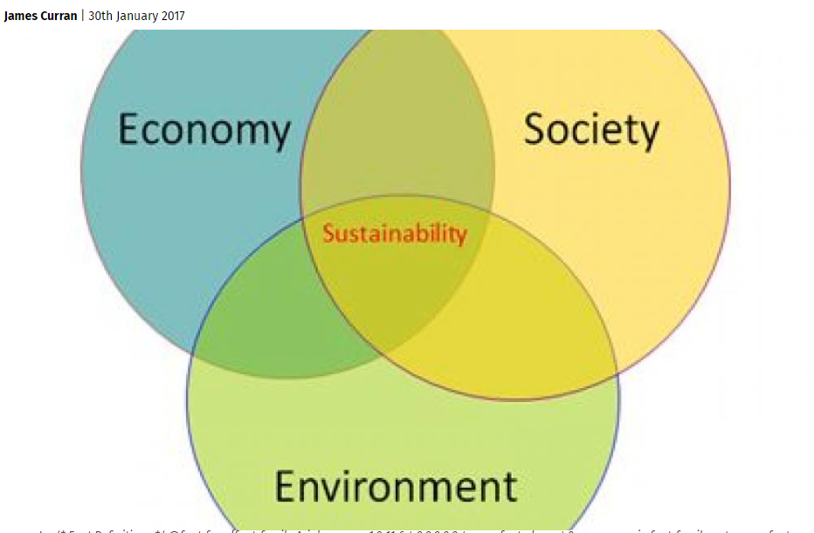
1. This diagram shows the 3 pillars of Sustainabilty which is Economy,Society and Environment and is also related to the 3’ps of sustainabilty which are People,Planet and Profit.
2.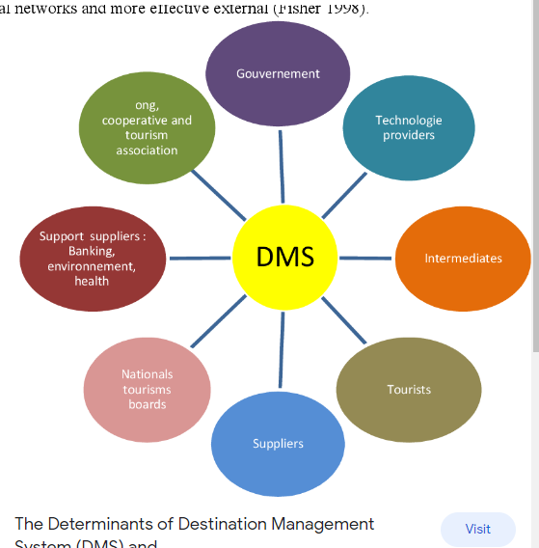

This diagram shows the different determinants management (DMS) systems of a destination management plan according to (Fisher 1998)

Appendices

Doxey Irridex Life Cycle of Tourism
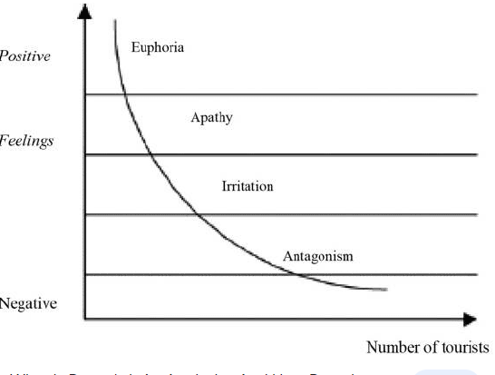3.The Doxey Irridex Life Cycle showing the different stages of the life cycle from how the locals or residents felt when the interest of a tourism destination management plan was presented to them.

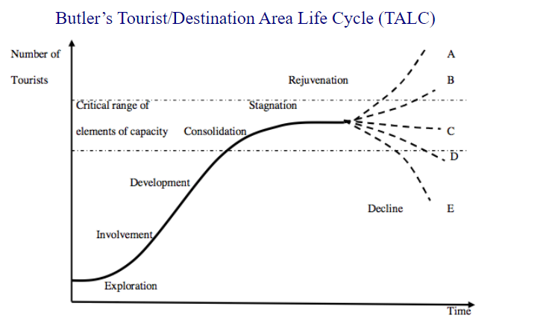

4.The Butler’s Tourist Destination Area Life Cycle (TALC) showing the different stages of the life cycle from interest to decline or rejuvenation.

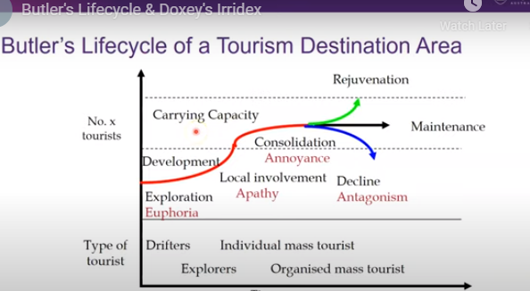
5. A mixed Butler and Doxey Irridex Tourist Destination Life cycle showing the comparison of both models.

