
Essential skills for study and employment

Essentials skills are highly transferable skills such as listening, problem solving and teamwork. They will support people as they move from school to work, from entry level to management roles and from a career in one industry to a career in another. They enable people to flex all their skills [1] to adapt to change and are the foundations for developing new technical and job-specific skills.
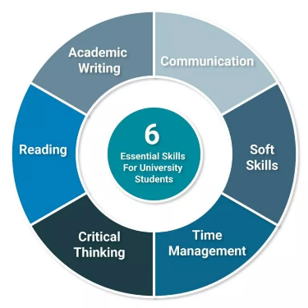
There are certain skills employers want in every candidate, no matter what role they will fill. From entry-level workers to executives, every employee should possess these personal skills in order to succeed and help your company move forward [2]

- Critical Thinking Skills: Critical thinking is a skill defined by thinking clearly, rationally and being able to recognise and understand good arguments
- Time Management Skill: Prior Proper Planning Prevents Poor Performance

Essential skills are the skills we all need to thrive in education, work and life and are proving to be ones heavily required in a time of crisis [3] . With estimates that unemployment has already risen to at least 2.5 million [4] and research showing that those who are most disadvantaged are the hardest hit [5] the UK must build the skills it needs for economic recovery while supporting people back to work and ensuring social mobility.

References
[1] https://eskill.com/blog/essential-skills-employees/
[2] https://www.cipd.co.uk/news-views/news-articles/essential-skills-framework#:~:text=Essentials%20skills%20are%20highly%20transferable,to%20a%20career%20in%20another.
[3] Businesses struggle to recruit school and college leavers with the essential skills needed for work.
[4] Essential skills are highly transferable skills like communication, problem solving and teamwork that are needed for almost any job
[5] Essential skills can be developed throughout our lives and can’t be automated out.

