
UNIVERSITY OF WALES TRINITY SAINT DAVID

Community Engagement – A Local Council Report

Community Engagement
LCBB4002

Student name: Sorina-Iulia Cosa
Student number: 2211474
Lecturer name: Efua Adams

Table of Contents

1.Introduction 3
2.1. Transforming the Waterside project by Leicester City Council 3
2.2. Models and standards of engagement. Principles. 5
2.3. Strategies in engaging the community 6
2.4. Consequences of the Waterside project 7
3. Conclusion 9
4. References 9

1.Introduction

The importance of understanding all of the processes involved in community engagement cannot be overstated. The process may consist of several stages and may take a considerable amount of time. A process should not be viewed as containing only one step, decision, event, or tool. Thinking about community engagement means considering how these systems interact. It is about mobilising the community to move. Participation and interest are only the beginnings of engagement. It entails capturing people's attention and directing their efforts towards the subject at hand - the subject means something directly to the person who is involved and is important enough to demand their attention. Engagement implies dedication to a process that includes choices and actions. (Aslin and Brown, 2004)
While managerial versions of liberal democratic theory have typically predominated, liberal democratic theory has long placed a strong emphasis on civic engagement and citizen participation. Over the past two decades, many nations have seen a shift away from top-down approaches towards establishing institutional bridges between government authorities and their communities, a concept known as "community engagement." (Head, 2007) Although the community engagement does not have a proper definition, Aslin and Brown, (2004) stated that great community engagement is linked to engagement procedures and activities in which a diverse group of people collaborate to achieve a common goal led by a shared set of values, beliefs, and principles. It does not inherently imply that each member of the community ought to or may be involved, but is important to make every effort to be as inclusive as possible and to provide everyone with the opportunity to participate if they so desire. A variety of instruments and strategies can be used to attain good community engagement.

2.1. Transforming the Waterside project by Leicester City Council

Leicester City Council put in place in April 2015 a project named ‘‘Transforming the Waterside‘’, which promise to ‘’ to attract new investment which will create a vibrant and thriving new neighbourhood with new homes and new work spaces.’’ (Transforming the waterside, 2015). Leicester Waterside is a regeneration initiative that will change a 150-acre, mostly derelict former industrial site in the centre of Leicester. The River Soar and the Grand Union Canal can be found in the Waterside neighbourhood, which is situated north-west of the city centre between the A6 and Rally Park. Leicester City Council has been collaborating with its development partner Keepmoat Homes to purchase and prepare the 7.3-hectare site designated for the first phase of the Waterside development, which will include the construction of three office structures and over 300 houses. (Leicester Waterside Regeneration Area, 2020).
The Waterside development, which overlooks the Grand Union Canal, contains over 350 new one and two bedroom flats as well as two, three, and four-bedroom houses, as well as at least 55 affordable units. Along with the new houses, there are public green areas and a new canalside walkway that connects to the waterfront. The city council's redevelopment strategy for the city included constructing this brownfield site using £25 million in funding and council money to compulsorily buy rundown and abandoned areas along the River Soar, as well as obtaining draught planning permission for these new homes. (First new homes completed in major Waterside regeneration, 2022). Nowadays, the project is still ongoing, just celebrating the ten-year milestone and the City Mayor Peter Soulsby said: “The regeneration of Waterside represents a tremendous boost to the city’s growth and prosperity. It’s been ten years since our purchase of a derelict and fire damaged historic factory kickstarted this ambitious project and it’s extremely encouraging to see the positive impact that has had over the last decade.” (Leicester’s Waterside regeneration reaches ten-year milestone, 2023)


IMAGE: Leicester’s Waterside regeneration reaches ten-year milestone, 2023

2.2. Models and standards of engagement. Principles.

Engaging in community planning requires participants to have a clear understanding of the communities they are working with, their history, and culture, the nature of local community organizations and networks, the range of needs and issues experienced locally, the assets and strengths of the community on which to build, and the nature of existing dialogues and participation within that community. (Hashagan, 2002)
To make an engagement process work, participants must agree on the ideals, principles, and standards to be applied. It also allows for the procedure to be evaluated. To reach this accord, the committee will need to collaborate with the community. Once decided upon, beliefs, principles, and criteria should be implemented throughout the decision-making process. Some of the principles are the following: courage, commitment, honesty and respect, inclusiveness, flexibility and practicability. (Aslin and Brown, 2004) The purpose of the project is to providing a unique and vibrant location to reside and room for local businesses to thrive, offering a thriving neighbourhood, to reconnect the Leicester city with its waterfront, enhancing the metropolitan wildlife and providing financial possibilities for employment and recreation, at the same time to provide a place where people feel secure and comfortable walking and cycling, where streets and homes are constructed to high design and sustainability standards, and a confident place that values its past while welcoming the future. (Transforming the waterside, 2015)
Based on the information provided online, on social media(Facebook and Twitter) and on the official website of the Leicester City Council, the funds came from the Government (LLEP Local Growth Found), £20 million, and also from the council money. The information was shared mostly on Facebook and their official website, and the council was asking the community to engage and share their opinion on the project, as a part of the consultation and people seemed to appreciate the initiative of the council. Some of the opinions 7 years ago coming from the people showed that they are excited of the idea of improvement the Leicester city, especially the waterside, and they think it will be a great idea to ‘’help to build housing for young people to get on the housing ladder’’ (source: Facebook).
Involving stakeholders and communities is critical to the effectiveness of an engagement process. A stakeholder is anyone who has a financial, moral, legal, personal, community-based, direct or tangential interest in a problem. Any person or member of the public who has an interest in the topic being addressed can be a stakeholder. Recognizing the existence of a diverse set of stakeholders implies accepting the possibility that local and distant interests may clash, as local communities frequently endure the personal and direct repercussions of decisions made in the long-term national interest. (Aslin and Brown, 2004)
Models of engagement or participation have been conceptualised as combining various levels, on a scale or spectrum, spanning from providing information to communities, through dialogue, co-production, and assigned authority, to complete community control over national interests. (Attree et al., 2011). The transitional type of community engagement has been used in this project, which is a type of interaction that falls somewhere between transactional and revolutionary in that it is substantial but lacks synergy. It, like transformational engagement, is distinguished by two-way dialogue and increased community participation. The company retains material control, but 'bridges are created' with communities. This type of engagement lacks the collaborative decision-making and shared sense-making that characterises genuinely transformational interaction. (Stirling et al., 2016)

2.3. Strategies in engaging the community

In order to have a successful project and to provide a safer neighbourhood, a cleaner area, a better city for the citizens, a better infrastructure and a great place to live in, the city council needs to have a series of strategies. Firstly, the relationships of the people and organisations involved with the community are very important to be maintained transparent and clear, showing exactly everything that is planned to be done or was already done. It is shown that the Government provided most of the funds for the project, and a small but significant part of the funds were provided by the council founds. They work closely with Keepmoat Homes, in order to provide the best services in building and planning the houses. Keepmoat Homes made a virtual structure of how the Waterside will look after the transformation, so the community can see what they should be expecting, and the results were amazing, this being one of the strategies used for making the community be interested and engaged. By showing those images when bringing the project in front of the community, they made the people dream about their new home, their new life and also to dream about how modern their city will look like. As a result, in April 2022, City Mayor Peter Soulsby toured the site to see Keepmoat's new showhome and met with some of the development's first inhabitants, who have already moved in. He stated that: "Leicester’s waterside has for a long time had immense potential for regeneration, and bringing that redevelopment forward for the benefit of the city has been a long-held ambition of mine.’’In the words of Shaun Fielding, Regional Managing Director at Keepmoat Homes: “We’re thrilled to have hosted the City Mayor and members of Leicester City Council, so that they can witness the great progress that we’ve made at Waterside and how the new housing development will provide the people of Leicester a great place to live.’’(First new homes completed in major Waterside regeneration, 2022)
Secondly, they strategized through the communications, keeping the community informed on their official website, on Facebook/Twitter, from the beggininog of the project to the ongoing phase which is on now, since it’s been 10 years since they started the project. It seems like people are still engaged on the Facebook page, but some of them, even though they like the initiative to transforming the Waterside, they are disappointed that few members of the community cannot keep up with the cleanliness of the river; ‘’the litter the locals throw on the canal bank and into the canal’’ someone said, is revolting. (Source: Facebook). The council also offered consultations events, and posted the notice on Facebook and their official website, and this is an important step in engaging with the community needs and wants, also to seek opinions of the people who may actually plan to live in the new area.

2.4. Consequences of the Waterside project

Being an ongoing project, the outcome cannot be rated as finished, but at the moment, the outputs seems to be successful, since in the waterside area, 1,000 new houses and flats have been built, as well as approximately 1,000 student spaces.(First new homes completed in major Waterside regeneration, 2022); the development of 9,000sqm of additional workplace space, and the production of around 500 new jobs. It has also aided in attracting approximately £300 million in private investment into the Leicester city. (Leicester’s Waterside regeneration reaches ten-year milestone, 2023) As seen on the images, it is a great improvement of the area, and it makes the city be prosperous. Waterside has rapidly become Leicester's most desirable new location. Waterside is an excellent option for both parents and workers. With several colleges nearby and quick access to the city's ring road and railway stop, it's easy to get in any place needed to reach. (Waterside, Leicester, Keepmoat.com)
The recommendations for the City Council would be to firstly make tougher regulations about polluting the waters from the city, because just by going around the area it can be seen the dirt of the water which affects both the people living in the area and the way the interface of the city. Also, they could also make brochures to be given in a door-to-door basis about the new homes built, so the elders will also have access to the information. Keeping in mind the level of homelessness in Leicester, the council could also build some houses for the people in need.

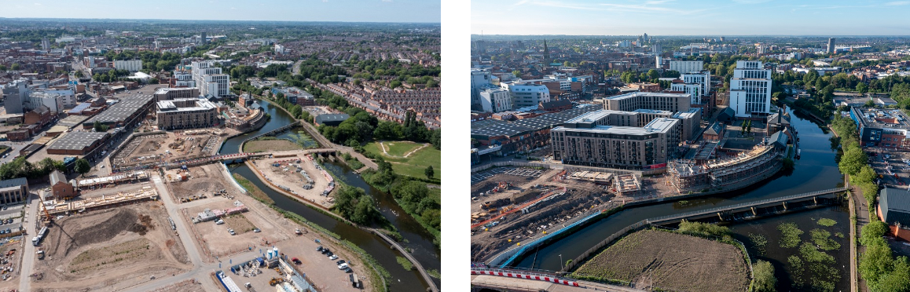
IMAGE: Leicester’s Waterside regeneration reaches ten-year milestone, 2023

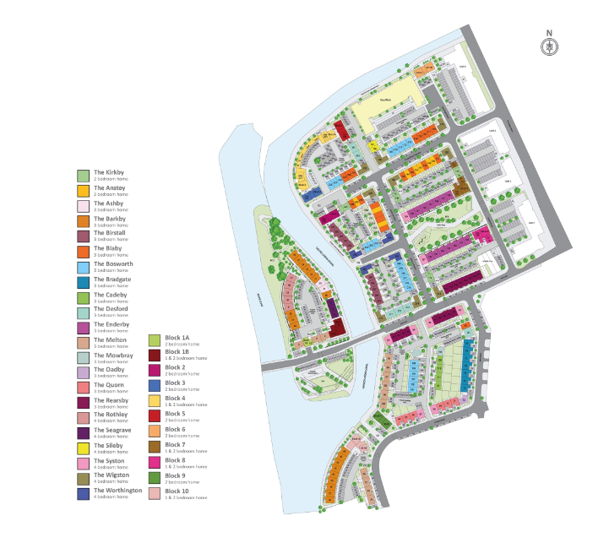
IMAGE: Keepmoat.com, Waterside Leicester

3. Conclusion

Even though the meaning of the word ‘engagement’ is not defined, It implies the existence of a 'administration' and a 'community' structure. To build the collaborative relationships required for a complex activity like community planning, the governance system must fully understand the dynamics of the communities with which it aspires to work and be willing to adapt and develop its systems and procedures to keep them available and applicable to those communities. (Hashagan, 2002) The work that Leicester City Council put in carrying out the project of ‘’Transforming the Waterside’’ is seen to be a step by step work, every process of the community engagement framework has been followed, and this results in a successful project which is in its ongoing phase and the final results are being waited impatiently. The city is changed since the first houses built in the Waterside area and this creates a better living space for everyone and a better face for the city of Leicester.

4. References

Aslin, H. and Brown, V. (2004) Towards whole of community engagement: A practical toolkit. Murray-Darling Basin Commission. (Accessed: February 20, 2023).
Attree, P. et al. (2011) “The experience of community engagement for individuals: a rapid review of evidence: Experience of community engagement: a review,” Health & social care in the community. (Accessed: February 19, 2023).
First new homes completed in major Waterside regeneration (2022) Leicester City Council. Available at: https://news.leicester.gov.uk/news-articles/2022/april/first-new-homes-completed-in-major-waterside-regeneration/ (Accessed: February 28, 2023).
Hashagan, S. (2002) Models of Community Engagement (Scottish Community Development Centre). Scotland: Scottish Community Development Centre. (Accessed: February 27, 2023).
Head, B. W. (2007) “Community engagement: Participation on whose terms?,” Australian journal of political science. (Accessed: February 28, 2023).
Leicester city council (2015a) Facebook.com. Available at: https://m.facebook.com/leicestercitycouncil/photos/a.168383059877291/785286284853629/?type=3 (Accessed: March 2, 2023).
Leicester city council (2015b) Facebook.com. Available at: https://m.facebook.com/leicestercitycouncil/photos/a.168383059877291/785275591521365/?type=3 (Accessed: March 2, 2023).
Leicester City Council (2016) Facebook.com. Available at: https://m.facebook.com/leicestercitycouncil/photos/a.168383059877291/966700790045510/?type=3 (Accessed: March 2, 2023).
Leicester City Council (2023) Facebook.com. Available at: https://www.facebook.com/story.php?story_fbid=pfbid0Y5QKd5bnTgTiXvMGjDw5RnrpSykvegRiEWSTePZQyDAkQqaftYvpgrdSuBNKwrk6l&id=100069144491840&_rdr (Accessed: March 2, 2023).
Leicester Waterside Regeneration Area (2020) LLEP. Available at: https://llep.org.uk/investments/leicester-waterside-regeneration-area/ (Accessed: February 28, 2023).
Leicester’s Waterside regeneration reaches ten-year milestone (2023) Leicester City Council. Available at: https://news.leicester.gov.uk/news-articles/2023/january/leicester-s-waterside-regeneration-reaches-ten-year-milestone/ (Accessed: February 28, 2023).
Stirling, L. et al. (2016) “Antecedents to transformational community engagement in South Africa,” South African journal of economic and management sciences. (Accessed: March 1, 2023).
Transforming the waterside (2015) Leicester City Council. Available at: https://www.leicester.gov.uk/your-council/city-mayor-peter-soulsby/my-vision/connecting-leicester/transforming-the-waterside/ (Accessed: February 28, 2023).
Waterside, Leicester (no date) Keepmoat.com. Available at: https://www.keepmoat.com/waterside-leicester (Accessed: March 1, 2023).

