
ASSIGNMENT
INTERCULTURAL COMPETENCE REPORT
MODULE
FOREIGN LANGUAGES & CULTURAL AWARENESS
MODULE CODE
BMIH5003
LECTURER
HEIDI PROSSER
STUDENT ID
2232425
STUDENT NAME
MADALIN LIVIU NOADA

TABLE OF CONTENTS
EXECUTIVE SUMMARY 3
INTRODUCTION 4
CULTURE OVERVIEW 4
GLOBE PROJECT ANALYSIS 5
CHALLENGES OF INTERCULTURAL LEADERSHIP IN HOSPITALITY 7
CONCLUSION 8
RECOMMENDATIONS 8
REFERENCES 10

EXECUTIVE SUMMARY
The executive summary highlights the main features of the report, elaborating on the most important issues of managing an intercultural team at the Inclusivity Hotel & Spa in London. With the role of an Assistant General Manager, the investigation of cultural differences between England and Confucian Asia assumes central importance for team integration. The report gives a detailed description, which is based on both qualitative descriptions and the most recent information from the GLOBE Project. The cultural peculiarities, communication methods, and business methods at the hotel industry are analyzed, identifying the leadership opportunities. Based on this understanding, the recommendations are centered on preventative measures; cross-cultural training, cultural liaisons, and team-building activities that lead to a cohesive and effective intercultural team. This executive summary provides a strategic plan for the Hotel Management Team to steer the Inclusivity Hotel & Spa to become a hub of cultural inclusion, characterized by the global interdependence that epitomizes success in the modern world.

INTRODUCTION
In the position of a new Assistant General Manager at the Inclusivity Hotel & Spa in London, I will have to study the operations and policies of the hotel chain and involve employees from the representative hotel branch of the chosen country. This undertaking involves a visit to Confucian Asia because in April 2024, a team of hotel workers will be sent to the London squad. This trip is critical in terms of understanding the differences between England and Confucian Asia beyond the functional details. This opening section aims at cultural sensitivity and the need to accept these differences in order to build a cohesive intercultural team. In the personalized service sector such as hospitality, sensitivity to cultural differences and communication styles significantly contributes to the establishment of a hospitable atmosphere for employees and guests.

CULTURE OVERVIEW
The cultural background of England and Confucian Asia shows the many nuances that result in the formation of interpersonal relations and business activity. Individualism is clearly present in societal values in England as success and self-reliance become the very foundations of society. However, the Confucian Asia consisting of Japan, China, and South Korea has a collectivistic orientation that emphasizes group harmony and interdependence. However, the communication styles are also quite distinct, with England being more direct and to the point, sometimes stressing the expression of ideas. Nevertheless, Confucian Asia prefers tacit communication since non-verbal cues and context are important. Because Confucian societies are organized hierarchically, their business practices must be built on this social hierarchical ladder, where respect for authority and consensus decision-making are encouraged (Chung et al., 2008).
Such cultural differences should not be underestimated regarding their influence on the team dynamics. English members may perceive indirect communication as ambiguity while Confucian Asian members interpret assertiveness as rudeness and such conflicts may occur in multicultural teams. In an operation it is difficult to strike a balance between individual and collective achievements, the arena for teamwork is created wherein diverse views are appreciated (Hanges et al., 2016). To demonstrate effective leadership, it is important to untangle these cultural intricacies that, in turn, require cultural savviness and adaptability for cultivating a unified and high-performing team in the cosmopolitan environment of Inclusivity Hotel & Spa.

GLOBE PROJECT ANALYSIS
The GLOBE Project cultural and leadership study provides a broad outlook which makes it possible to compare England and Confucian Asia, identifying their typical cultural dimensions and their influence on leadership style in the hospitality sector (House et al., 2004). On the performance orientation, England favors achievement and excellence, while Confucian Asia seeks to preserve the group harmony. This difference can be seen in leadership approaches in the hospitality area, where English leaders focus on individual results, while leaders in Confucian Asia focus on team success (Hanges et al., 2016).

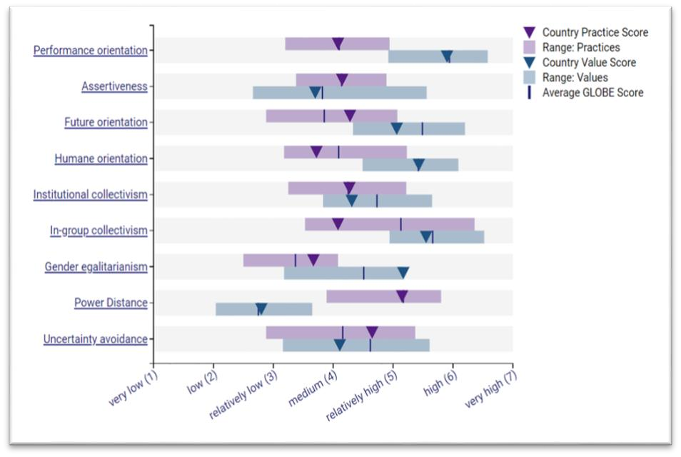
Figure 1: Cultural Practices and Values in England (GLOBEproject, 2023)
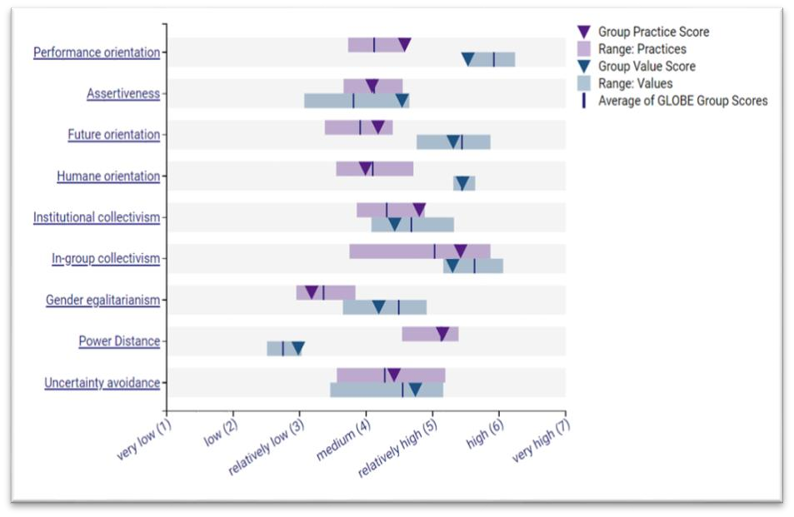

Figure 2: Cultural Practices and Values in the Confucian Asia Group (GLOBEproject, 2023)
The difference in assertion reflects the tendency of English leaders to be more direct and assertive in their communication styles, which reflects the cultural inclination of explicitness. On the other hand, leaders of Confucian Asian may opt for nonverbal communication, relaying messages through body language. This difference in communication norms can pose some difficulties in the management of a multicultural team in this industry where clear and efficient communication is critical. The opposite, power distance, demonstrates that England is less accepting of hierarchical structures, while Confucian Asia values the respect of authority. This can be interpreted to mean that English leaders will strive to cultivate a more egalitarian work environment but leaders from Confucian Asia might be more inclined to a hierarchical one (Luthans and Doh, 2018).
.
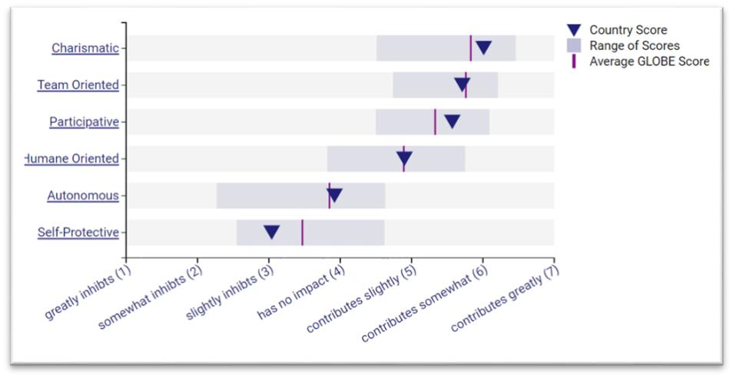
Figure 3: Leadership Scores for Outstanding Leadership in England (GLOBEproject, 2023)
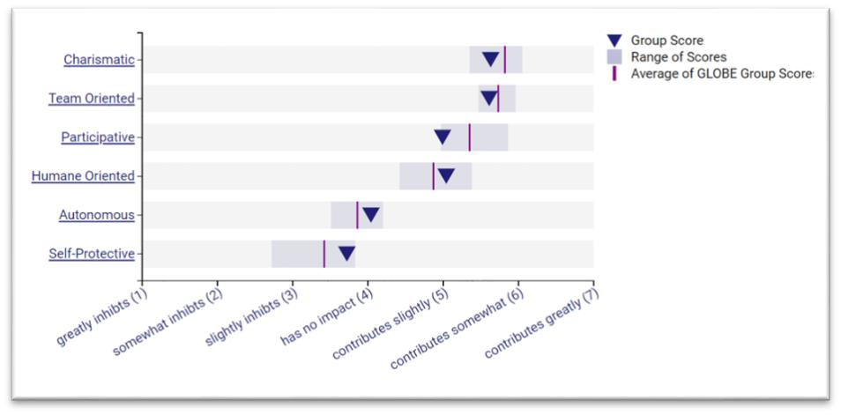
Figure 4: Leadership Scores for Outstanding Leadership in the Confucian Asia Group (GLOBEproject, 2023)
In England, leadership in the hospitality industry is more individualistic, with a focus on autonomy and future-oriented approaches, as evidenced by the transposition of these cultural dimensions into leadership styles. In the Confucian Asian culture, leadership is most likely to be a blend of group objectives and individual contributions, with more focus on relational and compassion (Luthans and Doh, 2018).

CHALLENGES OF INTERCULTURAL LEADERSHIP IN HOSPITALITY
The conflict threads of the mosaic of obstacles in the field of intercultural leadership in the hospitality industry are made up of different cultural traditions. One of the major hindrances, communication barriers may take different forms of communication. For example, the direct and unambiguous communication that is prevalent in England may be contrasted with the indirect and contextual communication that is observed in Confucian Asia. Such dissonance may cause a person to misunderstand or misinterpret something and, unintentionally, divide the team (Dorfman et al., 2012).
Work styles become a melting pot in which cultural differences can either strengthen as a resilient composite or create discord. In England, which values autonomy, an individualistic approach may clash with the cooperative and group-oriented work practices characteristic of Confucian Asian cultures. It takes the right leadership to harmonize these conflicting approaches so that the differences can create a culture that uses the strengths of each cultural viewpoint (Testa, 2007). Decision making is another area of potential conflict that is highlighted. The hasty decision-making, which is characteristic of England, can contradict the consensus-based approach of Confucian Asian cultures, where decisions are often made by consensus. These variations might cause frustration and negatively influence the effectiveness of decision-making procedures, which in turn will affect the general operational efficiency of the intercultural team (Rozman, 2014).

CONCLUSION
The Inclusivity Hotel & Spa needs intercultural leadership because the cultural overview and GLOBE Project study show cultural differences between England and Confucian Asia. Unique values and practices create problems and opportunities for team dynamics. Cultural differences affect communication, work, and decision-making, thus they must be acknowledged. The GLOBE Project's latest data highlights the necessity for adaptable leadership to balance cultural differences. As Assistant General Manager, addressing cultural gaps is strategic and essential for team integration. The hotel can turn these problems into opportunities for creativity and teamwork by promoting diversity, crosscultural knowledge, and inclusive leadership. Accepting and using cultural diversity is a requirement and a strategic advantage in the cosmopolitan hospitality sector.

RECOMMENDATIONS
Cross-Cultural Training Programs
- Implement comprehensive cross-cultural training programs for all team members to enhance their understanding of cultural nuances and foster cultural intelligence (Newman and Butler, 2014).
- Include modules on communication styles, decision-making processes, and teamwork, ensuring a shared understanding among staff from England and Confucian Asia (Zhang et al., 2005).
Cultural Liaison Appointments:
- Appoint cultural liaisons within the management team who have a deep understanding of both English and Confucian Asian cultures.
- These liaisons can serve as bridges, facilitating effective communication, and providing insights into cultural differences, thereby minimizing potential misunderstandings (Rozman, 2014).
Regular Intercultural Team-building Activities:
- Organize regular team-building activities that encourage collaboration and strengthen interpersonal relationships among team members (Luthans and Doh, 2018).
- Activities should be designed to celebrate diversity, fostering a sense of unity and shared purpose within the intercultural team (Kim, 2007).

REFERENCES
Chung, K.Y., Eichenseher, J.W. and Taniguchi, T. (2008) ‘Ethical perceptions of business students: Differences between East Asia and the USA and among “confucian” cultures’, Journal of Business Ethics, 79(1–2), pp. 121–132. Available at: https://doi.org/10.1007/s10551-007-9391-7.
Dorfman, P. et al. (2012) ‘GLOBE: A twenty year journey into the intriguing world of culture and leadership’, Journal of World Business, 47(4), pp. 504–518. Available at: https://doi.org/10.1016/j.jwb.2012.01.004.
GLOBEproject (2023) Confucian Asia. Available at: https://globeproject.com/results/clusters/confucian-asia%3Fmenu=list.html#list.
Hanges, P.J. et al. (2016) ‘Cross-cultural leadership: Leading around the world’, Current Opinion in Psychology, 8(3), pp. 64–69. Available at: https://doi.org/10.1016/j.copsyc.2015.10.013.
House, R. et al. (2004) Culture, leadership, and organizations: The GLOBE study of 62 societies. Sage publications.
Kim, K.H. (2007) ‘Exploring the interactions between Asian culture (Confucianism) and creativity’, Journal of Creative Behavior, 41(1), pp. 28–53. Available at: https://doi.org/10.1002/j.2162-6057.2007.tb01280.x.
Luthans, F. and Doh, J. (2018) International management: Culture, strategy, and behavior. McGraw-Hill.
Newman, A. and Butler, C. (2014) ‘The influence of follower cultural orientation on attitudinal responses towards transformational leadership: evidence from the Chinese hospitality industry’, International Journal of Human Resource Management, 25(7), pp.
1024–1045. Available at: https://doi.org/10.1080/09585192.2013.815250.
Rozman, G. (2014) The East Asian region: Confucian heritage and its modern adaptation. Princeton University Press.
Testa, M.R. (2007) ‘A deeper look at national culture and leadership in the hospitality industry’, International Journal of Hospitality Management, 26(2), pp. 468–484.
Available at: https://doi.org/10.1016/j.ijhm.2006.11.001.
Zhang, Y.B. et al. (2005) ‘Harmony, Hierarchy and Conservatism: A Cross-Cultural
Comparison of Confucian Values in China, Korea, Japan, and Taiwan’, Communication Research Reports, 22(2), pp. 107–115. Available at: https://doi.org/10.1080/00036810500130539.

