
dolce & gabbana customer relationship
Understanding and Engaging in the Customer Experience
(BMSK5003_LON)


Lecturer: Tanja Nathan
Student: MArius ionut Saiz (1605685)

August 2018

Contents
I. Introduction 2
II. Engaging and Understanding of customer experience 2
Understanding of CRM 3
III. Case study 4
a. Dolce and Gabbana's First Collection 5
b. Scent Line 5
c. Business Expansion 5
d. Private Policy 6
e. Activities 7
f. Operational structure 7
IV. Customer service plan 8
Brick and mortar 9
Online 9
Call Centre 10
V. The importance of customer relationship 10
1. Customer engagement 11
2. Customer satisfaction 11
3. Quality control plan 12
4. Customer profile 12
VI. Market Segmentation 13
Targeting 13
VII. Dolce & Gabbana Enterprise System 14
VIII. Dolce and Gabbana Marketing Mix 15
IX. Dolce and Gabbana Management Strategy 16
X. Conclusions and Recommendations 17
XI. References 19



Introduction
Luxury goods are characterized by a series of traits such as exclusivity, rarity, premium price, high quality and aesthetic value, but also to specific methods of production that focus on notions of excellent artistry carried out by expert craftspeople. This paper focuses on one of the most exclusivist brand worldwide, Dolce & Gabbana, and its relationship with its customers. According to Turban et al. (2002), "Customer service is a series of activities designed to enhance the level of customer satisfaction - that is, the feeling that a product or service has met the customer expectation."
The case study of Dolce & Gabbana is a valuable stamp in the world of fashion that is attributed to notions of Italian handmade craftsmanship, and in this sense, those practices will be examined regarding national identity. This phenomenon is known that both designers became more confident concerning the contemporary marketing strategies after the first success that gave them own vision regarding fashion employed by luxury fashion labels and the relationship they hold with regards to traditional conceptualizations of luxury.

Engaging and Understanding of customer experience
What is the customer experience?
Customer experience can be defined as an internal and subjective response that customers could have to any direct or indirect contact with a company (Meyer, 2005). However, a provider fulfills the obtaining bureau of its business client by giving an adjust of expenses and advantages; it performs tasks by offering items or administrations that are anything but trying to utilize, and it fulfills a client's officials by extending limit at an indistinguishable rate from the client and when all is said in done developing nearby it. In like manner, deals and advertising don't corner purposes of contact with clients: Operations individuals at the primary organization bargain specifically with their partners at the second, etc. The practical idea of the relationship—for sure, the way that it is a genuine relationship—makes an unavoidable consciousness of experience issues and needs.
Regardless of whether it is a business, or a shopper being contemplated, information about its encounters is gathered. Examples of direct contact either with the item or administration itself or with portrayals of it by the organization or some outsider. D&G utilize a specific expression "client passage" to depict the arrangement of touch focuses that a client encounters. This define a significant touch point variation throughout a client's life. For a young family with limited time and assets, a short experience with a protection intermediary or monetary organizer might be sufficient (Meyer, 2005).
People's desires are set to some extent by their past encounters with an organization's contributions. Clients intuitively think about each new experience, positive or something else, with their past ones and judge it as needs be. The client's close to home circumstance and desires can be formed been based on economic situations. The client can be disillusioned when an organization’s image set up different desires. In a perfect world, the grand plan makes both the most standard and the weightiest client encounters – checking a cost, getting an inquiry replied, or submitting a multimillion-dollar request charming and proficient.
Companies burned through a considerable number of pounds on client relationship administration programming, many CEOs view their concern as not an absence of client data but rather a pointlessness of it. Before contributing additional time and cash, administrators reasonably need to know how client encounter information is unique and what their esteem is (Schwager, 2007).

Understanding of CRM
To put it unmistakably, the difference is that CRM catches what an organization thinks about a particular client — his or her history of administration demands, item returns, and request, in addition to other things— during client encounter information catch clients' abstract musings about a particular organization. CRM tracks client actions afterward; CEM (client encounter administration) fasteners the quick reaction of the client to its experiences with the company. Workers acclimated with perusing the showcasing office's dry investigations of CRM purpose of-offer information effectively get a handle on the qualification after hearing a baffled client's remarkably words (Schwager, 2007).

Case study
Dolce and Gabbana (D&G) is a more than a fashion brand and cannot be defined using a universal definition. It's a world made up of sensations, conventions, culture and a Mediterranean nature where Domenico Dolce and Stefano Gabbana have made a trademark of their surnames which is known all through the world, effortlessly unmistakable because of its allure and extraordinary adaptability. Two Designers who have known how to make a banner out of their Italian character. Two Designers who have known how to decipher and force their exotic and remarkable style on an overall premise.
Two youthful Designers who deliver themselves to youngsters and who draw motivation from them. Two Designers venerated by the Hollywood stars who have made the pair their top choices: two Designers who dress the majority of the heroes existing apart from everything else and who have chosen them as their verifiable pioneers. The Designers of Madonna, Monica Bellucci, Isabella Rossellini, Kylie Minogue and Angelina Jolie, among others. The Dolce and Gabbana lady is stable: she prefers herself and knows she is enjoyed.
A cosmopolitan lady who has visited the world however who doesn't overlook her foundations. A lady who impassively wears to a high degree attractive guêpières or bras that can be seen under sheer garments, standing out them from the specific strong pinstripe suits finish with a tie and white shirt or a men's vest.
The same is valid for the man; he can go to the workplace wearing a faultless pinstripe suit or similarly with exhausted pants and overcoat. He's a man who sets out the tenets; he's not subjected to them. Oozing charm, he forces his customs by wearing the top, the petticoat and the ageless white T-shirt vest (Dolce&Gabbana.com, 2018).

Dolce and Gabbana's First Collection
In 1986 they delivered their first gathering, called "Genuine Women." In 1987 they propelled their knitwear line and in 1989 their beachwear and undergarments lines. Starting in 1988 they created their prepared to-wear line in Domenico Dolce's family-possessed atelier, situated in Legnano, Milan. The main Dolce and Gabbana men's accumulation showed up in 1990. In 1994 they propelled the D&G name, motivated by road style and a more energetic look. The garments were delivered and disseminated by Ittierre.

Scent Line
The organization propelled a few scents, including Dolce and Gabbana Perfume, By D&G, and Dolce and Gabbana Men. One of their fragrance advertisements was coordinated by the Italian movie executive Giuseppe Tornatore, with whom Dolce and Gabbana built up a cozy relationship, proceeding to act in his 1996 film The Star Maker. They presented a line of eyewear under the Dolce and Gabbana and D&G names and created music CDs (dolcegabbana.com, 2018).
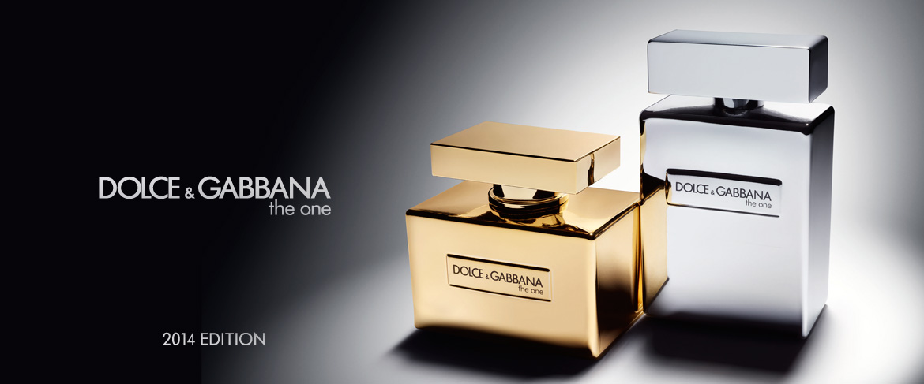
This Photo by Unknown Author is licensed under CC BY-NC-ND (d&g, 2018)

Business Expansion
In 1996, they celebrated a decade, the brand published Ten Years of Dolce & Gabbana, which included their most essential marketing pictures and scripts. In 1999 D&G Junior was created, their collection for children, which was presented at the children's fashion show Pitti Bimbo in Florence. Milan, Corso Venezia, 2003, D&G opened their newest store which cover three floors and is in the former home of Brigatti, ranked Milan’s best-known luxury sportswear store. The store is designed in the round from a central piazza and includes a bar, a traditional barber-shop, and an ultramodern spa. The individual stores are illuminated by lamps of Venini glass, made according to Domenico Dolce designs .
In a 1995 interview, Dolce and Gabbana recalled their first professional foray into fashion during the Milan collections as eliciting "one of the strongest emotions we have ever experienced" (Gastel,1995, p. 238). The birth of the D& G’s label was market with an amazing show designed to play a essential key role in their history as an Italian ready-to-wear. The designers showed full-length garments of stretch jersey, silk jackets, and oversized shirts that could be worn with casual sandals. The collection, characterized by fluidity and difference, soon found an enthusiastic public (Reinach, 2018).

Private Policy
This Privacy Policy gives clients of the site www.store.dolcegabbana.com (the "Site") with the fullest and most precise data on the preparing of their data through the Site under the General Data Protection Regulation (GDPR) (EU 2016/679) and the Italian Privacy Code (DL 196/2003).
By statutory necessities, this Privacy Policy likewise shows:
• The idea of the individual data prepared;
• The reasons and methods for the handling of unique data;
• The character and contact points of interest of the information controller(s);
• The subtle contact elements of the Data Protection Officer (DPO);
• Any outsiders engaged with the preparing exercises;
• The maintenance time of individual data;
• The safety efforts embraced to ensure personal data;
• The security privileges of clients.
This Privacy Policy applies to the Site and does not concern any site or stage to which the Site may connect. Clients with less than 16 (sixteen) years of age are not permitted to agree to the preparing of Personal data without parental approval (dolcegabbana.com, 2018).

Activities
As part of their actions Dolce and Gabbana, are developing and attend a lot of fashion shows to make the name known worldwide and to present the new arrivals on their collection.
However, they are also providing training and careers for young people that want to become models, sustaining the economy.
Also, they have fashion schools for young designers give them the opportunity to promote themselves and to have a bright future ahead.
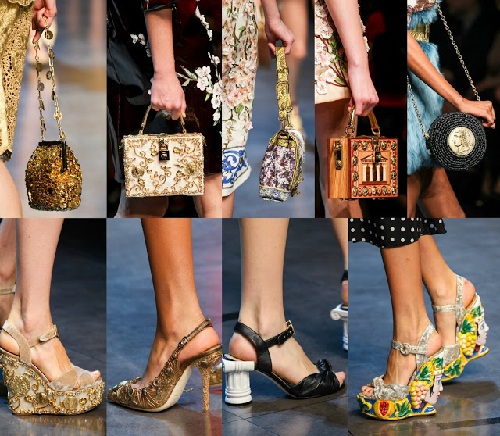
This Photo by Unknown Author is licensed under CC BY-NC-ND (d&g, 2018)

Operational structure
A luxury brand like Dolce and Gabbana is an alternative expression of high-quality, that is why when it comes to business and the fabric they use to operate a familiar saying - never blend business with delight. For couples who rest together and cooperate, the finish of an undertaking can likewise mean the finish of an expert relationship as well. In any case, when you have a large number of pounds in question, tied up in both your (regularly big name) names, there is a significantly more motivating force to keep the working association gelled regardless of whether your hearts are broken. (Guardian, 2005)
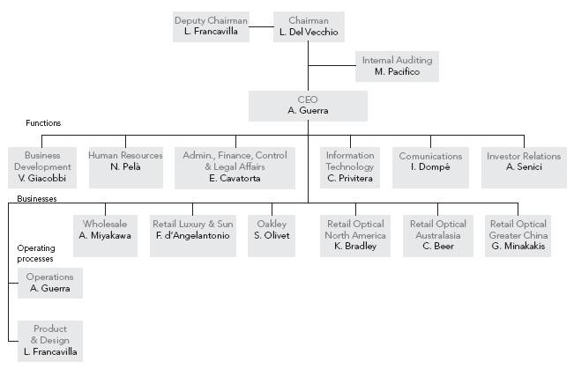 (SEC.gov, 2018)

Customer service plan
It ended up evident to me that the brand gave its walking requests to challenge the buyer regarding plan rationality. Regardless of where the innovative outline is going, the brand has a deep established history in quality. Indeed, they are characterizing another thought of extravagance that incorporates portrayal and regard for the millennial and Generation Z customers. Factual information expresses that recent college grads focus on credibility, quality, and legacy.
Additionally, they work with an impulse to reevaluate what is commendable. Be that as it may, how did the original and frequently highfaluting outlines of Dolce and Gabbana go from being superstar top choices to the most looked for after styles of the millennial commercial center. Its an approach, not every person grasps. Frequently mold commentators scorned their style as clearly exhibitionistic, even affected (Dolce&Gabbana.com, 2018).
Moreover, an ensuing whirlwind of theory from buyers had added to ascend in reputation for the worldwide brand. However, Dolce and Gabbana keep up that while they incline toward their style to be extraordinary, they should stand the trial of time concerning quality. On the off chance that I reviewed effectively, Domenico Dolce and Stefano Gabbana consolidated powers and filled in as a plan counseling organization approximately 36 years prior.
It is their cemented establishment of counseling abilities that propelled the brand to develop as one of the leading imaginative brands of the present-day customary outline. Enable me to clear up, the standard dialect of form plan and design marking can be reinterpreted currently for present-day times (Forbes, 2018).

Brick and mortar
The Italian luxury brand is opening stores in the most fantastic locations in the world, and as part of the brick and mortar, they are convinced that where ever open a shop will be a total success.
However, other brands, for example, Burberry another big name in the fashion industry, they don't open their store as D&G does because their tactic is to attract all different types of customers, on the other side, D&G is looking on drawing wealthy class only to buy from their stores.

Online
With the release of the official Dolce & Gabbana app in the Google Play Store, Android users now have the chance to browse the company’s catalog while being able to check on updated social media feeds. A simple browsing of the latest trends from the highly commended D&G, down to creating your wishlist of the things you fancy is also made possible in the said app.
Mostly, it resembles having a whole D&G store stuffed into your Android telephone. Every classification is exhibited as tabs, gathered for your benefit. The application has four principle tags: Woman, Man, Stores, and News. The first two tabs show things proposed for people clients. You can see item photographs, including official models wearing D&G attire. You'll additionally find the opportunity to take a look at some runway photographs from form occasions. These things, if they start your advantage, can be added to your list of things to get for conceivable reference.
As part of the online tools Dolce and Gabbana they use a wide range of social media, where they advertise, announce further fashion shows, etc. (dolcegabbana.com, 2018). According to a consumer survey conducted by McKinsey & Company, nearly half of luxury goods buying decisions are mostly influenced by online and tv campaign (Company, 2015).

Call Centre
When we are talking how D&G call center operates and what kind of people they are training to deal whit the name, well they take customer very serious offering him all the details and speaking whit him in a very delightful way, make him feel good. That is why them people are the face of the company if I can say like this because they are dealing whit all kinds of problems and different characters they maintain the same level of conversation whit all clients.

The importance of customer relationship
At its center, client relationship administration (CRM) is the majority of the exercises, systems, and innovations that organizations use to deal with their operations with their present and potential clients. A platitude often heard and said in numerous organizations is "client is the best."
CRM enables organizations to fabricate an association with their clients that, like this, makes devotion and client maintenance. Since client steadfastness and income are the two characteristics that influence an organization's revenue, CRM is an administration system that outcomes in expanded benefits for a business. At its center, a CRM apparatus makes a basic UI for a gathering of information that enables organizations to perceive and speak with clients scalable (Reinach, 2018).
At its core, customer relationship management is simple. However, it can be implemented in a vast array of methods: websites, social media, telephone calls, chat, mail, email and various marketing materials can all be integrated into a CRM solution. Due to CRM's diversity, it doesn't only benefit larger businesses -- using and maintaining a CRM tool is the basis for a scalable sales and marketing system. Any company will benefit from keeping a record of which conversations, purchases and marketing material can be associated with leads and customers.

Customer engagement
The best customer engagement can be worth millions of pounds on the annual revenue on every company depends on the size of it. However, intelligence Solution enables back to customer (B2C) marketers to run campaigns that are both customer-centric and aligned with their business objectives.
To create those businesses objectives trust is needed and relevant data. That’s what lets businesses to glean the relationship insights that customer personalization and the ability to offer the right content at the right time.
With trusted, well-governed customer data, businesses know who their customers are, what products they own, and what their preferences are. Trusted customer data is relevant and authoritative. Customer Data Strategy is to teach business how to manage their customer data as strategic and reasonable as possible.

Customer satisfaction
Customer Satisfaction is a powerful predictor of customer retention, loyalty, and product repurchase, that is why D&G had to put a big part of their money on research for best staff and tools for excellent customer satisfaction.
However we do know that Dolce and Gabbana when it comes to satisfy his customers the brand targeted a particular type of people that can buy and wear their products such as women in early 30s that they prepared for a success in life having a wealthy man near them, also men of young and old that they are already successful and they looking to enjoy the nightlife.
Also, when we talk about customer satisfaction towards the luxury brands, we are all unique, and this uniqueness is reflected in the consumption pattern and the purchase process.
Because a satisfied consumer that does the shopping in-store has the power to convince the on-users to use a brand via positive word of mouth, which will enable a company to decrease advertising cost through the recommendation made by consumers who had a good experience about that trademark (dolce&gabbana.com, 2017).

Quality control plan
Regarding the above, if it is to talk about how Dolce and Gabbana check their products to provide quality for the price they ask, well there is no doubt that the company put a big accent on quality for their products to offer the comfort, elegance, and durability over the years.
However, regarding quality Dolce and Gabbana, they are not cheap about the materials they use, they select only the best leather and fabric for their products.

Customer profile
A Customer Profile is otherwise called Customer Persona or Avatars. Fundamentally, a Customer Profile is a portrayal of a client or set of clients that incorporates statistic, geographic, and psychographic qualities, and purchasing behavior, financial soundness, and by history.
It encourages organizations to settle on essential choices by following client data, for example, patterns, socioeconomics, and mental illustrations. It is considerably less demanding to draw in more clients when you think about your present clients. With rivalry for clients expanding each day, it is one of the straightforward approaches to have the upper hand (AeroLeads, 2007).
Male and female adults and teenagers (17- 40 years old)

Brand loyalty

Price-insensitive

High Income
Magazines readers

Fashion and premium publication

Professional, modern, creative, cosmopolitan

Customer profile
Source: Author

Market segmentation
Marketing Mix of Dolce & Gabbana (D&G) investigates the brand/company which covers 4Ps (Product, Price, Place, Promotion) and describes the Dolce & Gabbana (D&G) marketing strategy. Its market segmentation is defined by the pricing, advertising & distribution strategies used by the company.
If Dolce and Gabbana consumers have unique needs and desire the market will demonstrate heterogeneity. This means that the company will have to offer different products, and more broadly marketing mixes, to satisfy the diverse needs of the market. In marketing, they deal with all customer differences through segmentation, with the hope that the world will only use their products in the future. However, instead of trying to appeal to the whole marketplace, the smart company and has to discover and find out what different kinds of customers might like, and decide which groups they can best serve.

Targeting
Now when it comes to what kind of market D&G is selecting one of the segments do we want to target is the big question when it comes to their Marketing strategy as this is based on the idea of selection.
So, what the company will do will create products for a specific group of customers such as wealthier people. However, they are also targeting the lower budget class of consumers. But all this type of customers can differ from country and region, so D&G adapted their market for worldwide success.

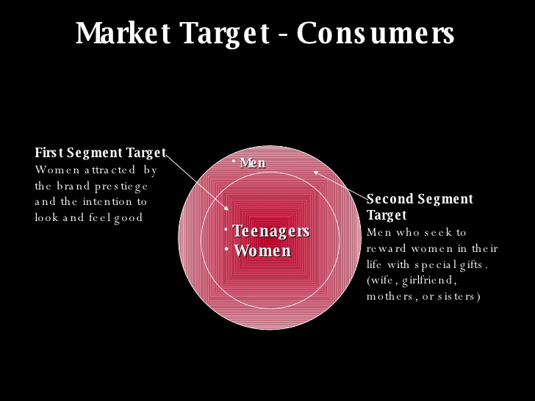

(d&g, 2018)

Dolce & Gabbana Enterprise System
An enterprise system is a bundled application that backings and mechanizes business, forms and oversees business information. They accompany pre-actualized and adaptable modules that reflect best practice for normal business activities. Business information from various utilitarian zones is incorporated and kept reliable (Gulla, 2004).
Dolce and Gabbana as an enterprise system integration and coordinate vital internal processes of the brand, collecting data from different business functions. A release date for the use by multiple services and business processes for a précised organizational management in coordination and control.

(Ricci, 2018)

Dolce and Gabbana Marketing Mix
Created by a form of social stratification, a luxury brand can be sometimes seen as a marker for its customers. Been mostly common for superior social classes. ‘A luxury item that extraordinary people would consider ordinary is the same time an extraordinary item to ordinary people’ (Bastien, 2012).
Price
Luxury customer price insensitive
An indicator of Brands Locating
Exclusivity and prestige of the product

Luxury pricing objective is profitability & return on investment.

Product – a vast range of products, including collection for Men, Women & Children such as clothes, sunglasses, handbags, underwear, beach-wear, perfume, books, make-up, jewelry, hi-tech accessories. D&G design reveals and enhances the whole look and lifestyle through its products.
Place – with stores more than 42 countries, the brand become vertically integrated, and since 2000 its vertical integration encouraged a specific investment and development which help D&G to deal with market challenges (Acemoglu et al.,2009).
Promotion – D&G present its products to its target consumers, while its growing demand and differentiating the product and brand identity. They are using advanced advertising techniques, public relations, personal selling, direct marketing and promotion sales to rich their objectives, using marketing strategies.

Dolce and Gabbana Management Strategy
The brand Management Strategy cannot be defined using only one management strategy because its organizational management strategy is made up of sensations, traditions, culture and Mediterranean nature. The brand name came from its creators, which made it easily recognizable thanks to its glamor and great versatility, knowing how to interpret and impose their unique style on worldwide bases (vBulletin, 2011).
Dolce & Gabbana products, named as luxury products, can be an indicator of the opulence of the wearer, being about quality and not quantity. Luxury can be defined as an art rather than a function (Chevalier and Mazzalovo, 2008). Starting with the design, managing, and monitoring the relationship between the brand and its customers, and allowing customers to customize and optimize their experience, is the primary factor for luxury brand marketers.
A product to be qualified as a luxury product have to be handmade. And exclusive services are part of luxury management which includes merits bring to personal honors, transforming for a short period every person in a prince/princess for a while, being the key factors in customer relationship management.
This year D&G lanced at Milan a new spring/summer collection for menswear, keeping the same energy that it had from its very first launch. With a very deeply rooted history in quality and customer satisfaction, ‘the brand gave its marching orders to challenge the consumer concerning design philosophy.' Always redefining the idea of luxury which contains respect and representation for the Millennial Generation Z costumes. D&G's data revealed that millennials hone in on genuineness, value, and tradition putting an accent on what is worthy.
D&G used a simple but challenging approach to become what they are today, the whimsical and often highfaluting designs. The brand is frequently criticized and described as ‘overtly exhibitionistic,' used this in the company advantage to rise the brand in publicity worldwide. Furthermore, with more than 36 years of experience as a design consulting company, D&G is keeping a solid foundation of combining skills who launched the brand to begin as one of the first creative products of modern traditional design.
Moreover, in the last past years, D&G's designers focus more on the millennial design makeup and millennial spectators and models, keeping and applying the same logic albeit on a slightly grander and, younger stage. Verily, a broadminded example of strategic sustainability and creative design that respects the new guard. Always presents at Dolce and Gabbana showcases will be celebrities such as artists, writers, actors from all over the world with one thing in common – they are all Millennials. The brand offers creativity and free expression for the new generation by defining and shaping ‘the multimedia society where they live.' In D&G’s collections is easy to observe their brand reflection and unicity in interpretation and expressivity of the language that they use (Forbes, 2018).

Conclusions and Recommendations
Dolce & Gabbana is not only a luxury brand designed for spoiled people, but Dolce & Gabbana is also about a culture that was created among time with passion, dedication and a lot of hard work. Furthermore, is about very delicate and high-quality handmade products, which requires time, creativity, the ability to make genuine masterpieces.
D&G reflects in its collections the band unicity in interpretation and expressivity of the language that they use. However, D&G's groups are not only for the high-income individual, but they are also for everyone who appreciates high-quality products, unicity, innovativeness and for people who would like to have outstanding pieces of art.
As a recommendation for D&G is to try to exclude the use of animals as experiments for their products, and to stop killing animals for making clothes, to avoid offending people by ‘boycotting' protests who could harm the brand image and bring negative media attention.
An excellent opportunity is a more significant expansion into the Asian market and furthermore to consider a brand extension which can include a new distribution line specially created for low-income customers, that could help to reinforce brand identity and future growth. Moreover, Dolce & Gabbana have to take more seriously environmental attitude, starting from cutting down on emissions, which will have a beneficial impact on the environment and lower costs for the company.

References
AeroLeads, 2007. https://aeroleads.com/blog/5-examples-ideal-customer-profile/. [Online]
Available at: https://aeroleads.com/blog/5-examples-ideal-customer-profile/
[Accessed 22 07 2018].
Bastien, J.-N. K. &. V., 2012. Advances in Luxury Brand Management. Journal of Brand Management: Advanced Collections, p. 18.
Company, M. &., 2015. Online survey, s.l.: s.n.
d&g, 2018. www.google.co.uk. [Online]
Available at: https://www.google.co.uk/search?q=dolce+and+gababana+scent&rlz=1C1AVFC_enGB793GB793&oq=dolce+and+gababana+scent&aqs=chrome..69i57j0l5.6152j0j7&sourceid=chrome&ie=UTF-8
[Accessed 28 August 2018].
dolce&gabbana.com, 2017. dolceand gabbana.codeofethics.com. [Online]
Available at: http://www.dolcegabbana.com/corporate/en/group/code-of-ethics.html
[Accessed 23 August 2018].
Dolce&Gabbana.com, 2018. Dolce & Gabbana.com. [Online]
Available at: http://www.dolcegabbana.com/corporate/en/group/company.html
[Accessed 20 August 2018].
dolcegabbana.com, 2018. www.dolcegabbana.com. [Online]
Available at: https://store.dolcegabbana.com/en/customer-care?cid=customer-service-menu-privacy-policy
[Accessed 20 August 2018].
forbes, 2018. Forbes. [Online]
Available at: https://www.forbes.com/
[Accessed 23 07 2018].
guardian, t., 2005. https://www.theguardian.com/lifeandstyle/2005/feb/20/fashion.shopping. [Online]
Available at: https://www.theguardian.com/lifeandstyle/2005/feb/20/fashion.shopping
[Accessed 25 08 2018].
Gulla, J. A., 2004. Introduction to Enterprise Systems, Norway: Norwegian University of Science and Technology.
Meyer, C., 2005. Understanding Customer Experience. Understanding Customer Experience, p. 1.
Reinach, S. S., 2018. Dolce & Gabbana Brand History. BEAUTY & FASHION.
Ricci, N., 2018. google.co.uk. [Online]
Available at: https://www.google.co.uk/search?rlz=1C1AVFC_enGB793GB793&biw=1366&bih=613&tbm=isch&sa=1&ei=ttKGW6K3GeTRgAats5u4CQ&q=dolce+and+gabbana+enterprise+system+framework&oq=dolce+and+gabbana+enterprise+system+framework&gs_l=img.3...15851.18425.0.18743.10.10.0.0.0
[Accessed 23 August 2018].
Schwager, C. M. a. A., 2007. Understanding Customer Experience. Harvard Business Review, Issue February.
SEC.gov, 2018. www.google.co.uk. [Online]
Available at: https://www.google.co.uk/search?q=dolce+and+gabbana+operational+structure&rlz=1C1AVFC_enGB793GB793&source=lnms&tbm=isch&sa=X&ved=0ahUKEwiTufrnzZLdAhVC2aQKHeghCs4Q_AUICigB&biw=1366&bih=662#imgrc=5UEJBMKxAeEuFM:
[Accessed 28 August 2018].
vBulletin, 2011. www.managemntparadise.com. [Online]
Available at: http://www.managementparadise.com/marketingstartegyof dolce&gabbanaSpA
[Accessed 25 August 2018].
Asnaghi, Laura "Dolce & Gabbana." In Dizionario della Moda. Edited by Guido Vergani. Milan: Baldini and Castoldi, 1999.
Gastel, Minnie 50 anni di moda italiana. Milan: Vallardi, 1995, pp238
Sozzani, Franca Dolce & Gabbana Translated by Marguerite Shore. New York: Universe Publishing/Vendome Press, 1998
Chevaller, M., Mazzalovo, G., Luxury Brand Management: A World of Privilege, Second Edition, John Wiley & Sons Singapore Pte.Ltd, 2012
Kapferer, J.-N., Bastien, V., The Luxury Strategy, Break the Rules of Marketing to Build Luxury Brands, 2012
Turban, E., Lee J., King D., & Chung, H. Electronic commerce: A managerial perspective (International ed.). Upper Saddle River, NJ: Prentice-Hall International, 2002

