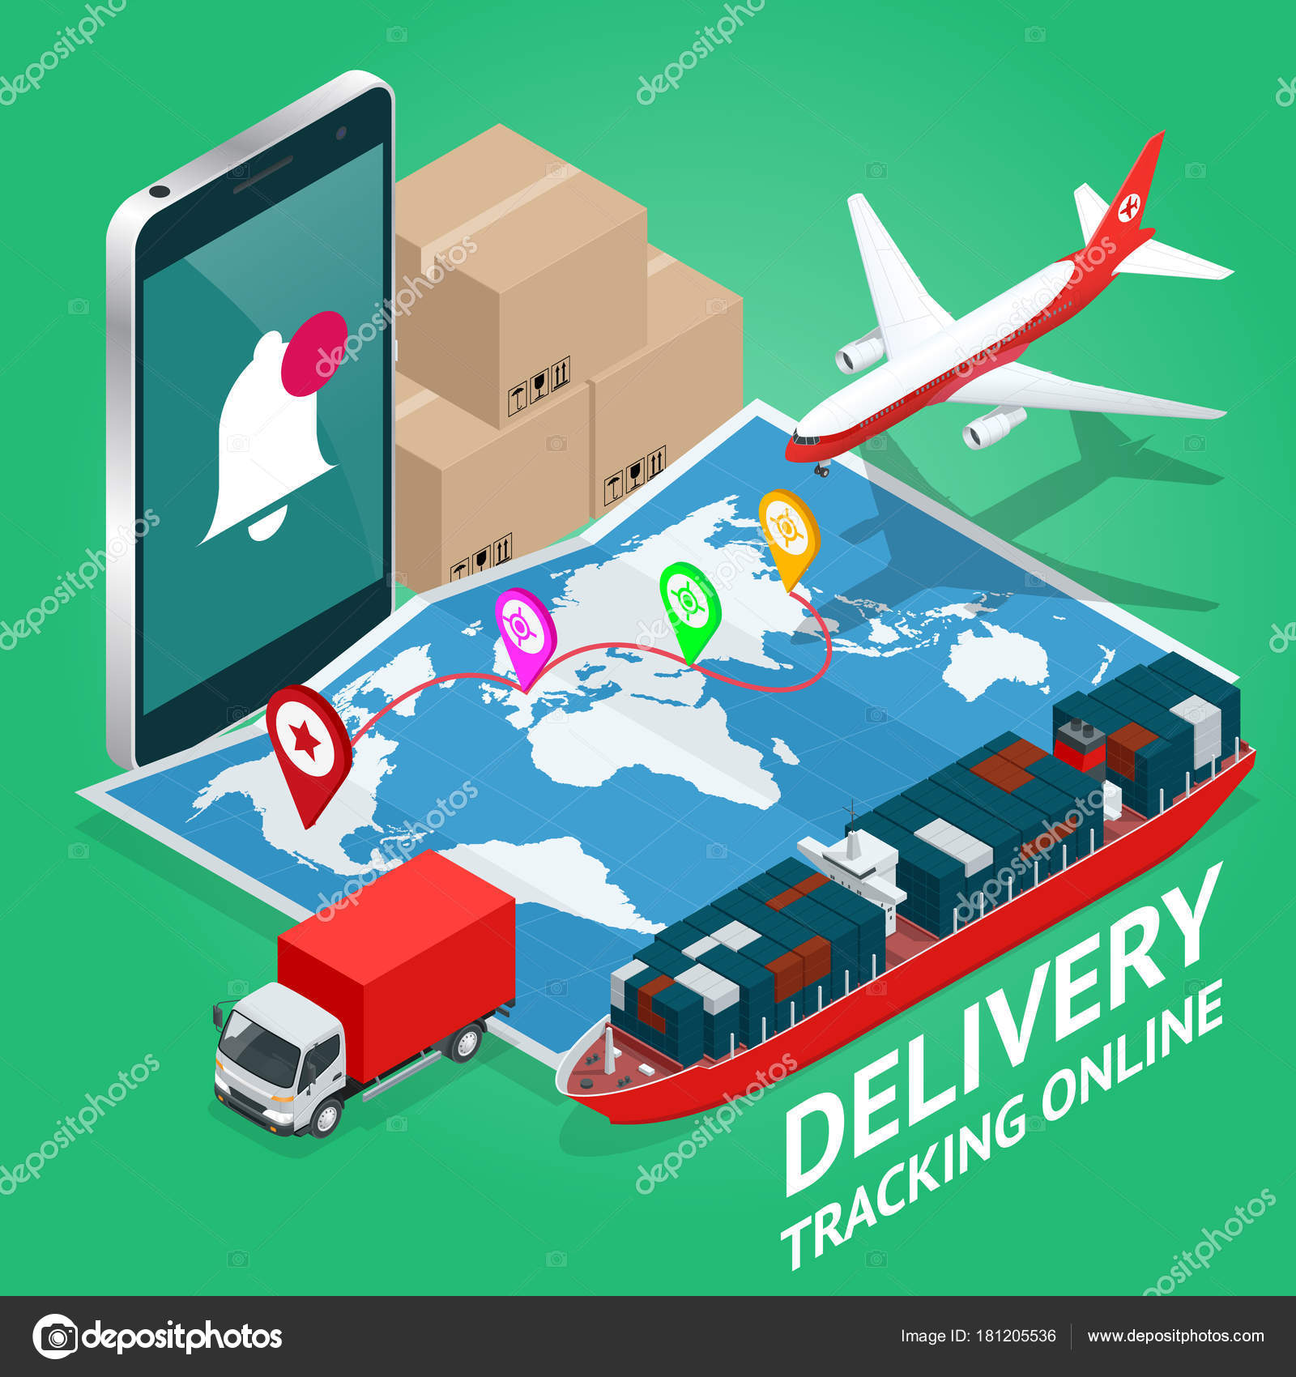
  - IT Application in Logistics
  - The Application of technologies in global logistics
Daniel Stokes | BSc Logistics and Supply Chain Management | 19/11/2019

1. Introduction
2. QR Codes
2.1. What are QR Codes
2.2. Tracking With QR Codes
3. RFID
3.1. What is RFID
3.2. RFID In Vehicle Tracking
3.3. RFID Vehicle Tags
3.3.1 RFID Windshield Tags
3.3.2. RFID Hang Tags
3.3.3. RFID License Plate Tags
3.4. Is RFID Outdated?
4. NFC
4.1.What is NFC
4.2. How NFC is Used By Companies
5. GPS Systems
5.1. What is a GPS System
5.2. How is GPS Use For Tracking
6. Radar
6.1. What is Radar
6.1.1How Radar works
6.1.2. How does Radar use radio?
6.2. How is radar used in Global Logistics?
7. Conclusion
References

1. Introduction
The aim of this report is to critically evaluate the application of asset tracking technologies in the movement of goods and people. This report will look at technologies such as;
- QR Codes
- RFID
- NFC
- GPS Devices
- Radar
This report will explain what each technology is, and their uses in asset and vehicle tracking. As Business Insider states in their article titled ‘$1.9 trillion of economic value could be created by the use of IoT devices and asset tracking solutions’ “Tracking tags and sensors can deliver real-time data about the location of goods in transit or in a warehouse, as well as data on the condition of those goods such as temperature, pressure, or potential damage to their packaging. However, gaining operational insights from these solutions can be a challenging task if companies don't implement organizational changes and other technologies that enable them to take instant action on real-time tracking data”.
2. QR Codes
2.1. What are QR Codes?
QR Codes (Quick Response Codes) belong to the barcode family. Although similar to a UPC (Universal Product Code) Barcode, in that they are both used “to uniquely identify an item when it is scanned”, QR Codes can significantly hold much more data. While a UPC can hold up to 16 alphanumeric characters, a QR Code can store up to 4,296. This is due to the design differences. A standard UPC is made up of black and white stripes and is only one dimensional, while the QR code is a two-dimensional design made up of black and white squares (Ahg.com, n.d.). Although the design differences do not sound like they make much difference, the capability differences between a UPC and a QR Code is significant. A QR Code is substantially better as, UPC codes “make it easy to ring up products at a grocery store, track inventory, reorder stock that is running low, print receipts that show the products a customer has purchased, make coupons scannable by computers, and so on” (The Balance Everyday, n.d.), while if a person scans a QR code they can “see information on your company and where to return that asset. At the same time, when an employee scans the same QR code label, he will be able to perform work-related functions: check an asset in or out, fill out a form or review asset information” (Ahg.com, 2019.).
2.2. Tracking with QR Codes
Although QR codes are mainly seen as a form of managing inventory they can also be used to track assets. According to Denny in 2017, writing for Airspace Technologies “enabled shippers and their customers to prevent numerous cases of cargo damage and loss. In the past, operations experts had to make several calls to their workers and clients in order to be sure that cargo was safely dispatched and delivered within the expected deadlines. QR codes have helped solve this challenge since they can be placed on packages to provide information at every stage of the shipping process”. Another way that QR Codes can be used for asset tracking is via mobile phones. In an article written on medium.com, it states “Using smartphone and QR Codes — based mobile app really changes situation. Now any authorized employee can record check-in or check-out in seconds by simply scanning QR Code on the asset with a smartphone. The update immediately goes into the central server and becomes available to all authorized devices. Result — no more wasted time and frustration”.
3. RFID
3.1. What is RFID?
RFID (Radio Frequency Identification) is used to identify assets through wireless communication. Although used in a number of situations to track, such as animal identification, or toll bridge collection systems (Hunt, Puglia and Puglia, 2007), this report is going to concentrate on how RFID is used for vehicle tracking.
3.2. RFID in Vehicle Tracking
Although tracking a vehicle which is hundreds of miles away is currently not a capability of RFID, there are ways that RFID can help a company keep track of their vehicle. An example of this is “if checkpoints are set up along the route, the location of the vehicle can be estimated based on when it passes each one” (Smiley, 2017). This is currently being used in America. According to Suzanne Smiley, “This is being done throughout the nation at large truck weigh stations along major interstates. When 18-wheelers are weighed, their RFID tags are read to pinpoint location and can also be used to document the journey. For companies or persons interested in tracking vehicles in real-time and without setting up expensive infrastructure”.
This can only be done however if the vehicle is tagged.
3.3. RFID Vehicle Tags
Using RFID tags in vehicles gives a small amount of options. A company must decide where they want the RFID tag on the vehicle, and then they can choose from the following three types of tag;
- RFID Windshield Tags
- RFID Hang Tags/Rearview Mirror Tags
- RFID License Plate Tags (Smiley, 2017)

3.3.1 RFID Windshield Tags
Windshield tags are applied using either a permanent or semi-permanent adhesive. These tags are usually applied to one of the top corners of the inside windshield, and can have a 20ft range. These tags are usually read overhead or the side of the vehicle which the tag is placed (Smiley, 2017).
3.3.2 RFID Hang Tags
Hang tags have a unique feature, in which they do not make contact with the vehicle, instead they hang off the rear view mirror. The advantage of this type of tag is they can be removed and put away when not in use. Like the windshield tags, the hang tags have a 20ft range from either overhead readers or either side of the vehicle (Smiley, 2017).
3.3.3. RFID License Plate Tags
These tags are the most common when it comes to longer range reading, as they can read up to 50ft away. These tags are read from behind with the antennas facing away from the vehicle. However, even they have the most range there is a distinguished disadvantage, and that is being on the outside of the vehicle. This means that the tag is more susceptible to theft or damage. (Smiley, 2017).
3.4. Is RFID Outdated
In an article titled ‘Asset Tracking: The View From The Top’, William Atkinson wrote “During the past several years, technology vendors have touted the benefits of radio frequency identification (RFID) over traditional bar-coding tools for tracking applications. Many shippers and warehouse operators were discouraged from investing in RFID, however, due to its high cost and shortcomings, such as lack of readability.
A new technology introduced by Sky-Trax, a New Castle, Del.-based solutions provider, tackles those shortcomings head on, offering the functionality of RFID with the added benefit of 100-percent accuracy”. Atkinson continued by stating “GENCO Supply Chain Solutions, a Pittsburgh, Pa.-based third-party logistics provider, recently installed Sky-Trax's optically enabled real-time location system (RTLS) to eliminate operator-dependent data collection processes. GENCO manages more than 25 operations and 37 million square feet of warehouse space throughout North America, providing contract, transportation, and reverse logistics services to retail, manufacturing, and government customers”.
4. NFC
4.1. What is NFC?
NFC (Near Field Communication), is used similarly to RFID however, the difference being an NFC reader usually has to be within an inch of the tag, meaning each item has to be scanned individually. Like RFID tags, NFC tags can be placed anywhere on the asset. According to ahg.com, “All NFC tags are passive (they send information to the reader only when they are in the reader's scanning range, do not have their own power), and have very short working range. Therefore you cannot use NFC to map real time assets location, which is possible with RFID system. Rather you can use NFC system along with or instead of barcode scanning in order to increase scanning speed and still be able to use smartphones for mobile asset tracking.”
In 2012, Bhargav Teja Manikonda stated, “NFC has a very powerful yet simple user interface. NFC technology has a short readability range. It can be used in a supply chain to track and share inventory information. For instance, a delivery driver would only need to tap a smartphone against a pallet of inventory and the shipment information would be instantly ready to be sent to a customer or back to the distribution center. This technology could be used to lower the percentage of inventory errors and track products and equipment along a supply chain. Imagine NFC collecting and feeding back the information related to usage of groceries to online stores in order to trigger automatic purchases. NFC enables sensing and detection capabilities to individual customers at a scale that has not been possible previously”.
Written on Payment Logistics NFC “allows for “Tap and Go” and “Proximity” type payments. NFC technology is used to support popular digital wallets such as Apple Pay and Android Pay. Many cards are also embedded with NFC technology using the Visa payWave and MasterCard PayPass specifications. Any card with a “wave” symbol can be used with an NFC enabled payment device or reader. NFC is an important component of contactless EMV technology. When an contactless payment is made at a merchant that has an EMV enabled payment solution, in most cases that payment will be considered a contactless EMV transaction and the merchant will not be liable for any counterfeit card fraud claims that may be associated with it”.
4.2. How NFC is used by companies
According to Melanie Pinola, in 2012, NFC has many uses, although mainly cashless or non-card payments, one use companies could use is its capability to download information. Pinola states “Advertisers and marketers can use NFC chips in porters and other promotional materials so all you have to do to get more information is tap or wave your phone (easier than QR codes, perhaps)”.
5. GPS Systems
5.1. What is a GPS System.
GPS, Global Positioning System, is 24hr real time satellite navigation system mainly used by people in order to reach their destination. Margaret Rouse stated “GPS receivers find their location by coordinating information from three or four satellite signals. That information includes the position of the satellite and the precise time of transmission. With three signals, any 2D position can be found on earth; additional satellite signals make it possible to find altitude.
GPS technology works in almost any condition and is accurate to within 3-15 meters, depending on the number of signals received, the spread of satellites in the sky and the technologies used in the receiver”.
5.2. How is GPS used for tracking?
Although most GPS systems are used in aid of a driver, ensuring they can get to their destination, there are some GPS systems with tracking technology. These systems are especially handy for companies with larges fleets of vehicles. Using real time broadcasts, a company can see their drivers habits and location (Laukkonen, 2018). Taxi companies will use this system, in order to give their customers a rough time of arrival, and to give the closest available driver, in order for customer satisfaction.
According to Laukkonen however there is a disadvantage. He states “Of course, there is the dark side of automobile GPS trackers, too. Some might use them without the vehicle owner's knowledge to keep track of where the vehicle goes and when. If you suspect that's the case, you can always try to locate GPS tracker that's been hidden on your vehicle”.

6. Radar
6.1. What is Radar
Radar, RAdio Detection And Ranging, is what it says. Using radio waves, radar is most commonly used to detect aircraft, whether in the air, or on the ground. In airports, the radar system will detect when an aircraft has entered the airports airspace and will allow the traffic controller to guide the aircraft safely to the ground. (Brain, n.d.).
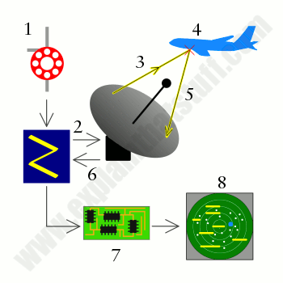
6.1.1 How Radar works
- Magnetron generates high-frequency radio waves.
- Duplexer switches magnetron through to antenna.
- Antenna acts as transmitter, sending narrow beam of radio waves through the air.
- Radio waves hit enemy airplane and reflect back.
- Antenna picks up reflected waves during a break between transmissions. Note that the same antenna acts as both transmitter and receiver, alternately sending out radio waves and receiving them.
- Duplexer switches antenna through to receiver unit.
- Computer in receiver unit processes reflected waves and draws them on a TV screen.
- Enemy plane shows up on TV radar display with any other nearby targets
(Woodford, 2019)

6.1.2. How does Radar use radio?
“ The radio waves used by radar are produced by a piece of equipment called a magnetron. Radio waves are similar to light waves: they travel at the same speed—but their waves are much longer and have much lower frequencies. Light waves have wavelengths of about 500 nanometers (500 billionths of a meter, which is about 100–200 times thinner than a human hair), whereas the radio waves used by radar typically range from about a few centimeters to a meter—the length of a finger to the length of your arm—or roughly a million times longer than light waves” (Woodford, 2019)
“Both light and radio waves are part of the electromagnetic spectrum, which means they're made up of fluctuating patterns of electrical and magnetic energy zapping through the air. The waves a magnetron produces are actually microwaves, similar to the ones generated by a microwave oven. The difference is that the magnetron in a radar has to send the waves many miles, instead of just a few inches, so it is much larger and more powerful”. (Woodford, 2019)
6.2. How is radar used in Global Logistics?
Radar is an important technology for global logistics. Looking at Heathrow Airport, London, UK, for example. Heathrow Airport takes in around 1.5 million cubic tonnes of cargo per year from aircraft. (Heathrow, 2018).

Radar allows the aircraft carrying the cargo land safely at Heathrow Airport safely, whether there is clear visibility or not for the pilot. Below is what radar technology allowed Heathrow Airport to accomplish this in 2017;
(Heathrow, 2018)
7. Conclusion
As Business Insider states “The enormous potential value created by these asset tracking technologies is due to the incredibly broad array of benefits that companies can obtain from them. Asset tracking solutions can create fiscal savings for supply chain and logistics operators at almost every step in the supply chain journey including extraction, transportation, production, storage, and final delivery to the customer. They can also help with compliance reporting and result in new revenue opportunities for supply chain and logistics operators”.
With technology continuing to evolve some of the current day technologies may soon be outdated. BBC News claim that by 2025 radar will be history in airports and replaced by a technology called ADS-B (Automatic Dependent Surveillance Broadcast). ADS-B will use GPS to track planes and relay the information back to Air Traffic Control and other planes. However, just like the airports secondary radar, ADS-B will not be able to track after a set distance over the ocean.
Although currently tracking technologies can be an essential requirement for customers and businesses alike, some of these technologies have proved that they may not be the most reliable, or even have the room to advance in the future.

References
Ahg.com. (2019). Mobile Asset Tracking Technologies: Barcodes, QR Codes, NFC, RFID, GPS Tags. [online] Available at: http://www.ahg.com/business-mobile-apps-blog/mobile-asset-tracking-technologies.html [Accessed 11 Nov. 2019].
Airspacetechnologies.com. (2017). How QR Codes Changed Shipping. [online] Available at: https://www.airspacetechnologies.com/blog/how-qr-codes-changed-shipping [Accessed 14 Nov. 2019].
Atkinson, W. (2009). Asset Tracking: The View From The Top - Inbound Logistics. [online] Inboundlogistics.com. Available at: https://www.inboundlogistics.com/cms/article/asset-tracking-the-view-from-the-top/ [Accessed 12 Nov. 2019].
Brain, M. (n.d.). How Stuff Works. Retrieved from https://science.howstuffworks.com/radar.htm
Business Insider. (2018). $1.9 trillion of economic value could be created by the use of IoT devices and asset tracking solutions. [online] Available at: http://uk.businessinsider.com/asset-tracking-in-the-supply-chain-and-logistics-2016-9 [Accessed 20 Nov. 2018].
Heathrow. (2018, July 09). Retrieved from Your Heathrow: https://your.heathrow.com/operations/cargo/
Hunt, V., Puglia, A. and Puglia, M. (2007). RFID. Hoboken, N.J: Wiley-Interscience.
Laukkonen, J. (2018). What are Car GPS Trackers and How Do They Work?. [online] Lifewire. Available at: https://www.lifewire.com/how-car-gps-trackers-work-4147185 [Accessed 14 Nov. 2019].
Manikonda, B. (2012). NFC in Supply Chain.. [online] Cmuscm.blogspot.com. Available at: http://cmuscm.blogspot.com/2012/10/nfc-in-supply-chain.html [Accessed 13 Nov. 2019].
Medium. (n.d.). Asset Tracking, Maintenance With QR Codes and a Smartphone. [online] Available at: https://medium.com/inventory-management-and-asset-tracking-for-small/asset-tracking-maintenance-with-qr-codes-and-a-smartphone-649567e7ef5b [Accessed 16 Nov. 2019].
Paymentlogistics.com. (n.d.). NFC. [online] Available at: http://paymentlogistics.com/nfc [Accessed 17 Nov. 2019].
Pinola, M. (2012). What Is NFC and How Can I Use It. [online] Lifehacker.com. Available at: https://lifehacker.com/5943006/what-is-nfc-and-how-can-i-use-it [Accessed 14 Nov. 2019].
Rouse, M. (2013). What is GPS navigation system? - Definition from WhatIs.com. [online] WhatIs.com. Available at: https://whatis.techtarget.com/definition/GPS-navigation-system [Accessed 16 Nov. 2019].
Smiley, S. (2017). How To: Track Vehicles with RFID - RFID Insider. [online] RFID Insider. Available at: https://blog.atlasrfidstore.com/track-vehicles-rfid [Accessed 15 Nov. 2019].
The Balance Everyday. (n.d.). UPC Codes: What They Are and How They Work. [online] Available at: https://www.thebalanceeveryday.com/upc-codes-what-they-are-and-how-they-work-897077 [Accessed 15 Nov. 2019].
Woodford, C. (2019, November 14). Retrieved from Explain That Stuff: https://www.explainthatstuff.com/radar.html

