
Omega Construction
Port Talbot Theatr
Harri Morgan – Quantity Surveyor
1908064

Feasibility Submission

6.1 Space requirements - internal & external (car parking)

Internal – All internals will be in line with the accommodation schedule as below. Taking careful consideration to access for disables, elderly and children.

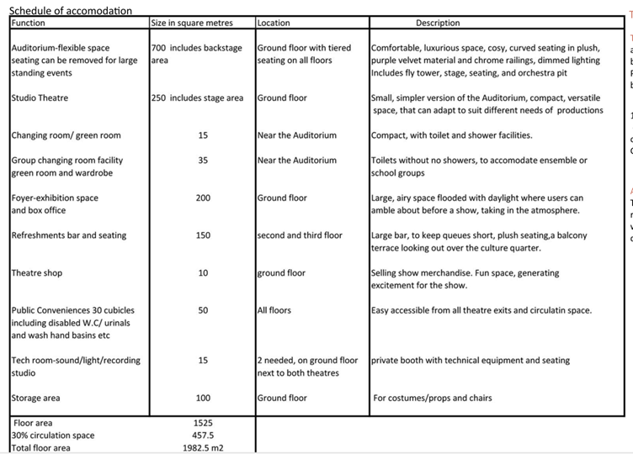

External – We plan to construct this project with an external façade that will attract locals from Port Talbot town, with a gathering area at the front of the theatre in Harlequin square. In addition, areas of open space will be landscaped to provide a better aesthetic to the area. Parking on the development is going to cause some logistical issues, due to there being no location currently on the masterplan that can facilitate this. Options;
- We could look at the possibility of having a basement for parking. Though with the current flood risk, this may not be feasible with the safety measures that need to be put in place to facilitate. Please refer to flood table and map provided by our Environmental specialist. To facilitate a basement car park, there is a lot of information you need to gather such as;

- Geotechnical Investigation Report
- Hydrogeological report
- Revised structural designs
- Revised drainage
- Ventilation report
- Fire safety report

- Purchasing a separate parcel of land to the South where a car park is currently located. Please see following screenshot from Google Maps. Again, the implications for such change would be land acquisition costs, further designs and legal fees, ground investigations.
- If purchasing this land is not an option, you could contact the council for grants to use the car park for the members attending the Theatr.

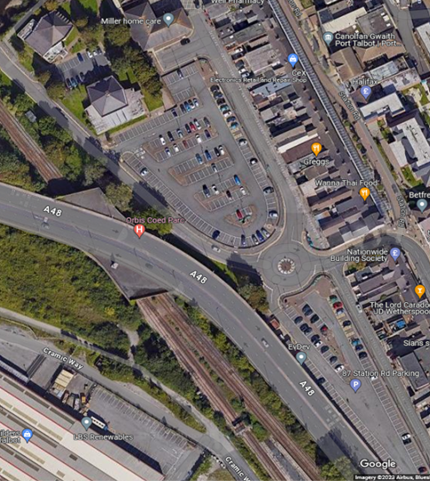

Current council car park. (Google Images)

In addition, we would look to incorporate some sustainable aspects to the exterior, such as charging points where applicable in the car park, as more and more cars now are electric and this will need to be faciliated within the developement.

6.2 Comparison with similar schemes previously undertaken

From reviewing the Welsh Government website in 2022, it states that there was £22 million Welsh Government funding given to support the redevelopment of Clwyd Theatr

6.3 Services requirements eg. abnormal loadings: IT suites, Design & Technology machinery – consult Mechanical & Electrical Group

Service requirements in buildings vary on the type of use and structure, though some common mechanical and electrical services that are required are as follows;

- Heating, ventilation and air conditioning
- Drainage and sewage systems
- Fire alarms and sprinklers
- Elevator systems
- Building management system for monitoring and controlling all building services and manage energy features
- Lighting
- Security
- Communications
- Solar panels
- Emergency lighting, exit systems

Due to the nature of the build, the specified service requirements would be in line with the accommodations schedule. In addition, specialist lighting and sound will need to be considered to ensure that the theatr performs as its best. These details can be agreed with the client as we progress through the project, but we do not see this being an issue in terms of the feasibility of the project.

6.4 External works - infrastructure works, hard and soft landscaping

We will be looking to utilise a road that is already on the site for access and exit, and landscaping will be complete during phase 1 to preserve the natural aesthetic of Bethany gardens. Due to the location of PH1, we will not be required to complete the S278 initially, due to the short programme the client has allowed, we would leave this until later on in the development to complete, to ensure that the Theatr can be complete and opened in the timeframe given.

6.5 Equipment / fixed and loose furniture

To be agreed with the client at a later date, there is no concerns in regard to furniture for the overall feasibility of the development

6.6 Furnishings

To be agreed with the client at a later date, there is no concerns in regard to furniture for the overall feasibility of the development

6.7 Customer supplied equipment/ furniture

To be agreed with the client at a later date, there is no concerns in regard to furniture for the overall feasibility of the development

6.8 Alternative accommodation proposals/ design options

None at present, the client has provided all the necessary designs.

6.9 Access for disabled persons - ambulant/ wheelchair/ visually and hearing impaired users/ elderly persons / young children

Our project will be constructed to comply with Part M building regulations, which addresses accessibility issues for disabled and members of the public. By complying with these legal documents, it will improve the theatres attendees as people of all backgrounds will be able to enter safely such as disabled, children and enderly. To comply with these regulations, you must have the following;

- Ramps where possible and acceptable change in levels
- Lifts
- Wheelchair accessible toilets
- Careful consideration for door widths
- Automatic entrance doors
- Disabled parking
- Suitable signage for visually and hearing impaired

6.11 Flexibility of use

Due to the nature of construction, there is not a lot of room for flexibility of use. A theatre is construction specifically for its purpose as a theatre.

7.1 Existing construction composition, level of specification

The existing construction on the site is mainly occupied by a large car park, which will need to be dug up, ground remediated, and any services re-routed. There are dwellings currently situated to the North-East of the site which will need to be demolished. This will have significant cost and programme implications. Both cost and programme items can be found in sections 8 & 9.

For the construction of the theatr, our initial recommendation would be a steel framed building, utilising reinforced concrete where applicable, and cladding to the external facade. A detailed internal specification will be agreed with the client if this project goes ahead, but we have already reviewed the current information to hand and can confirm that this is achievable for the project. Also, all works will be in line with the latest building regulations.

7.3 Fixed and loose equipment, furniture, furnishings

To be agreed with the client at a later date, no concerns with this in regards to the feasibility of the overall development

7.4 External works, solar shading (especially nurseries)

To be agreed with the client at a later date, no concerns with this in regards to the feasibility of the overall development

8.1 Capital costs - land acquisition, demolitions, building purchase, infrastructure costs

Through reviewing SPONS we can start to determine some estimated costs for the development. SPONS is a widely used database that includes estimated costs for all aspects of construction and rates for the London area. From this, we can use TPI’s and location factors to allow for our project in Wales. TPI’s are used to adjust costs to suit the quarter of the year that the project will start, to allow for any inflationary cost increases. While the location factor will adjust the cost to be relevant to the area.

- SPONS Civils page 181 to demolish buildings to ground level and dispose off site for a brick building with concrete floor and stairs is £13.36 m3

Based on the above information and the information provided by the client – the current estimated demolitions costs will be
£130,000.00

The demolition costs are based on the screenshot attached from Google Maps. Miller home care, Sky Thai, Flawless hair studio and the post office will need to be relocated. This has cost and programming implications. In addition, the tenants of the current dwellings may object to the mew construction and will need to be consulted accordingly.

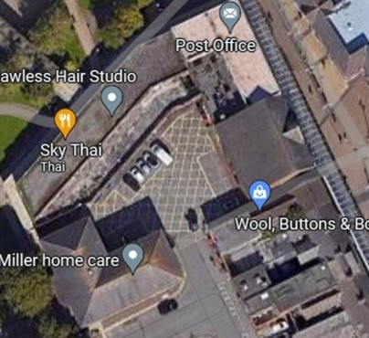

Land costs;

Land has already been purchased by the Client.

Infrastructure costs;

Following a review of the utilities layout and maps, it has become apparent that there are gas/water and electric pipes running through the centre of the site, and as such, these would need to be re-routed/diverted, having significant programme implications, but also cost. We have given an estimated cost of this work at ;
£22,500

Due to having the issue of the utilities that need to be diverted, we would also recommend that we undertaken the full site clearance, i.e the existing car park. While this will have some upfront cost and programme implications, we see no point in having to dig sections of road up to reroute utilities, then having to come back to complete the site clearance for future phases. The estimated cost for this works would be;
£104,000

8.2 Works to be undertaken by contractor?

To enable the demolitions to go ahead, we will need to take into consideration the removal of the trees to the West of the Theatr as they encroach on the site boundary. The estimated costs for this has been determined through SPONS of;

In addition to the removal of trees, we would need to re-instate the area to the North, Bethany Gardens prior to completion to ensure that the aethietics surrounding the theatr are to standard . This can be left until a later date while other phases are being complete, but for aesthetic purposes we encourage and reccomend this be completed as part of the first phase of the development. The costs associated with this are;

8.3 Maintenance costs

Unable to provide these at present as we are unaware of the full extent of the items requiring maintenance.

8.4 Whole Life Costs

Unable to provide at present, will look to do so if/when contracts are exchanged.

8.5 Fees

Please see below table of current fees that need to be carried out

Site investigation | 1 | 15000 | £15,000.00
Ecological survey | 1 | 18500 | £18,500.00
Bore hole study | 1 | 4000 | £4,000.00

8.6 VAT excluded

Please note that no costs provided as part of this feasibility study include VAT.

8.7 Notes and exclusions: estimates are approximate only; base date; site conditions; planning/ building regulation fees; specialist site investigation costs; exclusion of loose furniture, equipment/computers

All costs provided as part of the feasibility study are estimated and will be bottomed out through planning, design and further client meetings

