
Scheme of Work
Module: BMPL6 Digital and Operational Policing
Module Tutor: Kelly Andrews
Teaching:
Assessments: AC1 Presentation / AC2 Exam (50% each)
*SUBJECT TO CHANGE*

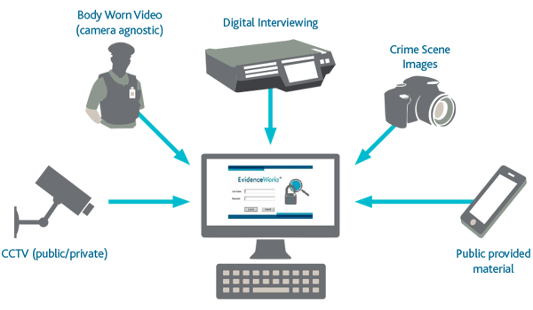

Workshop | Content | Notes
W1: 02/10/23 | An Introduction to Digital & Operational Policing | -SOW outline  -Assessment briefings  -Online reading lists  Recap of Op Pol Level 5
W2: 09/10/23 | Digital & Operational Policing Part 1 | Stop Search Powers recap.  PACE
W3: 16/10/23 | Digital & Operational Policing Part 2 | Arrest Recap  Guest Speaker SWP 13: 30 17th October 2023 Stephanie Samuel.
W4: 23/10/23 | Digital & Operational Policing Part 3  Public Protection Recap  Vehicles and Digital Investigation Opportunities | Read over Traffic pre read.
W5:30/10/23 | Traffic- Sarah Jones taking sessions. | Powers to Stop Vehicles  RTCs and Driver Obligations
W6: 6/11/23 | Assessment 1  Presentation to be submitted by 3rd Nov | Presentations: Individual  15 mins  09:00hrs Start  (No taught session this week)
13/11/23 | Employability Week | 13/03/23 - 17/11/23  There will not be a taught session this week.
W7: 20/11/23 | FGM/HBV  Introduction to sexual offences Sec 1-4 SOA | Exam Content
W8: 27/11/23 | Assessment 2 Role Play | We will be using this day to do the role play assessments.  Conducting investigations
W9: 04/12/23 | Further sexual offences  Sexual offences involving children. | Exam Content
W10 11/12/23 | Assessment 2:  Role Plays  There will be a drop-in session embedded here.

