
Program Name: Master of Business Administration
Module: International Business Concepts
Module Code: - LCMB7034
Selected Country: Germany

Industry: Automobile
Company: Tesla
Lecturer: Syed Mansoob Murshed
Name:- Bansi Vastarpara
Student ID:- 2508499
Submission Deadline – Friday 20th March 2026 by 2 PM
Word Count: 5,433

Table of Contents
Section 1: Report 3
1. Introduction to the report 3
2. Industry and Country Overview 3
2.1 Automotive industry within the context of Germany 3
2.2 Size, scope, and economic importance of the industry 4
2.3 Major firms and their competitive position in the German Automotive industry 7
3. Application of Porter’s Diamond Model to the German Automotive Industry 9
3.1 Factor Conditions 9
3.2 Demand Conditions 9
3.3 Related and Supporting Industries 10
3.4 Firm Strategy, Structure, and Rivalry 10
3.5 Role of Government 11
3.6 Role of Chance 11
4. Macro-Environmental Analysis and Market Attractiveness of the German Automotive Industry 13
4.1 Introduction & Framework Justification 13
4.2 Political & Legal Factors 15
4.2.1 Political Stability and Government Position 15
4.2.2 Regulatory Compliance and Legal Requirement 15
4.2.3 Government Incentives and Subsidies 16
4.2.4 CAGE Connection: Distance in Administration 16
4.3 Economic Factors 17
4.3.1 Macro Indicators 17
4.3.2 Infrastructure and Labour 17
4.3.3 Exchange Rates and International Trade 18
4.3.4 CAGE Link: Economic Distance 19
4.4 Socio-Cultural Factors 20
4.4.1 Demographics and Consumer Behaviour 20
4.4.2 Values, Beliefs, and CAGE Link 21
4.5 Synthesis: Overall Market Attractiveness and Success Factors 22
5. Conclusion to the report 22
Section 2: Reflective Account of the Research and Analysis Process 24
1. Description 24
2. Feelings 25
3. Evaluation 25
4. Analysis 26
5. Conclusion 26
6. Action plan 27
References 28

Section 1: Report

1. Introduction to the report
Car manufacturing is one of the most innovative and quick developing sectors of the world economy. Jobs, technology and trade are very important. Germany has a global reputation of producing cars due to its high engineering capabilities, skilled labour and good industry contacts. This report examines the German automobile market as the global competition and technology evolve particularly the transition to electric vehicles. In this report, the setup of the industry, its size, and its significance to the economy will be discussed. It will also identify the key companies and describe their competition. This report gives special attention to Tesla, which is a foreign firm that has transformed the conventional car business with electric cars, batteries and software. The report also provides a comprehensive picture of Germany as a destination of producing cars, analyses the existing trends, the size of the market, and the transforming competition. The report presents the opportunities and threats that will define the future of the German automobile industry by considering Germany and foreign firms.

2. Industry and Country Overview

2.1 Automotive industry within the context of Germany
Germany has been known to produce high-quality cars that are highly engineered. This is considered a pillar of the German manufacturing industry (Chandel, 2025). Germany is home to some of the best car companies in the world such as Volkswagen, BMW, and Mercedes-Benz. These firms remain global leaders through heavy research and development, advanced production processes, and marketing of strong brands in both the luxury and ordinary markets.
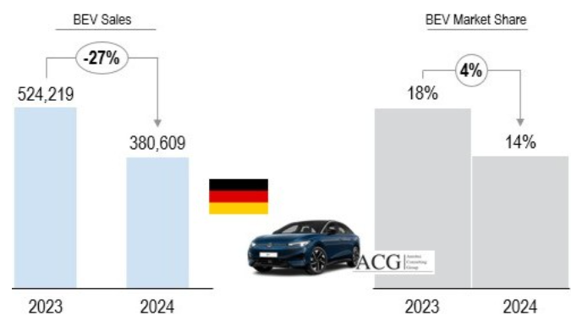
Figure 1: Sales growth of EV market in Germany
(Source: Chandel, 2025)
This transition to electric cars is now a priority in Germany. Regulations regarding pollution and assistance to the buyers of electric cars accelerate this shift. The facts that Tesla has entered Germany and it has a large factory in Brandenburg have facilitated stiff competition and transformed the traditional patterns of doing business. This was done even following the decline of 1% sales in the German car market (Chandel, 2025). Tesla specialises in batteries, driving without a driver, and software, and German manufacturers accelerate their projects and introduce additional e-cars. Germany is also well endowed with good suppliers, transport facilities, and best research universities. This network makes Germany innovative and competitive across the world.

2.2 Size, scope, and economic importance of the industry
One of the most significant and largest economic sectors in Germany is the car industry. It contributes significantly towards the GDP, industry and exports of the country. It is an important component of the national economy, accounting to about 5% of the GDP and 20.4% of the industrial revenues in Germany (SEB Research, 2025).
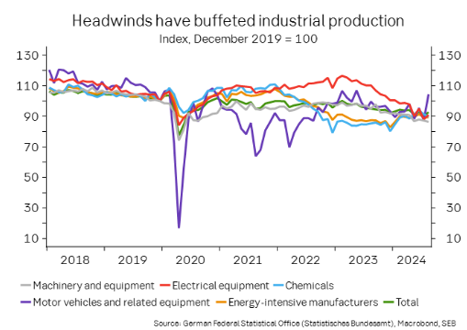
Figure 2: Industrial production index in Germany
(Source: SEB Research, 2025)
The industry generates over 780,000 direct jobs and countless indirect jobs in the manufacturing, logistics and engineering sectors (Leggett, 2025). This demonstrates that it is not only an economic engine, but it is also a significant source of employment and social stability. Germany also produces a leading car exporter. Germany has a good trade surplus through car exports and its annual exports exceed €118 billion in December 2025 (OEC, 2023). The US, China and other EU countries are the major export markets.
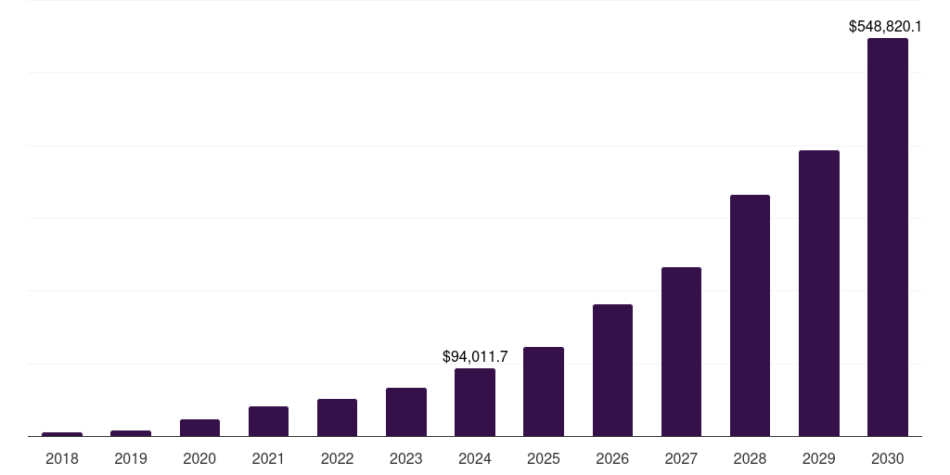
Figure 3: EV market of Germany
(Source: Grand View Research, 2025)
Despite the economic uncertainty in the world, the German car market continues to expand. It is reported that it may have hit approximately USD 548,820.1 million by 2030, most due to increased sales of electric and hybrid cars (Grand View Research, 2025).
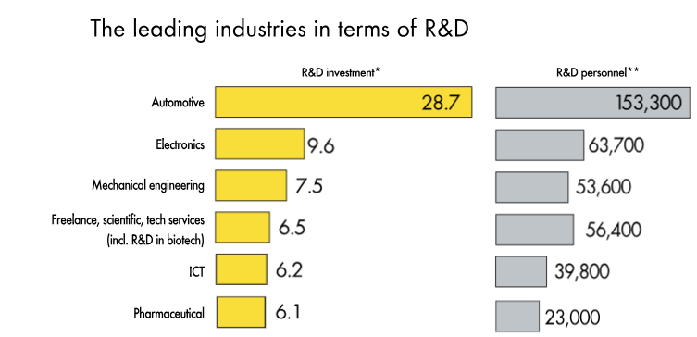
Figure 4: R&D investments in Germany
(Source: Research In Germany, 2022)
German automotive manufacturers invest heavily in research and development of approximately 28% of the total industrial research and development in Germany (Research In Germany, 2022). This funding assists in the advancement of electric cars, driver-less cars, and connected cars. The industry is not just in the production of cars as it manufactures components, software, batteries and mobility services. This combination renders it strong and allows the firms to adapt to market variations. The industry has been going through such challenges as high labour expenses, stringent regulations, and increasing foreign competition. The transition to clean mobility requires tumultuous investments and shifts, which may be detrimental to short-term profits.

2.3 Major firms and their competitive position in the German Automotive industry
Volkswagen: Volkswagen is the largest in terms of production and market share. It operates numerous brands and retails cars ranging cheap to luxurious. Volkswagen invested much in electric cars, particularly the ID line, and now it is a large player in the electric market (Chandel, 2025).
BMW Group: BMW is a specialist in luxury automobiles, performance-oriented, innovative, and customer oriented. It maintains high profits through the sale to rich consumers and investing in digital technology and green technology.
Mercedes-Benz Group: Mercedes-Benz is another competitor in the luxury industry, taking advantage of its good brand as synonymous with quality, comfort and state-of-the-art technology. It concerns itself with profits over volume and thus it remains strong even in the face of less sales than Volkswagen.
There are also other renowned brands such as Audi and Porsche that retail high quality and luxury sports cars. They have high profits and customer loyalty.
Other Operating Firms in Germany
Tesla’s battery, software and driverless technology innovations transform ancient business models. The massive plant in Germany enhances Tesla presence in Europe and reduces the manufacturing and shipping costs Zhang, 2023.
Firms such as Toyota and Hyundai have good, affordable, and fuel-efficient vehicles that attract individuals who are cost-conscious (Faraj and Milod, 2024). Moreover, the competitive positioning for the industry could be followed among the companies based on Volume leadership, Premium dominance, Innovation leadership and Cost competitiveness. The German automotive industry is highly competitive and driven by innovations. Here, the domestic companies are focused on the traditional segments, following the high demand of electric vehicles.
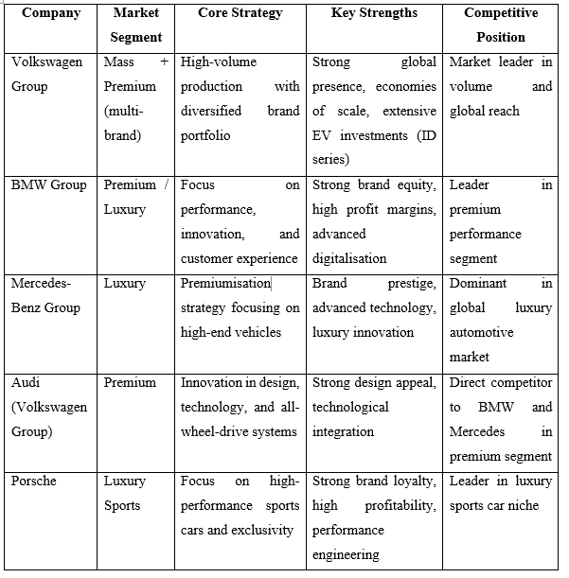
Table 1: Competitive positioning among the automotive companies
(Source: Self-created)

3. Application of Porter’s Diamond Model to the German Automotive Industry

3.1 Factor Conditions
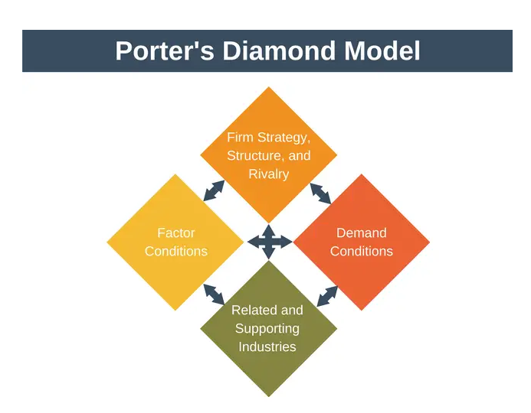
Figure 5: Porter Diamond Model
(Source: Expert Program Management, 2018)
The employees here are highly qualified, particularly in engineering, design and sophisticated production. There are good schools and research places in the country that provide trained individuals and support new ideas. Germany too boasts of good roads, train and logistics, which facilitates the making and transportation of cars (German Academic Exchange Service, 2026). Money is readily available and new technology such as automation and Industry 4.0 is available. All these allow businesses such as Tesla to operate properly and remain competitive in Germany.

3.2 Demand Conditions
German domestic market is well-developed and challenging and it contributes to making companies more competitive on the global level (Andersen, 2024). German consumers prefer high quality, high performance, and safe, sustainable as well as digital cars. Strict environmental regulations and emission restrictions have led to an increased desire by people to possess more electric and hybrid vehicles. This compels corporations like Tesla to concentrate on the introduction of electric vehicles. The high-performance cars and premium cars are also popular in the market and the value of global brands is increased (Andersen, 2024). In addition, the desire to use smart mobility solutions increases further, which promotes continuous progress and makes firms relevant everywhere.

3.3 Related and Supporting Industries
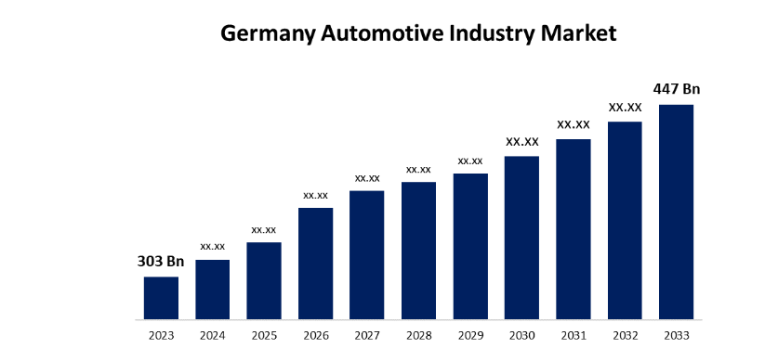
Figure 6: Market share of German automotive sector
(Source: Spherical Insights, 2024)
Germany has many well-developed suppliers and technology firms that produce vital components like electronics, sensors, batteries and modern systems beneficial to Tesla to access high quality parts and enhance production efficiency (Ledebur et al., 2026). The Germany Automotive Industry Market Size is projected to achieve a value of $447 billion by 2033 with a compound annual growth rate of 3.96% throughout the period from 2023 to 2033 (Spherical Insights, 2024). Close relationship between carmakers and suppliers promotes quick innovation and enhanced product development. Germany has good industries like steel, chemicals, and software that assist in the manufacturing of cars. Innovation is also enhanced by research centres, testing facilities and start-ups (Ledebur et al., 2026).

3.4 Firm Strategy, Structure, and Rivalry
High competition compels firms to continue improving their ability to make new ideas, good quality and good performance. Short-term money is not the main concern of German car companies, which prefer long-term growth, very high engineering, and good quality management (Pavegen, 2024). That is how they continue to invest in research, digital technology and green technology. The companies have their plans, some manufacture luxury cars, others concentrate on speed, others produce a lot of cars. That makes the entire market more powerful. There are also international firms such as Tesla in the market. That adds more competition (Pavegen, 2024). Due to this fact, the German and foreign brands strive more in the area of the electric car technology and quicker new concepts so that the industry might remain large and powerful at the global scale.

3.5 Role of Government
The car industry is highly dependent on the German government. It has been able to keep the industry competitive and sustainable in the long run. This has been impacted largely by its powerful rules that safeguard the environment, encourage new ideas, and facilitate industry development. Electric cars are also being moved forward through the government offering subsidies and charging stations accelerating the shift to greener transport. Strict measures for regulations on the emission levels ensure that companies such as Volkswagen and BMW continue to improve (Xia et al., 2024). Research, digital tools and new factory technologies funded by the public also help increase the productivity and make Germany one of the car leaders in the global market.

3.6 Role of Chance
The market in the car industry in Germany has been significantly impacted by technology shifts, global economic booms and slumps and green catastrophes (Ziegler and Heidling, 2023). Old carmakers have both opportunities and challenges in the electric cars that are increasing rapidly due to the concern about climate change and the global move towards sustainability. The emergence of Tesla demonstrates how a new and unexpected idea can transform the entire business. Another factor that has complicated the manufacturing of cars and the planning process is the issues of political tensions, supply chain issues and shortages of chips.
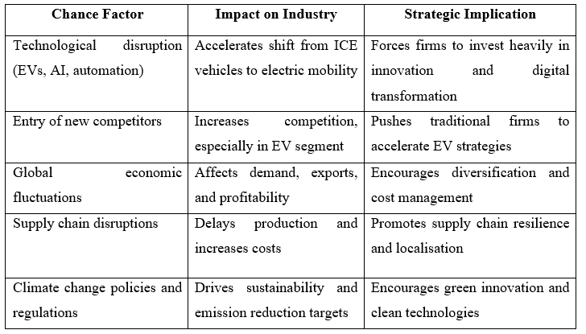
Table 2: Application and results of chance factors in the German car industry
(Source: Self-created)

4. Macro-Environmental Analysis and Market Attractiveness of the German Automotive Industry

4.1 Introduction & Framework Justification
Tesla operates within very developed economic, organisational, and social system in Germany, which has direct impact on its business outcomes (Tesla Inc., 2025). Meanwhile, the rapid shift towards electric vehicles, the increased use of digital technology, and sustainability is reshaping the opportunities, as well as the issues of the car industry. Such innovations imply that Tesla has to adapt quickly to remain competitive.
Dimension | Key Distance Elements | Market Attractiveness Level
Cultural | Common use of German language, similar emphasis on product quality and reliability | Very Strong: High customer trust and strong emotional connection with automotive brands
Administrative | Similar regulatory environment; government involvement in industry; part of EU system | Strong: Stable legal framework, though strict labour rules may limit flexibility
Geographic | Centrally located in Europe, highly connected transport and logistics infrastructure | Highly Favourable: Low distribution cost and easy access to innovation and production hubs
Economic | Use of Euro currency, strong income levels, relatively expensive labour market | Balanced: Strong consumer spending power but increased operational and manufacturing costs
Table 3: CAGE framework
(Source: Self-created)

Factor | Main Influencing Elements | Impact on Strategy
Political | Stable governance system; partial government stake in industry, supportive policy approach | Strong Influence: Government backing supports growth, but limits quick organisational changes
Economic | Slow economic growth; elevated borrowing costs, stable Euro environment | Medium Influence: Good purchasing ability, but affected by weak growth and high financing costs
Social | Increasing aging population, growing preference for shared mobility solutions | Balanced Influence: Strong traditional car culture, but reduced ownership among younger groups
Technological | Significant investment in innovation, progress in automation and artificial intelligence | Very Strong
Legal | Strict legal rules | Very Strong
Environmental | Effective rules and strategies ensuring SDG | Medium Influence
Table 4: PESTLE framework
(Source: Self-created)
The PESTLE framework is applied to observe the main external forces such as politics, economy, society, technology, environment rules, and the law to have a clear vision of this environment. This assists us to understand how these factors affect business and market growth. Besides, the CAGE framework is employed to determine the distance between Tesla and the German market, concerning culture, administration, geography, and economics (Tesla Inc., 2025). Having a combination of these approaches, Tesla can have a clear and systematic means of assessing the appeal of the German market.

4.2 Political & Legal Factors
German political and legal environment is extremely significant to Tesla performance in the automobile industry. Germany is a stable country with well-developed system of government, yet the industry is also covered by strict regulations regarding sustainability and global commerce. Tesla operates in an environment where government politics, labour regulations and environmental guidelines co-exist to set both opportunities and restrictions. This indicates that the market in Germany is very structured and rule oriented.

4.2.1 Political Stability and Government Position
Germany has been characterised by political stability, which facilitates the long run investment and growth of the industry. Nevertheless, the automotive industry is shifting due to the new regulations that are concerned with the green energy and reduced reliance on global supply. The government is also spending a lot on modernisation with an estimated cost of €500 billion on infrastructure and €100 billion on climate projects (Clean Energy Wire, 2025). Such investments have a good foundation to companies such as Tesla, particularly when it comes to the production of electric cars. Concurrently, the adjustments in trade policy, including the diminishing dependence on China, influence the organisation of the supply chain of companies in Europe (Clean Energy Wire, 2025).

4.2.2 Regulatory Compliance and Legal Requirement
The legal system in Germany is very strict and well organised and this directly influences the operations of businesses. The legislations on labour are robust and the worker participation mechanism provides the employees extensive rights in the decision-making process. This has the potential to delay restructuring of companies (BBC New, 2024). The rules drive the innovation of electric cars but also increase the operating costs. Besides, Supply Chain Due Diligence Act stipulates that companies maintain high levels of ethics and environmental standards in global operations hence compliance is a key responsibility.

4.2.3 Government Incentives and Subsidies
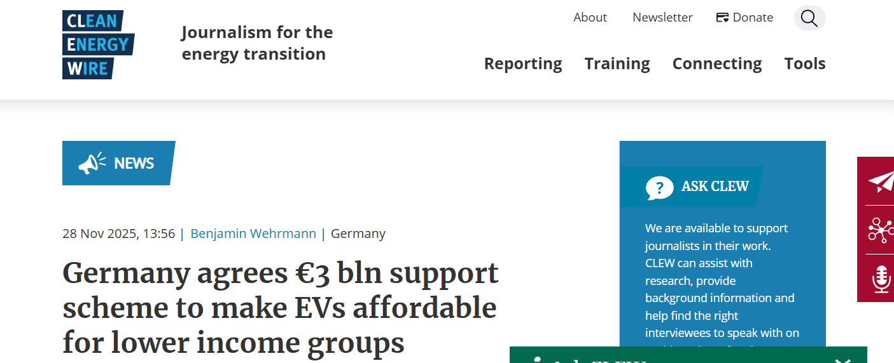
Figure 7: Scheme of Germany
(Source: Clean Energy Wire, 2025)
The government also provides funds to enable individuals and businesses to purchase electric cars. The new programme is a €3billion programme introduced in 2026. It subsidises a maximum of €6000 to buyers whose yearly earnings are less than €80000. Firms also receive tax breaks, including the opportunity to deduct up to 40% of the purchase price of a car at the first year of acquisition between 2025 and 2027 (Clean Energy Wire, 2025). These assist Tesla and electric cars in expanding in Germany.

4.2.4 CAGE Connection: Distance in Administration
Applying a CAGE perspective, the administrative distance between Tesla and Germany is low owing to the fact that the country has good institutions and definite legal regulations. This makes business operations and uncertainty less (Pavegen, 2024). However, Germany has numerous regulations and exact labour laws that may restrict flexibility to other markets. In general, Germany has a secure but very controlled situation where business organisations have to walk the fine line between adhering to rules and being creative in the long run.

4.3 Economic Factors

4.3.1 Macro Indicators
GDP Growth: In December 2025, BYD sold 4,109 vehicles in German market, which is an impressive growth per year; its gross sales in Germany in 2025 were 23,306 vehicles, and its cumulative sales were 23,306 vehicles in December 2025. The general market of German electric vehicles continued to grow in 2025 with the total number of new electric vehicle registrations at 545,142 vehicles, up by 43.2% per annum (World-energy, 2026). This is because such poor recovery will reduce the overall appeal of the market, especially to high value manufacturing industries such as automobiles.
Inflation and Purchasing Power: Tesla dropped 16% annually in the fourth quarter in terms of global deliveries to lose the title of the world leader in EV sales to BYD. Tesla was not able to achieve a two-year fall on an annual basis, and the 2025 deliveries have reached 1.64 million units. BYD, in its turn, reinforced its international initiative and sold 2.26 million EVs even though its growth rate at home slowed due to pricing neutrality (World-energy, 2026).
Monetary Stability: Germany is a part of the Eurozone, and it is therefore enjoying the currency stability that is favourable to such firms as Tesla. Those moves are supported by the rate of the EV market development in Europe. In Europe, the number of EV sold between January and October last year was 1.09 million, which is 12-percentage of the total sales of 9.09 million. The total goes up to 1.86 million with the addition of plug-in hybrids (World-energy, 2026). This has deterred people from buying new cars and changed the mindset of the consumers to the used car market.

4.3.2 Infrastructure and Labour
Infrastructure Quality
The good infrastructure at the Tesla location and highly qualified employees in Germany offer a favorable but dynamic climate to Tesla. The nation also enjoys developed logistic systems and industrial systems, which make it possible to produce and export efficiently. This is essential because Germany is still a world centre in the automotive innovation industry with an estimated share of 34 percent of the overall industrial research and development spending and more than 157, 741 research and development employees in the industry (Germany Trade & Invest, 2025).
Skilled Labour Supply
Labour market issues are getting more and more challenging. The German automotive industry dropped to 721,400 employees in 2025, which was the lowest number in more than a decade, as the industry is structurally shifting towards electrification and automation. It is especially affecting Tesla, which declared that it plans to reduce the number of jobs in Germany to as many as 50,000 by 2030 as a part of the cost restructuring (Reuters, 2025). The high-skilled labour force is a driver to the high-level manufacturing in Germany, the rising labour shortages and industrial restructuring cause differences in the capability, particularly in the digital and EV technology area, limiting Volkswagen competitiveness in the long term in the domestic market.

4.3.3 Exchange Rates and International Trade
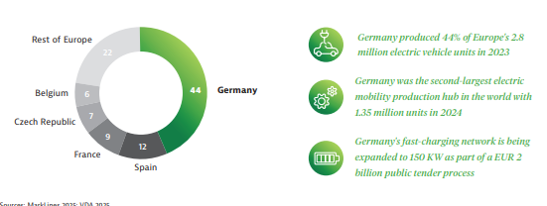
Figure 8: Impact of exchange rate
(Source: Germany Trade and Invest, 2025)
Tesla is strongly exposed to the changes in the euro exchange rate, and about 40% of its worldwide income is associated with the exports of Germany. A stable euro is beneficial in intra EU trade but trading against the main currencies like the US Dollar and the Chinese Yuan have a tattoo effect on Volkswagen competitiveness at the international level. A high euro currency increases the price of the German-made cars in non-euro markets, and this increases the level of price competition between the local and international competitors. This issue can be observed in the level of export of automotive in Germany where export values fell by approximately 5% to reach 372.2 billion Euros in 2024 (Germany Trade & Invest, 2025). In turn, the exchange rate pressures, along with the growing global competition, still limit the trade profitability and global marketplace of Volkswagen.

4.3.4 CAGE Link: Economic Distance
Cost Disparity: Tesla activities in Germany, especially in Berlin are vulnerable to the high cost of labour and energy. According to Nemitz (2024), on average labour costs were in Germany much higher than in the EU at 31.80 per hour. This implies that an hour of work was paid at about 30% higher in Germany than in the EU. This puts cost pressure in comparison to the global manufacturing presence of Tesla, particularly the cheaper production centres.
Market Attractiveness: Despite a high-income consumer base, which drives the demand of the EVs in Germany, the low market dynamics are caused by macroeconomic stagnation and conservative consumer spending. According to Nemitz (2024), in a bid to stay competitive, Tesla has resorted to competitive price changes and cost optimisation policies, as an indication of the stress on the domestic cost structure and the emerging competition.
Economic Factor | Current Status (2025-26) | Impact on Tesla Success
GDP Growth | 0.2% (Stagnant) | Slower EV demand Growth
Labour Cost | €62/hour (Highest in EU) | Increased production cost
Inflation | 2.3% (Easing) | Gradual recovery in demand
Infrastructure | Excellent (New 600bn fund) | High logistics and R&D efficiency

4.4 Socio-Cultural Factors

4.4.1 Demographics and Consumer Behaviour
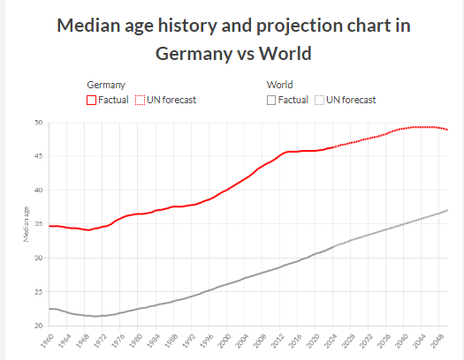
Figure 9: Demographic Projection
(Source: Geo rank, 2025)
The demographic aspect of Germany offers opportunities and structural problems to Tesla on its way to expansion in the automotive market in the country. In 2025, Germany has a population of about 84.1 million people, the most populated country in the European Union and offers a great market in the purchase of vehicles (United Nations Population Fund, 2025). The demographic composition is however skewed towards an older population with the median age approximated to be 45.7 -46.3 years, with Germany ranking among the oldest societies in the world. The proportion of the young population is relatively low, and a large percentage is over 65 years old, which means that the increase in the workforce is not fast, and consumers focus on comfort, safety, and usage, rather than performance (Georank, 2025). There is also a risk that an aging population would reduce the effect of high-performance EVs in the long-run demand by younger consumers who are traditionally faster in adopting new technologies. Concurrently, older age groups might want electric vehicles that put the focus on reliability, convenience, and safety-related aspect, which Tesla can capitalise on by utilising its advanced driver-assistance and comfort technologies. Moreover, the declining population of young consumers and low fertility will highlight the difficulty of maintaining a high number of future customers and labour force. It will rely on the ability to match the value propositions of its products with demographic realities to position EVs as a purchase option as comfortable, accessible, and low-maintenance among older demographics. Factors affecting the purchase decisions of younger consumers would influence the purchase decisions of older customers and viewers of infrastructure issues.

4.4.2 Values, Beliefs, and CAGE Link
The consumer expectation in the automobile industry is influenced by the attitude of Germany toward climate change, which has both opportunities and threats to Tesla. A survey conducted in 2025 indicates that one-half of the Germans indicate they personally feel the impact of climate change, including extreme weather and changes in biodiversity, but 33.0 per cent suggest that climate change has been among their top social issues, including such issues as social justice and economic development (Otto group, 2026). This indicates that although there has been a high awareness of the environment, it is not necessarily a priority when making daily decisions. According to the report of Eon (2018), approximately one-third of Germans consider climate change as the biggest social problem, and most of them are willing to change the way they live or pay a small fee on climate-friendly goods. Nevertheless, such an intention does not necessarily result in high sales of high-end EVs. In the case of Tesla, such a cultural terrain means that environmental sustainability will not necessarily lead to mass adoption in Germany without being correlated to actual value propositions- cost competitiveness, performance, and convenience. Younger customers are more climate-conscious and could prefer the flexible ownership approach such as leasing or mobility-as-a-service, which means that digital contact and localised marketing should be prioritised. Tesla therefore needs to weigh its sustainability communications with the strategies to consider the price sensitivity and wider consumer interests in order to establish itself better in the German EV market.

4.5 Synthesis: Overall Market Attractiveness and Success Factors
Germany presents Tesla with a strategically important market that is difficult to reach. The nation is the largest car market in Europe, as well as has excellent infrastructure, high buying and technological settings, where Tesla could produce, distribute, and innovate (UNFPA, 2025). Its determination to switch to EVs, the growth of charging stations, and its climate-focused policy make it a good place to be sustainable in mobility. Nevertheless, the macroeconomic conditions, such as low GDP growth of approximately 0.2 percent in 2025, high labour costs of approximately, in the range of, 60-62 per hour, and consumer spending is also reserved, limit the demands of high priced EVs (GeoRank, 2025).The cultural and social factors will also influence the market forces. Though 70 percent of the Germans are concerned with climate change, only a proportion of them are ready to pay high prices on green products, which indicates a sustainability-price gap (Otto Group, 2025). The younger generations are moving towards mobility-as-a-service where they consider convenience more than ownership. The success of Tesla lies in matching environmental positioning and affordability, localisation of digital marketing, diversifying flexible ownership models and the use of the technological and infrastructural strengths of Germany (Eon, 2018). Overall, Tesla has an opportunity to develop in Germany due to the strong level of EV knowledge, the presence of supportive infrastructure, and technological fit, yet to attain a successful evolution. The company needs to work on price sensitivity, evolving consumer expectations, and competitive threats by local brands.

5. Conclusion to the report
The high cost of labour and energy puts Tesla's operations in Germany, particularly Gigafactory Berlin, at risk. At 31.80 per hour, labour expenditures were much higher in Germany than in the EU. This suggests that the hourly wage in Germany was almost 30% more than in the EU. This puts pressure on costs when compared to Tesla's global manufacturing presence, especially the less expensive production facilities. However, the demand for EV’s in Germany is driven by a high-income customer base. Macroeconomic stagnation and cautious consumer spending are to blame for the poor market dynamics. Tesla has turned to competitive pricing adjustments and cost-optimisation strategies due to pressure on the domestic cost structure and competition. Germany offers Tesla a challenging-to-reach strategically significant market. It is an excellent location for sustainable mobility because to its commitment to switching to electric vehicles, the expansion of charging stations, and its climate-focused policies.

Section 2: Reflective Account of the Research and Analysis Process
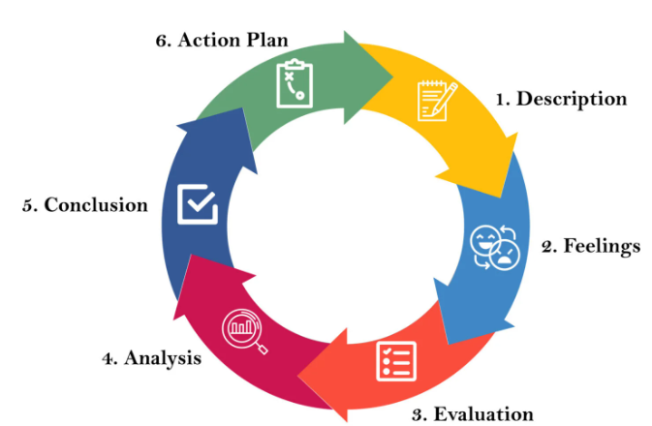
Figure 10: Gibbs reflective cycle
(Source: McLeod, 2025)

1. Description
The task has been based on selecting a multinational company and the operating country that the business operates on. Here, I chose Tesla and Germany to evaluate the way automobile brand operates in this country. Additionally, in this context, I was responsible to analyse the factors that influence business operations and how consumer behaviour needs to be analysed to shape business strategies. In this context, I demonstrated Michael Porter’s Diamond model to analyse global competitiveness of the automobile industry in Germany. Competitive advantage influences supply chain performance of the business (Shahadat et al., 2023). As a researcher, I evaluated the academic data that has been sourced from academic and peer-reviewed journals to justify the context how a multinational company operates in a country and considering the factors that influence business operations and functions. I demonstrated PESTLE framework to evaluate political, economic, social, technological, and legal and environment factors and evaluate how these factors influence business functions to increase competitiveness. It has been evaluated that transportation system of Germany was good and this contributes to the economic growth. This benefits Tesla in improving business sales, revenue and increase competitive edge into the competitive market.

2. Feelings
I was nervous and anxious to form a business report of a company that operates in a country. In this context, I feel thrilled to get a chance to evaluate a wide range of academic data such as information from journals, articles and the industry report to aid the preparation of business report. Additionally, I feel pressure to use my knowledge and insight to analyse the data minutely and make a decision. I think that I have lacked in time management skill because I get troubled to gather the data and analyse it within the deadline. However, I realised that I have strengths in research and critical thinking skills through which I can get the reliable data from the authentic sources. I acknowledged that Tesla is in stage of continuous improvement in product design and features because German consumers are preferred high quality-based cars that ensure safety and consider the sustainability standards.

3. Evaluation
I evaluated the fact that the German market is difficult yet well-developed, which helps businesses become to be more competitive in a global business context. Additionally, I obtained that high-quality, high-performing, safe, environmentally friendly, and digital vehicles are preferred by German consumers. The customer’s desire is to own more electric and hybrid vehicles has increased as a result of rigorous environmental legislation and emission restrictions. This forces companies such as Tesla to focus on introducing electric vehicles. User behaviour needs to be integrated in model design but the car makers need to consider the purchase policies of German automobile market to set model prices (Gnann et al., 2022). I evaluated that German automakers prioritise long-term growth, excellent engineering, and quality control over short-term financial gain. They keep funding research, digital technology, and green technologies in this way. Each company has its own ambitions; some make luxury vehicles, some focus on speed, while still others make large quantities of automobiles. The result showed that the market as a whole gains strength and this leverages business operation of an international companies like Tesla.

4. Analysis
In the analysis stage, I need to analyse my experiences both good and bad and give the justification behind the context. In this business module, I gained a lot of good experiences to form business report such as my supervisor helped me to gather information. Additionally, I feel blessed to get an opportunity to analyse business function of Tesla operates in German market and I analysed that I utilised research and analytic skills to evaluate the factors that influence business operations.
In application of Porter’s diamond model, I evaluated that he growth of the automobile sector is aided by Germany's strong inter-industry linkage. The nation has numerous advanced suppliers and technology companies that manufacture essential parts including electronics, sensors, batteries, and contemporary systems. Businesses like Tesla can get high-quality parts and increase production efficiency because to this strong supplier base. In relevance to this, I analysed that in terms of global deliveries, Tesla fell 16% yearly in the fourth quarter, losing its position as the world leader in EV sales to BYD. Based on the evaluation of macro indicators, it has been analysed that 1.64 million units delivered in 2025, Tesla was unable to accomplish a two-year decline on an annual basis. In response, BYD strengthened its global initiative and sold 2.26 million EVs despite a slowdown in its domestic growth rate as a result of pricing neutrality.

5. Conclusion
I can concluded with the facts that due to severe environmental regulations and emission limits, consumers' desire to own more electric and hybrid cars has grown. This compels businesses like Tesla to concentrate on launching electric cars. In forming the business report, I realised that model design must incorporate user behaviour, but when setting model prices, automakers must take the German auto market's purchasing habits into account. Companies like Tesla are able to obtain high-quality parts and boost production efficiency because of this robust supplier base. Moreover, I found that Tesla lost its position as the global leader in EV sales to BYD in the fourth quarter due to a 16% annual decline in global deliveries.

6. Action plan
I will focus on enhancing my time management and organised research skills. First, I will design a weekly study plan with the help of such apps as Trello or Notion to divide the report into two smaller assignments such as literature review, data analysis and writing. Second, I will also become a better academic researcher, as I will always rely on databases, such as Google Scholar, and narrow down my search to peer-reviewed materials to gain credibility. I will also enhance the aspect of analytical by working on business models like Porter’s Diamond Model and PESTLE Analysis on various case studies. I shall also consult my supervisor regularly to detect any gaps at the early stages. Last, I will enhance my knowledge about the global markets by tracking the trends related to the industry, particularly in the EV market, to be able to assess such companies as Tesla on an international scale.

References
Andersen, M.S. (2024) ‘Challenges facing the USA in matching Germany on advanced manufacturing for green growth’, International Journal of Innovation Studies, 8(1), pp. 13–24.Available at:https://www.sciencedirect.com/science/article/pii/S2096248723000486
BBC News (2024) Germany legalises cannabis, but makes it hard to buy. Available at: https://www.bbc.com/news/world-europe-68378807 (Accessed: 20 March 2026).
Chandel, A.S. (2025) The German car market declined by 1% from 2023 to 2024, with total sales dropping from 2.84 million to 2., Linkedin.com. Available at: https://www.linkedin.com/pulse/how-german-ev-market-continues-outpace-chinese-atul-u-chandel-gprwf (Accessed: 20 March 2026).
Clean Energy Wire (2025) Germany agrees €3 bln support scheme to make EVs affordable for lower income groups. Available at: https://www.cleanenergywire.org/news/germany-agrees-eu3-bln-support-scheme-make-evs-affordable-lower-income-groups (Accessed: 20 March 2026).
Clean Energy Wire (2025) Q&A – Germany’s €500bln infrastructure fund: What’s it for climate and energy?. Available at: https://www.cleanenergywire.org/factsheets/qa-germanys-eu500-bln-infrastructure-fund-whats-it-climate-and-energy (Accessed: 20 March 2026).
Eon (2018) Survey: German citizens see climate change as the greatest social challenge, Eon.com. Available at: https://www.eon.com/en/about-us/media/press-release/2018/2018-11-29-survey-german-citizens-see-climate-change-as-the-greatest-social-challange.html?utm_source
Expert Program Management (2018) Porter Diamond Model. Available at: https://expertprogrammanagement.com/2018/04/porter-diamond-model/ (Accessed: 20 March 2026).
Faraj, O. and Milod, T. (2024) ‘Case Study Analysis of Toyota Company and make time to market’, ResearchGate [Preprint]. Available at: https://doi.org/10.13140/RG.2.2.20038.45121.
Georank (2025) Germany demographics data 1960-2025: Median Age Growth, Georank. Available at: https://georank.org/demographics/germany (Accessed: 20 March 2026).
German Academic Exchange Service (2026) Mobility in Germany | Research in Germany. Available at:https://www.research-in-germany.org/en/plan-your-stay/living-in-germany/mobility.html (Accessed: 20 March 2026).
Gnann, T., Speth, D., Seddig, K., Stich, M., Schade, W. and Vilchez, J.J.G. (2022) How to integrate real-world user behavior into models of the market diffusion of alternative fuels in passenger cars: An in-depth comparison of three models for Germany. Renewable and Sustainable Energy Reviews, 158, p.112103. https://doi.org/10.1016/j.rser.2022.112103
Grand View Research (2025) Germany Electric Vehicle Market Size & Outlook, 2030, Grandviewresearch.com. Available at: https://www.grandviewresearch.com/horizon/outlook/electric-vehicle-market/germany (Accessed: 20 March 2026).
Ledebur, K., Bartuska, L., Friesenbichler, K. and Klimek, P. (2026) ‘Predicting the emergence of the EV industry: A product space analysis across regions and firms’, Journal of Cleaner Production, 538, p. 147348. Available at: https://doi.org/10.1016/j.jclepro.2026.147348.
Leggett, T. (2025) Germany’s car industry crisis - this is what may fix it, BBC News. Available at: https://www.bbc.com/news/articles/cz6pzwj6qq7o (Accessed: 20 March 2026).
McLeod, S. (2025) Gibbs’ reflective cycle. Simply Psychology. Available at: https://www.simplypsychology.org/gibbs-reflective-cycle.html (Accessed: 20 March 2026).
Nemitz, M. (2024) An hour’s work cost an average of 41.30 euros in 2023 - sixth highest value in the EU, Startbase.com. Startbase. Available at: https://www.startbase.com/news/eine-arbeitsstunde-kostete-2023-im-schnitt-4130-euro-sechsthoechster-wert-in-der-eu/?utm_source (Accessed: 20 March 2026).
OEC (2023) OEC - Germany (DEU) Exports, Imports, and Trade Partners, oec.world. Available at: https://oec.world/en/profile/country/deu (Accessed: 20 March 2026).
Otto group (2026) Survey shows: Germans feel the effects of climate change, but other issues rank higher, Ottogroup.com. Available at: https://www.ottogroup.com/en/medien/newsroom/meldungen/survey-shows-germans-feel-the-effects-of-climate-change-but-other-issues-rank-higher.php?utm_source (Accessed: 20 March 2026).
Pavegen (2024) Top 5 Automotive Brands and Their Winning Marketing Strategies. Available at: https://www.pavegen.com/blog/top-5-automotive-brands (Accessed: 20 March 2026).
Research In Germany (2022) Which Sectors Lead in R&D in Germany?, Research-in-germany.org. Available at: https://www.research-in-germany.org/en/research-landscape/r-d-companies-business-germany/Which-sectors-carry-out-R-D.html (Accessed: 20 March 2026).
Reuters (2025) ‘Employment in German auto sector at lowest level in over a decade’, Reuters, 20 November. Available at: https://www.reuters.com/world/china/employment-german-auto-sector-lowest-level-over-decade-2025-11-20/ (Accessed: 20 March 2026).
Reuters (2025) ‘Employment in German auto sector at lowest level in over a decade’, Reuters, 20 November. Available at: https://www.reuters.com/world/china/employment-german-auto-sector-lowest-level-over-decade-2025-11-20/ (Accessed: 20 March 2026).
SEB Research (2025) SEB Research, Sebgroup.com. Available at: https://research.sebgroup.com/macro-ficc/reports/53561 (Accessed: 20 March 2026).
Shahadat, M.M.H., Chowdhury, A.H.M.Y., Nathan, R.J. and Fekete-Farkas, M. (2023) Digital technologies for firms’ competitive advantage and improved supply chain performance. Journal of Risk and Financial Management, 16(2), p.94. https://doi.org/10.3390/jrfm16020094
Spherical Insights (2024) Germany Automotive Industry Market Size, Share, and Forecast 2023–2033. Available at: https://www.sphericalinsights.com/reports/germany-automotive-industry-market (Accessed: 20 March 2026).
Tesla Inc. (2025) About Tesla. Available at: https://www.tesla.com/about (Accessed: 20 March 2026).
United Nations Population Fund (2025) World Population Dashboard -Germany | United Nations Population Fund, United Nations Population Fund. Available at: https://www.unfpa.org/data/world-population/DE?utm_source (Accessed: 20 March 2026).
World-energy.org (2026) Tesla’s EV Sales in Germany Nearly Halved Year-on-Year in December - World-Energy, World-energy.org. Available at: https://www.world-energy.org/article/54979.html?utm_source (Accessed: 20 March 2026).
Xia, X., Li, P., Cheng, Y. and He, X. (2024) ‘Optimizing carbon emission reduction strategies in power batteries: Ensuring compliance with the EU battery regulation’s carbon labeling initiatives’, Journal of Energy Storage, 99, p. 113449. Available at: https://doi.org/10.1016/j.est.2024.113449.
Zhang, H. (2023) ‘The Application of Digital Technology in Tesla Automobile Industry: Key Factors and Global Market Expansion’, Highlights in Business, Economics and Management, 23, pp. 1094–1098. Available at: https://doi.org/10.54097/01fbhb62.
Ziegler, A. and Heidling, E. (2023) ‘The Chip Crisis in the Automotive Industry. Challenges - Measures - Action Areas’, pp. 1–53. Available at: https://doi.org/10.36194/HyValue_Chip_Crisis_2023.

