The Building Regulations 2025

Approved
Document

Volume 1 – New Builds
S

Solar thermal gain

2026 Edition
For use in Wales*
Table of Contents
0.0 Introduction 6
0.1 Scope 6
0.2 Purpose 6
0.3 Relationship with other approved documents 6
1.0 Application of the Requirements 6
1.1 Scope of application 6
1.2 Transitional provisions 7
2.0 Definitions 7
2.1 Net Zero 7
2.2 Fenestration 7
2.3 Orientation 7
2.4 Solar Gain 7
2.5 Passive House 7
3.0 General Principles 8
3.1 Design Principles 8
3.2 Incorporation with approved documents and sustainable frameworks 8
3.3 Thermal Mass considerations 9
4.0 Orientation and Solar Gain 9
4.1 Orientation Principles 9
4.2 Seasonal Sun Path 10
4.3 Shading strategies 10
5.0 Site Analysis 10
5.1 Requirements 10
5.2 Topography 11
5.3 Overshadowing Risks 11
5.4 Vegetation 11
6.0 Calculations Methods 11
6.1 Solar gain calculation 11
6.2 Overheating risk assessment 12
6.3 Tools and standards 12
7.0 Compliance criteria 12
7.1 Solar Gain percentage 12
7.2 G-Values and U-Values 13
8.0 Documentation and verification 14
8.1 Design stage documentation 14
8.2 Post-Construction stage documentation 15
9.0 Competence and certification 15
10.0 References and standards 15
References 17

Figure List
Figure 1: Solar radiation received depending on orientation and inclination (Online), Available at: https://www.cibsejournal.com/cpd/modules/2013-07/ [Accessed 08/12/2025]
Figure 2: Sun-path diagram (Online) Available at: https://www.cibsejournal.com/cpd/modules/2013-07/ [Accessed 08/12/2025]
Figure 3: Energy balance heating (Presentation) Available at: ACBA5026_6_ Door and Windows. [Accessed 08/12/2025]
Figure 4: U-Values for new dwellings (Online) Available at: https://www.gov.wales/sites/default/files/publications/2024-05/building-regulations-approved-document-l-vol-1.pdf [Accessed 08/12/2025]

Glossary of Terms
AECB – Association for Environment Conscious Building
BREEAM – Building Research Establishment Environmental Assessment Methodology
CIBSE – The Chartered Institution of Building Services Engineers
CIC – Construction Industry Council
CIOB – Chartered Institute of Building
GHG – Greenhouse Gases
PHPP – Passive House Planning Package
RIBA – Royal Institution of British Architects
RICS – Royal Institution of Chartered Surveyors

0.0 Introduction

0.1 Scope
This approved document, Document S: Volume 1, Solar thermal gain provides information on compliance for new domestic dwellings in Wales on regulating solar gain while maintaining the dwellings thermal mass and energy efficiency.

0.2 Purpose
The purpose of this approved document is to help all members involved within the construction industry understand how to:
- Improve human comfort and energy efficiency.
- Support Welsh Government’s net zero target of 2050.
- Optimise solar gain in colder seasons.
- Reducing overheating risks in the building’s fabrics in warmer seasons.
- Provide information of orientation and fenestration.
From following this approved document, new developments can meet building regulations and contribute to the reduction of carbon emissions in line with the Welsh Government goal of net zero by 2050.

0.3 Relationship with other approved documents
This approved document can be read in accordance with:
- Approved Document L – Conservation of Fuel and Power
- Approved Document O – Overheating
- Approved Document F- Ventilation
- Approved Document C – Site Preparation and resistance to Contaminants and moisture
- Approved Document B – Fire safety

1.0 Application of the Requirements

1.1 Scope of application
This document applies to:
- New domestic dwellings constructed in Wales from 2026 onwards.
- Extensions that affect the solar thermal gain and fenestration of the existing dwelling.
- Changes of use where glazing is renewed.
Exemptions include:
- Listed buildings.
It is important this document is read in accordance with the current building regulations mentioned in section 0.3 to ensure full compliance, all methodology introduced in this document must work in agreement with other requirements such as addressing overheating risks set out in Approved document O (Welsh Government, 2022 (1a)).

1.2 Transitional provisions
Projects approved before 01/01/2026 are not required to be compliant with the approved document, however, should implement the requirements where practicable.

2.0 Definitions

2.1 Net Zero
Net Zero is a worldwide scheme aimed at balancing all GHG emissions released into the atmosphere and the amount removed. The Welsh Government is currently pursuing a net zero scheme and have planned for the public sector to be net zero by 2030, with an overall national target of net zero by 2050 (Welsh Government, 2022).
In the built environment, net zero is linked to operational use of a building in the span of its active life. (George. C.B & Godefroy. J, 2022) state the target of net zero can be met once its operational energy has been reduced to the lowest practicable level.

2.2 Fenestration
Fenestration refers to the design and specification of windows, doors and all other glazed components in a building. Fenestration is a vital factor in regulating solar gain, ventilation and providing adequate natural lighting.
If practicable glazing should be prioritised on the south face of the building, maximising hours of consistent sunlight to enter the building whilst limiting east and west glazing reducing likelihood of overheating.

2.3 Orientation
Orientation is the arrangement and alignment of the structure in relation to cardinal directions. The orientation of a building can affect the daylight access, overheating risk and heating demand of the structure.

2.4 Solar Gain
Solar gain is the process by which heat is transferred from solar radiation into a building through its glazing, in colder seasons this process reduces the need for heating however, in warmer seasons there is the risk of overheating. Guidance published from CIBSE TM 37 (Littlefair, P, 2006a) highlights the use of effective orientation and fenestration design are essential to reduce its operational energy use and comply with net zero targets set by the Welsh Government.

2.5 Passive House
Passive House is an internationally recognised standard and scientific design tool that achieves highly efficient buildings, this is accomplished through a combination of airtight construction, insulation and high performance glazing.
A passive house relies on minimal operational energy for heating as it utilises natural sources such as the sun and effective fenestration design. The use of PHPP allows designers and architects to accurately calculate energy requirements of the structure (‌Bere, J, 2013).

3.0 General Principles
To efficiently control solar gain in a building, designers must adequately assess and calculate key factors including energy efficiency, human comfort and ensure compliancy with Net Zero targets.

3.1 Design Principles
The design and specification of the fenestration installed in the dwelling will determine the impact of solar gain. Guidance from BR 209 (Littlefair, P. et al, 2022a) suggests prioritising south face glazing to maximise solar gain, as shown in figure 1 the highest solar exposure in the UK is south faced with a tilt of 35 degrees.
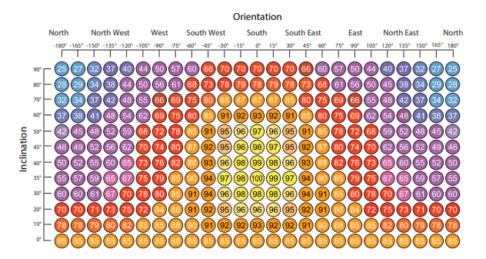
Figure 1: Solar radiation received depending on orientation and inclination
Shading devices including blinds, shutters and overhangs are to be considered to reduce overheating risks, as these devices intercept the radiation before it can enter the buildings fabric. External shading tends to be more effective in comparison to internal shading as it blocks the solar radiation before it reaches the glazing. Designers must calculate the g-value of the glazing in accordance with Approved document O (Welsh Government, 2022 (1b)). Additionally, the designer must ensure compliancy with Approved Document O (Welsh Government, 2022 (1c)) and Net Zero targets by reducing need for mechanical cooling.

3.2 Incorporation with approved documents and sustainable frameworks
Control measures for solar gain are required to work incorporation with a variety of building regulations and sustainable frameworks to ensure a complete approach to energy efficiency and human comfort. Stated below are approved documents that provide essential guidance:
- Approved Document L – Conservation of Fuel and Power (Welsh Government, 2024a): Sets standards for energy efficiency in buildings including insulation, heating systems and airtightness.
- Approved Document O – Overheating (Welsh Government, 2022 (1d)): Provides guidance on reducing risks of overheating, specifically new dwellings must be designed to prevent reaching excessive temperatures.
- Approved Document C – Site Preparation and resistance to Contaminants and moisture (Welsh Government, 2010): Provide guidance for protection against moisture, damp and contaminants which affect thermal performance of the building.
- Approved Document F- Ventilation (Welsh Government, 2022 (2)): Addresses the need for adequate ventilation for improving indoor air quality and provides guidance for cooling strategies mitigating the risk of overheating.
- Approved Document B – Fire safety (Welsh Government, 2020): Covers fire safety in buildings and considers glazing when incorporating shading devices to control solar gain.
Apart from legislative guidance, designers should also adopt practises from industry frameworks including:
- CIBSE TM 37 – Designing for improved Solar shading control
- BR 209 - Site layout planning for daylight and sunlight: a guide to good practice. 3rd edition
- CIBSE TM59 - Design methodology for the assessment of overheating risk in homes
- BR364 2E – Solar shading of buildings
- BS EN 17037:2018 - Daylight in buildings
- BS 8545:2014 - Trees: from nursery to independence in the landscape – Recommendations
- CIBSE Guide A – Environmental Design
- PHPP – Passive House Planning Package
- BREEAM - New Construction UK Technical Manual

3.3 Thermal Mass considerations
Thermal Mass is the ability of a material to absorb and release heat, in a building high-mass materials such as concrete and brick stabilise the building’s internal temperature by absorbing excess solar radiation during the day and release when temperature reduces. As a result of the risk of overheating heating, reliance for mechanical cooling is significantly reduced, accompanying net zero targets by minimising operational energy use.
CIBSE TM59 (Bonfigli, C. et al, 2017a), provides guidance designers should incorporate into new dwellings to ensure human comfort criteria is met.

4.0 Orientation and Solar Gain

4.1 Orientation Principles
The orientation of a building affects the solar gain received and the building’s overall energy use. As shown in figure 1, BR 209 (Littlefair, P. et al, 2022b) advises south faced glazing to be utilised where practicable to benefit from winter solar gains. If the building is orientated to the east or west less solar gain will be received especially during winter when it most needed, however during summer months overheating can become a concern causing the occupant to rely on mechanical cooling and shading devices. North façade receive sunlight on certain occasions, typically early mornings and late evenings in the summer. The designer must ensure they have complied with Approved document O (Welsh Government, 2022 (1e)) which states strategies to limit unwanted solar gains and preventing overheating. From optimising the orientation of the building, the requirement of operational energy can be drastically reduced contributing to Net Zero goals.

4.2 Seasonal Sun Path
Throughout the year the suns position changes, this affects the solar gain a building receives. As shown in figure 1, south facing surfaces at 35° are optimal for receiving solar exposure within the UK.
The designer should use tools and software such as sun path diagrams to visualise and predict solar exposure of the site. A sun path diagram is shown in figure 2, by understanding the sun path the designer can effectively install shading devices and the position of fenestration.
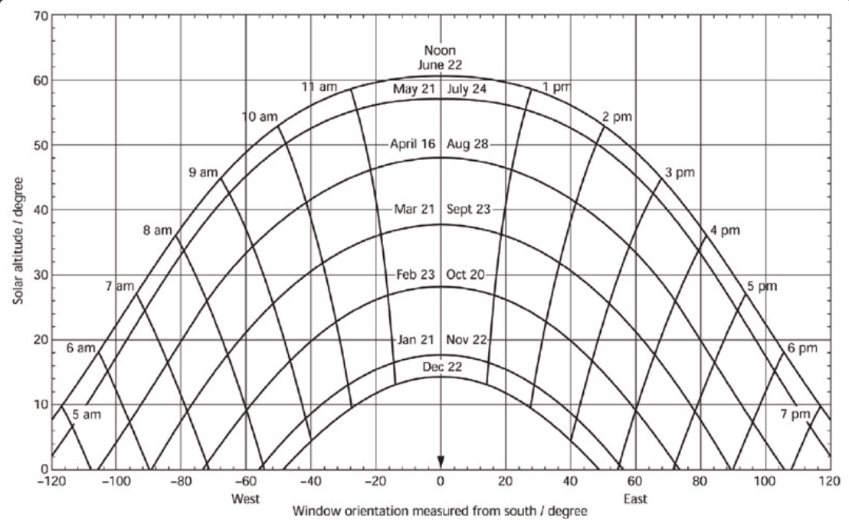
Figure 2: Sun-path diagram

4.3 Shading strategies
Shading devices used within the building should be chosen in conjunction with the orientation and sun path of the site. South facing orientation will benefit from fixed overhangs as it will block solar radiation during the summer when the sun is highest whilst allowing for the low winter sun. East and West fenestration would benefit from shutters to manage the morning and afternoon sun thereby reducing the likelihood of overheating.
BR364 2E (Littlefair, P, 2018) covers design and shading devices and goes in depth of characteristics, providing the designer with an in depth view and understanding on how to incorporate into the design to comply with regulations as well as practicality.

5.0 Site Analysis

5.1 Requirements
A site analysis survey is to be conducted during the design phase of the project in order to identify how the environment of the site can influence solar gain and access risks of overheating. Other factors including topography, overshadowing and vegetation must be evaluated in accordance with guidance BS EN 17037:2018 (BSI Standards Publication, 2021).

5.2 Topography
Topography has a direct influence on the buildings access to solar gain and it’s thermal mass behaviour. The sites topographical condition will determine the building’s ability to receive solar gain, if evaluated incorrectly there is greater risk for overheating and overall poor energy efficiency.
An in depth report of the sites topographical conditions is essential during the design phase, this will establish practical requirements needed to reduce operational energy use. By analysing the local environment of the site, designers can develop a dwelling that is energy efficient and aligns with net zero targets.

5.3 Overshadowing Risks
The sites physical environment including natural and physical structures nearby pose the highest risk of overshadowing. The height, distance and design must be analysed thoroughly, if not done correctly:
- Adjacent buildings can restrict daylight increasing usage of artificial lighting.
- High-rise structures can overshadow the site reducing solar gain.
- Seasonal variation can lead to overshadowing and reduced solar gain as the sun path varies throughout the year, the solar altitude throughout a year can be visualised in figure 2.
In order to mitigate overshadowing risks, designers should take into account the above points and consider the orientation and fenestration of the dwelling.

5.4 Vegetation
Vegetation of the sites area is to be surveyed and analysed at the same degree as the site’s topography. Vegetation of the site is to be assessed as it can provide natural shading affecting solar gain potential, BR 209 (Littlefair, P. et al, 2022c) explains areas of vegetation can affect daylight entering the dwelling, because of this designers must evaluate the species of all vegetation surrounding the site to determine how it may act for and against the dwelling and consider all designs including orientation and fenestration design and placement.
Although vegetation can be seen as an obstruction to the proposed dwelling, it can also function as natural shading mitigating overheating risks. The designer must consider planting vegetation such as trees to be in accordance with BS 8545:2014 (BSI Standards Publication, 2014) as local councils may enforce this as a requirement to combat GHG emissions produced and help to meet net zero targets.

6.0 Calculations Methods

6.1 Solar gain calculation
In the building design, the solar gain is calculated from all surfaces including windows, walls and internal surfaces. The calculation is often carried out from the following methods using a software tool at an hourly basis to ensure accurate energy analysis and correct HVAC systems (Holmes, M. Et al, 2021):
- PHPP
- CIBSE Guide A
New builds are to achieve a minimum solar gain of 25% per SQM, (Fosdick, J, 2008) provides calculations suggesting even with moderate solar design the 25% can be met, ensuring compliancy is realistic for all new dwellings.

6.2 Overheating risk assessment
The overheating risk is to be thoroughly assessed, using industry recognised frameworks including:
- CIBSE TM59 - Design methodology for the assessment of overheating risk in homes
- Approved Document O – Overheating
CIBSE TM59 (Bonfigli, C. et al, 2017b), covers guidance for which the assessment is to cover, the following requirements are stated below:
- Sample size
- Weather files
- Window and door openings
- Orientation
- Mechanical ventilation systems
- Air speed assumptions
- Shading devices
If the dwelling does not comply with legislation thresholds, the design of the dwelling must be evaluated and altered in order to comply in accordance with industry standards.

6.3 Tools and standards
The following tools and standards can be used in accordance with this approved document:
- PHPP
- CIBSE TM59 - Design methodology for the assessment of overheating risk in homes
- CIBSE Guide A
- BS EN ISO 52016-1:2017
- Approved Document O - Overheating

7.0 Compliance criteria

7.1 Solar Gain percentage
All new dwellings are to achieve a minimum of 25% solar gain achieved, as shown in figure 3 an average dwelling requires 100-150 [kWh/(m²a)].
As visualised heat loss from windows is roughly 25%, therefore if window heat loss is reduced and solar gain is optimised the dwelling can meet the specified target of achieving 100-150 [kWh/(m²a)].
As the heating demand is reduced, net zero targets can be reached through orientation and fenestration reducing reliance for mechanical systems and in total lowering the operational energy use of the dwelling.
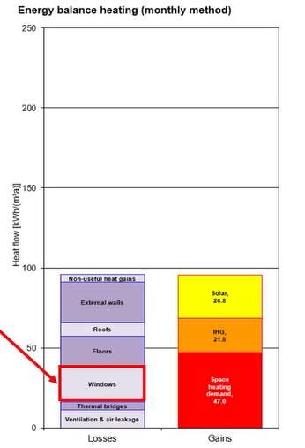
Figure 3: Energy Balance Heating

7.2 G-Values and U-Values
In compliance with Approved document L (Welsh Government, 2024b), new dwellings are to achieve a maximum U-Value of 1.4 W/(m².K)1 in regards for windows and doors. The G-Value of fenestration within the dwelling is to be selected in compliance with Approved document O (Welsh Government, 2022 (1f)), to maximise winter gains whilst limiting overheating risks in the summer.
The U-Value and G-Value of the fenestration is to be verified from the manufacturer and provided in the design and post-completion documentation.
The designer must ensure:
- U-Values are met in accordance with Approved document L.
- G-Vaues are selected in compliance with Approved document O.
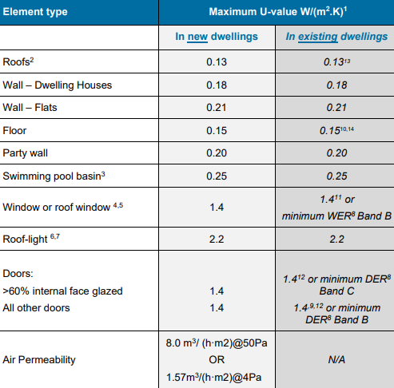
Figure 4: U-Values for new Dwellings

8.0 Documentation and verification
Documentation is to be recorded and provided, as it will be used to show compliance with approved documents, industry frameworks and net zero.

8.1 Design stage documentation
In the design report that is to be submitted as a part of the planning and building regulations application. This approved document follows BREEAM New Construction UK Technical Manual (BREEAM, 2025a) as it provides insight into evidence required for the design stage.
As of this, the design report must include:
- Solar geometry diagrams
- Orientation of the dwelling and fenestration placement
- Ratio of glazing within the dwelling
- Mitigation strategies in response to overshadowing risks
- Calculated U-Values and G-Values
- Site plans and analysis
- Net zero compliancy
- Compliance with other approved documents.
If all of the above is provided and approved, the construction phase can begin.

8.2 Post-Construction stage documentation
Once the dwelling has been constructed and signed off, an evidence report must be submitted to confirm the design report has been followed correctly and in compliance with supported approved documents and frameworks. In alignment with BREEAM New Construction UK Technical Manual (BREEAM, 2025a) the post construction report must contain:
- Site record card including sign in/out sheets
- Verification of fenestration and shading devices installed
- Ratio of glazing installed within the dwelling.
- EPC Certificate
- Final site analysis
- Proof of compliancy with net zero targets and approved documents

9.0 Competence and certification
To ensure documentation submitted in the design and post-completion stages of the project is reliable and authorised, all documentation is to be undertaken through qualified professionals and demonstrated such as:
- CIOB
- RICS
- CIBSE
- RIBA
- BREEAM Assessor License
- AECB
- CIC
The above credited bodies represent industry experts responsible for setting competency standards, that are in line with Government legislation and validate technical expertise within the construction and built environment industry (Construction Industry Council, N.D).

10.0 References and standards
- Approved Document B – Fire safety
- Approved Document C – Site Preparation and resistance to Contaminants and moisture
- Approved Document F- Ventilation
- Approved Document L – Conservation of Fuel and Power
- Approved Document O – Overheating
- BR 209 - Site layout planning for daylight and sunlight: a guide to good practice. 3rd edition
- BR364 2E – Solar shading of buildings
- BREEAM - New Construction UK Technical Manual
- BS 8545:2014 - Trees: from nursery to independence in the landscape – Recommendations
- BS EN 17037:2018 - Daylight in buildings
- CIBSE Guide A – Environmental Design
- CIBSE TM 37 – Designing for improved Solar shading control
- CIBSE TM59 - Design methodology for the assessment of overheating risk in homes
- PHPP – Passive House Planning Package

References
‌Bere, J (2013). An introduction to Passive House. [Online] Available at: https://products.ihserc.com/tmp_stamp/00334649723/DOCZRGAAAAAAAAAA.pdf?sess=00334649723&prod=CIS1 [Accessed 08/12/2025]
Bonfigli, C. et al (2017). Design methodology for the assessment of overheating risk in homes (Online) Available at: https://products.ihserc.com/tmp_stamp/00334649723/FHMASGAAAAAAAAAA.pdf?sess=00334649723&prod=CIS1 [Accessed 08/12/2025]
BREEAM (2025). BREEAM New Construction (Online) Available at: https://products.ihserc.com/tmp_stamp/00013144938/BRNHTIAAAAAAAAAA.pdf?sess=00013144938&prod=CIS1 [Accessed 09/12/2025]
BSI Standards Publication (2014). Trees: from nursery to independence in the landscape – Recommendations (Online) Available at: https://products.ihserc.com/tmp_stamp/00334649723/YGIMHFAAAAAAAAAA.pdf?sess=00334649723&prod=CIS1 [Accessed 08/12/2025]
BSI Standards Publication (2021). Daylight in Buildings (Online) Available at: https://products.ihserc.com/tmp_stamp/00334649723/VNMZVGAAAAAAAAAA.pdf?sess=00334649723&prod=CIS1 [Accessed 08/12/2025]
Construction Industry Council (N.D). Built Environment Professions Together. [Online] Available at: https://www.cic.org.uk/about [Accessed 08/12/2025]
Fosdick, J. (2008). Passive Solar Heating. [online] Available at: https://www.mountainsideinstitute.org/wp-content/uploads/2018/09/Passive-Solar-Heating-Whole-Building-Design-Guide.pdf. [Accessed 08/12/2025]
George. C.B & Godefroy. J (2022). LETi-CIBSE Net Zero FAQs Webinar. [Online] Available at: https://www.leti.uk/netzero [Accessed 03/12/2025]
Holmes, M. Et al (2021). Environmental Design (Online) Available at: https://products.ihserc.com/tmp_stamp/00334649723/EGGSSGAAAAAAAAAA.pdf?sess=00334649723&prod=CIS1 [Accessed 08/12/2025]
Littlefair, P (2006). Design for improved solar shading control (Online) Available at: https://products.ihserc.com/tmp_stamp/00334649723/MRTVRGAAAAAAAAAA.pdf?sess=00334649723&prod=CIS1 [Accessed 08/12/2025]
Littlefair, P (2018). Solar shadings of buildings (Online) Available at: https://products.ihserc.com/tmp_stamp/00334649723/BGSASGAAAAAAAAAA.pdf?sess=00334649723&prod=CIS1 [Accessed 08/12/2025]
Littlefair, P. et al (2022). Site layout planning for daylight and sunlight (Online) Available at: https://products.ihserc.com/tmp_stamp/00334649723/GVCOWGAAAAAAAAAA.pdf?sess=00334649723&prod=CIS1 [Accessed 08/12/2025]
Welsh Government (2010). Approved Document C: Site preparation and resistance to contaminants and moisture (Online) Available at: https://www.gov.wales/sites/default/files/publications/2019-05/building-regulations-guidance-part-c-resistance-to-contaminants-and-moisture.pdf [Accessed 08/12/2025]
Welsh Government (2020). Approved Document B: Volume 1 – Dwellinghouses – Fire safety (Online) Available at: https://www.gov.wales/sites/default/files/publications/2021-12/building-regulations-guidance-part-b-fire-safety-volume-1-dwellinghouses.pdf [Accessed 08/12/2025]
Welsh Government (2022). Net Zero Strategic plan. [Online] Available at: https://www.gov.wales/sites/default/files/publications/2022-12/welsh-government-net-zero-strategic-plan.pdf [Accessed 03/12/2025]
Welsh Government (2022 (1)). Approved Document O: Overheating (Online) Available at: https://www.gov.wales/sites/default/files/publications/2022-10/building-regulations-approved-document-o.pdf [Accessed 08/12/2025]
Welsh Government (2022 (2)). Approved Document F: Volume 1 – Dwellings – Ventilation (Online) Available at: https://www.gov.wales/sites/default/files/publications/2022-10/building-regulations-approved-document-f-vol-1.pdf [Accessed 08/12/2025]
Welsh Government (2024). Approved Document L: Volume 1- Dwellings – Conservation of fuel and power (Online) Available at: https://www.gov.wales/sites/default/files/publications/2024-05/building-regulations-approved-document-l-vol-1.pdf [Accessed 08/12/2025]

