Module Title: Management & Organisational Behaviour
Module Code: BMIH5004

Assignment Title: Hilton Hotels & Resorts – Organisational Structure, Culture, and Strategic Direction

Student Name: Silvia Daniela Grecu
Student ID: 2245642

Declaration:
I confirm that this assignment is my own work, and all sources used have been properly acknowledged in accordance with university academic integrity policies.

Executive Summary:

This report provides a critical assessment of Hilton Hotels & Resorts, one of the world's leading hospitality brands. It specifically focuses on the company's organisational structure, corporate culture, strategic direction, and recent change initiatives. Appropriate management and organisational behaviour theories underpin the analysis.
Hilton has a divisional organisational structure conducive to flexibility, market responsiveness and operability efficiency. The corporate culture promotes employee engagement, sustainability, and customer satisfaction in line with its long-term vision. This report will evaluate Hilton's digital transformation encompassing its sustainability efforts and remote, flexible work policies; these policies have enhanced operational efficiency for the hotel, although they also pose difficulties (such as costs and adaption) for the team.
Strategic Direction section of this Hilton Business Strategy Analysis explores statistics on Hilton's growth strategy, leadership style and competitive position, identifying strengths like brand equity and innovation and paying attention to threats from competition and economic downturns. This report will perform a SWOT analysis to make sense of Hilton's situation.
Lastly, the report discusses localisation strategies, cyber security risks, growing AI-powered personalisation, economy brand investments, and green tech. A specific plan for implementation makes execution feasible. By proficiently navigating change, leadership, and competitive pressures, Hilton may continue to be a chief player in international hospitality while fostering innovation and sustainability.

Table of Contents
Executive Summary: 2
1. Introduction: 4
2. Organisational Structure, Culture, and Goals: 4
2.1 Organisational Structure: 4
2.2 Corporate Culture: 5
2.3 Organisational Goals: 6
3. Recent Change Initiatives: 6
3.1 Digital Transformation: 6
3.2 Efforts for Sustainability: 7
3.3 Flexible Work Models: 7
3.4 Issues in the Change Management Process: 8
4. Strategic Direction: 8
4.1 Expansion Strategy: 8
4.2 Leadership & Change Management: 9
4.3 SWOT Analysis: 9
5. Recommendations: 10
Implementation Timeline: 11
6. Conclusion: 11
References: 12

1. Introduction:

Hilton Hotels & Resorts, established in 1919 by Conrad Hilton, is one of the oldest and largest hospitality brands in the world. Hilton owns over 6,500 properties in 116 countries. The organisation is recognised for providing quality service with constant innovation and high guest satisfaction rates (Boddy, 2017). A strong organisational culture, effective leadership, and a well-defined management system that facilitates operational efficiency and strategic growth have contributed to its longstanding reputation.
This report will examine Hilton's organisational structure and business culture and what makes the organisation effective in Bahrain. It also examines the recent change initiatives that the company has undertaken, evaluating their impact on employee performance and customer experience. In addition, the report analyses Hilton's strategic direction and competitive position in the global hospitality industry. Applying organisational behaviour theories, people can explain how Hilton's various processes, such as structure, leadership approach, and decision-making processes, affect its overall success.
This report includes a SWOT analysis to analyse Hilton's major strengths and weaknesses while also examining the opportunities and threats that will appear in the dynamic market. These insights add to the knowledge about how global hospitality brands, including Hilton (Mullins, 2023), overcome industry adversity within the context of digital transformation, sustainability push, and economic volatility. Based on this assessment, strategic options will be implemented as a roadmap for reinforcing Hilton's market leadership and sustainable growth.

2. Organisational Structure, Culture, and Goals:

2.1 Organisational Structure:

Hilton Hotels & Resorts adopts a divisional organisational structure characterised by decentralised decision-making and regional autonomy. This structure allows the company to effectively manage its vast global operations, distributing key responsibilities across its levels (Minas, Wright and Kakuma, 2014). At the corporate level, Hilton manages global brand strategy, finance, marketing, and overall business development. This guarantees that strategic targets are in sync with the business's long-term ambition while ensuring consistency between properties (Boddy, 2017).
At the regional level, the company functions via its divisions, which oversee operations in certain geographic regions, including the Americas, Europe, the Middle East and Africa (EMEA), and Asia-Pacific (APAC). They enable Hilton to effectively respond to regional marketplace demand, tailor its offerings and services, and contribute towards the local market (Middlewood and Lumby, 1998). Hotel-level operations are handled by general managers who supervise individual properties under Hilton's brand umbrella, ensuring day-to-day operations run smoothly and by corporate policies.
One of the divisional structure's main advantages is that it is very flexible (Young, 2013). This makes it easier to respond to changes in customer needs and improves management efficiency. This allows Hilton to further decentralise decision-making, delegate authority, and improve operational performance, all of which are essential in the competitive and dynamic hospitality business (Mullins, 2019).

2.2 Corporate Culture:

The corporate culture of Hilton is rooted in the organisation's core values, referred to as the "Hilton Values" and "The Hilton Effect" the behaviours that employees are expected to exhibit to help the organisation achieve its objectives and unite employees across the globe. The values stand for Hospitality (H), Integrity (I), Leadership (L), Teamwork (T), Ownership (O), and Now (N), which together create a customer-centric, innovative and performance-driven environment (Armstrong, 2021). Hilton has been widely acclaimed as one of the world's greatest employers, thanks largely to its commitment to employee satisfaction, diversity, and career development opportunities (Mullins, 2023). Cultural Aspect in the Hospitality Sector The hospitality sector is strongly linked with organisational culture as it becomes a key concern in encouraging employee involvement and customer service quality, ultimately leading to brand reputation (Foster, Ricaurte and Farrar, 2019)
.
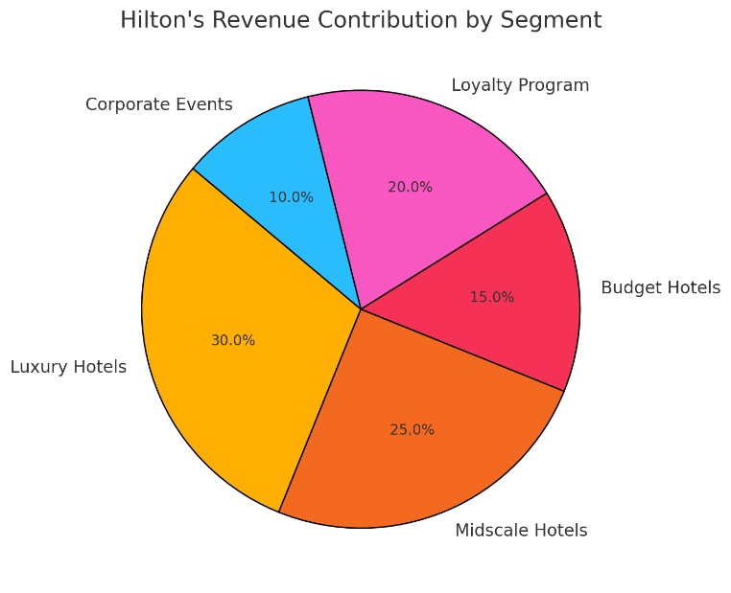
Figure 2: Hilton's Revenue Contribution by Segment (Authors made)

2.3 Organisational Goals:

Hilton's global and hotel-level objectives are focused on improving its competitive edge, retaining its place as an innovative leader in the hospitality industry, and increasing customer satisfaction. One key goal is to deliver great guest experiences via personalised service, digital transformation, and operational efficiency (Robbins & Judge, 2017). Hilton's approach to customer service emphasises technology, implementing AI-powered guest services, mobile check-ins, and smart room technology (Arnold, 2020).
Hilton has also placed a strong focus on sustainability. The company has also set ambitious targets (Armstrong, 2012), such as generating carbon neutrality by 2030 via energy reduction, water conservation, and waste reduction programmes. Not only do these initiatives reinforce Hilton's corporate social responsibility (CSR) strategy, but they also meet consumers' firm desire for ecologically sustainable hospitality solutions (Buchanan & Huczynski, 2007).

3. Recent Change Initiatives:

3.1 Digital Transformation:

The company has adopted digital transformation as a key strategy to improve operational efficiency and guest experience. The Hilton Honors App also enables digital check-ins, keyless room entry and mobile service requests to decrease reliance on front-desk operations (Su, 2007). Moreover, AI-driven chatbots have been implemented to enhance customer service efficiency, offering immediate responses to guest questions and relieving staff workload. The digital journey embarked upon by the hospitality industry is still the foundation of modern organisational behaviour, where automation leads to better efficiency and guest satisfaction (Mullins, 2019). According to Boddy (2017), services have become increasingly shaped by technology, and this is not only helping service sectors get organised seamlessly but also providing long-term loyalty for potential customers.

3.2 Efforts for Sustainability:

Hilton has a huge focus on sustainability, as seen in the LightStay Programme, which measures the initiative's impact on the environment and assists in making data-driven decisions on energy usage and resource conservation at all Hilton properties (Zientara et al., 2020). Through its Carbon Reduction Plan, Hilton has also pledged to cut its carbon footprint by 61% by 2030. Such initiatives prioritise CSR and may ultimately lead to cost savings and energy efficiency, as Armstrong (2021) noted, adding sustainability to management, which may complement corporate reputation. Hilton strengthens its image as a responsible global hospitality leader (Huczynski & Buchanan, 2019) by embedding sustainability in its core strategy.

3.3 Flexible Work Models:

Hilton also launched the Work-from-Hotel (WFH) program to tap into changing workplace trends, offering familiar office spaces to professionals who prefer a hotel environment to work remotely (Morrison, 2022). This service responds to an increasing trend of digital nomads and international business travellers seeking alternative working spaces. And staff retention and engagement have been bolstered through enhanced employee well-being programmes with a renewed focus on mental health support and professional development. Research shows that the policies focused on the employee increase job satisfaction and organisational commitment (Arnold, 2020).

3.4 Issues in the Change Management Process:

While these advancements sound promising, Hilton has numerous challenges in enacting change (Rajeev Semwal et al., 2024). Such delays are primarily due to the reluctance of conventional staff to adopt technologies, the high costs of implementing sustainability measures, and the fight between the standardisation of the brand and local market preference (Buchanan & Huczynski, 2007). Nevertheless, Hilton has successfully navigated these challenges through strong leadership and adaptability, cementing its position as an industry leader in innovation (Adair, 2009).
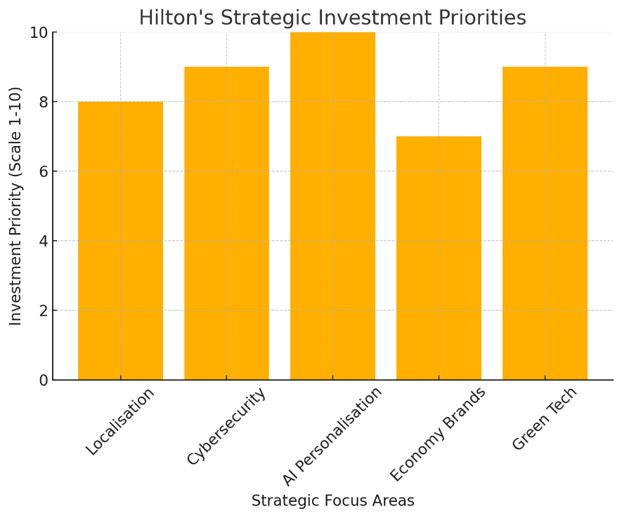
Figure 1: Hilton's Strategic Investment Priorities (Authors made)

4. Strategic Direction:

4.1 Expansion Strategy:

The growth strategy of Hilton involves an emphasis primarily based on emerging markets: These provide space for growth, and Hilton specifically targets these in countries such as South Africa and the south-eastern areas of Asia where increased business usage and tourism are leading to demand for luxury and midscale hotels (Mullins, 2019). There is enormous potential for generating revenue in these areas as economies evolve and disposable incomes increase. So Hilton's asset-light expansion strategy by partnering with franchise partners means the company can grow without taking on the financial responsibility of maintaining the property. This approach improves financial flexibility and allows Hilton to concentrate on brand management, customer experience, and operational efficiency (Boddy, 2017). Forming local partnerships would allow Hilton to respond more appropriately to regional market dynamics, offering more localised yet globally consistent services and branding. On the other hand, challenges, such as regulatory requirements, infrastructure limitations, and political instability in some emerging markets, need to be navigated carefully to ensure firms are expanding sustainably (Buchanan & Huczynski, 2007).

4.2 Leadership & Change Management:

Using Kotter's 8-Step Change Model, Hilton has successfully managed change, providing a framework for utilising its strengths to fulfil its strategic plans. The urgency to innovate is evident in Hilton's response to industry trends like digitalisation and sustainability (Huczynski & Buchanan, 2019). Hilton galvanises loyalty among a strong coalition involving getting executives and regional managers on board strategic initiatives, resulting in harmonic synchronisation operating at all levels of the organisation (Robbins & Judge, 2017). Establishing a clear vision for change — especially regarding sustainability and digital transformation has recently been key to Hilton's priorities. A prerequisite for successful change is communication, which Hilton promotes through digital training programmes and workshops for leaders (Adair, 2009). With decentralised decision-making, empowering teams amplifies operational agility, leading to fast responses to market evolutions (Armstrong, 2012). Another aspect of Hilton's strategy is to look for quick wins - implement something like AI-powered guest services so that the tangible wins will materialise early in the change process. Momentum can be maintained by consistently innovating guest experiences and embedding these updates in corporate culture, which fosters new strategies to become permanent organisation norms (Mullins & Dosser, 2013).

4.3 SWOT Analysis:

Hilton's agility helps it retain strategic positioning even in a competitive landscape. Mullins (2023) has shown that its strengths include a strong brand reputation, global presence, and leadership in digital transformation. Nevertheless, operational costs and the franchise business model raise serious weaknesses that could affect its profit and level of service (Rollinson et al., 2008). Emerging markets, demand for sustainable tourism, and the rise of wellness travel offer opportunities (Arnold, 2020). Nevertheless, Hilton has to deal with challenges like the intensifying competition from Marriott and Airbnb, the recession causing a decline in travel demand, and changing guest expectations (Bloisi et al., 2007). Hilton is a leading player in the global hospitality landscape through innovation, strategic leadership, and continuous adaptation to market trends.
Strengths | Weaknesses | Opportunities | Threats
Strong brand reputation | High operational costs | Growth in emerging markets | Competition from Marriott, Airbnb
Global presence | Franchise model reliance | Demand for sustainable tourism | Economic downturns affecting travel
Digital transformation | Cybersecurity risks | Expansion into wellness travel | Changing guest expectations
Table 1: SWOT Analysis

5. Recommendations:

Hilton should also increase its market position and intensify localisation by adapting the hotel experience to meet varying cultural preferences while ensuring appeal within their standardisation and market-specific needs. This principle is critical for maintaining guest satisfaction across various markets (Mullins, 2023). This can be achieved by implementing localised service models, allowing Hilton to remain distinctive among competitors whilst maintaining the brand's core values (Boddy, 2017).
As the risk of data breaches deepens with digital transformation, strengthening cybersecurity is critical, too (Morrison, 2022). Investing in AI-based security systems can protect data and earn guest confidence. Moreover, artificial intelligence-focused personalisation utilises these machine learning algorithms to provide differentiated services for guests depending on their preferences (Armstrong, 2021). Smart technologies have been increasingly developed and applied within hospitality to meet customer needs, as identified by Huczynski and Buchanan (2019).
Hilton will be able to serve cost-conscious travellers with the new midscale and economy brands, like Hilton Garden Inn and Hampton by Hilton (Jha et al., 2024). As competition increases within the budget hotel category, this move can make Hilton more viable in the market (Adair, 2009). In addition, investing in green technologies like smart energy-saving devices aligns with Hilton's sustainability objectives and will positively impact its corporate reputation (Mullins & Dosser, 2013).
Long-term objectives (5 years) aim for enhanced cybersecurity infrastructure and seamless AI solutions. The short-term objectives could be set around expanding to Asian and African countries, and in the medium/long term objectives, Hilton must be carbon neutral (Buchanan & Huczynski 2007). Such programs enhance Hilton's strategic agility and long-term sustainability (Bloisi et al., 2007).

Implementation Timeline:

Short-Term (1 Year): Cybersecurity upgrades, AI integration.
Medium-Term (3 Years): Expansion in Asia & Africa.
Long-Term (5 Years): Achieve carbon neutrality goals.

6. Conclusion:

Hilton Hotels & Resorts has remained at the forefront of the global hospitality sector through strong management, digital innovation, and sustainability-driven efforts. The divisional structure and corporate culture give this company the means required in a diversified market. New competitive drivers, such as digital transformation and sustainability programmes, are under the spotlight. However, cybersecurity risks and balancing standardisation and localisation are still important challenges. Therefore to maintain its market leadership, Hilton need to develop further localisation strategies, improve cybersecurity defenses, increase AI-based personalisation and further invest in green technologies. Through innovations, optimizations and strategic agility Hiltion can put itself in a win-win situation amidst challenges and maintain leadership postion. Proactive change management for future growth will be key and long-term success.

References:

Adair, J. (2009) The Inspirational Leader (2nd Ed), London: Kogan Page.
Armstrong, M. (2012) Armstrong’s Handbook of Management and Leadership (3rd Ed), London: Kogan Page.
Armstrong, M. (2021) Armstrong's Handbook of Performance Management (7th Ed), London: Kogan Page.
Bloisi, W., Cook, C. and Hunsaker, P. (2007) Management and Organisational Behaviour (2nd Ed), Maidenhead: McGraw-Hill.
Boddy, D. (2017) Management: An Introduction (7th Ed), Harlow: Pearson.
Buchanan, D. and Huczynski, A. (2007) Organisational Behaviour: An Introductory Text (6th Ed), Harlow: Prentice Hall.
Foster, D., Ricaurte, E. and Farrar, L. (2019). Calculating Hotel Industry Impact: The Case of Hilton Lightstay. ecommons.cornell.edu. [online] Available at: https://ecommons.cornell.edu/items/e237a789-6558-4eae-9d3f-07689e723b20. (Accessed on: Feb 10, 2025).
Huczynski, A. and Buchanan, D. (2019) Organisational Behaviour (10th Ed), Harlow: Pearson.
Jha, B., Giri, P., Dhanya, D. and Jha, D. (2024) Artificial Intelligence Adoption in the Hotel Industry. Chapman and Hall/CRC eBooks, pp.66–80.
Middlewood, D. and Lumby, J. (1998) Strategic Management in Schools and Colleges. SAGE Publications Ltd eBooks. SAGE Publishing.
Minas, H., Wright, A. and Kakuma, R. (2014) Goals and Organisational Structure of the Movement for Global Mental Health. International Journal of Mental Health Systems, 8(1).
Morrison, A.M. (2022) Hospitality and Travel Marketing. Hospitality and Travel Marketing.
Mullins, L. and Dosser, P. (2013) Hospitality Management and Organisational Behaviour (5th Ed), Harlow: Pearson.
Mullins, L. (2019) Organisational Behaviour in the Workplace (12th Ed), Harlow: Pearson.
Mullins, L. (2023) Management and Organisational Behaviour (13th Ed), Harlow: Pearson.
Rajeev Semwal, Tripathi, N., Ruchika Kulshrestha and Tyagi, P. (2024). Innovative Approaches to Sustainable Hospitality. Advances in hospitality, tourism and the services industry (AHTSI) book series, [online] pp.379–400.
Robbins, S. and Judge, T. (2017) Organizational Behaviour (17th Ed), Harlow: Pearson Education Limited.
Su, N. (2007) Towards Integrated Service Innovation: From Strategic Goals to Organisational Structures. International Journal of Services Operations and Informatics, 2(4), p.357.
Young, R. (2013) Saving Water and Energy Together: Helping Utilities Build Better Programs. Alliance for Water Efficiency. [Online] Available at: https://www.allianceforwaterefficiency.org/sites/default/files/assets/ACEEE-AWE-Saving-Water-and-Energy-Together-Oct-2013.pdf. (Accessed on: Feb 10, 2025).
Zientara, P., Bohdanowicz-Godfrey, P., Whitely, C. and Maciejewski, G. (2020) A Case Study of LightStay (2010–2017)—Hilton’s Corporate Responsibility Management System. Energies, 13(9), p.2303.

