Student name: Ioana Cocea
Student id: 1920428
Programme: BA Business Management Level 6
Module name: International Business Communications
Module code: LCBB6001
Assignment Title: Assessment 1: Tesco in Malaysia
Module Lecturer: Husam Helmi

Tesco in Malaysia

Table of Contents
1.Introduction to the company`s international business and communications 3
2.Introduction to the Developing country 3
3.Application of the Intercultural and International theories 4
4.Critical evaluation of cultural sensitivity while operating in another country 7
5.Significance of Networking 10
6.Analyzing different communication barriers faced in a foreign country 11
7.Suitable communication strategies with recommendations 12
8.Conclusion 13
References 14

1.Introduction to the company`s international business and communications
TESCO is one of the biggest supermarkets not only in the United Kingdom but also all around the world. The company is known for its superior quality and best services to its customers. The company’s international business model focuses on four components that are: Products, channels, reinvesting, and customers. These are the 4 parameters of the company’s business model that the company focuses on the most because these variables are the main component of every organisation to track its work progress.
Presently, the organisation is operating with 4752 stores approximately worldwide, and the number of stores has been decreased after the pandemic (Statista, 2022). Unfortunately, there are several numbers of countries in which the organisation is yet to expand its business like: Malaysia, Indonesia, India, Iraq, and many more. The organisation is concerned about the cultural, and communication barriers in terms of operating in these countries. The organisation follows a digital communication strategy in terms of communicating with people and increasing its awareness all over the world.

2.Introduction to the Developing country
The selected developing country in which the organisation has decided to increase its exposure is: Malaysia. Malaysia has a huge scope of business, and the company can increase its performance in this country because Malaysia is one of those developed countries that are developing very fast, and the sphere of this country has an increased from earlier. However, the demand of the Malaysian people is quite different from others, and that is the major concern for the organisation that how the supermarket’s staff will communicate with other people. In order to mitigate the challenge, the organisation can hire local people as the company staff to avoid the language issue. Malaysia is a very advanced country that is developing continuously, and from earlier times to now several changes have happened in Malaysian society.

3.Application of the Intercultural and International theories
The organisation wants to expand its business in Malaysia and is concerned about cross-cultural sensitivity issues. In terms of removing the cultural barriers, the organisation should follow some theories to reduce cultural communication issues and increase its capability in international business. The theories are: “Hofstede’s Cultural Dimension Theory”, “Trompenaars 7 cultural dimensions model”, and “Porter’s five forces model.
“Hofstede’s Cultural Dimension Theory”:
This theory describes different dimensions of culture and analyses the differences between the dimensions by giving an overview of each variable.

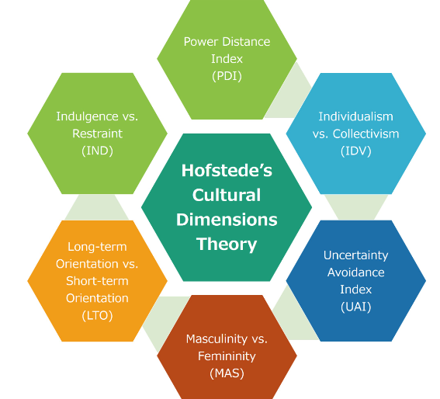
Figure 1: “Hofstede’s Cultural Dimension’s Theory
(Source: Huang, and Crotts, 2019)

The seven dimensions of this theory are seven different shades of cultural communication. For example, the variant “individualism versus collectivism” describes the difference between individual opinion and the opinion that is collected from others (Huang, and Crotts, 2019). In case, the organisation wants to proceed with a long-term business goal, then this theory should be appropriate for it. The “Uncertainty Avoidance index” describes the ratio of cultural uncertainty that the organisation is facing or can face in another country, or when communicating with other people of different cultures.
Another theory that is also important is the Trompenaars 7 cultural dimensions model” which also describes 7 different dimensions of cross-culture, but the variables are different from Hofstede’s model.

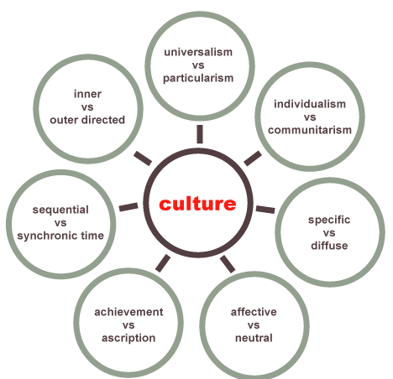
Figure 2: “Trompenaars 7 cultural dimensions model”
(Source: Pirlog, 2021)

The above image describes how culture is interconnected with different variables, and how each variable s influencing cultural communication. TESCO is very confused about proceeding the business in a different country because of the cultural barriers, but in case the organisation follows this theory, then it will be quite easier for the organisation to communicate, and maintain strong, and healthy relationships with the customers (Pirlog, 2021). The contrast among the variables is clearly described in this theory which can help the organisation to follow the right approach to communication. “Universalism versus particularism” describes how conducting an international business is different from a domestic business.
Another theory that should be used to describe the strengths, and weaknesses of the organisation, and that theory is “Porter’s Five forces model”. The model describes five variables of business that can help the organisation to understand the threats and opportunities by tracking its business performance.

Figure 3: “Porter’s five Forces Model”
(Source: Self-made)

TESCO is a supermarket that sells different kinds of food products, clothes, and daily necessary goods in the organisation (TESCO, 2022). This model describes different factors that can affect the company’s business performance. For example, “Threats of new entries” means it can detect the new organisations that have started similar types of business the organisation. “Threat of substitution” refers to detecting the organisations that can replace TESCO by selling alternative products. Another variable is detecting the existing threat which means identifying those organisations that are already present and can snatch the position from the company at any time.

4.Critical evaluation of cultural sensitivity while operating in another country
Cultural sensitivity or cultural empathy, is the awareness of and an honest caring about another individual`s culture (Deresky,2017). Cultural sensitivity cannot be observed but it can be felt because every time when an organisation is moving to another country for doing business, it might face a lot of issues based on language, food, religion or lifestyle.
Every people’s philosophy is different, and it is quite natural that the organisation cannot satisfy each people of Malaysia, but thinking from a broader perspective, the company has to do a detailed analysis regarding cultural barriers so that it can face fewer sensitivity issues regarding culture.
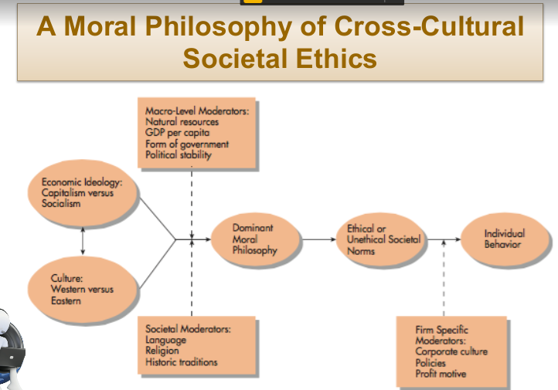
Figure 4: Philosophy of “Cross-Cultural Societal Ethics”
(Source: Week 2 Lecture slide)

From the above figure, the importance of cross-cultural ethics can be understood, and it is business ethics that every organisation should follow while doing business in another country because every country has different cultural values, and it depends on the organisation how it can deal with the cross-cultural communication.
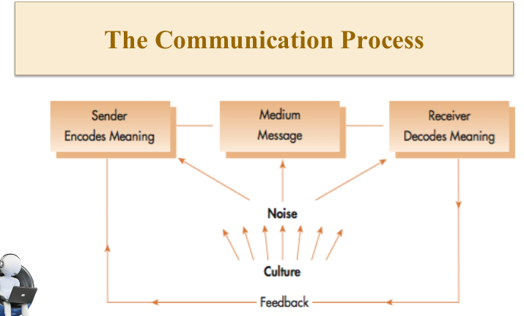
Figure 5: Communication Process
(Source: Week 4 Lecture slide)

The basic process of communication depends on the sender who sends a message, then the receiver decodes the message. In case, there is a gap between the sender, and receiver then there should be a medium between the sender, and the receiver that can connect both of them (Duralia et al. 2018). Proper marketing communication strategies involve positioning the brand, personality development of the brand, and proposition of the brand.
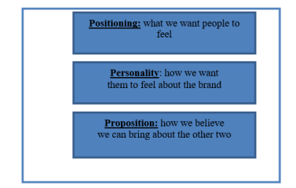
Figure 6: “Marketing Communication Effects”
(Source: Duralia, 2018)

On one hand, from the above image, it is clear that TESCO should make a strong position in the mind of the country’s people, and make them feel secure because it depends on the organisation that how it will continue to interact with people (Duralia, 2018). On the other hand, developing the personality of the brand in the eye of people will help the organisation to improve its business, and the proposition can give a suggestion to the brand that how it can establish its positioning, and personality of the brand. In terms of discussing cultural sensitivity, it can be said that the organisation can easily remove the sensitivity of culture by applying this marketing communication strategy in Malaysia.
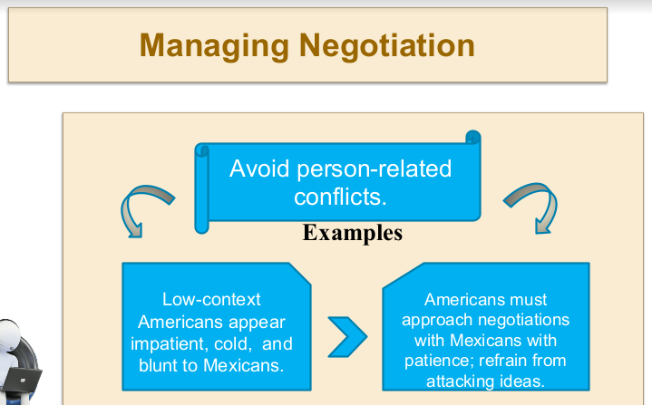
Figure 7: Managing Negotiation
(Source: Week 6 Lecture slide)

Cultural sensitivity can happen in every aspect because it is a different country, and the people of that country may feel insecure to buy products from a foreign organisation. In this scenario, the organisation has to negotiate with the customers and give them priority over the business because long-term business means losing some profits to gain the bigger one. However, there are some strategies that can be used to avoid cultural sensitivity in a different country, but it is also true if the organisation does a study thoroughly the market, and the buying pattern of the customers, then it will be quite easier for them to commerce in that country. The critical discussion has highlighted many shades of cultural sensitivity along with giving a few suggestions that how the organisation can overcome the “cultural sensitivity issues” in another country.
It depends on every organisation how can communicate with people, and what kind of communication strategy they can follow in the future. TESCO follows "a digital marketing strategy” and that strategy can become very helpful while operating in a different country (Desai,2019). For example, if the organisation is selling a product in Malaysia, but somehow people of Malaysia feels that it is not ethically right to be sold in this country, this creates a sensitivity issue. Culture is a very sensitive matter because feelings, emotions, and ethics are involved with it. Therefore, the organisation should be very careful while operating in a different country because of the "cultural sensitivity issue.

5.Significance of Networking
In this assignment, networking means the business networking that business professionals use to increase their connections and recognition of news and trends in their fields. Networking is a tool that helps businesses in conferences and encounters with other businesses, possible suppliers and potential customers or other professionals that can help in the growth of the business. In the networking process here, we are talking about “TESCO PLC” s networking process because they are entering a new country Malaysia to establish their business. Tesco is a well-known business all over the world. But Malaysia is totally a new place for the company. In there the company needs to imply a different kind of networking to capture the market. The networks are made to serve and satisfy an “objective” these objectives are specific and critical. “Transportation Network” means creating a web or matrix that can operate transportation properly. If Tesco is entering the Malaysian market the company has to build a proper transportation network so that if any product becomes unavailable the company can provide the product easily to the customers for example: transportation through roads, rails, highways. “A supplier’s network" means a group of suppliers that can provide products any time anywhere; it is up to the company how well they have built a relationship with the suppliers so that the company will get no trouble in getting the products. This applies to Tesco as well; they need to create a supply chain to get products any time anywhere in Malaysia. "Computer network” for transferring important data from one place to another that helps in building a good communicative network and fast transactional web. Language network is also an important part of it, where the business is operating, they have to use that language to communicate well with the buyers and sellers. Tesco also needs to obtain Malaysia's local language to operate the business without any trouble and that will help them and the customers in understanding each other. The relative importance of the network also takes an important role in networking. It ensures the research control directional relationships among items, helps in reducing over fitting, helps in comparing scalable items with graphs, and also helps in logistic regression of binary inputs.

6.Analyzing different communication barriers faced in a foreign country
There are different types of cultural barriers that can affect the performance of the organisation in Malaysia. The first barrier is the Language that can impact the confidence level of the company because the language of Malaysia is different from the language of the United Kingdom. Another barrier is the Culture of the country which is very different from the UK. The UK belongs to the western zone, and Malaysia is the Middle Eastern country. Also, if is about food habits or the way of living is different from each other. The country has to be very cautious about the matter in this case, the Malaysian people feel that this supermarket is hurting their cultural values, then the business of the organisation will not be continued in this country further. Another cultural barrier is the beliefs and behaviours of people. Malaysian people have different beliefs, and the beliefs of the British people are quite different. This mismatch can create a clash between the two country’s businesses.
TESC has to be very careful while selling the products in this country because another barrier is the etiquette of business that this country’s people follow. Naturally, the business etiquette of Britain is very different from the business etiquette of Malaysia, and this gap can be attained if the company’s marketing department can do elaborate research on the country, and its people’s buying pattern. Therefore, these are the cultural barriers that can impact the organisational performance of the company by creating cultural, and professional differences between these two countries which is not suitable for business. Hence, the organisation should try to find out appropriate strategies to overcome the barriers.

7.Suitable communication strategies with recommendations
Some suitable strategies can be applied to remove the cultural barriers effectively because in case, the cultural barriers will start to increase, then it will be quite difficult for the organisation to continue business in this country. The first strategy that the organisation should apply is: “Cultural contingency Leadership” which means following a particular leadership style that changes as per the cultural preferences in different countries. This leadership style is not only appliable in Malaysia but also it is applicable to every country because as per those country’s cultural preferences, the leadership style of the organisation will be changed to manage the business properly (Maruping et al. 2019). Another major step that should be applied to remove the cultural barriers is managing negotiation. The company has to negotiate with the customers of Malaysia because if the people will not feel that they can buy products from this organisation, then they will not show interest in buying products.

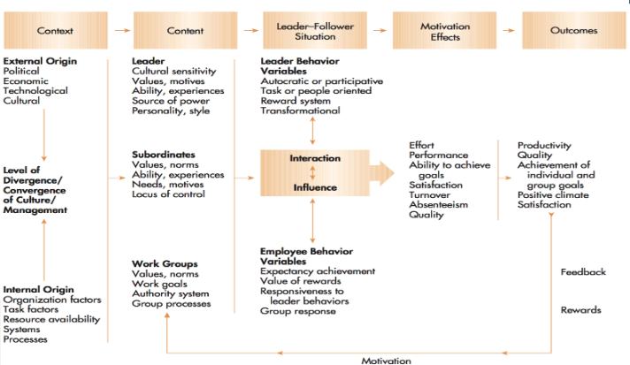
Figure 8: “Cross-Cultural Contingency Leadership Model”
(Source: Week 8 and 9 Lecture slides)
From the above figure, the steps of “Cross-Cultural Contingency Leadership” can be shown in detail. It will help the organisation to adapt to a new country very easily by increasing the marketing scope. Another important communication strategy is increasing brand awareness. Increasing the awareness of the brand can involve campaigning online, and offline. Online promotional strategies will be more useful in comparison to offline marketing because presently people are using the online options more for marketing in comparison to offline mode (Desai, 2019). Therefore, these communication strategies can reduce the chances of cultural sensitivity, or cultural differences, and increase the scope of marketing. By applying these strategies, the organisation will make a strong position in Malaysia, and increase the exposure of its business.

8.Conclusion
In this assignment, we have discussed the expansion of the businesses to other developing countries. How businesses can improve their strategies and develop unique strategies to get into other countries. Here the company was Tesco which was having trouble entering the emerging market of Malaysia to expand the business. The critical evaluation was also done to identify the cultural sensitivity of Malaysia. The appropriate way in making the network preferable for the company. Also, this assessment has helped in analyzing the different communication barriers and the solutions that a company faces while entering a new market. Overall, this analysis helped in understanding different barriers and their solutions while entering the new market.

References
Deresky, H. (2013) International Management: Managing Across Boarders and Cultures, London, Pearson, p.108
Duralia, O., 2018. Integrated marketing communication and its impact on consumer behaviour. Studies in Business and Economics, 13(2), pp.92-102.
Huang, S.S. and Crotts, J., 2019. Relationships between Hofstede's cultural dimensions and tourist satisfaction: A cross-country cross-sample examination. Tourism management, 72, pp.232-241.
Maruping, L.M., Venkatesh, V., Thong, J.Y. and Zhang, X., 2019. A risk mitigation framework for information technology projects: A cultural contingency perspective. Journal of Management Information Systems, 36(1), pp.120-157.
Pirlog, A., 2021. National Cultural Profile in the Republic of Moldova According Hofstede and Trompenaars-Hampden-Turner Models. Revista de Management Comparat International, 22(4), pp.450-457.
Statista. 2022. Tesco's number of stores worldwide from 2008 to 2022. Available at:https://www.statista.com/statistics/238667/tesco-plc-number-of-outlets-worldwide/ (Accessed on 15 August 2022)
TESCO. 2022. Home. Available at: https://www.tesco.com/ (Accessed on 17 August 2022)

