Story Department
I want this small animation to have a story even if its basic and not everything is explained. The story I want to go through is someone on the run as it will link to my final project animation where it is a robot escaping the police after stealing valuables. Because of this I want the animations to consist of actions that would be done with the action of escaping so I plan to write down ideas that I can think of that links to this.
Animation production and pipeline considerations
The plan I have for the animation is to build basic sets and backgrounds and have my rigged model move on it and also through it. My plan for my animation project pipeline is over the span of November is to research into the topic and style of work I want to accomplish and also plan the movements that I want to display. I also want the work to fit around and be based on my final animation project and base the animation loosely on what I plan to use in my own animation. I plan to have the research done over two to three days and then to start pre-production after that. My plan is for the pre-production to be over the course of a few days and then bring the pre-production in to concept designs and storyboards.
Pre-production and Concept design
The first thing that I plan to do is some pre-production work and concept designs.
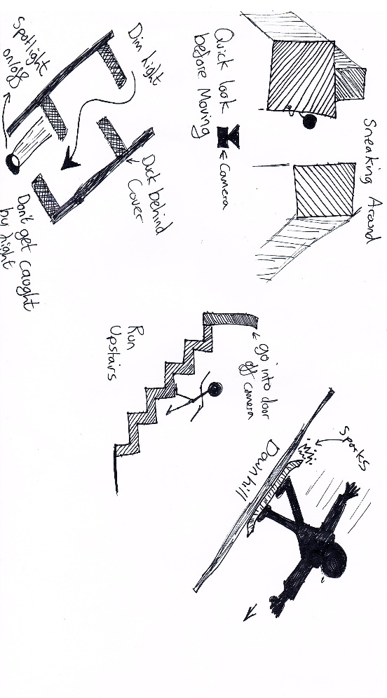
For the pre-production I wrote down ideas that I could take further along with ideas taken from my own project and started planning how I would incorporate the ideas in my animation. Looking at the ideas I started to think what ideas I should use, and I ended up looking more at the ideas that come from and link to my own final project animation and those ideas include sliding down hill, dodging, climbing stairs into spaceship and sneaking around. These actions I have planned for my animation are just ideas at this point so it would be nice to incorporate these sorts of ideas into this animation to give me practice in these actions so I can make a better and more clean final animation for my final project with some tuning from this assignment. It also gives me the chance of experimenting with the concept and making changes that suit the idea of the animation better.

I took these ideas and did a quick sketch plan on the motions that I wrote down as ideas for the animation. As I want these to be at lest a bit connected to my final project animation but most of the final animation is a space ship in space so I could do that for this as I don’t plan to use rigged models for that part so I had to use movement that can be used at the start when out main character steals the ship so I plan to use movements that can be use in that scenario and that would make sense in the situation. After looking at my plans for the animation I came to the conclusion of looking into doing an animation on sneaking around and sliding down a hill or a ramp.
Also, in the pre-production stage of this assignment I later looked at my different videos of different kinds of movement and I wrote some of them down as new ideas for my animation to do different kinds of animation on movement. The movement that I took the most interest in was jumping over a gap while running where there are two types of the actions where this movement is used which is ether a parkour style of free running and the Olympic sport triple jump so I looked into both of them and how I could incorporate them into this animation and also my final animation as well. In the end after considering both styles I went with the free running parkour style because it fits into the theme of my final animation project as it is based of escaping the police so free running to escape makes sense and this could be used in my final animation at the start of the story so I will try an animation based on it to see how I could incorporate it into my final animation.
In the end of the pre-production for brainstorm ideas and researching them I decided using the free running parkour with jumps and also the sneaking around which I then combined with the action of dodging in and out of cover which suits the story of my animation and fits in with my final project with the theme.
For the free running and jumping animation I plan for a straight line with multiple gaps in between for the model to run across and jump across. I plan for two to three jumps and then for them come to a stand still at the end. The other animation will be the sneaking around animation where our character will be sneaking around while dodging around and hiding behind walls and then peaking to see if they can move again. I also want to look into effects for both these scenes and how they can improve the storytelling and the scene itself.
I also want to look at doing the animation for sliding down a hill where I want to include the effects of sparks coming of the back of the board but will only go and give this a go if I need more animation for the time limit or if I can think of a way that this connects to my final project.

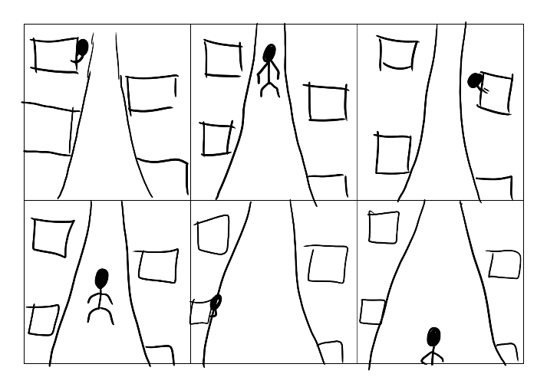
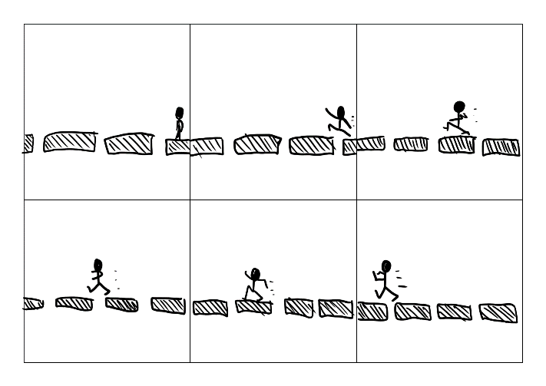
Story boards

These are my basic storyboard of the layout and the motion of the animation.

Rigging
I plan to use already rigged models for my animation, so I don’t have to do the rigging myself. However, even though I don’t plan to do the rigging myself I still want some key movements, so I plan to use models with these movements in mind. Because of I looked for a model that has movement in mind so I looked for models that allowed good leg and arm movement and also good body movements so I could make it look like the animation plan that I have mind. Because of the lack of focuses on face movements, it was not a top priority for me to look for and the already rigged model I will use doesn’t need them. Because I wanted this to link to my final animation project, I plan to use a human like model of the animation because even though my animation project is a robot, it moves and has the same movements parts as a human.
Character animation
For the character animation I plan to have a running and jumping animation in the style of speed running and also an animation on someone sneaking around and jumping into cover between moving from one point to another. The most important part of this animation is the movement, so I looked into to videos where these movements are performed. My take of the videos I watched of these actions I had planned is the arm movements while running and also jumping as the two actions have different arm movements and positions, so I need to work out how to get the arms for running into the arm position and its movement while in the air from jumping. I also aim to do a more realistic form of sneaking around, in cartoons the form of sneaking around is normally portrayed as the character on their tip toes with there arms in front of them and their hand facing down in front of them. However, I want to do a more realistic version of sneaking around so with the videos I watched how sneaking around is done in the more realistic fashion. I also want the character in the animation to go into and out of cover on the route between point A and point B and I also want the character to peek from behind the wall before moving again towards the destination.

Principles of animation
The principle of my animation that I’m doing is to have realistic and fluid animation to show what I want to be seen in the form of animation.
Use of technology to benefit animation workflows
The use of technology is very important in the making of an animation. It is important from the beginning of the animation production, all the way from the start with the basic idea of the animation through to the research to the concept design and animation itself. This is because of many reasons.
The first reason is at the start the computer allows a person to experience a massive number of different thoughts and ideas and also other people’s projects along with their own thoughts and ideas. This is good because it allows me and many others to take the idea of something and make it own with changes that suit our plan and idea. Another reason the use of technology improves our workful is that it allows easier access to other projects similar from online videos to movies and television shows and it allows inspiration to stem from them to form new ideas.
The second big reason the use of technology is very helpful to the animation workflow is how it helps research. This is because with the many different forms of information available that ranges from books and other texts that explains the how to use programs to display people projects in the form of animation with such programs like MAYA and blender.
The third reason is the use of technology allows animation to be make on a computer with computer programs which includes MAYA and Blender and also other programs that includes Adobe packages like premiere and photoshop that can be used in the pre-production of the animation to plan and create designs and textures for the animation and can also be used to add to the animation as effects and different lighting. It can also be used to add sound to the animation and also more important video making components to allow what is displayed be what the creator wants.
Another reason the use of technology is really important is it makes learning animation easier. This is because any issues and questions while using programs to animate can be found on the internet avoiding headaches when somethings not working and what the creator want to do in their animation.
Story design and evocation
The story of the animations I have done is based on my final project and the animations is mostly based on ideas that I had for the start of my final project animation when my main character is sneaking around to steal a spaceship to escape. The animations are based on ideas I had for how they sequence plays out. Using this I use my imagination and make concept designs and storyboards to see how these scenes tell their stories and how it fits into the bigger picture and the main story. The story I want is the sense of escaping the law that are chasing our main character for a unknown crime. The plan is a sneaking around scene and a free funning scene in the set of a futuristic scrap yard. However, I’m using basic sets for this animation with colours too show the key parts as I’m just showing the animation with a basic model, and it makes the parts stand out and easier to see but this would be more detailed and fit the theme that I’m doing more.
Story mechanics
The mechanics of the story is a small run though of a larger scene. The animation is based in the first part of the story and is split from the sneaking around scene to when our character gets caught and the free running scene happens to the target which is the escape ship, and the two scenes are loosely connected as the middle part of this story is not in these animations, but my hope is that it still makes scene make sense to the viewer.
I have now decided to switch the scenes around as I believe it would make more scene this way round.
This work I aim to be more in my animation skill set but is willing to push it a bit further in these areas like the movement and the lighting and camera work and not making it so basic like trying to make a darker scene and having multiple cameras.

How will this lead into my future animation project?
This project will lead to my future final animation project is that this assignment has allowed me to try out ideas that I had for my animation and allowing me to see how it plays out so I can see how it plays out and looks to see if I could make any changes for my final animation project. The scenes that these animations are based on were concept ideas for the animation so this opportunity allowed me to look at how these scenes would play out and where or not it would suit my final animation project and also all me to see if I could change it to make the scene better.
Another way this is going to lead to my future animation final project has allowed me to test out lighting. This helps me in my final project because it allows me to practice different lighting and how it affects the scene and what it does for the story itself. The lighting is important because not only does it dictate how the animation itself is seen by the viewer, but it can also be used to display emotions, and this can be allowed as extra version of storytelling in the form of imagery. For example, bright lighting can show high details and give the person watching a happy feeling because this lighting is used for happy emotional scenes while grey and darker scenes to give a more scary and also sad emotional scene. It has allowed me to try a darker lighting as I plan for this scene to use a muted colour scheme as I want a darker theme for this part of my final animation.
This will also lead into my future animation by allowing me to practice and plan out camera positions. This helps me plan and test out camera positions of the planed scenes and see what works and what does not so I can improve my camera positions for these scenes along with the knowledge on what angles make the scene make the most sense and how it complements the scene with a good viewing angle of the animation.
All together I have learnt a lot from this opportunity to practice all the things that go into the final animation.

Links
[1] https://www.youtube.com/watch?v=zsU9Icyuv3c

